DOKUMENTASI APLIKASI SISTEM HOTEL MANTAP

1. Class Diagram

|  |
| --- |
| Costumer |
| # jam : int  # id : String  # nik : String  # name : String  # ttl : String  # checkin : String  # checkout : String  # kamar : String |
| + Costumer(id=String,nik=String,name=String,  ttl=String,checkin=String,  checkout=String,kamar=String)  + Costumer()  + setNik(String nik) : void  + setName(String name) : void  + setTtl(String ttl) : void  + setCheckin() : void  + setJam() : void  + getId() : String  + getNik() : String  + getName() : String  + getTtl() : String  + getCheckin() : String  + getCheckout() : String  + getKamar() : String  + getTanggal() : String  + getjam() : int |

|  |
| --- |
| ROOM |
| # name : String  # idRoom : String  # status : String  # priceRoom : int  # discountRoom : double  # discount : double  # price : double |
| + Room(name=String,priceRoom=int,  idRoom=String,status=Status)  + setPrice(int x) : int  + setStatus(String status) : void  + getPriceRooml() : int  + getDiscount() : double  + getIdRoom() : String  + getStatus() : String  + getNamel() : String |

|  |
| --- |
| SUITE |
|  |
| + Suite(name=String,priceRoom=int,  idRoom=String,status=Status)  **+ getIdRoom() : String**  **+ getStatus() : String**  **+ getNamel() : String**  **+ getStatus() : String** |

|  |
| --- |
| REGULAR |
|  |
| + Regular(name=String,priceRoom=int,  idRoom=String,status=Status)  **+ getIdRoom() : String**  **+ getStatus() : String**  **+ getNamel() : String**  **+ getStatus() : String** |

|  |
| --- |
| VIP |
|  |
| + VIP(name=String,priceRoom=int,  idRoom=String,status=Status)  **+ getIdRoom() : String**  **+ getStatus() : String**  **+ getNamel() : String**  **+ getStatus() : String** |

|  |
| --- |
| PREMIUM |
|  |
| +Room(name=String,priceRoom=int,  idRoom=String,status=Status)  **+ getIdRoom() : String**  **+ getStatus() : String**  **+ getNamel() : String**  **+ getStatus() : String** |

1. Method

* Class Room

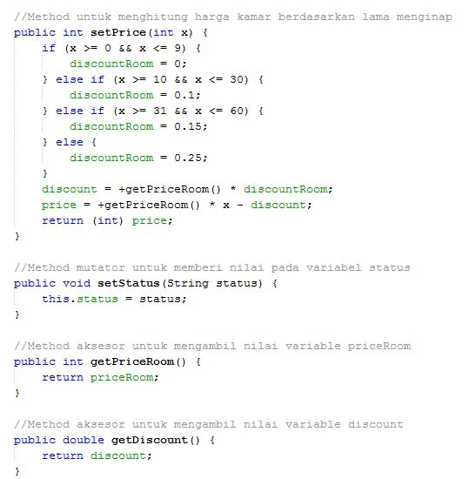

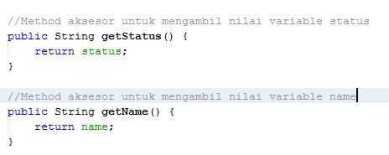

* Class Costumer

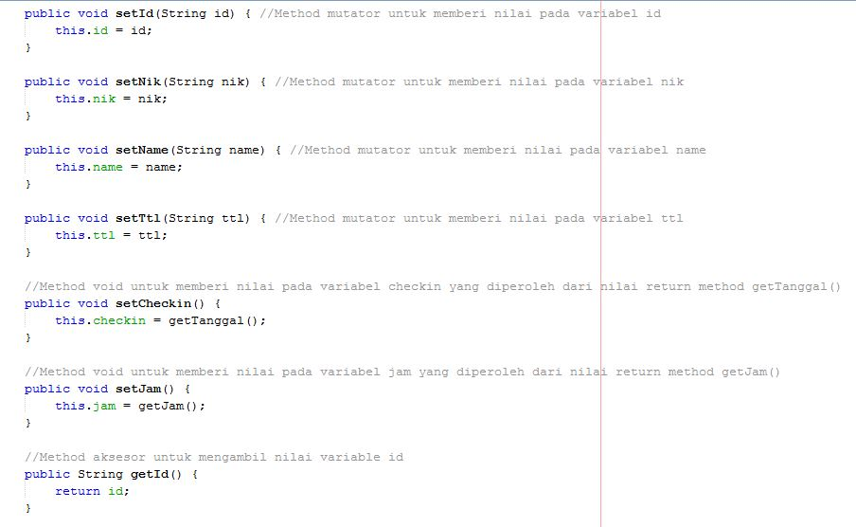

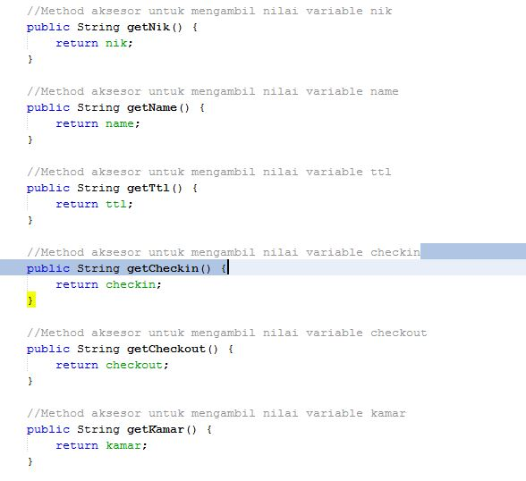

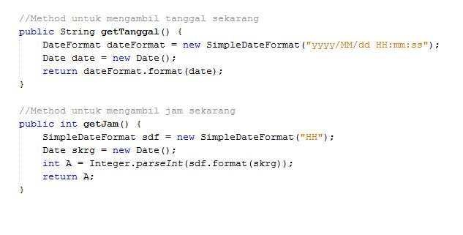

* Class VIP

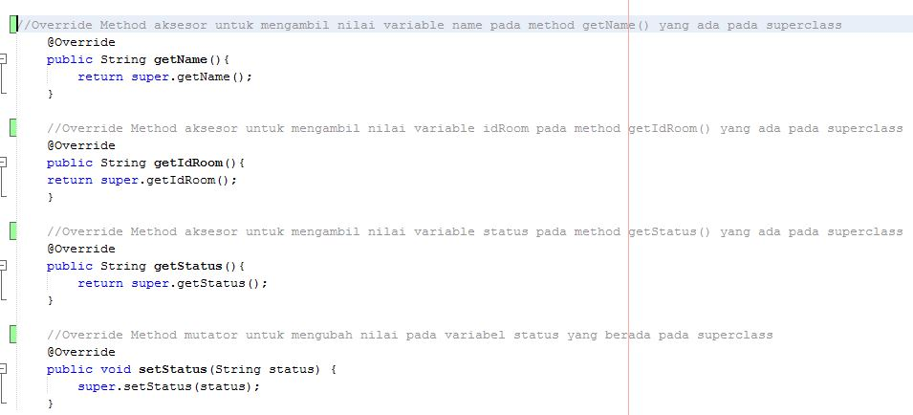

* Class Suite

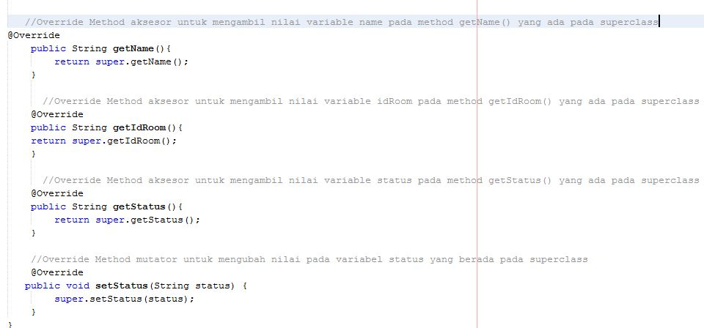

* Class Premium

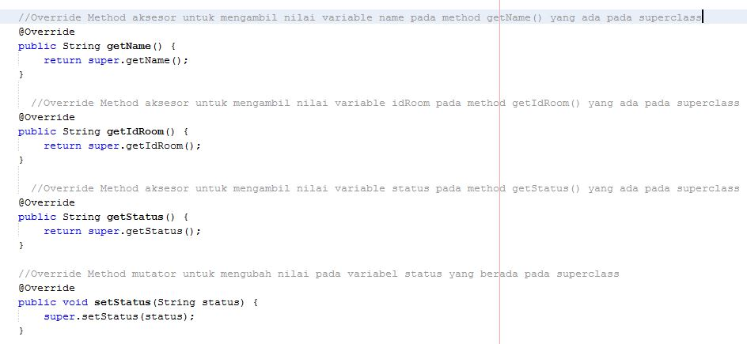

* Class Regular

