)

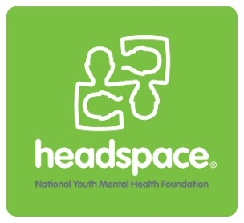

AGENDA/MINUTES

**headspace Gladstone Youth Reference Group Meeting**

**Where:** headspace Gladstone, Level 3, 93 Goondoon St, Gladstone

**When:** Wednesday, 1st June 2016

**Time:** 4:00pm to 5:00pm

1. **Introduction and acknowledgement of Country by Chair**

“We acknowledge the traditional owners of the land on which we meet, and their continuing connection to land and community. We pay our respect to them and their culture, and to their Elders past, present and future”

1. **Attendance**
2. **New Members**
3. **Apologies**
4. **Check in**

Each member of the YRG share a positive and a not so good of their month.

1. **Ice breaker /Activity**
2. **Discussion Items**
3. **Upcoming Events/Activities**
4. **Items for next meeting**

Chair/Minute taker

1. **Next Meeting**

The next YRG meeting is on Wednesday,