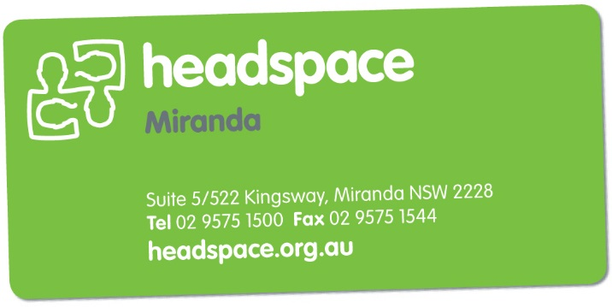Get Work Ready

Group program- registration form

*Please type or write in the boxes below*

|  |  |
| --- | --- |
| **Personal Information** | |
| Name: |  |
| Contact number: |  |
| Address: |  |
| Email |  |
| Age (& DOB): |  |
| **Emergency Contact/Parent** | |
| Name: |  |
| Mobile number: |  |
| Home Phone: |  |
| Work phone: |  |
| Email: |  |
| Relation to young person: |  |

|  |  |
| --- | --- |
| **Education and Work Information (please circle)** | |
| Currently working: | Yes/No |
| Looking for work: | Yes/No |
| Currently studying: | Yes/No |
| Level of study: | High school/Tafe/Private college/University |

|  |  |
| --- | --- |
| **Other Information (please circle)** | |
| How did you find out about this group? | Website/friend/parent/carer/facebook/school/Tafe  Other (please specify): |
| I am happy to be contacted for further group programs similar to this? | Yes/No |

**Once completed please email to** [**headspace.miranda@cesphn.com.au**](mailto:headspace.miranda@cesphn.com.au)