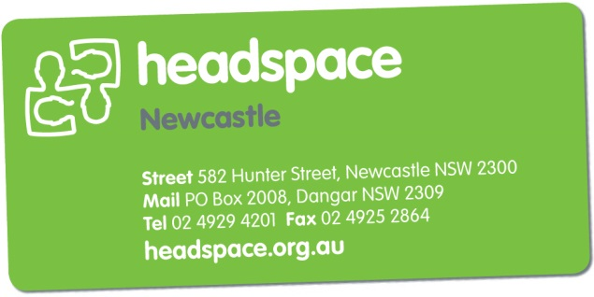**Referral Form   
headspace Newcastle  
Referral Date:** Click here to enter a date.

|  |  |  |  |  |  |  |  |
| --- | --- | --- | --- | --- | --- | --- | --- |
| **headspace Referral Criteria:** A young person **must meet the first 2 criteria** to be eligible for headspace | | | | | | | |
| 1. Has the young person given consent for the referral?   **PLEASE NOTE: IF YOU DO NOT HAVE THE YOUNG PERSONS CONSENT WE WILL BE UNABLE TO PROCESS THIS REFERRAL GP’s ARE NOT REQUIRED TO COMPLETE THIS FORM- PLEASE REFER VIA MHTP**   1. Is the young person aged between 12 and 25? | | | | | | | |
| 1. Has the parent/carer consented to referral (if appropriate)? | | | | | | |  |
| **headspace is not a crisis service. We are unable to support severe mental health concerns or crisis referrals. Please call the Mental Health Line on 1800 011 511 if the young person needs urgent mental health assistance.**  Please ensure these details are **correct** and legible as we use these to communicate with you and the young person. | | | | | | | |
| **Young Person’s Details:** | | | | | | | |
| Name: | | | Contact Number: | | | | |
| Date of Birth: | Age: | | |  | Gender: | | |
| Address: | | | | | | | |
| Suburb: | | | | | | Post code: | |
| Medicare Card:  Ref:  Expiry Date:    Healthcare Card:  Grant Date:  Expiry Date:   Pension Card:  Grant Date:  Expiry Date: | | | | | | | |
| **Does the young person identify as:**      **Does the young person have any difficulties with literacy:**    **Referral Method:** | | | | | | | |
| **Next of Kin:** This should be the young person’s closest living relative. Note: NOK must be over 25yo | | | | | | | |
| Name:  Relationship to YP | | | | | | | |
| Address: | | | Contact Number: | | | | |
| **Referrer Details:** | | | | | | | |
| Name of Referrer: | | Organisation: | | | | | |
| Relationship to YP: | | Contact Number: | | | | | |
| Address: | | | | | | | |
| Email : | | | | | | | |

|  |  |  |  |  |  |  |  |  |  |
| --- | --- | --- | --- | --- | --- | --- | --- | --- | --- |
| **Required Services:** Please indicate which services would be beneficial and attach any relevant documentation/notes. | | | | | | | | | |
|  | | |  | | | |  | | |
|  | | | **Please contact headspace Newcastle to inquire about current groups** | | | | | | |
| **Reason(s) for referral:** *(please tick)* | | | | | | | | | |
|  |  | | |  | |  | | |  |
|  |  | | |  | |  | | |  |
|  | | | | Details: |  | | | | |
| **Referral Information** (**please complete this section**):  Please attach any extra relevant information and assessments e.g.***Tertiary Mental Health Services:*** *Please attach Risk Assessment, A1, Discharge Summary* ***\*\*Please note we may be unable to process/accept referral if this information is not received***    *(The above field has an 880 character limit. Please attach additional documentation should you require more space)* | | | | | | | | | |
| Thanks for making a referral to **headspace** Newcastle. You can return the referral form by: | | | | | | | | | |
| **Fax**  (02) 4925 2864 | | **Email**  [intakeheadspacenewcastle@hunterml.com.au](mailto:intakeheadspacenewcastle@hunterml.com.au) | | | | | | **Or Drop In**  582 Hunter St, Newcastle | |
| If you would like to discuss this referral please contact **headspace** Newcastle staff on (02) 4929 4201 | | | | | | | | | |
| ***Office use only*:** | |  | | | | | | | |