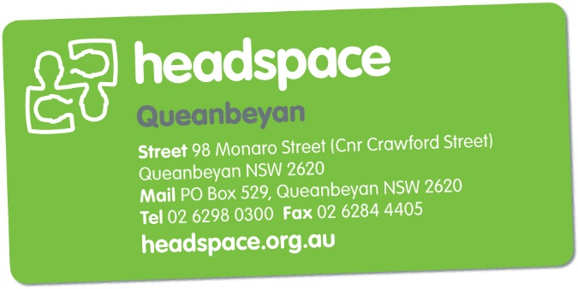

**Referral Form**

**To be completed by services wishing to refer a young person**

**to headspace Queanbeyan**

**Referral Criteria and Guidance**

**headspace** Queanbeyan is a free, youth-friendly and confidential service available to young people aged 12-25 years, in the Queanbeyan and surrounding area. The services available at **headspace** Queanbeyan include:

|  |  |
| --- | --- |
| * Youth Friendly GPs | * Counselling |
| * Alcohol & Drug Support | * Vocational support |
| * Psychologist services (under a GP Mental Health Treatment Plan) | |

**headspace** Queanbeyan work with young people experiencing mild to moderate mental health issues such as stress, anxiety, depression or grief.

**headspace** Queanbeyan is not an acute mental health / crisis service. If you have any immediate concerns regarding the safety of a young person, please call:

|  |  |
| --- | --- |
| * NSW Mental Health Line | 1800 011 511 |
| * ACT Crisis Assessment & Treatment Team (CATT) | 1800 629 354 |
| * Kids Helpline | 1800 551 800 |
| * Emergency services | 000 |

Please return the completed referral form to:

|  |  |
| --- | --- |
| **headspace** Queanbeyan | Phone: 02 6298 0300 |
| 98 Monaro Street (Corner Crawford Street) | Fax: 02 6284 4405 |
| Queanbeyan NSW 2620 |  |

**Self-Referral**

Young people can refer themselves to **headspace** Queanbeyan. Young people are encouraged to contact **headspace** Queanbeyan directly by either phoning, emailing or walk-in to the centre.

**Family and Friend Referral**

Family, carers and friends can refer a young person to **headspace** Queanbeyan. Please contact **headspace** Queanbeyan directly by either phoning, emailing or walk-in to the centre.

|  |  |
| --- | --- |
| Young Persons Details | |
| Has the young person consented to this referral?  Yes  No | |
| Name |  |
| Address |  |
| Date of Birth |  |
| Phone Number |  |
| Gender | Female  Male  Transgender  Other: |
| Cultural Identity | Aboriginal or Torres Strait Islander  CALD |

|  |  |
| --- | --- |
| Referring Service Details | |
| Date of Referral |  |
| Name |  |
| Address |  |
| Organisation |  |
| Position in Organisation |  |
| Phone Number |  |
| Email |  |

|  |
| --- |
| Reason for Referral:  *Please include any information which may be useful to assist with the referral (e.g. mental health, drug and alcohol, vocational / educational or physical health including past / current risk assessments).* |
|  |

|  |  |  |  |
| --- | --- | --- | --- |
| Does the young person have an existing GP? | Yes | No | Unsure |
| If yes, please detail: |  |  |  |
| Does the young person have an existing  Mental Health Treatment Plan? | Yes | No | Unsure |
| Does the young person require an interpreter? | Yes | No | Unsure |