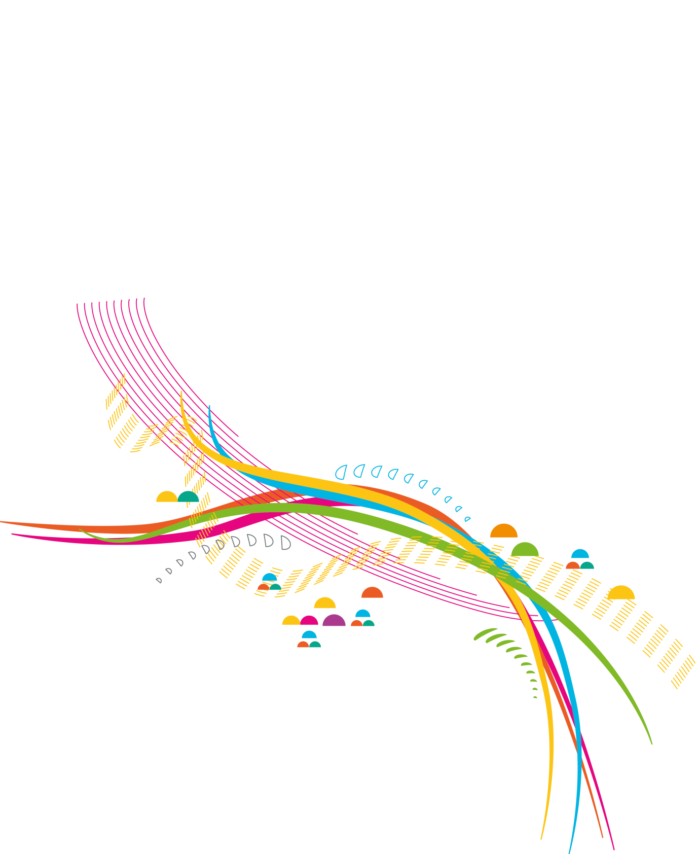

***“It has helped me move towards a more meaningful life”***

ninjaART

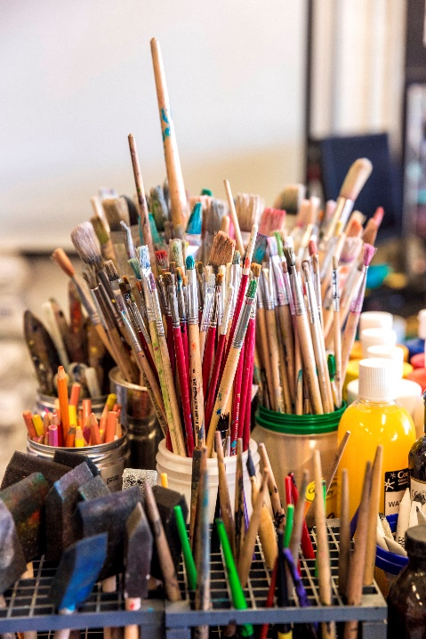

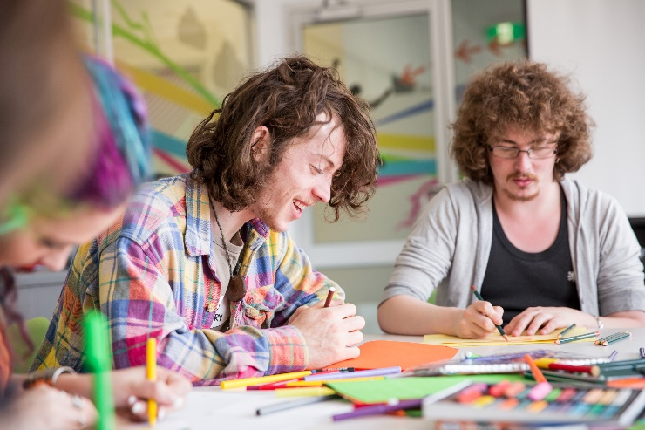

ninjaART is a FREE, fun & interactive art group that gives you the opportunity to explore meaning and creativity through a variety of mediums (painting, drawing, creative writing, aerosol art) in a safe and supportive space.

*no artistic skills necessary!

Who: Young people aged 12 – 18 years

When: 4pm –5.30pm Thursdays

Where: **headspace** Werribee,

5 Duncans Rd, Werribee





**Interested?** Contact **Access Team** at **headspace** Werribee on 8001 2366

or enquire at reception