**headspace Request Form – use of logo, website link or description**

This form is to be completed by organisations or individuals external to **headspace** wishing to use **headspace** logo, website link or description. All relevant sections of the form must be completed and sent to Richard Hunt, Centre Marketing Officer, **headspace**, Email: [rhunt@headspace.org.au](mailto:rhunt@headspace.org.au) for approval and use.

|  |  |  |  |
| --- | --- | --- | --- |
| **Applicant** | | | |
| **Name** |  | | |
| **Position** |  | | |
| **Type** | Government  Corporation   Not-for-Profit   Individual | | |
| **Organisation**  **(if appropriate)** |  | | |
| **Address** |  | | |
| **Phone No.** | (     ) | **Email** |  |

|  |  |
| --- | --- |
| **Usage of logo** |  |
| **Proposed use of logo/s (include publication type and audience)** |  |
| **Date/s of proposed use** |  |
| **Logo Format** | jpeg   eps |
| **Logo** | Colour (green panel)    Mono (black and white)  Colour reversed (white panel - for dark backgrounds) |

|  |  |  |  |  |
| --- | --- | --- | --- | --- |
| **Rules for usage of logo** | | | | |
|  |  |  |  |  |

1. **Logo Ownership**

The **headspace** logo is owned by **headspace**. Use of the logo without approval and/or in an inappropriate manner may result in legal action.

1. **Conditions of Using the Logo**

To maintain the credibility and integrity of the logo, it must be protected from inappropriate use. By requesting permission to use the logo, your organisation agrees to the following terms & conditions of use:

1. The logo must be used in connection with promoting public awareness of **headspace**, or recognise an affiliation with you or your organisation
2. No one may manufacture for sale a product containing or featuring the logo
3. The logo must always be clearly visible and distinct from the background
4. The **headspace** logo must be the same height as the highest other logo on the same line/space
5. Always ensure the logo is at a legible size (see minimum size requirements below) and it should always remain at 90 degrees (not angled)
6. The proportions of the logo must always remain true (no stretching out of shape)
7. **headspace** reserves the right to request that publications be removed from circulation if the document does not meet the above mentioned requirements.

**3. Logo Guidelines**

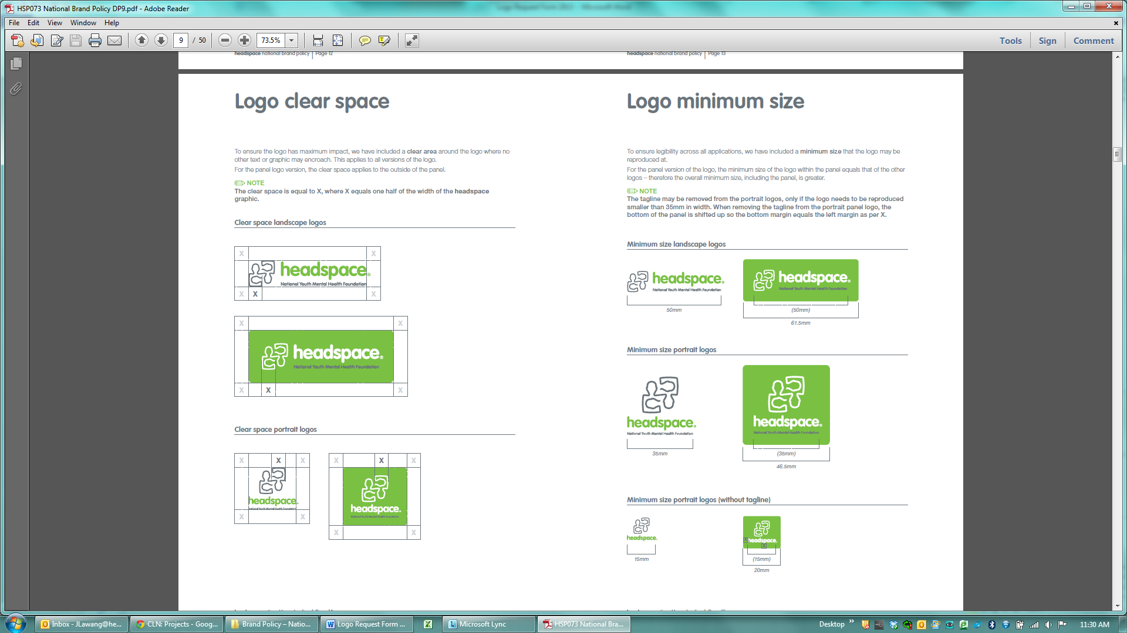

|  |  |
| --- | --- |
| **Usage of website link** |  |
| **Proposed use of** [**headspace.org.au**](http://www.headspace.org.au) **(include publication type and audience)** |  |
| **Date/s of proposed use** |  |
| **Usage of headspace description** |  |
| **Proposed use of headspace description template** |  |
| **Please type any additional content you wish to use (see below rules)** |  |
| **Date/s of proposed use** |  |

|  |  |  |  |  |
| --- | --- | --- | --- | --- |
| **Rules for usage of website link and/or headspace description** | | | | |
|  |  |  |  |  |

The **headspace** website should be written as: **headspace.org.au**

A variety of **headspace** description templates are outlined below and must be used. If you are intending to include additional content, please specify in section above.

* **headspace** helps young people aged 12-25 years who are going through a tough time. *(14 words)*
* **headspace** helps young people aged 12-25 years who are going through a tough time.

They assist young people and their families with mental health, physical health, alcohol and other drugs and education and employment support. *(35 words)*

* **headspace** helps young people aged 12-25 years who are going through a tough time.

**headspace** centres are located across Australia and help you to access the right type of health worker for your needs.

**eheadspace** provides online and telephone support for young people and their families.

**headspace** School Support provides advice, support and assistance to school communities affected by suicide. *(60 words)*

|  |  |  |  |
| --- | --- | --- | --- |
| **Usage Agreement** | | | |
| I agree that the requested items will be used in accordance with the Rules for Usage published within this document and I acknowledge that **headspace** reserves the right to rescind any prior approval for usage of the logo and/or website link and description.  **I will also send a copy to headspace of the final publication where the requested items will appear prior to it being published.** | | | |
| **Name** |  | **Position** |  |
| **Signature** |  | **Date** |  |

|  |  |  |  |
| --- | --- | --- | --- |
| **headspace approval** | | | |
| Approved  Not approved  Conditional approval | | | |
| **Comments** | | | |
| **Signature** |  | **Date** | /       / |
| **Logo/s or Image/s forwarded** |  | **Publication viewed** | /       / |