headspace Frankston and Project Headstart

1 in 4 Australians will experience a mental health problem. If you are a young person, it can be really hard to get help, or even just be heard.

What is headspace?
headspace is where young people can go to get help. headspace Frankston has doctors, counsellors and other health workers available to help you cope with stress, anxiety, depression or drug and alcohol issues. We can also help you find the right person to talk to about further study, getting a job or doing a course.
Who can apply?
The headspace Frankston Project Headstart group is for anyone aged between 12 and 25.
We are looking for
10 -12 young people from Frankston, Mornington, Hastings & Rosebud to be part of the core group.

We want you to apply if:
you have your
own experience of feeling depressed or anxious, substance abuse or other mental health issues.
have a family member who has/or had mental health issues.
or have an interest in youth mental health or other youth issues.

The group is also keen
to hear from Indigenous
young people, young people from different cultural backgrounds and young people who may have been homeless.

We want to make sure we get it right for you, so headspace wants to hear
from you. In order for us to do this, we created a Youth Reference Group,
now known as Project Headstart, to educate the community about youth
issues, and to make sure we have youth friendly services and some fun
stuff for young people to do here.

What is the headspace Frankston Project Headstart Group?

Project Headstart is a collection of young people who are passionate about
making the community a better place - with a focus on Youth. Young people are
under-represented as a whole in most communities, and we think your voices
need to be heard. We aim to address mental health Issues, alcohol and other
drug issues, and the ever-changing needs surrounding young people on the
Peninsula.

Our involvement includes helping organise community awareness activities,
talking to local media about youth mental health, organising
youth events, fundraising, participating in training and skills development, and
involvement in the running of the headspace Frankston’s website.

By getting involved you will have the opportunity to:

- Have your say and help direct youth mental health
services in the Frankston & Mornington Peninsula areas
- Develop new skills
- Participate in direct Media and Community Engagement
- Plan, organise and run local projects: BBQ’s and other awareness and
fundraisers such as music events, sports days and charity events
- Market, promote and develop community awareness of youth issues
such as youth mental health.
- Meet and work with other young people who are passionate about
youth issues
- Be involved in specific focus groups
- Research and evaluate Youth policies, facilities and support in the
Community

How do I get involved?
Complete the application form and hand it in. It’s that simple! ☺

If you have further enquiries please contact us on 03 9769 6419.

2014
headspace Frankston
Project Headstart Core Members
Project Headstart Application
Updated June 2014

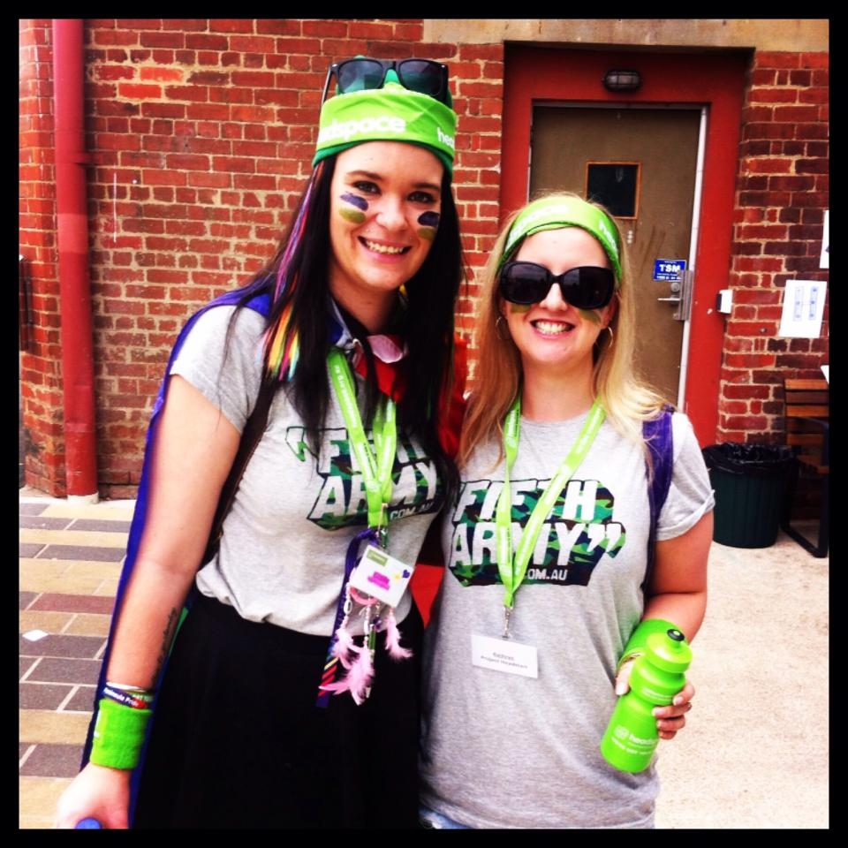
Project Headstart Application

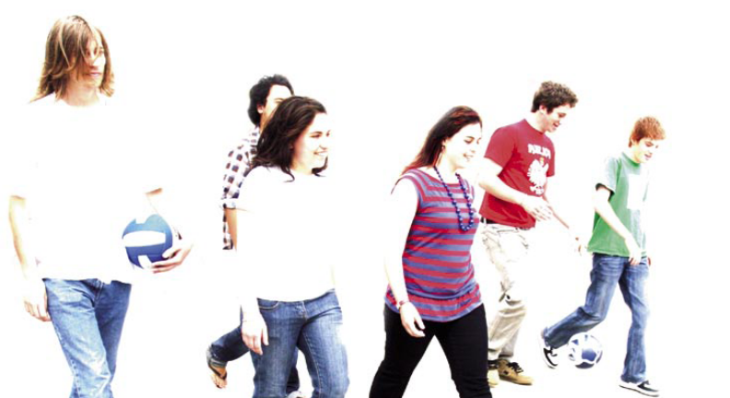
What is the headspace Frankston Project Headstart Group?
Project Headstart is a collection of young people who are passionate about making the community a better place - with a focus on Youth. Young people are under-represented as a whole in most communities, and we think your voices need to be heard. We aim to address mental health Issues, alcohol and other drug issues, and the ever-changing needs surrounding young people on the Peninsula.

Types Of Membership
We are offering two levels of membership, or involvement, if you like: Core Membership and Basic Membership.

Core Members meet weekly, and drive the group. They are responsible for recruitment, and the overall organisation and leadership of the group. Due to the nature of some of the work we do, and the issues Project Headstart aims to assist with (mental health, drug and alcohol issues for example), Core Members are required to be at least 15 years of age.

Basic Members meet infrequently on an as-needed basis and are responsible for assistance with organizing and running of events, and development of project ideas, and also for giving feedback on headspace services and on their part of the community.

Meetings
Upon joining Project Headstart, Core members will be required to attend weekly meetings. These meetings will be held every Thursday afternoon from 4.00pm until around 5.30. Basic Members are welcome to attend the same meetings when it is relevant (eg. Planning an upcoming project).
Meeting will take place at headspace Frankston – 62 Playne Street Frankston.

There will also be community awareness activities and youth initiated projects that the Project Headstart members can get involved with to whatever extent they choose.

Benefits
- Have the opportunity to have your say and direct youth mental health services in the Frankston & Mornington Peninsula region.
- Meet and work with other young people who are passionate about youth issues
- Develop a range of skills including working in groups, and representing the needs of your peers.
- Opportunities to participate in fun activities like festivals and camps.
- Take advantage of opportunities to work alongside and/or directly with other groups such as Peninsula Pride or our Aboriginal and Torres Straight Islander group.
- Make a valuable and significant contribution to your local community

Projects
Project Headstart’s current and recent projects include
- Mind Your Head DVD Project
- Consultants on the design of the new headspace site.
- Art programs and projects
- ‘Mind your head’ day/Youth Mental Health Awareness Walk
- Redevelopment of headspace Frankston website
- Fundraiser

Reimbursements
Peninsula headspace will cover the following costs:
- Travel costs to attend face-to-face events, such as meetings, as required.

Camps
From time to time, there are opportunities for a limited number of Project Headstart members to go on camps, similar to a school camp. These are run either by headspace Frankston or in association with external groups, and are usually free of charge. The numbers are limited, so get in quick!
Other
Parental (or Guardian) consent will be required for young people less than 18 years of age.

To apply – just complete the attached form and return it to us at 62 Playne St Frankston or via email to hryan@headspacefrankston.org.au

VOLUNTEER POSITION DESCRIPTION: Basic Member
headspace Frankston Project Headstart representative

1. WHAT WE ARE LOOKING FOR:
As a Group
- Ability to integrate and work in unison with the core group (and Headspace Youth Workers, where applicable) towards projects.
- Generate and develop ideas for new or existing projects
- A mix of ages, genders and cultures.
- A diverse range of life experiences and backgrounds: young people who are same sex attracted, who have experienced homelessness, those with or without mental illness, those who have experience with substance abuse, are ALL welcome!
- Collectively, we want as many skills as possible: whether it’s in communication, cooking, art, music, sport, science, computers…everyone brings something different to the table, and everyone will get their chance to shine.
- Members from all over the Mornington Peninsula and Frankston areas
As Individuals
- Communication skills and a willingness to learn
- The ability to work in a team and participate in group discussions, whilst understanding every team member has a right to speak and be heard
- The ability to work independently, where required and contribute that work to the group.
All members should have regular access to Internet or at least to a phone, in order to actively participate. (If this is a problem, speak to a Core Member or Headspace Youth Worker and we’ll see if there’s another way around it ☺)
- It is preferable (not compulsory) that individual members have an interest and passion, for mental health and/or, surrounding substance abuse in young people.
- Basic Members must be aged 12-25, however to attend meetings, they must be 15-25.

2. RESPONSIBILITIES:

- Participate in meetings – this is not a large commitment, but particularly in the lead-up to events, we need as much group consistency as possible.
- Encourage others in their involvement
- Support local headspace Frankston and some national headspace activities on occasion, subject to availability.
- Promote headspace’s key messages to other young people and the community
- Actively participate in improving community awareness of mental health and youth issues
- Members may be asked to be involved in community education activities, speak at public functions including schools, mental health forums etc. Whilst there is no obligation to do so, all members are encouraged to show leadership and get involved where possible.

VOLUNTEER POSITION DESCRIPTION: Core Member

headspace Frankston Project Headstart representative

1. WHAT WE ARE LOOKING FOR:
As a group:
- An ability to lead, support and organise basic members involvement.
- Generate and develop ideas for new or existing projects.
- A mix of ages, genders, abilities and cultures.
- A diverse range of life experiences and backgrounds: young people who are same sex attracted, who have experienced homelessness, those with or without mental illness, those who have experience with substance use and/or abuse, young carers are ALL welcome!
- Collectively, we want as many skills as possible: whether it’s in communication, cooking, art, music, sport, science, computers…everyone brings something different to the table, and everyone will get their chance to shine.
- Members from all over the Mornington Peninsula and Frankston areas.
As an individual:
- The ability to think about the big picture
- The ability to work as part of a team and actively participate in group discussion, while understanding every member has a right to speak and be heard.
- The ability to work independently and contribute that work to the group.
- Good communication skills
- Motivation, willingness and a commitment to the group
- All members should have regular access to Internet or at least to a phone, in order to actively participate. (If this is a problem, speak to a Core Member or Headspace Youth Worker and we’ll see if there’s another way around it ☺)
- The ability to work in a team and participate in group discussions
- The ability to balance health (including mental health), other responsibilities like school/work/uni/family and the demands of the group
- It is preferable (not compulsory) that individual members have an interest and passion, for mental health and/or other youth issues.
- All Members of the core group must be aged between 15 – 25 years of age.

2. RESPONSIBILITIES:
- Participate in Weekly meetings
- Promote headspace Frankston and in particular, headspace’s key messages.
- Encourage participation and application for new and prospective members, respectively
- Consider new member applications
- Be prepared to undertake training about headspace, mental health, mental illness, drugs and alcohol and community awareness, or in other youth issues.
- Support local headspace and some national headspace activities upon request, with respect to availability.
- Actively participate in improving community awareness of mental health and the factors which affect young people’s mental health.
- To follow the direction of headspace staff when required.
- To promote inclusion, acceptance and equal opportunity for all young people, regardless of their gender, sex, religion, racial and/or cultural background, sexuality, disability, or other personal characteristics.
- Help ensure headspace Frankston remains a place free from bullying, harassment, sexual harassment and discrimination
- Some young people may like to become active community promoters for youth mental health with the goal to raise awareness of youth mental health, encourage young people to seek help early and to educate the wider community about youth mental health. Young people may be involved in community education activities, or as media spokespeople on the issue of youth mental health. Project Headstart representatives may be requested to speak at public functions or at local schools, mental health forums, conferences and the like, Whilst there is no obligation to do so, all members, particularly those in the Core group, are encouraged to show leadership and get involved, or at least attend such external events, where possible.

Project Headstart Application

Personal Details:
Name: _______________________________ Email: ______________________________
Address: ____________________________ Phone: ____________________________
____________________________ Mobile: _____________________________
Date of Birth: _________________________ Sex: _______________________________

What is your preferred method of contact (e.g phone call, text message, email etc)?

Are you interested in being a Core Member or a Basic Member of Project Headstart? (please tick)
- Core Member
- Basic Member
- Not Sure

About you

Please tell us a bit about yourself?
(For example: My name is ______ I am 16 years old, and I am in Year 10 at xxxx school …I like soccer, etc)

Why do you want to be involved in Project Headstart?

What are your areas of interest?

What type of headspace activities are you most interested in?

- Organising and running of Project Headstart
- Making headspace a youth friendly environment
- Organising community awareness activities
- Getting involved in the Website
- Developing current projects
- Initiating new projects(please describe any project ideas below)…

- Other: (please list)…

Are you, or have you been in the past, involved with any other such organisations? If yes, which ones and what is/was your experience?

Is there anything else you would like to tell us?

Place of education/employment? _________________________________________________
Are you Aboriginal or Torres Strait Islander? Yes No
Do you have a family member with a mental illness? Yes No
Do you identify as having/or having had a mental illness? Yes No
Is this something that you would be happy and feel
comfortable to talk about? Yes No

