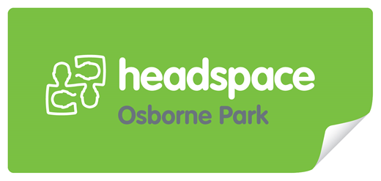


Referral Guidelines

About headspace Osborne Park

headspace Osborne Park is a free, youth-friendly and confidential service available to young people aged 12 – 25 years, in the metropolitan region north of Perth. It promotes and facilitates the improvement of young people in the key areas of primary health, mental health, drug and alcohol-related issues, social recovery and vocational services.

headspace Osborne Park is not an acute mental health/crisis service. If you have any immediate concerns regarding the safety/wellbeing of a young person, please call: Mental Health Emergency Response Line (MHERL) on 1800 555 788; Lifeline on 13 11 14; or Kids Helpline on 1800 55 1800. In an emergency, contact 000 immediately.

Eligibility for Drumbeat

Young person must be aged between 14-17 years.
Be willing to commit to one hour of drumbeat group activity per week for 10 weeks

How to refer

Self Referral

By phone/email: Call (08) 9208 9555 or email info@headspaceospk.com.au.

Drop in: Young people can call into headspace Osborne Park, Suite 2, 145 Main Street, Osborne Park between 9am and 4pm, Monday – Friday. Staff will endeavour to see the young person the same day to discuss drumbeat.

Professional Referral
GP’s, Allied Health Professionals, community-based agencies and educational institutions can all refer young people to the drum beat program using the Referral Form attached.

Family Referral
Families, carers or friends can refer a young person to the headspace drumbeat group. The young person needs to be aware of and consent to the referral and be willing to meet with a member from the headspace Osborne Park team.

Once receipt of referral has been confirmed, a worker will contact the young person within one to three working days to discuss the referral.

If we have a high demand for drumbeat, you may be placed on a waiting list.

Dress Style/Clothing
As you will be using large African drums ensure you were adequate clothes to drumbeat: Trousers, Jeans or shorts for example would more appropriate. Wearing a skirt or dress would not be suitable.

For details of the content of Drumbeat, please see/request the Drumbeat Brochure.

Referral Form

Please ensure you have read and understood the attached headspace Osborne Park Referral Guidelines prior to completing this referral. Please forward completed referral to either info@headspaceospk.com.au, fax to (08) 9208 9599, or hand deliver to Suite 2/145 Main Street, in Osborne Park.
Please follow up with a phone-call to ensure receipt of faxed referral.

Date of Referral: | Young Person consented to referral? □ Yes □ No
Please note: Referrals will not be accepted without the signed consent of the young person.
Young Person’s Details
Name: |  | DOB: | Gender: □ Male □ Female
Address: |  | Preferred Contact (e.g. phone, mobile, email, post):
Name of NOK/Emergency Contact: |  | Relationship:
 |  | Contact Phone:
Indigenous/Cultural Identity
Referrer Details:
Name: |  | Organisation and Position:
Address: |  | Email:
 |  | Phone: |  | Fax:
Reason/s For Referral:
(Please include here any information which may be useful as background information to assist with the referral)

Risk Assessment: Exclusion Criteria: Diagnosis of Psychosis
(Please include here any information on any risk (e.g suicidal ideation, psychosis)

Please complete consent form overleaf

Consent to Referral

The headspace Osborne Park Referral Form collects information to assist headspace Osborne Park staff to help young people get access to the services they need as quickly as possible.

All information will be treated confidentially and will not be used for any other purposes than what is stated on our confidentiality statement and consent form (signed when the young person arrives for their appointment).

- I am aware that this referral is being made. I understand that I can withdraw from
this referral or from the referred service at any time.

- I consent to headspace Osborne Park obtaining relevant information from government and community-based agencies, doctors and other allied health professionals, specifically relevant to my care whilst being a client of headspace Osborne Park

Signed: ___________________ Print Name: ____________________ Date: ______

If the young person is under 16 years of age, authorisation should (where possible) also be provided by a parent/guardian/carer.

Signed: ___________________ Print Name: ____________________ Date: ______


