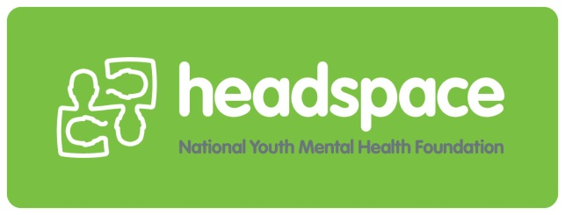
Youth Advisory Committee
Application Form

What does a Youth Advisory Committee Member do?
headspace Youth Advisory Committee members attend fortnightly meetings with other young people from the local area. In these meetings, we discuss headspace services and policies and implement youth driven campaigns to address the concerns of young people in the local area. The role also involves representing headspace at community events and meetings.

Thank you for taking the time to fill out this application form for the headspace Youth Advisory Committee (YAC).

Applicant Information:
Name: ……………………………………………………………………………………….......................
Address: ……………………………………………………………………………………………………..
Suburb: ……………………………… Postcode: …………………………………………………..……
Phone: ………..………………………Date of Birth………………………………………………………
Which sites are you applying for? (Please tick all that you would be willing to be part of)
Mount Druitt Penrith Parramatta Castle Hill

Which situation currently describes your circumstances? (Please tick and provide details)
School (year & name of school) ………………………………………………………………………..
TAFE (course) ……………………………………………………………………………………………
University (course) ……………………………………………………………………………………….
Working (p/t, casual or f/t) ………………………………………………………………………………
Transition from school to work …………………………………………………………………………
Looking for Employment ……………………………………………...………………………………..

Are you applying for one of the following identified positions? (Please tick as many as you would be happy to apply for)
Aboriginal & Torres Strait Islander
Lesbian, Gay, Bisexual, Transgender, Intersex, Queer, Asexual +
Culturally & Linguistically Diverse
None of the above

How is an Identified Position on the Committee different?
Being in an identified position on the Youth Advisory Committee means that you might be asked to give input both as a young person and as a person who identifies with the community you have identified. The work that you do would be the same as the other Committee members.

Please complete the following questions:
Why are you interested in mental health and wellbeing in Western Sydney?
Do you have an experience of accessing headspace or any other mental health services? Please tell us a bit about this if you feel comfortable.
What would you do to improve the mental health of young people in Western Sydney if you were given 1 million dollars?
What do you know about headspace?
What is the main reason you are interested in joining the headspace Youth Advisory Committee? e.g. want to have my say on things I feel passionate about.
What qualities or skills do you think you can bring to the group? e.g. organised, creative, good at working in a team.
We expect Youth Advisory Committee members to come to at least 80% of meetings. Meetings are fortnightly on a week night from 6 – 7.30pm.
Is there any reason you can think of that might make this hard for you?

Where to send the form:
Please return you completed application form to:
Carla.browne@ucmh.org.au

What's the next step?
If you are successful, you will hear from us and we'll call you to arrange an opportunity to discuss the role and your application.

