**Full Name : Yana Kirilova Kirova**

**Student Number: 16404534**

**Web site in GitHub :** [**https://yanakirova.github.io/csy1018-assign1/**](https://yanakirova.github.io/csy1018-assign1/)

**Assignment 1: Web Development**

**Date: 13 January 2017**

***CONTENT :***

**Introduction3**

**Ideas before starting the project**3

**Some important things3**

Basic structure of the website3

Basic concept4

Colors4

Fonts4

Navigation bar and contact form4

Animation4

Media query4

**Design wireframes**5

Home page wireframe5

CV page wireframe6

Bio page wireframe7

Contact page wireframe8

**Sketches**9

Sketches Home page9

Sketches CV page9

Sketches Bio page10

Sketches Contact page10

**Problems I had**11

Form button11

Underlining in Home page11

**Progress of the website**12

**Conclusion**12

## 

Introduction

The purpose of this report is to show the key stages in the development of my first website and to explain how exactly I created it.

Ideas before starting the project

When you start to create something (no matter what), it is essential to have some ideas about it. It is always useful to see other people’s work, their visions, and decide how you will create your own. I looked some CVs and personal websites and “stole” some ideas and personalized them. So, these are the websites:

* <https://joel.sh>
* <https://gosumo-cvtemplate.com/all-cv-templates/>

Some important things

* Basic structure of the website

First, I created root folder, sub-folders and added the main files.

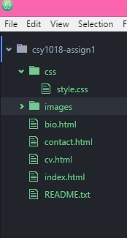

Root folder (later changed to “htdocs”)

Pages in my website

Sub-folders

I created link between HTML and CSS files. Initially, I was thinking about creating a separate style sheet for every single page, but it is not a good idea as we talked in class.

* Basic concept of my web site

My fundamental idea was to design simple and elegant website. I believe every element is quite simple, but when these elements go together it looks great.

* Colors

I believe colors have big impact on us and are very important. I tried different combinations (10 or more) of colors. At the end, I chose grey and pink, because I like that combination of one neutral and one bright color.

* Fonts

I used two Google’s fonts. I really love handwriting fonts but it is not a good idea to use that kind of fonts for the whole content. I wanted professional look. So, I used “Targerine” font only for the headers in my website. Beautiful font! For all other parts I used “Amiri” font, which also is fine but gives the website “serious” look.

* Navigation bar and contact form

I used these as template and just modify some of the things:

<http://www.w3schools.com/css/css_navbar.asp>

<http://www.w3schools.com/css/css_form.asp>

* Animation

Even my animation is quite simple- just changing headers of every page colors from light green to black. I like that illusion, it is like there is a fog, which gradually disappears. It is unobtrusively and not kitschy animation. At first, I wanted some bright colors to change but as I already said I want stylish website.

* Media query

For phones with maximal weight of 400 – perfect for Iphone 4, 5, 6 , Samsung Galaxy S6 and so on.

I used Chrome’s extension– Mobile/responsive Web Design Tester.

Design wireframes

* Home page:

Header

Most interesting part of my Home page is in that area. The images change their colors from black and white to colored then the cursor of the mouse is up on them. The frame of the pictures also change their color from black to light pink. These images are links to others pages and because of that there is not a navigation bar here.

Footer

* CV page

Navigation bar

Header

Footer

As you can see the structure is simple- navigation bar at the top, header, main box and footer.

The box is rounded, divided with a black line into two part- one smaller than other. Every important thing in that main box has its own “header”. That box at the center of the screen. A rounded picture at the left corner- extremely important to me, because the reader of the CV get some visual idea about the person, who he will hire to work or not. In my opinion, it is professional to have a picture in your CV and each must have one.

* Bio page

Navigation bar

Header

Footer

The structure is the same as in the CV page. It is important to have same look, because it makes website looks consistent.

Bio page should show my personality. So, I wanted more pictures of me at the one side and a text in rhymes by me. (I am not a poet and it is the first time I write poetry in English. But in class we discussed that, Bio page should be something interesting and fun. I tried to make it that way.)

* Contact page

Navigation bar

Header

The main part here is the contact form- shaped absolutely the same like boxes in other pages- centered, rounded corners, the same color.

footer

Form

Sketches

* Home page:

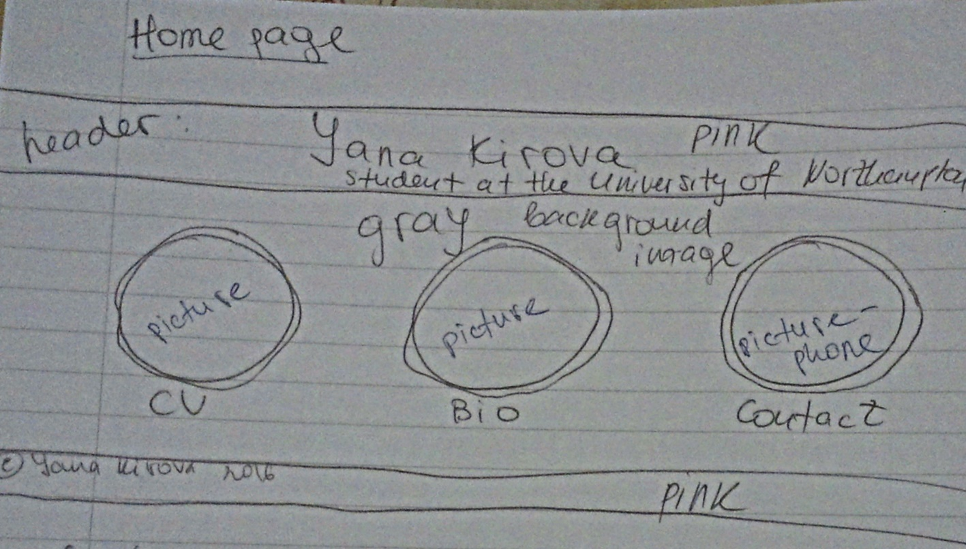

* CV page:

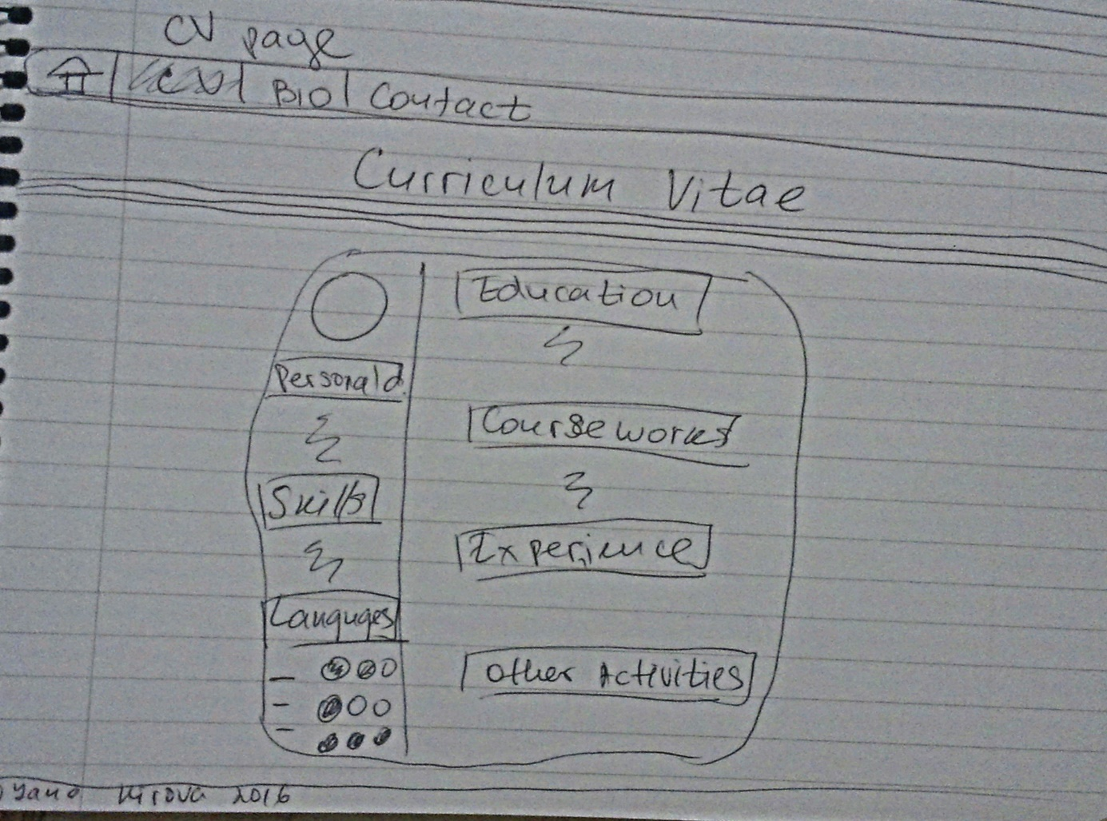

* Bio page:

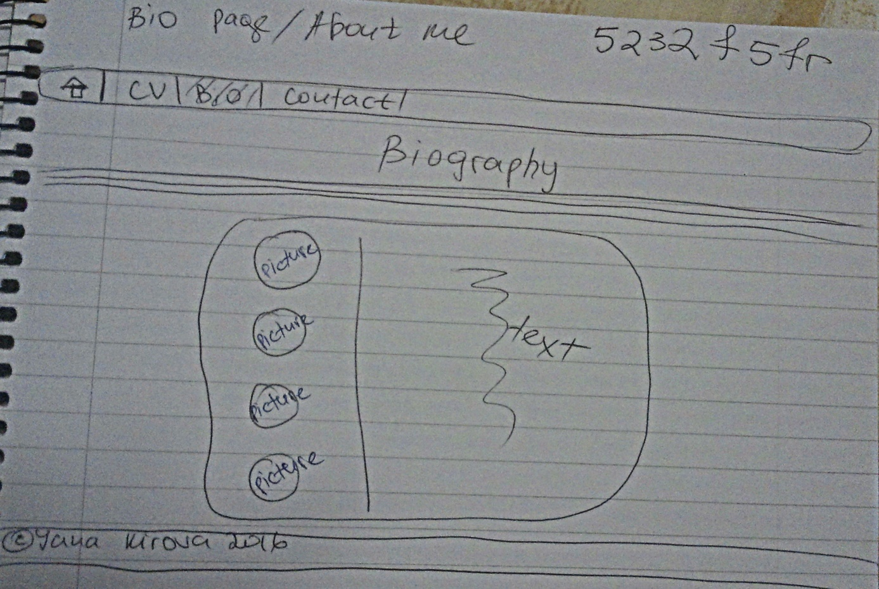

* Contact page:

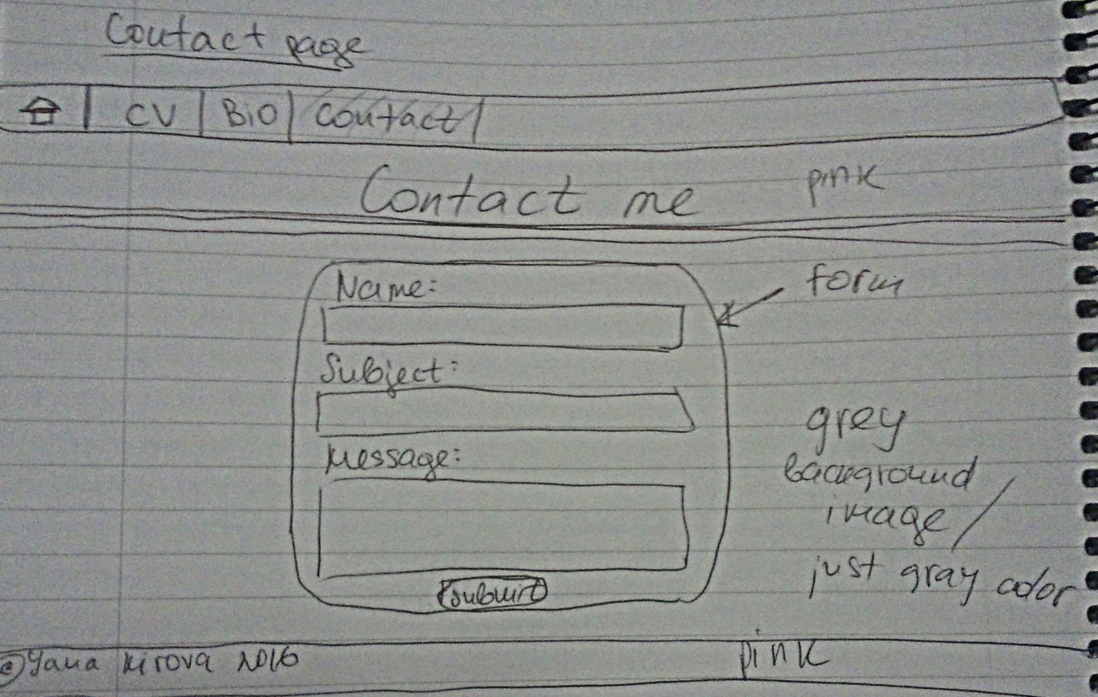

Problems I had

* Form button

First problem was related with the contact form and the button inside. I wanted to align that button at the center, but I could not . After 2 hard hours reading in forums about the problem I found that: <http://stackoverflow.com/questions/4221263/center-form-submit-buttons-html-css>

The answer- using of div element.

* Underlining in Home page

I could not deal with that problem and in Home page inscriptions or labels “CV”, “Bio” and “Contact” are underlined. I tried to fix that problem by using inline blocks, but aligning at the center, just under the pictures was broken. I had to choose which is more important- to have the right aligning or unasked underlining. So, you can see what I chose.

* Progress of the website

See the history in my Github account. I realized I had to make screenshots too late but I hope my explanation why I choose those and that convince you it is only my work.

* Conclusion

I hope you will be happy with what I have done ☺.