PROJECT REPORT ON

“E-COMMERCE SHOES STORE SUBMITTED BY: GROUP MEMBERS-6 TEAM LEADER:Y LAVANYA

TEAM MEMBER:M. MUBASHIRA NAZNEEN

TEAM MEMBER:K. KEERTHI

TEAM MEMBER:B. ISWARYA



# SRI VENKATESWARA INSTITUTE of TECHNOLOGY

B.TECH(COMPUTER SCIENCE AND ENGINEERING) MONTH & YEAR OF SUBMISSION:

DATE:August,2023

# DEDICATION

We dedicated all of this project to our dear parents.A special feeling of gratitude to our loving parents.As we always succedded in every field of life due to our parents and family prayers.I strongly dedicate my project to the one more personality that is my supervis or who always helped me in every aspects of my project.he always clarifies all doubts and guides us regarding the project information.And also supporting my group members.

# ABSTRACT

The business-to-consumer aspect of electronic commerce (e-commerce) is the most visible business use of the World Wide Web. The primary goal of an e commerce site is to sell goods and services online.

This project deals with developing an e-commerce website for Online Shoe Store. It provides the user with a catalog of different shoes available for purchase in the store. In order to facilitate online purchase a shopping cart is provided to the user. The system is implemented using a 3-tier approach, with a backend database, a middle tier of Microsoft Internet Information Services (IIS) and ASP.NET, and a web browser as the front-end client. In order to develop an e-commerce website, a number of Technologies must be studied and understood. These include multi tiered architecture, server and client -side scripting

techniques, implementation technologies such as ASP.NET, programming language (such as C#, VB.NET), relational databases (such as MySQL, Access). This is

# INTRODUCTION

Online shopping has become one of the most interesting parts of all internet activities,such that it is now in the third place after e-mail and web browsing. Shoes are itemsthat people purchase online these days. The motivations behind this behavior may be the online sales offers or variety of items and having a vast variety of choices.Reaching out to items that are not provided in different countries is also a good motivation for people in Europe or America. For many online retailers there are still a lot of challenges and long ways to reach out to safety zone and attract vast variety of users. In the online shop system users’ needs should be paid attention. On the other word user needs are now the center of study, what they needed and what we should provide to cover their needs. Like any other activities, in order to reach out the goal,one needs to take several steps. The steps of buying shoes via internet, is slightly different with offline (ordinary) shopping behavior.

# BACKGROUND

In past people have difficulty in meaning the foot and get the accurate size of shoes.people know a days have produced by measure their feet and get the accurate shoes of their choice.for this purpose,we do some preliminary study and research which follows

## OVERVIEW OF SHOES MART

The global e-commerce footwear market size was valued at USD 98.5 billion in 2021.it is projectd to reach USD 184.93 billion by 23030 ,growing at a CAGR OF 7.25% during the forecast period(2022-2030).

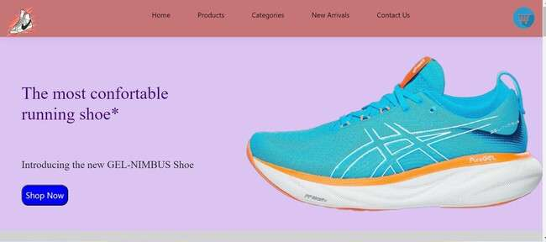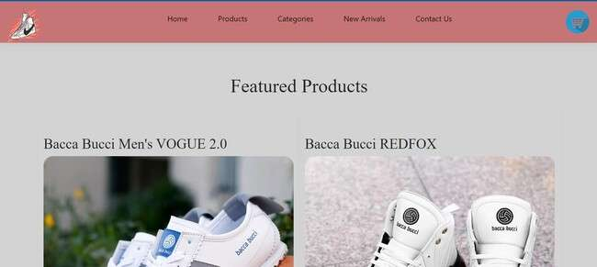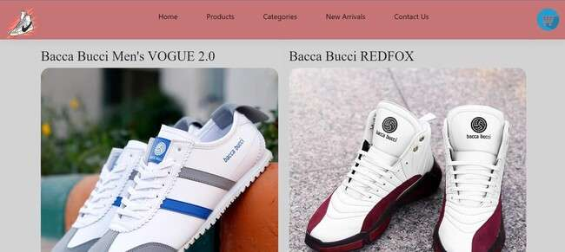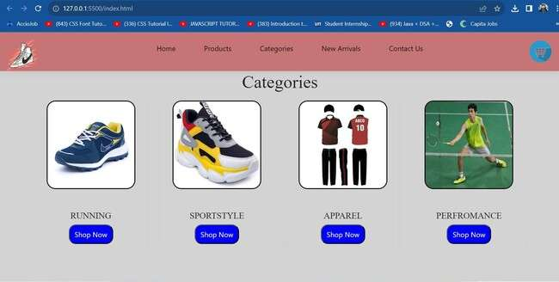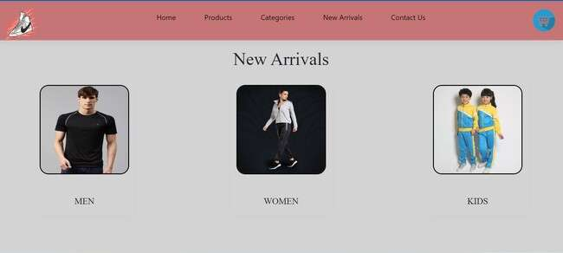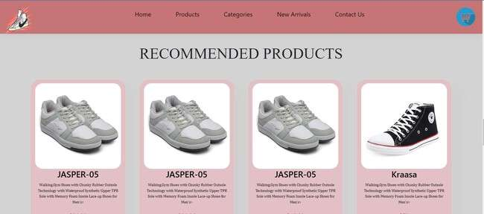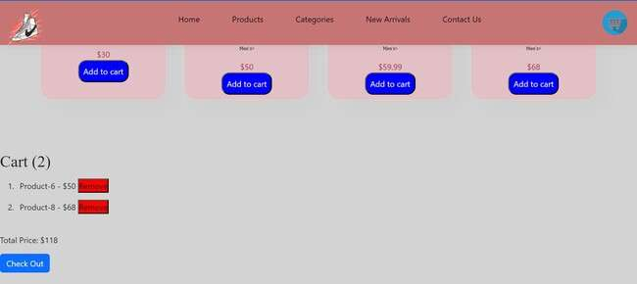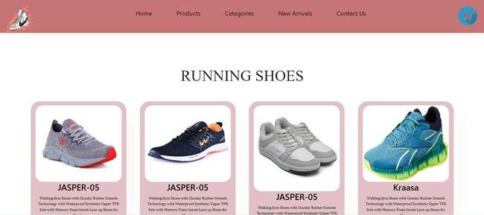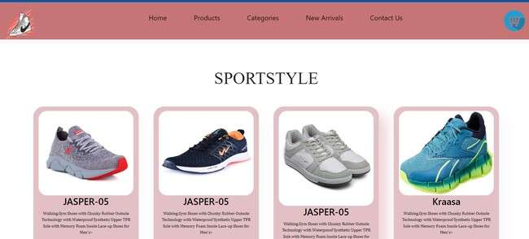

## CONCLUSION

E-commerce still represents one of the business methods that take advantage if done the right way.even if the stock market and commodities fell,but e-commerce still able to survive and receive high transaction