Homework1

Name：Yanan Liu Netid：yl2248

Q1：
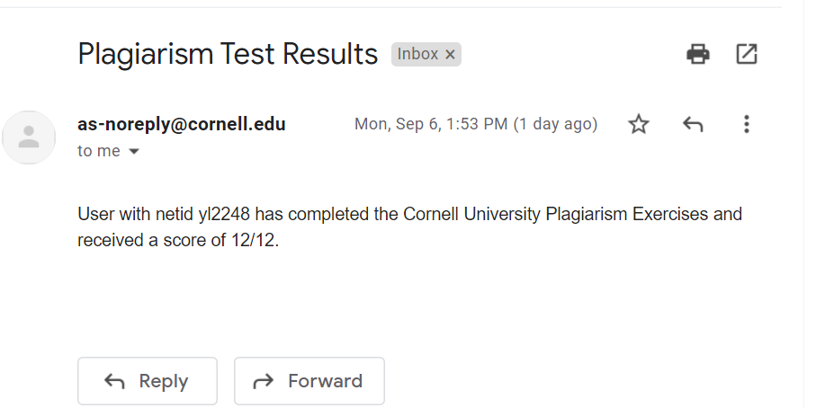
Q3：
- What is permission 777 ?

Permission 777 mean the file owner,group members and everyone else all have access to read write and execute this file.
- why might this be dangerous.
Since everyone have access to read,write and execute this file,it can be changed randomly.

- What is permission 644 and what would it allow users to do with your file?
Permission 644 means file owner can read and write this file,but can’t execute this file.
Groups and others can only read this file,they can’t write and execute this file.

- What is permission 700 and what does this allow users to do with your file?
Permission 700 means file owner can read, write and execute this file.
Groups and others can’t read, write and execute this file.

Q4:
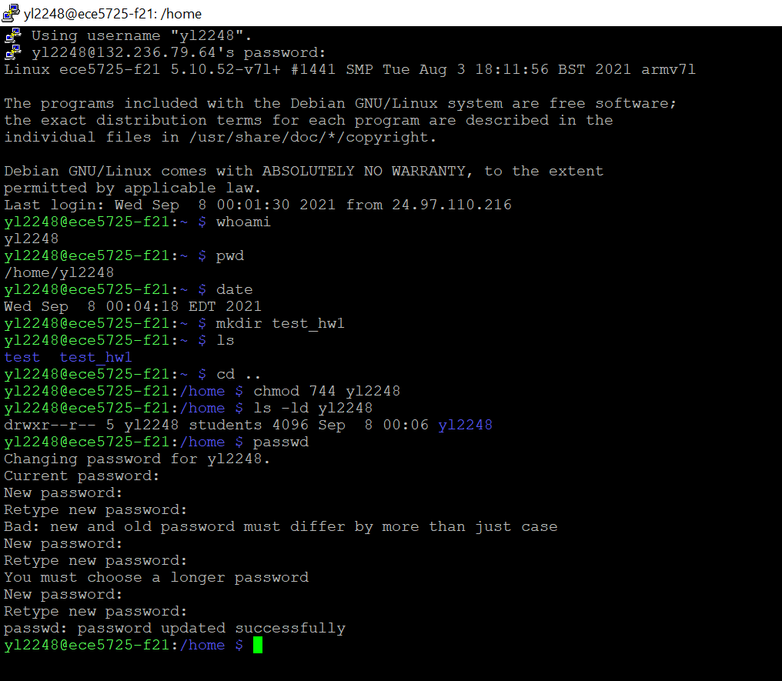

Q5:
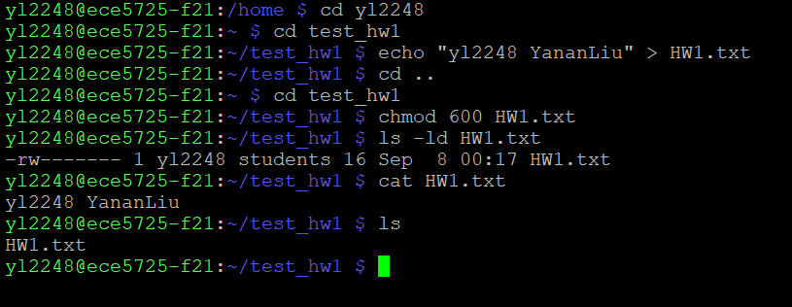

Q7:
- Df command description:”df “means disk free,which refers to the usage of file system disk on linux.
- “size settings for the /home entry”: the/home directory is a “place” to store all students directories and its files.Therefore the storage size should be big enough.As see in the picture above,the size of home/ entry is around 910G which is the biggest among others.

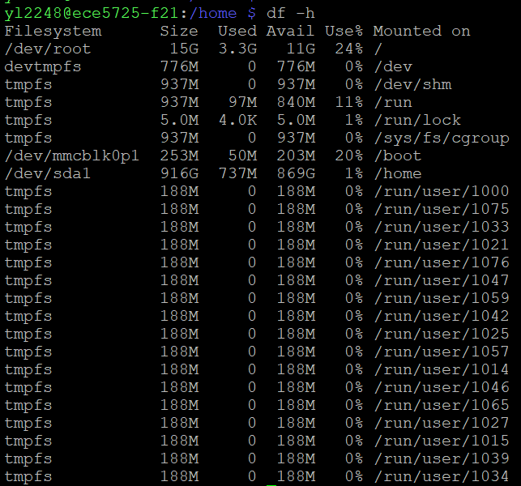

Q8:
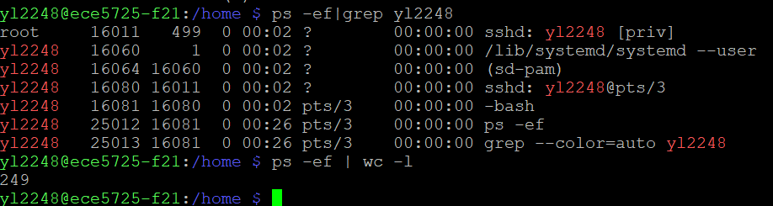

Q9:
Image source:https://www.bilibili.com/read/cv3910347/
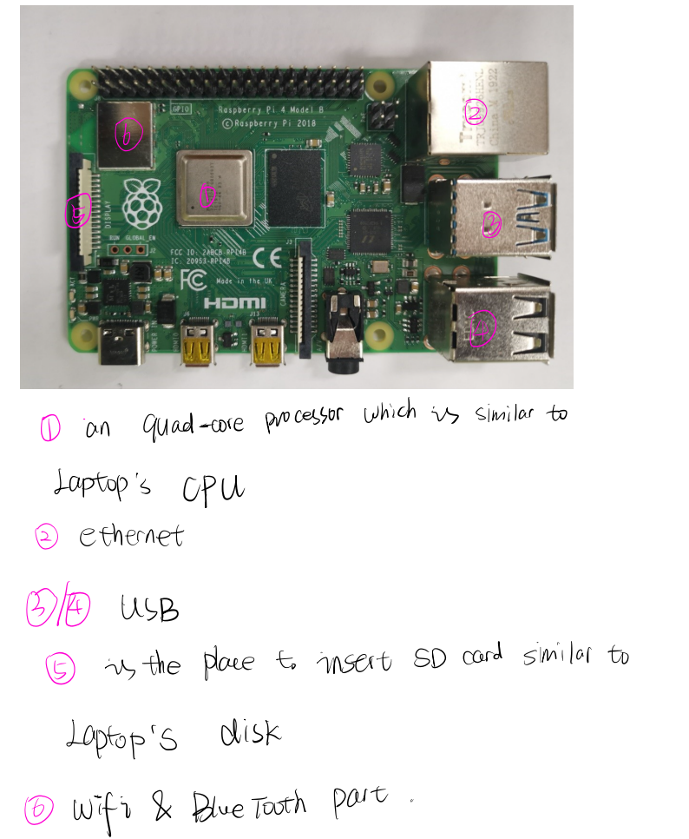

Advantages : Raspberry Pi is small in size and low in energy consumption.It is more portable(just like a card) and cheaper than computer. Raspberry Pi have GPIO which can connect to external devices.
Disadvantages : The OS of Raspberry Pi is linux,which is not so common.
Raspberry Pi don’t have battery,it need to plug in to power all the time.
Raspberry Pi is fragile.

Q10:
top | htop
- Single color  - Use PID to kill process | - colorful  - There are bars on the top, which can display each core’s memory usage.  - Faster launching than top  - Can scroll down and up to see process list and command lines as well  - Can process by mouse click

Htop is preferable, since it is more powerful (with many functions integrated) and easy to manipulate.

