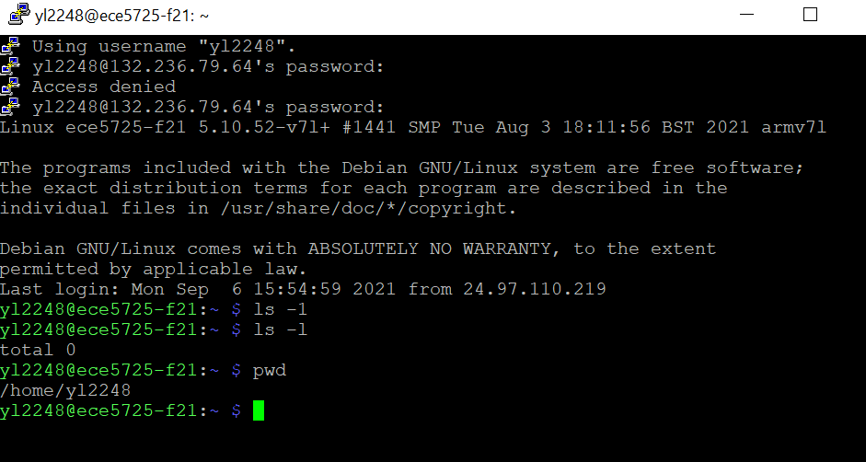

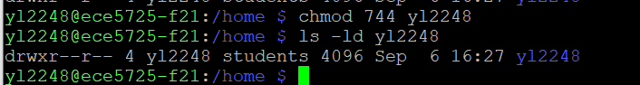

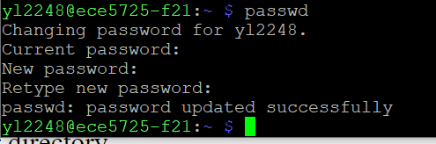

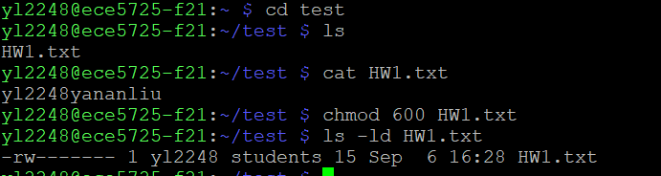

- 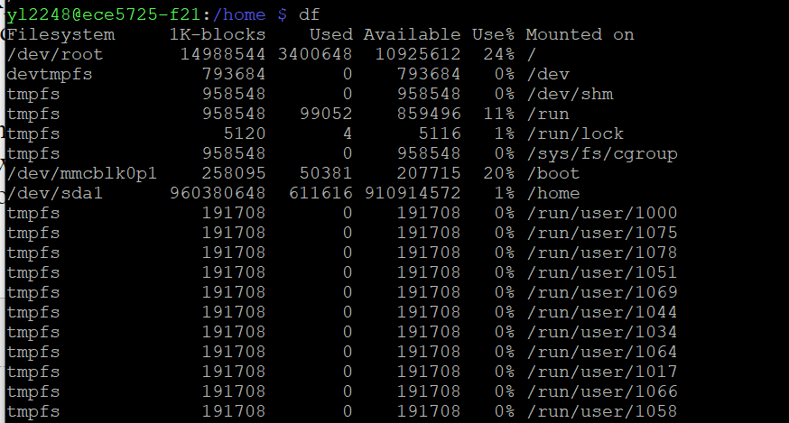
- Df command description:”df “means disk free,which refers to the usage of file system disk on linux.
- “size settings for the /home entry”: the/home directory is a “place” to store all students directories and its files.Therefore the storage size should be big enough.As see in the picture above,the size of home/ entry is around 910G which is the biggest among others.


 