Supplementary information

Supplementary guide
The Supplementary Methods define the analysis populations, endpoints and validation. Tables S1–S17 provide exact target rates, complete model metrics, safety-documentation coverage, reference-exclusion sensitivity, input/reference specifications, matched input comparisons, IgE missing-data sensitivity, laboratory coverage, IGA-definition sensitivity classification intervals, baseline serum concentrations, framework comparisons, molecular model extensions, transport benchmarks, single-visit low-activity states and all-available adjusted IgE changes. Figures are grouped by their clinical or measurement question below. Complete aggregate results, including negative and non-estimable findings, remain in the linked CSV collection. Missing estimates are not zero effects. Cohort structure and treatment comparability. Clinical and model eligibility, baseline balance and common treatment support.
Clinical outcomes and target comparisons. Observed and adjusted clinical scores, laboratory follow-up and all specified treatment contrasts.
Serum changes and regional disease. All available-pair molecular windows, complete adjusted treatment contrasts, clinical associations and regional burden. Fixed three-visit courses are in main Figure 4; baseline concentrations are in Table S12.
Individual EASI estimation and monitoring. Observed-versus-estimated scores, paired changes and response classification. Severity and holdout estimates remain in numerical source tables.
dupi denotes dupilumab; abro denotes abrocitinib, with initial dose stated in mg. Treatment colours are fixed throughout. Molecular changes use $\log_{2}$ concentration units; a change of $−1$ means a halving. Model errors use EASI points. Correlation describes ordering, whereas absolute errors and concordance address numerical agreement.

Supplementary Methods

Study design and clinical records
This analysis used longitudinal records from a Chinese observational treat-to-target project. The supplied protocol specified clinician-directed systemic treatment rather than random allocation. We retained the initial treatment group for longitudinal comparisons and separately extracted subsequent dose, interval, stopping, switching and restart information. The analysed records came from CAMS and Huashan. The protocol’s planned centre list and planned sample size were not substituted for the observed cohort.
The clinical dose-comparison population included patients aged at least 12 years with a known initial regimen. Six of 170 source patients were below age 12 and one had an unresolved initial dose, leaving 163 patients (65/56/42 by initial treatment). Records with unresolved simultaneous initial-dose assignments were excluded from dose-specific comparisons but retained in the source audit. Adult DLQI analyses used age at least 18. Baseline Table 1 uses one observed W0 record per eligible patient, with no weighting or imputation. Continuous summaries use median and quartiles with linear interpolation, rank $1+(n−1)p$ (type 7; Excel PERCENTILE.INC); all available denominators are reported. Age and BMI are also presented as medians, rather than means and standard deviations. Repeated records were linked by the study patient identifier and nominal visit; a patient was never treated as a new independent person at each visit. The requested reporting visits were W0, W2, W4, W12 and W24 for PP-NRS; W0, W4, W12 and W24 for EASI, IGA, DLQI, BSA, SCORAD and eosinophils; and W0, W12 and W24 for IgE. Low-coverage intermediate visits were retained in the underlying data but were not inserted into these trajectories.
EASI was the recorded clinical reference outcome. Source discrepancies between regional sums and total EASI were audited rather than silently repaired. IGA grades were retained as recorded, including grade 5. Confirmation of the exact IGA version and PP-NRS recall window remains necessary. Nominal clinical/serum visit linkage does not by itself verify that the blood draw and examination occurred on the same calendar day; exact dates and a permissible matching window require source confirmation. Among the 152/89/75 model visits at W0/W12/W24, 8/2/0 had complete regional scores whose sum differed from total EASI by more than 0.15; the largest absolute gaps were 18.7/8.5/0.0 points, and 1/1/4 visits lacked a complete regional reference. Restricting evaluation to all four regions observed with total–sum difference at most 0.01 retained 140/86/71 visits and gave MAEs 3.17/1.32/1.11. This evaluation-only sensitivity uses unchanged saved predictions. A separate training-exclusion sensitivity removed the eight W0 and two W12 discrepant visits from fitting, retained missing-region visits, and repeated preprocessing and inner structure/penalty selection within the original patient folds. Evaluation patients and recorded outcomes were unchanged. It gave W0/W12/W24 MAEs of 3.19/1.15/1.06; matched BSA controls were refitted identically. Neither analysis adjudicates which clinical reference is correct (Supplementary Table S4). Details are in model_reference_QC_audit.csv.
The supplied protocol is internally inconsistent on IGA: its eligibility text states 0–4, whereas Appendix 5 defines 0–5, with grade 5 labelled very severe. All 22 recorded grade-5 values occurred at baseline (9/2/11 by initial treatment) and were retained. A post hoc definition sensitivity removed the IGA alternative from the physician domain, leaving EASI50 at W4, EASI75 at W12 and EASI75 or EASI$≤5$ at W24; patient-domain rules were unchanged. Both definitions were compared on the same jointly evaluable patients, and their own available-case denominators were also reported. Three-valued AND/OR logic preserved unknown components. An additional sensitivity excluded the 22 patients with baseline IGA5; this was a different population, not a correction of known errors. Complete paired transitions and patient-deduplicated changes are supplied in the IGA-definition source tables and Supplementary Table S10. The protocol also specified 24-hour peak itch recall, without confirming its consistent implementation in the registry.

Local framework and comparison with published targets
The project presentation describes evidence review, stakeholder consultation, a questionnaire on assessment instruments, feedback and discussion, a second questionnaire on targets and timing, and steering-group review. The planned stakeholder sample comprised 30 physicians, 10 nurses and 10 patients; 49 returned questionnaires were reported. The planned agreement threshold was at least 75%. These source descriptions do not provide individual ballots, round-specific denominators or item-level agreement. The flow diagram therefore represents the documented process, without assigning unverified voting results. Later month-9/12 targets in the source framework were not evaluated as observed outcomes in this 24-week cohort.
Supplementary Table S13 compares the local framework with international 2021, Chinese 2022, Canadian 2023, AHEAD 2024, STRIVE AD and IEC 2026 recommendations. Original English publications were checked; the Chinese guidance thresholds were cross-checked against the guidance authors’ 2026 clinical-trial analysis.[1, 2, 3, 4, 5, 6, 7] The comparison is descriptive and does not retrospectively redefine the study endpoints. AHEAD minimal disease activity depends on agreed optimal targets. Using its EASI branch, IEC low disease activity requires EASI $≤7$ and PP-NRS $≤4$, and very low disease activity requires EASI $≤3$ and PP-NRS $≤1$. IEC complete control and off-drug remission additionally require persistence for at least six and twelve months, respectively. These duration-defined states were not inferred from isolated visits. Recorded local IGA was not silently recoded as vIGA-AD.

Clinical targets and treatment comparisons
The week-2 target was PP-NRS $≤4$. At week 4, the physician domain was EASI50 or an IGA decrease of at least two points, and the patient domain was PP-NRS $≤4$ or adult DLQI $≤10$. At week 12, the physician domain was EASI75 or IGA 0/1, and the patient domain was PP-NRS 0/1 or adult DLQI $≤4$. At week 24, EASI $≤5$ was an additional physician-domain criterion. The combined target required both domains. Because instrument identity and recall windows remain unresolved, these are exploratory targets based on the recorded scores. These are the investigators’ operational definitions; they were not retrospectively relabelled as the newer IEC low-disease-activity or remission definitions.[7]
For an OR criterion, one observed positive component established success; a negative result required all components to be observed and negative. For an AND criterion, one observed negative component established failure; success required both positive components. Other cases remained unknown. Adult DLQI was an unknown component for ages 12–17, not a negative component and not removed from the OR rule. Thus adolescent itch success establishes the patient target; itch failure alone does not establish patient-target failure. The audit exhaustively verified the nine two-component truth states and reconciled every saved composite. Among 15 adolescents, the patient domain had 6/0/9 successes/failures/unknowns at W4, 4/0/11 at W12 and 4/0/11 at W24; the combined domain had 5/1/9, 4/5/6 and 4/3/8. An explicitly different PP-NRS-only adolescent rule would make five W12 and four W24 patient-domain unknowns determinate, including one W24 combined outcome. This is a sensitivity count, not a redefinition of the primary composite. Age-stratified counts are in composite_age_evaluability_audit.csv. EASI response required an observed positive baseline. Individual thresholds were also analysed separately. Proportions used endpoint-specific observed denominators and Wilson 95% confidence intervals. Overall three-group tests used conditional Monte Carlo Pearson tests with 49,999 draws, and pairwise comparisons used Fisher’s exact test and risk-difference intervals. The three pairwise comparisons within an endpoint and visit formed a Holm family; exploratory FDR results were also retained. Overall tests were not included as an extra member of that pairwise family.
Baseline-adjusted binary target rates and risk differences used generalized overlap weights from a multinomial initial-treatment model with baseline EASI, age, sex, BMI and centre. We used 1,000 patient bootstrap resamples, stratified by initial treatment and refitting the propensity model, for percentile intervals. Two-sided P values used normal Wald tests based on bootstrap standard errors; three-group tests used a two-degree-of-freedom Wald statistic. The three individual pairwise comparisons formed a Holm family. Weighted results supplement the observed numerator and denominator. The primary target analysis used bootstrap seed 20261017. A revision W2 sensitivity added baseline PP-NRS to the propensity model. One patient lacked baseline PP-NRS; both the original-covariate model and the added-itch model were fitted on the remaining 162 patients, with the original 163-patient analysis retained. The same standardized logistic model (ridge parameter $C=1$), 1,000 stratified patient resamples and seed 20261018 were used for this sensitivity. The revision files also contain a separate full-cohort run with seed 20261018. Its point estimates use the same analysis, but its Monte Carlo intervals and Wald P values are not the frozen primary results; borderline changes were not selected for the main claim. The added-itch 100 mg–dupilumab contrast was 41.4 percentage points (95% CI, 13.0–66.8; three-contrast Holm $P=0.0104$); the 100-minus-200 mg contrast was 6.7 points ($−11.3$ to 26.2). The largest endpoint-specific absolute standardized difference was 0.53 even after adding itch, so residual imbalance remained. Baseline weights were retained when calculating available-case balance and ESS; no claim of balanced follow-up selection is made. The table below reports both unweighted and matching baseline-overlap-weighted worst/best bounds, assigning every unknown outcome failure/success while retaining baseline weights. These bound the initial cohort under extreme missing-outcome assignments; the reported weighted available-case rate represents patients with that endpoint observed. Endpoint-specific overlap-weight ESS is reported separately. Bounds are sensitivity limits, not confidence intervals.
Unweighted observed outcomes and initial-cohort bounds
Target | Initial group | Success/evaluable | Initial N | Observed  rate, % | Unweighted missing-  outcome bounds, %
W2 itch | dupi | 15/27 | 65 | 55.6 | 23.1–81.5
W2 itch | abro 100 mg | 34/37 | 56 | 91.9 | 60.7–94.6
W2 itch | abro 200 mg | 33/36 | 42 | 91.7 | 78.6–92.9
W24 combined | dupi | 26/36 | 65 | 72.2 | 40.0–84.6
W24 combined | abro 100 mg | 22/24 | 56 | 91.7 | 39.3–96.4
W24 combined | abro 200 mg | 20/23 | 42 | 87.0 | 47.6–92.9
Matching baseline-overlap-weighted analysis
Target | Initial group | Weighted available-  case rate, % | Available-case  weight ESS | Weighted missing-  outcome bounds, %
W2 itch | dupi | 51.9 | 17.6 | 19.4–82.0
W2 itch | abro 100 mg | 93.6 | 25.1 | 76.0–94.8
W2 itch | abro 200 mg | 85.8 | 21.1 | 63.3–89.5
W24 combined | dupi | 46.2 | 20.8 | 22.0–74.3
W24 combined | abro 100 mg | 85.4 | 14.7 | 26.2–95.5
W24 combined | abro 200 mg | 87.0 | 12.5 | 38.3–94.3
Bounds assign all unknown outcomes failure or success in the initial cohort. Weighted bounds retain the same baseline overlap weights in observed and unknown records. Weighted available-case rates use only endpoint-observed patients. ESS is the effective sample size of those weighted available cases, not a patient count or an incidence denominator. Bounds are sensitivity limits, not confidence intervals.
For generalized propensity scores $e_{t}(x)$, the weight is $h(x)/e_{t}(x)$, with h(x)=1/t​[1/et(x)]. The baseline weighting function defines a common treatment-overlap population; an available-outcome analysis can depart from that population through selective observation. Covariate balance, propensity distributions and analysis-specific effective sample sizes are reported; weighting does not establish elimination of confounding.[8]
Continuous treatment comparisons used marginal regression with baseline outcome, treatment-by-visit terms, age, sex, BMI and centre. Generalized overlap weights addressed measured baseline differences in initial treatment selection. Patient-cluster robust covariance accounted for repeated outcomes conditional on the estimated baseline weights, without propagating their estimation uncertainty. A singular-value decomposition check prevented reporting non-estimable treatment-by-visit cells. Exploratory contrasts of treatment differences over time used the same fitted coefficients and full patient-cluster covariance, comparing W2 to W12/W24 for itch and W4 to W12/W24 for EASI. Holm correction covered the three treatment contrasts within each endpoint and interval; these tests did not infer a time interaction from different visit-specific significance levels. The earlier weighted IgE and eosinophil contrasts used log$(1+x)$; back-transformed estimates were not arithmetic means. The entirely unmeasured dupi W4 eosinophil cell was not estimated in that categorical-visit analysis. Revised all-available laboratory display models and explicitly assumed W4 interpolation are described below; they use a different estimand and replace the entire fitted display series. The earlier complete-three-visit IgE analysis remains a numerical sensitivity. No assumed W4 value completes an observed trajectory or enters a treatment test. Eosinophil paired changes use all observed pairs for each interval, with descriptive t-based 95% intervals on the recorded scale; these intervals are not multiplicity-adjusted treatment-comparison tests. Supplementary Table S9 reports laboratory coverage and these paired changes. Unweighted adjustment, group balance, observation patterns and supplementary dupilumab-versus-pooled-abrocitinib contrasts were retained. Pooling used the observed dose mixture and did not erase the two initial abrocitinib groups. The comparisons estimate adjusted observational associations, not randomized fixed-dose effects. Nominal eligibility based on the registry filename date placed all initial patients beyond W24, but this administrative sensitivity is not an approved database lock or verified visit window. Reasons for absent assessments were unavailable.
Treatment reductions were assigned from recorded regimen intervals, with assessment/decision ordering marked uncertain at shared visit boundaries. A later reduction was not moved to an earlier visit. W12 response and subsequent regimen changes defined descriptive maintenance pathways. Analyses used observed W24 EASI75, explicit missing-outcome bounds and fixed-patient trajectories where all three visits were observed. This approach distinguishes treatment initiation from the selected maintenance pathways, consistent with the need to specify how intercurrent treatment changes enter the question being estimated.[9] It does not identify a counterfactual outcome under a different regimen. At W0, two source records labelled initial 100 mg explicitly listed a 200 mg starting regimen, and one labelled initial 200 mg listed 100 mg. These are conflicts between the source group and regimen fields, not demonstrated post-baseline switches. The group labels were retained, and exposure_W0_source_adjudication.csv preserves their counts separately from unknown exposure. Clinical-record adjudication is still required.

Serum measurements and molecular analyses
The laboratory source reports identify serum samples analysed with Luminex and MSD platforms. Luminex used an R&D Systems LXSAHM-13 panel and Luminex-200; the MSD reports identify K15067M-1/K15067M-2 kits and an SQ120 instrument. Reports describe 50-$μ$L serum and twofold dilution. The service-batch sample count was not used as the study sample size. Assay lots, run identifiers and source links remain in the restricted provenance records.
The analysis used the numeric integration export rather than the vendor’s filtered display matrix. Positive export numerics recorded in pg/mL were $\log_{2}$ transformed once, unchanged; the analysis applied no additional twofold dilution correction. This reproduces the fitted scale rather than verifying how the laboratory corrected its export for dilution. Explicit censoring strings and nonpositive values were not converted to measured positive concentrations. The vendor’s filtered output can replace values below range with zero and values above range with an upper bound; those conventions must not be interpreted as exact measured concentrations. A sensitivity analysis represented IL-5 values below twice the software calibration lower bound at that boundary and repeated the model workflow. The software boundary is not an independently validated clinical quantification limit. Cross-platform bridging, technical-repeat precision and lot effects require additional assay documentation.
All 23 measured markers were retained. Molecular changes were formed within each patient and visit pair before group summaries, avoiding subtraction of averages from different patient sets. We analysed W0–W12, W12–W24 and W0–W24 separately. Mean $\log_{2}$ changes were accompanied by t-based confidence intervals when at least five pairs were available. Smaller sets were descriptive. Two-sided paired mean-change sign-flip tests retained zero changes and ties. They enumerated all $2^{n}$ signs when $n≤15$; otherwise they used 19,999 random signs (seed 20261002), counting exceedances at the observed absolute mean with a plus-one numerator and denominator. All-zero changes gave $P=1$. The sign-flip null assumes independent patients and sign-exchangeable paired changes (symmetry about zero); it is not a randomized-treatment test. Benjamini–Hochberg adjustment covered the full 23-marker, three-treatment, three-window family: 207 planned cells, of which 193 had estimable P values. Non-estimable cells remained missing and were not counted as tests. Between-treatment change models adjusted for starting concentration, baseline EASI, age, sex, BMI and centre, with HC3 covariance. Centre-specific and assay-batch sensitivity analyses were retained. Each between-treatment molecular correction family included all marker, window and pairwise contrasts within one centre scope and analysis variant; scopes and variants were not pooled. Molecular–clinical change correlations formed their own panel-wide family across markers, clinical outcomes, treatments and windows, and response-depth contrasts formed a separate family. The global molecular treatment-by-visit family had 23 planned marker tests, with 21 estimable. A source-table inventory records the defined families and finite-test counts. Spearman correlations related molecular changes to clinical changes within treatment groups; baseline regional correlations were assessed separately. Sample sizes, intervals and multiplicity families accompany each source table.
Regional analyses used source-consistent regional totals. Regional EASI contributions were divided by their theoretical maxima (7.2, 14.4, 21.6 and 28.8 for head/neck, upper limbs, trunk and lower limbs). Percentage improvement required a positive regional starting value; zero-start exclusions were counted. Because very low W12 values can produce extreme W12–W24 percentage changes, the corresponding figure instead shows change as a percentage of the theoretical regional maximum. Both definitions are retained in the tables. Regional treatment contrasts used unadjusted Welch comparisons and HC3 models adjusted for starting regional severity, baseline total EASI, age, sex, BMI and centre, with FDR over the 48 region-by-window-by-contrast tests in each analysis/outcome family. Whole-body PP-NRS change was not labelled as regional itch.

Fixed-patient three-visit molecular display
For each marker and initial treatment, the main molecular figure retained patients with positive recorded concentrations at all three visits. Each patient’s baseline $\log_{2}$ concentration was subtracted from their follow-up value before averaging; baseline was zero by construction. Pointwise Student-t 95% intervals and two-sided sign-flip tests required at least five patients. All signs were enumerated for $n≤15$; larger sets used 49,999 random sign assignments with a plus-one correction. Tests with provisional q values between 0.04 and 0.06 were refined by exact enumeration for $n≤24$, or 1,999,999 random assignments otherwise, before the same family was recomputed. This addressed simulation precision without changing the hypotheses or populations.
The Benjamini–Hochberg family comprised 138 planned comparisons (23 markers, three initial treatments, two follow-ups). The 14 non-estimable hypotheses contributed $P=1$ to the correction but had no displayed q value. Stars identify within-group changes with q$<0.05$; they do not test treatment differences. The previous all-available-pair family remained separate because its populations differ. Baseline summaries in Supplementary Table S12 were calculated from positive recorded concentrations on the original pg/mL numeric scale, using type-7 quartiles and marker-specific denominators. Censored and other unavailable assay states were counted separately rather than substituted into these distributions.

Common EASI estimator and validation
The initial discovery registry required at least 70% baseline assay availability for model candidates, leaving 19 of 23 measured markers. Separate supervised searches ranked markers within training patients and compared panel sizes using inner validation; the final small EASI panel from that search contained CCL17 alone. In a subsequent exploratory revision, CCL17, CCL26 and IL-5 were fixed as a compact, biologically motivated candidate with relatively complete measurements. Supporting literature motivated evaluation of CCL17 and CCL26 in AD activity and of related type-2 markers; it did not validate this exact combination.[10, 11] The initial three-marker index standardized $\log_{2}$ concentrations using training-reference means and standard deviations and averaged them equally. That relative molecular index was distinct from the later BSA–serum EASI equation and the historical six-marker inflammation score. In the present estimator, inner validation selected formula structure and penalty, not the identities of the three fixed markers. Matched CCL17-only, BSA-plus-CCL17 and leave-one-marker-out controls did not establish that this panel was optimal or that every component provided a stable accuracy gain (Tables S6–S7).
Eligibility required age at least 12, observed EASI and BSA, and observed positive CCL17, CCL26 and IL-5 concentrations. Ambiguous initial-dose labels did not exclude otherwise eligible model records, because treatment was not a required input. The three-marker panel arose from earlier exploratory work and was fixed for this revision. No clinical outcome was imputed. Model development used W0 and W12; W24 did not enter fitting or selection. Because earlier project analyses had already examined W24, its results are described as within-cohort temporal application rather than untouched external validation.
All observations from one patient remained in the same outer fold. Five-fold validation was repeated twice using the established patient partitions. Each training fold contained development visits only. Three-fold patient-level inner validation selected the ridge penalty from 0.1, 1, 10 and 100, minimizing mean per-patient absolute error. Each patient received equal total fitting weight. Feature centring and scaling used training data only. Three common structures were considered: an additive BSA-plus-three-marker model; the same model with quadratic BSA; and BSA multiplied by a linear molecular component without a free intercept. Structure and penalty selection were nested together for the primary performance estimate. No treatment, phase, time, previous score, age or BMI was required at deployment.
After full-development inner selection, the fitted common equation was
$$\begin{aligned}\hat{EASI}={clip}_{[0,72]}\{BSA [&0.512721579+0.009847080\log_{2}(CCL17) \\ &+0.009646929\log_{2}(CCL26)−0.008270558\log_{2}(IL\text{-}5)]\}.\end{aligned}$$
BSA is entered as a percentage from 0 to 100, and concentrations must use the development export’s recorded pg/mL numeric scale, with $\log_{2}$ applied once. The implementation rejects missing, nonfinite or nonpositive molecular inputs and invalid BSA values. The area constraint returns zero when BSA is zero. It is a statistical constraint reflecting absent observed lesion extent, not proof of absent molecular inflammation. The released parameter file retains full precision. The main-text display multiplies the molecular coefficients by 100 and uses BSA/100, allowing two decimal places without dropping the smaller molecular terms. An explicit rounding audit gave nested-selection W0/W12/W24 MAEs of 3.194/1.298/1.193, compared with 3.194/1.297/1.192 at full precision. All primary results use full precision; the rounded equation is a reading aid. For the final fitted equation, maximum absolute arithmetic differences were 0.075550, 0.024807 and 0.018474 EASI points at W0/W12/W24; these are rounding differences, not clinical prediction errors. Response classifications at EASI50/75/90 were unchanged in the audit, but one of 150 week-24 fold-level evaluations crossed the absolute EASI 7 threshold, so threshold-based use should retain full precision. This single final fit has not received independent validation; primary metrics evaluate the nested development procedure that selected it.
Comparators used the same patients and folds: BSA alone, the three markers alone, the additive common model, and the earlier stage-interaction model. We evaluated MAE, RMSE, signed error, Spearman correlation, Lin’s concordance correlation, $R^{2}$, calibration intercept and slope, severity-band agreement and proportions within one and two EASI points. Metrics were calculated within each repetition before averaging, not from averaged predictions. Patient bootstrap intervals used 2,000 resamples of held-out errors. The same sampled patient indices were used in every repetition and comparator; metrics were scored within each repetition before averaging. These intervals describe uncertainty conditional on the saved cross-validation predictions: neither nested selection nor fitting was repeated, and earlier adaptive marker exploration is not covered. Calibration intervals resampled patients in the regression of observed on predicted EASI. The primary nested-procedure minus area-only MAE differences were 0.12 (95% CI, 0.04–0.20) at W12 and 0.17 (0.11–0.24) at W24. These paired estimates differ from the earlier fixed-structure comparison and do not establish molecular added accuracy. All comparator and fixed-structure results remain in the source tables. Descriptive agreement limits were mean error plus or minus 1.96 error standard deviations.[12]
Severity-band agreement used four categories: EASI $≤7$, $>7$ to $≤21$, $>21$ to $≤50$ and $>50$. Error subgroup analyses instead combined the two highest categories, using three strata: EASI $≤7$, $>7$ to $≤21$ and $>21$. Binary sensitivity and specificity used EASI $>7$ and are not interchangeable with every original p-EASI classification definition. Leave-centre-out and leave-initial-treatment-group-out analyses removed all records from held-out patients. Changes were paired within patient, repetition and fold before averaging. Each of W0–W12, W0–W24 and W12–W24 was evaluated separately; the windows share patients. EASI50/75/90 classification required positive observed and estimated starting scores, with exclusions counted. Observed response used observed scores at both visits, and estimated response used estimated scores at both visits. Scatter plots and any integer confusion matrices use the first outer repetition; the primary response forest and principal metrics average repetition-specific values. They must not be interpreted as one common confusion matrix. EASI75 sensitivity used 49 and 54 observed responders at W12 and W24; specificity used 36 and 13 observed nonresponders, respectively, in both repetitions. For sensitivity, specificity and overall agreement, each repetition is reported with a Wilson 95% binomial interval. For the repetition-average estimate, Clopper–Pearson intervals use a Bonferroni level of $1−0.05/R$ for each of $R$ repetitions, and their lower and upper limits are averaged separately. Within each endpoint, window and metric, these give conservative simultaneous bounds across repetitions under a conditional binomial working model without assuming independence between repetitions. They do not establish exact coverage for the full cross-validation procedure, whose shared fitted models and development uncertainty are not resampled. Patients are not multiplied by the number of repetitions. Repetition-level counts and intervals are in Supplementary Table S11; average bounds are in primary_EASI75_uncertainty.csv. Earlier percentile-bootstrap limits are retained as explicitly labelled diagnostic columns, not the primary classification bounds. The empirical cumulative absolute-error curve is the average of the two repetition-specific proportions. Pointwise bootstrap intervals carry all saved predictions from each sampled patient together and do not refit the development procedure. Applying the published formulas used the published rounded coefficients without local refitting, with local IL2RA as a nominal sIL-2R proxy and identical eligible patients for both methods. Original p-EASI outputs were initially left unbounded to preserve the published arithmetic, whereas local estimates were clipped to 0–72; matched clipping of the original outputs was examined separately. Patient-paired bootstrap intervals were calculated for differences between the current and published-formula metrics, retaining both repetitions for each sampled patient. These intervals characterize the local comparison; they do not remove the difference in inputs or establish assay equivalence.[13, 14, 15]

Independent auxiliary target models
PP-NRS and adult DLQI were fitted separately with original-scale or log$(1+x)$ ridge regression, using patient-level inner validation to select the link and penalty. Predictions were bounded to 0–10 and 0–30, respectively. Recorded IGA used a penalized proportional-odds model over the six observed grades, with ordered thresholds and six category probabilities. Normalized ranked probability score was the primary ordinal loss. All three targets used the same four-input panel for a practical shared measurement set, with BSA-only, molecular-only and training-only constant comparators. Neither EASI nor the target’s current observed score was an input. Development and temporal application followed the patient-level W0/W12 and W24 separation used above. This limited shared-panel study does not claim to select the optimal molecular set independently for each target. Details and full estimates are in the supplement.

Reproducibility and reporting
The model analysis used Python 3.9.6, NumPy 2.0.2, pandas 2.3.3, SciPy 1.13.1 and scikit-learn 1.6.1. Exact dependency versions, analysis specifications, input/output hashes and execution logs accompany the code. Clinical and prediction reporting follow the relevant STROBE and TRIPOD+AI domains; applicability and risk-of-bias issues are recorded explicitly.[16, 17, 18] No non-significant difference, high correlation or overlapping mean trajectory was taken as proof of individual interchangeability.

Matched input ablation
The original core population contained 316 visits from 160 patients; current PP-NRS was available for 315 visits from the same 160 patients. Adult current-itch and DLQI comparisons contained 207 visits from 111 patients. Models within each population used identical observations and the original patient outer folds. Development comprised W0/W12 only: 241 visits from 156 patients in the core, 240 visits from 156 in the itch comparison, and 163 visits from 107 in the adult comparison. Five outer folds with two repetitions and three inner patient folds selected ridge penalty and, for BSA-containing candidates, linear, BSA-quadratic or BSA-times-other-input structures. Serum-only and itch-plus-serum models used linear ridge. Standardization was fitted inside each training partition and each patient’s total fitting weight was equal. Predictions were bounded to 0–72. No clinical outcome or deployment input was imputed.
CCL17-only, BSA-plus-CCL17 and fixed-area leave-one-marker-out comparisons tested panel dependence. Coefficients were summarized only within the same structure; different parameterizations were not averaged. All metrics were calculated within each repetition before averaging. Paired differences resampled the same patients across models and repetitions in 2,000 draws, conditional on saved predictions. These post-result exploratory comparisons did not replace the frozen formula and did not correct for the earlier panel selection. Complete metrics, paired changes, coefficients and selection frequencies accompany Tables S6–S7.

IgE observation patterns and multiple imputation
The revised available-data display used every recorded IgE or eosinophil response at primary visits. On log$(1+x)$, a maximum-likelihood random-intercept model included initial-treatment-by-categorical-visit cells, log$(1+baseline EASI)$, age, sex, BMI and centre where variable. Baseline laboratory values entered as repeated outcomes with free treatment-specific means, rather than being required covariates in a follow-up ANCOVA. Patients with a single observed visit remained eligible. This contributed 147 patients and 258 IgE measurements across both centres, or 125 patients and 229 measurements within CAMS. Fixed-effect design rows were averaged over all eligible baseline patients in each scope, followed by inverse transformation; resulting values were shifted geometric means. Within-treatment ratios subtracted that group’s fitted baseline on the log scale and exponentiated the contrast. Confidence intervals used the full fixed-effect covariance, including shared endpoint covariance. Six pairwise W12/W24 contrasts per outcome and analysis received Holm correction. A centre-by-visit sensitivity relaxed the time-constant centre difference, but neither pooled specification could directly identify an absent Huashan dupi follow-up cell. These models assume missingness is explainable by included observed information. They do not resolve nonignorable missingness or identify randomized drug effects. Supplementary Table S17 gives IgE coverage and ratios; the earlier paired and imputed analyses below remain available as distinct sensitivities.
All IgE W4 cells and the dupi eosinophil W4 cell were entirely unmeasured. Optional display estimates used $m_{4}=(2/3)m_{0}+(1/3)m_{12}$ for fitted log$(1+x)$ group levels. If $v_{w}$ denotes the averaged fixed-effect design row, the conditional variance was $v_{4}^{T}\hat{Cov}(\hat{β})v_{4}$, where $v_{4}=(2/3)v_{0}+(1/3)v_{12}$. Inverse transformation produced the hollow point and interval. These estimates were never inserted into patient records, model fitting or treatment tests. Earlier-change and delayed-change time shapes remained numerical sensitivities. In particular, published dupilumab data show that early transient blood eosinophil rises can occur; interpolation does not exclude such a peak.[19]
IgE was observed at W0, W12 and W24, with no W4 measurement. All available two-visit pairs were analysed without requiring the third visit. Paired t intervals used log(1+IgE), so exponentiated mean differences are geometric mean ratios of IgE+1, not arithmetic mean ratios. An available-data maximum-likelihood random-intercept model included treatment-by-visit, baseline EASI, age, sex, BMI and centre where variable, with unconstrained treatment-specific baseline means. CAMS (130 patients) supplied observed follow-up in every initial treatment; Huashan supplied no dupi IgE at W12 or W24. Full-cohort imputation of 163 patients therefore involved unsupported treatment–centre follow-up cells and was retained only as an additional sensitivity. Five CAMS patients, and 16 across both centres, had no IgE at any of the three visits; their imputations relied entirely on clinical covariates and relationships learned from other patients.
Fully conditional imputation used one wide record per patient. Four chains each underwent 200 burn-in cycles and retained 100 draws separated by ten cycles. Incomplete variables were the three IgE values and W12/W24 EASI; complete predictors were initial treatment, baseline EASI, age, sex, BMI and centre where variable. Future observed measurements served as auxiliaries for retrospective reconstruction, not prospective prediction. EASI auxiliary imputations were used only inside the imputation model, never as validation outcomes. Type-1 predictive mean matching used five closest observed same-treatment/same-visit donors on log(1+IgE). The alternative drew coefficients, residual variance and positive IgE values from Bayesian Gaussian regression on log(IgE), without an invented upper ceiling. Both assumed common conditional slopes across treatment groups with separate intercepts. Observed values were unchanged.
Rubin variance and Barnard–Rubin small-sample degrees of freedom pooled group means, changes and baseline-adjusted contrasts. The latter used baseline log(1+IgE), treatment-by-visit, baseline EASI, age, sex, BMI and centre, with fixed previously estimated baseline overlap weights and patient-cluster covariance. They condition on those weights and do not include propensity-estimation uncertainty. Initial groups were not reassigned after treatment changes. Illustrative MNAR scenarios multiplied only missing follow-up IgE+1 by one-half or two, retaining a zero lower bound for IgE. The repeated value 5000 was not assumed to be a verified censoring limit. Mixing, effective draws, missing-information fractions, Monte Carlo errors, donor support and predictive tails were checked. The maximum MAR change diagnostic was $\hat{R}=1.013$, with Monte Carlo error at most 5.6% of the inferential standard error. In CAMS abro 200 mg at W24, 13 donors supported 28 missing values; 25.8% of PMM recipient fitted means lay outside the donors’ fitted-mean range, averaged across imputations. Gaussian draws could extrapolate, but 7.6% of imputed W24 values in that group exceeded the recorded maximum of 5000. Both methods were retained rather than selected by the direction of change; computational convergence did not remove this sensitivity.[20, 21]

Eosinophil interpolation sensitivity
No dupi patient had an observed W4 eosinophil value. Within the 15 patients with W0 and W12 measurements, the estimated value was $exp\{(2/3)log(1+{EOS}_{0})+(1/3)log(1+{EOS}_{12})\}−1$. The group median and a conditional 95% percentile interval used 2,000 patient bootstrap samples. A seven-patient subset observed at W0/W12/W24 was analysed separately; its estimated median was 0.396 (0.183–0.455), illustrating the effect of changing the population. Neither subset was spliced into an all-patient observed trajectory without identifying the denominator.
Sensitivity scenarios used raw-scale linear, early logarithmic-time and delayed quadratic-time interpolation. All assumed a smooth path and therefore did not encompass a transient rise. Masking observed W4 values in abro 100/200 mg supplied limited back-checks: log-scale interpolation MAEs were 0.162/0.222 recorded units in 22/11 patients. These checks were not validation of the missing dupi W4 measurements. No estimated EOS value entered target-rate calculations, treatment-effect inference or clinical prediction validation (Supplementary Fig. S6).

Exploratory molecular-only model extension
This extension used the original patient partitions and the core 316 visits from 160 patients (W0/W12/W24: 152/89/75). Development comprised 241 W0/W12 visits from 156 patients. Two repeats of five outer patient folds and three inner patient folds separated fitting, selection and evaluation. W24 did not enter fitting or tuning. Because this cohort had already been used extensively for model exploration, the comparison was exploratory and did not reset the validation history.
The compact panel contained CCL17, CCL26 and IL-5. The expanded panel contained the 19 markers already designated eligible for model discovery; CCL18, IL-13, IL-22 and IL-31 remained in descriptive analyses but were not promoted into the deployment panel because their earlier measurement limitations remained. Missing molecular values were replaced by the training-fold median and standardized using training-fold parameters. No clinical outcome was imputed and no missingness indicator was used. The models took only current molecular measurements at prediction, without BSA, clinical history, symptoms, treatment, time, centre or demographic inputs. Patient identity aligned folds and training pairs; recorded IGA served only as an auxiliary training outcome.
Thirty-four fixed candidates per panel comprised four weighted ridge models, 24 nonlinear radial-basis candidates and six auxiliary-target reduced-rank candidates. Ridge penalties were 0.1, 1, 10 and 100, with an unpenalized intercept and equal total fitting weight per patient. The nonlinear family used a 32-component Nyström approximation, two kernel widths, three ridge penalties and paired-change weights of 0, 0.3, 1 and 3. Its loss added a penalty on disagreement between observed W0–W12 EASI change and the difference between the corresponding model estimates. A zero weight allowed nonlinear learning without the paired constraint. This training loss did not require a baseline sample at deployment.
The auxiliary-target family jointly fitted standardized EASI and five ordered indicators, IGA$≥1$ through IGA$≥5$, with the IGA block scaled to comparable total weight. A rank-one or rank-two projection of training fitted responses was then used; only the EASI output was retained for prediction. The procedure did not assume that IGA was continuous or validate its recorded scale. Inner-fold mean per-patient absolute EASI error selected the candidate, and predictions were bounded to 0–72. Family-specific and overall-selection results were both preserved (Supplementary Table S14).
A separate expanded-data sensitivity removed the BSA and three-marker-completeness restrictions, requiring observed EASI, age at least 12, a linked blood sample and at least eight observed markers from the 19-marker panel. It retained 327 visits from 161 patients (155/94/78), with existing patients retaining their original folds. Development used 249 W0/W12 visits from 157 patients. Its 19-marker selection MAEs were 7.51/7.44/8.23; these were not directly substituted for the matched-population comparison. Intervals used 2,000 patient resamples of saved held-out predictions, with identical patients resampled across comparators and repetitions. These intervals condition on fitted predictions and do not include the full history of model adaptation. The primary E-EASI formula and parameters were unchanged.

Retrospective molecular formula-transfer benchmark
Existing molecular-only equations fitted to local W0/W12 data were applied unchanged to OMIX002850; these were separate serum-only ablation models, not E-EASI with BSA deleted. Eligible observations required measured EASI between 0 and 72 and positive finite CCL17, CCL26, IL-5, IL-22 and the recorded soluble IL-2 receptor proxy. Healthy controls were excluded, and no missing input or outcome was imputed. The matched public-data analysis included 125 baseline and 60 W16 observations.[22]
The primary p-EASI comparator used the 2017 full-precision pretreatment/during-treatment coefficients; published rounded coefficients were a sensitivity. All methods were bounded to 0–72 identically for the primary comparison, with unbounded outputs retained separately. MAE, RMSE, signed error, Spearman correlation, concordance, calibration and error-tolerance proportions were calculated within visit. Changes were formed only after pairing the same 60 patients. Patient bootstrap intervals and paired MAE differences used 2,000 identical resamples across methods (seed 20261101). No model was fitted, tuned or recalibrated against the public-data EASI values in this benchmark.
A separate local comparison required all inputs for the molecular formulas and BSA, retaining 60/12/13 visits at W0/W12/W24. Saved patient-held-out predictions were evaluated within each repetition before averaging; paired patient resamples were shared across methods. Low IL-22 coverage restricted this matched subset. These were exploratory comparisons, without a confirmatory multiplicity claim (Supplementary Table S15).
OMIX002850 had been examined in earlier project work, possible overlap with Huashan participants remained unresolved, and nominal concentration units did not establish assay equivalence. BSA was absent. Consequently the analysis was a retrospective formula-transfer benchmark, not independent external validation of E-EASI. Published trials and supplement tables were separately checked for compatible inputs; group summaries or relative proteomic signals were not substituted for missing individual absolute concentrations.

Post hoc comparison with IEC low-activity thresholds
The EASI branch of the IEC disease-control definitions was applied at W0, W4, W12 and W24: low disease activity required EASI $≤$7 and PP-NRS $≤$4; very low disease activity required EASI $≤$3 and PP-NRS $≤$1.[7] Primary proportions required both scores to be observed at the same nominal visit and used Wilson 95% confidence intervals. Full-population bounds retained known failures when either observed component failed, and assigned unresolved states to failure or success. These descriptive, post hoc analyses neither imputed scores nor tested additional treatment contrasts. They do not reconstruct patient-selected AHEAD priorities or establish continuous on-treatment control or off-treatment remission.

Supplementary tables
N is the endpoint-specific evaluable denominator. Unknown outcomes are excluded from the observed rate and retained in missing-outcome bounds. Adult DLQI requires age at least 18. This table covers the specified visits through W24; exploratory W48 component rates remain in the CSV collection. Exact tests and correction families accompany endpoint_tests.csv and endpoint_weighted_contrasts.csv.
Table S1. Exact target attainment, observed denominators and Wilson 95% confidence intervals.
Week and target | Initial treatment | Achieved/N | Rate, % | 95% CI
W0: Adult DLQI at most 10 | abro 100 mg | 16/32 | 50.0 | 33.6–66.4
W0: Adult DLQI at most 10 | abro 200 mg | 9/34 | 26.5 | 14.6–43.1
W0: Adult DLQI at most 10 | dupi | 12/47 | 25.5 | 15.3–39.5
W0: Adult DLQI at most 4 | abro 100 mg | 3/32 | 9.4 | 3.2–24.2
W0: Adult DLQI at most 4 | abro 200 mg | 0/34 | 0.0 | 0.0–10.2
W0: Adult DLQI at most 4 | dupi | 4/47 | 8.5 | 3.4–19.9
W0: EASI at most 3 | abro 100 mg | 4/56 | 7.1 | 2.8–17.0
W0: EASI at most 3 | abro 200 mg | 1/42 | 2.4 | 0.4–12.3
W0: EASI at most 3 | dupi | 0/65 | 0.0 | 0.0–5.6
W0: EASI at most 5 | abro 100 mg | 9/56 | 16.1 | 8.7–27.8
W0: EASI at most 5 | abro 200 mg | 3/42 | 7.1 | 2.5–19.0
W0: EASI at most 5 | dupi | 5/65 | 7.7 | 3.3–16.8
W0: IGA 0/1 | abro 100 mg | 0/56 | 0.0 | 0.0–6.4
W0: IGA 0/1 | abro 200 mg | 0/42 | 0.0 | 0.0–8.4
W0: IGA 0/1 | dupi | 0/65 | 0.0 | 0.0–5.6
W0: PP-NRS 0/1 | abro 100 mg | 3/55 | 5.5 | 1.9–14.9
W0: PP-NRS 0/1 | abro 200 mg | 1/42 | 2.4 | 0.4–12.3
W0: PP-NRS 0/1 | dupi | 0/65 | 0.0 | 0.0–5.6
W0: PP-NRS at most 4 | abro 100 mg | 11/55 | 20.0 | 11.6–32.4
W0: PP-NRS at most 4 | abro 200 mg | 7/42 | 16.7 | 8.3–30.6
W0: PP-NRS at most 4 | dupi | 5/65 | 7.7 | 3.3–16.8
W2: PP-NRS at most 4 | abro 100 mg | 34/37 | 91.9 | 78.7–97.2
W2: PP-NRS at most 4 | abro 200 mg | 33/36 | 91.7 | 78.2–97.1
W2: PP-NRS at most 4 | dupi | 15/27 | 55.6 | 37.3–72.4
W4: Adult DLQI at most 10 | abro 100 mg | 14/16 | 87.5 | 64.0–96.5
W4: Adult DLQI at most 10 | abro 200 mg | 13/15 | 86.7 | 62.1–96.3
W4: Adult DLQI at most 10 | dupi | 21/26 | 80.8 | 62.1–91.5
W4: Adult DLQI at most 4 | abro 100 mg | 12/16 | 75.0 | 50.5–89.8
W4: Adult DLQI at most 4 | abro 200 mg | 8/15 | 53.3 | 30.1–75.2
W4: Adult DLQI at most 4 | dupi | 11/26 | 42.3 | 25.5–61.1
W4: EASI50 | abro 100 mg | 26/34 | 76.5 | 60.0–87.6
W4: EASI50 | abro 200 mg | 14/18 | 77.8 | 54.8–91.0
W4: EASI50 | dupi | 14/39 | 35.9 | 22.7–51.6
W4: EASI75 | abro 100 mg | 15/34 | 44.1 | 28.9–60.5
W4: EASI75 | abro 200 mg | 5/18 | 27.8 | 12.5–50.9
W4: EASI75 | dupi | 6/39 | 15.4 | 7.2–29.7
W4: EASI90 | abro 100 mg | 10/34 | 29.4 | 16.8–46.2
W4: EASI90 | abro 200 mg | 3/18 | 16.7 | 5.8–39.2
W4: EASI90 | dupi | 0/39 | 0.0 | 0.0–9.0
W4: EASI at most 3 | abro 100 mg | 21/34 | 61.8 | 45.0–76.1
W4: EASI at most 3 | abro 200 mg | 4/18 | 22.2 | 9.0–45.2
W4: EASI at most 3 | dupi | 4/39 | 10.3 | 4.1–23.6
W4: EASI at most 5 | abro 100 mg | 24/34 | 70.6 | 53.8–83.2
W4: EASI at most 5 | abro 200 mg | 10/18 | 55.6 | 33.7–75.4
W4: EASI at most 5 | dupi | 9/39 | 23.1 | 12.6–38.3
W4: IGA 0/1 | abro 100 mg | 13/34 | 38.2 | 23.9–55.0
W4: IGA 0/1 | abro 200 mg | 2/17 | 11.8 | 3.3–34.3
W4: IGA 0/1 | dupi | 0/39 | 0.0 | 0.0–9.0
W4: IGA decrease at least 2 | abro 100 mg | 18/34 | 52.9 | 36.7–68.5
W4: IGA decrease at least 2 | abro 200 mg | 8/17 | 47.1 | 26.2–69.0
W4: IGA decrease at least 2 | dupi | 8/39 | 20.5 | 10.8–35.5
W4: PP-NRS 0/1 | abro 100 mg | 12/34 | 35.3 | 21.5–52.1
W4: PP-NRS 0/1 | abro 200 mg | 11/18 | 61.1 | 38.6–79.7
W4: PP-NRS 0/1 | dupi | 6/38 | 15.8 | 7.4–30.4
W4: PP-NRS decrease at least 4 | abro 100 mg | 24/29 | 82.8 | 65.5–92.4
W4: PP-NRS decrease at least 4 | abro 200 mg | 14/16 | 87.5 | 64.0–96.5
W4: PP-NRS decrease at least 4 | dupi | 22/36 | 61.1 | 44.9–75.2
W4: PP-NRS at most 4 | abro 100 mg | 33/34 | 97.1 | 85.1–99.5
W4: PP-NRS at most 4 | abro 200 mg | 16/18 | 88.9 | 67.2–96.9
W4: PP-NRS at most 4 | dupi | 26/38 | 68.4 | 52.5–80.9
W4: Both domains | abro 100 mg | 26/34 | 76.5 | 60.0–87.6
W4: Both domains | abro 200 mg | 13/17 | 76.5 | 52.7–90.4
W4: Both domains | dupi | 18/39 | 46.2 | 31.6–61.4
W4: Patient domain | abro 100 mg | 35/35 | 100.0 | 90.1–100.0
W4: Patient domain | abro 200 mg | 16/18 | 88.9 | 67.2–96.9
W4: Patient domain | dupi | 33/37 | 89.2 | 75.3–95.7
W4: Physician domain | abro 100 mg | 26/34 | 76.5 | 60.0–87.6
W4: Physician domain | abro 200 mg | 14/17 | 82.4 | 59.0–93.8
W4: Physician domain | dupi | 18/39 | 46.2 | 31.6–61.4
W12: Adult DLQI at most 10 | abro 100 mg | 22/22 | 100.0 | 85.1–100.0
W12: Adult DLQI at most 10 | abro 200 mg | 24/26 | 92.3 | 75.9–97.9
W12: Adult DLQI at most 10 | dupi | 29/34 | 85.3 | 69.9–93.6
W12: Adult DLQI at most 4 | abro 100 mg | 18/22 | 81.8 | 61.5–92.7
W12: Adult DLQI at most 4 | abro 200 mg | 20/26 | 76.9 | 57.9–89.0
W12: Adult DLQI at most 4 | dupi | 20/34 | 58.8 | 42.2–73.6
W12: EASI50 | abro 100 mg | 38/42 | 90.5 | 77.9–96.2
W12: EASI50 | abro 200 mg | 25/31 | 80.6 | 63.7–90.8
W12: EASI50 | dupi | 38/50 | 76.0 | 62.6–85.7
W12: EASI75 | abro 100 mg | 26/42 | 61.9 | 46.8–75.0
W12: EASI75 | abro 200 mg | 22/31 | 71.0 | 53.4–83.9
W12: EASI75 | dupi | 23/50 | 46.0 | 33.0–59.6
W12: EASI90 | abro 100 mg | 19/42 | 45.2 | 31.2–60.1
W12: EASI90 | abro 200 mg | 7/31 | 22.6 | 11.4–39.8
W12: EASI90 | dupi | 14/50 | 28.0 | 17.5–41.7
W12: EASI at most 3 | abro 100 mg | 29/42 | 69.0 | 54.0–80.9
W12: EASI at most 3 | abro 200 mg | 17/31 | 54.8 | 37.8–70.8
W12: EASI at most 3 | dupi | 23/50 | 46.0 | 33.0–59.6
W12: EASI at most 5 | abro 100 mg | 34/42 | 81.0 | 66.7–90.0
W12: EASI at most 5 | abro 200 mg | 22/31 | 71.0 | 53.4–83.9
W12: EASI at most 5 | dupi | 31/50 | 62.0 | 48.2–74.1
W12: IGA 0/1 | abro 100 mg | 24/42 | 57.1 | 42.2–70.9
W12: IGA 0/1 | abro 200 mg | 9/31 | 29.0 | 16.1–46.6
W12: IGA 0/1 | dupi | 10/50 | 20.0 | 11.2–33.0
W12: IGA decrease at least 2 | abro 100 mg | 26/42 | 61.9 | 46.8–75.0
W12: IGA decrease at least 2 | abro 200 mg | 23/31 | 74.2 | 56.8–86.3
W12: IGA decrease at least 2 | dupi | 25/50 | 50.0 | 36.6–63.4
W12: PP-NRS 0/1 | abro 100 mg | 25/42 | 59.5 | 44.5–73.0
W12: PP-NRS 0/1 | abro 200 mg | 24/31 | 77.4 | 60.2–88.6
W12: PP-NRS 0/1 | dupi | 23/50 | 46.0 | 33.0–59.6
W12: PP-NRS decrease at least 4 | abro 100 mg | 28/36 | 77.8 | 61.9–88.3
W12: PP-NRS decrease at least 4 | abro 200 mg | 27/28 | 96.4 | 82.3–99.4
W12: PP-NRS decrease at least 4 | dupi | 39/48 | 81.2 | 68.1–89.8
W12: PP-NRS at most 4 | abro 100 mg | 37/42 | 88.1 | 75.0–94.8
W12: PP-NRS at most 4 | abro 200 mg | 29/31 | 93.5 | 79.3–98.2
W12: PP-NRS at most 4 | dupi | 43/50 | 86.0 | 73.8–93.0
W12: Both domains | abro 100 mg | 21/34 | 61.8 | 45.0–76.1
W12: Both domains | abro 200 mg | 19/30 | 63.3 | 45.5–78.1
W12: Both domains | dupi | 20/48 | 41.7 | 28.8–55.7
W12: Patient domain | abro 100 mg | 27/30 | 90.0 | 74.4–96.5
W12: Patient domain | abro 200 mg | 27/30 | 90.0 | 74.4–96.5
W12: Patient domain | dupi | 29/41 | 70.7 | 55.5–82.4
W12: Physician domain | abro 100 mg | 30/42 | 71.4 | 56.4–82.8
W12: Physician domain | abro 200 mg | 22/31 | 71.0 | 53.4–83.9
W12: Physician domain | dupi | 26/50 | 52.0 | 38.5–65.2
W24: Adult DLQI at most 10 | abro 100 mg | 12/12 | 100.0 | 75.8–100.0
W24: Adult DLQI at most 10 | abro 200 mg | 16/18 | 88.9 | 67.2–96.9
W24: Adult DLQI at most 10 | dupi | 22/24 | 91.7 | 74.2–97.7
W24: Adult DLQI at most 4 | abro 100 mg | 11/12 | 91.7 | 64.6–98.5
W24: Adult DLQI at most 4 | abro 200 mg | 16/18 | 88.9 | 67.2–96.9
W24: Adult DLQI at most 4 | dupi | 20/24 | 83.3 | 64.1–93.3
W24: EASI50 | abro 100 mg | 29/29 | 100.0 | 88.3–100.0
W24: EASI50 | abro 200 mg | 21/24 | 87.5 | 69.0–95.7
W24: EASI50 | dupi | 35/40 | 87.5 | 73.9–94.5
W24: EASI75 | abro 100 mg | 26/29 | 89.7 | 73.6–96.4
W24: EASI75 | abro 200 mg | 21/24 | 87.5 | 69.0–95.7
W24: EASI75 | dupi | 30/40 | 75.0 | 59.8–85.8
W24: EASI90 | abro 100 mg | 19/29 | 65.5 | 47.3–80.1
W24: EASI90 | abro 200 mg | 14/24 | 58.3 | 38.8–75.5
W24: EASI90 | dupi | 16/40 | 40.0 | 26.3–55.4
W24: EASI at most 3 | abro 100 mg | 23/29 | 79.3 | 61.6–90.2
W24: EASI at most 3 | abro 200 mg | 17/24 | 70.8 | 50.8–85.1
W24: EASI at most 3 | dupi | 22/40 | 55.0 | 39.8–69.3
W24: EASI at most 5 | abro 100 mg | 27/29 | 93.1 | 78.0–98.1
W24: EASI at most 5 | abro 200 mg | 21/24 | 87.5 | 69.0–95.7
W24: EASI at most 5 | dupi | 28/40 | 70.0 | 54.6–81.9
W24: IGA 0/1 | abro 100 mg | 21/29 | 72.4 | 54.3–85.3
W24: IGA 0/1 | abro 200 mg | 15/23 | 65.2 | 44.9–81.2
W24: IGA 0/1 | dupi | 14/40 | 35.0 | 22.1–50.5
W24: IGA decrease at least 2 | abro 100 mg | 24/29 | 82.8 | 65.5–92.4
W24: IGA decrease at least 2 | abro 200 mg | 20/23 | 87.0 | 67.9–95.5
W24: IGA decrease at least 2 | dupi | 27/40 | 67.5 | 52.0–79.9
W24: PP-NRS 0/1 | abro 100 mg | 22/29 | 75.9 | 57.9–87.8
W24: PP-NRS 0/1 | abro 200 mg | 19/24 | 79.2 | 59.5–90.8
W24: PP-NRS 0/1 | dupi | 23/41 | 56.1 | 41.0–70.1
W24: PP-NRS decrease at least 4 | abro 100 mg | 21/25 | 84.0 | 65.3–93.6
W24: PP-NRS decrease at least 4 | abro 200 mg | 21/22 | 95.5 | 78.2–99.2
W24: PP-NRS decrease at least 4 | dupi | 31/38 | 81.6 | 66.6–90.8
W24: PP-NRS at most 4 | abro 100 mg | 29/29 | 100.0 | 88.3–100.0
W24: PP-NRS at most 4 | abro 200 mg | 23/24 | 95.8 | 79.8–99.3
W24: PP-NRS at most 4 | dupi | 37/41 | 90.2 | 77.5–96.1
W24: Both domains | abro 100 mg | 22/24 | 91.7 | 74.2–97.7
W24: Both domains | abro 200 mg | 20/23 | 87.0 | 67.9–95.5
W24: Both domains | dupi | 26/36 | 72.2 | 56.0–84.2
W24: Patient domain | abro 100 mg | 23/24 | 95.8 | 79.8–99.3
W24: Patient domain | abro 200 mg | 20/22 | 90.9 | 72.2–97.5
W24: Patient domain | dupi | 31/35 | 88.6 | 74.0–95.5
W24: Physician domain | abro 100 mg | 28/29 | 96.6 | 82.8–99.4
W24: Physician domain | abro 200 mg | 22/24 | 91.7 | 74.2–97.7
W24: Physician domain | dupi | 32/40 | 80.0 | 65.2–89.5
Table S2. Primary performance of the common-model development procedure and matched controls.
 | W0 | W12 | W24
Patients | 152 | 89 | 75
MAE (95% CI) | $3.19$ ($2.75$, $3.70$) | $1.30$ ($0.96$, $1.71$) | $1.19$ ($0.89$, $1.53$)
BSA-only area MAE | 3.12 | 1.18 | 1.02
Three-marker-only MAE | 7.63 | 7.57 | 8.69
Primary minus BSA-only area  MAE difference (95% CI) | $0.07$ ($−0.03$, $0.17$) | $0.12$ ($0.04$, $0.20$) | $0.17$ ($0.11$, $0.24$)
RMSE | 4.45 | 2.29 | 1.87
Mean signed error | $−0.59$ ($−1.27$, $0.07$) | $0.82$ ($0.43$, $1.29$) | $0.84$ ($0.50$, $1.25$)
Spearman correlation | 0.918 | 0.927 | 0.904
Concordance correlation | 0.910 | 0.900 | 0.869
$R^{2}$ | 0.819 | 0.770 | 0.656
Calibration intercept | $2.01$ ($0.92$, $3.28$) | $0.13$ ($−0.32$, $0.69$) | $0.07$ ($−0.20$, $0.42$)
Calibration slope | $0.91$ ($0.82$, $1.00$) | $0.81$ ($0.66$, $0.94$) | $0.73$ ($0.59$, $0.82$)
Within one point, % | 24.0 | 57.9 | 59.3
Within two points, % | 41.8 | 84.3 | 82.0
Severity-band agreement, % | 83.2 | 88.2 | 92.7
Sensitivity for EASI >7, % | 92.5 | 85.3 | 100.0
Specificity for EASI $≤$7, % | 92.1 | 90.3 | 91.9
W0/W12 use patient-grouped nested validation; W24 is same-cohort temporal application. Structure and penalty selection are internal to each training fold; earlier marker-panel selection is not repeated. Matched controls use the same patients and outer folds. BSA-only area uses the zero-intercept area structure; three-marker-only uses CCL17, CCL26 and IL-5 without BSA. Positive paired MAE differences mean greater primary-procedure error. Metrics are averaged after scoring each repetition. Intervals are 95% patient-bootstrap intervals conditional on saved predictions; selection and fitting are not repeated. MAE, mean absolute error; RMSE, root mean squared error. Positive signed error indicates overestimation. Severity-band agreement uses four EASI bands for observed and predicted values: $≤7$, $>7$ to $≤21$, $>21$ to $≤50$, and $>50$. Calibration regresses observed EASI on predicted EASI; ideal intercept/slope are 0/1. The single final formula is not independently validated.
Table S3. Coverage of recorded safety documentation by follow-up window.
Initial treatment | Initial N | With note through  W24, n/N | No note through  W24, n | With note at any  follow-up, n/N | Note records  through W24, n
Dupilumab | 65 | 27/65 | 38 | 28/65 | 30
Abrocitinib 100 mg | 56 | 20/56 | 36 | 20/56 | 28
Abrocitinib 200 mg | 42 | 19/42 | 23 | 19/42 | 37
Patients are counted once within each documentation window. The through-W24 window uses recorded nominal visits up to W24; the all-follow-up column also includes later recorded visits. Note records can repeat within a patient and are not adverse-event counts. Absence of a note means unknown documentation, not absence of an event. Initial-group N is a cohort denominator, not a verified safety-observation denominator. These counts do not estimate AE or SAE incidence, severity or causality, and do not establish event-time treatment attribution. Source, safety_documentation_windows.csv.
Table S4. Robustness to training-only exclusion of reference-inconsistent development visits.
 | W0 | W12 | W24
All original held-out observations
Patients | 152 | 89 | 75
Primary MAE (95% CI) | $3.19$ ($2.75$, $3.70$) | $1.30$ ($0.96$, $1.71$) | $1.19$ ($0.89$, $1.53$)
Training-exclusion MAE (95% CI) | $3.19$ ($2.72$, $3.70$) | $1.15$ ($0.82$, $1.57$) | $1.06$ ($0.75$, $1.40$)
Paired $Δ$MAE (95% CI) | $−0.007$ ($−0.090$, $0.078$) | $−0.149$ ($−0.228$, $−0.073$) | $−0.134$ ($−0.206$, $−0.064$)
Primary calibration slope | 0.913 | 0.814 | 0.735
Training-exclusion calibration slope | 0.915 | 0.821 | 0.733
Paired $Δ$slope (95% CI) | $0.002$ ($−0.008$, $0.015$) | $0.007$ ($−0.004$, $0.028$) | $−0.002$ ($−0.015$, $0.014$)
Patients | 140 | 86 | 71
Primary MAE (95% CI) | $3.17$ ($2.70$, $3.71$) | $1.32$ ($0.97$, $1.75$) | $1.11$ ($0.82$, $1.42$)
Training-exclusion MAE (95% CI) | $3.19$ ($2.72$, $3.72$) | $1.18$ ($0.83$, $1.60$) | $0.97$ ($0.70$, $1.30$)
Paired $Δ$MAE (95% CI) | $0.012$ ($−0.073$, $0.101$) | $−0.143$ ($−0.223$, $−0.066$) | $−0.131$ ($−0.203$, $−0.063$)
Primary calibration slope | 0.910 | 0.790 | 0.765
Training-exclusion calibration slope | 0.910 | 0.798 | 0.766
Paired $Δ$slope (95% CI) | $0.001$ ($−0.010$, $0.014$) | $0.008$ ($−0.003$, $0.035$) | $0.001$ ($−0.013$, $0.018$)
Eight W0 and two W12 visits with complete four-region scores whose sum differed from recorded total EASI by more than 0.15 points were excluded from development fitting only. Visits with missing regional references were retained. Original patient outer folds, evaluation patients and recorded outcomes were unchanged; preprocessing and inner structure/penalty selection were repeated. The strict evaluation subset requires all four regions and an absolute sum-to-total difference at most 0.01. Paired $Δ$ is training-exclusion minus primary; negative $Δ$MAE means less error. Calibration regresses observed on predicted EASI, with ideal slope 1. Metrics are scored within each repetition before averaging. Intervals use 2,000 paired patient resamples conditional on the saved predictions (seed 20261002); bootstrap resamples do not repeat fitting or selection. This is robustness to exclusion, not correction of clinical truth, independent validation or a replacement of the primary formula. Matched refitted BSA controls and complete metrics are in the reference_sensitivity aggregate directory.
Table S5. Input and clinical-reference specifications, with unresolved source requirements.
Element | Current analysis specification | Evidence boundary
EASI reference | Recorded total EASI, 0–72; observed outcomes only, with no imputed validation truth. | Regional-sum discrepancies are audited; the authoritative field in discrepant records and blinded repeat-assessment reliability are not confirmed.
BSA input | Affected BSA entered from 0 to 100 (10% is entered as 10). It supplies a clinical extent component of the hybrid estimate. | The source does not establish an observer-independent measurement protocol; this is not a blood-only score.
Molecular inputs | CCL17, CCL26 and IL-5. Positive finite integration-export numerics recorded in pg/mL are log2 transformed once. | A positive numeric export is not proof of validated quantification. Transfer to another export or assay requires confirmed scale compatibility.
Specimen and assay | Laboratory reports describe serum, Luminex LXSAHM-13/Luminex-200 and MSD K15067M-1/K15067M-2/SQ120 assays. | Matched specimen handling, technical-repeat precision and cross-platform bridging are not established by the analysis.
Dilution and limits | Reports describe 50-microlitre serum and twofold laboratory dilution. No additional dilution factor is applied to the integration export. | Whether dilution is already corrected in that export, and validated lower/upper quantification limits, require source confirmation. Software calibration boundaries are not validated LLOQ/ULOQ.
Clinical/serum timing | Patient identifier plus nominal W0, W12 or W24 links the clinical and molecular record. | Exact calendar-day separation and a permitted sampling window are unverified; nominal matching does not establish same-day measurement.
Development scope | Age $≥$12, observed EASI/BSA and all three positive molecular inputs. Fitting and selection use W0/W12 with patient-grouped inner and outer validation. | The marker panel arose from earlier exploration. W24 had previously been inspected and is same-cohort temporal application, not untouched external validation.
Calculator output | The precise frozen coefficients return EASI units clipped to 0–72. Missing, nonfinite or nonpositive molecular inputs and invalid BSA are rejected. | BSA=0 returns zero by the area constraint; it does not prove absence of molecular inflammation. Independent validation of the single final coefficient vector is unavailable.
Recorded IGA | Recorded grades 0–5 are retained. The supplied protocol appendix defines grade 5 as very severe, while its inclusion text says 0–4. No grade is recoded. | Actual implementation across centres/visits and correspondence to a validated IGA system require confirmation. IGA-free sensitivity is in Table S10.
PP-NRS and DLQI | Recorded PP-NRS uses 0–10; the supplied protocol specifies a 24-hour recall window. Adult DLQI uses 0–30 and age $≥$18. A PP-NRS decrease $≥$4 requires observed baseline $≥$4. | Actual recall-window implementation and questionnaire versions remain unconfirmed. Adult DLQI is unknown in adolescent composite rules.
IgE and eosinophils | Analyses retain the recorded numeric values; adjusted models use log(1+x) and back-transformation. | Clinical laboratory units and the meaning of repeated IgE values of 5000 require source confirmation; no censoring threshold is inferred from repetition alone.
Treatment targets | The September investigator framework supplies stage-specific physician and patient thresholds, with the stated three-valued missing-component logic. | The exact approved and prospectively implemented framework version and original voting records are not verified; target attainment is not validation of a new consensus or management effect.
Table S6. Matched input-set performance.
Inputs | W0 | W12 | W24
MAE in EASI points (95% CI)
BSA | 3.15 (2.71, 3.65) | 1.21 (0.87, 1.62) | 1.05 (0.75, 1.39)
BSA, fixed area structure | 3.12 (2.68, 3.62) | 1.18 (0.85, 1.59) | 1.02 (0.73, 1.35)
BSA + CCL17 | 3.16 (2.72, 3.64) | 1.25 (0.90, 1.69) | 1.15 (0.84, 1.51)
BSA + three markers | 3.19 (2.75, 3.70) | 1.30 (0.96, 1.71) | 1.19 (0.89, 1.53)
BSA + three markers, fixed area structure | 3.26 (2.78, 3.76) | 1.15 (0.81, 1.56) | 1.01 (0.71, 1.33)
CCL17 | 7.56 (6.61, 8.50) | 7.43 (6.56, 8.36) | 8.64 (7.64, 9.65)
Three serum markers | 7.63 (6.64, 8.70) | 7.57 (6.70, 8.51) | 8.69 (7.76, 9.66)
Fixed area, without CCL17 | 3.29 (2.82, 3.80) | 1.21 (0.86, 1.63) | 1.01 (0.72, 1.35)
Fixed area, without CCL26 | 3.19 (2.73, 3.69) | 1.12 (0.80, 1.54) | 1.02 (0.71, 1.35)
Fixed area, without IL-5 | 3.23 (2.76, 3.71) | 1.13 (0.80, 1.54) | 0.99 (0.70, 1.31)
BSA | 3.16 (2.70, 3.66) | 1.21 (0.87, 1.62) | 1.05 (0.75, 1.39)
BSA + PP-NRS | 3.06 (2.61, 3.54) | 1.10 (0.80, 1.47) | 0.96 (0.69, 1.27)
BSA + three markers | 3.20 (2.72, 3.71) | 1.29 (0.95, 1.71) | 1.19 (0.89, 1.53)
BSA + three markers + PP-NRS | 3.08 (2.62, 3.57) | 1.17 (0.86, 1.57) | 1.04 (0.76, 1.38)
PP-NRS + three markers | 7.14 (6.23, 8.15) | 4.54 (3.87, 5.23) | 4.05 (3.42, 4.69)
Three serum markers | 7.67 (6.65, 8.77) | 7.48 (6.60, 8.43) | 8.56 (7.63, 9.54)
BSA | 2.72 (2.28, 3.19) | 1.23 (0.82, 1.83) | 1.12 (0.70, 1.61)
BSA + PP-NRS + DLQI | 2.73 (2.30, 3.22) | 1.13 (0.75, 1.65) | 1.00 (0.61, 1.43)
BSA + three markers | 2.82 (2.35, 3.33) | 1.34 (0.92, 1.92) | 1.22 (0.79, 1.71)
BSA + three markers + DLQI | 2.86 (2.41, 3.35) | 1.12 (0.74, 1.65) | 0.96 (0.57, 1.42)
BSA + three markers + PP-NRS | 2.80 (2.33, 3.30) | 1.17 (0.77, 1.75) | 1.01 (0.59, 1.47)
BSA + three markers + PP-NRS + DLQI | 2.83 (2.39, 3.33) | 1.13 (0.75, 1.67) | 0.92 (0.54, 1.36)
BSA | 0.923 / 0.913 | 0.944 / 0.906 | 0.937 / 0.883
BSA, fixed area structure | 0.924 / 0.915 | 0.943 / 0.909 | 0.937 / 0.887
BSA + CCL17 | 0.915 / 0.913 | 0.936 / 0.897 | 0.924 / 0.866
BSA + three markers | 0.918 / 0.910 | 0.927 / 0.900 | 0.904 / 0.869
BSA + three markers, fixed area structure | 0.921 / 0.911 | 0.939 / 0.908 | 0.934 / 0.887
CCL17 | 0.345 / 0.356 | -0.102 / 0.085 | 0.076 / 0.060
Three serum markers | 0.384 / 0.329 | 0.071 / 0.103 | 0.114 / 0.051
Fixed area, without CCL17 | 0.920 / 0.908 | 0.940 / 0.906 | 0.934 / 0.886
Fixed area, without CCL26 | 0.922 / 0.914 | 0.941 / 0.909 | 0.938 / 0.885
Fixed area, without IL-5 | 0.922 / 0.912 | 0.941 / 0.911 | 0.934 / 0.891
BSA | 0.922 / 0.912 | 0.944 / 0.906 | 0.937 / 0.883
BSA + PP-NRS | 0.916 / 0.913 | 0.953 / 0.920 | 0.937 / 0.902
BSA + three markers | 0.917 / 0.909 | 0.928 / 0.900 | 0.904 / 0.869
BSA + three markers + PP-NRS | 0.912 / 0.912 | 0.944 / 0.911 | 0.935 / 0.887
PP-NRS + three markers | 0.431 / 0.426 | 0.297 / 0.312 | 0.337 / 0.377
Three serum markers | 0.378 / 0.335 | 0.049 / 0.101 | 0.101 / 0.055
BSA | 0.925 / 0.938 | 0.933 / 0.844 | 0.966 / 0.902
BSA + PP-NRS + DLQI | 0.924 / 0.934 | 0.934 / 0.866 | 0.959 / 0.920
BSA + three markers | 0.920 / 0.932 | 0.929 / 0.837 | 0.957 / 0.896
BSA + three markers + DLQI | 0.918 / 0.929 | 0.932 / 0.856 | 0.970 / 0.916
BSA + three markers + PP-NRS | 0.914 / 0.930 | 0.935 / 0.851 | 0.969 / 0.912
BSA + three markers + PP-NRS + DLQI | 0.915 / 0.930 | 0.937 / 0.862 | 0.969 / 0.922
All models within a population use identical observations and patient folds. Three markers are CCL17, CCL26 and IL-5. BSA and questionnaires are from the current visit; DLQI requires age at least 18. W0/W12 training precedes previously inspected W24 temporal application. Core and adult populations must not be compared as though their participants were identical. Fixed-area rows hold the model structure constant; other BSA models select among linear, quadratic and area structures inside training folds. Intervals use 2,000 paired patient resamples conditional on saved predictions; all comparisons are exploratory.
Table S7. Paired differences in mean absolute error.
Comparison | W0 | W12 | W24
Three markers versus CCL17 | +0.073 (-0.228, +0.428) | +0.140 (-0.212, +0.509) | +0.049 (-0.356, +0.451)
BSA + three markers versus BSA + CCL17 | +0.032 (-0.062, +0.135) | +0.050 (-0.030, +0.131) | +0.042 (-0.046, +0.117)
BSA + three markers versus BSA | +0.041 (-0.060, +0.149) | +0.089 (+0.006, +0.178) | +0.140 (+0.073, +0.207)
Same area structure: add three markers | +0.133 (-0.001, +0.280) | -0.031 (-0.086, +0.032) | -0.015 (-0.044, +0.014)
BSA + three markers: add PP-NRS | -0.125 (-0.277, +0.026) | -0.127 (-0.236, -0.011) | -0.145 (-0.246, -0.047)
BSA + PP-NRS: add three markers | +0.020 (-0.078, +0.123) | +0.064 (-0.012, +0.147) | +0.082 (+0.014, +0.162)
Adult BSA + three markers + PP-NRS: add DLQI | +0.035 (-0.096, +0.179) | -0.041 (-0.132, +0.045) | -0.082 (-0.172, -0.000)
Adult BSA + PP-NRS + DLQI: add three markers | +0.107 (+0.035, +0.186) | +0.006 (-0.035, +0.047) | -0.072 (-0.124, -0.021)
Differences are the first or augmented model minus its stated reference; negative values indicate less error. Confidence intervals use the same patient resample for both models. These exploratory intervals are not adjusted for the many input comparisons, and do not establish clinical importance. The adult rows use 105/58/44 patients; itch rows use 151/89/75, and core rows use 152/89/75. In particular, a sub-point adult W24 error cannot be compared directly with a larger full-cohort error.
Table S8. IgE observation patterns and missing-data sensitivity.
Initial group / analysis | W0–W12 | W0–W24 | W12–W24
Observed all-centre paired ratios of IgE+1 (95% CI); paired n
dupi | 0.51 (0.39, 0.67); 29 | 0.34 (0.20, 0.57); 14 | 0.65 (0.57, 0.75); 12
abro 100 mg | 0.56 (0.40, 0.79); 19 | 0.66 (0.40, 1.11); 12 | 1.06 (0.88, 1.27); 11
abro 200 mg | 0.45 (0.18, 1.14); 20 | 0.82 (0.50, 1.36); 13 | 1.16 (0.73, 1.82); 11
dupi | 0.55 (0.35, 0.87) | 0.37 (0.22, 0.62) | 0.67 (0.48, 0.93)
abro 100 mg | 0.56 (0.30, 1.07) | 0.63 (0.31, 1.27) | 1.12 (0.74, 1.69)
abro 200 mg | 0.56 (0.27, 1.14) | 0.69 (0.31, 1.52) | 1.24 (0.80, 1.91)
dupi | 0.58 (0.41, 0.84) | 0.43 (0.29, 0.64) | 0.73 (0.53, 1.02)
abro 100 mg | 0.50 (0.28, 0.90) | 0.68 (0.39, 1.19) | 1.37 (0.78, 2.39)
abro 200 mg | 0.78 (0.34, 1.75) | 1.92 (0.88, 4.18) | 2.48 (1.14, 5.41)
CAMS W0–W24 sensitivity to missing-value assumptions
Initial group / method | Half | MAR | Double
dupi; Log-normal | 0.23 (0.13, 0.38) | 0.37 (0.22, 0.62) | 0.60 (0.35, 1.02)
abro 100 mg; Log-normal | 0.39 (0.19, 0.78) | 0.63 (0.31, 1.27) | 1.03 (0.51, 2.09)
abro 200 mg; Log-normal | 0.43 (0.19, 0.96) | 0.69 (0.31, 1.52) | 1.10 (0.50, 2.45)
dupi; Donor | 0.26 (0.18, 0.39) | 0.43 (0.29, 0.64) | 0.70 (0.46, 1.06)
abro 100 mg; Donor | 0.42 (0.24, 0.74) | 0.68 (0.39, 1.19) | 1.12 (0.63, 1.97)
abro 200 mg; Donor | 1.20 (0.56, 2.56) | 1.92 (0.88, 4.18) | 3.08 (1.37, 6.93)
Ratios exponentiate mean changes in log(IgE+1); they are not arithmetic mean ratios. All-centre observed pairs and CAMS imputation have different target populations. The second block varies missing-value assumptions for W0–W24. MAR assumes that included observed information explains missingness; half/double multiply only missing follow-up (IgE+1) by 0.5/2, retaining the physical lower bound, and illustrate departures from MAR. Imputation targets 130 CAMS patients, with 400 retained completed datasets; these are not 400 independent patient cohorts. Complete all-centre sensitivity, centre-specific coverage, observation-pattern summaries, donor support and numerical diagnostics remain in the source tables. No IgE was observed at W4 and none was created. The value 5000 is retained as recorded; its assay-censoring status is unverified.
Table S9. Laboratory coverage and observed paired eosinophil changes
Measure | Initial group | W0 | W4 | W12 | W24
IgE | dupi | 62/65 | 0/65 | 30/65 | 15/65
IgE | abro 100 mg | 41/56 | 0/56 | 23/56 | 14/56
IgE | abro 200 mg | 37/42 | 0/42 | 22/42 | 14/42
Eosinophils | dupi | 34/65 | 0/65 | 20/65 | 17/65
Eosinophils | abro 100 mg | 51/56 | 28/56 | 39/56 | 24/56
Eosinophils | abro 200 mg | 38/42 | 16/42 | 29/42 | 24/42
Observed/initial patients. Zero denotes no recorded measurement, not a laboratory value of zero. Patients may differ between visits. All values remain in their recorded units. No W4 IgE or dupi eosinophil point was imputed.
Interval | Initial group | Pairs | Mean eosinophil change (95% CI)
W0–W12 | dupi | 15 | $−0.124$ ($−0.304$, $0.056$)
W0–W12 | abro 100 mg | 36 | $−0.158$ ($−0.289$, $−0.028$)
W0–W12 | abro 200 mg | 26 | $−0.308$ ($−0.439$, $−0.178$)
W0–W24 | dupi | 10 | $−0.158$ ($−0.405$, $0.089$)
W0–W24 | abro 100 mg | 23 | $−0.089$ ($−0.208$, $0.030$)
W0–W24 | abro 200 mg | 22 | $−0.263$ ($−0.442$, $−0.084$)
W12–W24 | dupi | 10 | $−0.117$ ($−0.201$, $−0.033$)
W12–W24 | abro 100 mg | 22 | $0.008$ ($−0.055$, $0.071$)
W12–W24 | abro 200 mg | 20 | $0.086$ ($−0.000$, $0.173$)
Later minus earlier measurements in all available pairs, without requiring the third visit. Descriptive t-based intervals are not multiplicity-adjusted treatment-comparison tests. Baseline-adjusted group contrasts and centre-specific coverage remain in the aggregate sources. No follow-up eosinophil measurements were recorded for Huashan dupi patients; an overall observed change cannot represent that unobserved cell.
Table S10. Combined-target sensitivity without an IGA component
Week | Initial group | Paired N | Recorded | No IGA | Changed
W4 | dupi | 39 | 18/39 | 14/39 | 4
W4 | abro 100 mg | 34 | 26/34 | 26/34 | 0
W4 | abro 200 mg | 17 | 13/17 | 13/17 | 0
W12 | dupi | 48 | 20/48 | 18/48 | 2
W12 | abro 100 mg | 34 | 21/34 | 17/34 | 4
W12 | abro 200 mg | 30 | 19/30 | 19/30 | 0
W24 | dupi | 36 | 26/36 | 26/36 | 0
W24 | abro 100 mg | 24 | 22/24 | 22/24 | 0
W24 | abro 200 mg | 23 | 20/23 | 20/23 | 0
Both definitions are evaluated in the same patients within each row. Recorded denotes the reconstructed framework, not a verified consensus endpoint. No IGA removes only the IGA alternative from the physician domain, retaining EASI50 at W4, EASI75 at W12 and EASI75 or EASI$≤5$ at W24; the patient domain is unchanged. This is a different, exploratory target definition, not a recoding of IGA.
Week | Initial group | Recorded, all evaluable | No IGA, all evaluable
W4 | dupi | 18/39 | 14/39
W4 | abro 100 mg | 26/34 | 26/34
W4 | abro 200 mg | 13/17 | 13/18
W12 | dupi | 20/48 | 18/48
W12 | abro 100 mg | 21/34 | 17/34
W12 | abro 200 mg | 19/30 | 19/30
W24 | dupi | 26/36 | 26/36
W24 | abro 100 mg | 22/24 | 22/24
W24 | abro 200 mg | 20/23 | 20/23
The second block uses each definition's own evaluable population; a change in denominator is not a change in the same patient's response. Unknown components follow three-valued AND/OR rules and are never filled with clinical scores. Full transition counts, physician-domain results and exclusion of the 22 patients with recorded baseline IGA5 are supplied in the source tables. The protocol inclusion text specifies 0–4 but its IGA appendix defines grades 0–5, including grade 5 as very severe. All original grades are therefore retained; actual implementation requires confirmation.
Table S11. Response classification by validation repetition
Visit / target | Repeat | Sensitivity | Specificity | Agreement
W12 / EASI50 | 1 | 64/70  91.4 (82.5, 96.0) | 14/15  93.3 (70.2, 98.8) | 78/85  91.8 (84.0, 96.0)
W12 / EASI50 | 2 | 66/70  94.3 (86.2, 97.8) | 14/15  93.3 (70.2, 98.8) | 80/85  94.1 (87.0, 97.5)
W12 / EASI75 | 1 | 36/49  73.5 (59.7, 83.8) | 36/36  100.0 (90.4, 100.0) | 72/85  84.7 (75.6, 90.8)
W12 / EASI75 | 2 | 39/49  79.6 (66.4, 88.5) | 35/36  97.2 (85.8, 99.5) | 74/85  87.1 (78.3, 92.6)
W12 / EASI90 | 1 | 17/27  63.0 (44.2, 78.5) | 57/58  98.3 (90.9, 99.7) | 74/85  87.1 (78.3, 92.6)
W12 / EASI90 | 2 | 17/27  63.0 (44.2, 78.5) | 56/58  96.6 (88.3, 99.0) | 73/85  85.9 (76.9, 91.7)
W24 / EASI50 | 1 | 57/60  95.0 (86.3, 98.3) | 7/7  100.0 (64.6, 100.0) | 64/67  95.5 (87.6, 98.5)
W24 / EASI50 | 2 | 57/60  95.0 (86.3, 98.3) | 7/7  100.0 (64.6, 100.0) | 64/67  95.5 (87.6, 98.5)
W24 / EASI75 | 1 | 46/54  85.2 (73.4, 92.3) | 13/13  100.0 (77.2, 100.0) | 59/67  88.1 (78.2, 93.8)
W24 / EASI75 | 2 | 47/54  87.0 (75.6, 93.6) | 12/13  92.3 (66.7, 98.6) | 59/67  88.1 (78.2, 93.8)
W24 / EASI90 | 1 | 18/35  51.4 (35.6, 67.0) | 30/32  93.8 (79.9, 98.3) | 48/67  71.6 (59.9, 81.0)
W24 / EASI90 | 2 | 19/35  54.3 (38.2, 69.5) | 30/32  93.8 (79.9, 98.3) | 49/67  73.1 (61.5, 82.3)
Each cell gives correctly classified patients/eligible patients and percentage (Wilson 95% interval). The repetitions contain the same patients and are not pooled as independent observations. The main figure averages repetition-specific percentages. Its conservative bounds average limits of two-sided 97.5% Clopper–Pearson intervals, using Bonferroni across the two repetitions within each target, visit and metric. These bounds assume independent Bernoulli patient outcomes within each repetition, permit dependence between repetitions, and condition on saved predictions. They do not propagate shared training fits or model-development uncertainty and do not provide simultaneous coverage across all targets and metrics. W24 remains same-cohort temporal application.
Table S12. Available pretreatment concentrations of all 23 serum markers.
Marker | Dupilumab | Abrocitinib 100 mg | Abrocitinib 200 mg
CCL11 | 99.19 (88.64–114.12)  n=59; outside range=0 | 97.38 (87.33–116.27)  n=54; outside range=0 | 103.39 (95.46–126.13)  n=41; outside range=0
CCL17 | 798.67 (462.16–1369.00)  n=59; outside range=0 | 673.25 (426.61–1005.86)  n=54; outside range=0 | 1232.00 (713.64–2435.00)  n=41; outside range=0
CCL18 | 12103.00 (10028.00–14058.00)  n=37; outside range=22 | 11880.00 (10310.50–12837.50)  n=31; outside range=23 | 13069.00 (11234.50–14926.25)  n=18; outside range=23
CCL26 | 9.85 (8.52–11.53)  n=59; outside range=0 | 8.73 (7.53–10.41)  n=51; outside range=3 | 10.41 (8.73–12.02)  n=41; outside range=0
IFN-beta | 0.81 (0.50–1.12)  n=52; outside range=0 | 0.69 (0.34–1.12)  n=42; outside range=0 | 0.51 (0.35–0.93)  n=38; outside range=0
IFN-gamma | 16.76 (11.29–25.79)  n=59; outside range=0 | 18.19 (11.04–29.20)  n=54; outside range=0 | 19.98 (13.81–29.10)  n=41; outside range=0
IL-10 | 0.51 (0.43–0.66)  n=59; outside range=0 | 0.50 (0.46–0.64)  n=54; outside range=0 | 0.51 (0.45–0.69)  n=41; outside range=0
IL-12p70 | 0.11 (0.07–0.22)  n=59; outside range=0 | 0.14 (0.07–0.23)  n=51; outside range=0 | 0.16 (0.09–0.25)  n=41; outside range=0
IL-13 | 0.82 (0.45–1.44)  n=32; outside range=0 | 0.78 (0.32–1.18)  n=20; outside range=0 | 1.36 (0.79–2.21)  n=10; outside range=0
IL-17A | 5.61 (5.48–6.44)  n=58; outside range=1 | 6.11 (4.57–7.29)  n=49; outside range=5 | 7.75 (6.11–9.48)  n=41; outside range=0
IL-18 | 366.21 (274.37–471.58)  n=59; outside range=0 | 381.15 (297.61–524.83)  n=53; outside range=1 | 459.69 (393.60–634.40)  n=41; outside range=0
IL-21 | 0.99 (0.54–1.87)  n=51; outside range=0 | 0.96 (0.58–2.73)  n=33; outside range=0 | 1.08 (0.74–2.02)  n=27; outside range=0
IL-22 | 1.12 (0.31–2.03)  n=23; outside range=0 | 0.62 (0.35–1.54)  n=11; outside range=0 | 2.34 (1.02–3.43)  n=26; outside range=0
IL-31 | 6.03 (3.42–10.59)  n=31; outside range=0 | 4.61 (3.13–9.76)  n=28; outside range=0 | 7.44 (5.78–10.72)  n=22; outside range=0
IL-33 | 15.34 (13.58–17.11)  n=59; outside range=0 | 16.98 (15.27–18.91)  n=54; outside range=0 | 17.15 (15.27–18.09)  n=41; outside range=0
IL-36beta | 12.62 (12.46–13.70)  n=59; outside range=0 | 12.54 (11.60–13.26)  n=54; outside range=0 | 13.21 (11.87–13.89)  n=41; outside range=0
IL-4 | 83.26 (79.09–90.48)  n=59; outside range=0 | 91.26 (83.39–95.48)  n=54; outside range=0 | 91.52 (87.49–99.37)  n=41; outside range=0
IL-5 | 1.07 (0.57–2.10)  n=59; outside range=0 | 0.81 (0.60–1.56)  n=54; outside range=0 | 0.91 (0.59–1.73)  n=41; outside range=0
IL-6 | 1.06 (0.63–1.65)  n=59; outside range=0 | 0.89 (0.61–1.43)  n=54; outside range=0 | 0.97 (0.68–1.60)  n=41; outside range=0
IL2RA | 499.34 (415.06–663.43)  n=59; outside range=0 | 562.21 (418.86–658.90)  n=54; outside range=0 | 593.76 (478.31–760.60)  n=41; outside range=0
Periostin | 82006.00 (66842.50–94006.50)  n=59; outside range=0 | 70030.50 (57474.50–93283.00)  n=54; outside range=0 | 87900.00 (65214.00–124773.00)  n=41; outside range=0
TNF-alpha | 4.61 (3.87–5.56)  n=59; outside range=0 | 3.84 (3.15–4.61)  n=54; outside range=0 | 3.86 (3.38–4.88)  n=41; outside range=0
TSLP | 6.47 (5.92–7.08)  n=59; outside range=0 | 7.05 (6.40–8.04)  n=54; outside range=0 | 7.17 (6.73–8.26)  n=41; outside range=0
Values are median (Q1–Q3) in recorded pg/mL, calculated on individual original-scale concentrations. n counts retained positive numeric results; outside range counts reported below- or above-quantification results excluded from these summaries. Other missing or nonnumeric entries are not included in either count. The table therefore describes the retained numeric sample, not an imputed full-group distribution. Positive numeric export values do not establish analytical validity or verified clinical quantification limits. Quartiles use linear interpolation. Complete detection-status counts are in baseline_marker_summary.csv.
Table S13. Published treatment-target frameworks and the local operational schedule.
Framework / timing | Decision rule | Clinical and patient targets | Use in this cohort
International T2T (2021)  3 and 6 months  Source | PtGA target plus $≥$1 disease-domain target  PtGA decrease $≥$1 then $≤$2; treatment choices also consider safety and tolerability | EASI-50 at 3 months; EASI-75 or EASI $≤$7 at 6 months  Itch decrease $≥$3 at 3 months; PP-NRS $≤$4 at 6 months. DLQI decrease $≥$4 then $≤$5; POEM decrease $≥$4 then $≤$7 | Can reproduce individual EASI/itch/DLQI components, but full algorithm requires verified PtGA
Chinese systemic-treatment guidance (2022)  Weeks 2, 4, 8, 12; 6 and 12 months  Source | Several clinical and patient-reported domains; ADCT added for control  ADCT <7 from Week 12 | EASI-50 early; EASI-75 or EASI $≤$7 at later assessments  Week 2: PP-NRS decrease $≥$4, not PP-NRS $≤$4. Later PP-NRS $≤$4; DLQI $≤$5 and POEM $≤$7 by Week 12 | Only measured domains can be reproduced; missing ADCT/POEM prevents full framework emulation
Canadian T2T (2023)  12–16 weeks; 6–8 months; 1 year  Source | $≥$1 clinician-reported AND $≥$1 patient-reported target  Topical care continues; unmet targets prompt treatment review | EASI-50/PGA $≤$2; EASI-75/PGA $≤$2; EASI $≤$7/EASI-90/PGA 0/1  Early improvement targets progress to absolute itch $≤$4, DLQI $≤$5 or POEM $≤$7 at 1 year | Only the early window overlaps directly; Week 24 is not the 1-year assessment
AHEAD / MDA (2024)  Review within 3–6 months  Source | Patient chooses priority features; clinician selects $≥$1 clinical measure; optimal agreed targets define MDA  Patient priorities determine selected targets; this is not one universal fixed composite | Examples: EASI-90 or EASI $≤$3; alternatively IGA 0/1 plus BSA $≤$2%  If selected: itch $≤$1, DLQI 0/1, POEM $≤$2, sleep $≤$1, pain $≤$1; mental health has separate targets | Can report a prespecified EASI-and-itch operationalization, not full individualized AHEAD attainment without chosen-priority records
STRIVE AD (2026)  Immediate <4 weeks; short term 3–6 months; long term $≥$1 year  Source | Shared targets; clear/almost-clear skin and minimal itch  Long-term goals include sustained control, fewer flares and reduced topical steroid use | Aspire to EASI-90 or EASI $≤$3 at 4–6 months  Pruritus NRS $≤$1 and DLQI $≤$3 at 4–6 months | Endpoint components measurable; durability and patient priorities require additional longitudinal records
IEC disease-control states (2026)  Single-visit LDA/vLDA; $≥$6 months on-drug control; $≥$12 months off-drug remission  Source | Clinical signs AND itch  A single visit meeting clear-skin thresholds does not establish complete control or remission | EASI branch: LDA $≤$7; vLDA $≤$3; complete-control/remission threshold EASI =0  PP-NRS $≤$4 for LDA; $≤$1 for vLDA and control/remission | Use EASI branch plus itch; sparse Week 0/12/24 visits cannot establish continuous 6-month control or 12-month off-drug remission
Local Chinese project framework  Weeks 2, 4, 12, 24 in this analysis | Week 2 itch only; then $≥$1 clinical-sign AND $≥$1 patient-experience target  Months 9/12 EASI-90 or EASI $≤$3 are planned later targets, not evaluated cohort follow-up | Week 4 EASI-50/IGA decrease $≥$2; Week 12 EASI-75/IGA 0/1; Week 24 adds EASI $≤$5  Week 2/4 itch $≤$4; Week 4 DLQI $≤$10 alternative; Week 12/24 itch $≤$1 or DLQI $≤$4 | Observed-visit implementation; quorum and vote-by-item evidence still require original ballots
MDA, minimal disease activity; LDA/vLDA, low/very low disease activity; PtGA, patient global assessment; POEM, Patient-Oriented Eczema Measure. These frameworks are not interchangeable. AHEAD MDA depends on patient-selected priorities. IEC complete control and remission require duration criteria in addition to a low score. The 2022 Chinese guidance thresholds were checked against the 2026 publication by the guidance authors because the original Chinese full text was not available. The local source framework also plans months 9/12: EASI-90, IGA 0/1 or EASI $≤$3 in the clinical domain, and PP-NRS 0/1 or DLQI $≤$4 in the patient domain. Those later targets were not assessed in the 24-week cohort. Source-specific verification details are in framework_comparison.csv.
Table S14. Molecular-only model extensions evaluated in the same patients and folds.
Model | Week | n | MAE (95% CI) | Spearman | CCC
Three markers: ridge | 0 | 152 | 7.63 (6.64–8.70) | 0.384 | 0.329
Three markers: ridge | 12 | 89 | 7.57 (6.70–8.51) | 0.071 | 0.103
Three markers: ridge | 24 | 75 | 8.69 (7.76–9.66) | 0.114 | 0.051
Three markers: nested candidate selection | 0 | 152 | 7.50 (6.54–8.51) | 0.378 | 0.361
Three markers: nested candidate selection | 12 | 89 | 7.21 (6.35–8.13) | 0.104 | 0.131
Three markers: nested candidate selection | 24 | 75 | 7.80 (6.89–8.79) | 0.061 | 0.060
markers: ridge | 0 | 152 | 7.53 (6.60–8.49) | 0.357 | 0.401
19 markers: ridge | 12 | 89 | 7.28 (6.43–8.19) | 0.066 | 0.093
19 markers: ridge | 24 | 75 | 8.39 (7.47–9.35) | 0.239 | 0.097
markers: paired nonlinear | 0 | 152 | 7.51 (6.66–8.40) | 0.338 | 0.420
19 markers: paired nonlinear | 12 | 89 | 7.08 (6.29–7.97) | 0.097 | 0.122
19 markers: paired nonlinear | 24 | 75 | 8.31 (7.32–9.29) | 0.176 | 0.091
markers: IGA auxiliary | 0 | 152 | 7.53 (6.61–8.48) | 0.353 | 0.403
19 markers: IGA auxiliary | 12 | 89 | 7.24 (6.39–8.17) | 0.078 | 0.099
19 markers: IGA auxiliary | 24 | 75 | 8.39 (7.49–9.36) | 0.243 | 0.099
markers: inner selection | 0 | 152 | 7.41 (6.57–8.29) | 0.351 | 0.424
19 markers: inner selection | 12 | 89 | 7.26 (6.48–8.14) | 0.088 | 0.116
19 markers: inner selection | 24 | 75 | 8.49 (7.54–9.46) | 0.177 | 0.084
All rows use the same legacy core evaluation set, complete for BSA and the three-marker panel, with 152/89/75 patients at W0/W12/W24. Other serum values are imputed within training folds. Only molecular concentrations are inputs at prediction. The three-marker set is CCL17, CCL26 and IL-5; the 19-marker set follows the prespecified assay-quality screen. Training uses W0/W12, with the existing two repeats of five patient-level outer folds and three inner folds. Imputation, scaling and tuning are training-fold operations. The candidate set permits ridge, paired nonlinear constraints (including a zero-constraint setting) and IGA-assisted reduced-rank estimation; the inner criterion selects the candidate without using held-out scores. IGA is an auxiliary training outcome, not a prediction input. W24 is previously inspected same-cohort temporal application. Patient-bootstrap intervals condition on the fitted predictions and do not include all model-selection uncertainty. The extensions are exploratory after prior inspection of this cohort; they do not replace the frozen E-EASI equation. Complete RMSE, bias, calibration, severity strata, paired-change results, expanded-training populations and paired comparisons are in the aggregate CSV tables.
Table S15. Unchanged serum equations applied to matched local and OMIX002850 samples.
Dataset / visit | Equation | n | MAE (95% CI) | Spearman | CCC
OMIX W0 | Local three-marker serum | 125 | 11.51 (9.87–13.28) | 0.127 | 0.075
OMIX W0 | Published p-EASI | 125 | 11.27 (9.75–12.90) | 0.140 | 0.128
OMIX W16 | Local three-marker serum | 60 | 6.92 (6.20–7.69) | 0.557 | 0.332
OMIX W16 | Published p-EASI | 60 | 3.89 (2.96–4.90) | 0.364 | 0.173
Local W0 | Local three-marker serum | 60 | 9.16 (7.42–11.11) | 0.455 | 0.334
Local W0 | Published p-EASI | 60 | 9.25 (7.41–11.24) | 0.462 | 0.394
Local W12 | Local three-marker serum | 12 | 10.42 (7.98–13.01) | 0.168 | 0.169
Local W12 | Published p-EASI | 12 | 3.84 (2.33–5.71) | 0.014 | 0.122
Local W24 | Local three-marker serum | 13 | 7.80 (4.36–11.57) | 0.154 | 0.062
Local W24 | Published p-EASI | 13 | 4.93 (3.48–6.51) | -0.082 | -0.073
The serum-only model is a separately fitted CCL17/CCL26/IL-5 equation, not the hybrid E-EASI equation with BSA deleted. Local evaluations use held-out predictions and identical eligible records; published p-EASI is applied unchanged. OMIX estimates use the frozen serum equation without refitting; 125 pretreatment and 60 week-16 AD samples are available. Healthy controls are excluded. Both calculations are clipped to 0–72 here; raw outputs and the rounded 2020 p-EASI version are retained in source tables. OMIX lacks BSA, was previously inspected, and may share patients with the local source centre; participant nonoverlap and assay equivalence are unverified. This is a transport benchmark, not untouched independent validation of E-EASI. The local IL2RA assay is an unbridged proxy for published sIL-2R. The three-marker formula did not establish superiority over p-EASI.
Table S16. Single-visit low and very low disease activity using the IEC EASI-and-itch branch.
Initial treatment | Week | Joint n / full N | LDA | vLDA
Dupilumab | 0 | 65 / 65 | 0/65: 0.0% (0.0–5.6)  Full-group bounds: 0.0–0.0% | 0/65: 0.0% (0.0–5.6)  Full-group bounds: 0.0–0.0%
Dupilumab | 4 | 38 / 65 | 12/38: 31.6% (19.1–47.5)  Full-group bounds: 18.5–58.5% | 1/38: 2.6% (0.5–13.5)  Full-group bounds: 1.5–41.5%
Dupilumab | 12 | 50 / 65 | 32/50: 64.0% (50.1–75.9)  Full-group bounds: 49.2–72.3% | 15/50: 30.0% (19.1–43.8)  Full-group bounds: 23.1–46.2%
Dupilumab | 24 | 40 / 65 | 30/40: 75.0% (59.8–85.8)  Full-group bounds: 46.2–84.6% | 18/40: 45.0% (30.7–60.2)  Full-group bounds: 27.7–66.2%
Abro 100 mg | 0 | 55 / 56 | 3/55: 5.5% (1.9–14.9)  Full-group bounds: 5.4–5.4% | 0/55: 0.0% (0.0–6.5)  Full-group bounds: 0.0–0.0%
Abro 100 mg | 4 | 34 / 56 | 25/34: 73.5% (56.9–85.4)  Full-group bounds: 44.6–83.9% | 9/34: 26.5% (14.6–43.1)  Full-group bounds: 16.1–55.4%
Abro 100 mg | 12 | 42 / 56 | 35/42: 83.3% (69.4–91.7)  Full-group bounds: 62.5–87.5% | 20/42: 47.6% (33.4–62.3)  Full-group bounds: 35.7–60.7%
Abro 100 mg | 24 | 29 / 56 | 29/29: 100.0% (88.3–100.0)  Full-group bounds: 51.8–100.0% | 20/29: 69.0% (50.8–82.7)  Full-group bounds: 35.7–83.9%
Abro 200 mg | 0 | 42 / 42 | 4/42: 9.5% (3.8–22.1)  Full-group bounds: 9.5–9.5% | 1/42: 2.4% (0.4–12.3)  Full-group bounds: 2.4–2.4%
Abro 200 mg | 4 | 18 / 42 | 11/18: 61.1% (38.6–79.7)  Full-group bounds: 26.2–83.3% | 2/18: 11.1% (3.1–32.8)  Full-group bounds: 4.8–61.9%
Abro 200 mg | 12 | 31 / 42 | 24/31: 77.4% (60.2–88.6)  Full-group bounds: 57.1–83.3% | 15/31: 48.4% (32.0–65.2)  Full-group bounds: 35.7–61.9%
Abro 200 mg | 24 | 24 / 42 | 22/24: 91.7% (74.2–97.7)  Full-group bounds: 52.4–95.2% | 16/24: 66.7% (46.7–82.0)  Full-group bounds: 38.1–81.0%
All treatments | 0 | 162 / 163 | 7/162: 4.3% (2.1–8.6)  Full-group bounds: 4.3–4.3% | 1/162: 0.6% (0.1–3.4)  Full-group bounds: 0.6–0.6%
All treatments | 4 | 90 / 163 | 48/90: 53.3% (43.1–63.3)  Full-group bounds: 29.4–73.6% | 12/90: 13.3% (7.8–21.9)  Full-group bounds: 7.4–51.5%
All treatments | 12 | 123 / 163 | 91/123: 74.0% (65.6–80.9)  Full-group bounds: 55.8–80.4% | 50/123: 40.7% (32.4–49.5)  Full-group bounds: 30.7–55.2%
All treatments | 24 | 93 / 163 | 81/93: 87.1% (78.8–92.5)  Full-group bounds: 49.7–92.6% | 54/93: 58.1% (47.9–67.6)  Full-group bounds: 33.1–76.1%
LDA requires EASI $≤$7 AND PP-NRS $≤$4; vLDA requires EASI $≤$3 AND PP-NRS $≤$1. Percentages and Wilson 95% confidence intervals use patients with both observed scores at the same nominal visit. Joint n is that observed denominator; full N is the initial treatment population. Full-group bounds assign every unresolved AND state to failure or success, while any observed failing component remains a failure. These bounds are missing-outcome scenarios, not confidence intervals. They can differ from the observed-joint rate because a partially measured patient can already be known to fail. The analysis is post hoc, with no imputed clinical scores or new between-treatment significance tests. It evaluates a single-visit state, not individualized AHEAD MDA, six-month continuous control, remission or a causal treatment effect. All components and unknown counts are in joint_low_activity_rates.csv and joint_low_activity_rates_overall.csv.
Table S17. All-available IgE coverage and baseline-relative adjusted changes.
Scope | Initial treatment | W0 n | W12 n | W24 n | W12/W0 ratio (95% CI) | W24/W0 ratio (95% CI)
Both centres | dupi | 62 | 30 | 15 | 0.55 (0.38–0.79) | 0.38 (0.23–0.61)
Both centres | abro 100 mg | 41 | 23 | 14 | 0.55 (0.36–0.86) | 0.70 (0.41–1.17)
Both centres | abro 200 mg | 37 | 22 | 14 | 0.56 (0.36–0.86) | 0.85 (0.51–1.43)
CAMS | dupi | 49 | 30 | 15 | 0.53 (0.37–0.77) | 0.37 (0.22–0.60)
CAMS | abro 100 mg | 35 | 18 | 11 | 0.55 (0.34–0.89) | 0.68 (0.38–1.23)
CAMS | abro 200 mg | 36 | 22 | 13 | 0.55 (0.35–0.86) | 0.79 (0.46–1.36)
Counts are measured IgE values, not interpolations. The full-cohort model uses 258 measurements from 147 patients; CAMS uses 229 measurements from 125 patients. A patient need not have all three visits. Adjusted ratios compare geometric mean (IgE+1) at follow-up with the same treatment group’s modelled W0 value. Maximum-likelihood random-intercept models include initial-treatment-by-visit effects, log(1+baseline EASI), age, sex, BMI and centre where variable. Treatment-specific baseline IgE means are unconstrained. Intervals are model-based 95% confidence intervals. The pooled model assumes centre differences can be shared across treatments because Huashan has no dupi follow-up IgE; CAMS-only and centre-by-visit models assess that dependence. There are no observed W4 IgE values; illustrative W4 interpolation does not enter this table or any treatment test. The abro 100-versus-200 mg ratio of baseline-relative change at W24 was 0.81 (0.39–1.69; Holm-adjusted P=1.00), without a clear dose difference. Complete pairwise estimates and correction families are in between_treatment_changes.csv; coverage and fitted trajectories are in coverage_by_centre.csv, longitudinal_levels.csv and longitudinal_changes.csv. Earlier multiple-imputation sensitivity remains in Table S8.

Independent auxiliary target models

Auxiliary clinical targets.
We fitted separate models for PP-NRS, adult DLQI and the recorded six-category IGA using the same restricted inputs as the EASI model: BSA, CCL17, CCL26 and IL-5. Continuous targets used ridge regression on the original or log-transformed scale, selected by patient-level inner validation and bounded to the scale range. Recorded IGA used a proportional-odds ordinal logistic model, selected by normalized ranked probability score (RPS). All fits used observed baseline and week-12 outcomes. Week 24 was excluded from model selection. DLQI analyses were restricted to participants aged at least 18 years. These models estimated separate targets; the EASI coefficients were not reused as their prediction formulas.
The common input panel did not yield comparably accurate estimates of itch or quality of life. PP-NRS MAE was 2.35, 2.78 and 2.53 points at baseline, week 12 and week 24, respectively (151, 89 and 75 participants). Adult DLQI MAE was 6.25, 5.90 and 6.28 points (105, 58 and 44 participants). For recorded IGA, normalized RPS was 0.071, 0.099 and 0.124, with exact-category agreement of 54.3%, 35.4% and 28.0% (152, 89 and 75 participants). Adding the three molecular measurements to BSA did not produce a consistent improvement for PP-NRS or DLQI, and ordinal performance was poorer than the BSA-only reference at weeks 12 and 24. These findings limit the interpretation of the common panel to the outcomes for which it was informative. They do not establish that every independently selected panel would fail. The exact identity of the recorded 0–5 IGA instrument requires confirmation, so these ordinal results are reported as exploratory analyses of recorded grades.

Transport of published equations
Published p-EASI coefficients were applied unchanged to identical eligible records, retaining both raw and 0–72-clipped outputs. The numerical source tables distinguish the primary nested procedure from fixed-structure, BSA-only and molecular-only comparisons. Published p-EASI uses serum alone, whereas the present procedure includes clinical BSA; local IL2RA is an unbridged proxy for sIL-2R. These local applications assess transport under unverified assay compatibility and do not establish model superiority or an ethnicity-specific difference.[13, 14, 15]
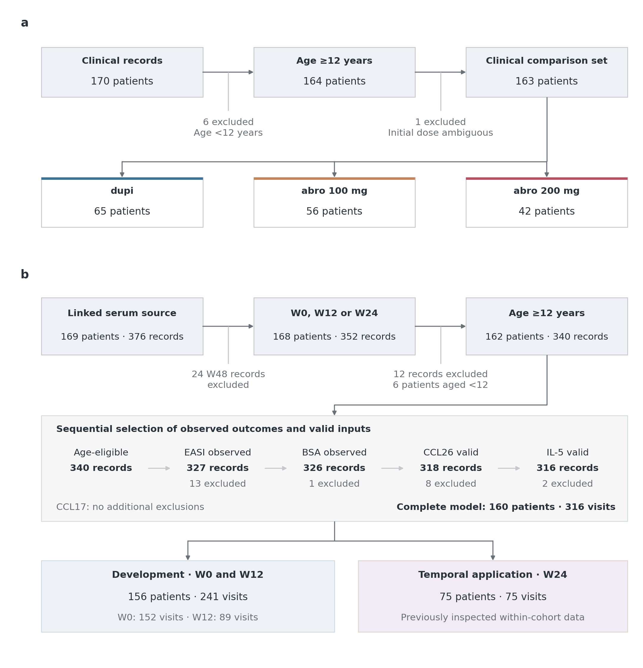
Figure S1. Patient and record flow into the clinical and model analyses. a, The curated clinical source contains 170 patients, not a screened or consented recruitment denominator. Six patients aged <12 years and one age-eligible patient with an ambiguous initial dose are excluded, leaving 163 patients classified by initial treatment: dupi, 65; abro 100 mg, 56; and abro 200 mg, 42. b, The linked serum source is a separate entry branch; model eligibility is not conditional on membership of the clinical comparison population. Removing 24 W48 records leaves 168 patients with 352 W0/W12/W24 records; age exclusions remove 12 records from six patients. Further ordered exclusions are mutually exclusive at the record level: 13 EASI, one BSA, zero CCL17, eight CCL26 and two IL-5 inputs are unavailable, leaving 316 complete model visits from 160 patients. A valid molecular input requires an available positive concentration for the log2 transformation. Loss of a record does not necessarily remove a patient. Development uses 241 W0/W12 visits from 156 patients, with patient-level validation splits; W24 includes 75 visits from 75 patients and is previously inspected within-cohort temporal application, not external validation. Development and W24 share 71 patients, with 85 development-only and four W24-only patients. Fifty-one patients have all three complete visits. The clinical and complete-input model populations share 159 patients, with four clinical-only and one model-only patient; the treatment-free model can retain an ambiguous initial dose. Scheduled empty visit slots are not counted as observed visits, and no filled-in clinical outcome is used as validation truth. Panel key: a, Clinical comparison population; b, Serum-linked model population.
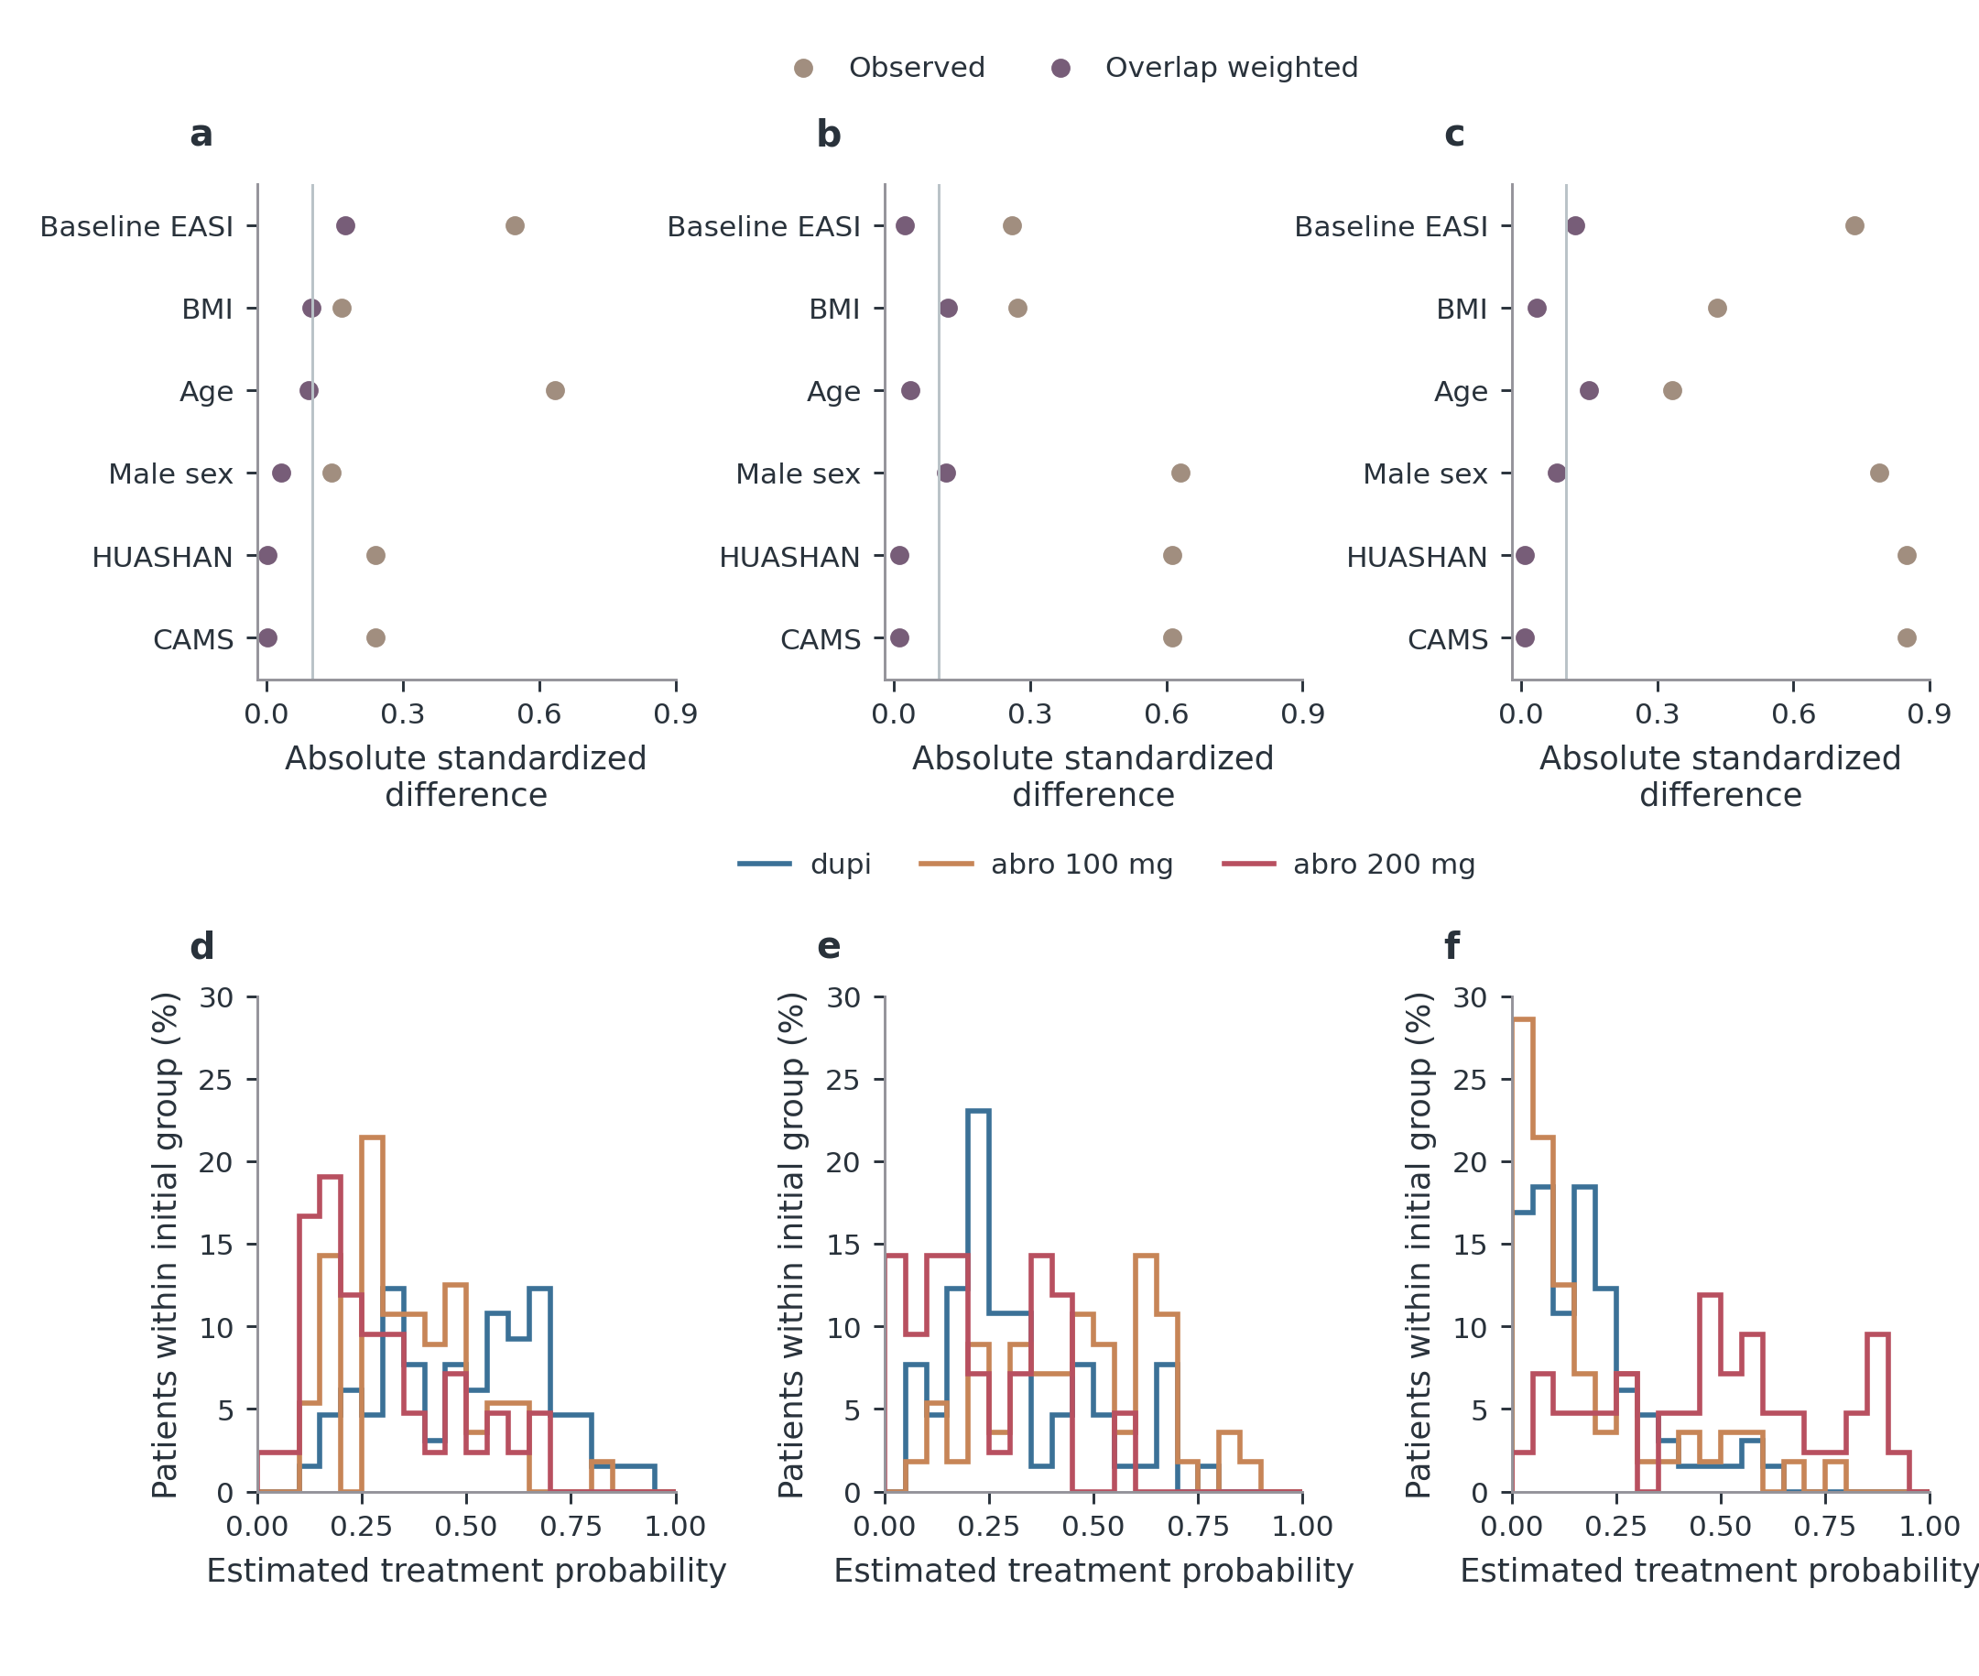
Figure S2. Baseline balance, treatment overlap and effective sample size. a–c, Absolute standardized mean differences for every covariate in the initial-treatment propensity model, before and after generalized overlap weighting. Differences use the unweighted pairwise pooled standard deviation in both displays. The light 0.10 reference line is a descriptive balance guide, not a statistical significance threshold. Residual imbalance remains. d–f, Baseline multinomial treatment probabilities, stratified by actual initial treatment; each distribution uses all patients in that initial group and sums to 100%. These show common support rather than longitudinal drug exposure. The footer reports original N and effective sample size, (sum w)$​^{2}$/sum($w^{2}$). All centre, sex, age, BMI and EASI variables are shown. Overlap weighting targets comparable baseline patients; it cannot remove unmeasured confounding or correct outcome-driven dose changes. Endpoint- and marker-specific availability/ESS diagnostics are retained in the source tables. Panel key: a, dupi versus abro 100 mg; b, dupi versus abro 200 mg; c, abro 100 mg versus abro 200 mg; d, Probability of dupi; e, Probability of abro 100 mg; f, Probability of abro 200 mg.
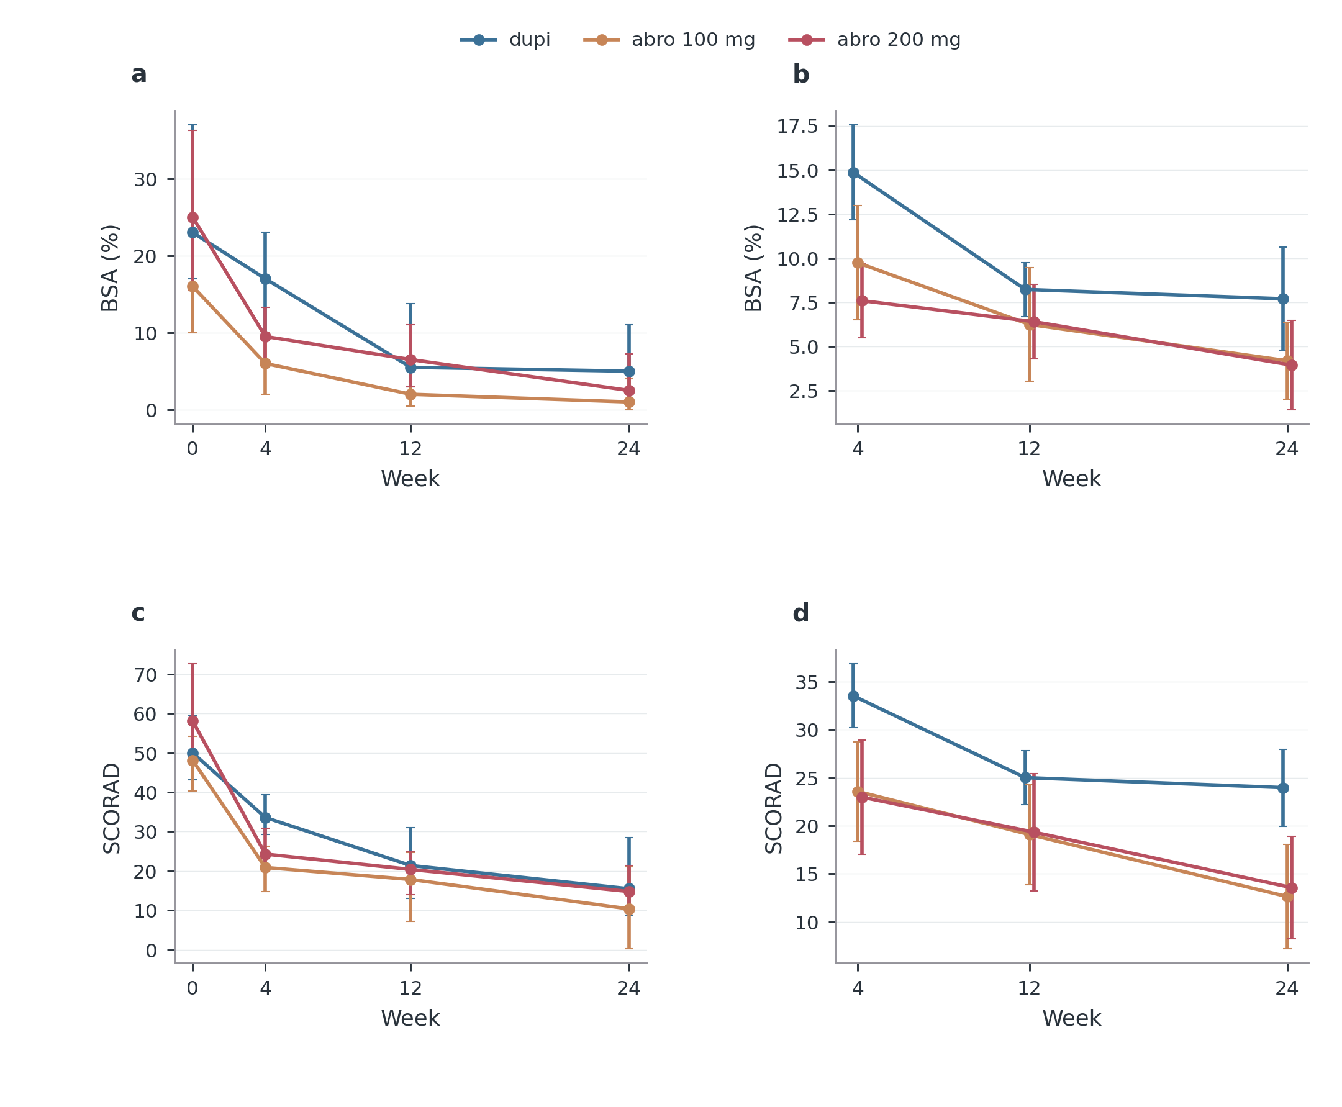
Figure S3. Observed and adjusted BSA (%), SCORAD. Left, observed medians with interquartile ranges by initial treatment; all available values are used at each specified visit. Right, generalized-overlap-weighted marginal estimates with patient-cluster robust 95% confidence intervals conditional on the estimated baseline weights, adjusted for baseline outcome, age, sex, BMI and centre. Patient sets can differ between visits. Exact outcome-specific counts and numerical comparisons are in the source tables; they are not replaced by a common denominator. Initial treatment groups describe observational management strategies, including subsequent regimen changes, rather than randomized fixed-dose effects. Panel key: a, Observed median and IQR; b, Baseline-adjusted estimate and 95% CI.
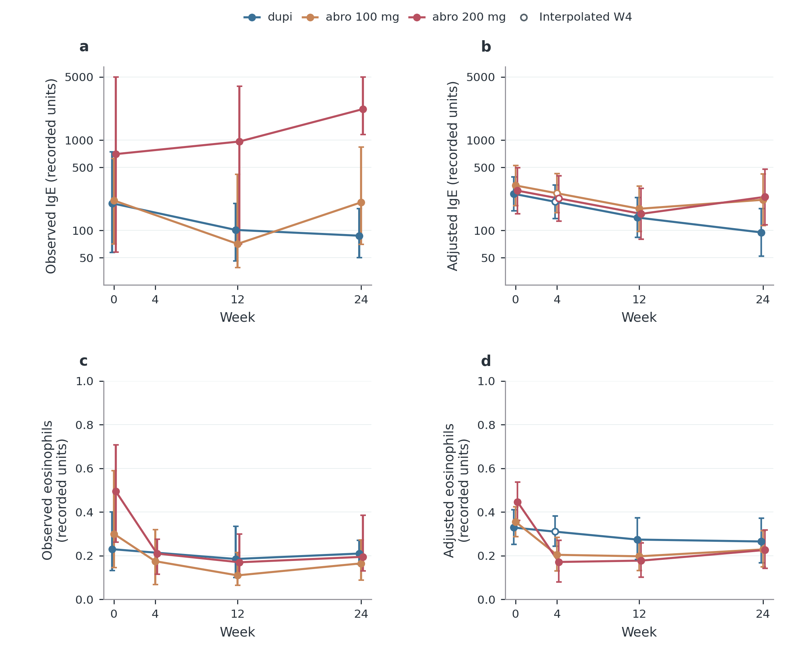
Figure S4. Observed laboratories and available-data adjusted trajectories. a,c, Available-case medians and interquartile ranges at measured visits, using every eligible observed value; patients can differ between visits. Lines connect summaries and do not create measurements at unobserved visits. b,d, Maximum-likelihood random-intercept models use all available IgE or eosinophil measurements, including patients with only one recorded value. Initial treatment-by-categorical-visit terms allow treatment-specific W0 levels and changes; adjustment includes log(1+baseline EASI), age, sex, BMI and centre. Fixed-effect log(1+x) predictions are standardized over the initial cohort, then back-transformed; these are shifted geometric means, not observed medians. Bars in b,d are model-based 95% confidence intervals. Filled points are estimates at visits with measurements in the source population. Hollow points denote entirely unmeasured cells: every W4 IgE cell and dupi W4 eosinophils. They are separate temporal illustrations, obtained one-third of the way from modelled W0 to W12 on the log(1+x) scale. Their intervals propagate endpoint covariance conditional on that shape assumption; no W4 test or measurement is created. Such interpolation can miss an early transient eosinophil rise. Huashan has no follow-up dupi IgE, so pooled predictions assume transferable centre differences; CAMS-only and centre-by-visit sensitivities are provided separately. All denominators and contrasts remain in source tables. Initial treatment reflects observational management, including later regimen changes, and does not identify causal dose effects.
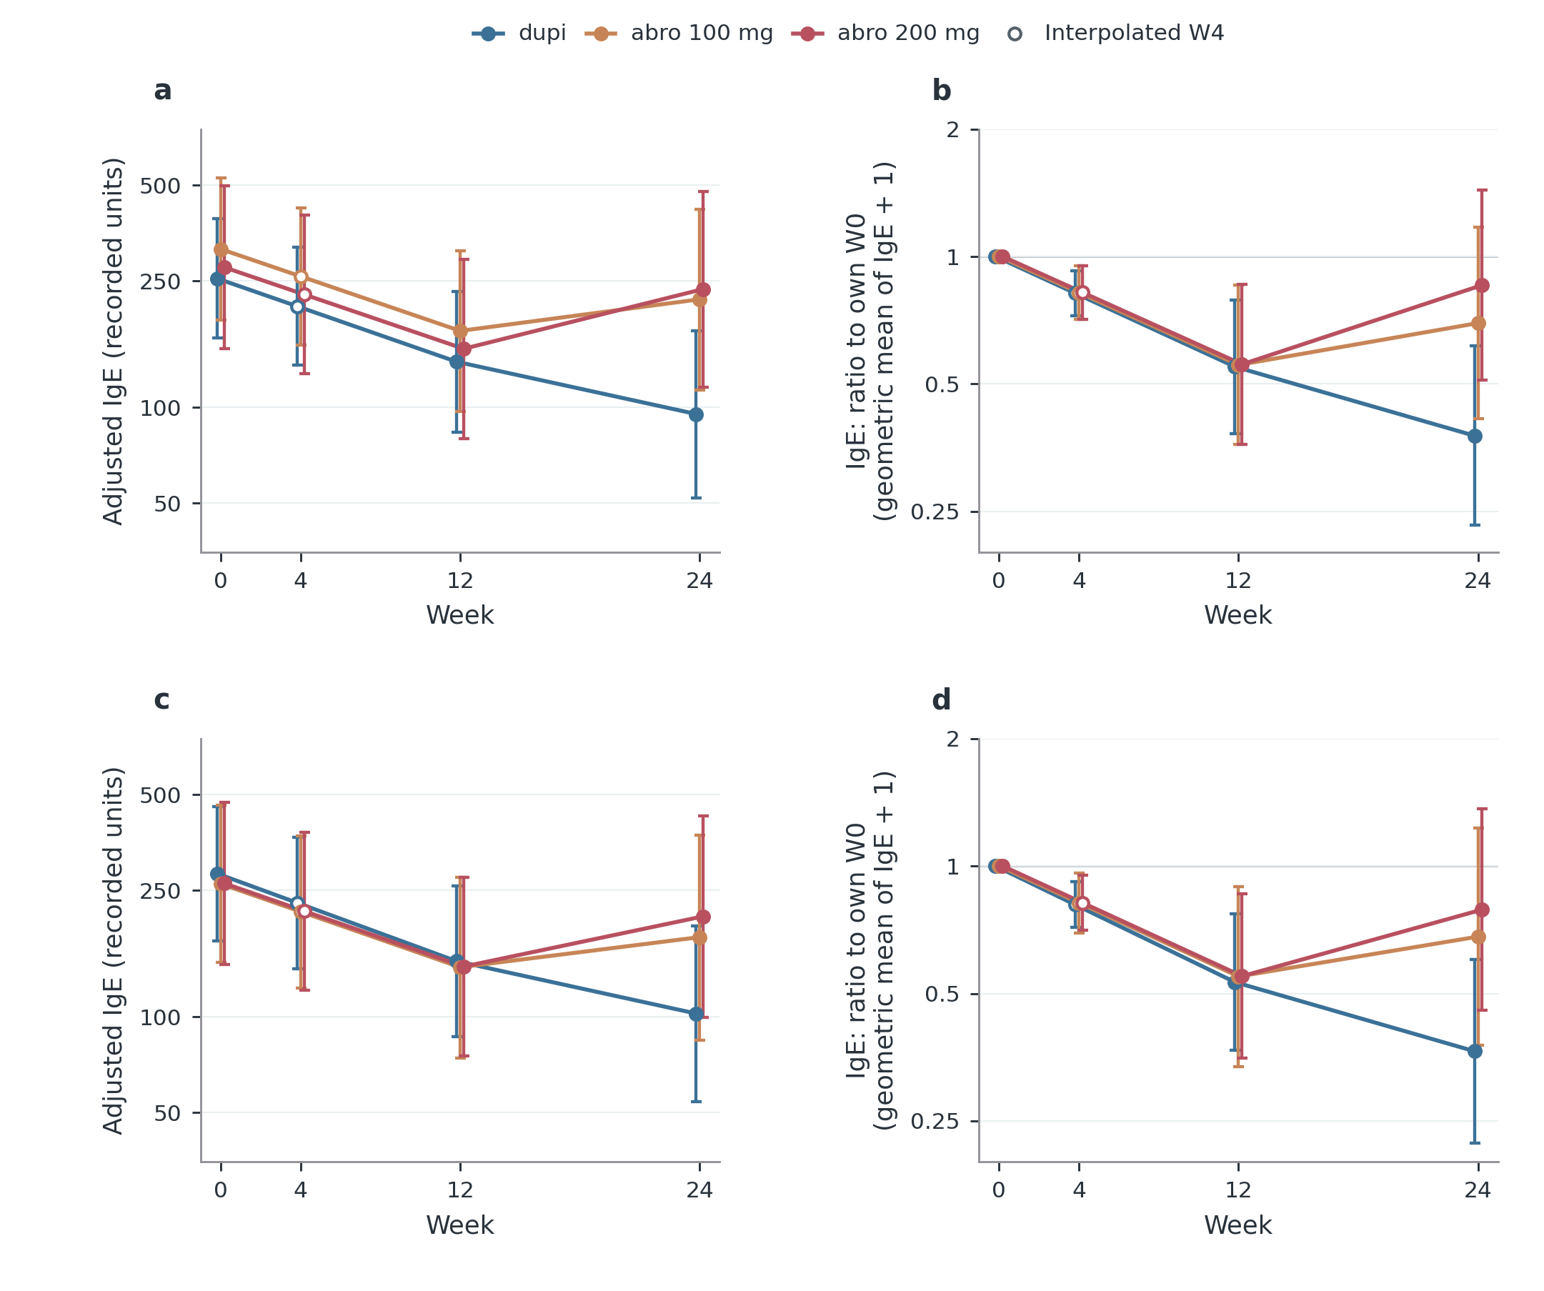
Figure S5. All-available IgE trajectories and centre sensitivity. a,b, All-centre available-data model; c,d, CAMS-only sensitivity. a,c, Adjusted shifted geometric mean IgE; b,d, The modelled ratio of geometric mean (IgE+1) to the same treatment group’s own W0 value. A ratio below one indicates a lower follow-up level. The all-centre analysis uses 258 observed values from 147 patients; CAMS uses 229 values from 125 patients. No complete-three-visit requirement is imposed; patients with only one measured visit can contribute. Models include initial treatment-by-categorical-visit effects, log(1+baseline EASI), age, sex and BMI, plus centre in a,b, with a patient random intercept. The baseline IgE response is modelled jointly, with free treatment-specific baseline means; this is not a follow-up ANCOVA that explicitly conditions on each observed baseline IgE. Predictions are standardized to the baseline population of the stated scope. Lines and 95% confidence intervals describe adjusted group trajectories, not individual prediction or causal drug effects. There are no W4 IgE measurements. Hollow W4 points are illustrative log-scale interpolations between modelled W0 and W12, with conditional intervals; no hypothesis test uses these points. Huashan has baseline and abro follow-up IgE but no dupi follow-up IgE. The all-centre model therefore assumes shared centre differences, examined using CAMS-only and centre-by-visit sensitivity. Two previous multiple-imputation methods, their differing assumptions and results remain in Table S8 and the complete source tables. Drug-curve ordering alone does not establish a dose effect. Exact coverage, model diagnostics, interpolation alternatives and baseline-relative between-treatment tests remain available in source data.
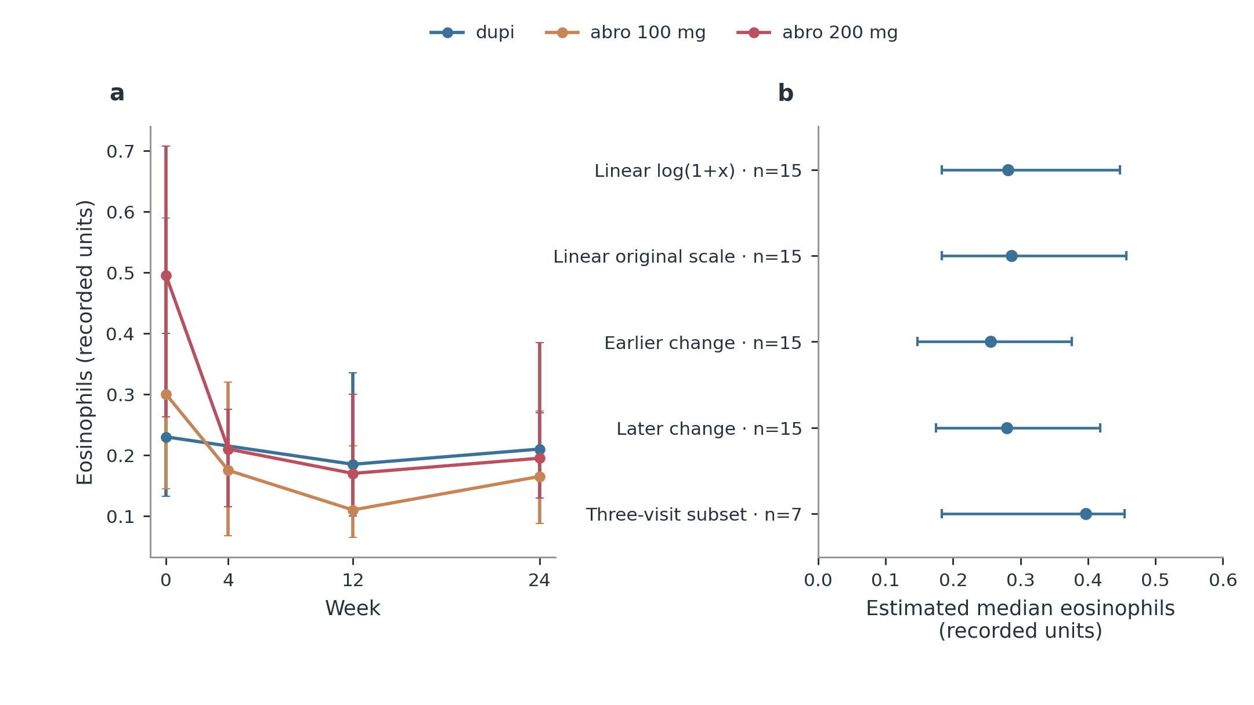
Figure S6. Observed eosinophil data and sensitivity of the W4 estimate. a, Available-case medians and interquartile ranges at observed visits. The dupi line connects W0 to W12 because no W4 measurement exists; crossing the W4 position does not create an observation. No imputed value enters this panel. b, Estimated dupi W4 medians and patient-bootstrap 95% intervals under different temporal assumptions. The first four estimates use the same 15 W0/W12 pairs. Earlier/later change replaces the linear time fraction with log(1+t)/log(13) or (t/12)$​^{2}$ at t=4. The last row restricts to seven patients also observed at W24, illustrating selection sensitivity, not a better estimate. Intervals condition on the stated assumptions and do not cover all uncertainty about the unmeasured W4 distribution. These are post hoc descriptive estimates, not multiple imputation under an identified treatment-specific W4 model. All original observations remain unchanged. Panel key: a, Observed eosinophils; b, dupi: W4 estimation sensitivity.
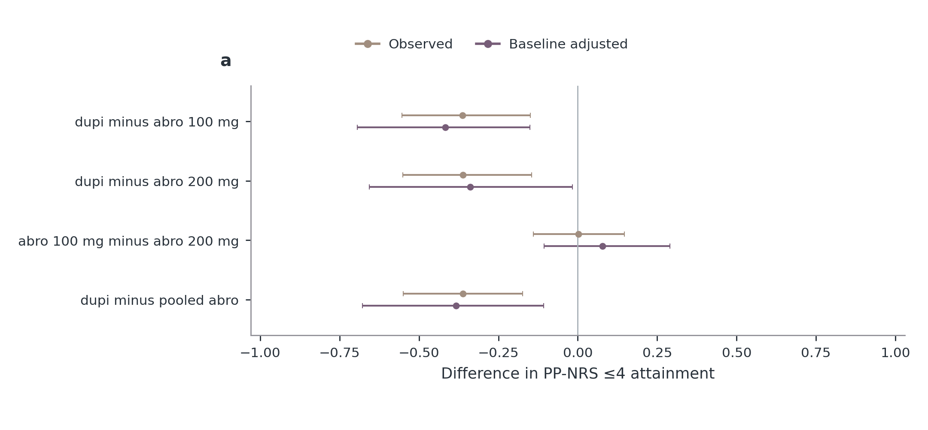
Figure S7. Week 2: all initial-treatment target contrasts. Observed and baseline-adjusted risk differences with nominal 95% confidence intervals. Positive values favour the first named treatment for target attainment. Adjustment uses generalized overlap weights from baseline EASI, age, sex, BMI and centre; it does not estimate a randomized current-dose effect. Treatment labels refer to the initial prescribed regimen. pooled abro is supplementary. Missing estimates are left absent; all exact denominators, Fisher/weighted tests, Holm-adjusted P values and exploratory FDR values are in the source tables. Panel key: a, Week 2 itch target.
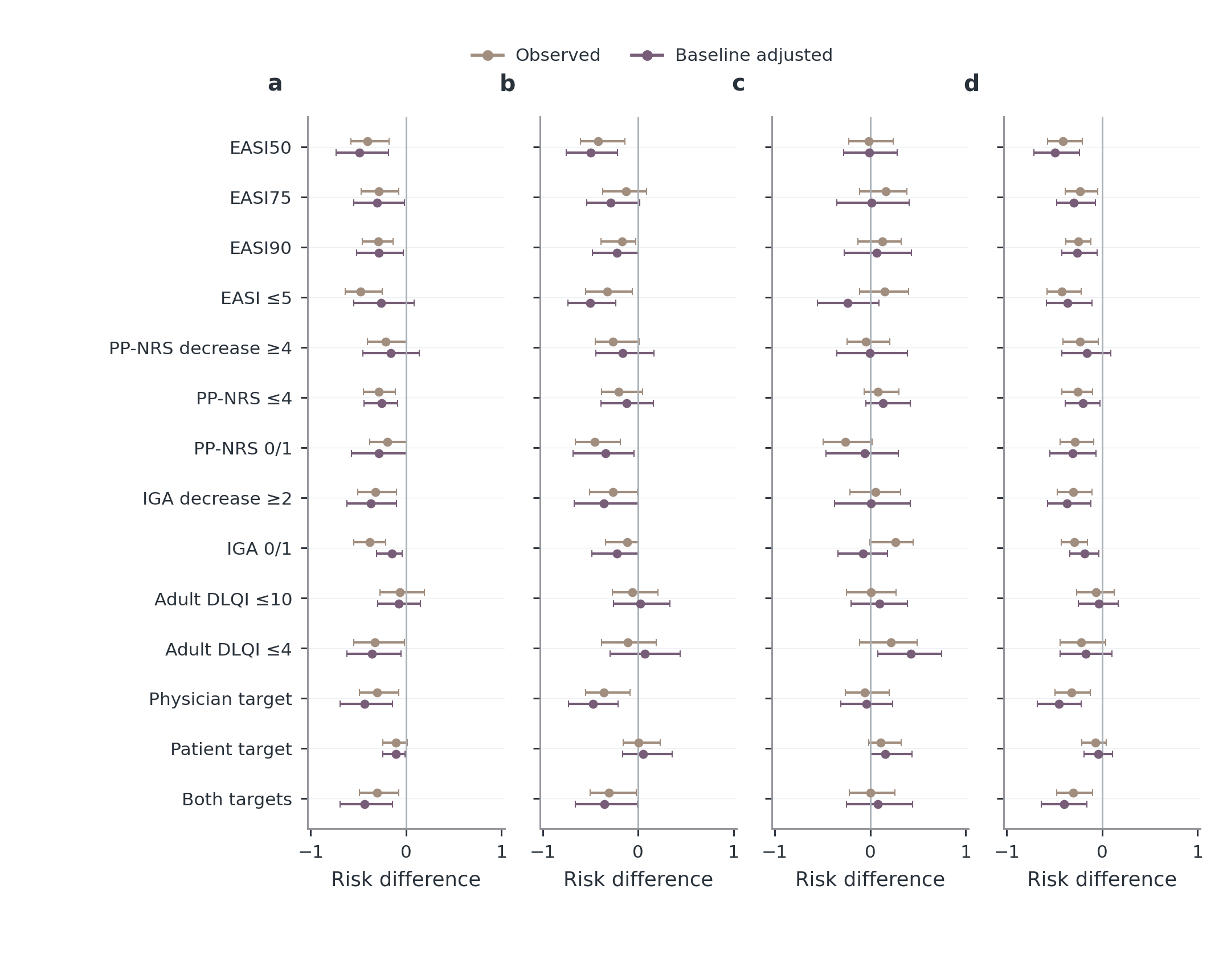
Figure S8. Week 4: all initial-treatment target contrasts. Observed and baseline-adjusted risk differences with nominal 95% confidence intervals. Positive values favour the first named treatment for target attainment. Adjustment uses generalized overlap weights from baseline EASI, age, sex, BMI and centre; it does not estimate a randomized current-dose effect. Treatment labels refer to the initial prescribed regimen. pooled abro is supplementary. Missing estimates are left absent; all exact denominators, Fisher/weighted tests, Holm-adjusted P values and exploratory FDR values are in the source tables. Panel key: a, dupi minus abro 100 mg; b, dupi minus abro 200 mg; c, abro 100 mg minus abro 200 mg; d, dupi minus pooled abro.
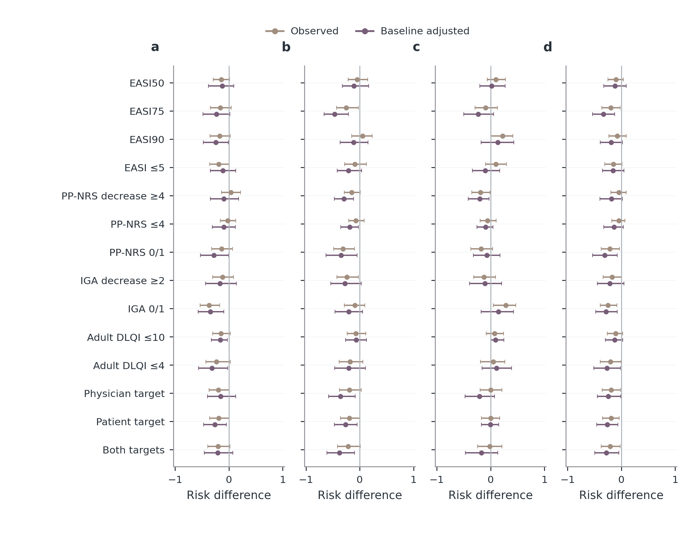
Figure S9. Week 12: all initial-treatment target contrasts. Observed and baseline-adjusted risk differences with nominal 95% confidence intervals. Positive values favour the first named treatment for target attainment. Adjustment uses generalized overlap weights from baseline EASI, age, sex, BMI and centre; it does not estimate a randomized current-dose effect. Treatment labels refer to the initial prescribed regimen. pooled abro is supplementary. Missing estimates are left absent; all exact denominators, Fisher/weighted tests, Holm-adjusted P values and exploratory FDR values are in the source tables. Panel key: a, dupi minus abro 100 mg; b, dupi minus abro 200 mg; c, abro 100 mg minus abro 200 mg; d, dupi minus pooled abro.
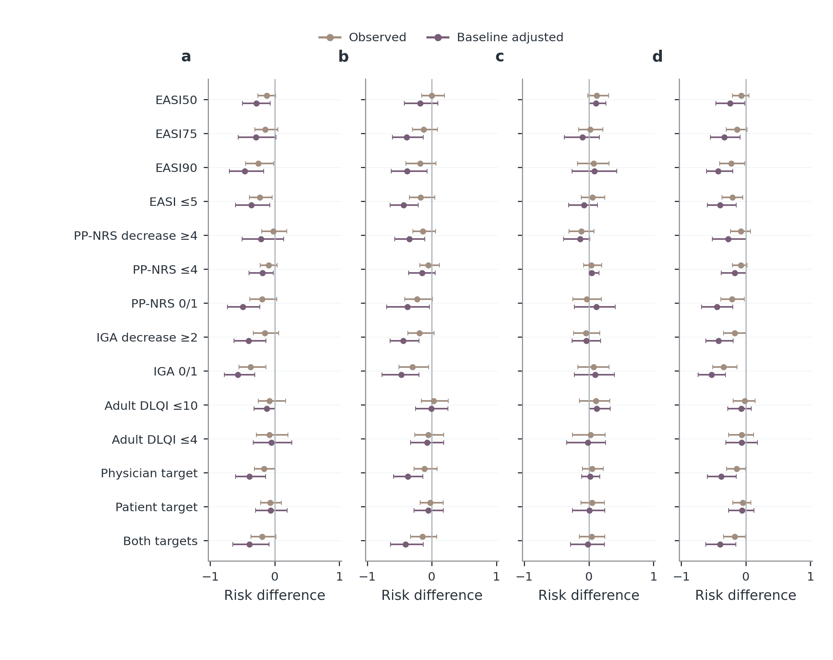
Figure S10. Week 24: all initial-treatment target contrasts. Observed and baseline-adjusted risk differences with nominal 95% confidence intervals. Positive values favour the first named treatment for target attainment. Adjustment uses generalized overlap weights from baseline EASI, age, sex, BMI and centre; it does not estimate a randomized current-dose effect. Treatment labels refer to the initial prescribed regimen. pooled abro is supplementary. Missing estimates are left absent; all exact denominators, Fisher/weighted tests, Holm-adjusted P values and exploratory FDR values are in the source tables. Panel key: a, dupi minus abro 100 mg; b, dupi minus abro 200 mg; c, abro 100 mg minus abro 200 mg; d, dupi minus pooled abro.
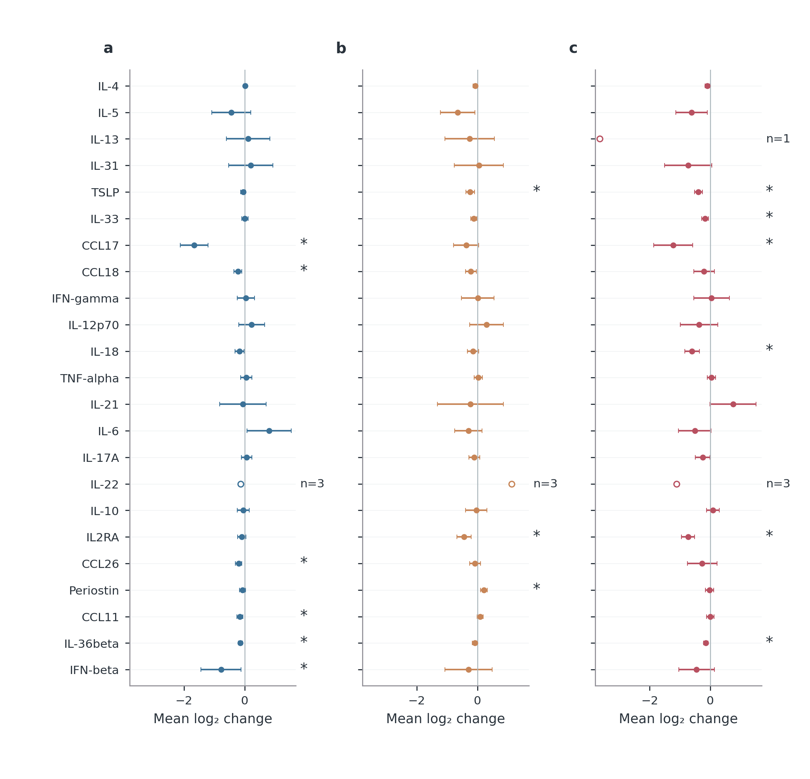
Figure S11. Molecular changes from W0 to W12. Mean paired $\log_{2}$ concentration changes with 95% t confidence intervals. Negative values indicate lower later concentration. Each marker/treatment uses all available pairs for this interval; exact counts are in the source table. All 23 measured markers are retained. Hollow circles with n labels denote fewer than five pairs; these are descriptive and have no inferential interval or star. Unavailable estimates are blank. Stars denote BH q<0.05 across the 193 estimable tests among 207 planned marker-by-treatment-by-window comparisons, not a separate family for the displayed interval. Panel key: a, dupi; b, abro 100 mg; c, abro 200 mg.
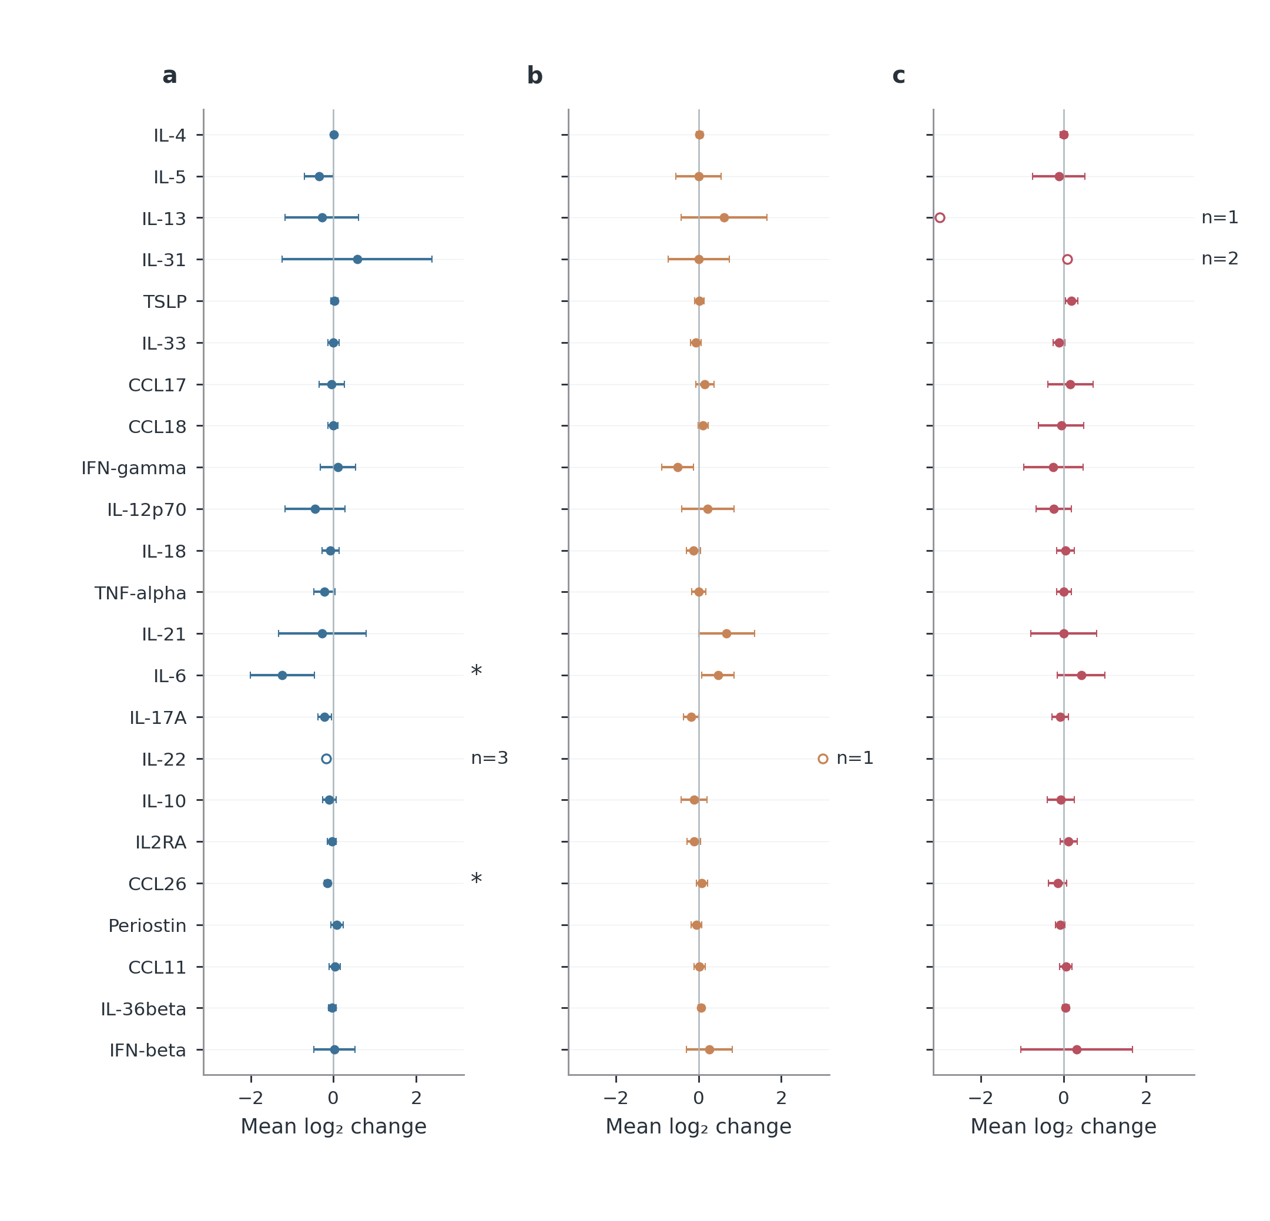
Figure S12. Molecular changes from W12 to W24. Mean paired $\log_{2}$ concentration changes with 95% t confidence intervals. Negative values indicate lower later concentration. Each marker/treatment uses all available pairs for this interval; exact counts are in the source table. All 23 measured markers are retained. Hollow circles with n labels denote fewer than five pairs; these are descriptive and have no inferential interval or star. Unavailable estimates are blank. Stars denote BH q<0.05 across the 193 estimable tests among 207 planned marker-by-treatment-by-window comparisons, not a separate family for the displayed interval. Panel key: a, dupi; b, abro 100 mg; c, abro 200 mg.
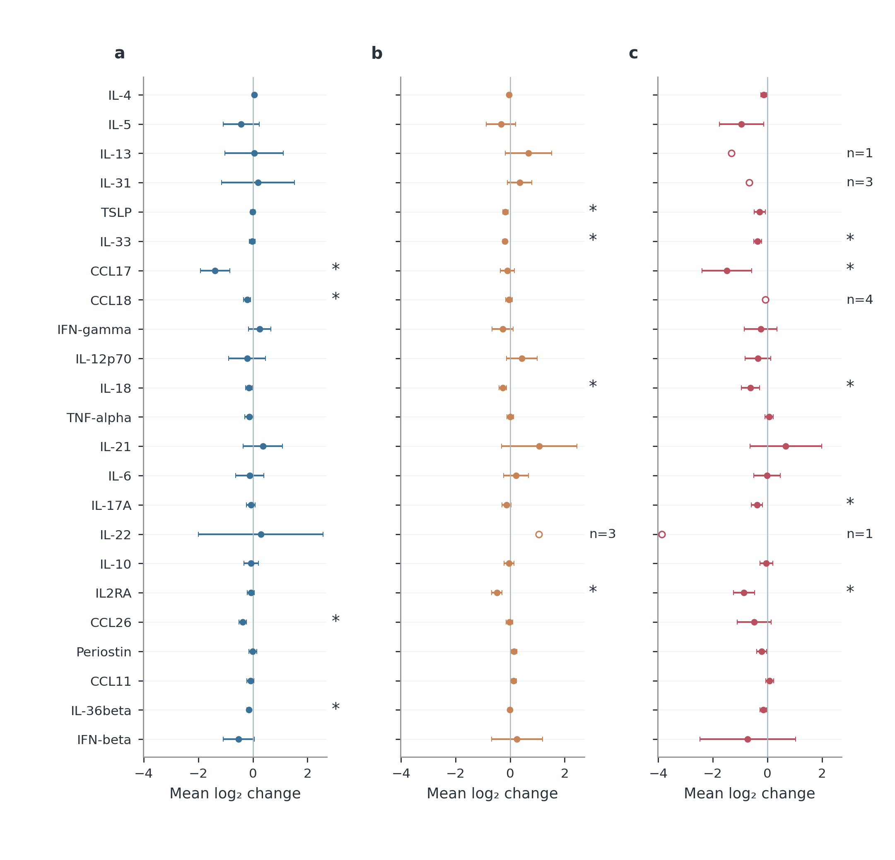
Figure S13. Molecular changes from W0 to W24. Mean paired $\log_{2}$ concentration changes with 95% t confidence intervals. Negative values indicate lower later concentration. Each marker/treatment uses all available pairs for this interval; exact counts are in the source table. All 23 measured markers are retained. Hollow circles with n labels denote fewer than five pairs; these are descriptive and have no inferential interval or star. Unavailable estimates are blank. Stars denote BH q<0.05 across the 193 estimable tests among 207 planned marker-by-treatment-by-window comparisons, not a separate family for the displayed interval. Panel key: a, dupi; b, abro 100 mg; c, abro 200 mg.
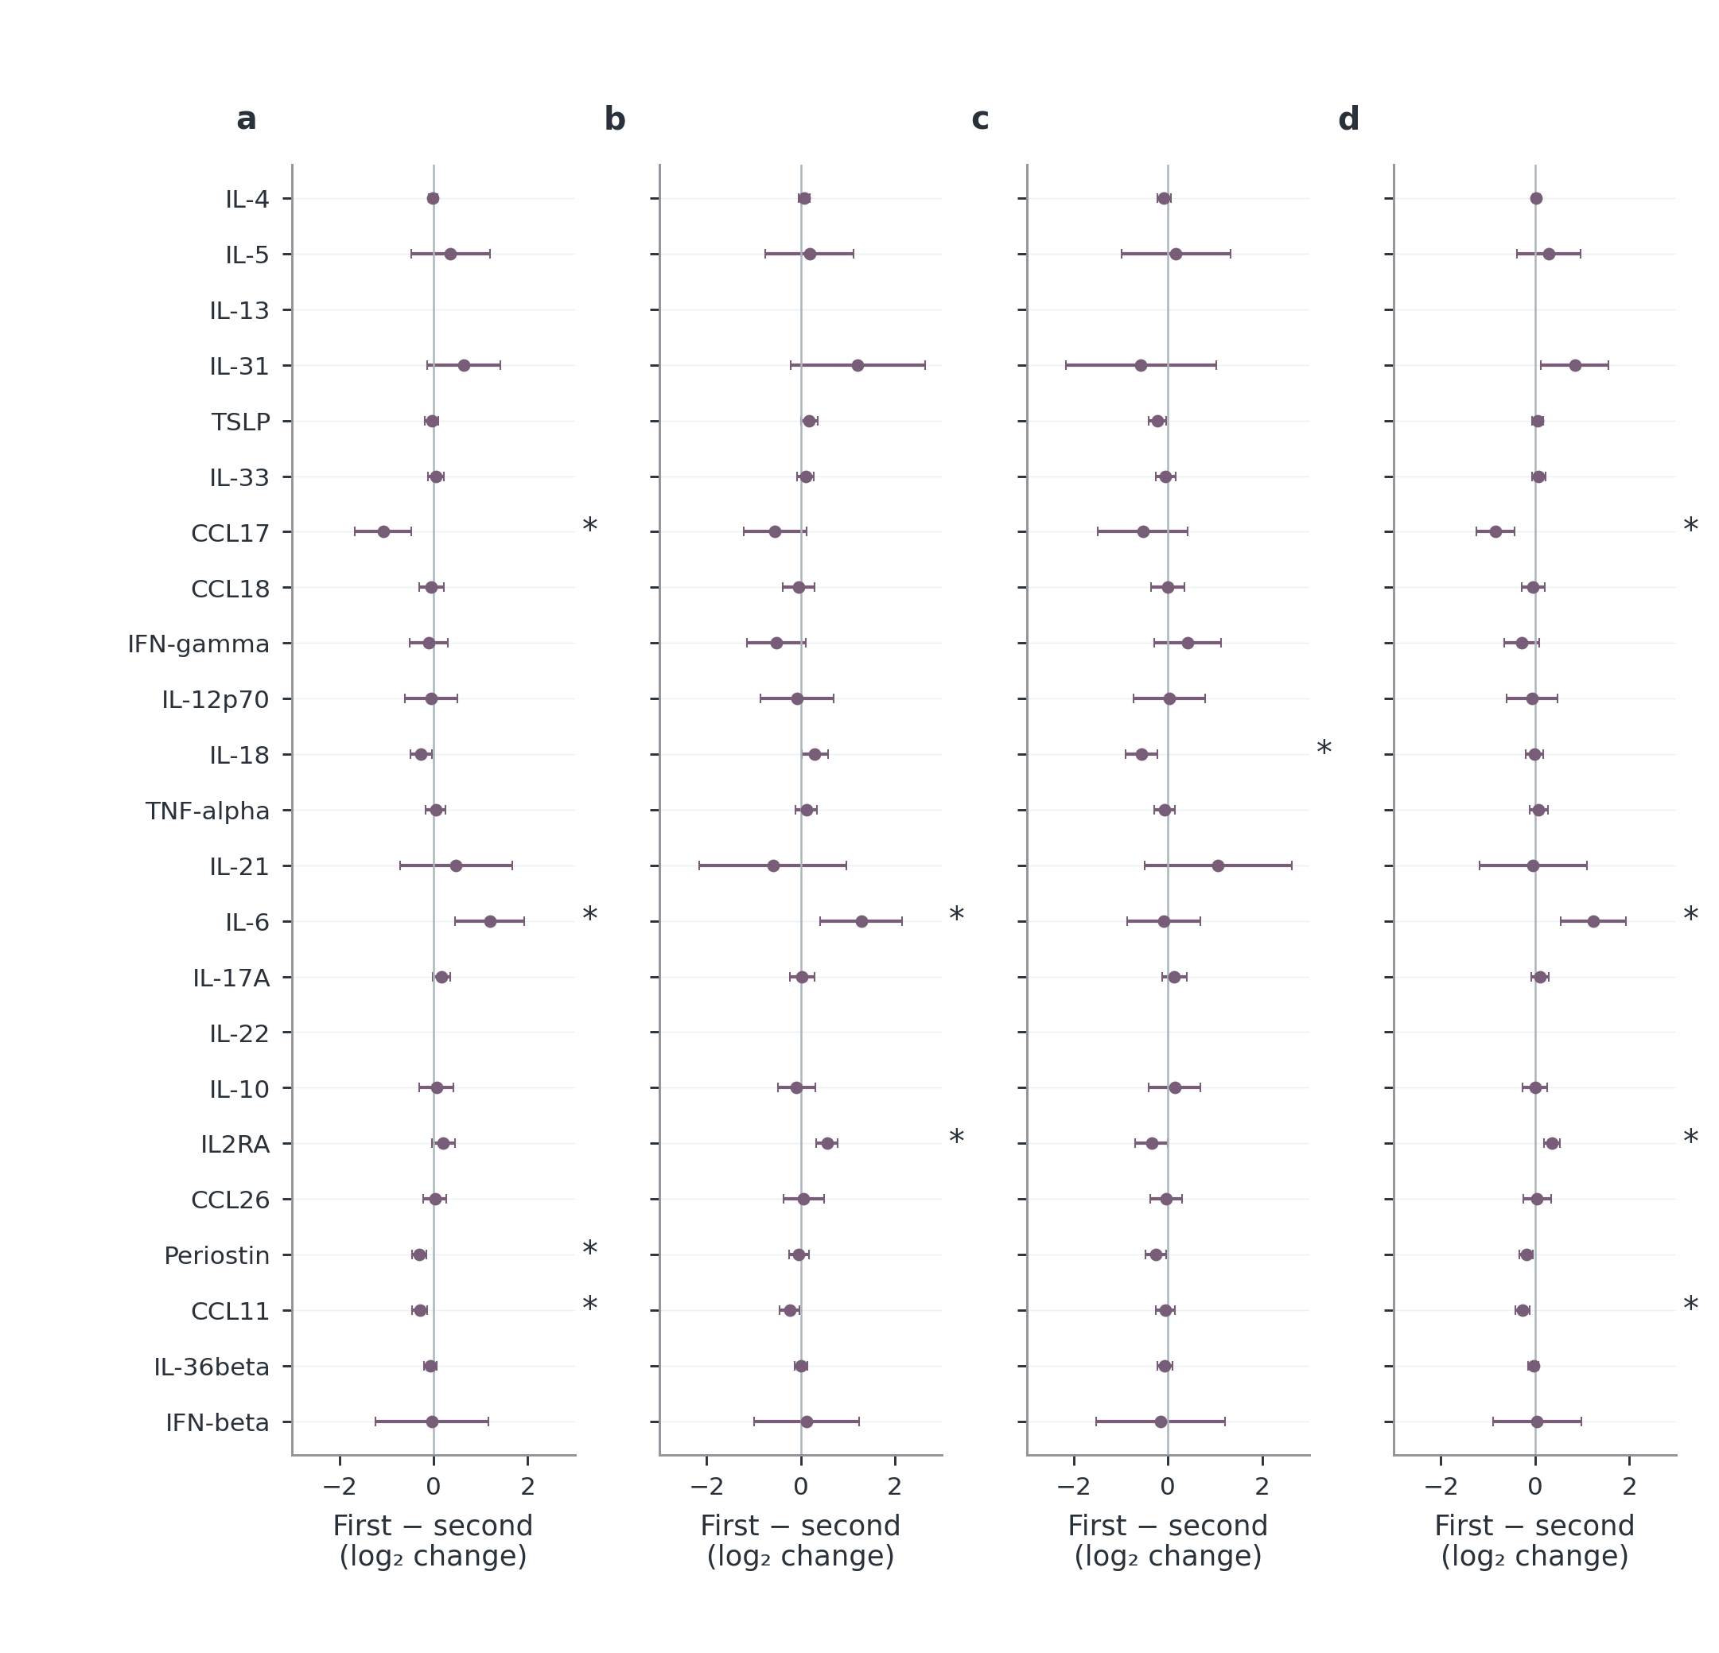
Figure S14. Adjusted molecular comparisons from W0 to W12. Differences in within-patient $\log_{2}$ changes with HC3 95% confidence intervals. Negative values mean a smaller, more negative change in the first named treatment. Models adjust starting $\log_{2}$ concentration, baseline total EASI, age, sex, BMI and centre. dupi denotes dupilumab; abro denotes abrocitinib, with 100/200 mg identifying initial dose. pooled abro retains the observed dose mixture. Stars denote the original BH q<0.05 family; no multiplicity family is recalculated after display selection. Blank positions have no estimable contrast. Complete counts, diagnostics, centre/batch sensitivities and tests remain in the source table. These are adjusted observational associations, not randomized current-dose effects. Panel key: a, dupi minus abro 100 mg; b, dupi minus abro 200 mg; c, abro 200 mg minus abro 100 mg; d, dupi minus pooled abro.
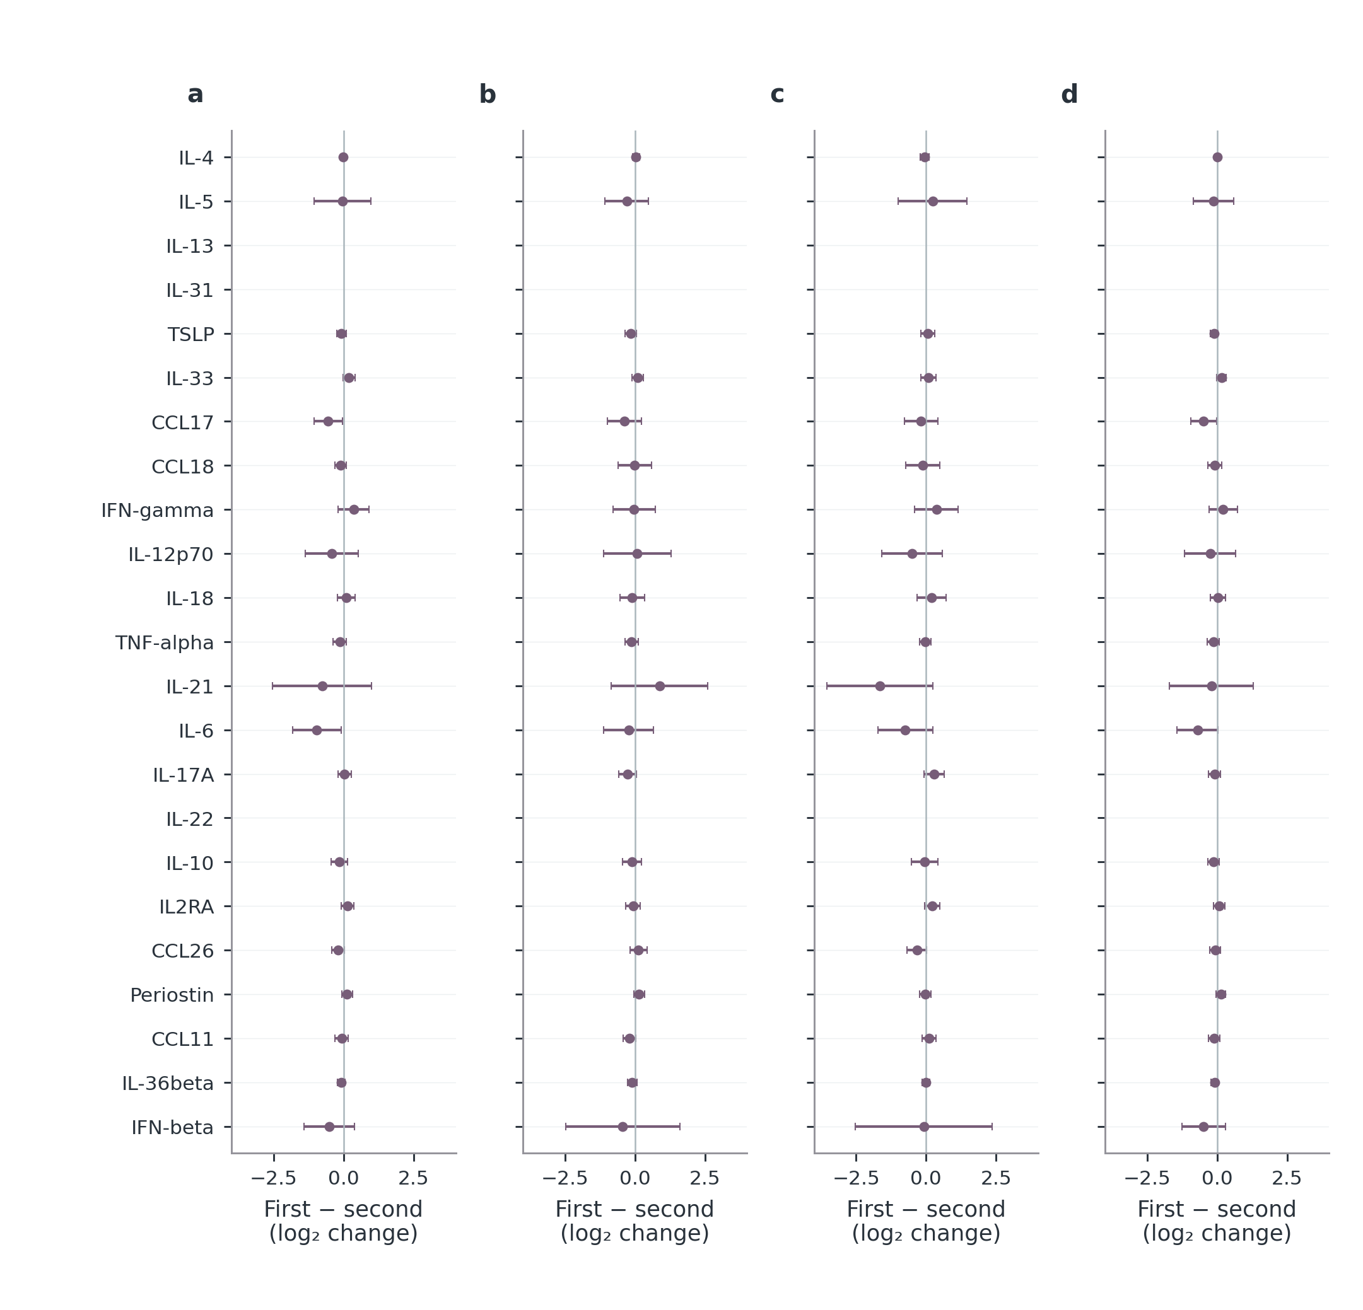
Figure S15. Adjusted molecular comparisons from W12 to W24. Differences in within-patient $\log_{2}$ changes with HC3 95% confidence intervals. Negative values mean a smaller, more negative change in the first named treatment. Models adjust starting $\log_{2}$ concentration, baseline total EASI, age, sex, BMI and centre. dupi denotes dupilumab; abro denotes abrocitinib, with 100/200 mg identifying initial dose. pooled abro retains the observed dose mixture. Stars denote the original BH q<0.05 family; no multiplicity family is recalculated after display selection. Blank positions have no estimable contrast. Complete counts, diagnostics, centre/batch sensitivities and tests remain in the source table. These are adjusted observational associations, not randomized current-dose effects. Panel key: a, dupi minus abro 100 mg; b, dupi minus abro 200 mg; c, abro 200 mg minus abro 100 mg; d, dupi minus pooled abro.
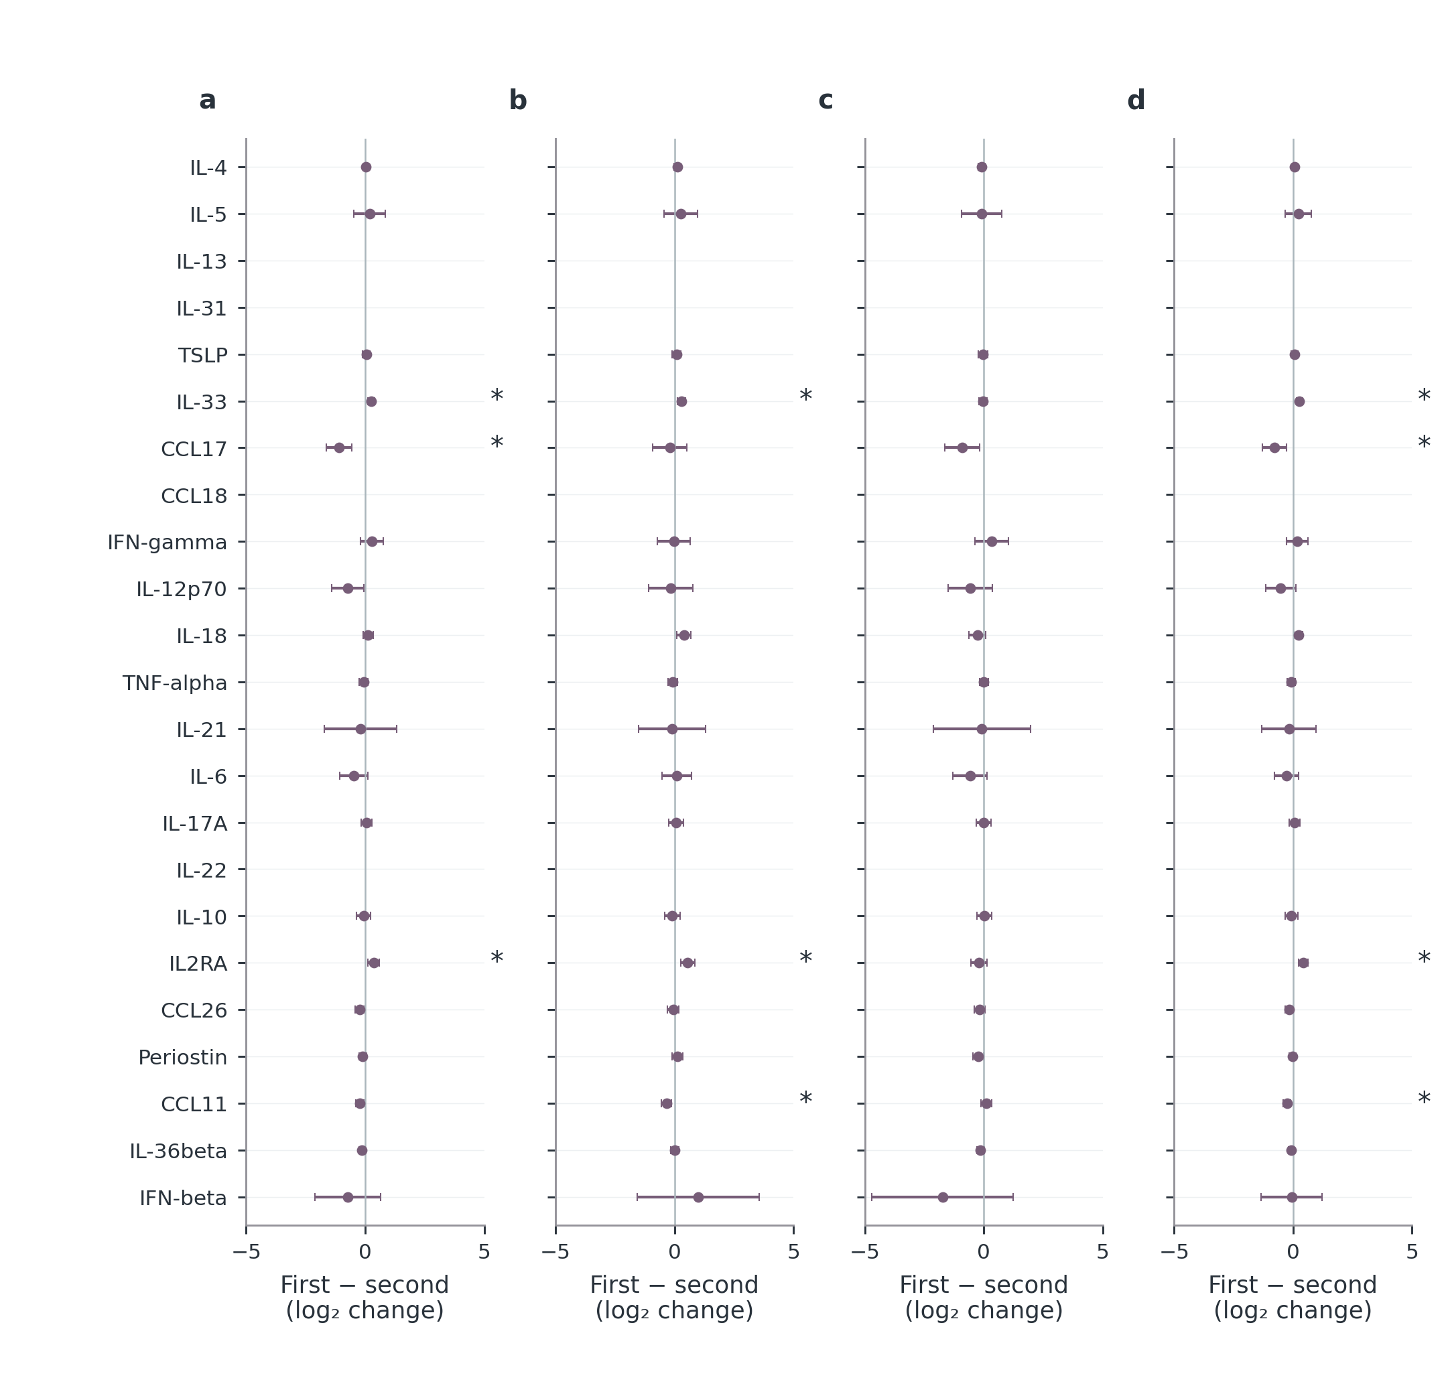
Figure S16. Adjusted molecular comparisons from W0 to W24. Differences in within-patient $\log_{2}$ changes with HC3 95% confidence intervals. Negative values mean a smaller, more negative change in the first named treatment. Models adjust starting $\log_{2}$ concentration, baseline total EASI, age, sex, BMI and centre. dupi denotes dupilumab; abro denotes abrocitinib, with 100/200 mg identifying initial dose. pooled abro retains the observed dose mixture. Stars denote the original BH q<0.05 family; no multiplicity family is recalculated after display selection. Blank positions have no estimable contrast. Complete counts, diagnostics, centre/batch sensitivities and tests remain in the source table. These are adjusted observational associations, not randomized current-dose effects. Panel key: a, dupi minus abro 100 mg; b, dupi minus abro 200 mg; c, abro 200 mg minus abro 100 mg; d, dupi minus pooled abro.
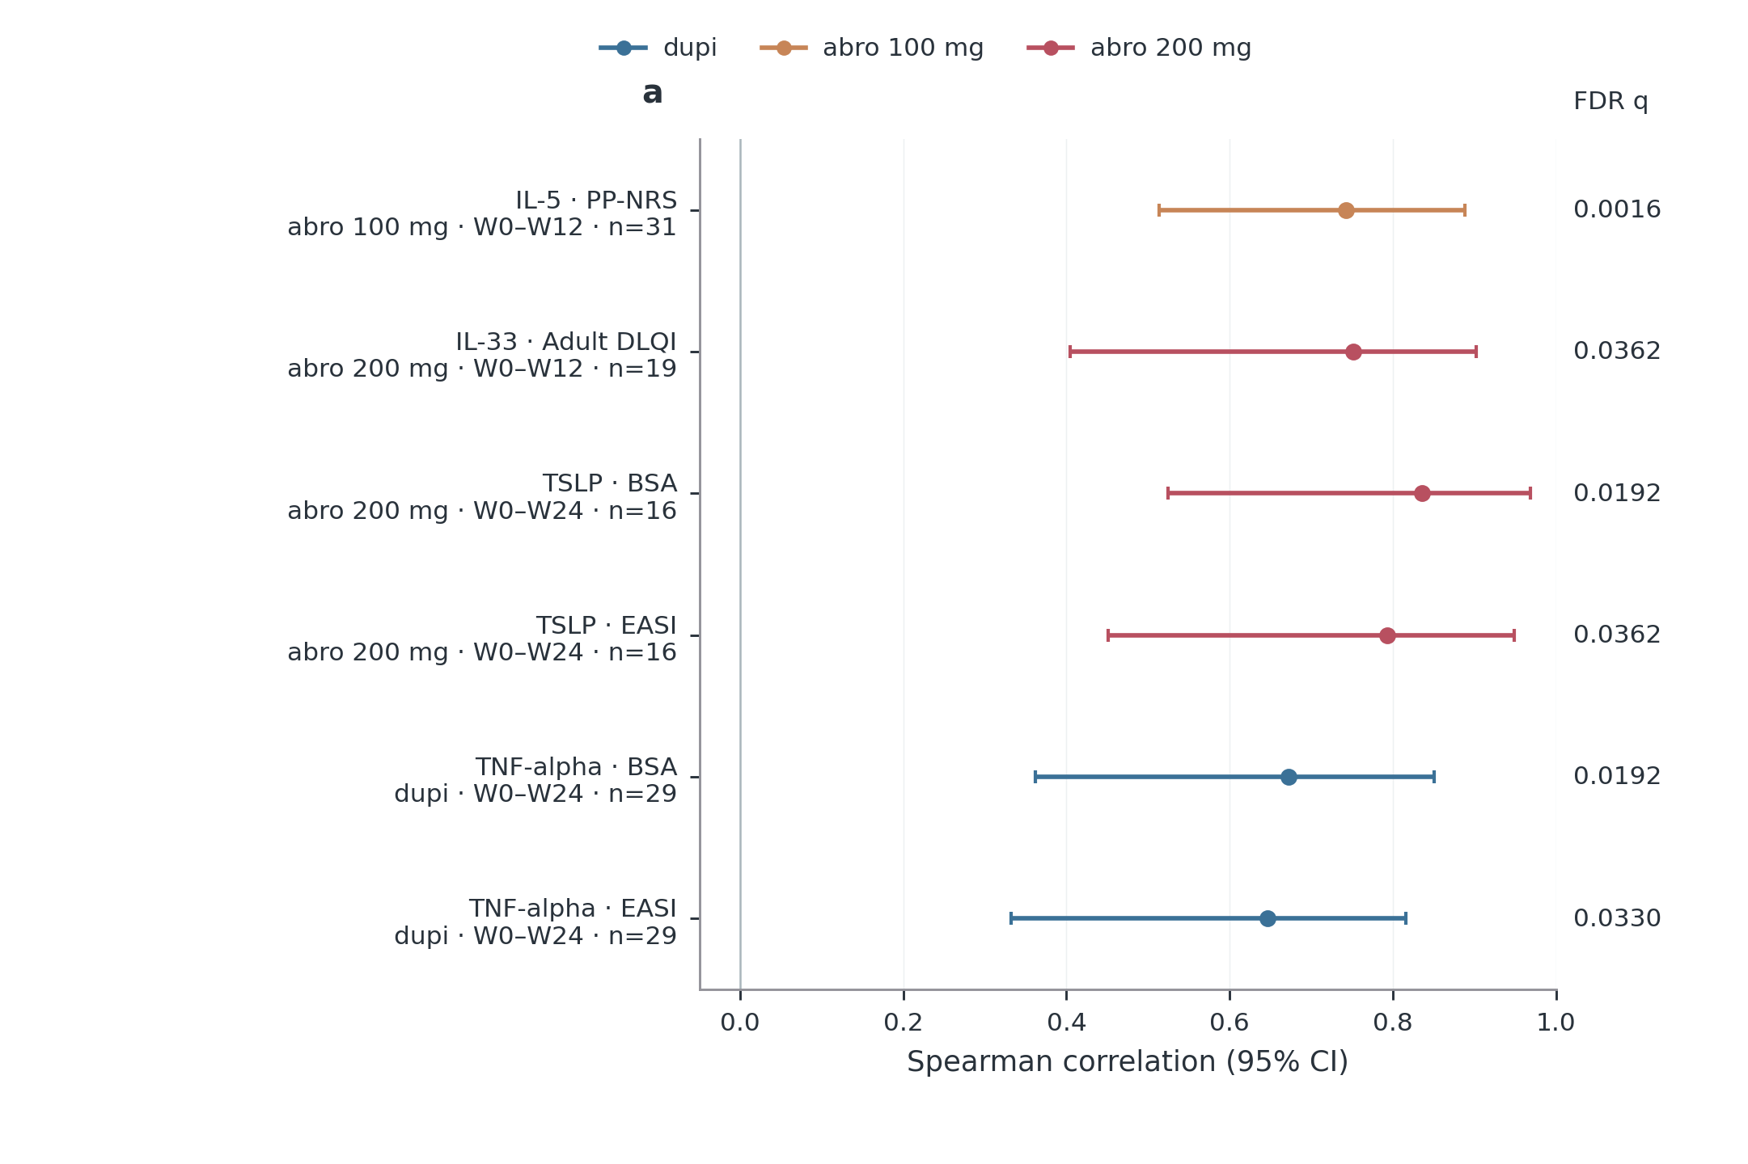
Figure S17. Molecular and clinical changes associated after multiplicity correction. Every association meeting BH q<0.05 in the full declared change-association family is displayed; selection spans 23 markers, five clinical outcomes, three initial treatments and three intervals. No W12–W24 association met this threshold. Points are Spearman correlations between within-patient clinical change and $\log_{2}$ molecular change, both later minus earlier, with patient-bootstrap 95% confidence intervals. Positive correlations indicate changes in the same direction. Labels give paired-patient counts and the interval; colours indicate initial treatment only. Adult DLQI requires age $≥$18. All tested coefficients, non-significant results and unestimable pairs remain in the complete source table. This significance-selected display is exploratory and is not independent validation, numerical agreement or a causal molecular effect.
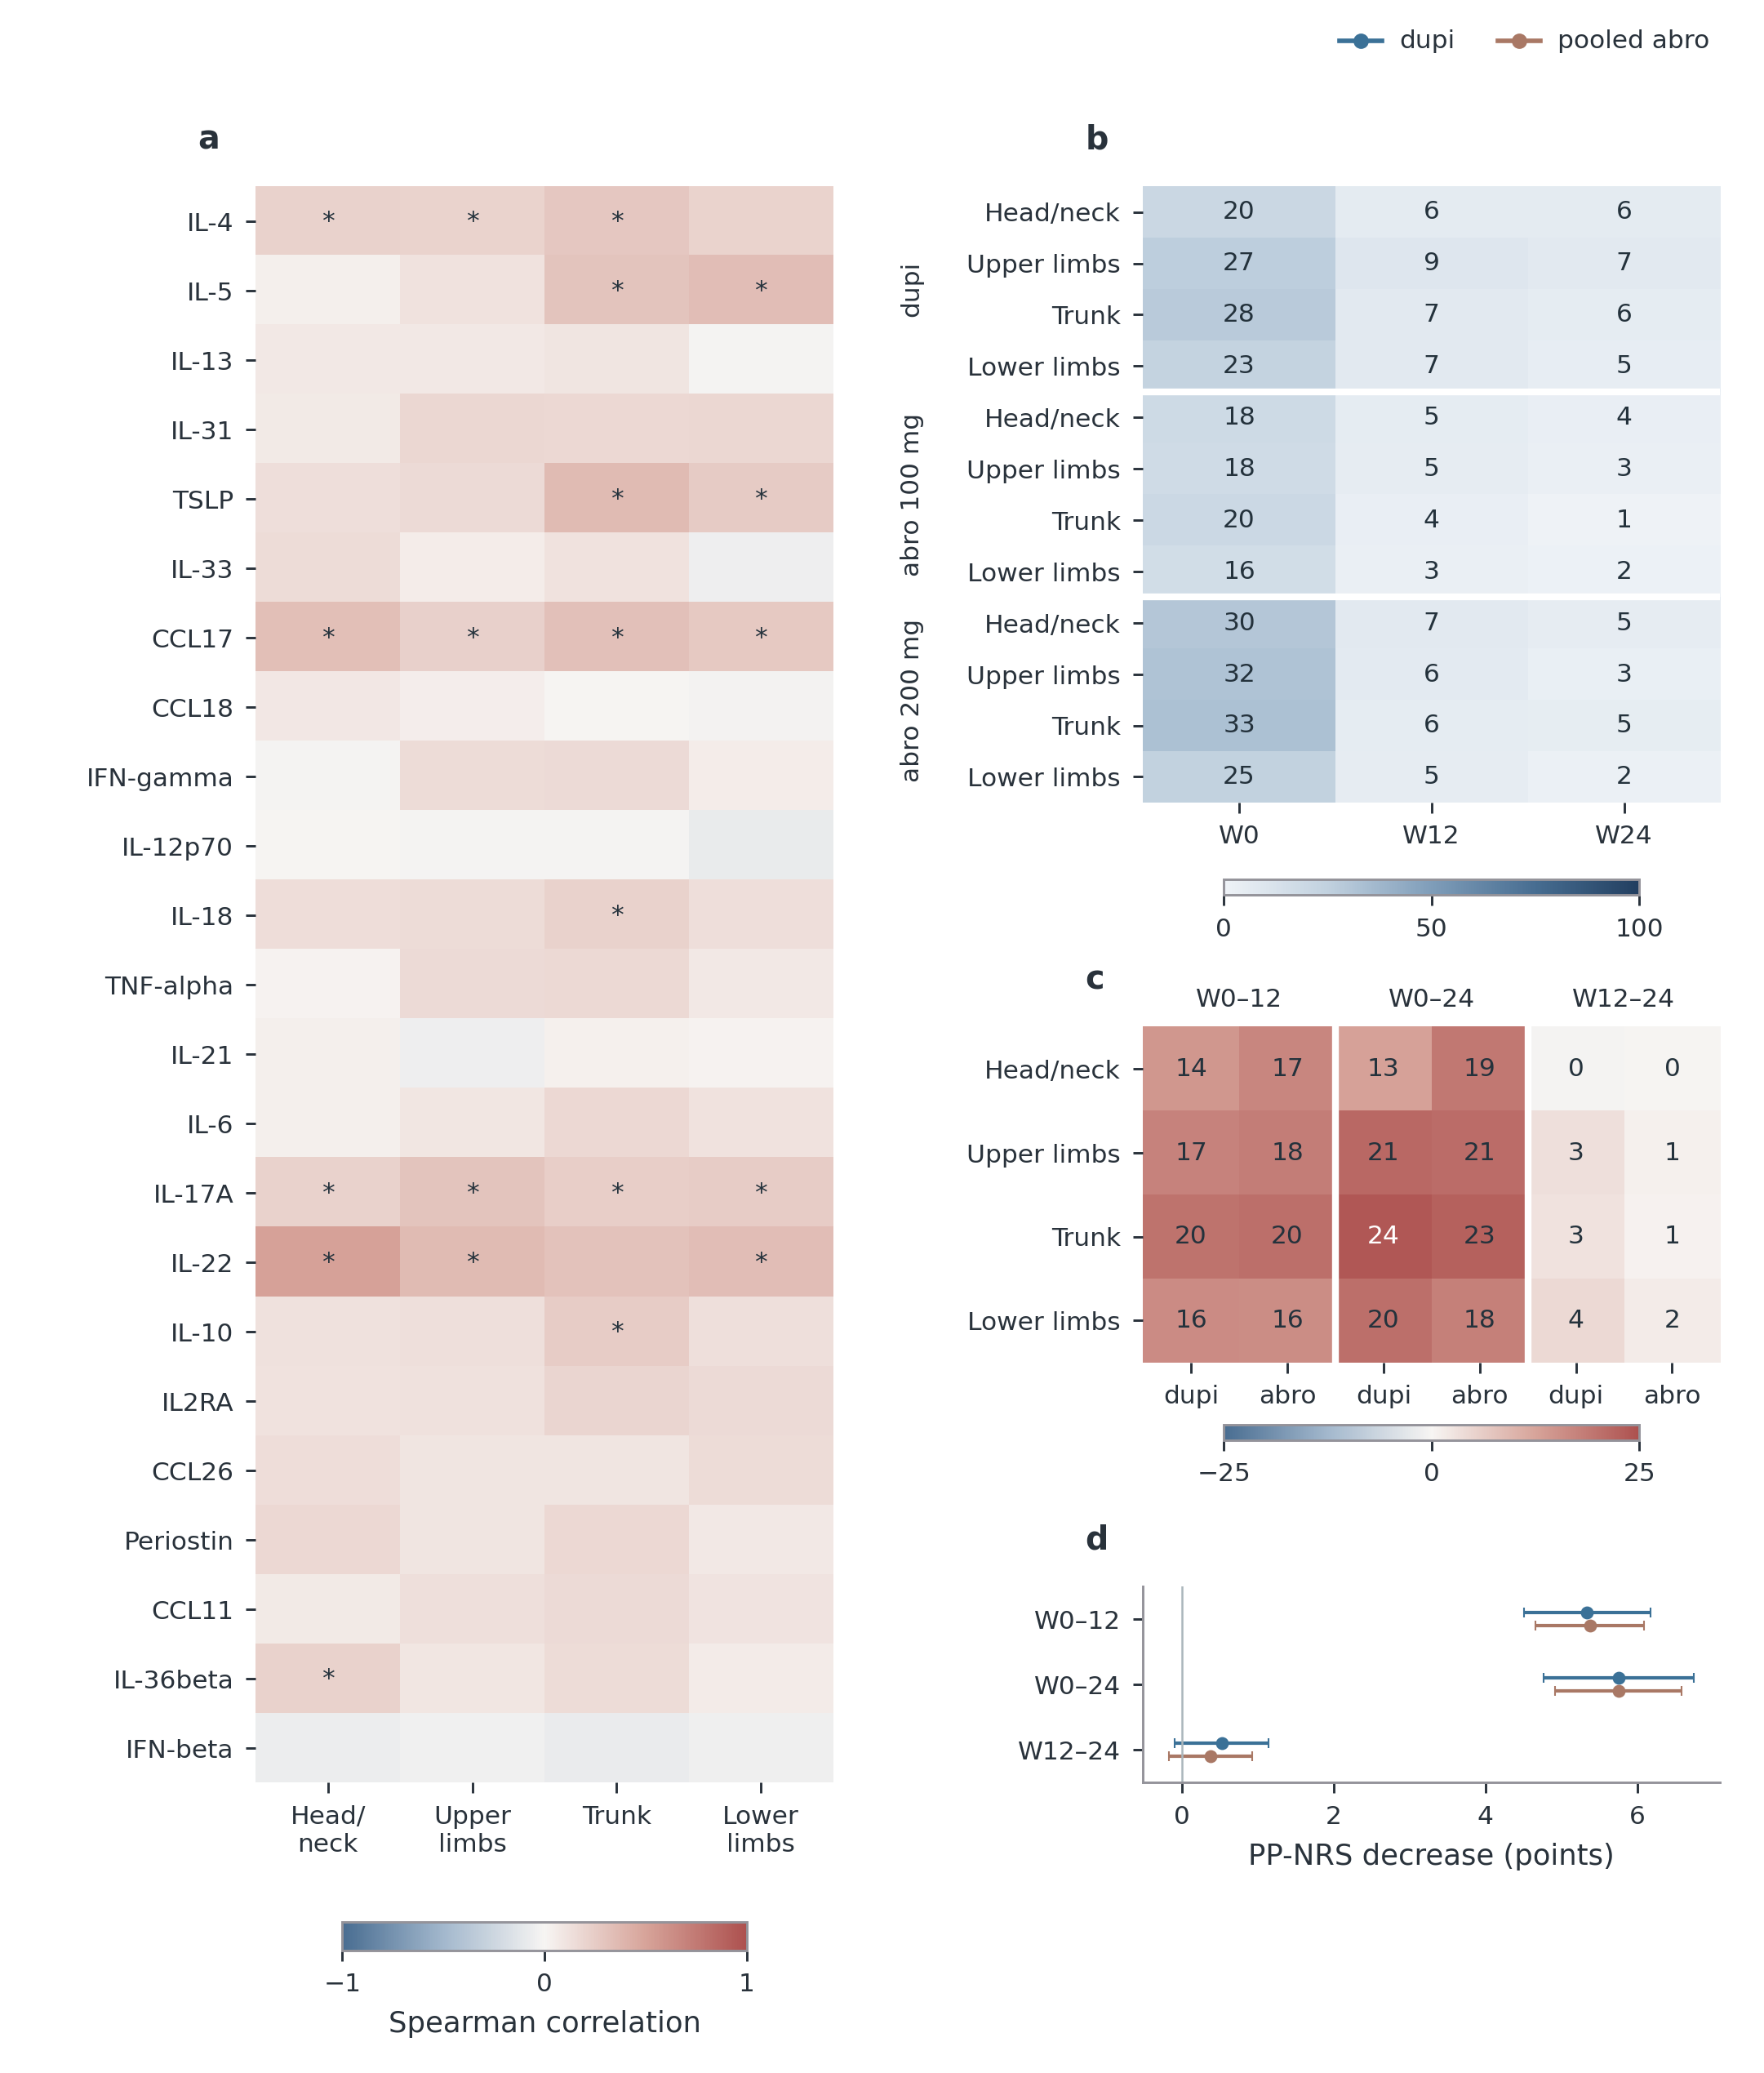
Figure S18. Regional clinical burden and molecular associations. a, Baseline Spearman associations between all 23 markers and the four regional EASI contributions; stars mark BH q<0.05, with complete coefficients, patient counts and bootstrap intervals retained in the source. b, Available-case mean regional EASI divided by its theoretical maximum and multiplied by 100; cells show percentages, not patient counts. c, Mean paired regional decrease as a percentage of the same regional maximum for three separately labelled intervals; positive values indicate improvement. The abro columns represent the observed pooled-dose mixture. These heatmaps summarize magnitude; exact 95% t intervals and counts are in the source tables. d, Whole-body PP-NRS mean decreases with 95% t intervals, not region-specific itch. Regional maxima are 7.2, 14.4, 21.6 and 28.8 for head/neck, upper limbs, trunk and lower limbs. All regional analyses require complete, bounded regional records consistent with total EASI. Intervals can share patients and are not successive cumulative effects. Colour bars encode distinct quantities and are not interchangeable. No baseline-adjusted regional treatment contrast passed the FDR threshold; full separate-dose comparisons remain available. Panel key: a, Baseline serum–region association; b, Regional burden (% of maximum); c, Paired decrease (% of maximum); d, Whole-body itch.
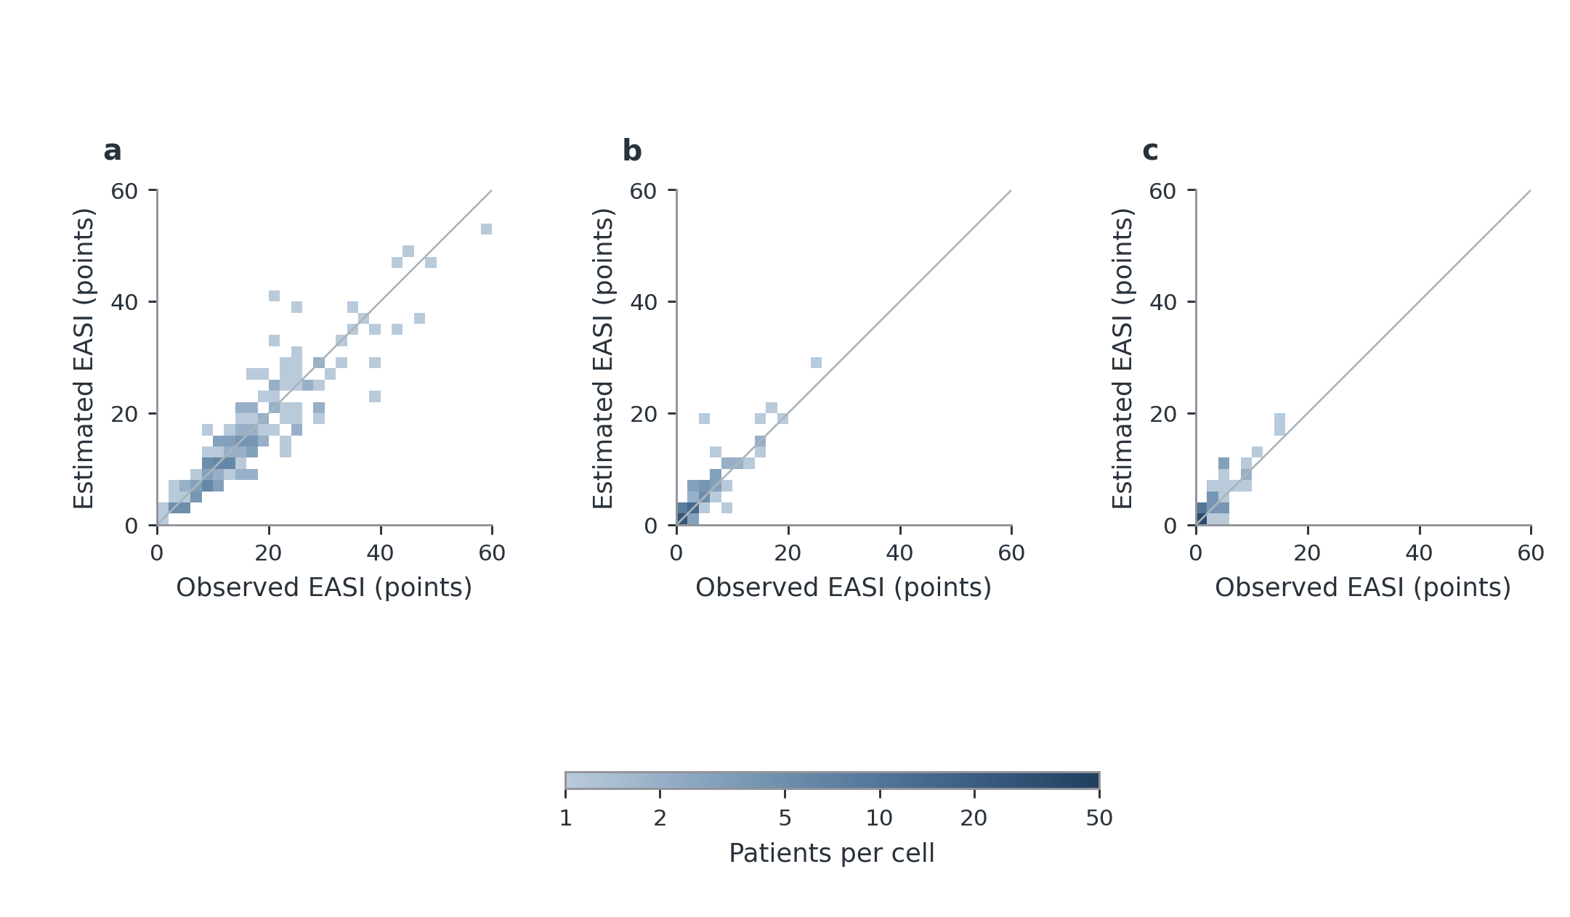
Figure S19. Observed and estimated EASI at each visit. a–c, Estimated versus observed EASI in the first patient-held-out repetition at W0/W12 and same-cohort temporal application at W24. Each fixed 2$×$2-EASI-point cell counts all exact score pairs within its boundaries. Colour gives patient count on one shared logarithmic scale; white cells contain no observations. All 152/89/75 eligible patients are retained. Identical axes preserve the severity-range comparison; grey diagonals denote exact agreement. W0/W12 use nested patient-level structure and penalty selection; earlier marker selection is not repeated. W24 had previously been inspected. These results assess the development procedure rather than independent validation of the final coefficient vector. Overall performance is in Table 2; the main figure displays the complete absolute-error distribution. Panel key: a, Week 0 · n=152; b, Week 12 · n=89; c, Week 24 · n=75.
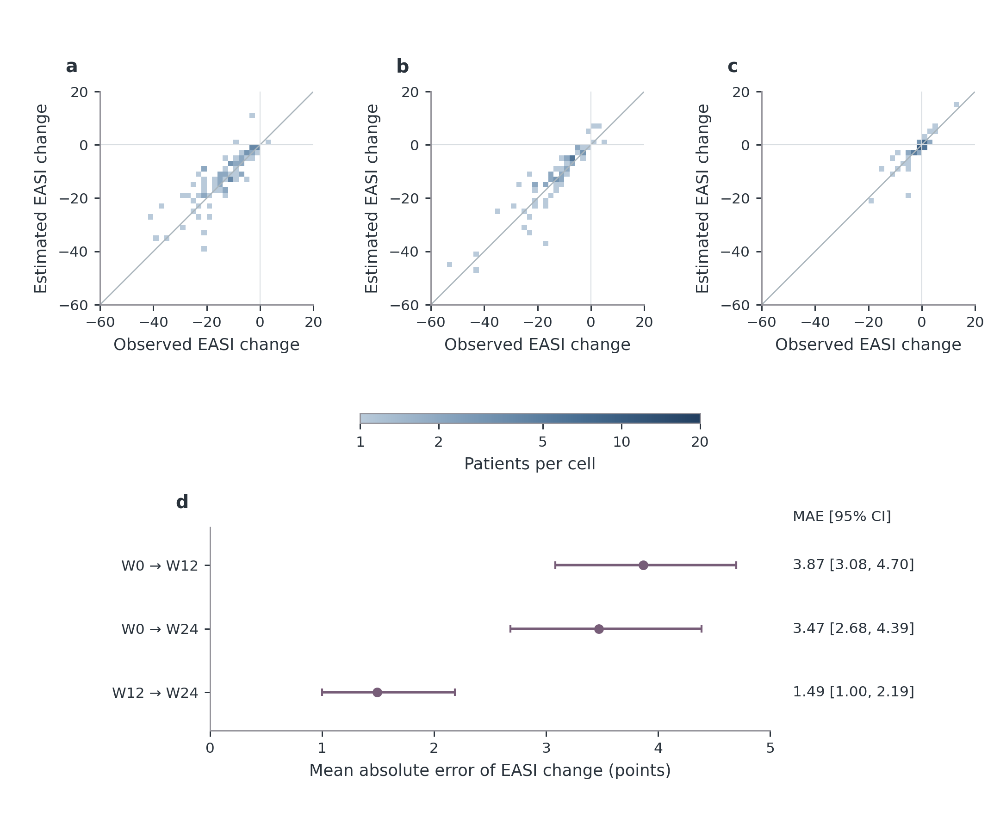
Figure S20. Within-patient EASI change and absolute error. a–c, Estimated versus observed EASI changes in the first patient-held-out repetition. Change is end minus start: negative values indicate improvement. Fixed 2$×$2-EASI-point cells count exact paired changes on one logarithmic count scale. Identical axes retain all 85, 67 and 55 pairs; the intervals can share patients and are not consecutive categories on a time axis. White cells contain no observations; diagonals mark exact agreement. d, Change MAE calculated within each of two repetitions before averaging, with 2,000 patient-bootstrap 95% confidence intervals conditional on saved predictions. Both scores are paired within each repetition before subtraction. W24 is previously inspected same-cohort temporal application. EASI75 classification is shown in the main model figure; complete EASI50/75/90 classifications are retained separately. Panel key: a, W0 $→$ W12 · n=85; b, W0 $→$ W24 · n=67; c, W12 $→$ W24 · n=55; d, Paired-change error.
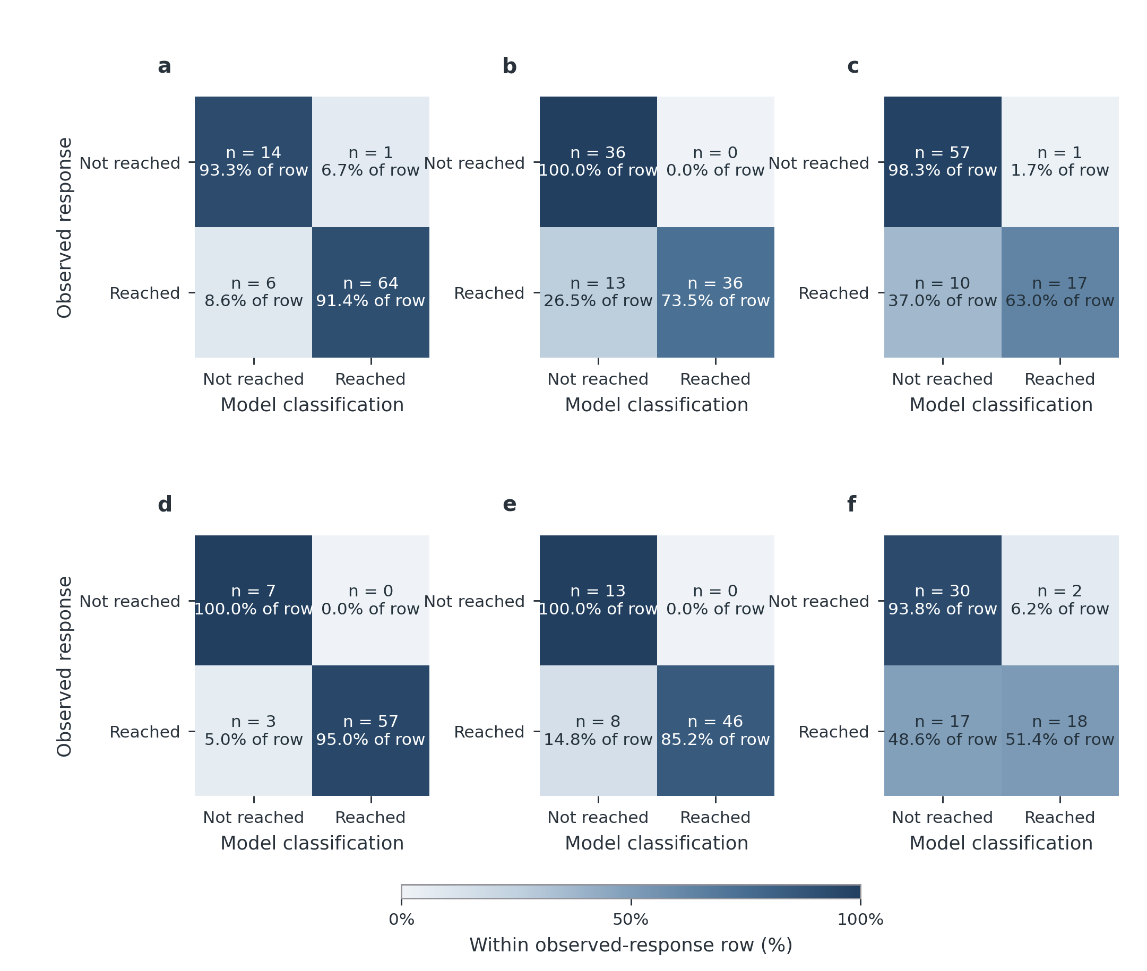
Figure S21. Classification of EASI50, EASI75 and EASI90 response. Each panel shows actual patient counts from the first outer repetition, separately for W0$→$W12 and W0$→$W24. Rows are observed response and columns model-estimated response. Diagonal cells are correct; upper-right cells falsely indicate response and lower-left cells miss an observed responder. Percentages are within each observed-response row, so the lower-right percentage is sensitivity and the upper-left percentage specificity. Observed response uses observed baseline/follow-up scores, whereas estimated response uses predicted baseline/follow-up scores. Counts are integers from one repetition, not the primary two-repetition average; the full metrics table retains the latter. The paired denominators are 85 and 67, with no excluded pair for invalid baseline in this displayed repetition. The two intervals can share patients. This assesses response classification, not alternative-treatment outcomes or continuous-score equivalence. Panel key: a, W0 $→$ W12 · EASI50 n=85 paired patients; b, W0 $→$ W12 · EASI75 n=85 paired patients; c, W0 $→$ W12 · EASI90 n=85 paired patients; d, W0 $→$ W24 · EASI50 n=67 paired patients; e, W0 $→$ W24 · EASI75 n=67 paired patients; f, W0 $→$ W24 · EASI90 n=67 paired patients.

Aggregate source tables
The machine-readable source-table index lists the complete aggregate collection, including unplotted and negative results. Figure-specific dependencies are in figure_catalog.json. The versioned aggregate directory includes clinical, molecular, model, regional, matched-input and missing-data sensitivity tables; restricted patient-level files are not part of the public collection.

References
1. Marjolein de Bruin-Weller et al. Treat-to-Target in Atopic Dermatitis: An International Consensus on a Set of Core Decision Points for Systemic Therapies. Acta Dermato-Venereologica, 101: adv00402, 2021. doi: 10.2340/00015555-3751.
2. Zuotao Zhao and Xinghua Gao. Expert recommendations on treat-to-target in the systemic treatment of moderate to severe atopic dermatitis. Chinese Journal of Dermatovenereology, 36 (8): 855–864, 2022. doi: 10.13735/j.cjdv.1001-7089.202205115. In Chinese; thresholds cross-checked against the authors’ 2026 clinical-trial analysis.
3. Zuotao Zhao, Xing-Hua Gao, Yangfeng Ding, Hong Liu, Stephan Weidinger, Selena Pan, Shiqi Li, Xin Luo, Claire Feeney, Melissa Watkins, and Meena Arumugam. Efficacy of Abrocitinib and Dupilumab in Adults with Moderate-to-Severe Atopic Dermatitis Using Treat-to-Target Goals Recommended by Experts in China. International Archives of Allergy and Immunology, 2026. doi: 10.1159/000550965. Published online 23 February 2026.
4. Jensen Yeung et al. Treat-to-target in the management of moderate-to-severe atopic dermatitis in adults: A canadian perspective. Journal of the American Academy of Dermatology, 89 (2): 372–375, 2023. doi: 10.1016/j.jaad.2023.01.053. URL https://pubmed.ncbi.nlm.nih.gov/37074241/.
5. Jonathan I. Silverberg et al. Combining treat-to-target principles and shared decision-making: International expert consensus-based recommendations with a novel concept for minimal disease activity criteria in atopic dermatitis. Journal of the European Academy of Dermatology and Venereology, 38 (11): 2139–2148, 2024. doi: 10.1111/jdv.20229. URL https://onlinelibrary.wiley.com/doi/10.1111/jdv.20229.
6. Maria Angeliki Gkini et al. Set targets, assess response, intervene early to achieve minimal disease activity in atopic dermatitis (STRIVE AD): A modified delphi consensus project to optimize management of atopic dermatitis in the united kingdom. JAAD International, 25: 56–68, 2026. doi: 10.1016/j.jdin.2025.11.028. URL https://pmc.ncbi.nlm.nih.gov/articles/PMC12873730/.
7. Joseph F. Merola et al. International Eczema Council Definitions of Low Disease Activity and Remission in Atopic Dermatitis: A Consensus Statement. JAMA Dermatology, 162: 631–639, 2026. doi: 10.1001/jamadermatol.2026.0662.
8. Fan Li and Fan Li. Propensity score weighting for causal inference with multiple treatments. The Annals of Applied Statistics, 13 (4): 2389–2415, 2019. doi: 10.1214/19-AOAS1282.
9. International Council for Harmonisation. E9(r1) addendum on estimands and sensitivity analysis in clinical trials, 2019. URL https://www.ema.europa.eu/en/documents/scientific-guideline/ich-e9-r1-addendum-estimands-and-sensitivity-analysis-clinical-trials-guideline-statistical-principles-clinical-trials-step-5_en.pdf. Accessed 2026-10-17.
10. Jesper Grønlund Holm, Guillem Hurault, Tove Agner, Maja Lisa Clausen, Sanja Kezic, Reiko J. Tanaka, and Simon Francis Thomsen. Immunoinflammatory biomarkers in serum are associated with disease severity in atopic dermatitis. Dermatology, 237 (4): 513–520, 2021. doi: 10.1159/000514503. URL https://pubmed.ncbi.nlm.nih.gov/33730733/.
11. S. Kagami, T. Kakinuma, H. Saeki, Y. Tsunemi, H. Fujita, K. Nakamura, T. Takekoshi, M. Kishimoto, H. Mitsui, H. Torii, M. Komine, A. Asahina, and K. Tamaki. Significant elevation of serum levels of eotaxin-3/CCL26, but not of eotaxin-2/CCL24, in patients with atopic dermatitis: serum eotaxin-3/CCL26 levels reflect the disease activity of atopic dermatitis. Clinical and Experimental Immunology, 134 (2): 309–313, 2003. doi: 10.1046/j.1365-2249.2003.02273.x. URL https://pmc.ncbi.nlm.nih.gov/articles/PMC1808865/.
12. J. Martin Bland and Douglas G. Altman. Agreement between methods of measurement with multiple observations per individual. Journal of Biopharmaceutical Statistics, 17: 571–582, 2007. doi: 10.1080/10543400701329422.
13. Judith L. Thijs et al. EASI p-EASI: Utilizing a combination of serum biomarkers offers an objective measurement tool for disease severity in atopic dermatitis patients. Journal of Allergy and Clinical Immunology, 140: 1703–1705, 2017. doi: 10.1016/j.jaci.2017.06.046.
14. Judith L. Thijs et al. EASI p-EASI: Predicting disease severity in atopic dermatitis patients treated with cyclosporin A. Allergy, 74: 613–617, 2019. doi: 10.1111/all.13651.
15. Daphne S. Bakker et al. EASI p-EASI: Predicting disease severity in atopic dermatitis patients treated with dupilumab using a combination of serum biomarkers. Allergy, 75: 3287–3289, 2020. doi: 10.1111/all.14492.
16. Erik von Elm et al. The Strengthening the Reporting of Observational Studies in Epidemiology (STROBE) statement: guidelines for reporting observational studies. PLoS Medicine, 4: e296, 2007. doi: 10.1371/journal.pmed.0040296.
17. Gary S. Collins et al. TRIPOD+AI statement: updated guidance for reporting clinical prediction models that use regression or machine learning methods. BMJ, 385: e078378, 2024. doi: 10.1136/bmj-2023-078378.
18. Karel G. M. Moons et al. PROBAST+AI: an updated quality, risk of bias, and applicability assessment tool for prediction models using regression or artificial intelligence methods. BMJ, 388: e082505, 2025. doi: 10.1136/bmj-2024-082505.
19. Michael E. Wechsler et al. Effect of dupilumab on blood eosinophil counts in patients with asthma, chronic rhinosinusitis with nasal polyps, atopic dermatitis, or eosinophilic esophagitis. Journal of Allergy and Clinical Immunology: In Practice, 10 (10): 2695–2709, 2022. doi: 10.1016/j.jaip.2022.05.019.
20. Jonathan A. C. Sterne, Ian R. White, John B. Carlin, Michael Spratt, Patrick Royston, Michael G. Kenward, Angela M. Wood, and James R. Carpenter. Multiple imputation for missing data in epidemiological and clinical research: potential and pitfalls. BMJ, 338: b2393, 2009. doi: 10.1136/bmj.b2393.
21. Rushani Wijesuriya, Margarita Moreno-Betancur, John B. Carlin, Ian R. White, Matteo Quartagno, and Katherine J. Lee. Multiple imputation for longitudinal data: A tutorial. Statistics in Medicine, 44 (3-4): e10274, 2025. doi: 10.1002/sim.10274.
22. Y. Wu et al. Serum biomarker-based endotypes of atopic dermatitis in China and prediction for efficacy of dupilumab. British Journal of Dermatology, 188: 649–660, 2023. doi: 10.1093/bjd/ljad032.

