University of Waterloo
Faculty of System Design Engineering

SYDE 730: Societal-Environmental Systems
Term Project

Sea Ice and Open Water SAR Images Classification Using Convolutional Neural Networks

Yan Xu
20676702

December 13, 2016

Contents

1. Introduction 3
1.1 Background 3
1.2 Purposes 4
2. The Dataset 4
2.1 SAR Images 4
2.2 Image analysis charts 5
2.3 Patches 6
3. Method 6
3.1 Preprocessing 6
3.2 Feature Extraction and Classification Method 9
4. Results 11
5. Discussion 16
6. Conclusion 17
7. References 17

1. Introduction

1.1 Background
Mapping sea ice and open water in oceans has many significant purposes, including weather forecasting, natural-resource extraction, and ship navigation. The accurate and real-time classification of sea ice and open water is in high demand. With the continuous advancements and developments in satellite science, a great number of synthetic aperture radar (SAR) images are available now, which facilitate the analysis of ocean conditions. SAR images, with their high spatial resolution, are different from common images. It is more complicated to interpret SAR images since the interactions between SARs and sea ice are affected by various factors, including the frequencies and incidence angles of SAR signals, and the surface conditions of sea ice. The Canadian Ice Service (CIS) has stipulated a need for an automated ice-water discrimination algorithm using dual-polarization images produced by RADARSAT-2[7]. Due to the lack of suitable algorithms for automatic ice concentration estimation from SAR images, SAR images with ancillary data are manually interpreted by human experts working in government agencies to produce operational ice charts [1]. It is obvious that there are several errors in the ice charts because of experts' subjectivities and inexperience. Thus, these inaccurate image analysis charts might bring challenges to the classification of sea ice and open water.

However, Convolutional networks (ConvNets) have recently enjoyed a great success in large-scale image and video recognition, and convolutional neural networks(CNNs) have been becoming increasingly popular in many research communities due to the available large-image datasets and the high-performance computing systems, such as GPUs or large-scale distributed clusters. A CNN is neural network model that enforces weight sharing and local connections between adjacent layers of neurons. A successful application of CNNs is image classification, for example, AlexNet, ZFNet, VGGNet, GoogLeNet, and ResNet are the ImageNet challenge winning ConvNets in recent years,

1.2 Purposes
The target of this project is to find a method to improve the performance of sea ice and open water classification. As ConvNets achieved such a great success on image classification tasks. We suppose that using a large number of labelled SAR patch images as inputs of CNN to classify sea ice and open water can provide more robust and accurate estimation results.

2. The Dataset

2.1 SAR Images
The image dataset we developed for training and testing consists of 25 scenes from the SAR satellite, each scene has images in HH (horizontal transmit polarization, vertical receive polarization) and HV(horizontal transmit polarization, horizontal receive polarization) polarizations and incidence angles. The available SAR images are captured from Gulf of St. Lawrence in the period of January 16, 2014 to February 10, 2014, and the dataset is provided by Canadian Ice Service (CIS), which is part of Environment and Climate Change Canada (ECCC). As showed in Figure 1, these files are the source files that we used in all the experiments.
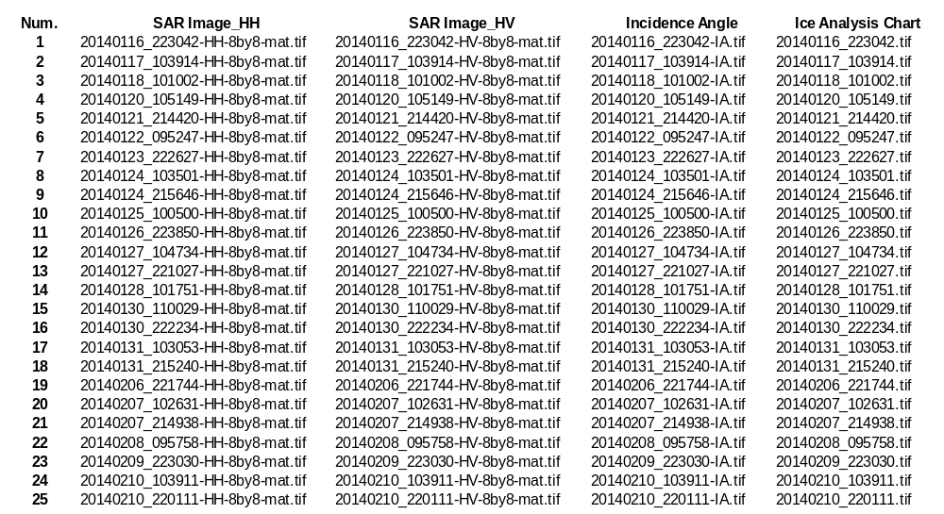
Figure 1: Source files

2.2 Image analysis charts
A very necessary tool for this project is image analysis charts, which are ice maps produced by ice experts from CIS through visual interpretation of SAR images [1]. Ice charts are considered to be the most reliable ice concentration product available. However, it is obvious that there are several errors existing in the ice charts because of experts' subjectivities and inexperience, the precision of analysis images’ice concentration is normally considered to be approximately 10%. The ice concentration of image analysis charts is in the range of 0 to 11, the number 11 represents land, and the numbers between 0 and 10 represent the percentages of ice concentration.

2.3 Patches
Image patches, with size of 45*45*3, are extracted from those files as shown in Figure 1 from each scene, We obtained 23014 patches in total after discarding land contaminated patches, and those patches are divided into two part: training set (18918) and testing set (4096). The method for extracting image patches are presented in the following section.

3. Method

3.1 Preprocessing
SAR images are corrupted with significant multiplicative speckle noise due to the coherent nature of the imaging process. Besides, the images are sensitive to the incidence angle resulting in statistical non-stationarities across scenes. Ice types and water often have tremendous within class variability both within and across scenes and have highly nonlinear backscatter signatures [7]. In order to eliminate the influence of noise and reduce the data volume, all the SAR images are sub-sampled by 8 × 8 block averaging, and this reduction in pixels count by a factor of 64. The input of the CNN model that we used for this project requires 3 dimensional data, such as image data with 3 colour channels (RGB). Therefore, obtaining 3 dimensional data as inputs of the CNN is necessary. The SAR in HH polarization scene, the SAR in HV polarizations scene, and the incidence angle combined together to generate 3 channels’ data is a reasonable way to interpret SAR image. These 3 dimensional data contain more detailed information than one dimension data, and each channel has its unique features. An example scene of these three channels from our dataset is shown in Figure 2. This scene was captured on Jan.17, 2014.
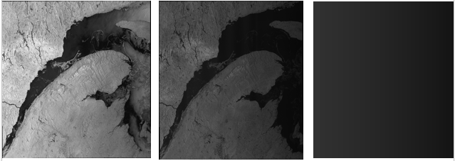
Figure 2: The SAR Image in HH plo., SAR Image in HV pol. and Incidence Angle derived from 20140117(Scene ID: 103914). Left: HH pol. Middle: HV pol. Right: Incidence Angle

The ice concentration values in image analysis charts is in the range of 0 to 11, the number 11 represents land. We only need to classify two classes (sea ice and open water) for this specific project, Therefore, we made empirical definitions by ourselves. We suppose that sea ice refers to the ice concentration greater than 3, while open water refers to ice concentration less than 3.

The method for extracting patches is to extract one patch every 20 points (stride=20) and record the central points’ ice concentration value of patches at the same time. These values are the labels for the patches. We define that the label of a patch is its central points' ice concentration value. Since the image analysis charts contain information of land, we need to eliminate the influence of land because we are only interested in ocean conditions, i.e., sea ice and open water. We abandoned all the patches which contain lands, even those patches contain only one points of land are not used as the dataset of the experiments. Several patches are showed in Figure 2
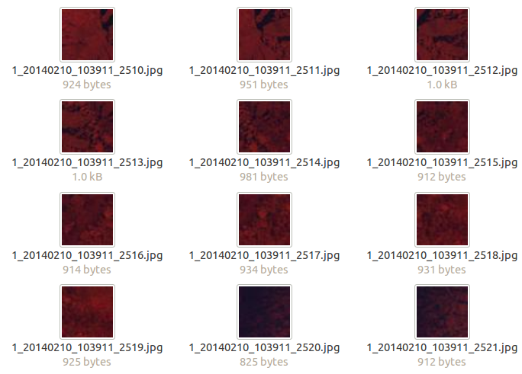

Figure 3: Patches Visualization

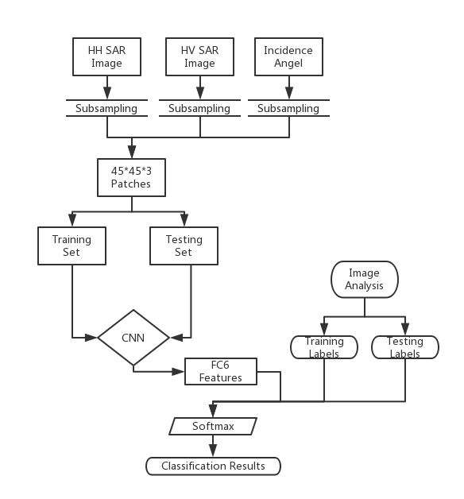
Figure 4: Flowchart of Method

The main method of this project are showed in Figure 4. This method consists of three steps: preprocessing, feature extraction, and classification.

3.2 Feature Extraction and Classification Method
In this project, we classify patch images with the bundled CaffeNet model, which based on the network architecture of Krizhevsky et al. for ImageNet called AlexNet. Generally, this is a transfer learning method with CNNs, we treat AlexNet as fixed feature extractor and fix all weights, and then retrain only the classifier, which is Softmax in this project. We split SAR image patches into two groups: a training set and a testing set. After being preprocessed, a large number of labelled patch images are regarded as inputs of the CNN. The CNN can learn image features automatically and then extract features from the sixth fully-connected layer, and then we used Softmax classifier to estimate the labels of the testing set. In this way, sea ice and open water can be classified. The classification accuracy can be determined by comparing the estimation results to the labels of the testing set. Figure 5 shows the architecture of ConvNet used.
Inputs:
Image Patches

CONV1
Parts of AlexNet
Features
MAX POOL1
NORM1
CONV2
MAX POOL2
NORM2
CONV3
CONV4
CONV5
MAX POOL3
FC6(4096 neurons)
SOFTMAX

Outputs:
Classification Results

Figure 5: Architecture of the Convolutional Neuron Network

4. Results
We used 20 scenes (from 20140116_223042 to 20140207_102631) for training and 5 scenes(from 20140207_214938 to 20140210_220111) for testing, The classification results that we obtained is quite good with 96.647%classification accuracy. The classification accuracies for different scenes are shown in the Table 1.
Table 1

Scene Num. | Test Patches N. | Classification Accuracy
20140207_214938 | 86 | 86.047%
20140208_095758 | 2204 | 97.096%
20140209_223030 | 60 | 88.333%
20140210_103911 | 380 | 98.684%
20140210_220111 | 1893 | 96.355%
Total | 4623 | 96.690%

As we do not have one patch for each point in the image analysis chart. We map 45*45 SAR image patches to its corresponding 45*45 ice charts regions with stride 20. Therefore, we only predict some points in image analysis charts instead of all of them. The reason why the predicted image has several squares and looks blocky is that we only classify the central points of 45*45 patches, i.e., when we produce a prediction image, we filled the labels of 45*45 regions by using the central points' labels. The
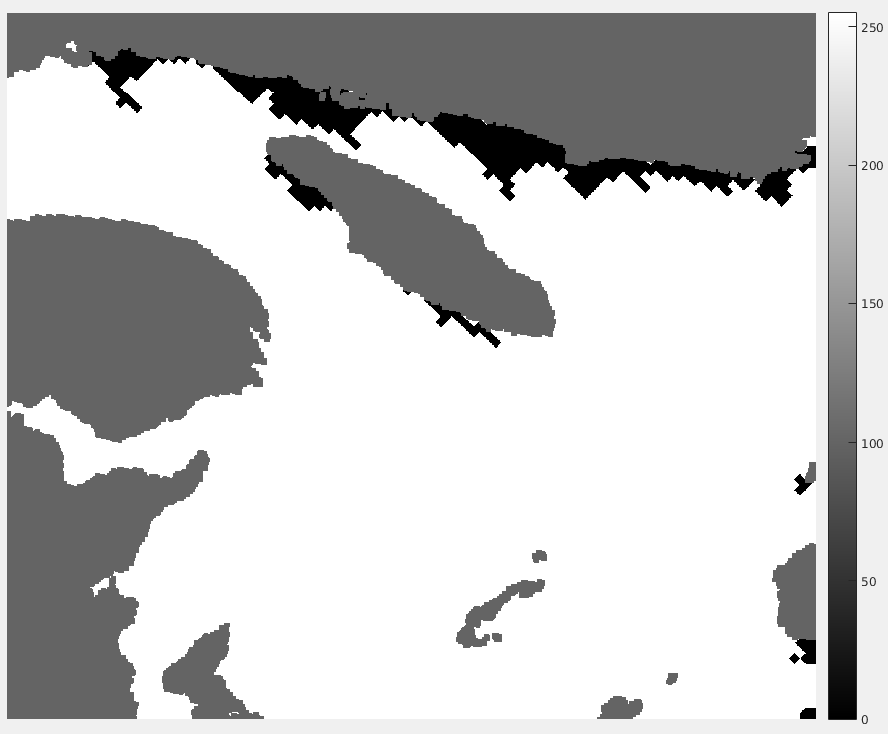
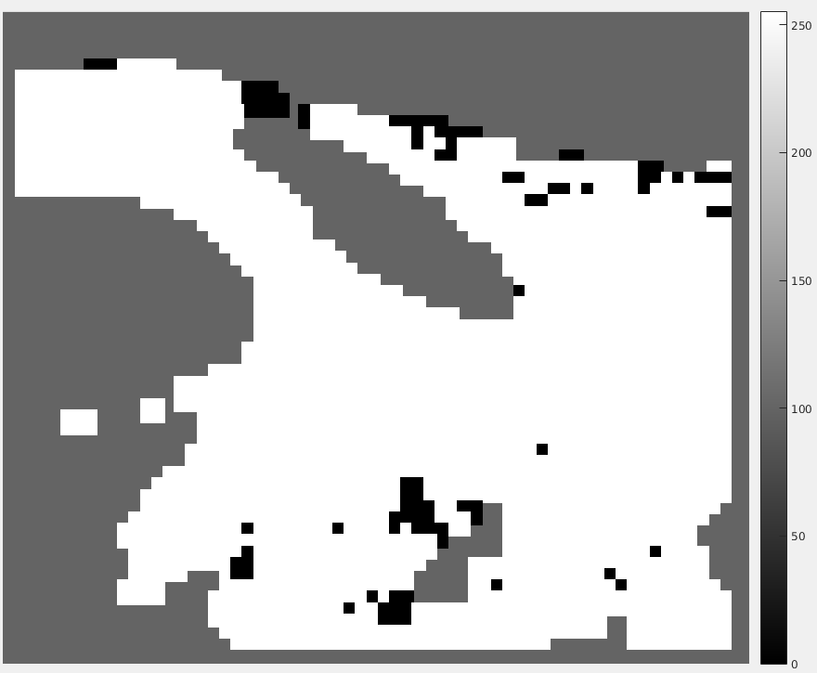
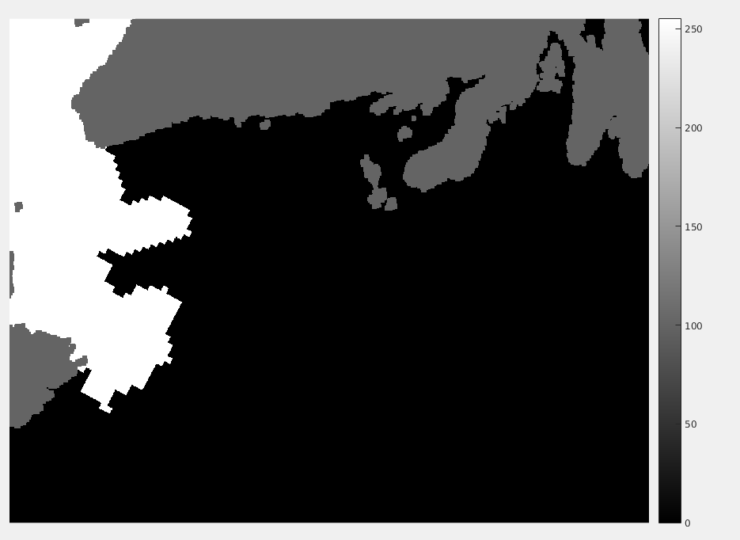
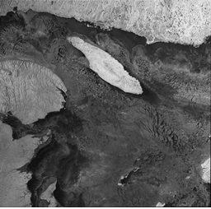
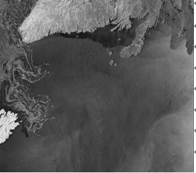
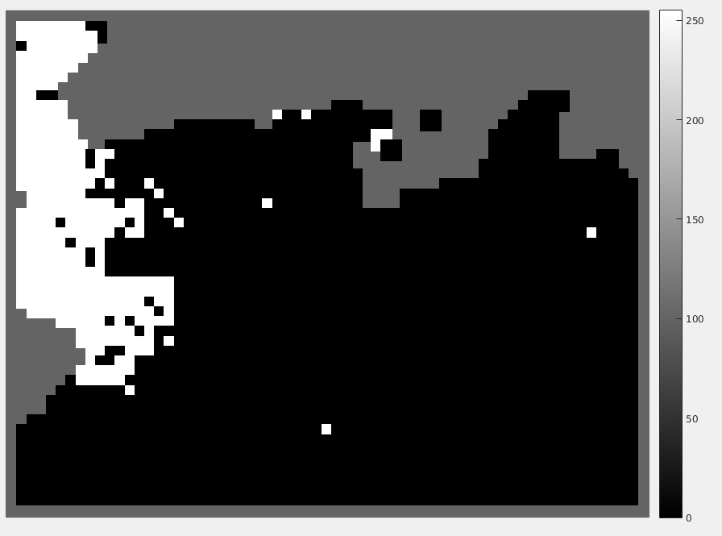

Figure 4: Figure 4 shows the differences for the February 8th and February 10th scenes (Right: February 8th, Left: February 10th). The first row are SAR images in HH pol., the middle row are the prediction images, the third row are the image analysis charts. ((Black: Water, White: Ice, Grey: unclassified. Pixels on land or near land, near image borders, or on image region boundaries are not classified).

Moreover, pixels near boarders are unclassified as well because we cannot extract 45*45*45 patches in these regions, and several pixels near land are unclassified as well due to land contamination, for example, if we extract 45*45*3 patches using these points as center points, the possibilities of these patches containing land points are very high, then we discard these patches.

In order to obtain the predicted labels for every points in image analysis charts, we changed the method of extracting patches that we used before, for every points in image analysis charts, we find 45*45*3 patches for them, i.e., stride equals to one. As deadline is approaching and extracting a lot of patches is time-consuming. We do not have enough time to obtain that patches for every scene. Therefore, we only obtained patches for one scene (20140210_103911), there are 150968 patches in total. The classification accuracies are shown in the Table 2
Table 2

Ice Classification Accuracy | Water Classification Accuracy | Classification Accuracy
77.32% | 99.24% | 98.47%

To illustrate table 2, 77.32% of the points identified as ice in the image analysis charts are classified correctly, 99% of the points identified as water in the image analysis charts are classified correctly. The SAR images we have are over the ice growth season, so there is a significant difference between what the ice looks like on Jan 17 and what it looks like on Feb 10. Therefore, we use more water patches sample patches as training data, which might be a reason why the water classification accuracy is higher than that of ice. Another reason might be in the testing scene, there are a lot of ice points while water points are not too many, so ice classification tend to be wrong, The SAR image, the predicted labels, and the image analysis chart are shown in Figure 5.
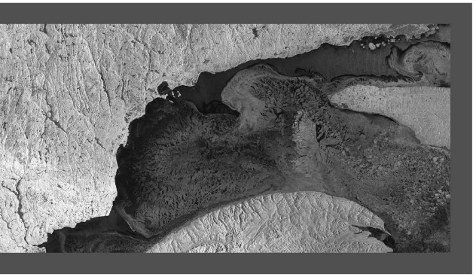

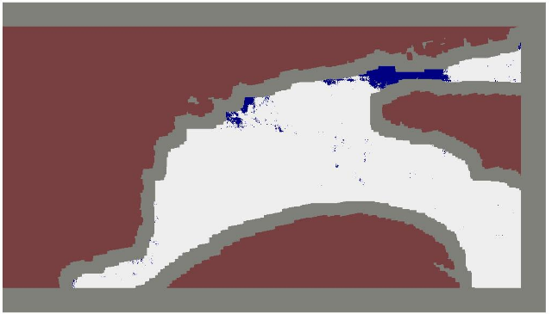

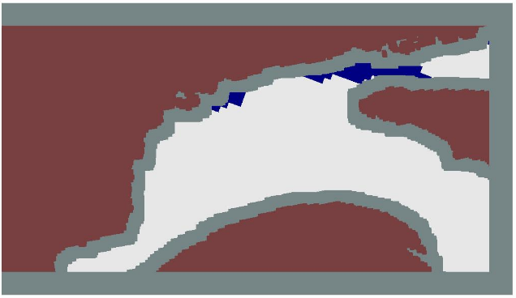

Figure 5: Figure 5 shows the results of the second method of extracting patches. Top: SAR image in HH pol of 20140210(Scene number: 103911). Middle: the results of labels prediction. Bottom: Image analysis charts. (Black: Water, White: Ice, Brown: Land, Grey: unclassified. Pixels on land or near land, near image borders, or on image region boundaries are not classified).

Compared to the image analysis charts, this prediction are insufficient, because a lot of points near land and near image borders are unclassified, which might be a concern if we want these kind of information. Several ice points that are identified as ice in image analysis charts are classified as water, this is quite tricky because it is possible that the image analysis chart might misidentified these points and it is also possible that our method misclassified these points.

5. Discussion
At the patch extraction process, the stride is an important hyper-parameter which can influence the classification accuracy and the resolution of prediction images. Moreover, small stride setting can results in patches overlapping. This might be a concern because those patches contain repetitive and redundant information. Besides, one of the most significant prerequisites for ensuring the best performance of the CNN is considerably large training data set. However, it is not easy to collect such a SAR image data set, we only have 20 scenes, so the accuracy of classification results remain restricted. As the ConvNet has 60 million parameters, while this experience only has small number of patches for training. This therefore turns out to be insufficient to learn so many parameters without considerable overfitting. Here below are two primary methods to combat overfitting that we can look into in the future work.
• Data Augmentation
The easiest and most common way to reduce overfitting on image data is to artificially enlarge the dataset using label-preserving transformation.
• Dropout
The recently-introduced technique, called dropout, consists of setting to zero the output of each hidden neuron with probability of 50%. The neuron which are “dropped out” in this way do not contribute to the forward pass and do not participated in back-propagation. So every time an input is presented, the neural network samples a different architecture, but all architectures share weights. This technique reduces complex co-adaptions of neurons, since a neuron cannot rely on the presence of particular other neurons. Therefore, it is forced to learn more robust features that are useful in conjunction with many different random subset of the other neurons. At test time, we can use all the neurons but multiply their output by 0.5, which is a reasonable approximation to taking the geometric mean of the predictive distributions produced by the exponential overfitting[5]. Besides, How to predict the labels for points near land is an aspect to consider as well.

6. Conclusion

Overall, this project applied a new method of sea ice and open water classification and achieved a good classification accuracy. However, the method that this project presented still has many possibilities to improve the performance.

7. References
[1] Lei Wang, K. Andrea Scott, Linlin Xu, and David A. Clausi, “Sea Ice Concentration Estimation During Melt From Dual-Pol SAR Scenes Using Deep Convolutional Neural Networks: A Case Study,” IEEE Geosci. Remote Sens. Lett., vol. 54, no. 8, pp. 4524–4533, Aug. 2016.
[2] Jianwei Ma and Gerlind Plonka, “The Curvelet Transform,” IEEE signal processing magazine, pp. 118-133, March 2010.
[3] Thorsten Markus and Donald J. Cavalierl, “The AMSR-E NT2 sea ice concentration algorithm: its basis and implementation,” Journal of the Remote Sensing Society of Japan, vol. 29, no. 1, pp. 216-225, 2009.
[4] K.A. Scott, M. Buehner. A. Caya and T. Carrieres, “Direct assimilation of AMSR-E brightness temperatures to estimate sea ice concentration,” Monthly Weather Review, vol. 140, pp. 997-1013, 2012.
[5]Alex Krizhevsky, Nya Sutskever, Geoffrey E. Hinton, “ImageNet Classification with Deep Convolutional Neural Networks,” In NIPS, pp. 1106–1114, 2012.
[6]Karen Simonyan and Andrew Zisserman, “Very Deep Convolutional Networks for Large-Scale Image Recognition,” In ICLR, 2015.
[7]Steven Leigh, Zhijie Wang, and David A. Clausi, “Automated Ice-Water Classification Using Dual Polarization SAR Satellite Imagery.”

