01 Bienville Capital Management
http://www.bienvillecapital.com/


02 La Moulade - Creative Studio
http://lamoulade.com/#!/services
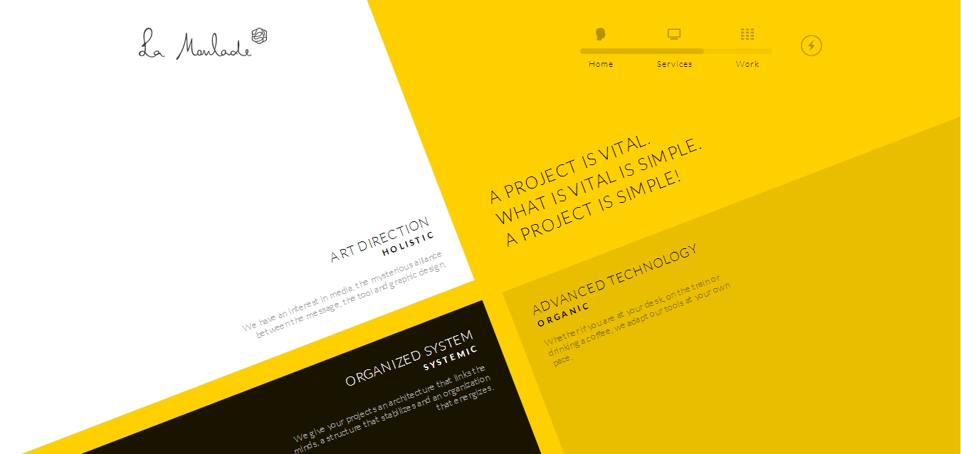

03 Whiteboard
http://whiteboard.is/


04 Mahedine Yahia
http://www.mahedineyahia.fr/


- Tool of North America
http://toolofna.com/#!/home
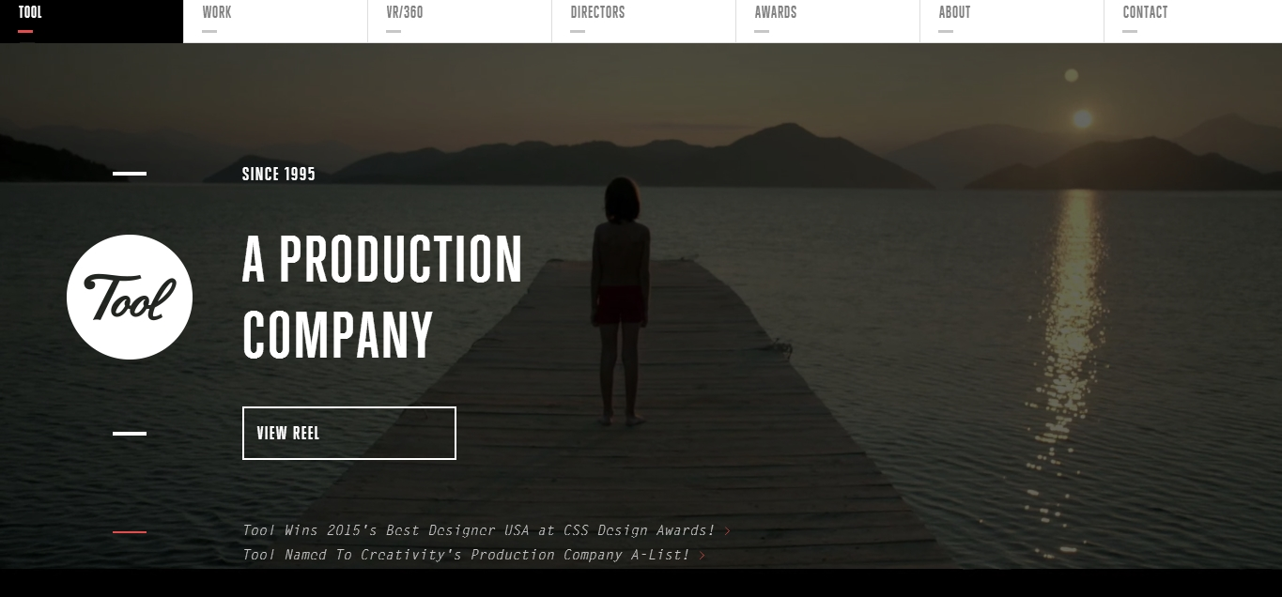

- Sketchin
http://www.sketchin.ch/en/
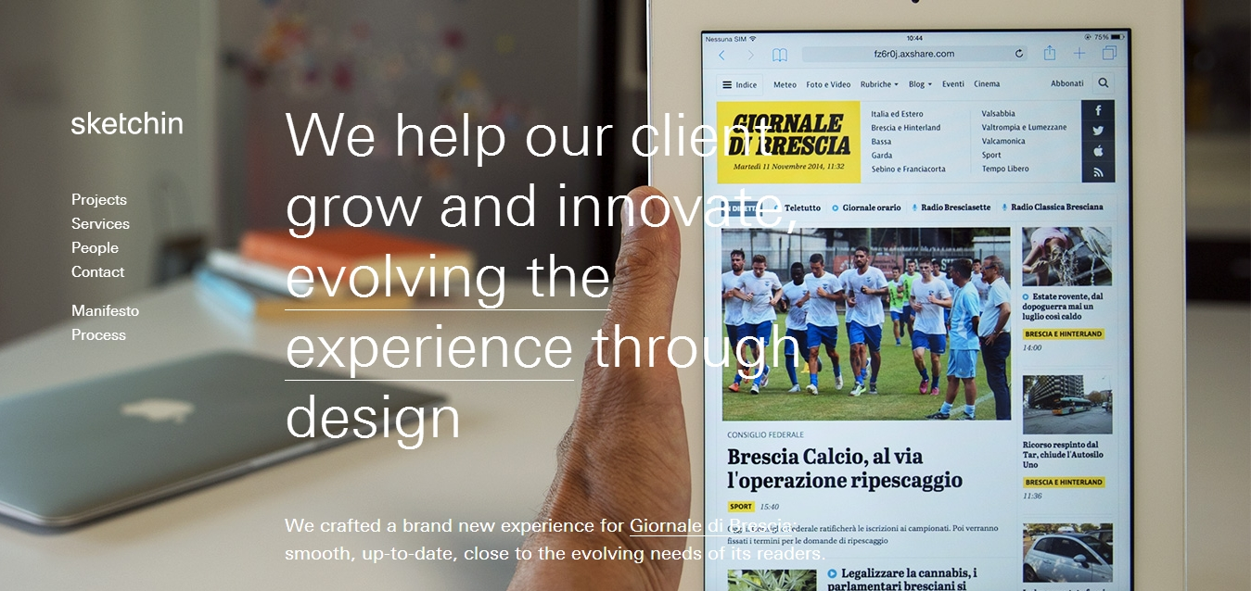

- Wink TTD
http://winkttd.es/#


- Life of Pi
http://journey.lifeofpimovie.com/#!/


- PLONGEON
http://www.lecoldeclaudine.com


- Antro
http://www.antro.ca/en/
