# Investigation of Housing Price to District Amenities in Central London Coursera Capstone Project Final Report

### Introduction

Central London has seen its real estate prices constantly rise since 1995 with only minor correction during this timeframe. It is therefore increasingly more difficult for young professionals to afford mortgages to buy properties to get onto the property ladder. This situation thus increases the amount of time these people will be renting in properties that are farther away from their workspace hence increasing daily commute time and stress. The following report aims to investigate the rise in housing prices in central London against the spur of local amenities by district. The objective is to provide a quantitative analysis of districts wherein housing price are undervalued compared to other similar districts with a similar amenities density. The typical target audience for this report are:

* Young professional buyers working in central London
* Investors looking for a good investment in central London
* Businesses looking for opportunities to open new shops in London
* Advertisement agencies looking for promotion opportunities

### Business Problem

The rising price of real estate in central London is straining potential young first time buyers to look for properties farther away from their typical workplace in central London increasing their commute time and stress. Also the rising prices are making increasingly more difficult for investors to find properties with a good ROI making the decision of whether to buy or hold onto the capital more blurred than in the past. Small businesses are also finding increasingly more difficult renting and opening shops in high street venues, thus pushing these farther away from ideal hotspots where their customers might be. The following report aims to narrow the problem of property search by identifying districts housing prices which are undervalued compared to the average housing price in other parts of the city using different metrics such as: local amenity density, local restaurant density, multi-ethnical restaurant density and office amenity density.

The main objective of this report is to provide an analysis to the correlation of prices with respect to the above metrics to make a more informed investment decision.

*Disclaimer: All suggestions and results shown in this report are purely informative and is by no means an actionable investment opportunity more detailed analysis is required. The author takes no responsibility in any loss from investment decision from the following paper. Have a good read.*

### Data Description

* Location data of local amenities in London is obtained from the [Foursquare API sandbox](https://developer.foursquare.com/). This will be used to retrieve data regarding the most frequent and popular amenities by type for each neighbourhood and use this data to train the machine learning algorithm.
* Housing Data index will be scraped from the [London Datastore](https://data.london.gov.uk/) and other sources affiliated regarding housing price data and district boundaries coordinates.
* Price data is web-scraped from Foxton public available data in London and used to assign market value price data to each of the neighbourhoods in London.
* London postcodes and neighbourhood data has been web-scraped from the [wikipedia page](https://www.wikiwand.com/en/London_postal_district), this will be used to identify and categorise each neighbourhood in London.

### Methodology

#### 4.1 Data Engineering and Understanding

The project will make use of the data described in section 3. Firstly the district data has been imported from the wikipedia page and went through a subsequent process of data cleaning and engineering to put in a pandas dataframe such that information is correctly labelled and ready to use.

The Foxton median price data has then been added to the original postcodes and neighbourhoods dataframe which enabled early visualization analysis of the current housing market situation in London. Figure 1 below shows the price distribution of all neighbourhoods in London from the most expensive to the least, the neighbourhood name is not as important as identifying a clear trend. From figure 1 we can assume that each neighbourhood is part of a price category which we can arbitrary define by identify where there is a step change in housing median price.

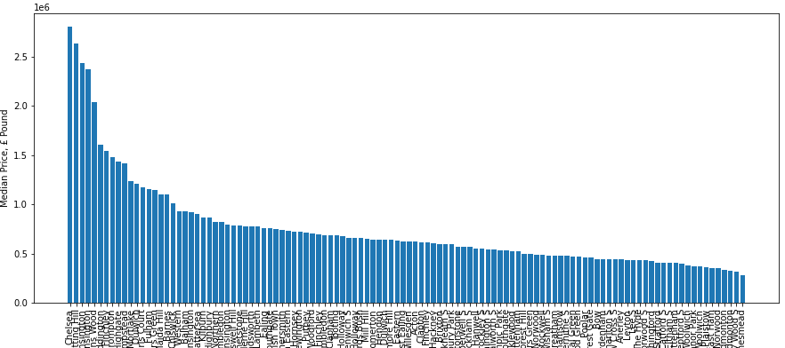

Figure 1 Median housing price distribution across all neighbourhoods in London

As an initial iteration the market price categories have been identified to be the following:

* Very High Valued Neighbourhoods > £1,600,000
* High Valued Neighbourhoods > £1,000,000
* Medium Valued Neighbourhoods > £600,000
* Low Valued Neighbourhood < £600,000

To better visualise this we can plot this price ranges onto the median price distribution to obtain Figure 2 below.

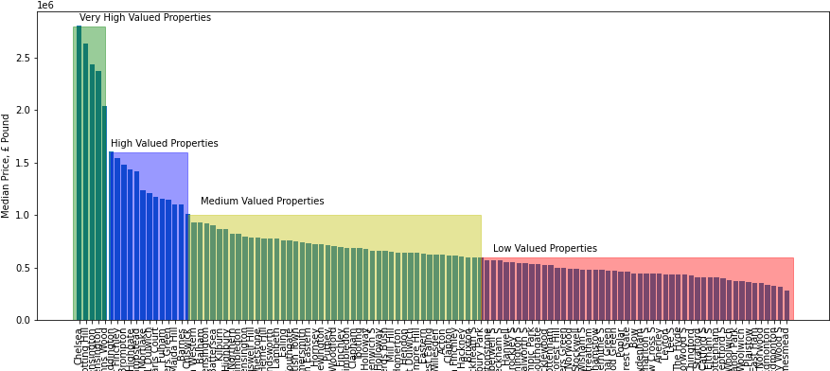

Figure 2 Market price category plotted on top of the neighbourhood price distribution

The above market price categorization is arbitrary and based by inspection on price step change in the distribution. Future work can improve on this categorization by taking into account neighbourhood location data and to improve on the estimation.

#### 4.2 Foursquare API Amenities location retrieval

The foursquare api have been used to return 100 amenities for each neighbourhood given its coordinates in latitude and longitude. The api then return the amenities and the notebook will then categorize them and return the 10 most frequent amenities for each neighbourhood as shown in Figure 3 below.

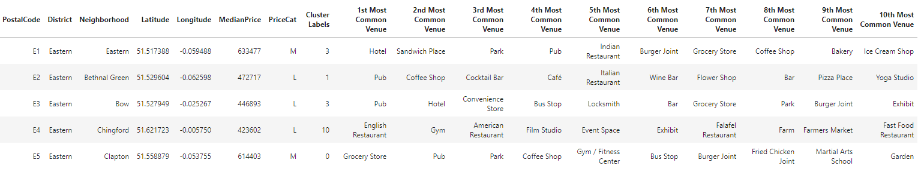

Figure 3 Pandas Dataframe showing cleaned data with top 10 most frequent amenities per neighbourhood

#### 4.3 Clustering and K-Mean Algorithm

The goal here is to predict the price category of each neighbourhood based on the local amenity density and type and compare it against the market price category and see whether our prediction confirm the market or whether it detects any change.

We will be using the K-means supervised learning algorithm to cluster the different neighbourhood based on the top 10 local amenity type alone. The K parameter has been set to 20 as this seems to provide the best differentiation between the four category type. The K-means algorithm has been used due to its flexibility in providing clustering capabilities on structured data such as the amenity density per neighbourhood.

The model essentially is trained to recognize patterns between amenities and cluster them accordingly. Ideally the model would capture that similar neighbourhoods would acquire a similar cluster whereas very different will have different labels. Any discrepancy in this is what the scope for this project is. To identify overpriced and undervalued neighbourhoods based on amenities alone.

After training the model and clustering each of the neighbourhood the following approach has been employed to predict price category based on amenity:

* Divide our original dataframe now containing information of market price category and amenity based price category into 4 subsets defined by the market based price category.
* For each subset dataframe I would extract the 75% percentile amenity based cluster label for each neighbourhood.
* A comparison between the extracted labels and the market based price category would then be carried out.
* The code would then plot to identify any discrepancy between the predicted amenity based value and the current market based price value.

### Results

As shown in Figure 2 the distribution of the property prices per neighbourhood is not linear but almost follow an exponential trend. Figure 4 below shows the difference between the top most expensive and most affordable neighbourhoods in London.

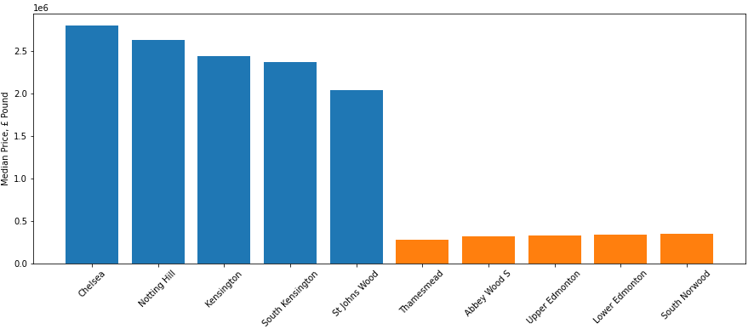

Figure 4 Top 5 most expensive and most affordable neighbourhoods in London

Using the approach outlined in the above section all neighbourhoods have been assigned a category price based on current market price data, as shown in table 2 to 5 in appendix A.

The 75% percentile of the label for each price category, shown in table 1, has then been obtained to use as a benchmark to classify what each market price based category should be identified through the cluster label.

Table 1 75% percentile cluster label for each market price based category

|  |  |  |  |  |
| --- | --- | --- | --- | --- |
|  | **Very High Valued** | **High Valued** | **Medium Valued** | **Low Valued** |
| **75% Cluster Label** | 18 | 9.75 | 7 | 14 |

With the valued of the 75% for each category we can then compare individual neighbourhoods cluster label against the values in table 1 and identify whether the particular neighbourhood falls within the category based on the market price data or whether its amenities density and type resemble more the ones of other price categories. Full details of the cluster label can be found in table 2-5 in Appendix A.

#### Very High Valued Neighbourhood Predictions

Figure 5 below shows the prediction of our model against the current market price for the Very High Valued neighbourhoods. It can be seen that the model predictions are in agreement with the current market price data across all the most valuable neighbourhoods in London.

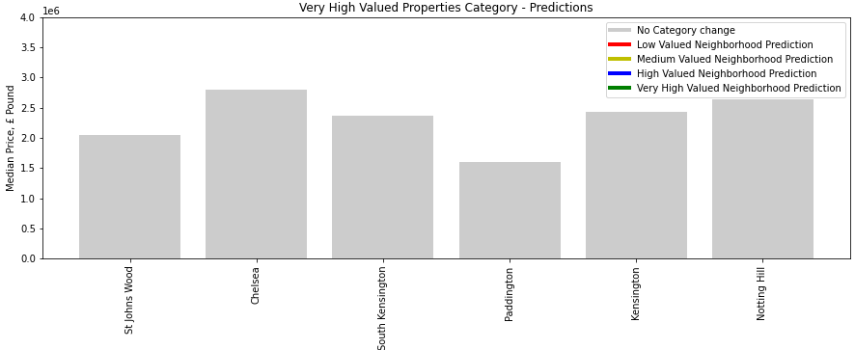

Figure 5 Very High Valued neighbourhood predictions, predictions in agreement with current market price data

#### High Valued Neighbourhoods Predictions

Figure 6 below show the predictions for the high valued properties. All predictions are in disagreement with the current market valuation.

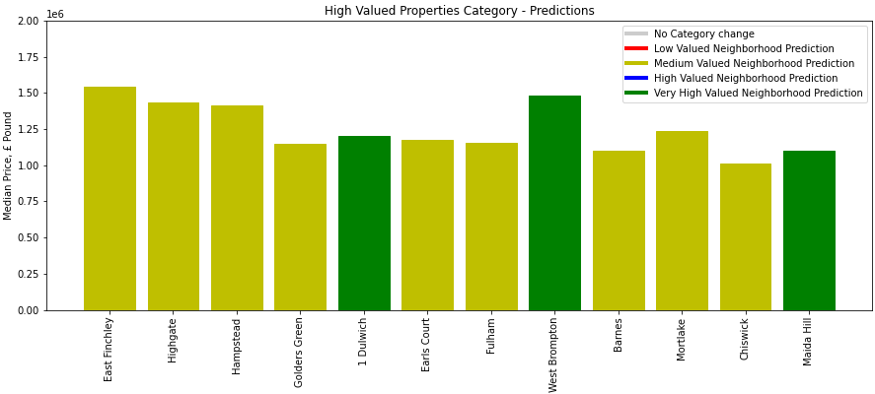

Figure 6 High Valued neighbour predictions

#### Medium Valued Neighbourhoods Predictions

For the medium valued neighbourhoods the predictions are for the most part in agreement with the market with few postcodes being predicted to be very similar to very high valued postcodes. Only Willesden has been predicted to be overpriced.

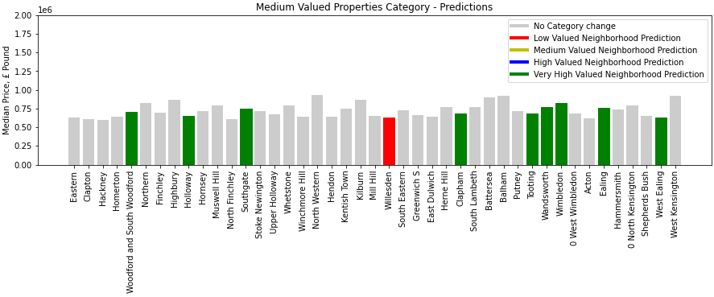

Figure 7 Medium Valued neighbourhoods predictions

#### Low Valued Neighbourhoods Predictions

The plot in Figure 8 shows that the majority of the neighbourhoods are undervalued by the market and present amenity characteristics more similar to a medium valued neighbourhood with some exception where this predicted to very high and high valued neighbourhoods.

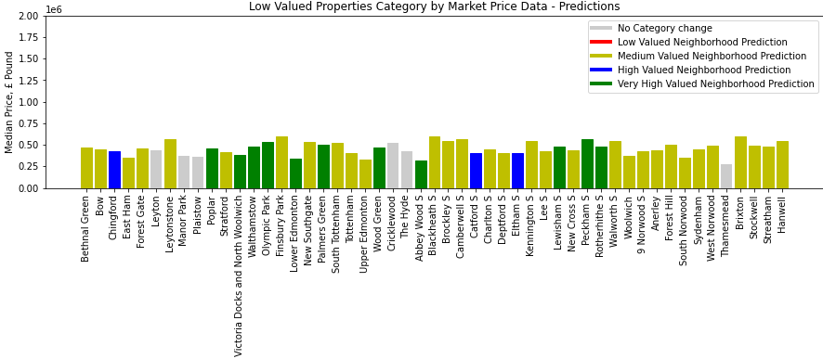

Figure 8 Low Valued neighbourhoods Predictions

### Discussion

From the results section we can clearly deduct some conclusions regarding the current valuation of the properties in the area of London. Firstly we can notice that concerning the very high valued properties the model is in perfect agreement with the market valuation with none of the neighbourhoods being downgraded to a lower tier. This results reflect the highly specific type of amenities density for these neighbourhoods with amenities such as museum, vicinity to large parks such as Hyde Park and high end restaurants which push the value of these areas well above the average housing price in London.

In stark contrast to our very high value properties prediction the High valued neighbourhoods predictions are in complete disagreement with the market valuation. As shown in figure 6 most properties are actually being downgraded to medium valued neighbourhoods. This signifies that there is a large proportion of housing in London which is overvalued compared to the offered amenities which do not match the ask price for many of the properties residing in these areas. Exception to this rule are: Dulwhich, West Brompton and Maida Hill which are predicted to be undervalued and to be more similar to the very high neighbourhoods in terms of amenities. Indeed, all of these areas do presents characteristics such as closeness to greenery, attractions and rare all relatively well connected to the city centre.

Medium valued properties are well in agreement with the models with just Willesden being downgraded. Other few exceptions have insted being predicted to be on a very high value range.

Lastly, the low valued properties are the one which shows the most variation across all neighbourhoods, with the majority be predicted to be in the medium range and some of them high and very high range. This might suggest that maybe the original arbitrary distribution might not be representative of the real market conditions especially towards the most affordable neighbourhoods.

### 7. Conclusion

The work presented in this report aims to identify neighbourhoods that are overpriced and undervalued using metrics such as amenity density and type against the current market valuation.

This has been performed using the K-Means clustering algorithm to cluster neighbourhoods’s amenities and find patters and similarities between sets of amenities.

It has been shown that amenities such as closeness to parks/greenery, museum, tourist attractions and high-end restaurant all contribute to the increase the neighbourhood value and this seems to be a good predictor of its value with all the model predictions being in agreement with the market valuation. However, towards the lower end of the spectrum the vast variety of amenities type makes predicting and differentiating high, medium and low valued properties harder to do.

In order to improve the accuracy at this price range spectrum it is intended for the model to include other parameters such as access to TFL (Transport for London) and national railway services, distance to high street venues and proximity to recreational locations. This would make the model even more general and able to better predict the real value of the High, Medium and Low valued neighbourhoods.

### Appendix A - Tables containing amenities per neighbourhood divided by market price category

### Very High Valued Neighbourhoods

Table 2 Very High Valued Neighbourhoods

|  |  |  |  |  |  |  |  |  |  |  |  |  |  |  |  |  |  |  |
| --- | --- | --- | --- | --- | --- | --- | --- | --- | --- | --- | --- | --- | --- | --- | --- | --- | --- | --- |
| **PostalCode** | **District** | **Neighborhood** | **Latitude** | **Longitude** | **MedianPrice** | **PriceCat** | **Cluster Labels** | **Predictions** | **1st Most Common Venue** | **2nd Most Common Venue** | **3rd Most Common Venue** | **4th Most Common Venue** | **5th Most Common Venue** | **6th Most Common Venue** | **7th Most Common Venue** | **8th Most Common Venue** | **9th Most Common Venue** | **10th Most Common Venue** |
| NW8 | North Western | St Johns Wood | 51.53227236 | -0.174576944 | 2042682 | VH | 18 | VH | Cricket Ground | Deli / Bodega | Pub | Coffee Shop | Café | Yoga Studio | Fast Food Restaurant | Gastropub | Lebanese Restaurant | Garden |
| SW3 | South Western | Chelsea | 51.4891305 | -0.165711226 | 2804697 | VH | 18 | VH | Café | Bakery | Restaurant | Bookstore | Ice Cream Shop | Hotel | Coffee Shop | Pub | English Restaurant | Burger Joint |
| SW7 | South Western | South Kensington | 51.49628504 | -0.177008489 | 2371696 | VH | 18 | VH | Exhibit | Science Museum | Hotel | Café | Bakery | Burger Joint | Sandwich Place | Pizza Place | Italian Restaurant | Gift Shop |
| W2 | Paddington | Paddington | 51.51495981 | -0.186585418 | 1608012 | VH | 18 | VH | Hotel | Pub | Coffee Shop | Garden | Chinese Restaurant | Café | Gym / Fitness Center | Persian Restaurant | Indian Restaurant | Pizza Place |
| W8 | Paddington | Kensington | 51.50112505 | -0.194330145 | 2437705 | VH | 18 | VH | Café | Juice Bar | Italian Restaurant | Bakery | Restaurant | Burger Joint | French Restaurant | Clothing Store | Indian Restaurant | Spa |
| W11 | Paddington | Notting Hill | 51.51229824 | -0.216151032 | 2633748 | VH | 16 | VH | Gym / Fitness Center | Theme Park Ride / Attraction | Park | Wine Bar | Department Store | Cosmetics Shop | Indoor Play Area | Massage Studio | Latin American Restaurant | Bakery |

### High Valued Neighbourhoods

Table 3 High Valued Neighbourhoods

|  |  |  |  |  |  |  |  |  |  |  |  |  |  |  |  |  |  |  |
| --- | --- | --- | --- | --- | --- | --- | --- | --- | --- | --- | --- | --- | --- | --- | --- | --- | --- | --- |
| **PostalCode** | **District** | **Neighborhood** | **Latitude** | **Longitude** | **MedianPrice** | **PriceCat** | **Cluster Labels** | **Predictions** | **1st Most Common Venue** | **2nd Most Common Venue** | **3rd Most Common Venue** | **4th Most Common Venue** | **5th Most Common Venue** | **6th Most Common Venue** | **7th Most Common Venue** | **8th Most Common Venue** | **9th Most Common Venue** | **10th Most Common Venue** |
| N2 | Northern | East Finchley | 51.59007719 | -0.169284532 | 1541812 | H | 7 | M | Café | Coffee Shop | Pub | Platform | Grocery Store | Italian Restaurant | Japanese Restaurant | Movie Theater | Middle Eastern Restaurant | Shoe Store |
| N6 | Northern | Highgate | 51.57319105 | -0.146024433 | 1432396 | H | 5 | M | Pub | Café | Italian Restaurant | Indian Restaurant | Bakery | Tea Room | Coffee Shop | Theater | Park | French Restaurant |
| NW3 | North Western | Hampstead | 51.55234997 | -0.172517828 | 1415477 | H | 5 | M | Pub | Bagel Shop | Italian Restaurant | Bakery | Hotel | Coffee Shop | Clothing Store | Chinese Restaurant | Museum | Movie Theater |
| NW11 | North Western | Golders Green | 51.57842827 | -0.197467481 | 1148698 | H | 1 | M | Bakery | Turkish Restaurant | Grocery Store | Coffee Shop | Italian Restaurant | Restaurant | Yoga Studio | Event Service | Event Space | Exhibit |
| SE21 | South Eastern | 1 Dulwich | 51.43900012 | -0.088764721 | 1205694 | H | 19 | VH | Flower Shop | Restaurant | Park | Bakery | Coffee Shop | Gym / Fitness Center | Garden Center | Wine Shop | Gift Shop | Fast Food Restaurant |
| SW5 | South Western | Earls Court | 51.49162191 | -0.191974039 | 1173065 | H | 3 | M | Hotel | Garden | Café | Coffee Shop | Italian Restaurant | Thai Restaurant | Lebanese Restaurant | Pizza Place | Pub | Hotel Bar |
| SW6 | South Western | Fulham | 51.47663358 | -0.201205103 | 1157224 | H | 1 | M | Coffee Shop | Café | Pub | Italian Restaurant | French Restaurant | Bakery | Grocery Store | Thai Restaurant | Yoga Studio | Juice Bar |
| SW10 | South Western | West Brompton | 51.48378494 | -0.18280067 | 1478159 | H | 18 | VH | Italian Restaurant | Grocery Store | Pub | Nightclub | Restaurant | Juice Bar | French Restaurant | Bakery | Coffee Shop | Sandwich Place |
| SW13 | Battersea | Barnes | 51.47617202 | -0.243661189 | 1100733 | H | 1 | M | Pizza Place | Farmers Market | Coffee Shop | Pub | Grocery Store | Movie Theater | Food & Drink Shop | French Restaurant | Breakfast Spot | Gastropub |
| SW14 | Battersea | Mortlake | 51.46539662 | -0.266983167 | 1235414 | H | 1 | M | Coffee Shop | Pub | Pizza Place | Grocery Store | Italian Restaurant | Beer Store | Gelato Shop | Supermarket | Pharmacy | Chinese Restaurant |
| W4 | Paddington | Chiswick | 51.4912038 | -0.264028271 | 1011246 | H | 5 | M | Pub | Bookstore | Bakery | Italian Restaurant | Café | Supermarket | Sushi Restaurant | Coffee Shop | Playground | Vietnamese Restaurant |
| W9 | Paddington | Maida Hill | 51.52489396 | -0.192637574 | 1103532 | H | 18 | VH | Deli / Bodega | Pizza Place | Coffee Shop | Indian Restaurant | Grocery Store | Fast Food Restaurant | Food & Drink Shop | Dance Studio | Middle Eastern Restaurant | Bus Stop |

### Medium Valued Neighbourhoods

Table 4 Medium Valued Neighbourhoods

|  |  |  |  |  |  |  |  |  |  |  |  |  |  |  |  |  |  |  |
| --- | --- | --- | --- | --- | --- | --- | --- | --- | --- | --- | --- | --- | --- | --- | --- | --- | --- | --- |
| **PostalCode** | **District** | **Neighborhood** | **Latitude** | **Longitude** | **MedianPrice** | **PriceCat** | **Cluster Labels** | **Predictions** | **1st Most Common Venue** | **2nd Most Common Venue** | **3rd Most Common Venue** | **4th Most Common Venue** | **5th Most Common Venue** | **6th Most Common Venue** | **7th Most Common Venue** | **8th Most Common Venue** | **9th Most Common Venue** | **10th Most Common Venue** |
| E1 | Eastern | Eastern | 51.51738819 | -0.059488273 | 633477 | M | 3 | M | Hotel | Sandwich Place | Park | Pub | Indian Restaurant | Burger Joint | Grocery Store | Coffee Shop | Bakery | Ice Cream Shop |
| E5 | Eastern | Clapton | 51.55887905 | -0.053755096 | 614403 | M | 0 | M | Grocery Store | Pub | Park | Coffee Shop | Gym / Fitness Center | Bus Stop | Burger Joint | Fried Chicken Joint | Martial Arts School | Garden |
| E8 | Eastern | Hackney | 51.54372465 | -0.066177023 | 601868 | M | 7 | M | Coffee Shop | Wine Shop | Restaurant | Café | Pub | Modern European Restaurant | Convenience Store | Gym / Fitness Center | Music Venue | Gastropub |
| E9 | Eastern | Homerton | 51.54415318 | -0.042844989 | 645092 | M | 5 | M | Pub | Café | Supermarket | Coffee Shop | Yoga Studio | Train Station | Bus Stop | Pizza Place | Butcher | Beer Store |
| E18 | Eastern | Woodford and South Woodford | 51.59275775 | 0.024951511 | 703027 | M | 18 | VH | Italian Restaurant | Grocery Store | Supermarket | Café | Fast Food Restaurant | Coffee Shop | Chinese Restaurant | Furniture / Home Store | Multiplex | Yoga Studio |
| N1 | Northern | Northern | 51.53774667 | -0.097050804 | 824273 | M | 5 | M | Pub | Bakery | French Restaurant | Burger Joint | Park | Mediterranean Restaurant | Theater | Gastropub | Boutique | Café |
| N3 | Northern | Finchley | 51.600241 | -0.193892859 | 696893 | M | 1 | M | Coffee Shop | Supermarket | Turkish Restaurant | Pizza Place | Japanese Restaurant | Pub | Park | Restaurant | Chinese Restaurant | Café |
| N5 | Northern | Highbury | 51.55386741 | -0.098605089 | 864120 | M | 7 | M | Café | Pub | Thai Restaurant | Fish & Chips Shop | Seafood Restaurant | Bookstore | Cheese Shop | Tapas Restaurant | Restaurant | Tennis Court |
| N7 | Northern | Holloway | 51.55346009 | -0.118347097 | 657539 | M | 18 | VH | Pub | Supermarket | Café | Ramen Restaurant | School | Clothing Store | Restaurant | Coffee Shop | Yoga Studio | Bed & Breakfast |
| N8 | Northern | Hornsey | 51.58275284 | -0.120155774 | 722079 | M | 7 | M | Café | Pub | French Restaurant | Grocery Store | Coffee Shop | Bar | Japanese Restaurant | Thai Restaurant | Convenience Store | Tapas Restaurant |
| N10 | Northern | Muswell Hill | 51.59477278 | -0.144997996 | 789727 | M | 7 | M | Pizza Place | Café | Coffee Shop | Japanese Restaurant | Diner | Tapas Restaurant | English Restaurant | Stationery Store | Restaurant | Greek Restaurant |
| N12 | Northern | North Finchley | 51.6149065 | -0.177626614 | 614343 | M | 1 | M | Coffee Shop | Supermarket | Fast Food Restaurant | Grocery Store | Pharmacy | Breakfast Spot | Bookstore | Sandwich Place | Bar | Sushi Restaurant |
| N14 | Northern | Southgate | 51.63431777 | -0.130840799 | 753964 | M | 18 | VH | Gym / Fitness Center | Café | Coffee Shop | Ice Cream Shop | Sandwich Place | Spanish Restaurant | Food & Drink Shop | Bus Stop | Fast Food Restaurant | Chinese Restaurant |
| N16 | Northern | Stoke Newington | 51.56251025 | -0.076646293 | 717834 | M | 7 | M | Pub | Café | Pizza Place | Cocktail Bar | Coffee Shop | Italian Restaurant | Beer Store | Japanese Restaurant | Thai Restaurant | Gift Shop |
| N19 | Northern | Upper Holloway | 51.56525904 | -0.129951364 | 673721 | M | 0 | M | Grocery Store | Coffee Shop | Pizza Place | Indian Restaurant | Café | Italian Restaurant | Pub | Bus Stop | Fast Food Restaurant | Farmers Market |
| N20 | Northern | Whetstone | 51.62925528 | -0.174356015 | 789223 | M | 1 | M | Coffee Shop | Café | Italian Restaurant | Pub | Turkish Restaurant | Metro Station | Mediterranean Restaurant | Brazilian Restaurant | Sandwich Place | Supermarket |
| N21 | Northern | Winchmore Hill | 51.63672767 | -0.099693179 | 637069 | M | 5 | M | Bar | Italian Restaurant | Train Station | Middle Eastern Restaurant | Bus Stop | Bistro | Pub | Coffee Shop | Supermarket | Yoga Studio |
| NW1 | North Western | North Western | 51.53324963 | -0.143852827 | 927202 | M | 1 | M | Coffee Shop | Pizza Place | Japanese Restaurant | Pub | Greek Restaurant | Tea Room | Music Venue | Sandwich Place | Park | Hotel |
| NW4 | North Western | Hendon | 51.58734792 | -0.224318383 | 639635 | M | 0 | M | Grocery Store | Chinese Restaurant | Bagel Shop | Café | Middle Eastern Restaurant | Metro Station | Plaza | Pub | Coffee Shop | Noodle House |
| NW5 | North Western | Kentish Town | 51.55181344 | -0.144925739 | 750442 | M | 1 | M | Pub | Coffee Shop | Grocery Store | Gastropub | Cocktail Bar | Café | Sandwich Place | Italian Restaurant | Indian Restaurant | Bakery |
| NW6 | North Western | Kilburn | 51.54222582 | -0.196298879 | 870595 | M | 7 | M | Café | Indian Restaurant | Brazilian Restaurant | Supermarket | Pub | Thai Restaurant | Discount Store | Fast Food Restaurant | Czech Restaurant | Sandwich Place |
| NW7 | North Western | Mill Hill | 51.6148558 | -0.235174541 | 647837 | M | 6 | M | Park | Yoga Studio | Fast Food Restaurant | Event Service | Event Space | Exhibit | Falafel Restaurant | Farm | Farmers Market | Film Studio |
| NW10 | North Western | Willesden | 51.54126467 | -0.248085856 | 626244 | M | 15 | L | Park | Warehouse Store | Fast Food Restaurant | Chinese Restaurant | Flower Shop | Flea Market | Food & Drink Shop | Fish Market | Fish & Chips Shop | Escape Room |
| SE1 | South Eastern | South Eastern | 51.499183 | -0.091531182 | 727875 | M | 5 | M | Pub | Café | Park | Italian Restaurant | Sandwich Place | Garden | Ice Cream Shop | Moroccan Restaurant | Fast Food Restaurant | Movie Theater |
| SE10 | South Eastern | Greenwich S | 51.48446818 | 0.000178235 | 662483 | M | 5 | M | Pub | Grocery Store | Pier | Indian Restaurant | Turkish Restaurant | English Restaurant | Historic Site | Café | Museum | Japanese Restaurant |
| SE22 | South Eastern | East Dulwich | 51.45445892 | -0.072426041 | 637255 | M | 7 | M | Café | Gastropub | Ice Cream Shop | Grocery Store | Convenience Store | Pub | Restaurant | Coffee Shop | Cocktail Bar | Chinese Restaurant |
| SE24 | South Eastern | Herne Hill | 51.45629412 | -0.100249853 | 776182 | M | 7 | M | Pub | Café | Pizza Place | Bookstore | Coffee Shop | Restaurant | Middle Eastern Restaurant | Platform | Deli / Bodega | Cocktail Bar |
| SW4 | South Western | Clapham | 51.46111161 | -0.136480999 | 684309 | M | 18 | VH | Pub | Restaurant | Burger Joint | Café | Cocktail Bar | Bar | Grocery Store | Coffee Shop | Italian Restaurant | Tapas Restaurant |
| SW8 | South Western | South Lambeth | 51.47653832 | -0.132007959 | 772247 | M | 5 | M | Bus Stop | Portuguese Restaurant | Fish & Chips Shop | Pub | Gym / Fitness Center | Park | Pizza Place | Coffee Shop | Supermarket | Bakery |
| SW11 | Battersea | Battersea | 51.46811017 | -0.16382522 | 898709 | M | 5 | M | Pub | Café | Thai Restaurant | Theater | Bar | Italian Restaurant | Gym / Fitness Center | Supermarket | Coffee Shop | Breakfast Spot |
| SW12 | Battersea | Balham | 51.44629866 | -0.149127963 | 926724 | M | 1 | M | Coffee Shop | Pub | Pizza Place | Bakery | Indian Restaurant | Sandwich Place | Bar | Café | Supermarket | Steakhouse |
| SW15 | Battersea | Putney | 51.45703289 | -0.228502539 | 712352 | M | 4 | M | Photography Studio | Yoga Studio | Escape Room | Event Service | Event Space | Exhibit | Falafel Restaurant | Farm | Farmers Market | Fast Food Restaurant |
| SW17 | Battersea | Tooting | 51.43079473 | -0.164678271 | 682780 | M | 18 | VH | Pub | Coffee Shop | Burger Joint | Indian Restaurant | Supermarket | Pharmacy | South Indian Restaurant | Convenience Store | Fish & Chips Shop | Bar |
| SW18 | Battersea | Wandsworth | 51.4512825 | -0.191483098 | 772571 | M | 18 | VH | Clothing Store | Coffee Shop | Burger Joint | Gym | Supermarket | Bookstore | Asian Restaurant | Pharmacy | Pub | Fountain |
| SW19 | Battersea | Wimbledon | 51.42416024 | -0.203041058 | 823783 | M | 18 | VH | Clothing Store | Coffee Shop | Sushi Restaurant | Pub | Bar | Pharmacy | Supermarket | Grocery Store | Sandwich Place | Shoe Store |
| SW20 | Battersea | 0 West Wimbledon | 51.41091436 | -0.227736715 | 687295 | M | 7 | M | Bus Stop | Platform | Indian Restaurant | Pub | Café | Coffee Shop | Fast Food Restaurant | Grocery Store | Trail | Hotel |
| W3 | Paddington | Acton | 51.51065486 | -0.267983473 | 623048 | M | 3 | M | Pub | Grocery Store | Coffee Shop | Gym / Fitness Center | Park | Hotel | Supermarket | Wine Shop | Creperie | Sandwich Place |
| W5 | Paddington | Ealing | 51.51321291 | -0.302338374 | 758890 | M | 18 | VH | Coffee Shop | Pub | Platform | Burger Joint | Italian Restaurant | Clothing Store | Park | Bus Stop | Café | Thai Restaurant |
| W6 | Paddington | Hammersmith | 51.49261206 | -0.228568505 | 743192 | M | 5 | M | Pub | Coffee Shop | Café | Sandwich Place | Hotel | Gym / Fitness Center | Platform | Italian Restaurant | Vegetarian / Vegan Restaurant | Gastropub |
| W10 | Paddington | 0 North Kensington | 51.52317219 | -0.216552786 | 794587 | M | 7 | M | Café | Gym / Fitness Center | Furniture / Home Store | Middle Eastern Restaurant | Pizza Place | Pub | Park | Bar | Bakery | Supermarket |
| W12 | Paddington | Shepherds Bush | 51.50828427 | -0.24064901 | 656182 | M | 0 | M | Café | Grocery Store | Gastropub | Hotel | Pizza Place | Fast Food Restaurant | Park | African Restaurant | Pub | Department Store |
| W13 | Paddington | West Ealing | 51.51300753 | -0.321175607 | 627489 | M | 18 | VH | Coffee Shop | Grocery Store | Hotel | Supermarket | Indian Restaurant | Persian Restaurant | Bagel Shop | Bistro | Sandwich Place | Furniture / Home Store |
| W14 | Paddington | West Kensington | 51.49468437 | -0.210255941 | 920117 | M | 3 | M | Pub | Hotel | Sandwich Place | Indian Restaurant | Grocery Store | Persian Restaurant | Café | Bus Stop | Convention Center | Convenience Store |

### Low Valued Neighbourhoods

Table 5 Low Valued Neighbourhoods

|  |  |  |  |  |  |  |  |  |  |  |  |  |  |  |  |  |  |  |
| --- | --- | --- | --- | --- | --- | --- | --- | --- | --- | --- | --- | --- | --- | --- | --- | --- | --- | --- |
| **PostalCode** | **District** | **Neighborhood** | **Latitude** | **Longitude** | **MedianPrice** | **PriceCat** | **Cluster Labels** | **Predictions** | **1st Most Common Venue** | **2nd Most Common Venue** | **3rd Most Common Venue** | **4th Most Common Venue** | **5th Most Common Venue** | **6th Most Common Venue** | **7th Most Common Venue** | **8th Most Common Venue** | **9th Most Common Venue** | **10th Most Common Venue** |
| E2 | Eastern | Bethnal Green | 51.52960366 | -0.062597572 | 472717 | L | 1 | M | Pub | Coffee Shop | Cocktail Bar | Café | Italian Restaurant | Wine Bar | Flower Shop | Bar | Pizza Place | Yoga Studio |
| E3 | Eastern | Bow | 51.52794913 | -0.025266637 | 446893 | L | 3 | M | Pub | Hotel | Convenience Store | Bus Stop | Locksmith | Bar | Grocery Store | Park | Burger Joint | Exhibit |
| E4 | Eastern | Chingford | 51.62172288 | -0.005749971 | 423602 | L | 10 | H | English Restaurant | Gym | American Restaurant | Film Studio | Event Space | Exhibit | Falafel Restaurant | Farm | Farmers Market | Fast Food Restaurant |
| E6 | Eastern | East Ham | 51.52656045 | 0.053931972 | 356263 | L | 3 | M | Sandwich Place | Pub | Grocery Store | Park | Falafel Restaurant | English Restaurant | Escape Room | Ethiopian Restaurant | Event Service | Event Space |
| E7 | Eastern | Forest Gate | 51.54713032 | 0.027600408 | 458009 | L | 0 | M | Grocery Store | Bus Stop | Pub | Fast Food Restaurant | Train Station | Indian Restaurant | Chinese Restaurant | Fish & Chips Shop | Bakery | Comfort Food Restaurant |
| E10 | Eastern | Leyton | 51.56797042 | -0.014401682 | 437812 | L | 15 | L | Park | Farm | Hotel | Cricket Ground | Convenience Store | Coffee Shop | Chinese Restaurant | Ethiopian Restaurant | Event Service | Event Space |
| E11 | Eastern | Leytonstone | 51.56875539 | 0.013606637 | 571463 | L | 5 | M | Pub | Café | Pizza Place | Bus Stop | Coffee Shop | Fast Food Restaurant | Grocery Store | Burger Joint | Italian Restaurant | Supermarket |
| E12 | Eastern | Manor Park | 51.55073797 | 0.052999742 | 370138 | L | 12 | L | Gas Station | Restaurant | Indian Restaurant | Gym / Fitness Center | Event Service | Event Space | Exhibit | Falafel Restaurant | Farm | Farmers Market |
| E13 | Eastern | Plaistow | 51.52781453 | 0.026579545 | 362300 | L | 13 | L | Pub | Bus Station | Café | Gym | Yoga Studio | Fast Food Restaurant | Event Space | Exhibit | Falafel Restaurant | Farm |
| E14 | Eastern | Poplar | 51.50619731 | -0.018549308 | 461299 | L | 18 | VH | Coffee Shop | Italian Restaurant | Plaza | Sushi Restaurant | Burger Joint | Park | Sandwich Place | Pizza Place | Stationery Store | Street Food Gathering |
| E15 | Eastern | Stratford | 51.54041159 | 0.00351993 | 410347 | L | 5 | M | Pub | Sandwich Place | Fast Food Restaurant | Supermarket | Coffee Shop | Shopping Mall | Bar | Bus Stop | Platform | General Entertainment |
| E16 | Eastern | Victoria Docks and North Woolwich | 51.51067097 | 0.028975913 | 382309 | L | 18 | VH | Chinese Restaurant | Hotel | Italian Restaurant | Bridge | Fast Food Restaurant | Sandwich Place | Light Rail Station | Tapas Restaurant | English Restaurant | Restaurant |
| E17 | Eastern | Walthamstow | 51.58692234 | -0.020732971 | 479394 | L | 18 | VH | Grocery Store | Coffee Shop | Sandwich Place | Pizza Place | Clothing Store | Café | Bookstore | Bakery | Pub | Pharmacy |
| E20 | Eastern | Olympic Park | 51.54647951 | -0.010048731 | 536667 | L | 18 | VH | Clothing Store | Café | Italian Restaurant | Coffee Shop | Ice Cream Shop | Burger Joint | Pizza Place | Hotel | Gym / Fitness Center | Toy / Game Store |
| N4 | Northern | Finsbury Park | 51.57008864 | -0.104145355 | 594613 | L | 7 | M | Café | Coffee Shop | Hotel | Pub | Tapas Restaurant | Clothing Store | Tennis Court | Restaurant | Park | Athletics & Sports |
| N9 | Northern | Lower Edmonton | 51.62850915 | -0.058026114 | 335369 | L | 18 | VH | Coffee Shop | Sporting Goods Shop | Gym / Fitness Center | Supermarket | Bus Station | Clothing Store | Furniture / Home Store | Grocery Store | Train Station | Noodle House |
| N11 | Northern | New Southgate | 51.61376457 | -0.138994755 | 534361 | L | 0 | M | Grocery Store | Pet Store | Sporting Goods Shop | Train Station | Coffee Shop | Hardware Store | Furniture / Home Store | Toy / Game Store | Shopping Plaza | Fast Food Restaurant |
| N13 | Northern | Palmers Green | 51.61809998 | -0.104231204 | 498635 | L | 18 | VH | Pub | Grocery Store | Sandwich Place | Coffee Shop | Ice Cream Shop | Supermarket | Bookstore | Breakfast Spot | Café | Pizza Place |
| N15 | Northern | South Tottenham | 51.58280679 | -0.080745122 | 519177 | L | 5 | M | Pub | Hardware Store | Hostel | Deli / Bodega | Coffee Shop | Café | Grocery Store | Farmers Market | Event Service | Event Space |
| N17 | Northern | Tottenham | 51.59809565 | -0.071699437 | 404286 | L | 5 | M | Pub | Supermarket | Park | Gym / Fitness Center | Gas Station | Sandwich Place | Greek Restaurant | Bar | Grocery Store | Discount Store |
| N18 | Northern | Upper Edmonton | 51.61389149 | -0.06662715 | 328007 | L | 1 | M | Turkish Restaurant | Coffee Shop | Fast Food Restaurant | Asian Restaurant | Sandwich Place | Supermarket | Bookstore | Bakery | Grocery Store | Park |
| N22 | Northern | Wood Green | 51.59988773 | -0.110238173 | 469949 | L | 18 | VH | Fast Food Restaurant | Café | Turkish Restaurant | Pub | Supermarket | Restaurant | Park | Bar | Bakery | Convenience Store |
| NW2 | North Western | Cricklewood | 51.55813094 | -0.22028118 | 526348 | L | 14 | L | Fast Food Restaurant | Grocery Store | Hotel | Bagel Shop | Clothing Store | Sandwich Place | Café | Supermarket | Warehouse Store | Coffee Shop |
| NW9 | North Western | The Hyde | 51.58808427 | -0.255298496 | 430114 | L | 14 | L | Ice Cream Shop | Asian Restaurant | Clothing Store | Event Service | Park | Sushi Restaurant | Grocery Store | Gym / Fitness Center | Hardware Store | Furniture / Home Store |
| SE2 | South Eastern | Abbey Wood S | 51.48970142 | 0.115893822 | 315939 | L | 17 | VH | Supermarket | Platform | Grocery Store | Convenience Store | Coffee Shop | Yoga Studio | Event Space | Exhibit | Falafel Restaurant | Farm |
| SE3 | South Eastern | Blackheath S | 51.46955365 | 0.019670623 | 596804 | L | 2 | M | Café | Yoga Studio | Film Studio | Event Space | Exhibit | Falafel Restaurant | Farm | Farmers Market | Fast Food Restaurant | Fish & Chips Shop |
| SE4 | South Eastern | Brockley S | 51.46100172 | -0.035209397 | 548412 | L | 7 | M | Café | Convenience Store | Grocery Store | Coffee Shop | Fish & Chips Shop | Pizza Place | Gastropub | Beer Store | Train Station | Brewery |
| SE5 | South Eastern | Camberwell S | 51.47382072 | -0.091455886 | 568848 | L | 7 | M | Café | Coffee Shop | Bus Stop | Pub | Grocery Store | Vietnamese Restaurant | Gym / Fitness Center | Bakery | Park | Gastropub |
| SE6 | South Eastern | Catford S | 51.43854702 | -0.016583802 | 407619 | L | 11 | H | Shopping Plaza | Discount Store | Grocery Store | Furniture / Home Store | Turkish Restaurant | Event Space | Exhibit | Falafel Restaurant | Farm | Farmers Market |
| SE7 | South Eastern | Charlton S | 51.4841087 | 0.034310607 | 444886 | L | 0 | M | Bus Stop | Grocery Store | Food Truck | Platform | Fast Food Restaurant | Sporting Goods Shop | Café | Supermarket | Chinese Restaurant | Thai Restaurant |
| SE8 | South Eastern | Deptford S | 51.48191812 | -0.029464787 | 400492 | L | 1 | M | Coffee Shop | Pub | Cocktail Bar | Bar | Vietnamese Restaurant | Plaza | Park | Grocery Store | Performing Arts Venue | Italian Restaurant |
| SE9 | South Eastern | Eltham S | 51.44514241 | 0.054826263 | 407166 | L | 9 | H | Golf Course | Hardware Store | Historic Site | Fast Food Restaurant | Event Service | Event Space | Exhibit | Falafel Restaurant | Farm | Farmers Market |
| SE11 | South Eastern | Kennington S | 51.48983614 | -0.111633851 | 543337 | L | 5 | M | Pub | Café | Coffee Shop | Fish & Chips Shop | Indian Restaurant | Gastropub | Italian Restaurant | Pizza Place | Park | Motorcycle Shop |
| SE12 | South Eastern | Lee S | 51.44463881 | 0.019838025 | 430360 | L | 3 | M | Hotel | Veterinarian | Pub | Fast Food Restaurant | Bus Stop | Polish Restaurant | Historic Site | Falafel Restaurant | English Restaurant | Escape Room |
| SE13 | South Eastern | Lewisham S | 51.45943974 | -0.009609356 | 481274 | L | 18 | VH | Clothing Store | Pub | Fast Food Restaurant | Coffee Shop | Restaurant | Grocery Store | Video Game Store | Café | Pharmacy | Supermarket |
| SE14 | South Eastern | New Cross S | 51.47589074 | -0.042474433 | 440925 | L | 7 | M | Café | Pub | Chinese Restaurant | Coffee Shop | Thai Restaurant | Grocery Store | Gastropub | Lebanese Restaurant | Clothing Store | Bus Stop |
| SE15 | South Eastern | Peckham S | 51.47273415 | -0.065648807 | 564763 | L | 18 | VH | Pub | Grocery Store | Supermarket | Pharmacy | Italian Restaurant | Fast Food Restaurant | Restaurant | Gym / Fitness Center | Cocktail Bar | Bar |
| SE16 | South Eastern | Rotherhithe S | 51.49660289 | -0.052928296 | 478043 | L | 18 | VH | Clothing Store | Café | Pharmacy | Sporting Goods Shop | Coffee Shop | Bar | Grocery Store | Metro Station | Food Truck | Breakfast Spot |
| SE17 | South Eastern | Walworth S | 51.48822933 | -0.093331843 | 541613 | L | 7 | M | Café | Pub | Coffee Shop | Hostel | Sandwich Place | Brewery | Thai Restaurant | Caribbean Restaurant | Grocery Store | Bakery |
| SE18 | South Eastern | Woolwich | 51.48433928 | 0.072565626 | 368158 | L | 0 | M | Indian Restaurant | Bus Stop | Chinese Restaurant | Child Care Service | Pub | Grocery Store | Fish & Chips Shop | Convenience Store | Health & Beauty Service | Yoga Studio |
| SE19 | South Eastern | 9 Norwood S | 51.41798038 | -0.086109746 | 429458 | L | 1 | M | Coffee Shop | Italian Restaurant | Pizza Place | Café | Gastropub | Pub | Thai Restaurant | Flea Market | Garden Center | Latin American Restaurant |
| SE20 | South Eastern | Anerley | 51.41230182 | -0.059452762 | 438354 | L | 3 | M | Hotel | Hardware Store | Furniture / Home Store | Fast Food Restaurant | Supermarket | Trail | Train Station | Park | Dessert Shop | Event Service |
| SE23 | South Eastern | Forest Hill | 51.4414675 | -0.049153782 | 499709 | L | 5 | M | Pub | Café | Coffee Shop | Fish & Chips Shop | Bookstore | Garden Center | Train Station | Gym / Fitness Center | Bar | Farmers Market |
| SE25 | South Eastern | South Norwood | 51.3977841 | -0.076781304 | 349226 | L | 8 | M | Platform | Café | Supermarket | Indian Restaurant | Bus Stop | Pub | Fish & Chips Shop | Park | Gas Station | Coffee Shop |
| SE26 | South Eastern | Sydenham | 51.42795202 | -0.05481565 | 445166 | L | 5 | M | Gastropub | Sandwich Place | Café | Supermarket | Indian Restaurant | Portuguese Restaurant | Pharmacy | Pub | Coffee Shop | Italian Restaurant |
| SE27 | South Eastern | West Norwood | 51.43056204 | -0.102368291 | 491183 | L | 7 | M | Café | Grocery Store | Bakery | Pub | Coffee Shop | Train Station | Farmers Market | Movie Theater | Breakfast Spot | Sporting Goods Shop |
| SE28 | South Eastern | Thamesmead | 51.50234594 | 0.104426943 | 278195 | L | 14 | L | Fast Food Restaurant | Clothing Store | Grocery Store | Warehouse Store | Furniture / Home Store | Pet Store | Supermarket | Yoga Studio | Farm | Event Service |
| SW2 | South Western | Brixton | 51.44928805 | -0.119834055 | 598472 | L | 0 | M | Grocery Store | Hardware Store | Auto Garage | Bus Stop | Spa | Portuguese Restaurant | Pub | Coffee Shop | Vegetarian / Vegan Restaurant | Caribbean Restaurant |
| SW9 | South Western | Stockwell | 51.46936044 | -0.113860548 | 490704 | L | 5 | M | Pub | Ice Cream Shop | Spanish Restaurant | Skate Park | Caribbean Restaurant | Music Venue | Bike Shop | Restaurant | Bakery | Bus Stop |
| SW16 | Battersea | Streatham | 51.42125279 | -0.129235431 | 479709 | L | 5 | M | Pub | Supermarket | Gastropub | Playground | Park | Burger Joint | Pizza Place | Skating Rink | Fast Food Restaurant | Fried Chicken Joint |
| W7 | Paddington | Hanwell | 51.51188247 | -0.335952125 | 548776 | L | 7 | M | Café | Flower Shop | Pizza Place | Convenience Store | Gym | Coffee Shop | Supermarket | Yoga Studio | Farmers Market | Event Space |