Lee Yan Cheng A0199141B

GitHub Repo link: <https://github.com/yanchenglee98/OTOT-B>

1. Running the API locally

In the root folder, run `npm run dev` to start the server. Go to localhost:3000 to ensure that it is running. You should see this web page:

Postman link to collection to access the APIs

<https://go.postman.co/workspace/Contacts-Backend-Workspace~5169e805-3fe0-43e3-a89c-3d0687b68cf4/collection/23127033-52c15d94-e3d1-48f9-9625-a57d5d33f47f?action=share&creator=23127033>

The collection consists of various http methods to access the APIs.

Variables include {{localhost}} which is used to access the API when the backend is run locally and {{gcloud}} to access the API of the backend hosted on Google Cloud App Engine. Adjust the {{mongoid}} variable accordingly to access the update, delete and get methods.

Here is a screenshot of a successful post method to the backend

Here is a screenshot of a unsuccessful get method to the backend when the contact does not exist

1. Access the deployed API

Adjust the variable from {{localhost}} and {{gcloud}} accordingly to access the localhost or the deployed site.

1. Run test locally and via GitHub actions

In order to run test, enter this command `npm test`.

Here is a screenshot of a successful CI using GitHub actions

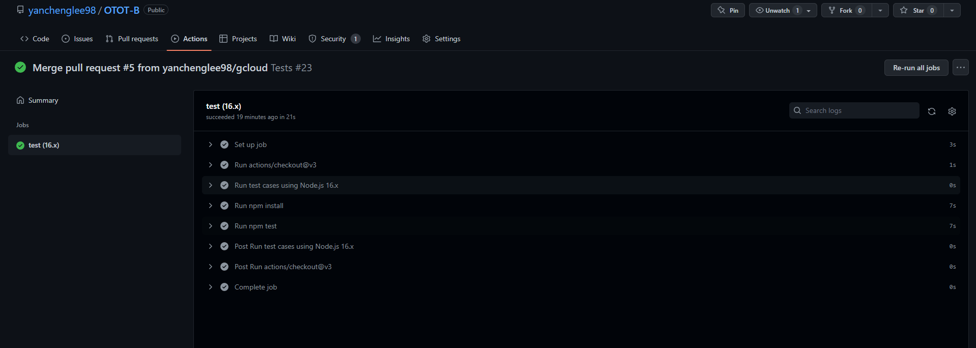

1. Set up frontend

To set up the frontend, ensure that the backend is running as per the instructions in (i). Ensure that the current directory is in the frontend folder and enter `npm start` in the terminal. Go to localhost:8080 and you should see a webpage similar to the one below

1. Severless function

The severless function which is deployed on Google Cloud Function, pulls weather data from <https://api.data.gov.sg/v1/environment/2-hour-weather-forecast> and extracts out the weather data specific to Clementi. The severless function can be accessed at <https://python-http-function-yilw3np2zq-as.a.run.app/>

Here is a screenshot of the response from the severless function

1. Screenshots of front end interaction with severless function

The frontend pulls data from the severless function and displays it on the frontend

