Lee Yan Cheng A0199141B

OTOT-E

GitHub link: <https://github.com/yanchenglee98/OTOT-E>

Cache miss response time: 128ms

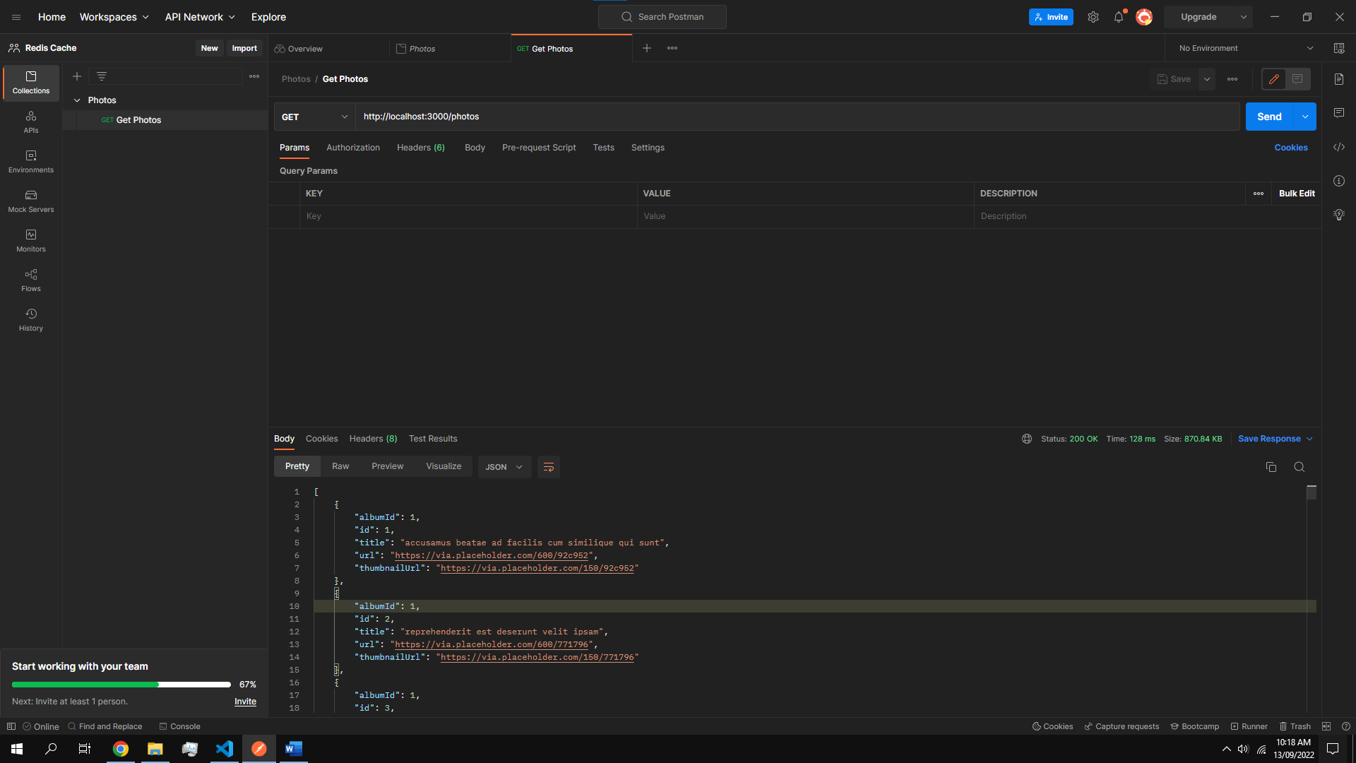

Cache hit response time: 20ms

