|  |  |  |  |
| --- | --- | --- | --- |
| **Name:** | **Lee Yan Cheng** | **Lab Group#:** | **B10** |
| **Student Id:** | |  |  |  |  |  |  |  |  |  | | --- | --- | --- | --- | --- | --- | --- | --- | --- | | **A** | **0** | **1** | **9** | **9** | **1** | **4** | **1** | **B** | |  | |

Step 1. Truth Table **[ 4 pts ]**

|  |  |  |  |  |
| --- | --- | --- | --- | --- |
| *P* | *Q* | *R* | *S* | *F* |
| 0 | 0 | 0 | 0 | **0** |
| 0 | 0 | 0 | 1 | **1** |
| 0 | 0 | 1 | 0 | **1** |
| 0 | 0 | 1 | 1 | **1** |
| 0 | 1 | 0 | 0 | **0** |
| 0 | 1 | 0 | 1 | **1** |
| 0 | 1 | 1 | 0 | **0** |
| 0 | 1 | 1 | 1 | **0** |

|  |  |  |  |  |
| --- | --- | --- | --- | --- |
| *P* | *Q* | *R* | *S* | *F* |
| 1 | 0 | 0 | 0 | **1** |
| 1 | 0 | 0 | 1 | **0** |
| 1 | 0 | 1 | 0 | **0** |
| 1 | 0 | 1 | 1 | **0** |
| 1 | 1 | 0 | 0 | **0** |
| 1 | 1 | 0 | 1 | **1** |
| 1 | 1 | 1 | 0 | **0** |
| 1 | 1 | 1 | 1 | **0** |

Step 2. Using 4x16 Decoder with active low output: **[ 4 pts ]**

|  |
| --- |
|  |

Step 3. Alternative Implementations **[ 4 pts ]**

### **F**

0

1

2

3

4

5

6

7

**S0**

**8:1**

**MUX**

**S1**

**S2**

### **P Q R**

**(b)**

### **F**

0

1

2

3

4

5

6

7

**S0**

**8:1**

**MUX**

**S1**

**S2**

### **Q R S**

**(a)**

P

P’

P’

P’

0

1

0

0

S

1

S

0

S’

0

S

0

**3a)**

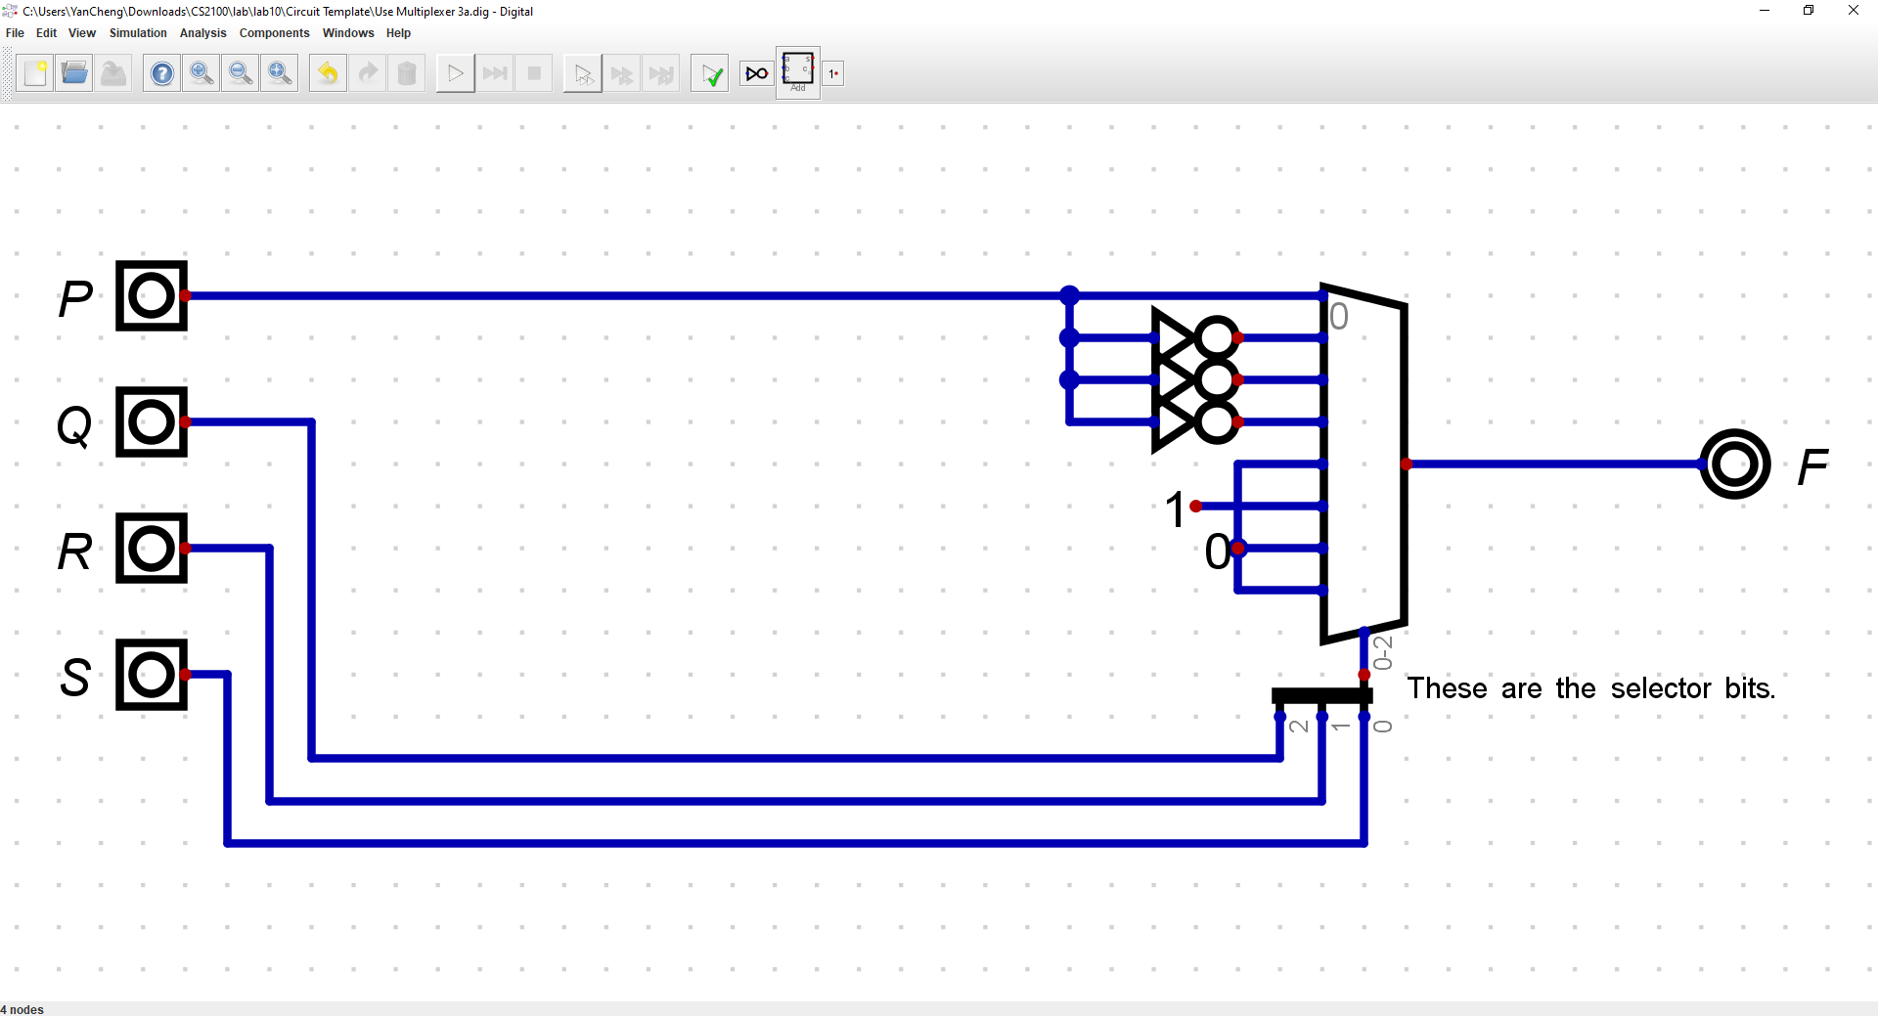

**3b)**

