**Todo App: Lee Yan Cheng, A0199141B**

**User manual**

**Signing in**

1. Enter your email and password into the corresponding fields

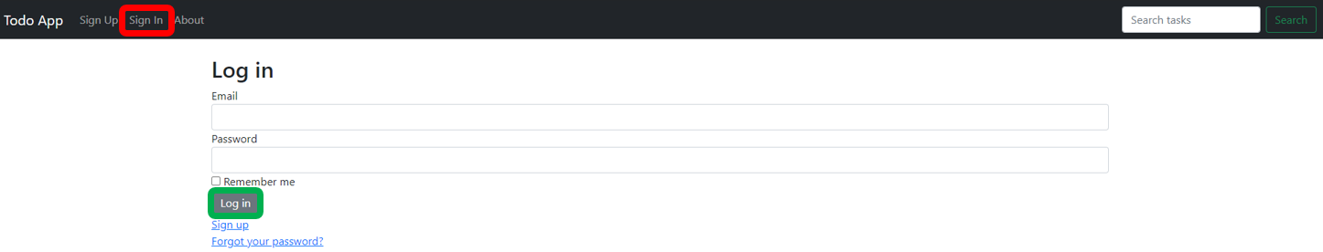

1. Click on the ‘Log In’ button to sign in

**Signing out**

1. Simply click on the ‘Sign Out’ option located in the header to sign out



**Viewing of tasks**

1. Click on the ‘Task List’ option located in the header.



1. The task list will be shown.

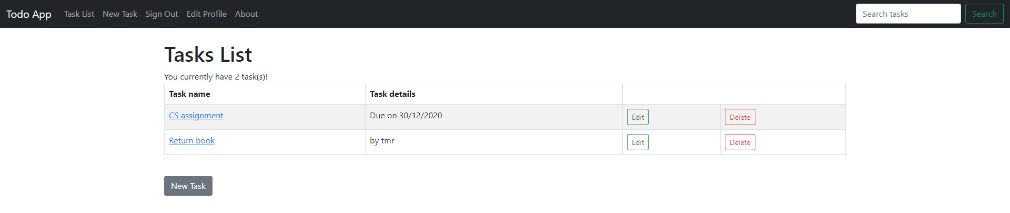

1. To view individual task, click on the name of the task to view it.

**Creating a new task**

1. Click on the ‘New Task’ option located in the header.



1. Fill in the details of the task in the form.

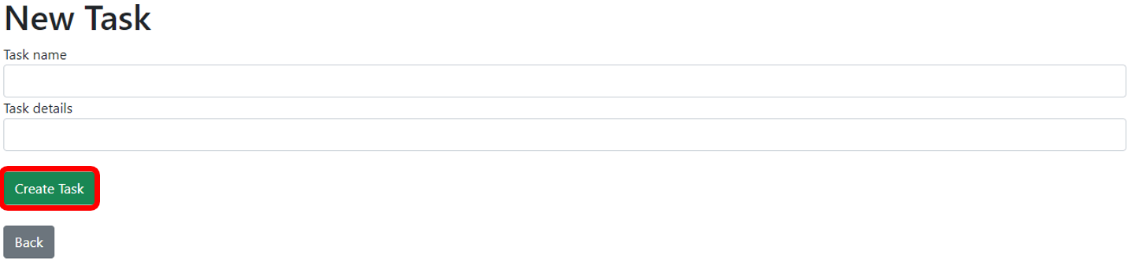

1. Click on the ‘Create Task’ button to save it to the task list.

**Editing a task**

1. Click on the ‘Edit’ button when in the Tasks List.

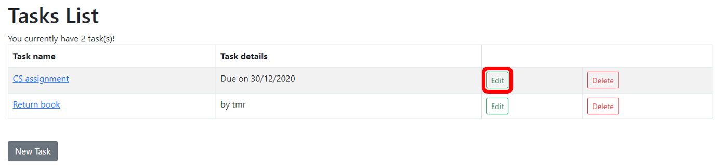

1. Update the task details accordingly and press the ‘Update Task’ button to save.

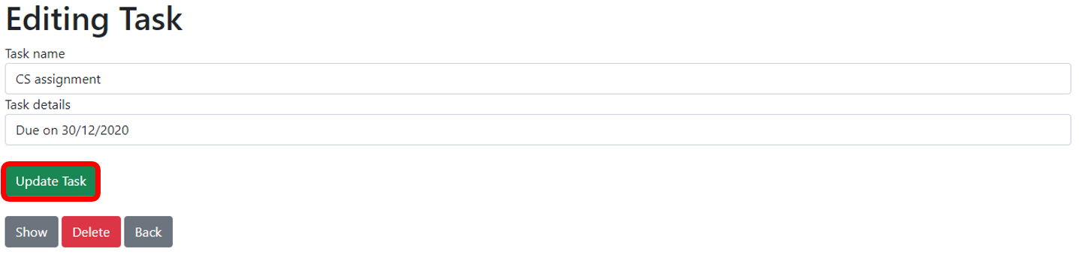

**Deleting a task**

1. Click on the ‘Delete’ button when in the Tasks List.

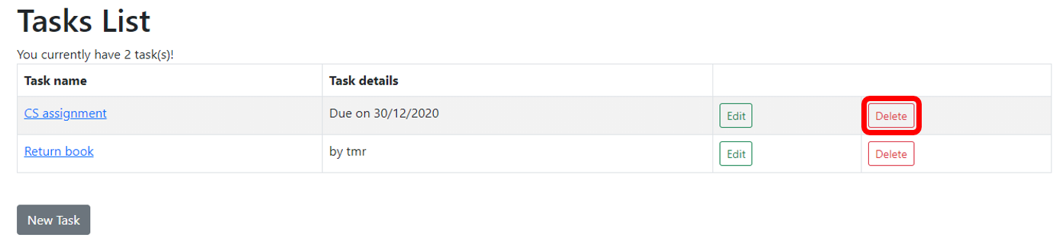

1. The task will be deleted from the tasks list.

**Tagging/Searching**

1. Tagging can be done through the task details by adding keywords. E.g., urgent

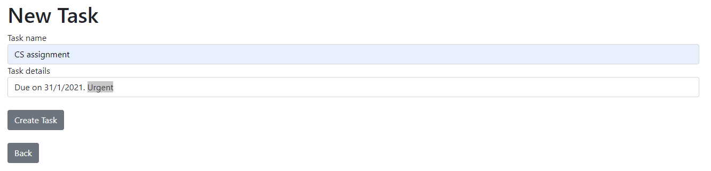

1. Enter the keywords or the search query in the search bar located in the header and press enter.



1. The corresponding search results will be displayed.

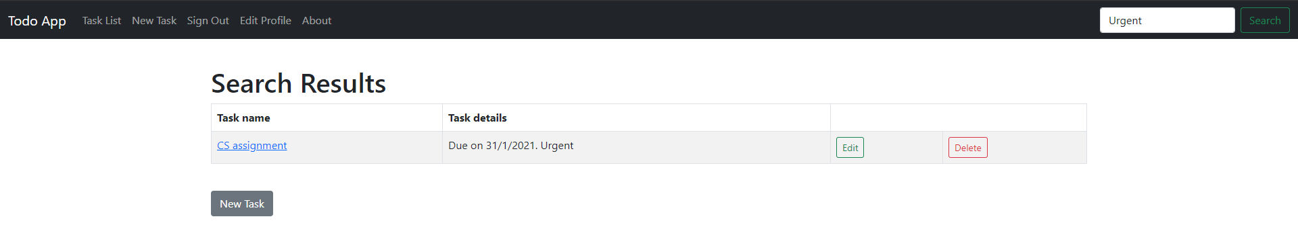

Note that keywords are case sensitive. I.e., urgent will not match Urgent.

**Reflection**

Given that this is my first experience with web dev, I had no clue on where to start from and was abit lost at the beginning. But with some quick google searches, I managed to find several YouTube videos to help guide me through the process. The initial installation was also a huge mess and I encountered several errors trying to install Ruby on Rails. But with some perseverance and Google searches, I managed to install it after several days. Being able to see the Ruby on Rails start up page after running the ‘rails s’ command was itself an achievement due to how complicated the installation process was. Afterwards I followed some guides and videos on how Ruby on Rails works and learnt more about the MVC pattern and databases. It was definitely a good learning experience as design patterns and database schemas are quite commonly used in software engineering/ web dev projects. I also managed to integrate bootstrap to the app which helped improve the UI of the website. Using bootstrap to style the web components was definitely a highlight as I found it fun to play around with the different styles. I also installed a gem called devise to allow users to sign in and sign out and track their individual tasks. This was especially useful once I hosted the app on the Internet. Overall, despite the lack of web dev experience, I feel proud that I managed to craft a simple Todo App from scratch and host it on the Internet for public use. However, some things can still be improved. Currently the database schema is abit messy and the website UI is abit bare. This are things that I hope to improve on in the future so that I can further refine this app.