1. Open the link <https://github.com/yanchenru/CodeTest.git>

Click the green button “Code”, then click “Open with Visual Studio”

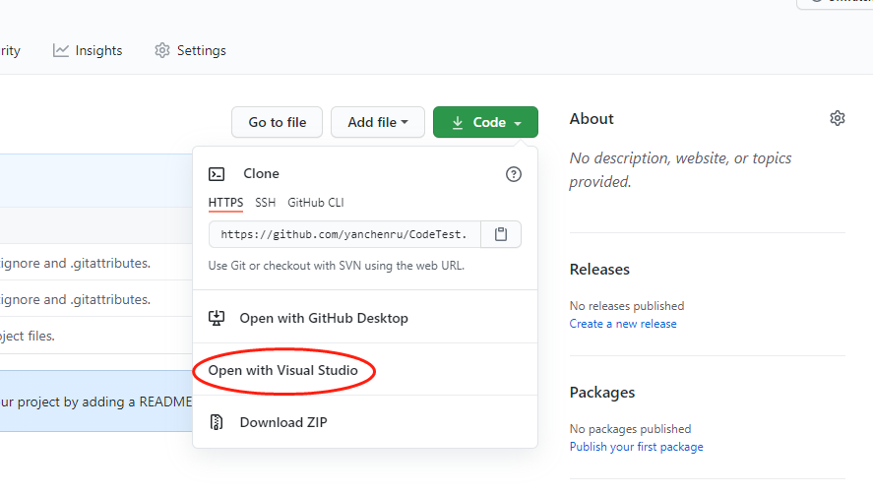

1. Click “Open” if the permission dialog pops up

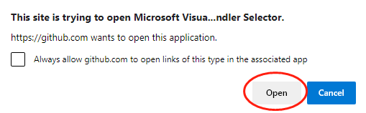

1. In Visual Studio, Team Explorer, Local Git Repositories, Click “Clone”

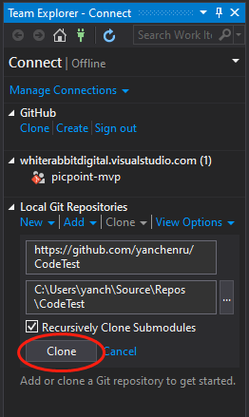

1. Doble click the “CodeTest.sln” to open the project

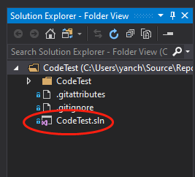

1. Click the “IIS Express” with the green triangle to run the web application

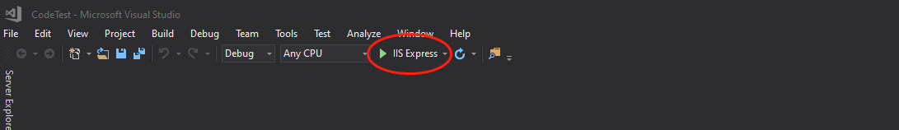

1. If everything goes fine, the web site “https://localhost:44345” will show in the default web browser, the required functionalities can be tested under different pages

