Write Up template for (CCIT4058-AY2324-S1)
Webpage Programming and Design Assignment #2
(Max. 6 pages) This document is for reference only!
Introduction:
This is a sportswear and sports gear selling website. Consist of a interface, a product catalog, 2 difficulties of flipping game, and also a founder page that shows my information.

Built (actual) web site structure:
In this website, I created 4 pages to display content. The “Home” part shows the interface of the website, it allows users to switch to different pages by the header index (highlighted part). The “Product” part first allows users to choose 2 categories, and when user clicks in each category, it displays 5 products each. Next would be the “game” part, same as “product”, it allows users to choose a difficulty when clicked on, and it shows both easy and hard difficulties for a card flipping game. Last would be the “founder” page, which it shows information of myself when password is typed in.


Founder’s Page (Keep your personal web site – password protected):
When the password “JavaScript” is typed, it would display my portfolio that I done on the previous assignment.
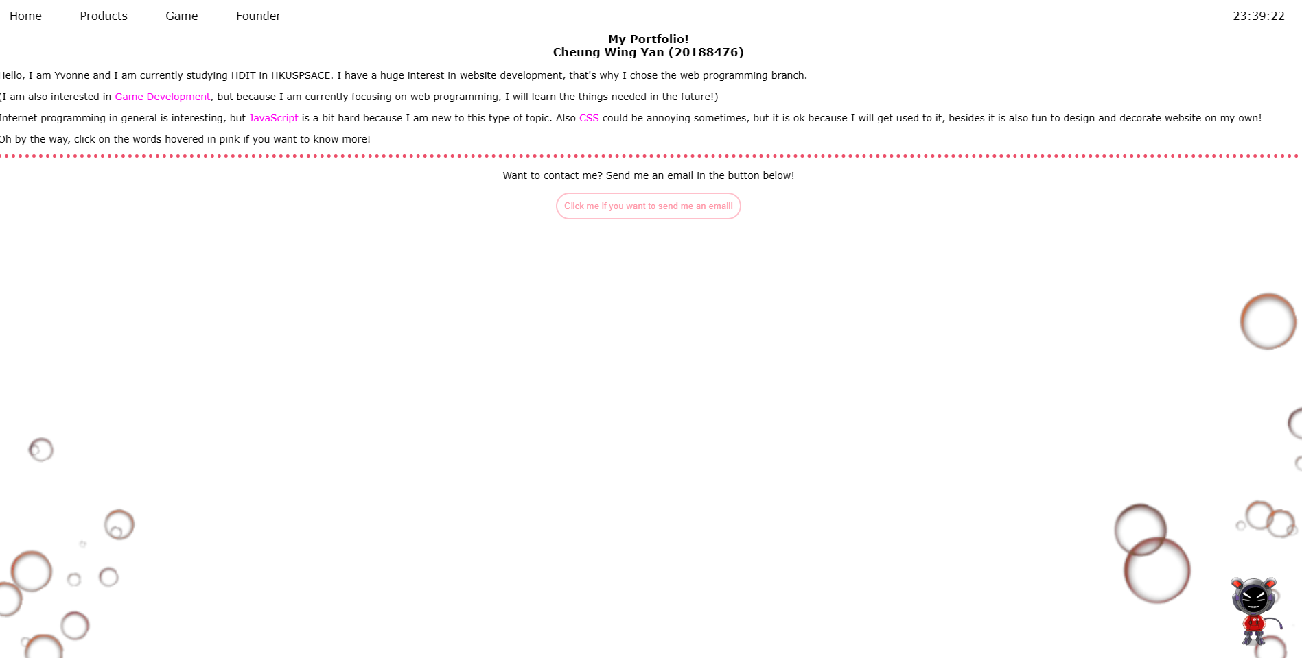

Game (2 levels):
A card flipping game, it popups a message prompt when the user successfully flip all the cards correctly. Consists of hard and easy parts.

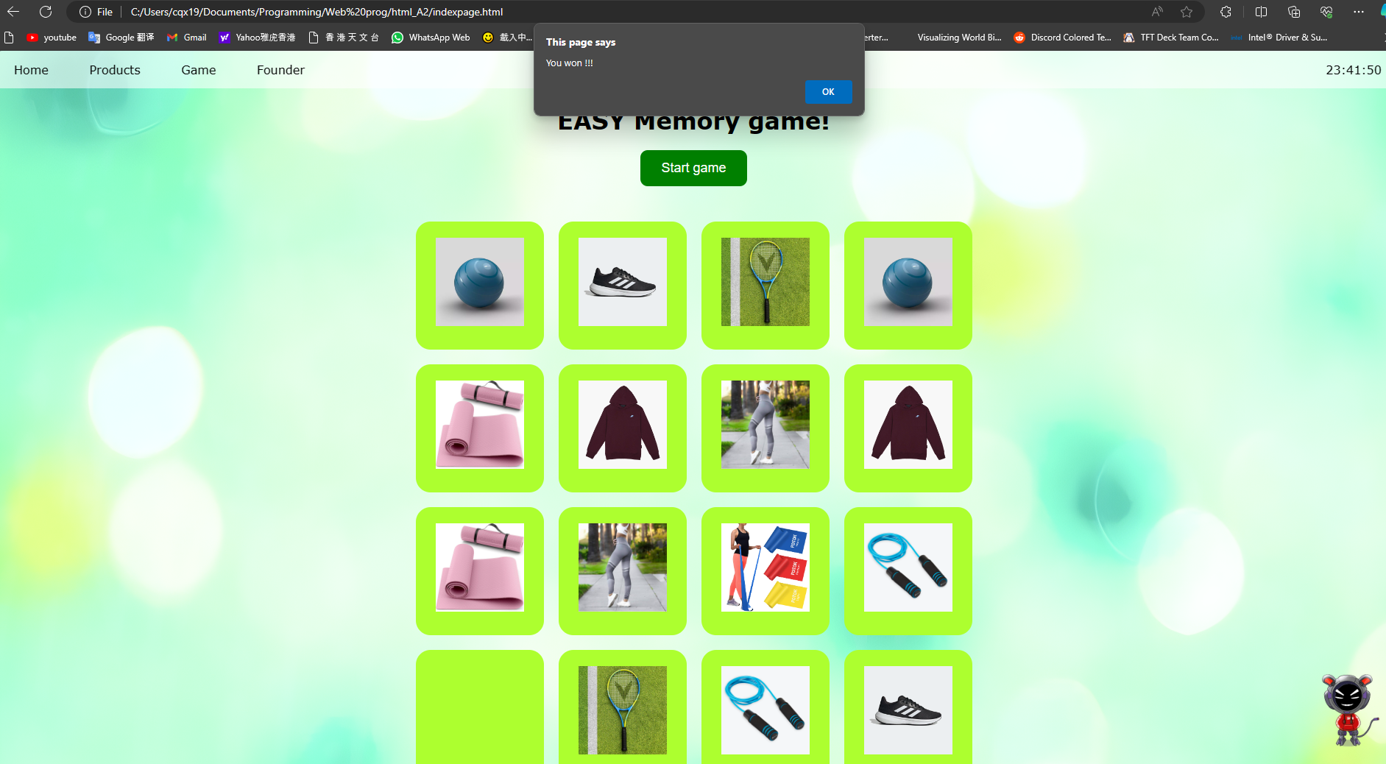

DHTML and JavaScript techniques:
Effect | Applied? | Applied location / locations.  Give proper descriptions.
Top Navigational Bar | Yes / No | All pages
Live Clock | Yes / No | Home.html
Floating images (up and down) | Yes / No | Home.html, Product.html
Fade-in slideshow | Yes / No | Home
Image Rollover | Yes / No | Product.html
Dynamic Content | Yes / No

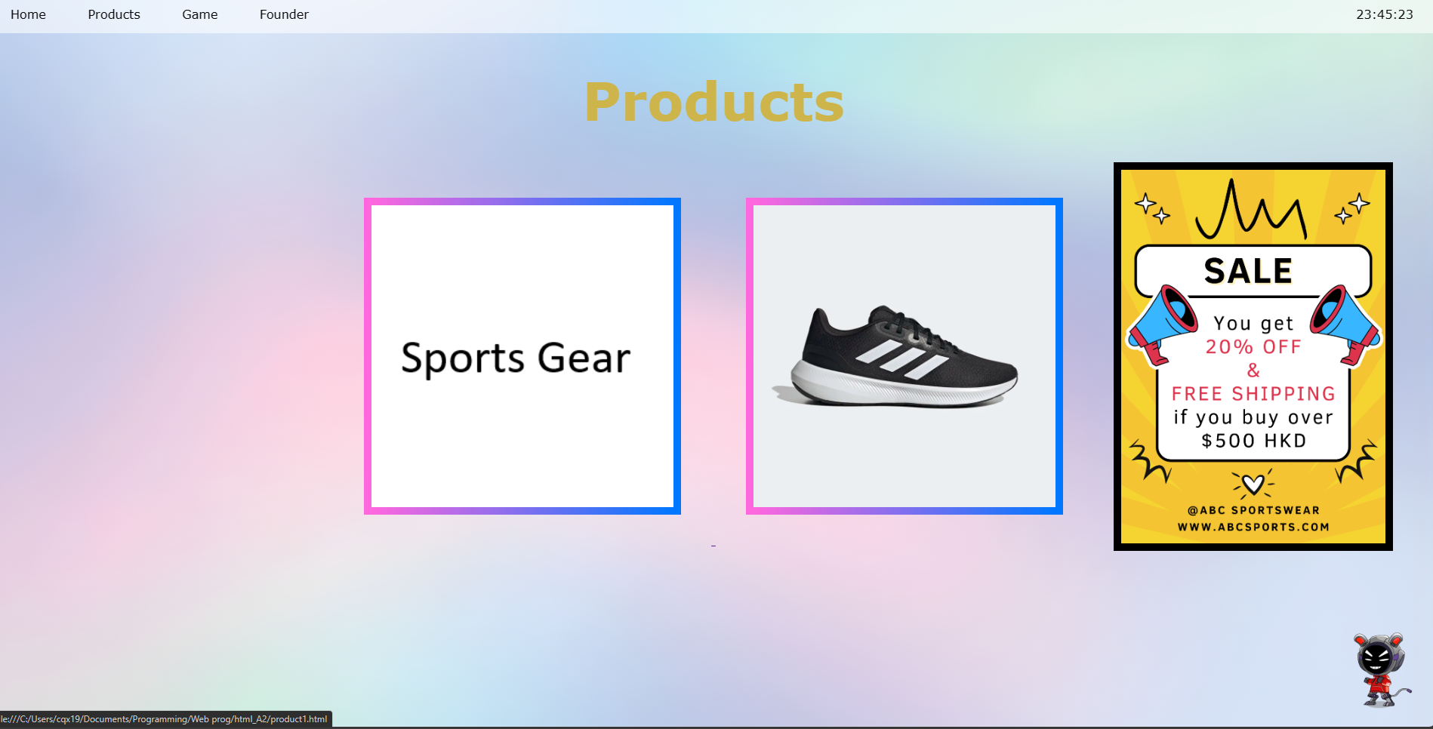

Animations (at least 2 JavaScript enabled animations):
The hiring and sale poster, floating up and down.


Summary / Conclusion
The extra skill I used is that in both the flipping card games, is that I made a prompt that tells the user they won instead of just nothing. Also, every time when the user clicks the “Start game” button, all the cards would be shuffled instead of being in the same position every time. I used a bit of a reference of a website and edited it for a bit.

Reflections:
In this Assignment, I get to know how to make an official website by combining javascript, css, and html. I believe that the skills I used in this assignment could be well used whenever I need to create a website for someone, or for myself in the future. Also, it enhanced my javascript skills because I get to go online and search how do the flipping card game’s code work, as I am not good at javascript.

References:
https://data-flair.training/blogs/flip-card-memory-game-in-javascript/
(how to make a flip card memory game)

