HTML5_Day2_Hands_On_Yandamuri_priyanka
Problem 1
Assessment Goal: Validate understanding of links and form elements.
Hands-on Tasks:
- Create two HTML pages and link them using navigation links
- Add a navigation bar with Home and Contact links
- Create a registration form with:
  - Name
  - Email
  - Password
  - Gender (radio buttons)
  - Course selection (dropdown)
- Use required and placeholder attributes
Expected Outcome:
A multi-page website with working navigation and a basic form.
Actual Code
Index.html
<!DOCTYPE html>
<html lang="en">
<head>
<meta charset="UTF-8">
<title>FORMS</title>
</head>
<body>
<nav>
<a href="home.html">Home</a> |
<a href="contact.html">Contact</a>
</nav>
<h1>Registration Form</h1>
<form action="success.html">
<!--Name Field-->
<label for="name">Name</label><br>
<input id="name" name="name" type="name"
placeholder="Enter Your Name" required>
<br>
<!--Email Field-->

<label for="email">Email</label><br>
<input id="email" name="email" type="email"
placeholder="Enter Your Mail" required>
<br>
<!--Password Field-->

<label for="password">Password</label><br>
<input id="password" name="password" type="password"
placeholder="Enter Your Password" required>
<br>
<!--Gender Field-->

<label>Gender</label><br>
<input type="radio" name="gender" value="Male" required> Male
<input type="radio" name="gender" value="Female" required> Female
<br>
<!--Gender Field-->
<label for="course">Courses</label><br>
<input id="course" name="course" list="courselist"
placeholder="Select a course" required>
<datalist id="courselist">
<option value="HTML">
<option value="CSS">
<option value="JS">
<option value="JAVA">
</datalist>
<br><br>
<!--Register-->
<input type="submit" value="Register">
</form>
</body>
</html>

Home.html
<!DOCTYPE html>
<html lang="en">
<head>
<meta charset="UTF-8">

<title>
home
</title>

</head>
<nav>
<a href="home.html">Home</a> |
<a href="contact.html">Contact</a>
</nav>

<body>
<h1>This is Home Page.</h1>
</body>
</html>

Success.html
<!DOCTYPE html>
<html lang="en">
<head>
<meta charset="UTF-8">
<title>Registration Success</title>
</head>
<body>
<nav>
<a href="home.html">Home</a> |
<a href="contact.html">Contact</a>
</nav>

<h1>Successfully Registered!</h1>

<p>Your form has been submitted.</p>
<p>Thank you for joining our coaching institute.</p>

<a href="home.html">Go Back to Home</a>

</body>
</html>

Code Screenshot
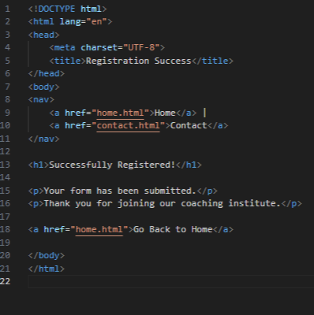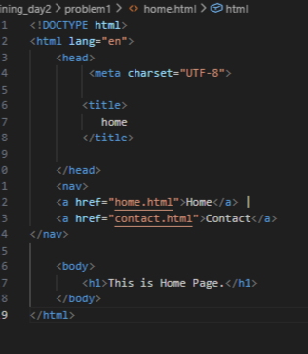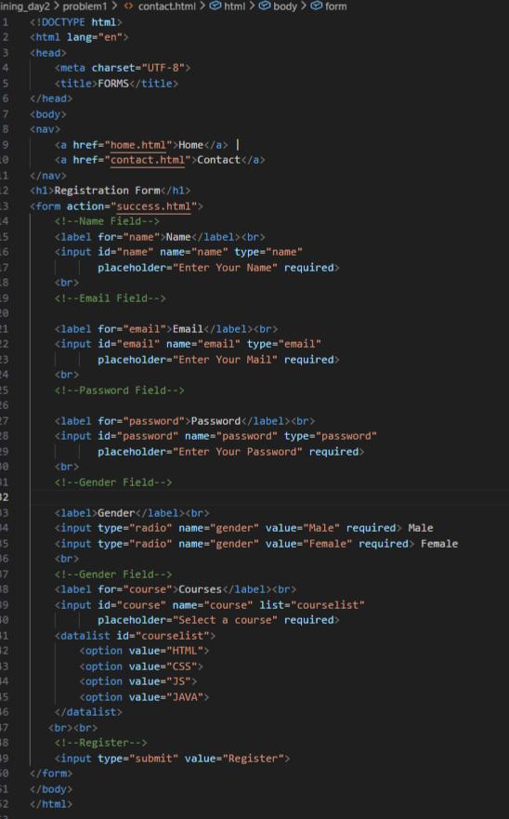

Code Output
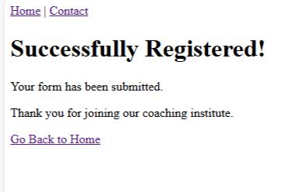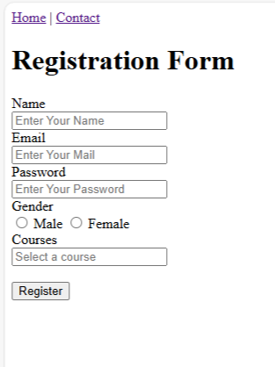

Technical Requirements
This task creates a simple multi-page website with Home and Contact pages connected using navigation links.
The Contact page includes a registration form to collect name, email, password, gender, and course.
HTML5 attributes like required and placeholder are used for basic validation and user guidance.
Problem_2
Problem 2: Simple Website Navigation System (Level-1)
Scenario
A small coaching institute wants a basic static website with multiple pages so students can easily navigate between sections like Home, Courses, and Contact.
📌 Requirements
- Create 3 HTML pages:
  - index.html (Home)
  - courses.html
  - contact.html
- Use:
  - <nav> element to create a navigation menu
  - <a> anchor tags for navigation
- Navigation menu should appear on all pages
- Use relative paths to link pages
- Include at least:
  - One internal anchor link (#section)
  - One external link (e.g., institute’s social media)

🛠️ Technical Constraints
- Only HTML5
- No CSS or JavaScript
- Navigation must be semantic (<nav>)
🎯 Learning Outcome
You should be able to:
- Use <nav> and <a> elements
- Understand relative paths
- Build a simple multi-page navigation structure
- Users should move seamlessly between pages
- Code should be readable and well-indented
- Navigation links should work correctly

Actual code
Contact.html
<!DOCTYPE html>
<html>
<head>
<meta charset="UTF-8">
<title>Coaching Institute - Contact</title>
</head>
<body>
<nav>
<a href="index.html">Home</a> |
<a href="courses.html">Courses</a> |
<a href="contact.html">Contact</a> |

<a href="https://www.facebook.com" target="_blank">Our Facebook</a>
</nav>
<h1>Contact Us</h1>

<p>Email: info@brightfuture.com</p>
<p>Phone: +91 9876543210</p>
<p>Address: Hyderabad, India</p>
</body>
</html>

Courses.html
<!DOCTYPE html>
<html>
<head>
<meta charset="UTF-8">
<title>Coaching Institute - Courses</title>
</head>
<body>
<nav>
<a href="index.html">Home</a> |
<a href="courses.html">Courses</a> |
<a href="contact.html">Contact</a> |

<a href="https://www.facebook.com" target="_blank">Our Facebook</a>
</nav>
<h1>Our Courses</h1>
<ul>
<li>Mathematics</li>
<li>Physics</li>
<li>Chemistry</li>
<li>Computer Science</li>
</ul>
</body>
</html>

Index.html
<!DOCTYPE html>
<html lang="en">
<head>
<meta charset="UTF-8">
<title>Coaching Institute - Home</title>
</head>
<body>

<!-- Navigation Menu (same in all pages) -->
<nav>
<a href="index.html">Home</a> |
<a href="courses.html">Courses</a> |
<a href="contact.html">Contact</a> |

<a href="https://www.instagram.com" target="_blank">Instagram</a>
</nav>

<h1>Welcome to ABC Coaching Institute</h1>
<p>We provide quality education for students.</p>

<h2 id="about">About Us</h2>
<p>
ABC Institute helps students prepare for exams, programming,
and career skills. Our trainers are experienced professionals.
</p>

</body>
</html>

Code Screenshot
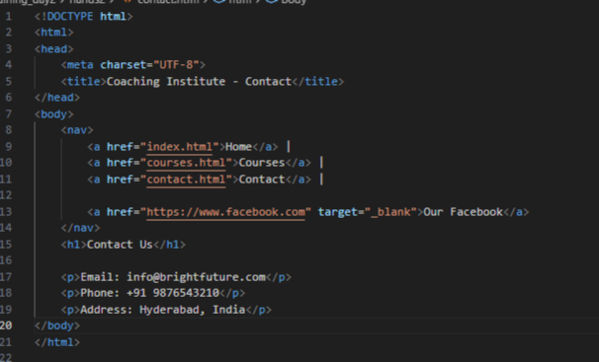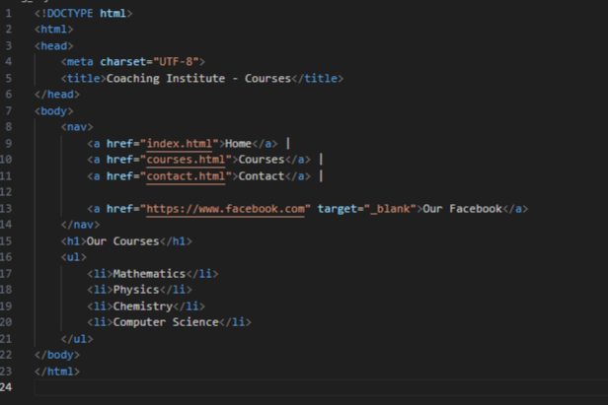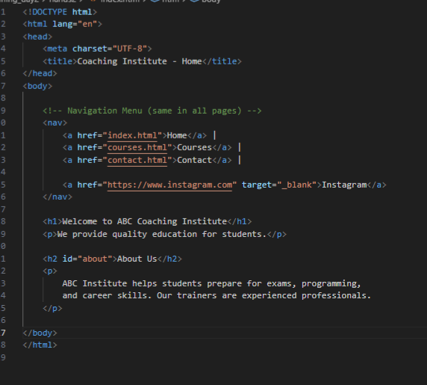

Code output
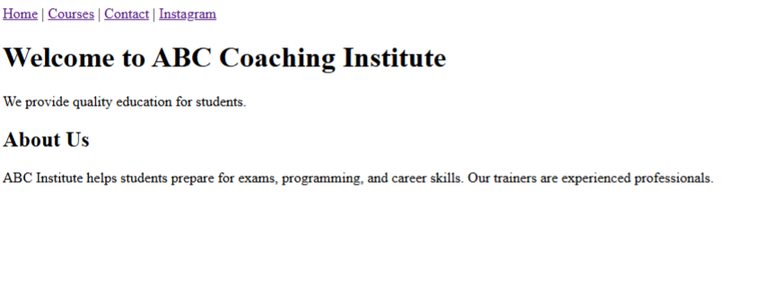
Technical Requirements
The website should be developed using only HTML5 without CSS or JavaScript. A semantic <nav> element must be included on every page, containing <a> anchor links that connect index.html, courses.html, and contact.html using relative paths. The same navigation menu should appear consistently across all pages. The site must also include one internal anchor link (#section) and one external link (such as a social media page). All links should function correctly to allow smooth navigation between pages, and the code should be properly structured and readable.

Problem_3

Problem 3: Student Registration Form with Input Types (Level-1)
Scenario
An institute wants a basic student registration form with built-in validation to reduce incorrect submissions.
📌 Requirements
Create an HTML webpage that includes:
Create a form with following input types:
- text (Name)
- email
- tel
- number (Age)
- date
Use HTML5 built-in validation:
- required
- min, max
- pattern (for phone number)
Add submit button

🛠️ Technical Constraints
- HTML5 only
- No JavaScript validation
- Use proper <label> tags

🎯 Learning Outcome
You will be able to:
- Use advanced input types
- Apply built-in HTML5 validation
- Improve form usability without JavaScript
- Browser should show validation errors automatically
- Inputs should restrict invalid values
- Form should be user-friendly
Actual Code
<!DOCTYPE html>
<html lang="en">
<head>
<meta charset="UTF-8">
<title>Student Registration</title>
</head>
<body>

<h2>Student Registration Form</h2>

<form>

<!-- Name -->
<label for="name">Full Name:</label><br>
<input type="text" id="name" name="name"
placeholder="Enter your name"
required>
<br><br>

<!-- Email -->
<label for="email">Email:</label><br>
<input type="email" id="email" name="email"
placeholder="example@gmail.com"
required>
<br><br>

<!-- Phone -->
<label for="phone">Phone Number:</label><br>
<input type="tel" id="phone" name="phone"
placeholder="10 digit mobile number"
pattern="[0-9]{10}"
required>
<br><br>

<!-- Age -->
<label for="age">Age:</label><br>
<input type="number" id="age" name="age"
min="17" max="60"
required>
<br><br>

<!-- Date of Birth -->
<label for="dob">Date of Birth:</label><br>
<input type="date" id="dob" name="dob"
required>
<br><br>

<!-- Submit -->
<input type="submit" value="Register">

</form>

</body>
</html>

Code Screenshot
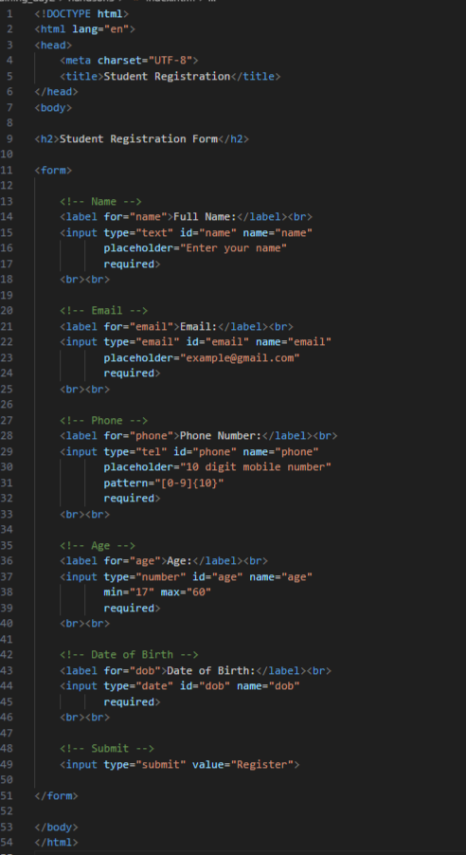
Code output
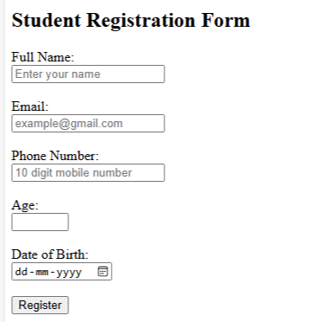

Technical Requirements
In this program I created the student registration form using only HTML5 tags. I did not use any JavaScript for validation because the browser itself checks the input values. I used HTML attributes like required, min, max, and pattern to prevent wrong data entry. I also connected every input field with proper <label> tags using for and id so the form is clear and user-friendly. The form completely depends on HTML5 validation to accept only correct details from the user.
Problem_4
Problem 4: Multi-Page Website with Breadcrumb Navigation (Level-2)
Scenario
A training portal website has multiple levels of pages and users often get confused about where they are. The company wants breadcrumbs for better navigation.
📌 Requirements
Pages:
- Home
- Courses
- Web Development
- HTML Course
Implement:
- <nav> for main menu
- Breadcrumb navigation using anchor tags
Example:
Home > Courses > Web Development > HTML
Use:
- Hierarchical linking
- Relative paths
Breadcrumb should update based on page hierarchy

🛠️ Technical Constraints
- HTML5 only
- No CSS frameworks
- Semantic elements preferred

🎯 Learning Outcome
Learners should be able to:
- Breadcrumbs must reflect correct page structure
- Navigation must work without broken links
- Clear hierarchy in folder structure
- Design hierarchical navigation
- Implement breadcrumbs
- Understand real-world website structure
Actual Code
<!DOCTYPE html>
<html lang="en">
<head>
<meta charset="UTF-8">
<title>Home</title>
</head>
<body>

<!-- Main Menu -->
<nav>
<a href="index.html">Home</a> |
<a href="courses/index.html">Courses</a>
</nav>

<h1>Training Portal</h1>

<!-- Breadcrumb -->
<nav>
<a href="index.html">Home</a>
</nav>

<p>Welcome to our training website.</p>

</body>
</html>

<!DOCTYPE html>
<html lang="en">
<head>
<meta charset="UTF-8">
<title>Home</title>
</head>
<body>

<!-- Main Menu -->
<nav>
<a href="index.html">Home</a> |
<a href="courses/index.html">Courses</a>
</nav>

<h1>Training Portal</h1>

<!-- Breadcrumb -->
<nav>
<a href="index.html">Home</a>
</nav>

<p>Welcome to our training website.</p>

</body>
</html>

<!DOCTYPE html>
<html lang="en">
<head>
<meta charset="UTF-8">
<title>Web Development</title>
</head>
<body>

<nav>
<a href="../../index.html">Home</a> |
<a href="../index.html">Courses</a>
</nav>

<h1>Web Development</h1>

<!-- Breadcrumb -->
<nav>
<a href="../../index.html">Home</a> >
<a href="../index.html">Courses</a> >
Web Development
</nav>

<p>Available Course:</p>
<a href="html-course.html">HTML Course</a>

</body>
</html>

<!DOCTYPE html>
<html lang="en">
<head>
<meta charset="UTF-8">
<title>HTML Course</title>
</head>
<body>

<nav>
<a href="../../index.html">Home</a> |
<a href="../index.html">Courses</a>
</nav>

<h1>HTML Course</h1>

<!-- Breadcrumb -->
<nav>
<a href="../../index.html">Home</a> >
<a href="../index.html">Courses</a> >
<a href="index.html">Web Development</a> >
HTML Course
</nav>

<p>This page contains HTML course details.</p>

</body>
</html>

Code screen shot
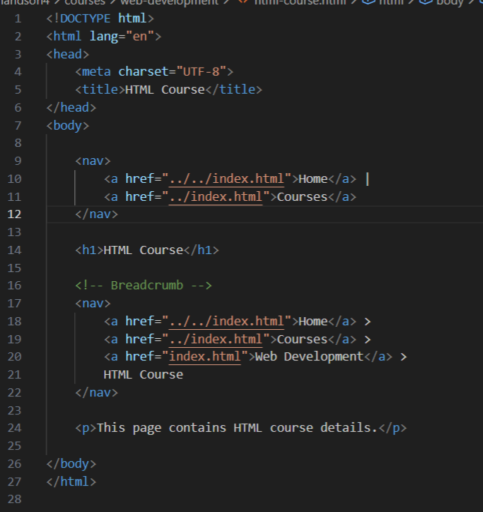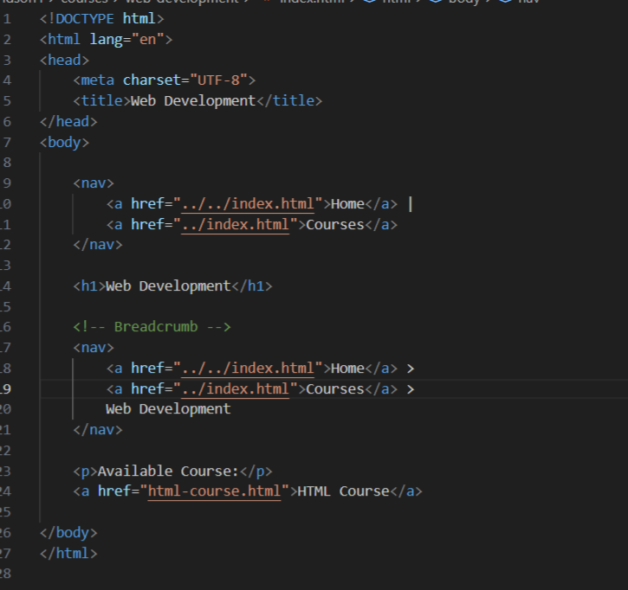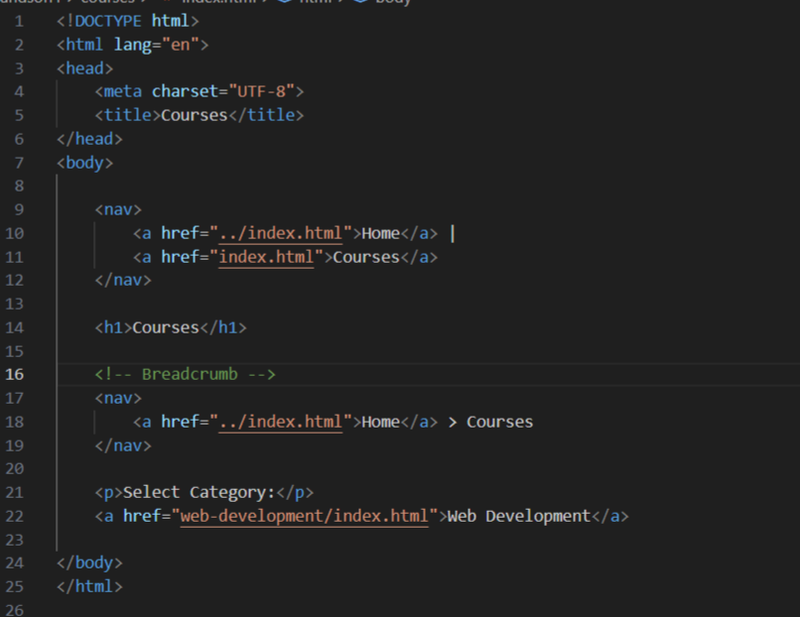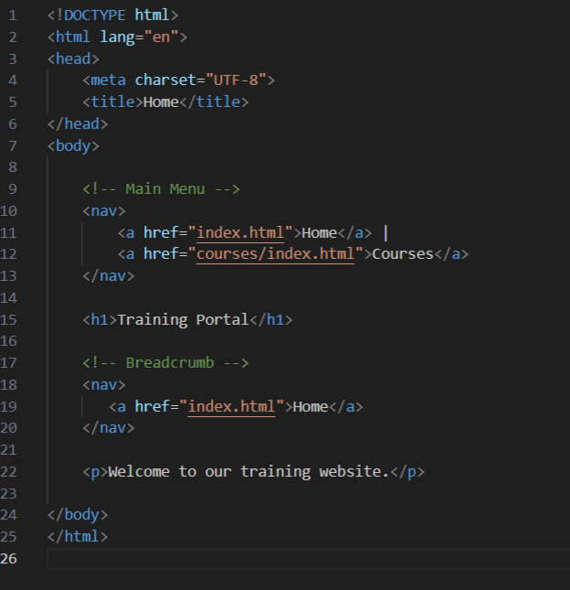
Code output
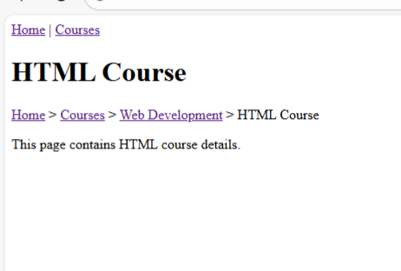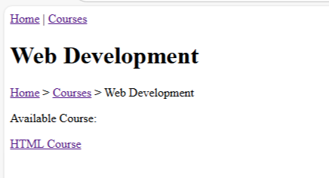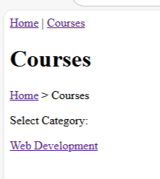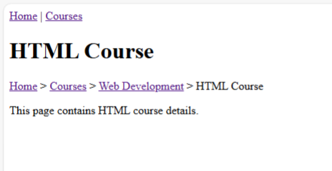
Technical Requirements
In this task I created a multi-page website using only HTML5. I did not use any CSS frameworks or external libraries. I used semantic tags like <nav> to design the main navigation menu and breadcrumb navigation. All pages are connected using relative paths based on the folder hierarchy. The breadcrumb links are created using anchor tags and they change according to each page level (Home > Courses > Web Development > HTML Course). The navigation works correctly without broken links and follows the proper website structure.

Problem 5: Course Enrollment Form with Advanced HTML Elements
Scenario
An online learning platform wants to enhance user experience by showing course progress, skill levels, and suggested inputs while filling the form.
📌 Requirements
Create an enrollment form using:
- <datalist> for course suggestions
- <progress> to show enrollment completion
- <meter> to indicate skill level (Beginner–Advanced)
Include modern input types:
- email
- range
- number
Use built-in validation

🛠️ Technical Constraints
- HTML5 only
- No JavaScript or CSS
- Must use semantic elements

🎯 Learning Outcome
You will be able to:
- Use advanced HTML5 elements
- Enhance form UX without JavaScript
- Understand real-time data representation in HTML
Browser should display:
- Dropdown suggestions via <datalist>
- Progress bar updates (static value)
- Meter shows skill level visually
Clean and structured form layout
Actual Code
<!DOCTYPE html>
<html lang="en">
<head>
<meta charset="UTF-8">
<title>Course Enrollment</title>
</head>
<body>

<header>
<h1>Online Learning Platform</h1>
</header>

<main>

<!-- Progress Section -->
<section>
<h2>Enrollment Completion</h2>
<!-- static progress value -->
<progress value="70" max="100"></progress>
<p>70% completed</p>
</section>

<hr>

<!-- Form Section -->
<section>
<h2>Enroll in a Course</h2>

<form action="#" method="post">

<!-- Name -->
<label for="name">Full Name:</label><br>
<input type="text" id="name" name="name" required>
<br><br>

<!-- Email -->
<label for="email">Email:</label><br>
<input type="email" id="email" name="email" placeholder="example@gmail.com" required>
<br><br>

<!-- Course Suggestion using datalist -->
<label for="course">Select Course:</label><br>
<input list="courses" id="course" name="course" placeholder="Start typing..." required>

<datalist id="courses">
<option value="HTML">
<option value="CSS">
<option value="JavaScript">
<option value="Python">
<option value="React">
<option value="Data Science">
</datalist>
<br><br>

<!-- Age -->
<label for="age">Age:</label><br>
<input type="number" id="age" name="age" min="15" max="60" required>
<br><br>

<!-- Skill Range -->
<label for="skill">Your Skill Level:</label><br>
Beginner
<input type="range" id="skill" name="skill" min="0" max="100" value="50">
Advanced
<br><br>

<!-- Meter Indicator -->
<label>Skill Level Indicator:</label><br>
<meter value="50" min="0" max="100" low="30" high="70" optimum="90"></meter>
<br><br>

<!-- Submit -->
<input type="submit" value="Enroll">

</form>

</section>

</main>

<footer>
<p>© 2026 Online Learning Platform</p>
</footer>

</body>
</html>
Code screenshot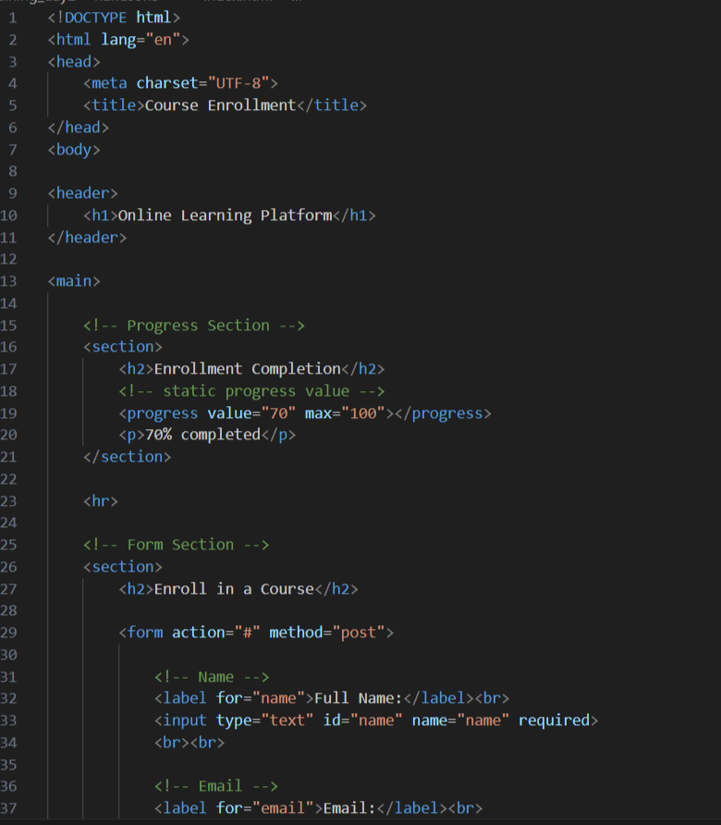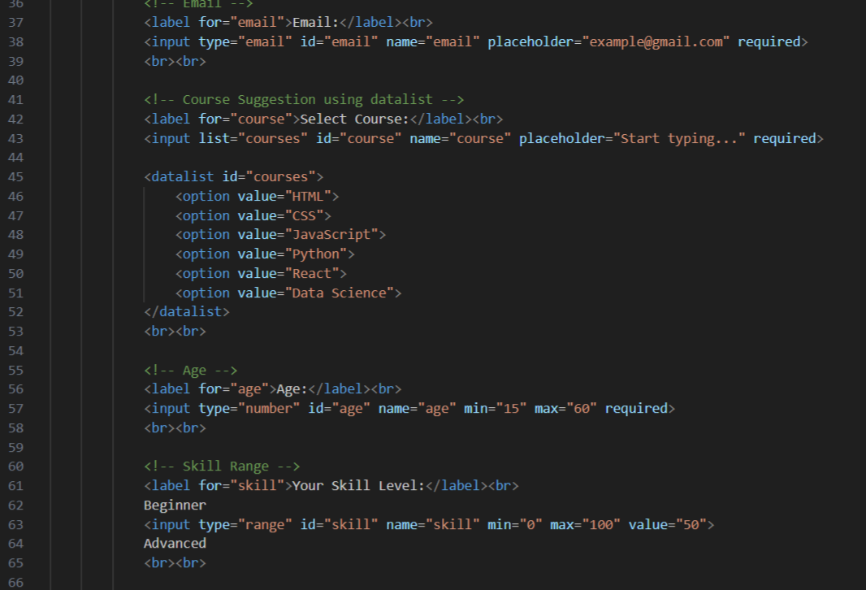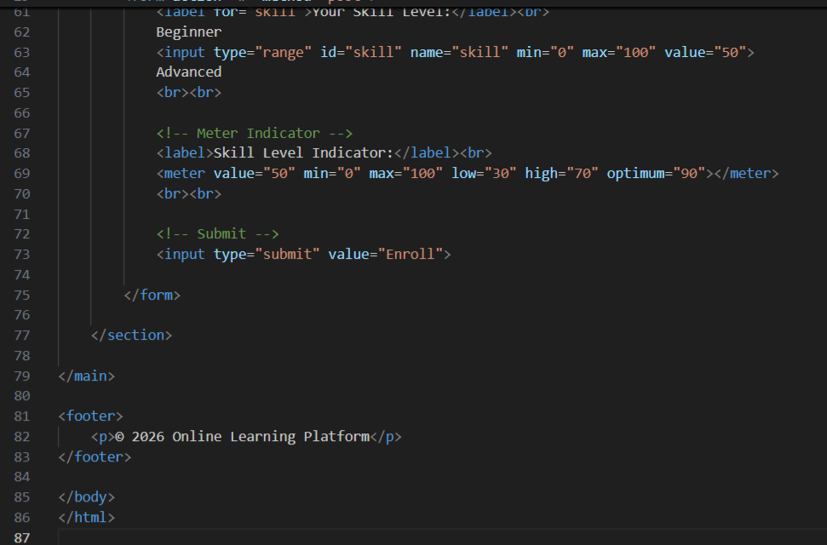
output
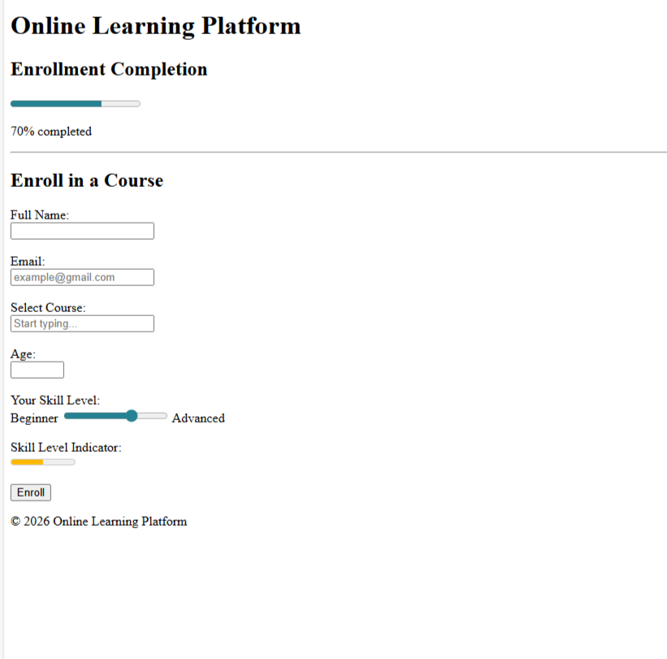
Technical requirements
In this task I created the course enrollment form using only HTML5 features without using JavaScript or CSS. I used semantic elements like <header>, <main>, <section>, and <form> to structure the page properly. The <datalist> element is used to provide course suggestions while typing. The <progress> tag shows the enrollment completion status and the <meter> tag displays the skill level visually. I also used modern input types such as email, number, and range with built-in validation attributes so the browser automatically checks user input.

