HTML5_Day1_Hands_On_Yandamuri_Priyanka
Problem1
1.Assessment Goal: Check if learners understand basic HTML structure and content creation.
Hands-on Tasks:
1. Create a basic HTML page with proper structure (DOCTYPE, head, body)
2. Add a heading and a paragraph introducing yourself
3. Create an unordered list showing your hobbies
4. Create an ordered list showing daily routine steps
5. Create a simple table showing:
o Student Name
o Subject
o Marks
Expected Outcome:
A static HTML page that displays structured content correctly in the browser.

Actual Code
<!DOCTYPE html>
<html lang="en">
<head>
<meta charset="UTF-8">
<title>problem1</title>
</head>
<body>
<h1>About Myself</h1>
<p>My name is Yandamuri Priyanka. I had completed my B.Tech.</p>
<h3>Hobbies</h3>
<ul>
<li>Cooking</li>
<li>Watching Movies</li>
<li>Playing games</li>
</ul>
<h3>Daily Routine</h3>
<ol>
<li>Eating</li>
<li>Reading</li>
<li>Sleeping</li>
</ol>
<h3>Student Table</h3>
<table border="1">
<thead>
<tr>
<th>Student Name</th>
<th>Subject</th>
<th>Marks(%)</th>
</tr>
</thead>
<tbody>
<tr>
<td>priya</td>
<td>maths</td>
<td>80%</td>
</tr>
<tr>
<td>pramee</td>
<td>science</td>
<td>30%</td>
</tr>
</tbody>
</table>
</body>
</html>

Code Screenshot
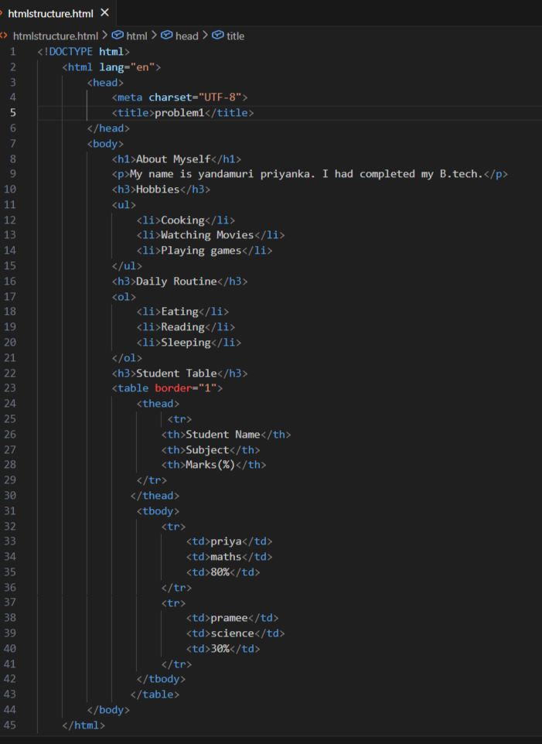
Code output
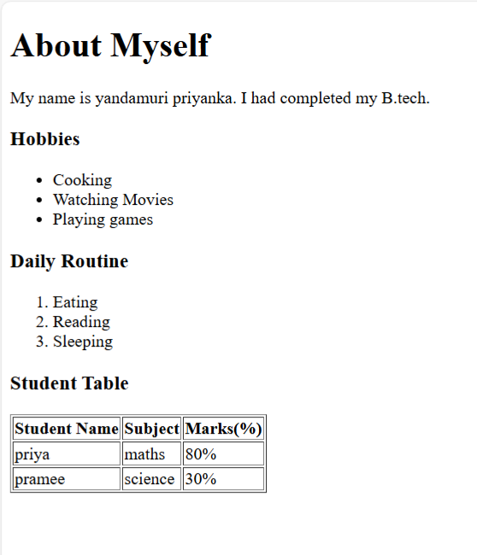
Technical requirements
We need to create a simple webpage using basic HTML only.
The page must start with the proper HTML5 structure and should run correctly in a browser.
Inside the page, we should write a heading and a small paragraph about ourselves.
Then we need to show our hobbies using a bullet list and our daily routine using a numbered list. After that, we must create a table that displays student name, subject, and marks using rows and columns. The file should be saved as a .html file, all tags must be properly opened and closed, and no CSS or JavaScript is required.

PROBLEM_2
Problem: Restaurant Menu Webpage (Level-1)
Scenario
A small restaurant wants a basic menu webpage to display their offerings online before moving to a full website.
Requirements
Create an HTML page that displays:
Restaurant Name (Heading)
About the Restaurant (Paragraph)
Menu Categories (Unordered List)
Price List (Table)
Table Structure
Item Name
Category
Price (₹)
Paneer Butter Masala
Main Course
220
Veg Biryani
Main Course
180
Masala Dosa
Breakfast
90
Cold Coffee
Beverages
120
️ Technical Constraints
Use proper HTML boilerplate
Use at least 5 HTML elements
Use HTML attributes such as border, title, align
Use:
<table>, <tr>, <th>, <td>
<ul> and <li>
Learning Outcome
You should be able to:
Build a complete HTML page structure
Use tables for structured data
Use lists for grouped information

Actual Code
<!DOCTYPE html>
<html lang="en">
<head>
<meta charset="UTF-8">
<title>problem2</title>
</head>
<body>
<h1>Hotel International</h1>
<p>A popular Spot in Kurnool known for high quality food, good service.</p>
<h3>
Menu Categories
</h3>
<ul>
<li>Main course</li>
<li>Breakfast</li>
<li>bevarages</li>
<li>Staters</li>
</ul>
<h3>Price List</h3>
<table border="1">
<thead>
<tr>
<th>Item Name</th>
<th>Category</th>
<th>Price(₹)</th>
</tr>
</thead>
<tbody>
<tr>
<td>Paneer Butter Masala</td>
<td>Main Course</td>
<td>220</td>
</tr>
<tr>
<td>Veg Biryani</td>
<td>Main Course</td>
<td>180</td>
</tr>
<tr>
<td>Masala Dosa</td>
<td>Breakfast</td>
<td>90</td>
</tr>
<tr>
<td>Cold Coffee</td>
<td>Beverages</td>
<td>120</td>
</tr>
</tbody>
</table>
</body>
</html>

Code Screenshot
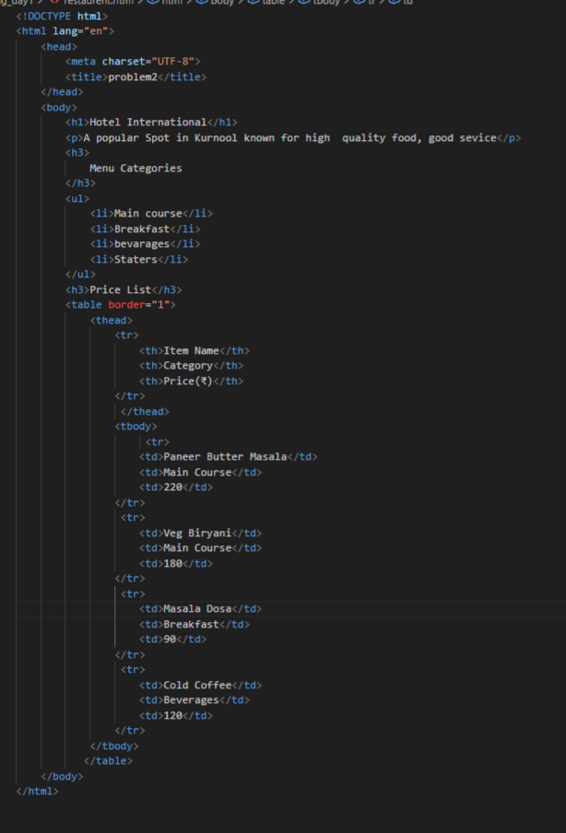
Code Output
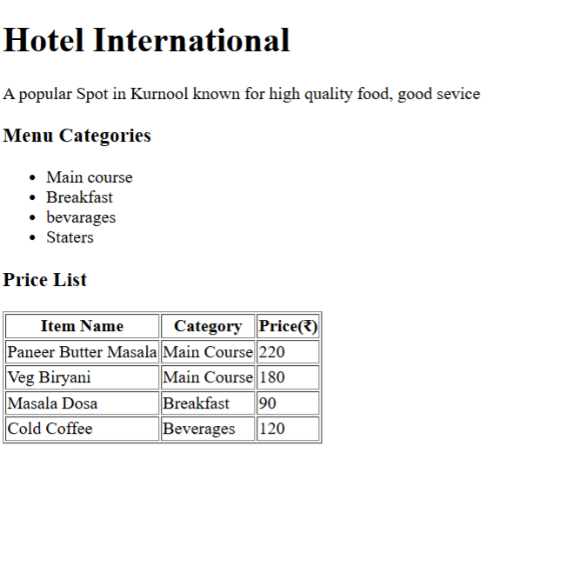
Technical Requirements
We need to create a simple restaurant menu webpage using only basic HTML.
The page must follow the proper HTML structure with DOCTYPE, html, head, and body. The restaurant name should appear as a heading and a short description should be written in a paragraph.
Menu categories must be shown using a bullet list, and the food items with prices must be displayed in a table using rows and columns. We should use tags like <table>, <tr>, <th>, <td>, <ul>, and <li>, and also include attributes such as border, title, and align. The file should be saved as a .html file and open correctly in the browser. No CSS or JavaScript is needed.

PROBLEM_3
Problem 3: Personal Grocery Checklist (Level-1)
Scenario
You are building a simple webpage for personal use to plan your weekly grocery shopping. The page should clearly show priority items and optional items, so it’s easy to decide what to buy first.
Requirements
Create an HTML webpage that includes:
A page title:
Weekly Grocery Checklist
A main heading displaying the same title.
An Ordered List showing high-priority grocery items, such as:
Rice
Milk
Vegetables
Cooking Oil
An Unordered List showing optional or non-essential items, such as:
Snacks
Ice cream
Soft drinks
️ Technical Constraints
Use proper HTML boilerplate:
<!DOCTYPE html>
<html>, <head>, <body>
Use:
<ol> and <ul> correctly
<li> for each item
Add at least one HTML attribute (example: title)
Ensure proper indentation and readability

Actual Code
<!DOCTYPE html>
<html lang="en">
<head>
<meta charset="UTF-8">
<title>Weekly Grocery Checklist

</title>

</head>
<body>
<h1>Weekly Grocery Checklist</h1>
<h3>high-priority grocery items</h3>
<ol>
<li>Rice</li>
<li>Milk</li>
<li>Vegetables</li>
<li>Cooking Oil</li>

</ol>
<h3>optional or non-essential items</h3>
<ul>
<li>Snacks</li>
<li>Ice cream</li>
<li>Soft drinks</li>

</ul>

</body>
</html>

Code screenshot
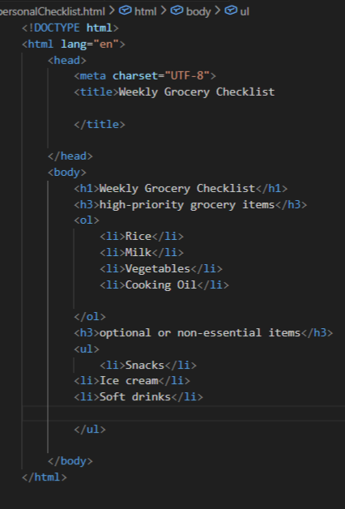
Output
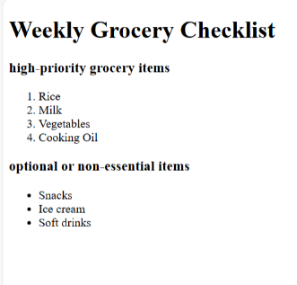
Technical Requirements
We need to create a basic HTML webpage for a grocery checklist using the correct HTML structure (DOCTYPE, html, head, body).The page should show the title “Weekly Grocery Checklist” as both the page title and the main heading. High-priority items must be displayed using a numbered list (<ol>), and optional items must be displayed using a bullet list (<ul>). Each item should be written inside <li> tags. At least one HTML attribute (like title) should be used, and the code should be neatly indented and readable. No CSS or JavaScript is required.

PROBLEM_4
Problem 4: Employee Onboarding Page (Level-2)
Scenario
A company wants a basic onboarding page for new employees that HR can later style using CSS.
Requirements
Use Semantic HTML:
<header> → Company name & welcome message
<section> → Employee details
<article> → Company policies
<footer> → Contact information
Content Structure
Employee Information (Table)
Employee ID
Name
Department
Joining Date
Company Policies (Ordered List)
Working hours
Leave policy
Code of conduct
Facilities Provided (Unordered List)
Laptop
Internet access
Training materials
️ Technical Constraints
· Use semantic tags only (no <div> for layout)
· Add meaningful attributes (title, lang, etc.)
· Proper indentation & readability
Learning Outcome
Learners should be able to:
Explain why semantic HTML matters
Differentiate between structural and non-structural tags
Build readable, SEO-friendly HTML
Actual Code
<!DOCTYPE html>
<html lang="en">
<head>
<meta charset="UTF-8">
<title>problem4</title>
</head>
<body>
<header>
<h1>XYZ</h1>
<p>Welcome to XYZ</p>
</header>
<section>
<h2>Employee Information</h2>
<table border="1">
<thead>
<tr>
<th>Employee ID</th>
<th>Name</th>
<th>Department</th>
<th>Joining Date</th>
</tr>
</thead>
<tbody>
<tr>
<td>123</td>
<td>Priyanka</td>
<td>ECE</td>
<td>13/5/2026</td>
</tr>
<tr>
<td>233</td>
<td>Sreya</td>
<td>ECE</td>
<td>14/2/2025</td>

</tr>
<tr>
<td>45523</td>
<td>Kavya</td>
<td>CSE</td>
<td>14/03/2024</td>
</tr>
</tbody>
</table>
</section>
<article>
<h3> Company Policies</h3>
<ol>
<li>Working hours</li>
<li>Leave Policy</li>
<li>Code of conduct</li>
</ol>
</article>
<h3>Facilites Provided</h3>
<ul>
<li>Laptop</li>
<li>Internet access</li>
<li>Training materials</li>
</ul>
<footer>
<h3>Contact Information</h3>
<p>venkaya palle road, vizag.
<br/>contact:+91 47829746235e
<br/>mail: XYZ1234@gmail.com</p>

</footer>
</body>
</html>

Code Screenshot
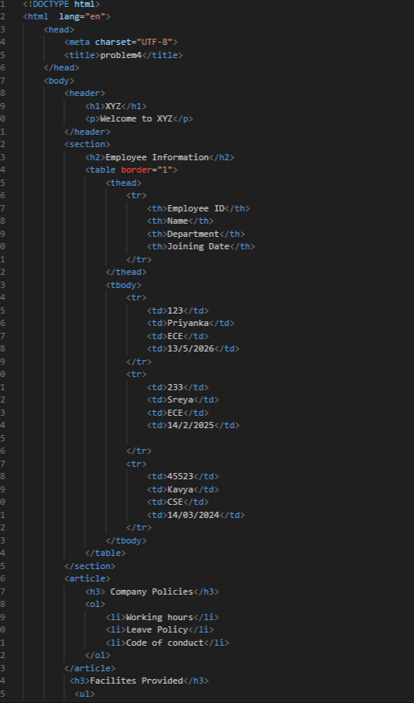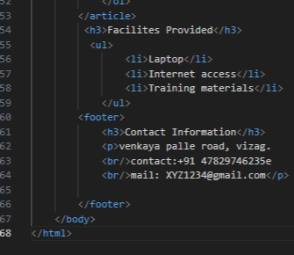

Code output
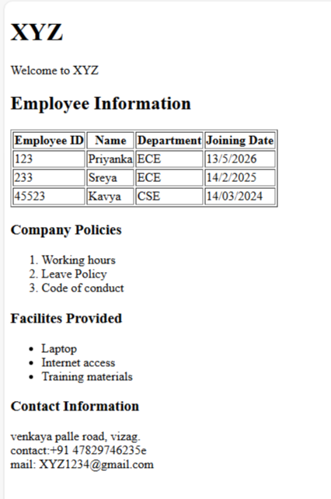

Technical requirements
We need to create an employee onboarding webpage using semantic HTML tags only.
The page should have a <header> for company name and welcome message, a <section> for employee details, an <article> for company policies, and a <footer> for contact information. Employee information must be shown in a table, company policies in a numbered list, and facilities in a bullet list. We should also use meaningful attributes like lang or title, and keep the code properly indented and easy to read.

PROBLEM_5
Problem 5: College Department Information Page (Level-2)
Scenario
A college wants to create a basic informational webpage for one of its departments (e.g., Computer Science, Information Technology).
The page will be used by students and parents to understand faculty details, subjects offered, and the weekly timetable before the site is enhanced with CSS and backend features.
📌 Requirements
Create an HTML webpage that includes the following sections:
- Header
  - Department Name
  - College Name
- Section 1: Faculty Details
  - Display faculty information in a table with columns:
    - Faculty Name
    - Designation
    - Subject Handled
- Section 2: Subjects Offered
  - Display the list of subjects using an unordered list
- Section 3: Weekly Timetable
  - Display timetable details in a table with columns:
    - Day
    - Subject
    - Time Slot
- Footer
  - College address
  - Contact information

🛠️ Technical Constraints
- Use proper HTML document structure:
  - <!DOCTYPE html>
  - <html>, <head>, <body>
- Use semantic HTML elements:
  - <header>, <section>, <footer>
- Use:
  - <table>, <tr>, <th>, <td>
  - <ul> and <li>
- Add meaningful HTML attributes such as lang or title
- Avoid CSS and JavaScript (HTML only)
🎯 Learning Outcome
You will be able to:
- Build real-world HTML pages with structured content
- Understand how semantic HTML improves readability and maintenance
- Organize information logically using tables and lists
- Prepare HTML content that is ready for CSS styling and backend integration

Actual code
<!DOCTYPE html>
<html lang="en">
<head>
<meta charset="UTF-8">
<title>problem5</title>
</head>
<body>
<header>
<h1>Department of CSE</h1>
<p>Aditya Engineering College</p>
</header>
<h3>Faculty Details</h3>
<table border="1">
<thead>
<tr>
<th>Faculty Name</th>
<th>Designation</th>
<th>Subject Handled</th>

</tr>
</thead>
<tbody>
<tr>
<td>Bhanu Priya</td>
<td>Professor</td>
<td>Web development</td>
</tr>
<tr>
<td>sravani</td>
<td>Assistant professor</td>
<td>java</td>
</tr>
<tr>
<td>swetha</td>
<td>PHD</td>
<td>python</td>
</tr>
</tbody>
</table>
<h3>Subjects Offered</h3>
<ul>
<li>
web developement
</li>

<li>Java</li>
<li>Python</li>
</ul>
<h3>Weekly Timetable</h3>
<table border="1">
<thead>
<tr>
<th>Day</th>
<th>Subject</th>
<th>Time slot</th>
</tr>
</thead>
<tbody>
<tr>
<td>Monday</td>
<td>DBMS</td>
<td>9:00AM to 10:00 AM</td>
</tr>
<tr>
<td>Tuesday</td>
<td>Java</td>
<td>10:00AM to 11:00 AM</td>
</tr>
<tr>
<td>Wednesday</td>
<td>Python</td>
<td>11:00AM to 12:00 AM</td>
</tr>
<tr>
<td>Thursday</td>
<td>Web developement</td>
<td>9:00AM to 10:00 AM</td>
</tr>
</tbody>
</table>
<footer>
<p>venkaya palle road, vizag.</p>
<p>+91 47829746235e</p>
<p>mail: XYZ1234@gmail.com</p>
</footer>

</body>
</html>

Code Screenshot
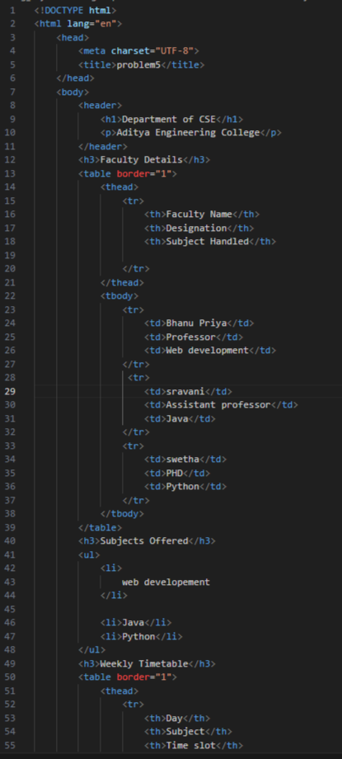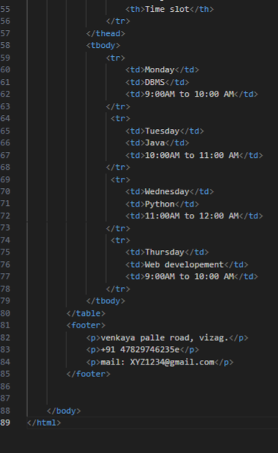

Code Output
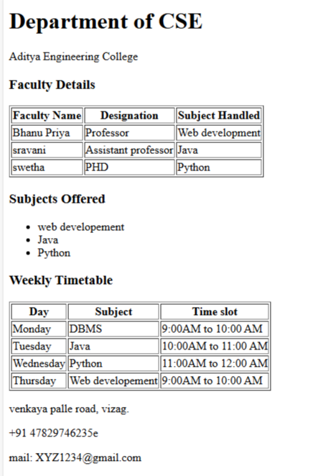

Technical Requirements
Create a department webpage using proper HTML structure and semantic tags.
Show department and college name in the header, faculty and timetable in tables, and subjects in a bullet list.
Use tags like <table> and <ul>, add attributes like lang or title, keep the code clean, and use only HTML (no CSS or JavaScript).

To show image from external site and from you local folder create a html file.
<!DOCTYPE html>
<html lang="en">
<head>
<meta charset="UTF-8">
<title>Images Example</title>
</head>
<body>
<h1>Image Display Example</h1>
<h2>Image from Internet</h2>
<img src="https://res.cloudinary.com/dpuggyn4d/image/upload/v1714299805/cld-sample-3.jpg"
alt="Random Online Image"
title="External Image"
width="300" height="300"/>
<h2>Image from Local Folder</h2>
<img src="image.jpg"
alt="My Photo"
title="Local Image"
width="300" height="300"/>
</body>
</html>

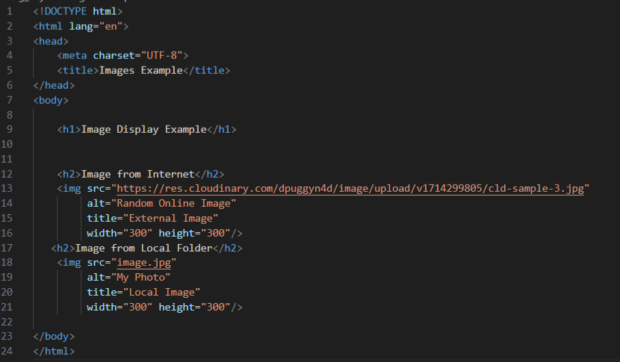
Output
