CSS3_day3_Hands_on_Yandamuri_Priyanka
Problem 1
Assessment Goal: Check ability to apply styling and understand selectors and box model.
Hands-on Tasks:
- Create an external CSS file and link it to HTML
- Apply different text styles to headings and paragraphs
- Add background color and borders to a section
- Demonstrate margin and padding on a div
- Style the form created on Day 2
Expected Outcome:
A visually styled webpage using external CSS and proper selectors.
Actual Code
Index.html
<!DOCTYPE html>
<html lang="en">
<head>
<meta charset="UTF-8">
<title>CSS Styling Assignment</title>
<link rel="stylesheet" href="index.css">
</head>
<body>

<header>
<h1>Welcome to My Webpage</h1>
<p>This page demonstrates CSS selectors and box model</p>
</header>

<!-- Section with background & border -->
<section class="section-box">
<h2>About CSS</h2>
<p>CSS is used to style HTML elements and control layout, colors and spacing.</p>
</section>

<!-- Box Model Demo -->
<div class="box-model">
<h3>Box Model Example</h3>
<p>This div shows margin and padding spacing.</p>
</div>

<!-- Day-2 Registration Form -->
<section class="form-area">
<h2>Student Registration Form</h2>

<form>

<label>Full Name</label>
<input type="text" placeholder="Enter your name" required>

<label>Email</label>
<input type="email" placeholder="Enter your email" required>

<label>Password</label>
<input type="password" placeholder="Enter password" required>

<label>Gender</label>
<div class="radio-group">
<input type="radio" name="gender" required> Male
<input type="radio" name="gender"> Female
</div>

<label>Select Course</label>
<select required>
<option value="">--Choose Course--</option>
<option>HTML</option>
<option>CSS</option>
<option>JavaScript</option>
<option>Python</option>
</select>

<button type="submit">Register</button>

</form>
</section>

</body>
</html>

Index.css
/* Universal Selector */
*{
margin:0;
padding:0;
box-sizing:border-box;
font-family:Arial, sans-serif;
}

/* Body */
body{
background-color:#f4f6f9;
padding:20px;
}

/* Headings */
h1{
color:darkblue;
text-align:center;
margin-bottom:10px;
}

h2{
color:darkgreen;
margin-bottom:10px;
}

h3{
color:brown;
}

/* Paragraph */
p{
font-size:16px;
line-height:1.6;
color:#333;
}

/* Section background & border */
.section-box{
background-color:#e3f2fd;
border:2px solid blue;
padding:15px;
margin:20px 0;
border-radius:8px;
}

/* Box Model Demo */
.box-model{
background-color:#fff3cd;
border:3px solid orange;
padding:25px;
margin:40px 0;
border-radius:10px;
}

/* Form Styling */
.form-area{
background-color:#e8f5e9;
border:2px solid green;
padding:20px;
border-radius:8px;
max-width:400px;
}

form{
display:flex;
flex-direction:column;
}

label{
margin-top:12px;
font-weight:bold;
}

input, select{
padding:8px;
margin-top:5px;
border:1px solid #ccc;
border-radius:4px;
}

.radio-group{
margin-top:5px;
}

button{
margin-top:15px;
padding:10px;
background-color:green;
color:white;
border:none;
border-radius:5px;
cursor:pointer;
}

button:hover{
background-color:darkgreen;
}

Code screenshot
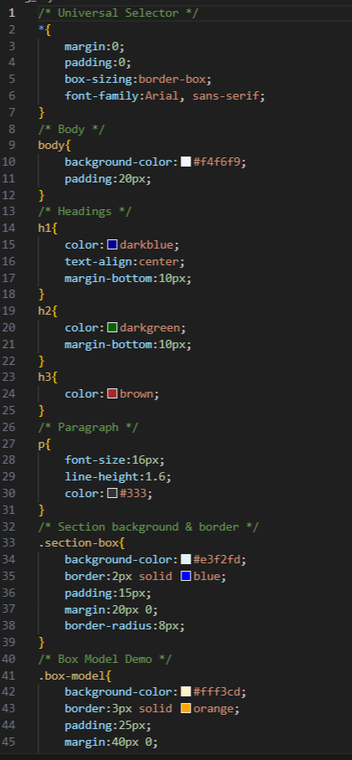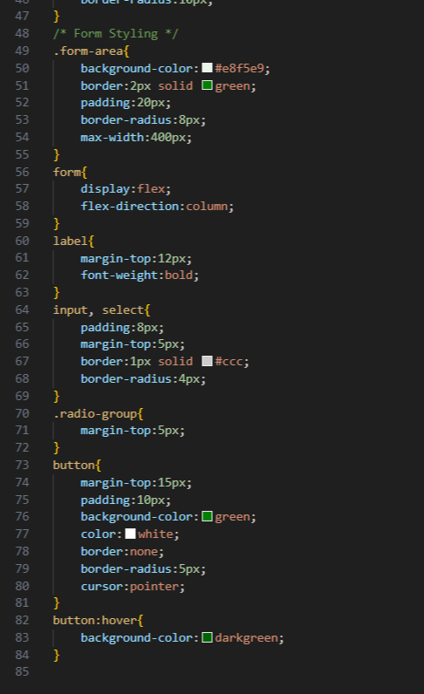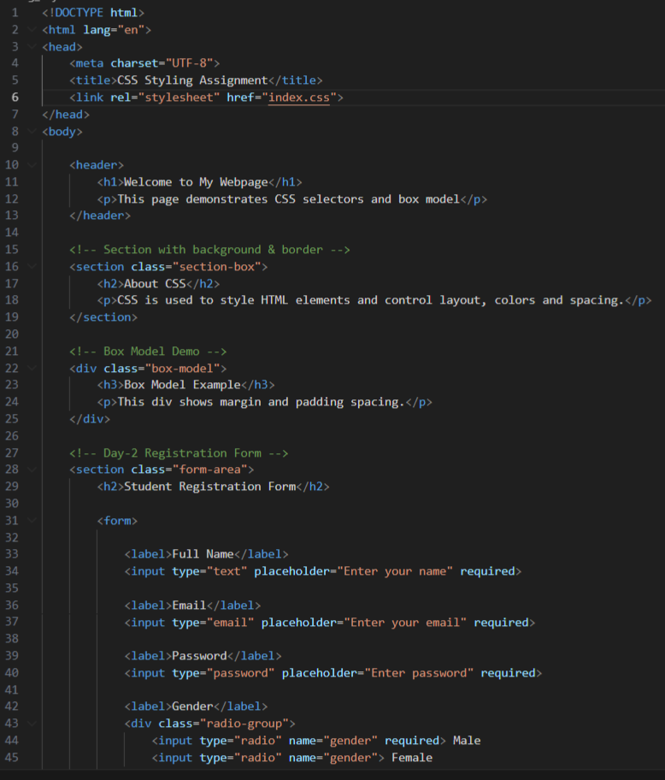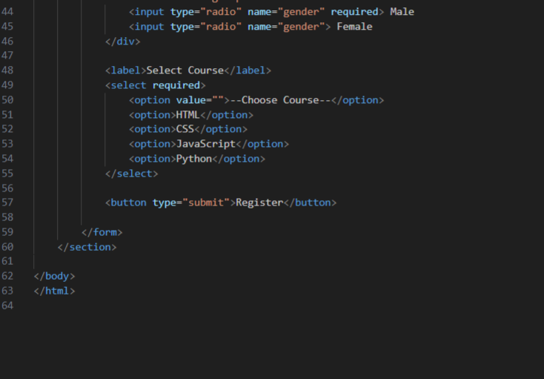
Code output
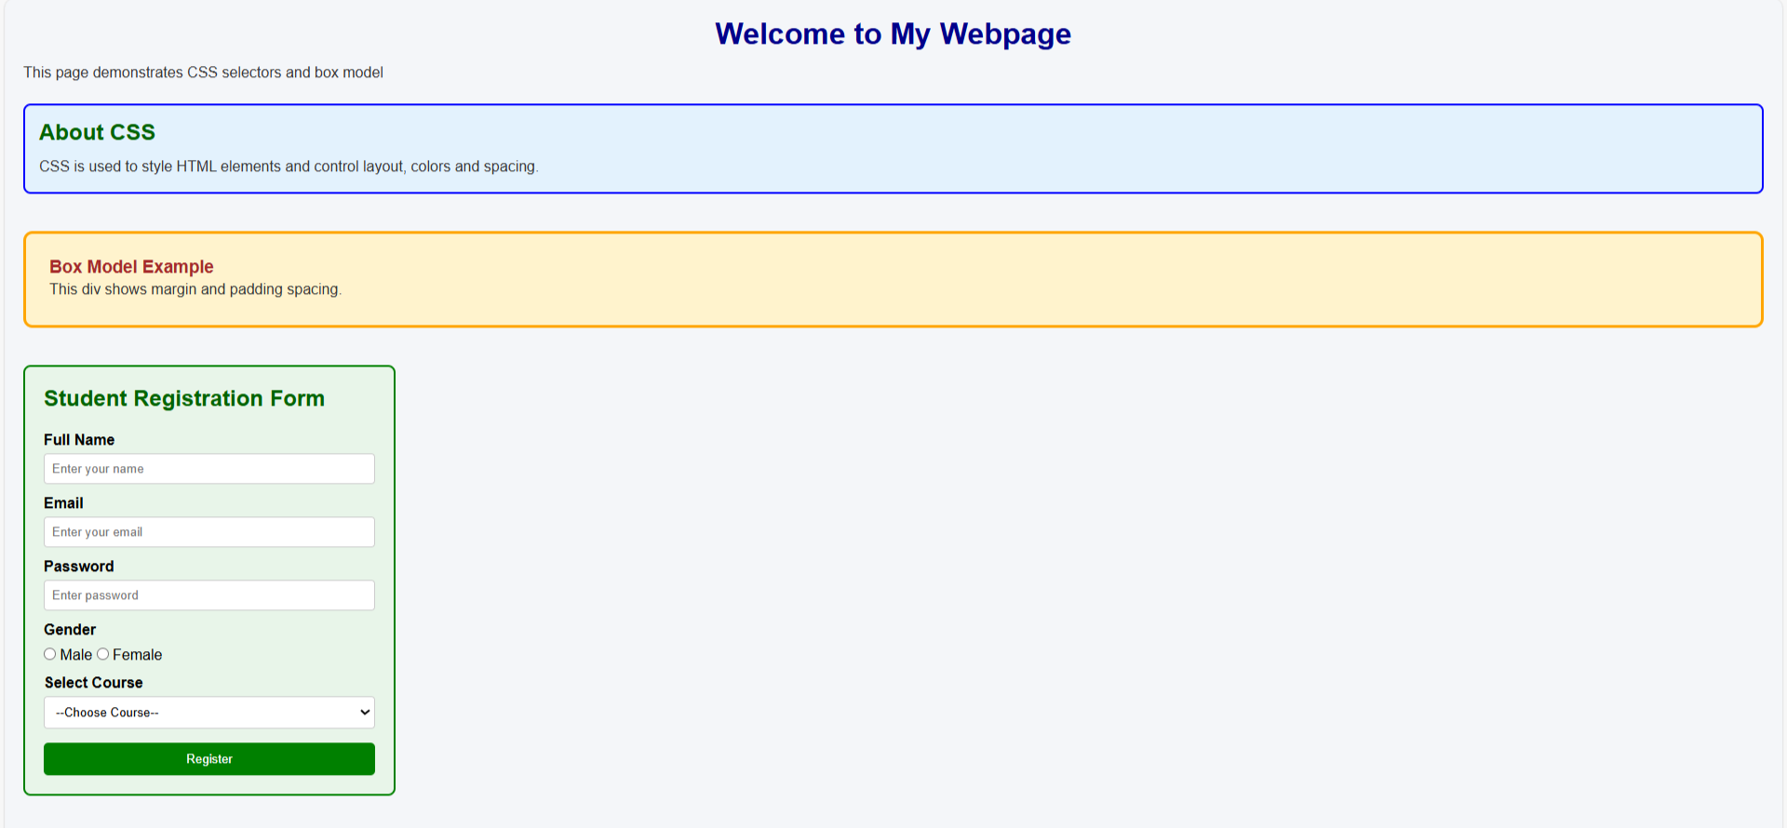
Technical Requirements
I created an external CSS file and linked it to the HTML page to separate design from structure. I applied styles to headings and paragraphs using different selectors and changed font color, size, and alignment. I added background color and borders to a section to improve appearance. I demonstrated margin and padding using a div element to explain spacing in the box model. I also styled the form inputs and buttons to make the webpage more user-friendly. The final result is a visually styled webpage using proper selectors and box model properties.

Problem 2: Personal Profile Card (Level-1)
Scenario
You are building a simple personal profile card for a portfolio website.
The card will display a user’s name, role, short bio, and contact button, styled purely using CSS.
📌 Requirements
Create a profile card layout containing:
- Name (heading)
- Role/title
- Short description paragraph
- Contact button
Apply:
- Text formatting (alignment, decoration)
- Font styles (font-family, size, weight)
- Typography enhancements (line-height, letter-spacing)
Use the CSS Box Model:
- Padding for spacing inside the card
- Border to define the card boundary
- Margin to separate the card from the page edges
Add:
- Background color
- Border radius
- Hover effect on the button

🛠️ Technical Constraints
- Use only HTML + CSS
- No images or icons
- No frameworks (Bootstrap, Tailwind, etc.)
- Inline CSS not allowed (use <style> or external CSS)

🎯 Learning Outcome
You should be able to:
- Understand how CSS styles text and fonts
- Apply box model concepts effectively
- Style elements using colors, borders, and spacing
- Improve visual hierarchy using typography
Actual code
Index.html
<!DOCTYPE html>
<html lang="en">
<head>
<meta charset="UTF-8">
<title>Personal Profile Card</title>
<link rel="stylesheet" href="index.css">
</head>
<body>
<div class="card">
<h1 class="name">Priyanka</h1>
<h3 class="role">Web Developer</h3>
<p class="bio">
Passionate about building responsive and user-friendly websites.
Interested in frontend development and learning modern web technologies.
</p>
<button class="contact-btn">Contact Me</button>
</div>
</body>
</html>
Index.css
/* Reset */
*{
margin:0;
padding:0;
box-sizing:border-box;
font-family:Arial, Helvetica, sans-serif;
}
/* Page background */
body{
background-color:#eef2f7;
display:flex;
justify-content:center;
align-items:center;
height:100vh;
}
/* Profile Card */
.card{
background-color:white;

/* Box Model */
padding:25px;
border:2px solid #4a90e2;
margin:20px;
border-radius:12px;

width:300px;
text-align:center;
}
/* Name */
.name{
font-size:24px;
font-weight:bold;
letter-spacing:1px;
color:#333;
margin-bottom:8px;
}
/* Role */
.role{
font-size:16px;
color:#4a90e2;
text-decoration:underline;
margin-bottom:15px;
}
/* Bio */
.bio{
font-size:14px;
line-height:1.6;
letter-spacing:0.5px;
color:#555;
margin-bottom:20px;
}
/* Button */
.contact-btn{
padding:10px 18px;
background-color:#4a90e2;
color:white;
border:none;
border-radius:6px;
font-weight:bold;
cursor:pointer;
}
/* Hover Effect */
.contact-btn:hover{
background-color:#2f6fc0;
}

Code Screenshot
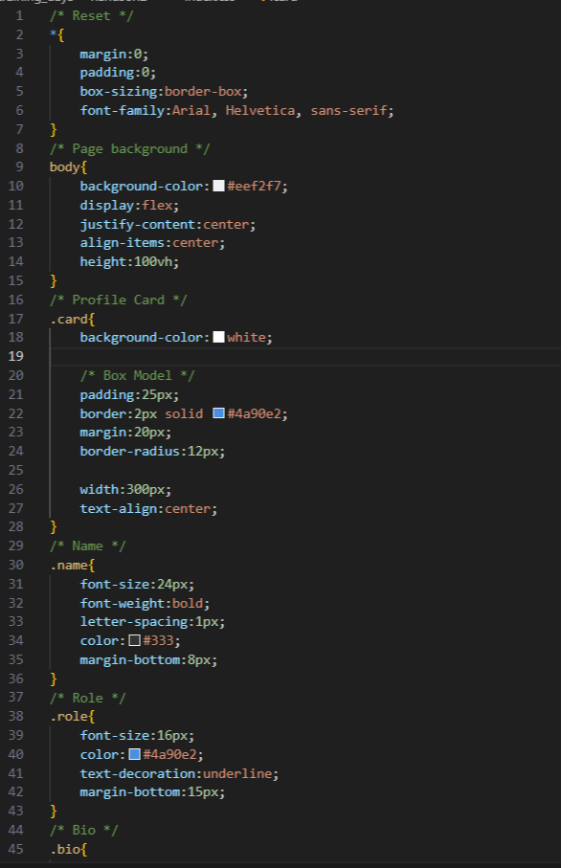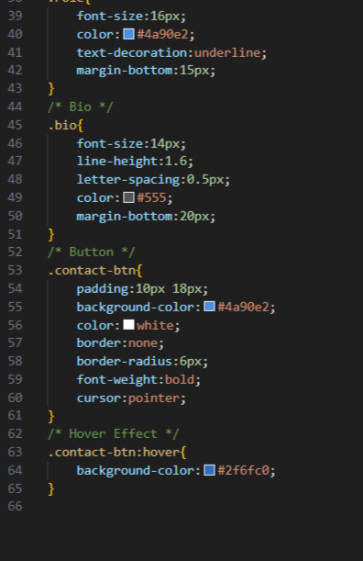

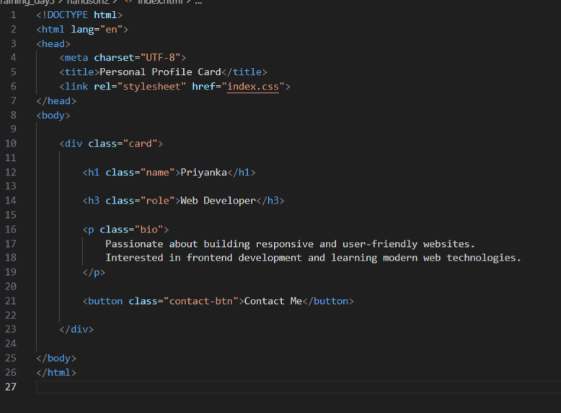

Code Output

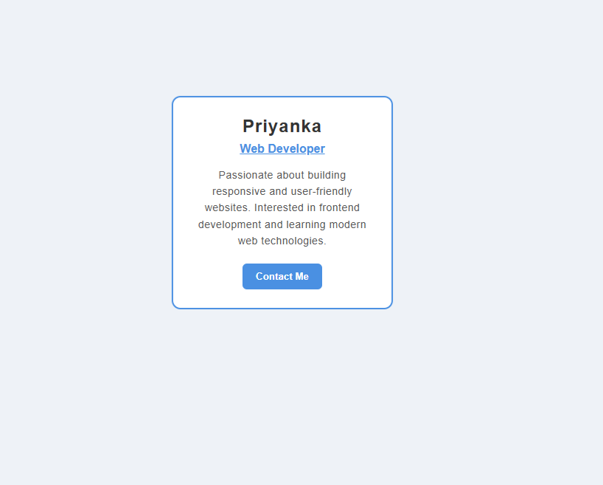
Technical Requirements
I designed a personal profile card using HTML and CSS containing a name, role, description, and contact button. I applied text formatting and font styling to improve readability. The CSS box model was demonstrated using padding, border, and margin. I added background color, rounded corners, and a hover effect on the button to enhance the appearance and interaction.

Problem 3: Product Feature List Section (Level-1)
Scenario
You are designing a feature highlight section for a product landing page that lists key features in a visually appealing way.
📌 Requirements
Create a section with:
- Section heading
- List of 4–5 features
Style the list using:
- Custom fonts
- Text color and background color
- Border and padding for each feature item
Use:
- CSS selectors (element, class, descendant)
Apply hover effects on feature items

🛠️ Technical Constraints
- Use unordered list (<ul>)
- No JavaScript
- No layout frameworks
- Only basic HTML structure
🎯 Learning Outcome
You will be able to:
- Practice CSS selectors
- Style lists professionally
- Improve UI consistency
Actual Code
Index.html
<!DOCTYPE html>
<html lang="en">
<head>
<meta charset="UTF-8">
<title>Product Features</title>
<link rel="stylesheet" href="index.css">
</head>
<body>

<section class="product-features">

<h2 class="features-heading">Product Key Features</h2>

<ul class="features-list">
<li class="feature-item">Fast and smooth performance</li>
<li class="feature-item">User friendly interface</li>
<li class="feature-item">Secure data protection</li>
<li class="feature-item">Cloud backup support</li>
<li class="feature-item">24/7 customer support</li>
</ul>

</section>

</body>
</html>
Index.css
/* Element Selector */
body{
font-family:"Segoe UI", Arial, sans-serif;
background-color:#f4f6fb;
padding:40px;
}
/* Section container */
.product-features{
max-width:500px;
margin:auto;
text-align:center;
}
/* Heading inside section (Descendant Selector) */
.product-features .features-heading{
color:#2c3e50;
margin-bottom:20px;
letter-spacing:1px;
}
/* List styling */
.features-list{
list-style-type:none;
padding:0;
}
/* Feature items */
.product-features .feature-item{
background-color:white;
color:#333;

padding:15px;
margin-bottom:12px;

border:2px solid #3498db;
border-radius:8px;

font-size:16px;
letter-spacing:0.5px;

transition:0.3s;
}
/* Hover effect */
.product-features .feature-item:hover{
background-color:#3498db;
color:white;
cursor:pointer;
transform:scale(1.04);
}

Code screenshot
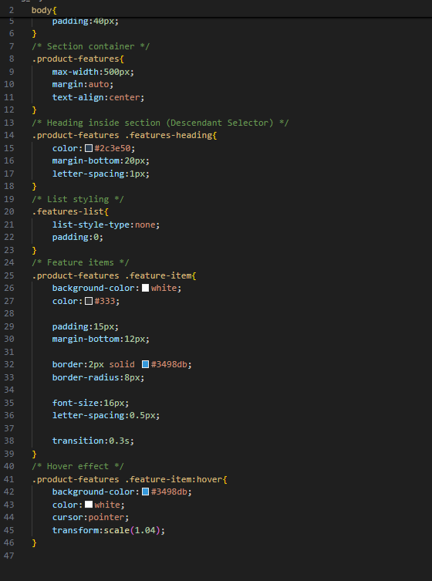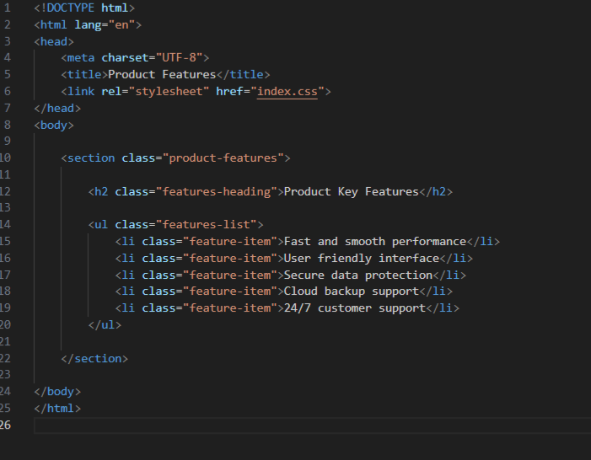
Code Output
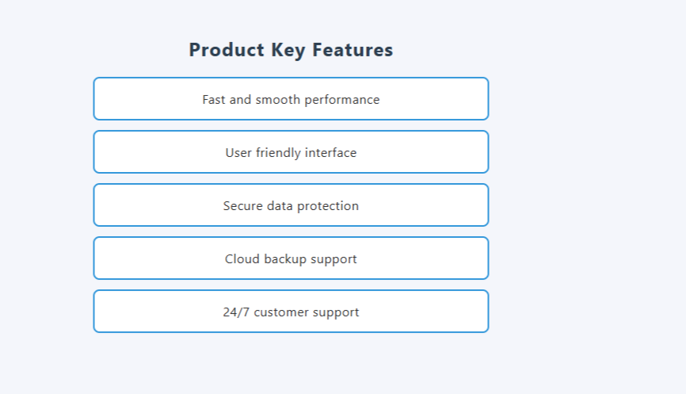
Technical Requirements
I created a product feature section with a heading and an unordered list containing multiple features. I styled the list using custom fonts, text colors, background colors, borders, and padding for each item. Different CSS selectors such as element, class, and descendant selectors were used to apply styles. I also added hover effects on the feature items to improve user interaction and maintain a consistent UI design.

Problem 4: Responsive Blog Layout (Level-2)
Scenario
You are creating a blog homepage that displays articles in a modern responsive layout suitable for desktop, tablet, and mobile screens.
📌 Requirements
Create a page layout with:
- Header
- Main content area with multiple blog cards
Use:
- Flexbox or CSS Grid for layout
- Box model for spacing
Each blog card should contain:
- Title
- Short description
- Read More button
Apply:
- Background colors
- Borders
- Typography enhancements
Use media queries to:
- Display multiple columns on desktop
- Switch to single column on mobile
🛠️ Technical Constraints
- Only HTML + CSS
- No CSS frameworks
- No fixed widths (use percentages or flexible units)
🎯 Learning Outcome
Learners should be able to:
- Understand Flexbox/Grid layouts
- Apply responsive design principles
- Write effective media queries
- Build real-world page layouts
Actual Code
Index.html
<!DOCTYPE html>
<html lang="en">
<head>
<meta charset="UTF-8">
<title>Responsive Blog</title>
<link rel="stylesheet" href="index.css">
</head>
<body>

<header>
<h1>My Blog</h1>
</header>

<main class="blog-container">
<div class="card">
<h2>HTML Basics</h2>
<p>Learn the structure of web pages using HTML elements and tags.</p>
<button>Read More</button>
</div>
<div class="card">
<h2>CSS Styling</h2>
<p>Understand colors, layouts, and responsive design using CSS.</p>
<button>Read More</button>
</div>
<div class="card">
<h2>JavaScript Intro</h2>
<p>Make websites interactive with JavaScript programming.</p>
<button>Read More</button>
</div>
<div class="card">
<h2>Responsive Design</h2>
<p>Create layouts that adapt to mobile, tablet, and desktop screens.</p>
<button>Read More</button>
</div>
</main>
</body>
</html>

Index.css
/* Reset */
* {
margin: 0;
padding: 0;
box-sizing: border-box;
font-family: Arial, sans-serif;

}
/* Header */
header {
background-color: #333;
color: white;
text-align: center;
padding: 20px;
}
/* Blog Container */
.blog-container {
display: grid;
grid-template-columns: repeat(3, 1fr);
gap: 20px;
background-color: #007bff;
padding: 20px;

}
/* Card */
.card {
background-color: #f4f4f4;
padding: 20px;
border: 1px solid #ccc;
border-radius: 8px;
}
.card h2 {
margin-bottom: 10px;
}
.card p {
margin-bottom: 15px;
line-height: 1.5;
}
/* Button */
button {
background-color: #007bff;
color: white;
border: none;
padding: 10px 15px;
cursor: pointer;
border-radius: 5px;
}
button:hover {
background-color: #0056b3;
}
/* Tablet */
@media (max-width: 900px) {
.blog-container {
grid-template-columns: repeat(2, 1fr);
}
}

/* Mobile */
@media (max-width: 600px) {
.blog-container {
grid-template-columns: 1fr;
}
}

Code Screenshot
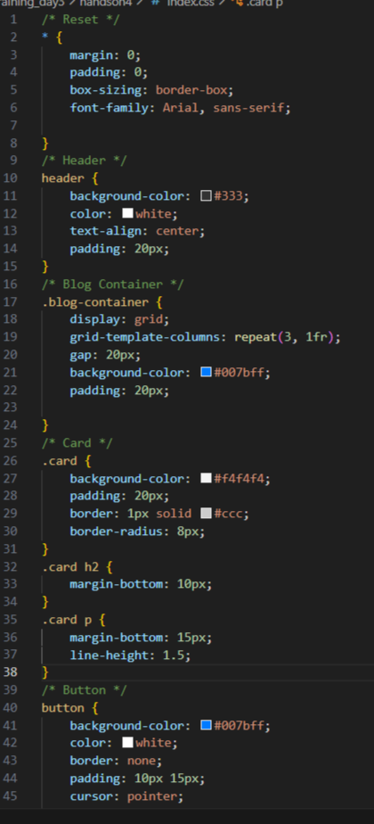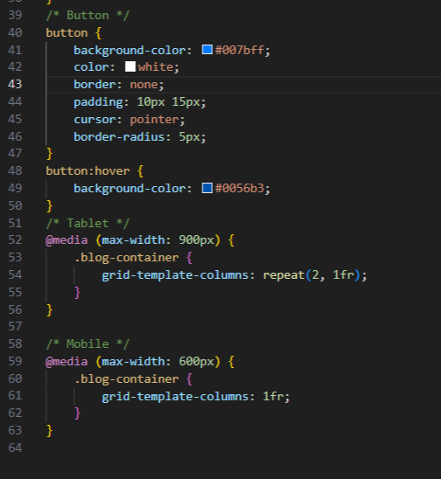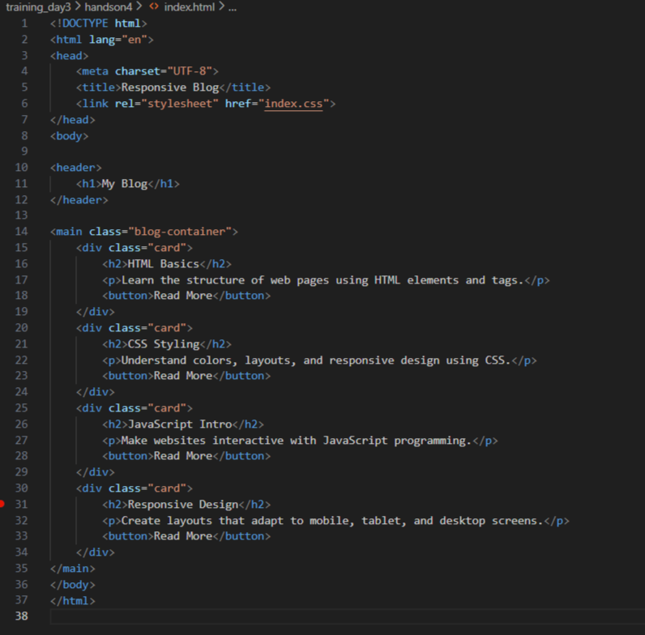
Code output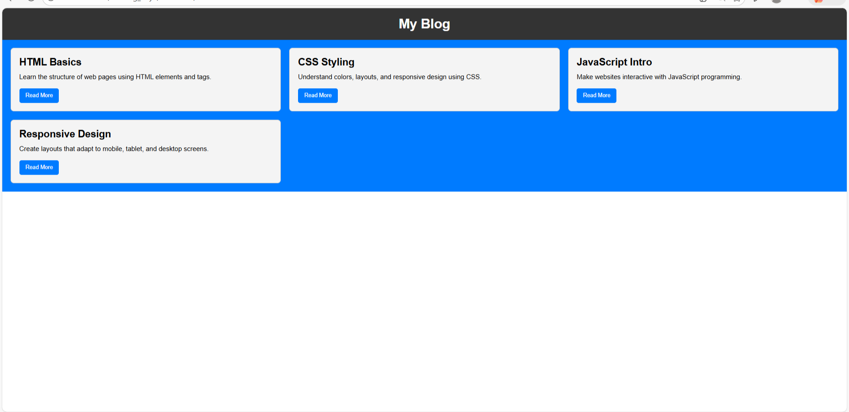
Technical Requirements
I created a responsive blog layout using HTML and CSS with a header and multiple blog cards. I used Flexbox/Grid for arranging the cards and applied the box model for spacing. Each card contains a title, short description, and a Read More button with proper typography, colors, and borders. Media queries were used to display multiple columns on desktop screens and a single column on mobile devices, ensuring the layout adapts to different screen sizes without fixed widths.

Problem 5: Responsive Dashboard Layout (Level-2)
Scenario
You are designing a simple admin dashboard layout for a web application.
📌 Requirements
Create a layout with:
- Sidebar navigation
- Main content area
- Info cards inside the main section
Use:
- display properties
- Flexbox or Grid for page structure
Style:
- Sidebar with background color
- Cards with borders, padding, and margins
Apply media queries to:
- Convert sidebar into top navigation on mobile
- Stack cards vertically on small screens

🛠️ Technical Constraints
- HTML + CSS only
- No JavaScript
- No external UI libraries

🎯 Learning Outcome
You will be able to:
- Master page layouts using Flexbox/Grid
- Apply modern responsive web design techniques
- Understand how layout adapts across devices
- Build industry-relevant UI structures
Actual Code
Index.html
<!DOCTYPE html>
<html lang="en">
<head>
<meta charset="UTF-8">
<title>Responsive Dashboard</title>
<link rel="stylesheet" href="index.css">
</head>
<body>
<div class="dashboard">
<!-- Sidebar -->
<nav class="sidebar">
<h2>Admin</h2>
<a href="#">Dashboard</a>
<a href="#">Users</a>
<a href="#">Reports</a>
<a href="#">Settings</a>
</nav>
<!-- Main Content -->
<main class="main-content">
<h1>Dashboard Overview</h1>
<div class="cards">
<div class="card">
<h3>Total Users</h3>
<p>1,250</p>
</div>
<div class="card">
<h3>Orders</h3>
<p>320</p>
</div>
<div class="card">
<h3>Revenue</h3>
<p>$8,420</p>
</div>
<div class="card">
<h3>Messages</h3>
<p>18 New</p>
</div>
</div>
</main>
</div>
</body>
</html>

Index.css
/* Reset */
* {
margin: 0;
padding: 0;
box-sizing: border-box;
font-family: Arial, sans-serif;
}
/* Layout */
.dashboard {
display: flex;
min-height: 100vh;
}
/* Sidebar */
.sidebar {
width: 220px;
background: #2c3e50;
color: white;
padding: 20px;
display: flex;
flex-direction: column;
}
.sidebar h2 {
margin-bottom: 20px;
}
.sidebar a {
text-decoration: none;
color: white;
padding: 10px;
margin: 5px 0;
border-radius: 5px;
}
.sidebar a:hover {
background: #34495e;
}
/* Main Content */
.main-content {
flex: 1;
padding: 20px;
background: #f4f6f8;
}
.main-content h1 {
margin-bottom: 20px;
}
/* Cards */
.cards {
display: flex;
gap: 20px;
flex-wrap: wrap;
}
.card {
flex: 1 1 200px;
background: white;
padding: 20px;
border: 1px solid #ddd;
border-radius: 8px;
}
/* Tablet */
@media (max-width: 900px) {
.cards {
justify-content: center;
}
}
/* Mobile Layout */
@media (max-width: 600px) {
/* Sidebar becomes top nav */
.dashboard {
flex-direction: column;
}
.sidebar {
width: 100%;
flex-direction: row;
justify-content: space-around;
align-items: center;
}
.sidebar h2 {
display: none;
}
.sidebar a {
margin: 0;
padding: 12px;
}
/* Cards stacked vertically */
.cards {
flex-direction: column;
}
}

Code Screenshot
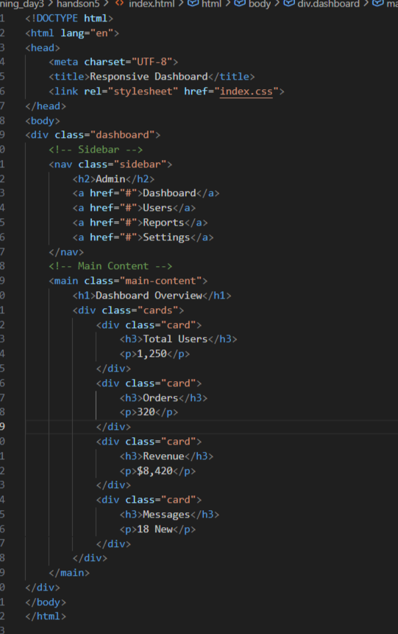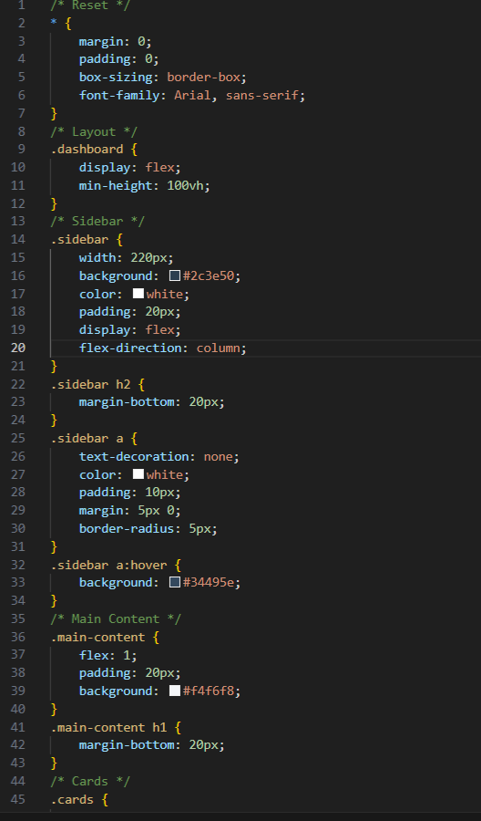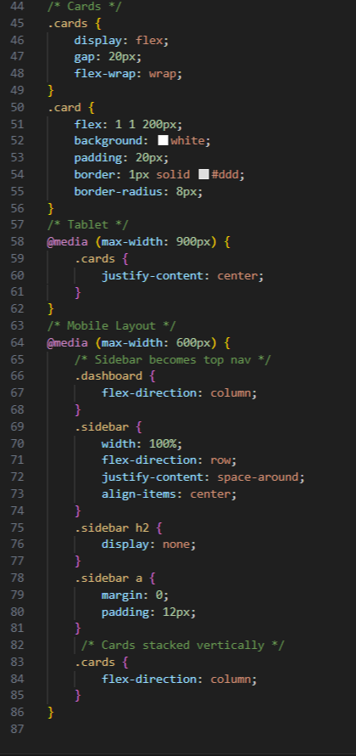
Code output
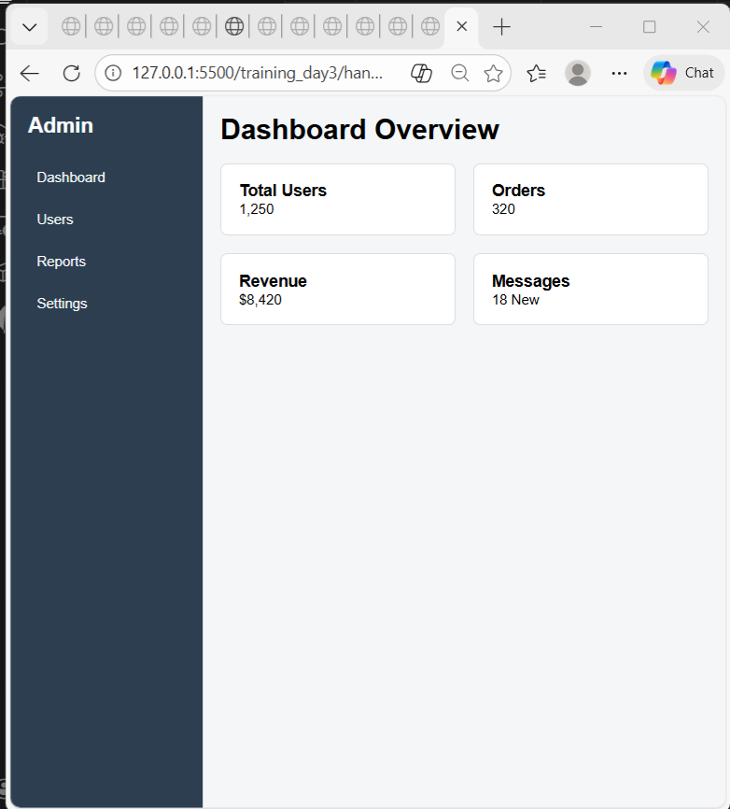
Technical requirements
I created a responsive dashboard layout using only HTML and CSS. The layout contains a sidebar navigation and a main content section with multiple information cards. I used Flexbox to structure the page and arranged the cards, and applied the box model using padding, margin, and borders. The sidebar was styled with a background color and the cards were designed with spacing and borders for clarity. Media queries were implemented to convert the sidebar into a top navigation bar on mobile screens and to stack the cards vertically on smaller devices, ensuring the layout adapts across different screen sizes.

