Ace Admin 前端框架

## Files

### Css 样式

主要的css文件：ace.css

Ie9 css文件：

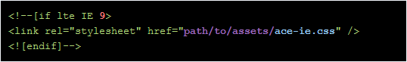

或者

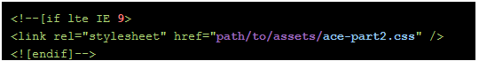

bootstrap.css ：基于bootstrap

fontawesome.css：使用fontawesome图标， 字体图标

ace-fonts.css ：字体

### js

压缩版在 dist/js 下面

费压缩版在 assets/js 下面

单独的插件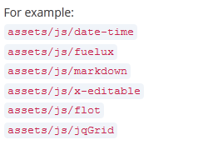

ace.js包含网站的主要功能

ace-elements.js包含自定义插件

ace-extra.js 保存cookie信息，例如菜单的展开、皮肤等等

x-editable / ace-editable.js ：包含5个额外的内联编辑插件：日期，滑块，微调

jquery-ui.custom.js： 包含了jquery-ui一些插件和部分所需的功能

jquery-ui.js : jquery-ui 所有功能

**html5shiv.js** & **respond.js : html5兼容 IE8**

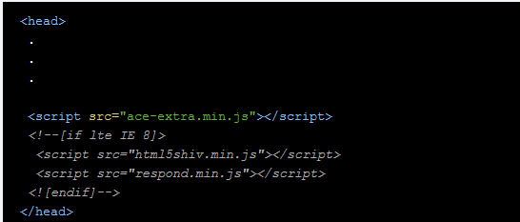

---Js 引入顺序---

1、Jquery.js / jquery.1.x.js x 代表 1.9以下兼容IE9

2、Bootstrap.js

3、Excanvas.js : IE8 下使用html插件 Flotchart 、Sparklines 、jquery knob 、easy Pie chart

4、其他的插件: 例如，下拉框 chosen.js

5、最后引入 ：**ace-elements.js** and **ace.js**

6、兼容性： 例如

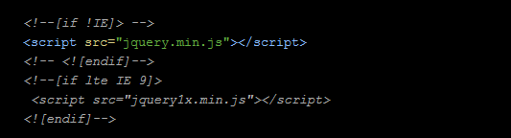

## Basics 基础模块

### Page Layout 页面布局

#### Layout 布局

##### Layout

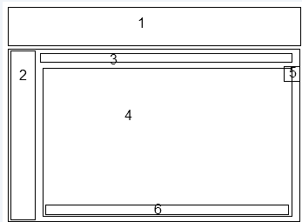

1. Navbar
2. Sidebar
3. Breadcrumbs (inside "main-content")
4. Page content (inside "main-content")
5. Settings box (inside "page-content")
6. Footer

例子：

<!DOCTYPE html>

<html lang="en">

<head>

<!-- title, meta tags, list of stylesheets, etc ... -->

</head>

<body class="no-skin">

<div class="navbar" id="navbar">

<!-- navbar goes here -->

</div>

<div class="main-container" id="main-container">

<div class="sidebar responsive" id="sidebar">

<!-- sidebar goes here -->

</div>

<div class="main-content">

<div class="breadcrumbs">

<!-- breadcrumbs goes here -->

</div>

<div class="page-content">

<!-- setting box goes here if needed -->

<div class="row">

<div class="col-xs-12">

<!-- page content goes here -->

</div><!-- /.col -->

</div><!-- /.row -->

</div><!-- /.page-content -->

</div><!-- /.main-content -->

<!-- footer area -->

</div><!-- /.main-container -->

<!-- list of script files -->

</body>

</html>

##### Head

<!DOCTYPE html>

<html lang="en">

<head>

<meta charset="utf-8" />

<!-- use the following meta to force IE use its most up to date rendering engine -->

<meta http-equiv="X-UA-Compatible" content="IE=edge,chrome=1" />

<meta name="viewport" content="width=device-width, initial-scale=1.0" />

<title> page tite </title>

<meta name="description" content="page description" />

<!-- stylesheets are put here, refer to files/css documentation -->

<!-- some scripts should be here, refer to files/javascript documentation -->

</head>

##### Viewport meta tag

移动设备响应式

<meta name="viewport" content="width=device-width, initial-scale=1.0, maximum-scale=1.0, user-scalable=no" />

##### Body element

<body class="no-skin">

...

</body>

皮肤：

1. .no-skin
2. .skin-1
3. .skin-2
4. .no-skin.skin-3

#### Empty layout空页面布局

例子：html/empty.html

<html>

<head>

<!-- title, meta tags, list of stylesheets, etc ... -->

</head>

<body class="no-skin">

<div class="navbar" id="navbar">

<!-- navbar goes here -->

</div>

<div class="main-container" id="main-container">

<div class="sidebar responsive" id="sidebar">

<!-- sidebar goes here -->

</div>

<div class="main-content">

<div class="page-content">

<div class="row">

<div class="col-xs-12">

<!-- page content goes here -->

</div><!-- /.col -->

</div><!-- /.row -->

</div><!-- /.page-content -->

</div><!-- /.main-content -->

</div><!-- /.main-container -->

<!-- list of script files -->

</body>

</html>

#### Login layout

##### layout

<html>

<head>

</head>

<body class="login-layout">

<div class="main-container">

<div class="main-content">

<div class="row">

<div class="col-sm-10 col-sm-offset-1">

<!-- page content goes here -->

</div><!-- /.col -->

</div><!-- /.row -->

</div><!-- /.main-content -->

</div><!-- /.main-container -->

</body>

</html>

##### Scripts : login.js

### Navbar 顶部导航

#### Navbar basics

##### Layout





1. **toggle buttons**: 一些按钮，比如 屏幕变小或者是手机端，折叠菜单按钮 
2. **.navbar-header**: 头信息，例如
3. **.navbar-menu**: 导航栏菜单
4. **.navbar-buttons.navbar-header**: 包含用户信息的下拉菜单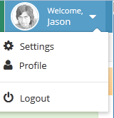

例子：

<div id="navbar" class="navbar navbar-default">

<div id="navbar-container" class="navbar-container">

<!-- toggle buttons are here or inside brand container -->

<div class="navbar-header pull-left">

<!-- brand text here -->

</div><!-- /.navbar-header -->

<div class="navbar-buttons navbar-header pull-right ">

<ul class="nav ace-nav">

<!-- user buttons such as messages, notifications and user menu -->

</ul>

</div><!-- /.navbar-buttons -->

<nav class="navbar-menu pull-left">

<!-- optional menu & form inside navbar -->

</nav><!-- /.navbar-menu -->

</div><!-- /.navbar-container -->

</div><!-- /.navbar -->

##### Responsive Navbar 响应式 导航条

480px 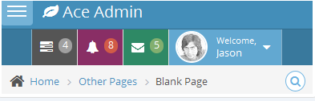

992px 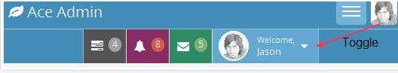

可以修改 ace.less 和 assets/css/less/variables.less 中的：

@screen-topbar-down

1、.navbar 元素 添加 .navbar-collapse 样式

2、.navbar-buttons 元素 添加 .navbar-collapse 和 .collapse

3、导航条菜单 .navbar-menu 元素添加 .navbar-collapse 和 .collapse

##### Navbar options

1. 固定导航条 ，例如页面滚动时固定在顶部

在 .navbar 元素上添加 .navbar-fixed-top

1. 导航条容器

在 .navbar-container元素上添加 .container

1. 水平导航条

在 .navbar 元素添加 .h-navbar

##### Brand 网站标题 名字

<div class="navbar-header pull-left">

<a href="#" class="navbar-brand">

<small>

<i class="ace-icon fa fa-leaf"></i>

Brand Text

</small>

</a>

</div>

#### User buttons/ Dropdowns

##### Overview

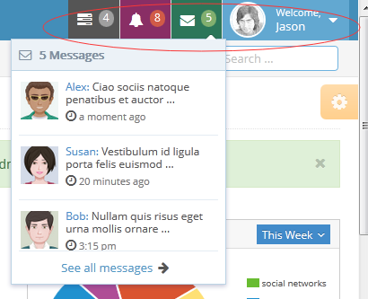

一个 .navbar-buttons div里面包含一个 .nav ace-nav ul列表

<div class="navbar-buttons navbar-header pull-right">

<ul class="nav ace-nav">

<li class="light-blue">

<a data-toggle="dropdown" class="dropdown-toggle" href="#">

<i class="ace-icon fa fa-tasks"></i>

<span class="badge">5</span>

</a>

<ul class="dropdown-menu dropdown-navbar dropdown-menu-right dropdown-caret dropdown-close">

<li class="dropdown-header">

title text

</li>

<li>

item#1.

</li>

<li>

item#2.

</li>

<li class="dropdown-footer">

bottom text or link

</li>

</ul>

</li>

<li>

Another button and dropdown

</li>

</ul>

</div>

##### Button & menu colors 按钮和菜单颜色

默认、grey、purple、green、light-blue、light-blue2 、red、light-green、light-purple、light-orange、light-pink、white-opaque、dark-opaque

等等。。。。

<li class="light-pink no-border margin-1">

<!-- dropdown content goes here -->

</li>

<li class="grey">

</li>

这些 颜色都可以通过 js 脚本动态改变

下拉菜单按钮 颜色 ：

默认、navbar-pink、navbar-grey、navbar-green

<li class="purple">

<a href="#">

...

</a>

<ul class="dropdown-navbar navbar-pink dropdown-menu dropdown-menu-right dropdown-caret dropdown-close">

...

</ul>

</li>

##### dropdown-content & Scrollbars 下拉内容和滚动条

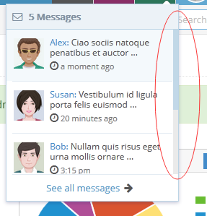

<li class="purple">

<ul class="dropdown-navbar dropdown-menu dropdown-menu-right">

<li class="dropdown-header"></li>

<li class="dropdown-content">

<ul class="dropdown-menu dropdown-navbar">

<!-- content and list of items are here -->

</ul>

</li>

<li class="dropdown-footer"></li>

</ul>

下拉框高度默认是 200px，可以通过 data-size 属性修改

<li class="dropdown-content" data-size="250">

</li>

##### Tabbed dropdown表格下拉

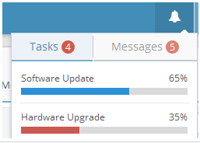

在 .dropdown-menu 元素上加上 .tab-pane 样式

<ul class="nav ace-nav">

<li class="light-blue">

<a data-toggle="dropdown" class="dropdown-toggle" href="#">

<i class="ace-icon fa fa-bell icon-animated-bell"></i>

</a>

<!-- it should be a "DIV.dropdown-menu" here not a "UL.dropdown-menu" -->

<div class="dropdown-navbar dropdown-menu dropdown-menu-right dropdown-caret dropdown-close">

<div class="tabbable">

<!-- tab buttons here -->

<ul class="nav nav-tabs">

<li class="active">

<a data-toggle="tab" href="#navbar-tasks">

Tasks

<span class="badge badge-danger">4</span>

</a>

</li>

<li>

<a data-toggle="tab" href="#navbar-messages">

Messages

<span class="badge badge-danger">5</span>

</a>

</li>

</ul><!-- .nav-tabs -->

<!-- tab content here -->

<div class="tab-content">

<div id="navbar-tasks" class="tab-pane in active">

<!-- first tab pane and the .dropdown-menu inside it -->

<ul class="dropdown-navbar dropdown-menu dropdown-menu-right">

<li>

item # 1

</li>

<li>

item # 2

</li>

<li class="dropdown-footer">

...

</li>

</ul>

</div><!-- /.tab-pane -->

<div id="navbar-messages" class="tab-pane">

<!-- second tab pane and the .dropdown-menu inside it -->

<ul class="dropdown-navbar dropdown-menu dropdown-menu-right">

<!-- .dropdown-content -->

<li class="dropdown-content">

<ul class="dropdown-menu dropdown-navbar">

<li>

item # 1

</li>

<li>

item # 2

</li>

</ul>

</li><!-- /.dropdown-content -->

<li class="dropdown-footer">

...

</li>

</ul>

</div><!-- /.tab-pane -->

</div><!-- /.tab-content -->

</div><!-- /.tabbable -->

</div><!-- /DIV.dropdown-menu -->

</li>

</ul><!-- /.ace-nav -->

#### User menu 系统显示用户信息菜单



在 ul.ace-nav 里面

<ul class="ace ace-nav">

...

<li class="light-blue">

<a data-toggle="dropdown" href="#" class="dropdown-toggle">

<img class="nav-user-photo" src="path/to/avatar.jpg" alt="Jason's Photo" />

<span class="user-info">

<small>Welcome,</small> Jason

</span>

<i class="ace-icon fa fa-caret-down"></i>

</a>

<ul class="user-menu dropdown-menu dropdown-menu-right dropdown-yellow dropdown-caret dropdown-close">

<li><a href="#"><i class="ace-icon fa fa-cog"></i> Settings</a></li>

<li class="divider"></li>

<li><a href="#"><i class="ace-icon fa fa-power-off"></i> Logout</a></li>

</ul>

</li>

</ul>

#### Toggle buttons 切换按钮

在 **.navbar-header 之前**

<button

class="pull-right navbar-toggle navbar-toggle-img collapsed" type="button"

data-toggle="collapse" data-target=".navbar-buttons,.navbar-menu">

<span class="sr-only">Toggle user menu</span>

<img src="path/to/avatar/user.jpg" alt="Jason's Photo" />

</button>

<button class="pull-right navbar-toggle collapsed" type="button"

data-toggle="collapse" data-target=".navbar-buttons">

<span class="sr-only">Toggle user menu</span>

<i class="ace-icon fa fa-user fa-2x white"></i>

</button>

#### Navbar Menu & Form

##### Navbar Menu 导航栏菜单

<nav role="navigation" class="navbar-menu pull-left collapse navbar-collapse">

<ul class="nav navbar-nav">

<li>

<a href="#" class="dropdown-toggle" data-toggle="dropdown">

item # 1

</a>

<ul class="dropdown-menu dropdown-light-blue dropdown-caret">

<!-- optional submenu items -->

</ul>

</li>

<li>

<a href="#">

item # 2

</a>

</li>

</ul>

<!-- you can also have a form here -->

</nav>

##### Navbar Form

<nav role="navigation" class="navbar-menu pull-left collapse navbar-collapse">

<!-- you can also have a menu here -->

<form class="navbar-form navbar-left form-search" role="search">

<div class="form-group">

<input type="text" placeholder="search" />

</div><button type="button" class="btn btn-xs btn-info2">

<i class="ace-icon fa fa-search icon-only bigger-110"></i>

</button>

</form>

</nav>

### Sidebar 侧边栏

#### Sidebar basics

##### Layout

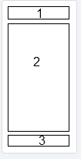

1. **shortcut buttons 选项**
2. **.nav-list 侧边栏内容、项**
3. **expand/collapse button 侧边栏折叠按钮**

<div class="sidebar responsive" id="sidebar">

<div class="sidebar-shortcuts" id="sidebar-shortcuts">

...

</div>

<ul class="nav nav-list">

...

</ul>

<div class="sidebar-toggle sidebar-collapse">

...

</div>

</div><!-- /.sidebar -->

##### Menu item 菜单项

一级菜单

<li>

<a href="#">

<i class="menu-icon fa fa-leaf"></i>

<span class="menu-text">

Item text

</span>

<b class="arrow fa fa-angle-down"></b>

<!-- arrow down icon if there's a submenu -->

</a>

<b class="arrow"></b>

<!-- optional arrow for minimized menu & hover submenu -->

<ul class="submenu">

....

</ul>

</li>

菜单图标 ： .menu-icon 样式，例如 <i class="menu-icon fa fa-caret-right"></i>

##### Shortcut Buttons

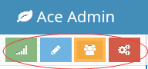

<div class="sidebar-shortcuts" id="sidebar-shortcuts">

<div class="sidebar-shortcuts-large" id="sidebar-shortcuts-large">

<button class="btn btn-success"><i class="ace-icon fa fa-signal"></i></button>

<button class="btn btn-info"><i class="ace-icon fa fa-pencil"></i></button>

<button class="btn btn-warning"><i class="ace-icon fa fa-users"></i></button>

<button class="btn btn-danger"><i class="ace-icon fa fa-cogs"></i></button>

</div>

<div class="sidebar-shortcuts-mini" id="sidebar-shortcuts-mini">

<span class="btn btn-success"></span>

<span class="btn btn-info"></span>

<span class="btn btn-warning"></span>

<span class="btn btn-danger"></span>

</div>

##### Minimize Button 折叠按钮



<div data-target="#sidebar" id="sidebar-collapse" class="sidebar-toggle sidebar-collapse">

<i class="ace-icon fa fa-angle-double-left" data-icon1="ace-icon fa fa-angle-double-left" data-icon2="ace-icon fa fa-angle-double-right"></i>

</div>

##### Other notes 菜单按钮，其他元素

徽章



<span class="menu-text">

Menu Text

<span class="badge badge-info">4</span>

</span>

Tooltip 提示：



<span class="menu-text">

Menu Text

<span class="label label-transparent tooltip-error" title="some title for tooltip!">

<i class="red ace-icon fa fa-exclamation-triangle"></i>

</span>

</span>

#### Sidebar functions

##### Basic functions

Js构造 侧边栏

$('.sidebar').ace_sidebar();

//or

$('#my-specific-sidebar').ace_sidebar();

.sidebar 元素是默认的

菜单切换，展开、收缩

$('.sidebar').ace_sidebar('toggleMenu');

$('.sidebar').ace_sidebar('toggleMenu', toggleButton);

//if there is an optional toggleButton element, its icons will be flipped

 图表反转

记录保存到cookie

$('.sidebar').ace_sidebar('toggleMenu', false);

//optional false value means don't save changes to cookies

$('.sidebar').ace_sidebar('toggleMenu', [toggleButton , false/true ]);

//optional second value means save or don't save changes to cookies

展开、收缩

$('#my-sidebar').ace_sidebar('collapse');

$('#my-sidebar').ace_sidebar('collapse', toggleButton);

//if there is an optional toggleButton element, its icons will be flipped

菜单切换、隐藏、显示 (特效)持续时间()

$('#my-sidebar').ace_sidebar('toggle', [sub, 300]);

##### Sidebar scrollbars 侧边栏滚动条

有两种方法：

第一种：只适用于固定的侧边栏，没有元素溢出

第二种：

添加滚动条

$('.sidebar').ace_sidebar_scroll({

//options here

});

scroll_to_active滚动到页面加载活动项目  
  
include_shortcuts包括滚动区域的快捷按钮  
  
include_toggle包括滚动区域或不切换按钮  
  
scroll_style滚动条样式作为自定义滚动条的部分描述  
  
mousewheel_lock是否锁定鼠标滚轮在侧边栏即使没有滚动条或者不  
  
only_if_fixed只有第二法  
  
smooth_scroll使用第一种方法只。指定要启用或禁用平滑滚动错误数

$('#my-sidebar').ace_sidebar_scroll('updateStyle', 'scroll-dark no-track');

//for example such update is done which switching to another skin in Ace's demo

##### Submenu positioning and scrollbars 子菜单和滚动条定位

隐藏延迟和滚动条功能调整菜单

$('.sidebar').ace_sidebar_hover({

//options here

});

$('#my-sidebar').ace_sidebar_hover('updateStyle', 'scroll-dark no-track');

$('#my-sidebar').ace_sidebar_hover('changeDir', 'left');

#### Responsive Sidebar 响应式 侧边栏(手机端)

##### Default mobile menu style

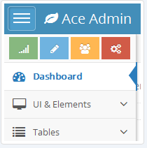

.sidebar需要添加： . responsive 样式

还可以添加 .push_away

<div id="sidebar" class="sidebar responsive push_away">

</div>

data-auto-hide=true 点击菜单其他区域，自动隐藏

<div id="sidebar" class="sidebar responsive" data-auto-hide="true">

</div>

##### Automatically minimized menu style 自动缩小菜单

.responsive-min .sidebar-toggle .sidebar-expand

<a href="#" class="menu-toggler invisible" id="menu-toggler"></a>

<div id="sidebar" class="sidebar responsive-min">

.

.

.

.

<div class="sidebar-toggle sidebar-collapse">

...

</div>

<div data-target="#sidebar" class="sidebar-toggle sidebar-expand">

...

</div>

</div>

<div id="sidebar" class="sidebar responsive-min" data-auto-hide="true">

</div>

##### Bootstrap collapse style

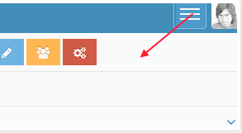

<div id="sidebar" class="sidebar collapse navbar-collapse">

</div>

##### Toggle Button 切换按钮

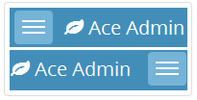

<button data-target="#sidebar" type="button" class="navbar-toggle menu-toggler pull-left" id="menu-toggler">

<span class="sr-only">Toggle sidebar</span>

<span class="icon-bar"></span>

<span class="icon-bar"></span>

<span class="icon-bar"></span>

</button>

<div class="navbar-header pull-left">

<!-- toggle button can also be here -->

<!-- brand text -->

<!-- toggle button can also be here -->

</div>

#### Sidebar Options 侧边栏选项

##### Horizontal Sidebar 水平

只使用于 991px 大屏幕

.sidebar 添加 .h-sidebar

.navbar添加.h-navbar

<div id="navbar" class="navbar navbar-default h-navbar navbar-collapse">

</div>

<div id="main-container">

<div id="sidebar" class="sidebar h-sidebar collapse navbar-collapse">

.

.

.

</div>

</div>

.hover 子菜单鼠标悬停

<ul class="nav nav-list">

<li class="hover">

<a href="#">

...

</a>

<b class="arrow"></b>

<ul class="submenu">

...

</ul>

</li>

</ul>

.no-gap 没有间隙

.lower-highlight 移动高亮显示

.h-navbar

<div id="sidebar" class="sidebar h-sidebar no-gap lower-highlight">

</div>

<div id="navbar" class="navbar h-navbar">

</div>

##### Submenu on Hover 子菜单 悬停

在 子菜单之前 li 标签 添加 .hover 、.arrow

<ul class="nav nav-list">

<li class="hover">

<a href="#">

...

</a>

<b class="arrow"></b>

<ul class="submenu">

...

</ul>

</li>

</ul>

##### Compact Sidebar 紧凑的侧边栏

.sidebar 添加.compact样式

<div class="sidebar responsive compact" id="sidebar">

</div>

##### Highlight Item 高亮突出

li 标签添加 .highlight

<ul class="nav nav-list">

<li class="highlight">

...

</li>

</ul>

##### Fixed Sidebar 固定侧边栏

.sidebar 添加 .sidebar-fixed

<div class="sidebar responsive sidebar-fixed" id="sidebar">

</div>

##### Minimized Sidebar 最小侧边栏

.sidebar 添加 .menu-min

<div class="sidebar responsive menu-min" id="sidebar">

</div>

##### Multiple Sidebar 多个侧边栏

每一个 div 元素都有 .sidebar 样式

<div class="main-content">

<div class="main-content-inner">

<div id="sidebar2" class="sidebar h-sidebar navbar-collapse collapse">

<!-- second sidebar, horizontal -->

</div>

<div class="page-content">

<!-- page content area -->

</div>

</div>

</div>

第二个栏不水平，.page-content 、.footer 应移到最后

<div class="main-content">

<div class="main-content-inner">

<div id="sidebar2" class="sidebar responsive">

<!-- second sidebar, horizontal -->

</div>

<div class="page-content main-content">

<!-- page content area -->

</div>

<div class="footer"></div>

</div>

</div>

#### Sidebar Active Item 侧边栏活动的菜单项

##### Ajax

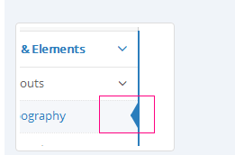

//inside the function when ajax content is loaded

//somehow get a reference to our newly clicked(selected) element's parent "LI"

var new_active = $(this).parent();

//remove ".active" class from all (previously) ".active" elements

$('.nav-list li.active').removeClass('active');

//add ".active" class to our newly selected item and all its parent "LI" elements

new_active.addClass('active').parents('.nav-list li').addClass('active');

//you can also update breadcrumbs:

var breadcrumb_items = [];

//$(this) is a reference to our clicked/selected element

$(this).parents('.nav-list li').each(function() {

var link = $(this).find('> a');

var text = link.text();

var href = link.attr('href');

breadcrumb_items.push({'text': text, 'href': href});

})

##### non-Ajax

### Content 中部内容

#### Content

##### Layout

默认的布局

1. **breadcrumbs** and searchbox
2. **page title** optional
3. **page conent**
4. **settings box** optional

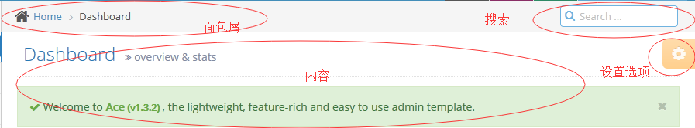

<div class="main-container" id="main-container">

<!-- sidebar here -->

<div class="main-content"><div class="main-content-inner">

<div class="breadcrumbs" id="breadcrumbs">

<!-- breadcrumbs here -->

</div>

<div class="page-content">

<div class="ace-settings-container" id="ace-settings-container">

<!-- settings box goes here -->

</div>

<div class="page-header">

<!-- page header goes here -->

</div>

<div class="row">

<div class="col-xs-12">

<!-- page content goes here -->

</div>

</div>

</div><!-- /.page-content -->

</div></div><!-- /.main-content -->

<a class="btn-scroll-up" id="btn-scroll-up">

...

</a>

</div><!-- /.main-container -->

##### Breadcrumbs 面包屑导航



<div id="breadcrumbs" class="breadcrumbs">

<ul class="breadcrumb">

<li><i class="fa fa-home home-icon"></i> <a href="#">Home</a></li>

<li><a href="#">...</a></li>

<li><a href="#">...</a></li>

<li class="active">...</li>

</ul><!-- /.breadcrumb -->

<!-- searchbox -->

</div>

##### Search box 搜索



<div id="nav-search" class="nav-search">

<form class="form-search">

<span class="input-icon">

<input type="text" class="nav-search-input" id="nav-search-input" autocomplete="off" placeholder="Search ..." />

<i class="ace-icon fa fa-search nav-search-icon"></i>

</span>

</form>

</div>

搜索框自动完成

根据 js 数组内容

//auto complete's data source is a static array

$('#nav-search-input').typeahead({

source: some_static_array,

updater: function (item) {

//when an item is selected from dropdown menu, focus back to input element

$('#nav-search-input').focus();

return item;

}

});

Ajax

//auto complete's data is dynamically retrieved from server

source: function(query, process) {

$.ajax({url: 'source.php?q='+encodeURIComponent(query)}).done(function(result_items){

process(result_items);

})

}

小的搜索框

<div id="nav-search" class="nav-search minimized">

...

</div>

##### Page Title & Content 页标题和内容

包含 设置选项框 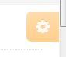

<div class="page-content">

<div class="ace-settings-container" id="ace-settings-container">

<!-- settings box goes here -->

</div>

<div class="page-header">

<!-- page header goes here -->

</div>

<div class="row">

<div class="col-xs-12">

<!-- page content goes here -->

</div>

</div>

</div><!-- /.page-content -->

标题头部



<div class="page-header">

<h1>

Dashboard

<small><i class="ace-icon fa fa-angle-double-right"></i> overview & stats</small>

</h1>

</div>

内容样式 .row 、 .col-xs-12

<div class="row">

<div class="col-xs-12">

<!-- page content goes here -->

</div>

</div>

##### Settings Box

详情见 Settings Box

### Ajax Content Ajax内容布局

#### Ajax

##### Overview

$('#some-content-area').ace_ajax({

//options

});

$('[data-ajax-content=true]').ace_ajax({

//options

});

##### Setting up 参数设置

content_url

default_url

loading_icon

$('#some-content-area').ace_ajax({

content_url: function(hash) {

//hash is the value from document url hash

//take "url" param and return the relevant url to load

return "path/to/content/"+hash+".html";

},

default_url: 'homepage.html'//default url

,

loading_icon: "fa-cog fa-2x blue"

});

##### Options

content_url：”是最重要的部分。功能返回URL检索。  
  
default_url：默认URL加载  
  
loading_icon：图标显示加载新内容的时候。默认的是：fa-spinner fa-2x orange  
  
loading_text：显示加载新的内容时，文本。默认值为“”  
  
update_active：一个函数或布尔值，指示是否更新“新选定的链接及其父母主动”状态。默认是真的  
  
update_breadcrumbs和布尔值指示一个函数更新面包。默认true  
  
update_title：一个函数或布尔值，指示是否更新窗口标题。默认true  
  
close_active：是否关闭先前的活动项目或子菜单。默认为false  
  
max_load_wait：等待时间在秒之前如果需要太长的内容来停止AJAX内容检索。默认为false

##### Functions

停止加载

$('#some-content-area').ace_ajax('stopLoading', true);

开始加载

$('#some-content-area').ace_ajax('startLoading');

loadScripts、loadUrl

$('#some-content-area').ace_ajax('loadUrl', hash);

##### Loading JS & CSS Files

'loadScripts' 加载的js脚本只执行一次

<script type="text/javascript">

var scripts = ['path/to/plugin1.js', 'path/to/other-plugin.js']

$('#some-content-area').ace_ajax('loadScripts', scripts, function() {

//put inline scripts related to this page here

alert('hello!');

})

</script>

执行多次可以用 jQuery.getScript

<script type="text/javascript">

var scripts = ['path/to/plugin1.js', 'path/to/other-plugin.js']

$('#some-content-area').ace_ajax('loadScripts', scripts, function() {

//for example put inline scripts related to this page here

jQuery.getScript('path/to/mypage-script.js', function() {

//this page's script is loaded

//now do domething else

});

})

</script>

清理上个页面的内容 ，例子

var scripts = ['path/to/plugin1.js', 'path/to/other-plugin.js']

$('#some-content-area').ace_ajax('loadScripts', scripts, function() {

//put inline scripts related to this page here

//and clean up some plugin remainings before leaving to another page

$('#some-content-area').one('ajaxloadstart', function(e, params) {

//cleanup plugin1

//for example for jqGrid:

$('#grid_selector').jqGrid('GridUnload');

$('.ui-jqdialog').remove();

//or for some datepicker, etc elements:

$('.daterangepicker.dropdown-menu').remove();

//or inline editable

$('.editable').editable('destroy');

})

})

##### Events 事件

ajaxloadstart触发时。  
  
如果调用 “preventdefault()”事件对象，加载将被取消  
  
ajaxloaddone内容加载  
  
ajaxloadcomplete 内容被加载并插入到DOM  
  
ajaxloaderror 加载失败  
  
ajaxloadlong如果max_load_wait指定，则加载时间太久   
  
ajaxscriptsloaded 加载脚本完成

$('#some-content-area')

//or

//$(document)

.on('ajaxloadstart', function(e, params) {

//params.url and params.hash are available

if(params.url == 'something') e.preventDefault();

if(params.hash == 'something') e.preventDefault();

//you can also return "false" from "content_url" function to prevent loading

})

### Footer 页脚

<div class="footer">

<div class="footer-inner">

<div class="footer-content">

<!-- footer content here -->

</div>

</div>

</div>

## Elements 元素

### Buttons 按钮

#### Buttons 基本按钮

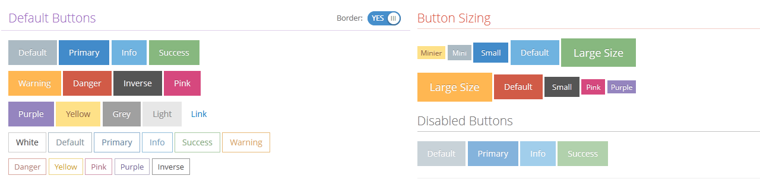

按钮颜色、大小

.btn-info2、.btn-purple、.btn-pink、.btn-light、.btn-yellow、.btn-grey

.btn-mini、.btn-minier、btn-sm

<button type="button" class="btn btn-sm btn-purple">

<i class="ace-icon fa fa-check"></i>

Click

</button>

<a href="#" class="btn btn-sm btn-purple">

<i class="ace-icon fa fa-check"></i>

Click

</a>

.no-hover 和 .no-border

<button type="button" class="btn btn-sm btn-purple no-border">

No Border!

</button>

<button type="button" class="btn btn-sm btn-purple no-hover">

No Hover Effect!

</button>

.icon-on-right

<button type="button" class="btn btn-sm btn-purple">

<i class="icon-on-right ace-icon fa fa-check"></i>

</button>

.icon-only

<button type="button" class="btn btn-sm btn-purple">

<i class="icon-only ace-icon fa fa-check"></i>

</button>

#### White Buttons 白色按钮

 .btn-white 白色

<button type="button" class="btn btn-sm btn-info btn-white">

<i class="ace-icon fa fa-check"></i>

white button

</button>

 .btn-bold 、.btn-round 圆角

<button type="button" class="btn btn-sm btn-danger btn-white btn-round">

<i class="ace-icon fa fa-trash-o"></i>

rounder

</button>

#### Large Buttons 大图标按钮

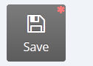 .btn-app

<button class="btn btn-app btn-grey btn-sm radius-4">

<i class="ace-icon fa fa-floppy-o bigger-160"></i>

Save

</button>

.width-auto 宽度自动

<a class="btn btn-app btn-primary width-auto" href="#">

<i class="ace-icon fa fa-pencil-square-o fa-2x"></i>

Longggggg textttttttt

</a>

#### Button Groups 按钮组

.btn-corner 第一个和最后一个有圆角

.btn-overlap 按钮之间没有空隙



<div class="btn-group btn-overlap btn-corner" data-toggle="buttons">

<label class="btn btn-sm btn-white btn-info">

<input type="checkbox" value="1" />

<i class="ace-icon fa fa-bold icon-only bigger-110"></i>

</label>

...

...

</div>

### Labels & Badges

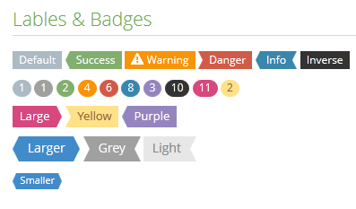

#### Labels

颜色、大小

.label-pink、.label-purple、.label-grey、.label-light、.label-yellow

.label-sm、.label-lg、.label-xlg



<span class="label label-lg label-purple arrowed-right">label-lg</span>

标签箭头样式

.arrowed、.arrowed-right、.arrowed-in、.arrowed-in-right



<span class="label label-info arrowed-in arrowed-in-right">Promotion!</span>

#### Badges

.badge-info、.badge-primary、.badge-success、.badge-danger



<span class="badge badge-primary">4 new</span>

### Icons 图标

#### Icons

FontAwesome Icons、Glyphicons

.ace-icon

例如 ： .menu-icon

<ul class="nav nav-list">

<li>

<a href="#">

<i class="menu-icon fa fa-leaf"></i>

<span class="menu-text">Dashboard</span>

</a>

</li>

</ul>

#### Animated Icons 动画图标

ringing 、vertical 、hand-pointer 、pulsating、wrenching、blinking

.my-pulsating-icon {

/* pulsating duration repetition timing_function delay */

-moz-animation: pulsating 2s 2 linear 1s;

-webkit-animation: pulsating 2s 2 linear 1s;

-o-animation: pulsating 2s 2 linear 1s;

-ms-animation: pulsating 2s 2 linear 1s;

animation: pulsating 2s 2 linear 1s;

}

#### Fontawesome

<link rel="stylesheet" href="path/to/assets/css/font-awesome.css" />

或者

<linkrel="stylesheet" href="//netdna.bootstrapcdn.com/font-awesome/4.2.0/css/font-awesome.min.css" />



<i class="ace-icon fa fa-heart"></i>

#### Glyphicons

Bootstrap 默认的字体图标类库

### Form 表单

#### Forms

参考 bootstrap 表单

<form class="form-horizontal" role="form">

<div class="form-group">

<label class="col-sm-3 control-label no-padding-right" for="form-field-1">Label</label>

<div class="col-sm-9">

<input type="text" class="form-control" placeholder="Username" id="form-field-1" />

</div>

</div>

</form>

.col-xs-10、.col-sm-5、.form-control 布局

.no-padding-right、.no-padding-left 无间距

.no-option 无内容，例如 select、dropdowns

<option value="0" class="no-option"></option>

#### Input 输入框

参考 bootstrap

.input-icon、.input-icon-right、



<span class="input-icon">

<input type="text" id="form-field-icon-1" />

<i class="ace-icon fa fa-leaf blue"></i>

</span>

<span class="input-icon input-icon-right">

<input type="text" id="form-field-icon-1" />

<i class="ace-icon fa fa-leaf green"></i>

</span>

输入框大小

.input-mini、.input-small、.input-medium、.input-large、 .input-xlarge

校验状态

.has-warning、.has-error、.has-success、.has-info

<div class="form-group has-warning">

<label class="col-xs-12 col-sm-3 control-label no-padding-right" for="inputWarning">Input with warning</label>

<div class="col-xs-12 col-sm-5">

<span class="block input-icon input-icon-right">

<input type="text" class="width-100" id="inputWarning" />

<i class="ace-icon fa fa-leaf"></i>

</span>

</div>

<div class="help-block col-xs-12 col-sm-reset inline">

Warning tip help!

</div>

</div>

#### 3rd Party & Custom Inputs 第三方控件



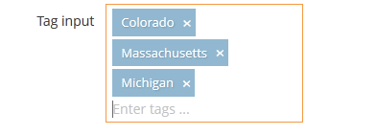

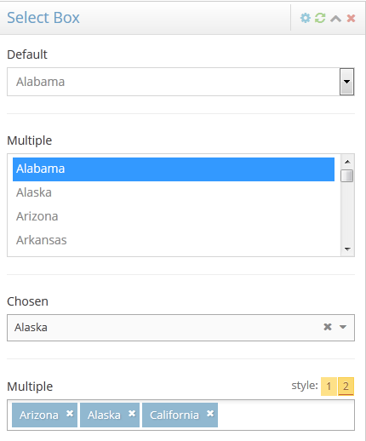

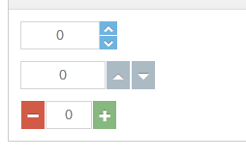

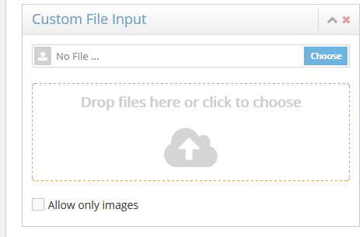



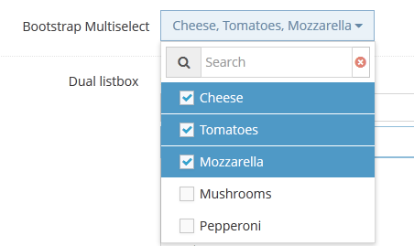

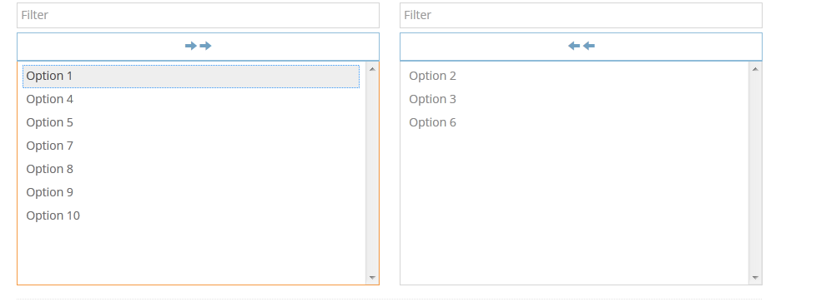

### Tabs 标签页(选项卡)

#### Tabs

参考 bootstrap

<div class="tabbable">

<ul id="myTab" class="nav nav-tabs">

<li class="active">

<a href="#home" data-toggle="tab">Home</a>

</li>

<li>

<a href="#profile" data-toggle="tab">Messages</a>

</li>

</ul>

<div class="tab-content">

<div class="tab-pane in active" id="home">

home tab content

</div>

<div class="tab-pane" id="profile">

profile tab content

</div>

</div>

</div>

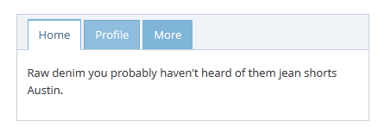

#### Position 方向

.tabs-below、.tabs-left、.tabs-right

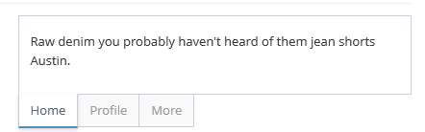

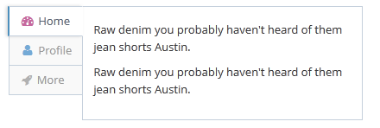

#### Color & Size 颜色、大小

.tab-color-blue 、.background-blue 背景色为蓝色

<ul class="nav nav-tabs tab-color-blue background-blue"></ul>

.tab-size-bigger 大按钮

.nav-tabs 添加 .tab-space-1 .tab-space-2 间隔

.nav-tabs 添加.padding-2 .padding-4

.tab-content 添加 .padding-2 .padding-4

<ul class="nav nav-tabs padding-18 tab-size-bigger"></ul>

<div class="tab-content no-border padding-24"></div>

#### Notes

重置

$('#myTab a[data-toggle="tab"]').on('shown.bs.tab', function (e) {

//if( $(e.target).attr('href') == "#home" ) drawChartNow();

//if($(e.target).is('#my-chart-tab')) drawChartNow();

})

### Accordion

#### Accordion

参考 bootstrap panels

两种样式 : .accordion-style1 、 .accordion-style2

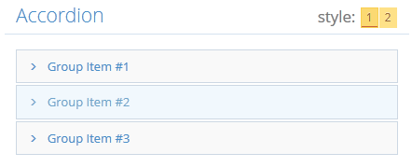

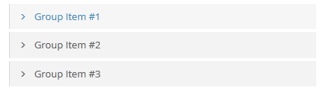

div class="accordion-style1 panel-group" id="accordion">

<div class="panel panel-default">

<div class="panel-heading">

<h4 class="panel-title">

<a class="accordion-toggle collapsed" data-toggle="collapse" data-parent="#accordion" href="#collapseOne">

<i data-icon-show="ace-icon fa fa-angle-right" data-icon-hide="ace-icon fa fa-angle-down" class="bigger-110 ace-icon fa fa-angle-right"></i>

Group Item #1

</a>

</h4>

</div>

<div id="collapseOne" class="panel-collapse collapse">

<div class="panel-body">

Panel Body

</div>

</div>

</div>

<!---

... other panels ...

-->

</div>

#### Toggle Icon 切换图标

.accordion-toggle或者 data-toggle="panel"

data-icon-show、data-icon-hide 两种图标

<i data-icon-show="ace-icon fa fa-plus" data-icon-hide="ace-icon fa fa-minus"

class="ace-icon fa fa-plus"></i>

#### Notes

重新设置内容

$('#accordion').on('shown.bs.collapse', function (e) {

//if($(e.target).is('#collapseTwo')) drawChartNow();

});

### Tooltip

#### Tooltip

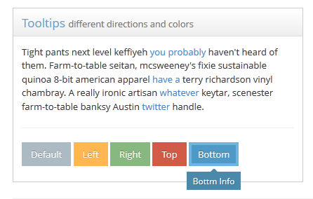

参考 bootstrap

.tooltip-error、.tooltip-warning、.tooltip-success、.tooltip-info

<a href="#" title="message" class="my-tooltip-link tooltip-error">

Show Tooltip

</a>

或者

$('.my-tooltip-link').tooltip();

$('.my-tooltip-link').tooltip({

'container': 'body',

'template': '<div class="tooltip tooltip-error"><div class="tooltip-arrow"></div><div class="tooltip-inner"></div></div>'

});

#### Notes

最好使用 'container': 'body'

<div class="tab-pane">

<a href="#" title="message which may be very long" class="my-tooltip-link tooltip-error">

Show Tooltip

</a>

</div>

$('.my-tooltip-link').tooltip({

'container': 'body'

});

加到其他元素

//find "pie chart tooltip example" in mustache/app/views/assets/scripts/index.js

var tooltip = $("<div class='tooltip top in'><div class='tooltip-inner'></div></div>").hide().appendTo('body');

//and when necessary

tooltip.show().children(0).text(tip);//dynamically change its text

tooltip.css({top: y, left: x});

tooltip.hide();

或者

/find "range slider tooltip example" in mustache/app/views/assets/scripts/form-elements.js

if(! ui.handle.firstChild ) {

$(ui.handle).

append("tooltip right in' style='display:none; left:16px; top:-6px;'><div class='tooltip-arrow'></div><div class='tooltip-inner'></div></div>")

}

$(ui.handle.firstChild).show().children().eq(1).text(val);//update (.tooltip-inner)'s text and show it

提示位置

//placement parameter can be a function

$('[data-rel="tooltip"]').tooltip({placement: tooltip_placement});

function tooltip_placement(context, source) {

var $source = $(source);

var $parent = $source.closest('div.container_selector')//or maybe 'body' > $parent = $('body')

//get containers offset and width

var off1 = $parent.offset();

var w1 = $parent.width();

//get elements offset

var off2 = $source.offset();

//this is approximate and optional, you can change it

if( parseInt(off2.left) < parseInt(off1.left) + parseInt(w1 / 2) ) return 'right';

return 'left';

}

#### Popovers 气泡样式

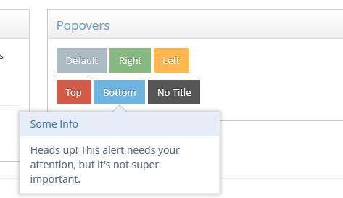

### Dropdown

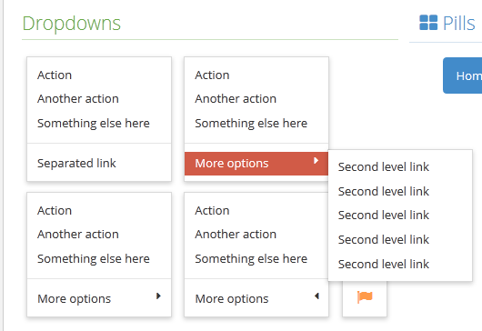

#### Colors 颜色

.dropdown-default、.dropdown-info、.dropdown-primary、.dropdown-success

<ul class="dropdown-menu dropdown-danger">

<li><a tabindex="-1" href="#">Action</a></li>

<li><a tabindex="-1" href="#">Another action</a></li>

<li><a tabindex="-1" href="#">Something else here</a></li>

</ul>

#### Options

data-position="auto" ，自动下来

<button data-position="auto" data-toggle="dropdown" class="dropdown-toggle">

<i class="ace-icon fa fa-cog icon-only bigger-110"></i>

</button>

<ul class="dropdown-menu">

...

</ul>

overflow:hidden、overflow:scroll

下拉悬停、选择内容

$('.dropdown-hover').on('mouseenter', function() {

var offset = $(this).offset();

var $w = $(window)

if (offset.top > $w.scrollTop() + $w.innerHeight() - 100)

$(this).addClass('dropup');

else $(this).removeClass('dropup');

});

.dropdown-caret

.dropdown-close 、.dropdown-closer

<div class="inline pos-rel">

<a href="#" class="dropdown-toggle" data-toggle="dropdown">Show menu</a>

<ul class="dropdown-menu dropdown-light dropdown-caret dropdown-closer">

<li> <a href="#">...</a> </li>

</ul>

</div>

.dropdown-only-icon 仅仅是图标下拉样式

<ul class="dropdown-menu dropdown-only-icon">

...

</ul>

.dropdown-hover 下拉悬停 ，data-toggle="dropdown"

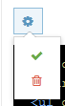

<div class="inline pos-rel dropdown-hover">

<a href="#" class="dropdown-toggle">Show menu</a>

<ul class="dropdown-menu dropdown-light dropdown-only-icon">

<li> <a href="#">...</a> </li>

</ul>

</div>

.dropdown-50 .dropdown-75 .dropdown-100 下拉宽度

<ul class="dropdown-menu dropdown-50 dropdown-light">

<li class="action-buttons"><a href="#" tabindex="-1" class="center"><i class="fa fa-flag blue bigger-130"></i></a></li>

</ul>

子菜单 可以 在 父 li 元素添加 .dropdown-hover

<ul class="dropdown-menu dropdown-light">

<li class="dropup dropdown-hover">

<a href="#">More options</a>

<ul class="dropdown-menu dropdown-menu-left">

<li><a href="#">Second level link</a></li>

</ul>

</li>

</ul>

### Progress Bar

<div class="progress progress-mini progress-striped active">

<div style="width: 40%;" class="progress-bar progress-bar-purple"></div>

</div>

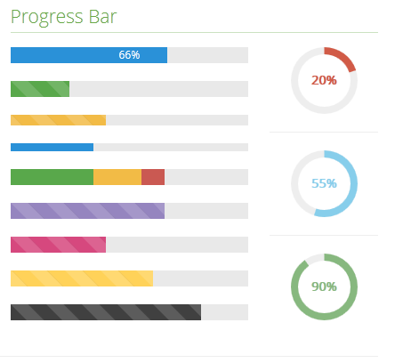

## Custom Elements 自定义元素

### Widget Box 容器

#### Widget Box

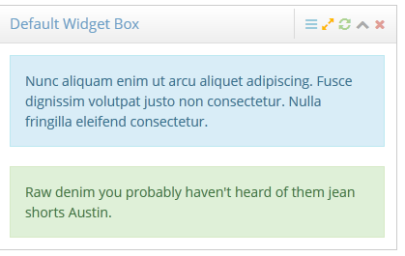

<div class="widget-box">

<div class="widget-header"></div>

<div class="widget-body"></div>

</div>

#### Widget Box Options 选项

颜色

.widget-color-blue、.widget-color-blue2、.widget-color-blue3

、.widget-color-green、.widget-color-red

<div class="widget-box widget-color-blue">

...

</div>

透明 .transparent

<div class="widget-box transparent">

...

</div>

边框 .light-border

<div class="widget-box widget-color-dark light-border">

...

</div>

折叠 .collapsed

<div class="widget-box collapsed">

...

</div>

#### Widget Header 头部

<div class="widget-header">

<h4 class="widget-title smaller">title!</h4>

<div class="widget-toolbar"></div>

</div>

.widget-header-small 小

.widget-header-large 大

.widget-header-flat 禁用渐变背景

控件工具栏

<div class="widget-toolbar">

<a data-action="settings" href="#"><i class="ace-icon fa fa-bars"></i></a>

<a data-action="reload" href="#"><i class="ace-icon fa fa-refresh"></i></a>

<a data-action="fullscreen" class="orange2" href="#"><i class="ace-icon fa fa-expand"></i></a>

<a data-action="collapse" href="#"><i class="ace-icon fa fa-chevron-up"></i></a>

<a data-action="close" href="#"><i class="ace-icon fa fa-times"></i></a>

</div>

1. settings
2. reload
3. fullscreen
4. collapse
5. close

可以有多个 工具栏

<div class="widget-header">

<h4 class="widget-title"></h4>

<div class="widget-toolbar no-border"></div>

<div class="widget-toolbar"></div>

</div>

工具栏 无边框线.no-border

容器菜单 .widget-menu

<div class="widget-toolbar">

<a data-action="reload" href="#"><i class="ace-icon fa fa-refresh"></i></a>

<div class="widget-menu">

<a data-toggle="dropdown" data-action="settings" href="#"><i class="ace-icon fa fa-bars"></i></a>

<ul class="dropdown-menu dropdown-menu-right dropdown-light-blue dropdown-caret dropdown-closer">

<li><a href="#dropdown1" data-toggle="tab">Option#1</a></li>

<li><a href="#dropdown2" data-toggle="tab">Option#2</a></li>

</ul>

</div>

</div>

容器选项卡 .nav-tabs

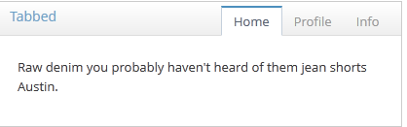

<div class="widget-header widget-header-small">

<h5 class="widget-title">Tabbed</h5>

<div class="widget-toolbar no-border">

<ul id="myTab" class="nav nav-tabs">

<li class="active"><a href="#home" data-toggle="tab">Home</a></li>

<li><a href="#profile" data-toggle="tab">Profile</a></li>

<li><a href="#info" data-toggle="tab">Info</a></li>

</ul>

</div>

</div>

<div class="widget-body">

<div class="widget-main">

<!-- tab content here -->

</div>

</div>

#### widget-body 主体

<div class="widget-body">

<div class="widget-toolbox"> ... </div>

<div class="widget-main"> ... </div>

<div class="widget-toolbox padding-8"> ... </div>

</div>

.widget-main 、.widget-toolbox(底部工具栏)可以添加.no-padding

<div class="widget-body">

<div class="widget-main no-padding">

<table class="table table-striped table-bordered table-hover">

<thead class="thin-border-bottom">

</thead>

<tbody>

</tbody>

</table>

</div>

</div>

.widget-toolbox 可以在 .widget-main 前面或者后面

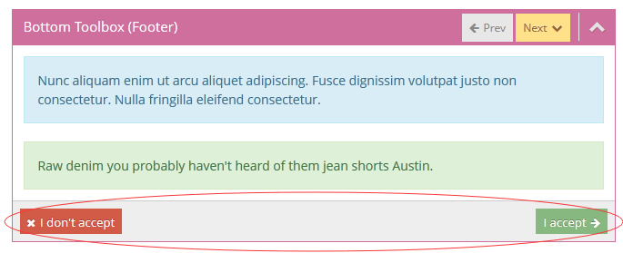

<div class="widget-toolbox">

<div class="btn-toolbar">

...

</div>

</div>

<div class="widget-main">

...

</div>

<div class="widget-toolbox padding-8 clearfix">

<button class="btn btn-xs btn-danger pull-left">

<i class="ace-icon fa fa-times"></i>

I don't accept

</button>

<button class="btn btn-xs btn-success pull-right">

I accept

<i class="ace-icon fa fa-arrow-right icon-on-right"></i>

</button>

</div>

#### Functions & Events 方法、事件

• toggle 关闭

• hide 隐藏

• show 显示

• reload 刷新

• fullscreen 全屏

$('#my-widget').widget_box('toggle');

$('#my-widget').widget_box('show');

$('#my-widget').widget_box('close');

$('#my-widget').widget_box('reload');

触发前 事件

show.ace.widget

hide.ace.widget   
close.ace.widget   
reload.ace.widget   
fullscreen.ace.widget   
setting.ace.widget

$('#my-widget').on('close.ace.widget reload.ace.widget', function(event) {

if(waitingForContent) {

event.preventDefault();//action will be cancelled, widget box won't close

}

});

setting.ace.widget 没有触发后事件，可以用来弹出自定义dialog

$('#my-widget').on('setting.ace.widget', function(ev) {

//launch a modal (settings box) or other appropriate action

});

触发后 事件

shown.ace.widget   
hidden.ace.widget   
closed.ace.widget   
reloaded.ace.widget   
fullscreened.ace.widget

$('#my-widget').on('shown.ace.widget', function(event) {

//$(this).doSomething();

});

reloaded.ace.widget 可以加载内容

$('#my-widget').on('reload.ace.widget', function(ev) {

$.ajax({url: 'remote-data.php'}).done(function(content) {

//use content

//when ready ...

$('#my-widget').trigger('reloaded.ace.widget');

});

});

#### Widget Drag & Drop 可拖拽(移动)

<div class="row">

<div class="col-sm-6 widget-container-col">

<div class="widget-box">

...

</div>

</div>

<div class="col-sm-6 widget-container-col">

<div class="widget-box">

...

</div>

</div>

</div>

$('.widget-container-col').sortable({

connectWith: '.widget-container-col',

items: '> .widget-box',

opacity: 0.8,

revert: true,

forceHelperSize: true,

placeholder: 'widget-placeholder',

forcePlaceholderSize: true,

tolerance: 'pointer',

start: function(event, ui){

//when an element is moved, its parent (.widget-container-col) becomes empty with almost zero height

//we set a "min-height" for it to be large enough so that later we can easily drop elements back onto it

ui.item.parent().css({'min-height': ui.item.height()})

},

update: function(event, ui) {

//the previously set "min-height" is not needed anymore

//now the parent (.widget-container-col) should take the height of its child (.wiget-box)

ui.item.parent({'min-height':''})

}

});

### Scrollbars 滚动条

#### Scrollbars

$('#my-content').ace_scroll({size: 400});

#### Options

size 默认是 200px

data-size

<div id="my-content" data-size="300">

...

</div>

Horizontal 水平滚动，默认是 false

$('#my-content').ace_scroll({horizontal: true});

mouseWheel 默认 true

mouseWheelLock 默认false

lockAnyway 默认false

$('#my-content').ace_scroll({size: 300, mouseWheelLock: true});

hoverReset 默认true ，随着窗口或者其他布局的变化，滚动条大小改变

reset默认true

dragEvent默认false ，使用鼠标滚动

scrollEvent默认false 内容滚动

touchDrag默认true 触摸屏，触摸滚动

hideOnIdle 隐藏滚动条

$('#my-content').ace_scroll({

//other options

hideOnIdle: true,

hideDelay: 1500,

observeContent: true

});

#### Styles

styleClass选项设置样式

scroll-margin

scroll-left

scroll-top

scroll-dark

scroll-light

no-track 隐藏滚动轨迹

scroll-thin 更小

scroll-visible 显示

scroll-chrome 类似于谷歌浏览器滚动条

$('#my-content').ace_scroll({

size: 300,

styleClass: 'scroll-dark scroll-left scroll-thin'

});

#### Events 事件

$('#my-content').ace_scroll({

scrollEvent: true

}).on('scroll', function() {

//element scrolled

});

最好监听 原生滚动事件

$('#my-content').find('.scroll-content').on('scroll', function() {

//element scrolled

});

dragEvent

$('#my-content').ace_scroll({

dragEvents: true

}).on('drag.start', function() {

//started dragging

}).on('drag._end', function() {

//ended dragging

})

#### Touch Drag Event 触摸滚动事件

$('#some-element').on('ace_drag', function(event) {

//var dir = event.direction;// up down left right

//var distanceX = event.dx

//var distanceY = event.dy

})

也可以使用 **Hammer.js**

#### Functions

• reset resets scrollbar size

• disable disables scrollbars

• enable enables scrollbars

• end scroll to end

• start scroll to start

• update updates an option (currently only size, style and mousewheel options)

$('#my-content').ace_scroll('reset');

$('#my-content').ace_scroll('disable');

$('#my-content').ace_scroll('update', {size: 250});

$('#my-content').ace_scroll('modify', completely_new_options);

#### Horizontal 水平

默认从左到右

$('#my-content').ace_scroll({

horizontal: true,

size: 600,

styleClass: 'scroll-top',

mouseWheelLock: true

});

$('#my-content').ace_scroll({

horizontal: true,

//options here

}).css('padding-top', 15);

从右到左

$('#my-content').addClass('make-ltr')

.find('.scroll-content').wrapInner('<div class="make-rtl" />');

或者

<div id="my-content" class="make-ltr">

<div class="make-rtl">

...

</div>

</div>

$('#my-content').ace_scroll({

horizontal: true,

//other options here

})

### File Input

#### Custom File Input 自定义文件框

更高级控件的可以使用: dropzone.js



<input type="file" name="myfile" id="my-file-input" />

$('#my-file-input').ace_file_input();

#### Options 参数

Style 默认 false ，

no_file ：没有文件选择时，显示的文字

no_icon ：无文件选择时，显示的图标 、

btn_choose:没有选择文件的按钮样式 

btn_change ：选择后，更改按钮

icon_remove : 移除选择的文件 

droppable ：默认false， ture则为启用拖放

thumbnail：缩略图大小**small**, **large** or **fit**.

allowExt：选择文件类型允许的列表(白名单)

denyExt：选择文件类型不允许的列表(黑名单)

allowMime 白名单

denyMime 黑名单

maxSize 文件大小

#### Callbacks 回调函数

before_change

$('#my-file-input').ace_file_input({

...

,

before_change: function(files, dropped) {

//files is a "File" object array in modern browsers

//files is a "string" (file name) array in older browsers

//dropped=true if files are drag & dropped

var valid_files = []

for(var i = 0; i < files.length; i++) {

var file = files[i];

if( typeof file === 'string') {

/older browsers that don't support FileReader API, such as IE

//here, file is just a filename string

//if (file is valid) valid_files.push(file);

} else if( 'File' in window && file instanceof window.File ) {

//file is a "File" object with following properties

//file.name

//file.type (mime type)

//file.size

//if (file is valid) valid_files.push(file);

}

}

return valid_files;

//or

return true;//original input files

//or

return false;//all are invalid, but don't reset input

//or

return -1;//all are invalid, reset input

}

**before_remove**

**$('#my-file-input').ace_file_input({**

**...**

**,**

**before_remove : function() {**

**if( uploadInProgress) return false;//don't allow resetting**

**return true;**

**}**

**});**

**preview_error**

$('#my-file-input').ace_file_input({

...,

preview_error : function(filename, error_code) {

//filename = name of the file that had a problem

switch(error_code) {

case 1:

//FILE_LOAD_FAILED

break;

case 2:

//IMAGE_LOAD_FAILED

break;

case 3:

//THUMBNAIL_FAILED

break;

}

}

});

#### File Filtering 文件过滤

allowExt

denyExt

allowMime

denyMime

maxSize

before_change

#### Functions

show_file_list

$('#my-input').ace_file_input('show_file_list', ['file1.txt']);

$('#my-input').ace_file_input('show_file_list', [

{type: 'image', name: 'name of image', path: 'http://path/to/image/for/preview'},

{type: 'file', name: 'hello.txt'}

]);

//type can be 'image', 'video', 'audio', 'file'

update_settings

$('#my-input').ace_file_input('update_settings', {

allowExt: ['pdf', 'doc', 'docx']

});

files

var files = $('#my-input').ace_file_input('files');

//is similar to:

var files = $('#my-input').data('ace_input_files');

method

var method = $('#my-input').ace_file_input('method');

//is similar to:

var method = $('#my-input').data('ace_input_method');

disable

$('#my-input').ace_file_input('disable');

enable

$('#my-input').ace_file_input('enable');

enable_reset

$('#my-input').ace_file_input('enable_reset', false);

$('#my-input').ace_file_input('enable_reset', true);

reset_input

$('#my-input').ace_file_input('reset_input');

reset_input_ui

$('#my-input').ace_file_input('reset_input_ui');

$('#my-form').on('reset', function(e) {

$('#my-input').ace_file_input('reset_input_ui');

});

reset_input_field

loading

$('#my-input').ace_file_input('loading' , true);//adds overlay

$('#my-input').ace_file_input('loading' , false);//removes overlay

$('#my-input').ace_file_input('loading' , ' custom content inside overlay such as a progressbar ');

#### Events

$('#my-file-input').ace_file_input({

droppable: true

}) .on('change', function() {

var files = $(this).data('ace_input_files');

var method = $(this).data('ace_input_method');

});

#### Uploading

启用 拖动 文件时候，应对上传文件校验

var files = $('#my-file-input').data('ace_input_files');

var myform = $('#myform');

var fd = new FormData(myform.get(0));//populate FormData with myform data

var myform = $('#myform');

var fd = new FormData();//empty FormData object

$.each(myform.serializeArray(), function(i, item) {

//add form fields one by one to our FormData

fd.append(item.name, item.value);

});

myform.find('input[type=file]').each(function(){

var field_name = $(this).attr('name');

//for fields with "multiple" file support

//field name should be something like `myfile[]`

var files = $(this).data('ace_input_files');

if(files && files.length > 0) {

for(var f = 0; f < files.length; f++) {

fd.append(field_name, files[f]);

}

}

});

var deferred = $.ajax({

url: myform.attr('action'),

type: myform.attr('method'),

processData: false,//important

contentType: false,//important

dataType: 'json',//depending on your server side response

data: fd//our FormData object

})

Ajax 提交 from数据

deferred.done(function(result) {

//on success (successful response from server)

}).fail(function(result) {

//unable to receive a valid response from server

});

低版本浏览器

var deferred = new $.Deferred //create a custom deferred object, because there's no ajax here to create it for us

var temporary_iframe_id = 'temporary-iframe-'+(new Date()).getTime()+'-'+(parseInt(Math.random()*1000));

var temp_iframe =

$('<iframe id="'+temporary_iframe_id+'" name="'+temporary_iframe_id+'" \

frameborder="0" width="0" height="0" src="about:blank"\

style="position:absolute; z-index:-1; visibility: hidden;" />')

.insertAfter(myform)

myform.append('<input type="hidden" name="temporary-iframe-id" value="'+temporary_iframe_id+'" />');

temp_iframe.data('deferrer' , deferred);

//we save the deferred object to the iframe and in our server side response

//we use "temporary-iframe-id" to access iframe and its deferred object

myform.attr({

'method': 'POST',

'enctype': 'multipart/form-data',

'target': temporary_iframe_id //important

});

myform.get(0).submit();

//if we don't receive a response after 30 seconds, let's declare it as failed!

ie_timeout = setTimeout(function(){

ie_timeout = null;

temp_iframe.attr('src', 'about:blank').remove();

deferred.reject({'status':'fail', 'message':'Timeout!'});

} , 30000);

}

#### Notes

<input multiple type="file" name="myfiles[]" id="myfiles" />

### Checkbox & Switch 复选框与开关按钮

#### Checkbox & Radio 复选框与单选按钮

.ace 、.lbl

<label>

<input type="checkbox" name="myoption[]" class="ace" />

<span class="lbl">Optional Text</span>

</label>

.ace-checkbox-2

<label>

<input type="checkbox" name="myoption[]" class="ace ace-checkbox-2" />

<span class="lbl">Optional Text</span>

</label>

Radio buttons

<label>

<input type="radio" name="myoption" class="ace" value="1" />

<span class="lbl">Optional Text</span>

</label>

#### Switch elements 开关按钮

.ace-switch、.ace-switch-2、.ace-switch-3……7

<label>

<input type="checkbox" name="myoption" class="ace ace-switch" />

<span class="lbl"></span>

</label>

<label>

<input type="checkbox" name="myoption" class="ace ace-switch ace-switch-4" />

<span class="lbl"></span>

</label>

.btn-rotate 开关按钮上添加水平的线



<label>

<input type="checkbox" name="myoption" class="ace ace-switch ace-switch-4 btn-rotate" />

<span class="lbl"></span>

</label>

.btn-empty 空白的开关按钮



<label>

<input type="checkbox" name="myoption" class="ace ace-switch ace-switch-4 btn-empty" />

<span class="lbl"></span>

</label>

.btn-flat 矩形



<label>

<input type="checkbox" name="myoption" class="ace ace-switch ace-switch-4 btn-flat" />

<span class="lbl"></span>

</label>

.data-lbl 自定义开关按钮内容

<label>

<input type="checkbox" name="myoption" class="ace ace-switch ace-switch-4 btn-flat" />

<span class="lbl" data-lbl="Hi&nbsp;&nbsp;&nbsp;&nbsp;&nbsp;&nbsp;&nbsp;&nbsp;&nbsp;&nbsp;&nbsp;&nbsp;&nbsp;Bye"></span>

</label>

重写 css ，调整按钮

input[type=checkbox].ace.ace-switch + .lbl::before {

text-indent: -21px;

}

input[type=checkbox].ace.ace-switch:checked + .lbl::before {

text-indent: 8px;

}

/* or other ones */

input[type=checkbox].ace.ace-switch.ace-switch-4 + .lbl::before {

text-indent: -25px;

}

input[type=checkbox].ace.ace-switch.ace-switch-4:checked + .lbl::before {

text-indent: 9px;

}

#### Notes

.lbl 必须在 checkbox 之后(紧跟)

这样写是错误的

<label>

<input type="checkbox" name="myoption" class="ace" />

<input type="hidden" name="asp-inserted-hidden-input" />

<span class="lbl"></span>

</label>

只能有一个 .lbl 元素

这样写是错误的

<label>

<input type="checkbox" name="myoption" class="ace" />

<input type="hidden" name="asp-inserted-hidden-input" />

<span class="lbl">Will be styled </span>

<span class="lbl">This will also be styled with new ASP.net rules!</span>

</label>

Checkbox 元素前不能有其他元素，在有些浏览器下不兼容

处理办法：hidden 放在 checkbox (.lbl)后面

或者 把 checkbox 加上 ID

<label>

<input type="hidden" name="rails-inserted-hidden-input" />

<input type="checkbox" name="myoption" class="ace" />

<span class="lbl"></span>

</label>

<label for="myoption">

<input type="hidden" name="rails-inserted-hidden-input" />

<input id="myoption" type="checkbox" name="myoption" class="ace" />

<span class="lbl"></span>

</label>

多个 按钮

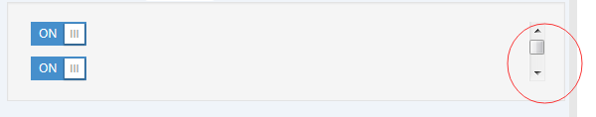

<div style="overflow-y: scroll; overflow-x: hidden; height: 60px;">

<div>

<label class="pos-rel">

<input type="checkbox" name="myoption1" class="ace ace-switch ace-switch-4 btn-flat" />

<span class="lbl"></span>

</label>

</div>

<div>

<label class="pos-rel">

<input type="checkbox" name="myoption2" class="ace ace-switch ace-switch-4 btn-flat" />

<span class="lbl"></span>

</label>

</div>

.

.

.

</div>

有时候可以不把 .lbl 和 checkbox 放在 一个 label中，可以动态添加checkbox复选框样式

例如，jqGrid 插件中的 复选框，和 jqGrid 中的数据发生冲突，则需要这样解决

form.find('input[type=checkbox]')

.addClass('ace ace-switch ace-switch-5').after('<span class="lbl"></span>');

为了更好的垂直， .lbl应该添加. middle

<label>

<input type="checkbox" name="myoption" class="ace ace-switch ace-switch-4 btn-flat" />

<span class="lbl middle"></span>

</label>

.padding-* ， 复选框与文字的间隔距离



<label>

<input type="checkbox" name="myoption" class="ace" />

<span class="lbl padding-8"></span>

</label>

#### Color picker 颜色选择器

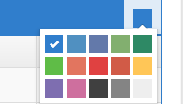

<select name="mycolor" id="mycolor">

<option value="red">red</option>

<option value="blue">blue</option>

<option value="black">black</option>

<option value="green">green</option>

<option value="purple">purple</option>

</select>

$('#mycolor').ace_colorpicker().on('change', function() {

alert(this.value);

alert(this.selectedIndex);

});

pick ，选择颜色

$('#mycolor').ace_colorpicker('pick', '#FFAA77');//select '#FFAA77' color

$('#mycolor').ace_colorpicker('pick', 3);//select 3rd index

//or

var color_picker = $('#mycolor').data('ace_colorpicker');

color_picker.pick('#EE6699', true);

//"true" means select #EE6699 and insert it if it doesn't exist

Destroy ，注销一个颜色选择器

$('#mycolor').ace_colorpicker('destroy');

### Inline Editable Addons 网页文本即时编辑插件

#### Overview

<script src="dist/js/x-editable/bootstrap-editable.min.js" />

<script src="dist/js/x-editable/ace-editable.min.js" />

#### Image editable 图像元素编辑

基于 file input

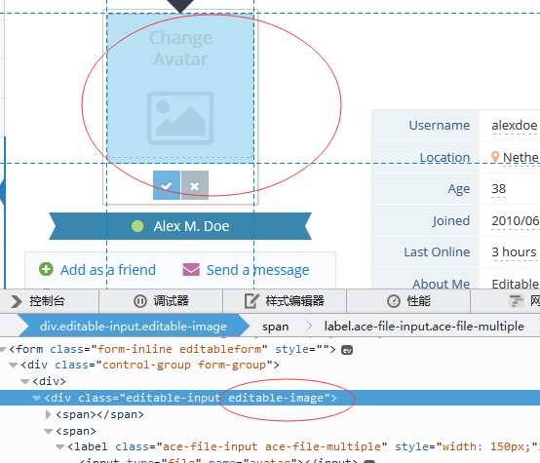

//first let's add a fake appendChild for Image element for browsers that have a problem with this

//because it seems that editable plugin calls appendChild, and it causes errors on IE at unpredicted points

try {

document.createElement('IMG').appendChild(document.createElement('B'));

} catch(e) {

Image.prototype.appendChild = function(el){}

}

$('#avatar').editable({

type: 'image',

name: 'avatar',

value: null,

image: {

name: 'avatar',//name should be here as well

//custom file input options

btn_choose: 'Change Avatar',

droppable: true,

maxSize: 110000,//~100kb

//inline editable callback option

//inline editable callback option

on_error : function(error_type) {

//invalid file selected, for example display an error message

if(error_type == 1) {

//file format error

} else if(error_type == 2) {

//file size rror

}

else {

//other error

}

},

on_success : function() {

//valid file selected, for example remove error messages

}

},

url: function(params) {

//actual file upload happens here

//see "examples/profile-avatar-update.js"

}

});

元素已载入就是 编辑状态

$('#avatar').editable('show').on('hidden', function(e, reason) {

if(reason == 'onblur') {

$('#avatar').editable('show');

return;

}

$('#avatar').off('hidden');

})

#### Slider 滚动条编辑



$('#element').editable({

type : 'slider',

name : 'element-name',

//jQuery UI slider options

slider : {

min: 1,

max: 50,

//and slider's width (default is 200)

width: 100

//,nativeUI: true //this will use browser's built-in range control if available

},

success: function(response, newValue) {

alert(parseInt(newValue));

}

});

#### Spinbox



$('#element').editable({

type: 'spinner',

name: 'element-name',

//spinner options

spinner : {

min: 16,

max: 99,

step: 1

//,nativeUI: true //this will use browser's built-in number input if available

}

});

#### Wysiwyg 文本编辑器

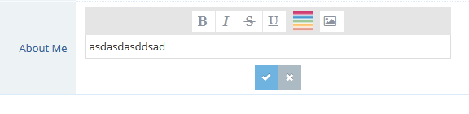

$('#element').editable({

mode: 'inline',

type: 'wysiwyg',

name: 'element-name',

//wysiwyg plugin options, such as buttons, etc

wysiwyg : {

//optional max-width

//css : {'max-width':'300px'}

},

success: function(response, newValue) {

}

});

### Content Slider 内容滑块

top bottom right left

<div class="modal aside" data-placement="top">

...

</div>

$('.aside').ace_aside();

Placement

Backdrop ，false则无背景

Fixed 固定

Background 背景颜色应为黑色或者白色

offset

body_scroll 滚动时可见

transition 禁用 c33 transition

scroll_style 滚动条样式

<div class="modal aside" data-placement="top" data-offset="true" data-background="true" data-body-scroll="false">

...

</div>

或者

$('.aside').ace_aside({

placement: 'top',

offset: true,

background: true,

body_scroll: false

});

切换

<div class="modal-content">

...

</div>

<button type="button" data-toggle="modal" data-target="#target-modal" class="aside-trigger btn btn-info btn-app btn-xs ace-settings-btn">

<i class="ace-icon fa bigger-110 icon-only fa-plus" data-icon2="fa-minus" data-icon1="fa-plus"></i>

</button>

### Onpage Help 帮助页

#### Overview

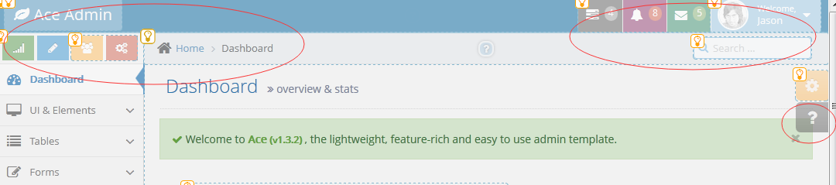

点击 则以对话框的形式 弹出

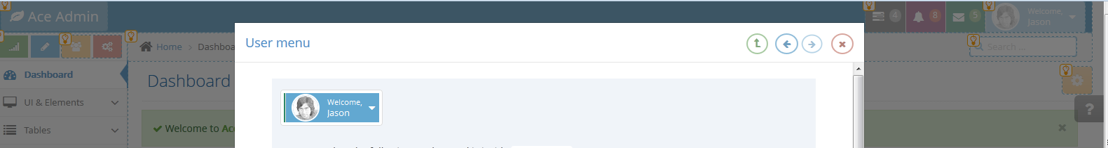

引用 assets/js/ace/elements.onpage-help.js

#### Usage

jQuery(function($) {

var help = new Onpage_Help({/* for available options, see below */});

$('#some-button').on('click', function() {

help.toggle();

//or help.enable()

//or help.disable()

})

})

帮助页面的内容是另外一个文件，程序中有相对应的 data-id

data-id="#manage/user"

<!-- #section:manage/user -->

Some elements are here which will show a help dialog when clicked!

<!-- /section:manage/user -->



<!-- #section:manage/user -->

Documentation and help content for "manage/user" are here inside some file.

<!-- /section:manage/user -->

<!-- #section:manage/user.edit -->

Manage user documentation is here

<!-- /section:manage/user.edit -->

..

..

..

<!-- #section:manage/user.delete -->

Delete user documentation is here

<!-- /section:manage/user.delete -->

<!-- #section:manage/user.edit -->

<a href="#">Edit</a><!-- will display help dialog -->

<!-- /section:manage/user.edit -->

..

..

..

<!-- #section:manage/user.delete -->

<a href="#">Delete</a><!-- will display help dialog -->

<!-- /section:manage/user.delete -->

<code class="open-file" data-open-file="js">path/to/some/file.js</code>

#### Options

icon_1 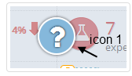

icon_2 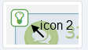

include_all 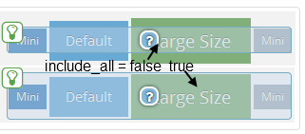

base 帮助文档路径

section_url 回调函数 返回一个url加载内容

'section_url': function(section_name) {

//From Ace Demo's example

//according to a section_name such as `basics/navbar.toggle` return the file url which contains help content

section_name = section_name || '';

//for example convert section_name=`basic/navbar.layout.brand` to `basic/navbar`

//because in Ace's documentation files 'basic/navbar.layout.brand' section is inside `basic/navbar.html` file

var url = section_name.replace(/\..*$/g, '');

var parts = url.split('/');

if(parts.length == 1) {

//for example convert `changes` to `changes/index.html`

if(url.length == 0) url = 'intro';//or convert `empty string` to `intro/index.html`

url = url + '/index.html';

}

else if(parts.length > 1) {

//for example convert `basics/navbar.layout` to `basics/navbar.html`

url = url + '.html';

}

return this.settings.base + '/docs/sections/' + url;

}

file_url 类似于'section_url ，打开一个文件

img_url 插入 图像

code_highlight 代码片段 高亮显示

before_enable 启用前

after_enable 启用后

before_disable

add_panels

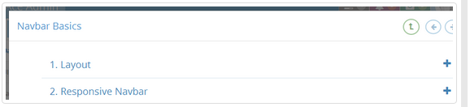

panel_content_selector 选择器

panel_content_title

## Plugins 插件

### Date & Time 日期时间控件

#### Date picker 日期

引入 js

assets/css/datepicker.css   
assets/js/date-time/bootstrap-datepicker.js

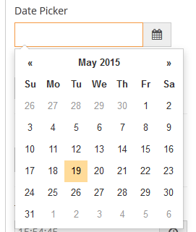

使用浏览器内置的 date，这样手机端显示比较好

<input type="date" name="mydate" id="mydate" />

var mydate = $('#mydate')[0];

if(mydate.type !== 'date') {//if browser doesn't support "date" input

$(mydate).datepicker({

//options

})

}

最基本的

$('#my-date-picker-input').datepicker({

autoclose: true,

todayHighlight: true

})

日期控件组

<div class="input-daterange input-group">

<input type="text" name="start" />

-

<input type="text" name="end" />

</div>

$('.input-daterange').datepicker({autoclose:true});

#### Daterange picker

assets/css/daterangepicker.css   
assets/js/date-time/moment.js   
assets/js/date-time/daterangepicker.js

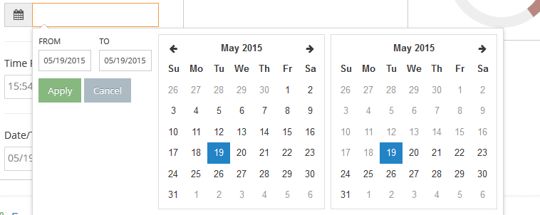

#### Time picker 时间

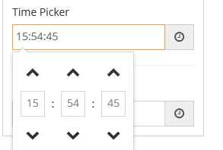

assets/css/bootstrap-timepicker.css   
assets/js/date-time/bootstrap-timepicker.js

<input type="date" name="mytime" id="mytime" />

var mytime = $('#mytime')[0];

if(mytime.type !== 'time') {//if browser doesn't support "time" input

$(mytime).timepicker({

//options

})

}

基本的时间控件

$('#timepicker1').timepicker({

minuteStep: 1,

showSeconds: true,

showMeridian: false

})

#### Datetime picker 日期时间

assets/css/bootstrap-datetimepicker.css   
assets/js/date-time/moment.js   
assets/js/date-time/bootstrap-datetimepicker.js

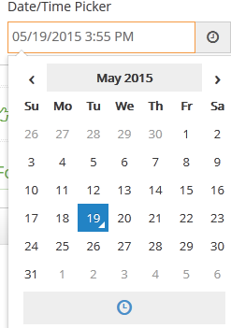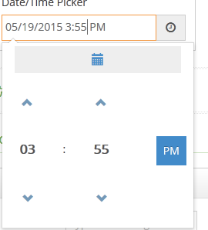

#### Fullcalendar 日历

assets/css/fullcalendar.css   
assets/js/jquery-ui.custom.js

assets/js/date-time/moment.js   
assets/js/fullcalendar.js

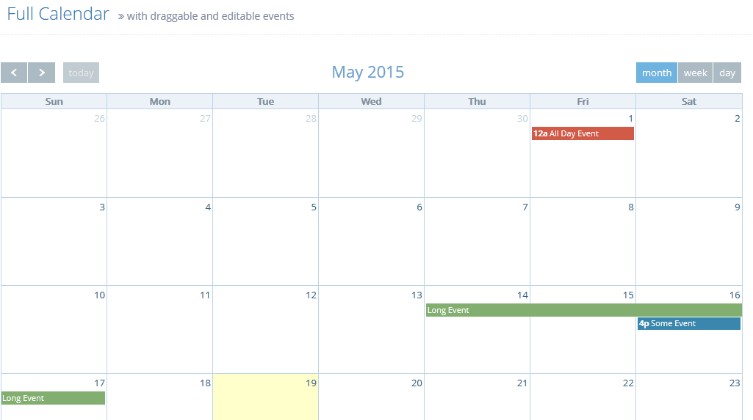

### Tables & Grids

##### dataTables

assets/js/jquery.dataTables.js   
assets/js/jquery.dataTables.bootstrap.js

var myTable =

$('#my-table')

.dataTable({

/**

sScrollY: "200px",//enable vertical scrolling

sScrollX: "100%",

sScrollXInner: "120%",//enable horizintal scrolling with its content 120% of its container

bScrollCollapse: true,

*/

bAutoWidth: false,//for better responsiveness

aoColumns": [

{ "bSortable": false },

null, null,null, null, null,

{ "bSortable": false }

]

})

var myTable =

$('#my-table')

.wrap("<div class='dataTables_borderWrap' />")

.dataTable({

//options

});

##### jqGrid

assets/css/ui.jqgrid.css   
assets/js/jqGrid/jquery.jqGrid.src.js

function aceSwitch( cellvalue, options, cell ) {

setTimeout(function(){

$(cell) .find('input[type=checkbox]')

.addClass('ace ace-switch ace-switch-5')

.after('<span class="lbl"></span>');

}, 0);

}

var parent_column = $(grid_selector).closest('[class*="col-"]');

$(window).on('resize.jqGrid', function () {

$(grid_selector).jqGrid( 'setGridWidth', $(".page-content").width() );

})

//optional: resize on sidebar collapse/expand and container fixed/unfixed

$(document).on('settings.ace.jqGrid' , function(ev, event_name, collapsed) {

if( event_name === 'sidebar_collapsed' || event_name === 'main_container_fixed' ) {

$(grid_selector).jqGrid( 'setGridWidth', parent_column.width() );

}

})

### Form Inputs & Controls

#### Chosen 下拉选择

assets/css/chosen.css   
assets/js/chosen.jquery.js

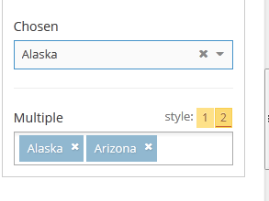

<select name="myselect" class="chosen-select">

<option value="1">Option#1</option>

<option value="2">Option#2</option>

<option value="2">Option#3</option>

</select>

$('.chosen-select').chosen();

.tag-input-style 另一种多选风格

<select multiple name="myselect" class="chosen-select tag-input-style">

...

</select>

如果是在隐藏的 容器内，则会有不兼容的问题，解决方案

//an example of a chosen inside a modal

$('#modal-form').on('shown.bs.modal', function () {

$('.chosen-select').chosen();

})

//or

$('#modal-form').on('shown.bs.modal', function () {

$(this).find('.chosen-container').each(function(){

$(this).find('a:first-child').css('width' , '210px');

$(this).find('.chosen-drop').css('width' , '210px');

$(this).find('.chosen-search input').css('width' , '200px');

});

})

有碰到插件不响应时，应改变窗口大小

$(window).on('resize.chosen', function() {

//get its parent width

var w = $('.chosen-select').parent().width();

$('.chosen-select').siblings('.chosen-container').css({'width':w});

}).triggerHandler('resize.chosen');

不支持 触摸屏

if(!ace.vars['touch']) {

//only enable chosen if not a touch device!

$('.chosen-select').chosen();

}

#### Select2

assets/css/select2.css   
assets/js/select2.js

<select multiple name="myselect" class="select2 tag-input-style">

...

</select>

#### Tag Input 标签输入框

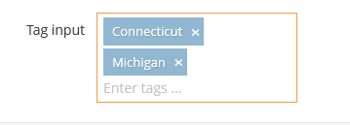

<input type="text" name="tags" id="form-field-tags" value="mytag1,mytag2" />

var tag_input = $('#form-field-tags');

try{

tag_input.tag({

placeholder: tag_input.attr('placeholder'),

//source: ['tag 1', 'tag 2'],//static autocomplet array

//or fetch data from database, fetch those that match "query"

source: function(query, process) {

$.ajax({url: 'remote_source.php?q='+encodeURIComponent(query)})

.done(function(result_items){

process(result_items);

});

}

});

}

catch(e) {

//display a textarea for old IE, because it doesn't support this plugin or another one I tried!

tag_input.after('<textarea id="'+tag_input.attr('id')+'" name="'+tag_input.attr('name')+'" rows="3">'+tag_input.val()+'</textarea>').remove();

}

动态添加

//programmatically add a new tag

var $tag_obj = $('#form-field-tags').data('tag');

$tag_obj.add('new tag');

#### Dual Listbox

assets/css/bootstrap-duallistbox.css   
  
assets/js/jquery.bootstrap-duallistbox.js

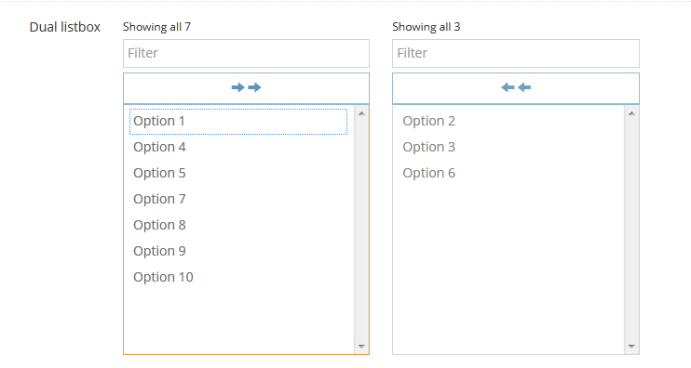

#### Bootstrap Multiselect 多选

assets/css/bootstrap-multiselect.css   
assets/js/bootstrap-multiselect.js

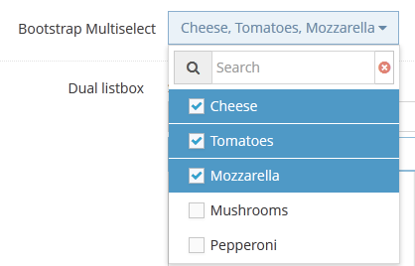

#### Masked Input 格式输入

assets/js/jquery.maskedinput.js

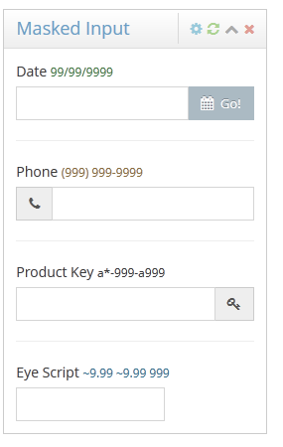

#### Input Limiter 输入长度限制，以及提示

assets/js/jquery.inputlimiter.1.3.1.js

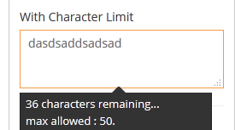

$('textarea.limited').inputlimiter({

remText: '%n character%s remaining...',

limitText: 'max allowed : %n.'

});

#### Auto Size

assets/js/jquery.autosize.js

$('textarea.autosize').autosize({append: "\n"});

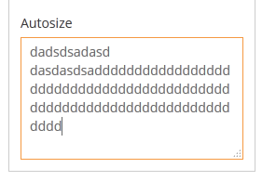

### Editor 编辑器

#### Wysiwyg Editor

assets/js/jquery.hotkeys.js   
assets/js/bootstrap-wysiwyg.js

<div id="my-editor"><!-- custom html data --></div>

$('#my-editor').ace_wysiwyg();

##### Options

Wysiwyg

speech_button 语音输入按钮

toolbar工具栏按钮

toolbar_place可选配置功能的工具栏

$('#my-editor').ace_wysiwyg({

toolbar: {

'bold',

'italic',

null,

{

name: 'font',

title: 'Custom tooltip',

values: ['Some Font!', 'Arial', 'Verdana', 'Comic Sans MS', 'Custom Font!']

}

}

});

工具栏按钮属性

Title

icon

className

工具栏按钮选项

Font 字体

{

name: 'font',

title: 'optional custom tooltip',

icon: 'fa-leaf', //some custom icon

values: ['Some Font!', 'Arial', 'Verdana', 'Comic Sans MS', 'Custom Font!']

}

fontSize 字体大小

{

name: 'fontSize',

title: 'optional custom tooltip',

values:{1 : 'Size#1' , 2 : 'Size#2' , 3 : 'Size#3' , 4 : 'Size#4' , 5 : 'Size#5'}

}

Bold 加粗

'bold',

//or

{

name: 'bold',

title: 'optional custom tooltip',

icon: 'fa-leaf' //some custom icon

}

Italic

Strikethrough

Underline

Insertunorderedlist

Insertorderedlist

Outdent

indent

justifyleft

justifycenter

justifyright

justifyfull

createLink

{

name: 'createLink',

title: 'optional custom tooltip',

placeholder: 'link input placeholder',

button_class: 'btn-purple',//insert button's class

button_text: 'Add Link'//insert button's text

}

Unlink

insertImage

{

name: 'createLink',

title: 'optional custom tooltip',

placeholder: 'image url input placeholder',

button_insert_class: 'btn-purple',//insert button's class

button_insert: 'Add Link',//insert button's text

choose_file: true,//'Whether there should be a "Choose File" button

button_class: 'btn-success',//choose button's class

button_text: 'Choose an Image'//choose button's text

}

foreColor 、backColor

{

name: 'foreColor',

title: 'optional custom tooltip',

values: ['red', 'blue', '#FF7721']

}

Undo

Redo

viewSource

$('#editor2').css({'height':'200px'}).ace_wysiwyg({

toolbar_place: function(toolbar) {

//for example put the toolbar inside '.widget-header'

return $(this).closest('.widget-box')

.find('.widget-header').prepend(toolbar)

.find('.wysiwyg-toolbar').addClass('inline');

}

});

$('#editor2').ace_wysiwyg().prev().addClass('wysiwyg-style2');

##### Notes

发送编辑内容到服务器

$('#myform').on('submit', function() {

var hidden_input =

$('<input type="hidden" name="my-html-content" />')

.appendTo('#myform');

var html_content = $('#myeditor').html();

hidden_input.val( html_content );

//put the editor's HTML into hidden_input and it will be sent to server

});

#### Markdown Editor

assets/js/markdown/markdown.js assets/js/markdown/bootstrap-markdown.js

assets/js/bootbox.js

<div class="widget-box widget-color-blue">

<div class="widget-header widget-header-small"></div>

<div class="widget-body">

<div class="widget-main no-padding">

<textarea name="content" data-provide="markdown" rows="10"></textarea>

</div>

</div>

</div>

### FuelUX

#### Spinbox 微调

assets/js/fuelux/fuelux.spinner.js

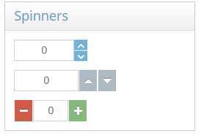

<input type="text" name="my-spinner" id="my-spinner" />

$('#my-spinner').ace_spinner({

min: 0,

max: 100,

step: 1,

icon_up: 'fa-plus',

icon_down: 'fa-minus',

btn_up_class: 'btn-success',

btn_down_class: 'btn-danger',

on_sides: true

});

icon_up图标可用于“上升”按钮  
  
icon_down图标可用于“下降”按钮  
  
btn_up_class“”按钮的按钮类  
  
btn_down_class“向下”按钮，按钮类  
  
on_sides向上和向下按钮在输入框两边  
  
touch_spinner大按钮将

$('#my-spinner').ace_spinner('disable');

$('#my-spinner').ace_spinner('enable');

$('#my-spinner').ace_spinner('value', 3);

$('#my-spinner').closest('.ace-spinner').spinbox('disable');

$('#my-spinner').closest('.ace-spinner').on('changed.fu.spinbox', function () {

//do something

})

#### Wizard 向导

assets/js/fuelux/fuelux.wizard.js

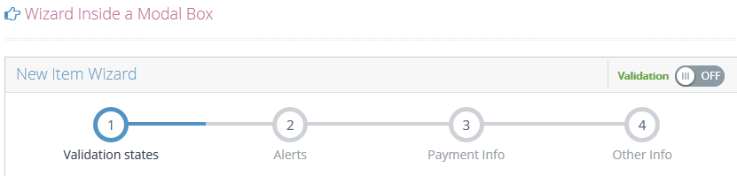

<div id="my-wizard"><!-- wrap step list and step panes -->

<!-- step list -->

<ul class="steps">

<li data-step="1" class="active">

<span class="step">1</span>

<span class="title">Step1</span>

</li>

<li data-step="2">

<span class="step">2</span>

<span class="title">Step2</span>

</li>

</ul>

<!-- step panes -->

<div class="step-content">

<div class="step-pane active" data-step="1">

<!-- step 1 -->

</div>

<div class="step-pane" data-step="2">

<!-- step 2 -->

</div>

</div>

</div>

上一步、下一步 按钮

<div id="my-wizard">

</div>

<div class="wizard-actions">

<button class="btn-prev btn">

<i class="ace-icon fa fa-arrow-left"></i> Prev

</button>

<button class="btn-next btn btn-success" data-last="Finish ">

Next <i class="ace-icon fa fa-arrow-right icon-on-right"></i>

</button>

</div>

启用向导

$('#my-wizard')

.ace_wizard({

//step: 2 //optional argument. wizard will jump to step "2" at first

//buttons: '.my-action-buttons' //which is possibly located somewhere else and is not a sibling of wizard

})

.on('actionclicked.fu.wizard' , function(e, info) {

//info.step

//info.direction

//use e.preventDefault to cancel

})

.on('changed.fu.wizard', function() {

//after step has changed

})

.on('finished.fu.wizard', function(e) {

//do something when finish button is clicked

}).on('stepclick.fu.wizard', function(e) {

//e.preventDefault();//this will prevent clicking and selecting steps

});

向导功能

var wizard = $('#my-wizard').data('fu.wizard');

//move to step 3

wizard.currentStep = 3;

wizard.setState();

//determine selected step

wizard.selectedItem().step

#### Treeview 树

assets/js/fuelux/fuelux.treeview.js

1. open-icon 打开状态图标
2. close-icon 关闭状态图标
3. selectable 默认
4. selected-icon 选中
5. unselected-icon 未选中

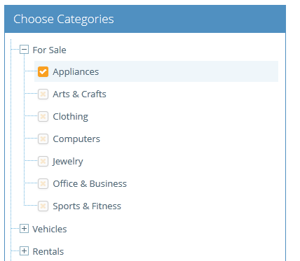

<ul id="tree1"></ul>

$('#tree1').ace_tree({

dataSource : treeDataSource ,

multiSelect : true,

loadingHTML : '<div class="tree-loading"><i class="ace-icon fa fa-refresh fa-spin blue"></i></div>',

'open-icon' : 'ace-icon tree-minus',

'close-icon' : 'ace-icon tree-plus',

'selectable' : true,

'selected-icon' : 'ace-icon fa fa-check',

'unselected-icon' : 'ace-icon fa fa-times'

});

.tree-minus 、.tree-plus 图标

事件

$('#tree1').on('opened.fu.tree', function () {

//do something

})

dataSource

$('#tree1').ace_tree({

dataSource : treeDataSource

// ... other options

});

var treeDataSource = function(options , callback) {

//options has extra info such as "type" "text" "additionalParameteres", etc

//which you can use to specify requested set of data

var myData = [ ... ];//set of data

callback({ data: myData });

}