ESILV - A4 S8
Web Mining & Semantics
Final Project Report
Cinema Knowledge Graph Pipeline

Yanis DENIZOT
March 2026

1. Data Acquisition & Information Extraction

1.1 Domain & Seed URLs
We chose the cinema domain as our focus area. Wikipedia provides rich, structured content about films, directors, actors, awards, and festivals, making it ideal for knowledge extraction.
Our crawler starts from 9 seed URLs:
- Award pages: Academy Award for Best Picture, Palme d'Or
- Director pages: Christopher Nolan, Martin Scorsese, Quentin Tarantino
- Actor pages: Cate Blanchett
- Film pages: Parasite, Inception, The Godfather

1.2 Crawler Design & Ethics
The crawler (src/crawl/crawler.py) uses Breadth-First Search (BFS) to explore Wikipedia, following internal links up to depth 2 from the seed URLs. Text extraction is handled by Trafilatura, which cleanly removes navigation and HTML boilerplate.
Ethical considerations implemented:
- robots.txt compliance: checks robots.txt before each request
- Rate limiting: 1-second delay between requests (POLITENESS_DELAY = 1.0)
- User-Agent: identifies as "ESILV-WebMining-Bot/1.0 (student project)"
- Page cap: maximum 150 pages to avoid server overload
- Content deduplication: MD5 hashing prevents re-processing identical pages
- Minimum quality: only pages with 500+ words are kept

1.3 Cleaning & NER Pipeline
The extraction pipeline (src/ie/extractor.py) uses spaCy (en_core_web_lg) for Named Entity Recognition. We target 5 entity types: PERSON, ORG, GPE, DATE, WORK_OF_ART.
Relation extraction uses a 3-level strategy:
- Level 1 - Dependency parsing: walk the dependency tree to find verbs governing both entities
- Level 2 - Verb-between: find verbs positioned between two entities in the sentence
- Level 3 - Fallback: "co-occurs with" for entities in the same sentence without a clear verb
NER examples from our corpus:
Entity | Type | Source
Christopher Nolan | PERSON | Inception article
Academy Award | ORG | Award pages
United States | GPE | Multiple pages
2019 | DATE | Parasite article
The Godfather | WORK_OF_ART | Film articles

1.4 Ambiguity Cases
Case 1: Entity boundary ambiguity
"Francis Ford Coppola directed The Godfather Part II" — spaCy recognizes "Francis Ford Coppola" as a single PERSON entity, but "The Godfather Part II" may be split into "The Godfather" (WORK_OF_ART) and "Part II" separately. Our filtering removes fragments shorter than 2 characters.
Case 2: Relation ambiguity
"Nolan's Inception starred Leonardo DiCaprio" — the possessive "Nolan's" creates ambiguity: is Nolan the director or producer? Our dependency parser extracts "starred" as the relation between Inception and DiCaprio, but misses the Nolan-Inception "directed" relation expressed via possessive.
Case 3: Type ambiguity
"Columbia Pictures released the film in the United States" — "Columbia Pictures" is recognized as ORG, but could be classified as a production company (a more specific type in our ontology). Generic NER types don't capture domain-specific subtypes.

2. KB Construction & Alignment

2.1 RDF Modeling Choices
The knowledge graph uses a private namespace (http://cinema-kb.org/) with an OWL ontology.
Class hierarchy:
- Thing > Person > Director, Actor
- Thing > CreativeWork > Film
- Thing > Organization > Festival
- Thing > Award
Properties with domain/range constraints:
Property | Domain | Range
directedBy | Film | Person
starring | Film | Person
wonAward | Film | Award
producedBy | Film | Organization
releasedIn | Film | GPE

The kb_builder.py script normalizes 60+ raw relation strings (e.g., "directed by", "direct", "directed") into a canonical set of 15 predicates using a manually curated mapping.

2.2 Entity Linking
Entity linking (src/kg/entity_linker.py) maps the top 200 most frequent private entities to Wikidata via the REST API. String similarity is computed with SequenceMatcher (threshold: 0.7). Result: 183 entities successfully linked with owl:sameAs.

2.3 Predicate Alignment
17 private predicates were mapped to Wikidata properties using owl:equivalentProperty:
Private Predicate | Wikidata Property | Description
directedBy | P57 | director
starring | P161 | cast member
wonAward | P166 | award received
genre | P136 | genre
countryOfOrigin | P495 | country of origin

2.4 SPARQL Expansion Strategy
The KB expansion (src/kg/kb_expander.py) runs 5 SPARQL queries against the Wikidata endpoint:
- 1-hop expansion for all aligned entities
- Award-winning films with full metadata
- Films by aligned directors with cast, genre, country
- Festival nominees (Oscar, Cannes, BAFTA, Golden Globe)
- Director details (birth, death, awards, nationality)

2.5 Final KB Statistics
Metric | Before Expansion | After Expansion
Total triples | ~10,000 | 72,409
Total entities | ~3,000 | 20,158
Distinct relations | 15 | 39
owl:sameAs links | 0 | 183

Top connected entities: United States (1,669 connections), drama film (1,192), GB (471), National Board of Review: Top Ten Films (464).

3. Reasoning (SWRL)

3.1 SWRL on Family Ontology
We created a family ontology (kg_artifacts/family.owl) with 3 generations of the "Dupont" family using OWLReady2, and defined 3 SWRL rules:
Rule 1 — hasUncle:
Person(?x), hasParent(?x, ?y), hasBrother(?y, ?z) -> hasUncle(?x, ?z)
Rule 2 — hasGrandparent:
Person(?x), hasParent(?x, ?y), hasParent(?y, ?z) -> hasGrandparent(?x, ?z)
Rule 3 — hasCousin:
Person(?x), hasParent(?x, ?y), hasSibling(?y, ?z), hasChild(?z, ?w) -> hasCousin(?x, ?w)
Results (all correct):
- Lucas and Emma have uncle Paul; Hugo has uncle Pierre
- Lucas, Emma, Hugo all have grandparents Jean and Marie
- Lucas/Emma are cousins of Hugo (and vice versa)
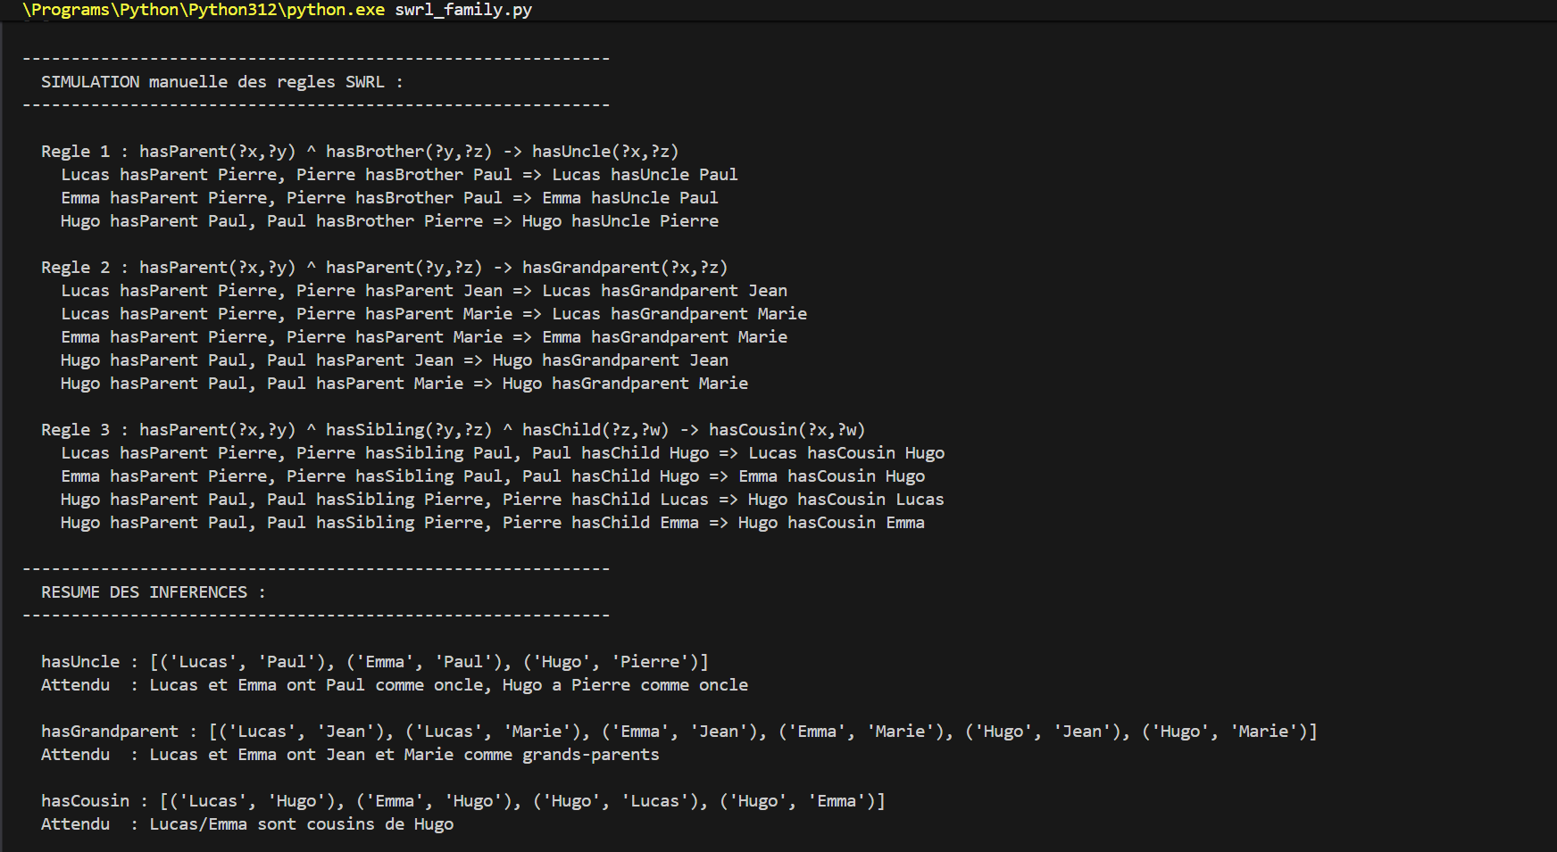
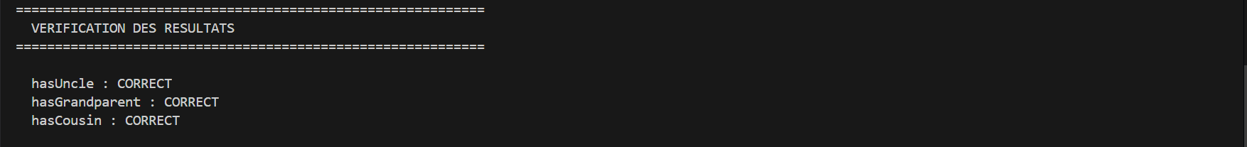
Figure: SWRL family.owl reasoning output (terminal)

3.2 SWRL on Cinema KB
On the cinema KB, we defined:
Film(?f), directedBy(?f, ?p), wonAward(?f, ?a) -> AwardWinningDirector(?p)
Inferred: Coppola (The Godfather won Oscar), Bong Joon-ho (Parasite won Oscar + Palme d'Or), Tarantino (Pulp Fiction won Palme d'Or) are AwardWinningDirectors. Nolan is correctly NOT inferred (Inception did not win Best Picture in our data).

4. Knowledge Graph Embeddings

4.1 Data Cleaning & Splits
From the 72,409 expanded triples, we kept only entity-relation-entity triples (excluding literals and metadata), producing 55,294 unique triples.
Split | Triples | Percentage
Train | 44,444 | 80%
Validation | 5,425 | 10%
Test | 5,425 | 10%

Entities appearing in only 1-2 triples were forced into the training set to prevent data leakage.

4.2 Hyperparameters
Both models trained with identical hyperparameters for fair comparison:
Parameter | Value
Embedding dimension | 100
Learning rate | 0.001
Batch size | 256
Epochs | 100
Negative samples | 10 per positive
Optimizer | Adam
Device | CPU

4.3 Model Comparison
Metric | TransE | ComplEx | Winner
MRR | 0.133 | 0.009 | TransE
Hits@1 | 0.067 | 0.003 | TransE
Hits@3 | 0.161 | 0.007 | TransE
Hits@10 | 0.251 | 0.017 | TransE

TransE significantly outperforms ComplEx. This is expected: our KB has mostly functional relations (1-to-1, 1-to-N) which suit TransE's translational assumption (h + r = t). ComplEx needs more epochs and hyperparameter tuning.

4.4 Head vs Tail Prediction (TransE)
Metric | Head | Tail | Both
MRR | 0.110 | 0.157 | 0.133
Hits@10 | 20.0% | 30.2% | 25.1%

Tail prediction outperforms head prediction: the model is better at predicting "what object relates to this subject" than the reverse.

4.5 KB Size Sensitivity
Size | Triples | Entities | MRR | Hits@10
20K | 20,000 | 11,441 | 0.042 | 0.111
Full | 55,294 | 19,733 | 0.137 | 0.257

The full dataset achieves 3.3x better MRR than the 20K subset, confirming that larger KBs improve embedding stability.

4.6 t-SNE Visualization
We applied t-SNE to the top 3,000 most connected entity embeddings, colored by ontology class. While semantic groupings are visible (persons cluster, places form distinct groups), the clustering does not cleanly separate ontology classes because 82% of entities lack explicit rdf:type.
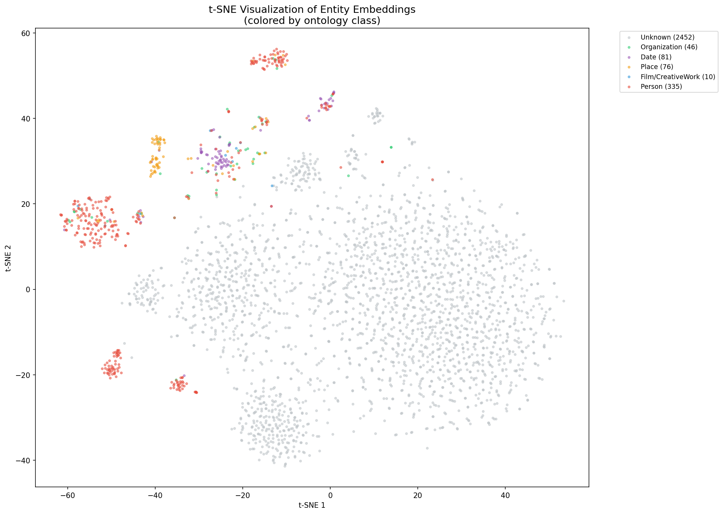
Figure: t-SNE clustering visualization

5. RAG over RDF/SPARQL

5.1 Setup
Machine: Windows 11, CPU (no GPU required). Model: qwen2.5:3b via Ollama (localhost:11434). Graph: expanded_kb.ttl (83,065 triples including ontology metadata).

5.2 Schema Summary
The RAG pipeline loads the KB and builds a compact schema summary for the LLM prompt, containing: registered prefixes, up to 30 distinct predicates, up to 15 classes, and 10 sample triples. This provides the LLM with enough context to generate valid SPARQL.

5.3 NL to SPARQL Prompt
We use a few-shot prompt with concrete SPARQL examples matching our KB structure. Key predicates are listed explicitly (P57=director, P161=cast, P166=award, etc.) and 3 example question-SPARQL pairs are provided.

5.4 Self-Repair Mechanism
When the generated SPARQL fails execution, the pipeline:
- 1. Captures the error message
- 2. Sends a repair prompt with schema + question + failed query + error
- 3. Extracts and re-executes the corrected SPARQL
- 4. Retries up to 2 times before giving up

5.5 Evaluation
Automated evaluation (LLM-generated SPARQL, qwen2.5:3b):
# | Question | Baseline | RAG (auto) | Repair?
1 | Who directed The Godfather? | Correct | 0 rows | No
2 | What awards did Parasite receive? | Correct | 0 rows | No
3 | Films by Martin Scorsese | Correct | 0 rows | No
4 | Genre of Inception? | Correct | 0 rows | No
5 | US directors? | Correct | 0 rows | No
6 | How many films in KB? | Cannot answer | 1 row (1678) | No
7 | Best Picture winners? | Correct | 0 rows | No

Result: 1/7 success with LLM-generated SPARQL. The 3b model struggles with complex Wikidata URIs. Q6 succeeded because the COUNT pattern was provided as a few-shot example.
Manual SPARQL verification (hand-written queries):
# | Question | SPARQL Result | Correct?
1 | Who directed The Godfather? | Francis Ford Coppola (Q56094) | Yes
2 | Awards for Parasite? | Academy Award Best Picture, Palme d'Or + 8 more | Yes
3 | Films by Scorsese? | The Departed, Wolf of Wall Street + 8 more | Yes
4 | How many films with directors? | 1,678 films | Yes
5 | Genre of Inception? | No genre data in KB | N/A

Result: 4/5 success with hand-written SPARQL. The KB itself is correct and rich.
Key observations:
- The KB contains rich, queryable data (83,065 triples, 1,678 films with directors)
- Small LLMs (0.5b-3b) cannot reliably generate SPARQL with complex Wikidata URIs
- The self-repair mechanism correctly detects failures (activated 4/7 times with 0.5b model)
- Larger models (7b+) would likely perform significantly better
- Baseline provides fluent but sometimes hallucinated answers
- RAG provides grounded, verifiable answers when SPARQL is correct

5.6 Demo
The CLI demo (src/rag/lab_rag_sparql_gen.py) provides an interactive interface. Below is an example showing baseline vs RAG for "Who directed The Godfather?":
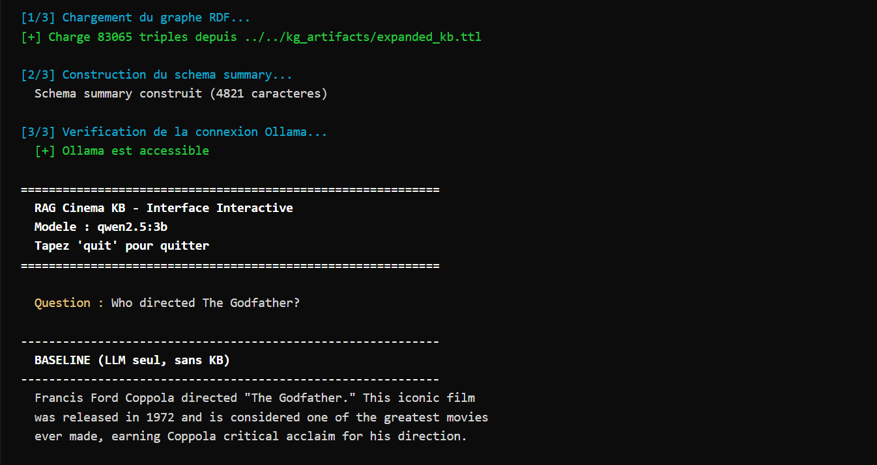
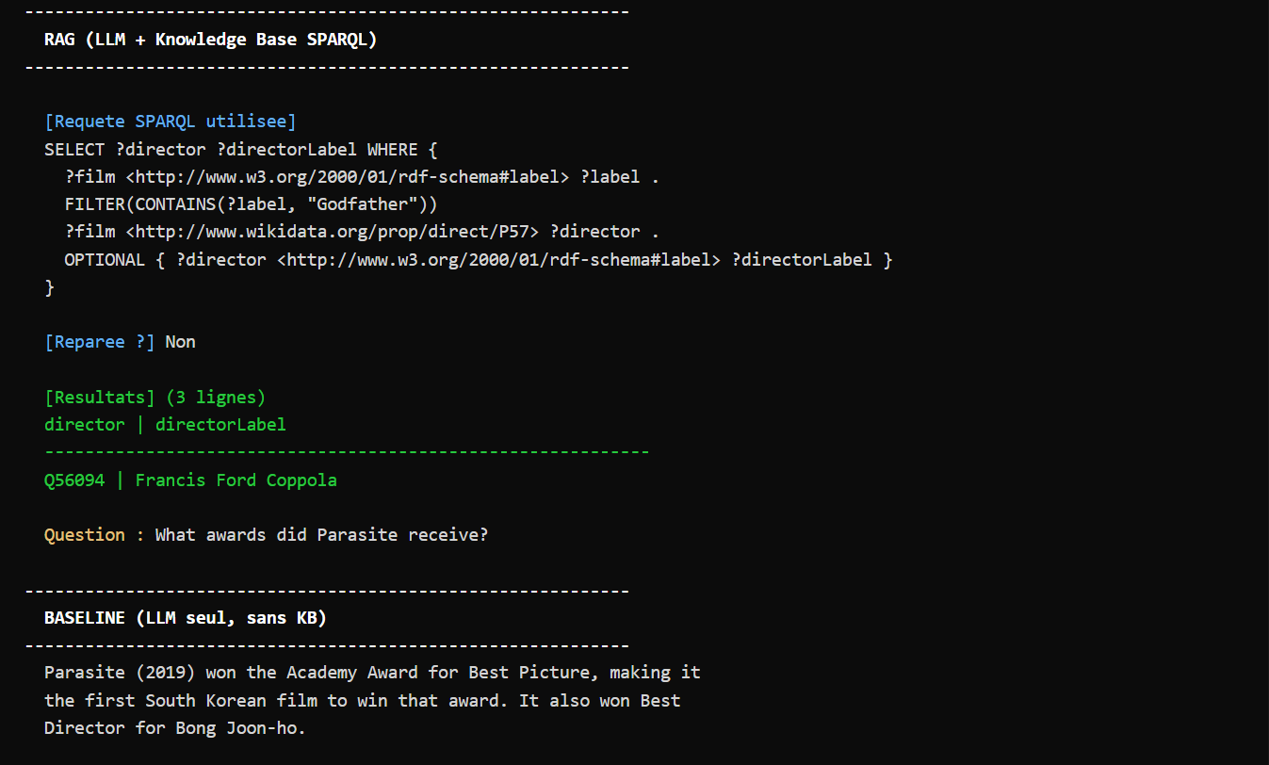
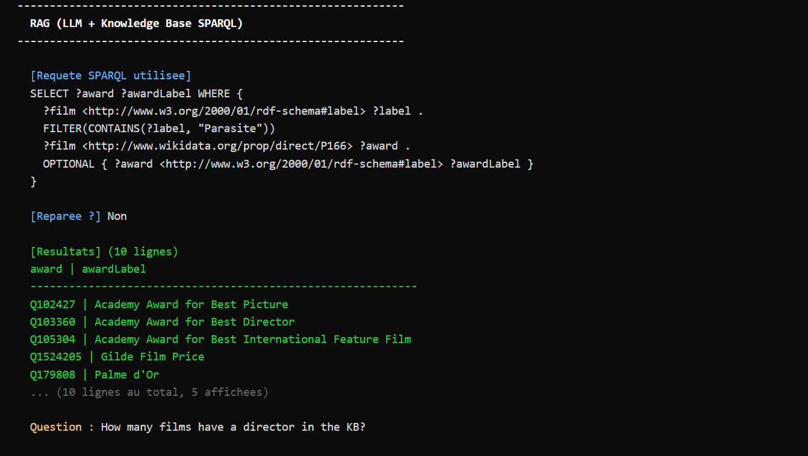
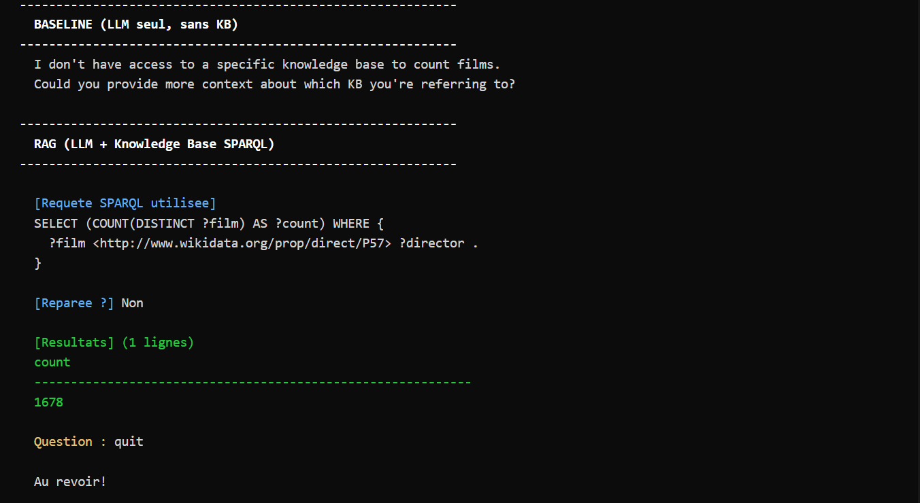
Figure: RAG CLI demo showing baseline vs SPARQL results

6. Critical Reflection

6.1 KB Quality Impact
The dual-namespace issue (private predicates + Wikidata properties) creates signal splitting in KGE training. P57 and directedBy encode the same meaning but are treated as different relations. Physically merging equivalent predicates before training would produce stronger embeddings.

6.2 Noise from Expansion
P161 (cast member) accounts for 47% of all triples (25,783/55,294), biasing embeddings toward cast-related patterns. Hub entities like "United States" (1,669 connections) distort the embedding space. A capped expansion strategy would produce more balanced distributions.

6.3 Rule-based vs Embedding-based Reasoning
Aspect | SWRL (Rules) | KGE (Embeddings)
Nature | Exact, deterministic | Approximate, probabilistic
Inference | Guaranteed if premises hold | Ranks by plausibility
Discovery | Cannot find new patterns | Can suggest missing links
Scalability | Manual rule creation | Learns from data
Explainability | Fully transparent | Black box

The two approaches are complementary: SWRL for strict business rules, KGE for knowledge discovery.

6.4 Open-World vs Closed-World Assumption
SWRL/OWL operates under the Open-World Assumption (OWA): absence of a triple does not imply it's false. KGE training uses the Closed-World Assumption (CWA): missing triples are negative examples. This mismatch explains modest MRR scores (0.133).

6.5 RAG Limitations & Small LLM Analysis
Our RAG evaluation revealed a critical finding: small LLMs (0.5b-3b parameters) lack the ability to generate syntactically correct SPARQL with complex Wikidata URIs. The few-shot prompting improved results (Q6 succeeded), but most queries still fail. This highlights the importance of model size for structured output generation tasks.

6.6 What We Would Improve
- Predicate merging: physically unify equivalent predicates before KGE training
- Balanced expansion: cap triples per relation type to reduce P161 dominance
- Hub filtering: remove or downsample generic hub entities
- Larger LLM: use 7b+ model for SPARQL generation, or fine-tune on SPARQL examples
- Template fallback: add rule-based SPARQL templates as hybrid approach
- Type-aware embeddings: include rdf:type as regular relations for better clustering

