Football page

Thami Mnyandu

WDD 130

Site Plan
Overview

Purpose
This website serves as an educational hub for everything related to football, helping visitors understand and appreciate the sport. Rather than focusing on live scores or current events, the site is designed to explain the fundamentals of football. Such as its rules, positions, terminology, equipment, and the basic strategies that shape the game. The goal is to give visitors a clear, well-organized resource where they can learn what football is and how it works, whether they're trying to understand the sport for the first time or looking to deepen their existing knowledge.

Audience
The primary audience for this website includes people who are new to football and want a clear, approachable introduction to how the sport works, as well as existing fans who want to brush up on rules or terminology they may not fully understand. This includes a wide range of visitors. From someone watching their first game and trying to follow along, to parents wanting to understand a sport their child is starting to play, to casual fans who want a deeper grasp of the game's fundamentals. The site is designed to serve all of these groups by presenting information in a way that's clear and educational without assuming prior knowledge of the sport.

Branding

Website logo



Style guide

Color Palette

Primary | Secondary | Accent 1 | Accent 2


Typography

Heading font: Times New Roman

Paragraph Font: Georgia

Paragraph Example:

This webpage will show all things football related

Colored paragraph example:

This webpage will show all things football related
Navigation with Hover

HomePage2Contact Us

Site Map

Home

[Page2]

Contact Us /About

Wireframes

Home

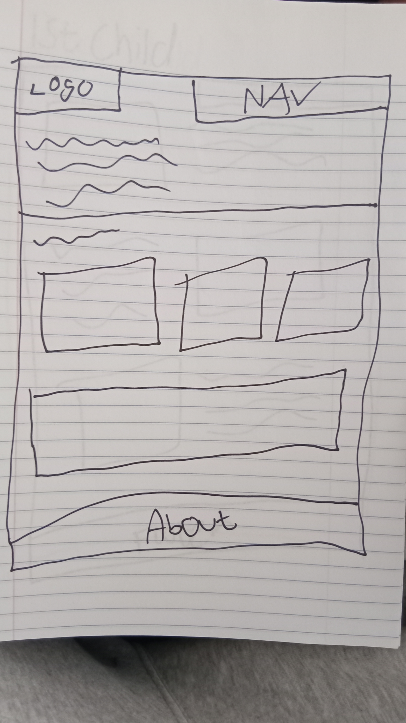

Child
