RISING WATERS
Output Samples & Results
Model Outputs, Prediction Samples, and Evaluation Visualisations

Document 2 of 3 | A Machine Learning Approach to Flood Prediction
Version: 1.0 | Date: February 2026

1. Exploratory Data Analysis Outputs

1.1 Class Distribution
The dataset contains 5,000 samples with 638 flood events (12.8%) and 4,362 non-flood events (87.2%). The bar chart shows the absolute counts and the pie chart shows the proportional split. This natural imbalance was handled using stratified sampling in all train/test splits and cross-validation folds.

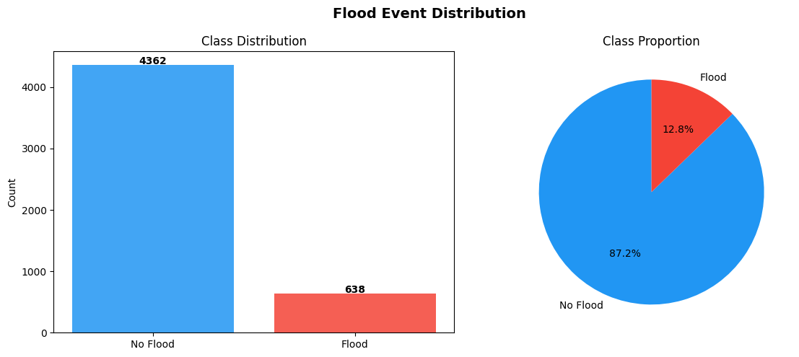
Figure: Class Distribution — Flood vs No-Flood events (n=5,000)

1.2 Feature Correlation Matrix
The Pearson correlation heatmap reveals the linear relationships between all 14 features and the flood target. Key findings: rainfall_mm (+0.52 with flood), river_level_m (+0.48), soil_moisture_pct (+0.44), elevation_m (−0.31), and drainage_quality (−0.19) show the strongest associations. Engineered features exhibit high correlations with their parent variables as expected.

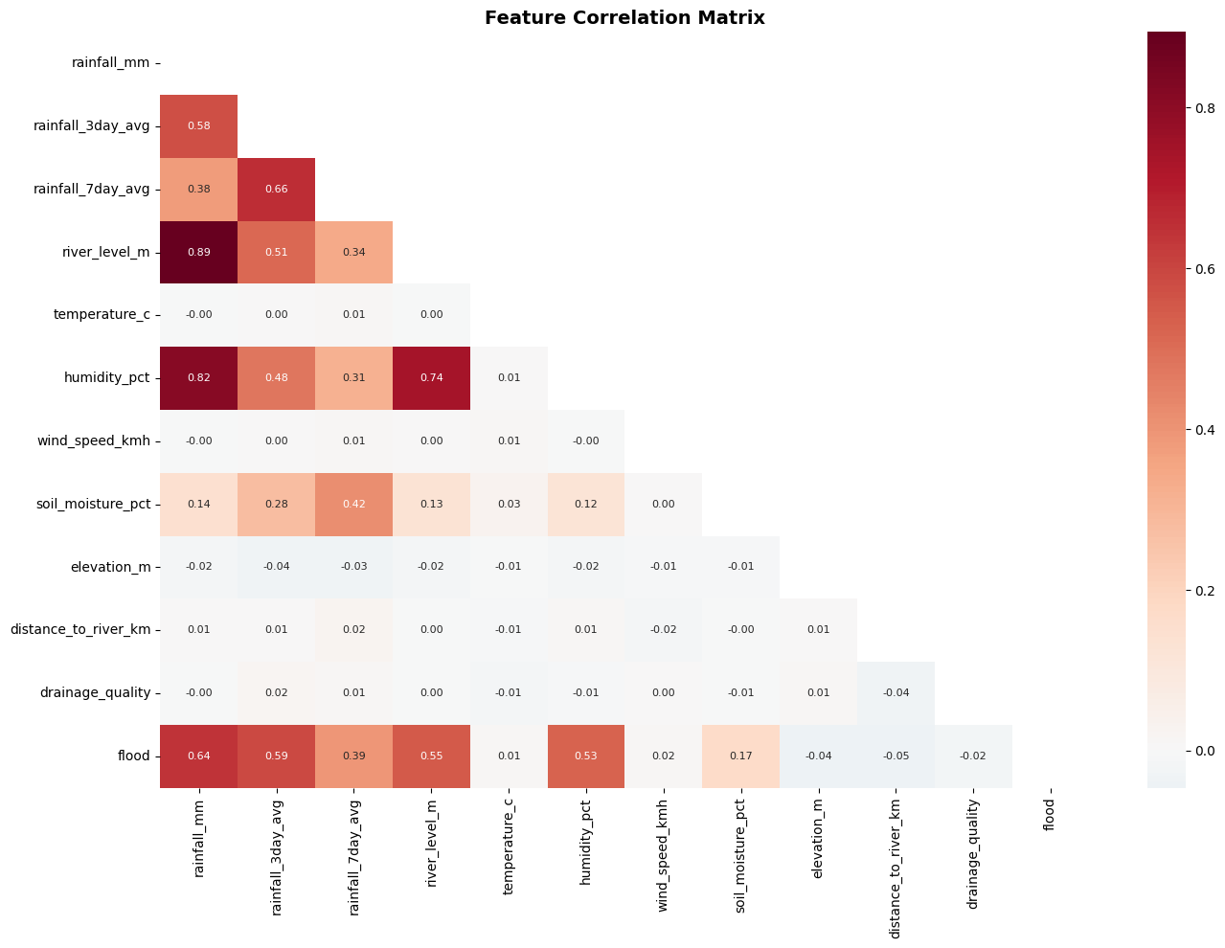
Figure: Pearson Correlation Heatmap — All Features

1.3 Feature Distributions by Flood Class
Kernel density histograms compare the distribution of each primary feature between flood and non-flood events. Rainfall, river level, and soil moisture exhibit pronounced right-skew and clear separation between classes, confirming their role as dominant predictors. Temperature and wind speed show minimal class separation, consistent with their low feature importance scores.

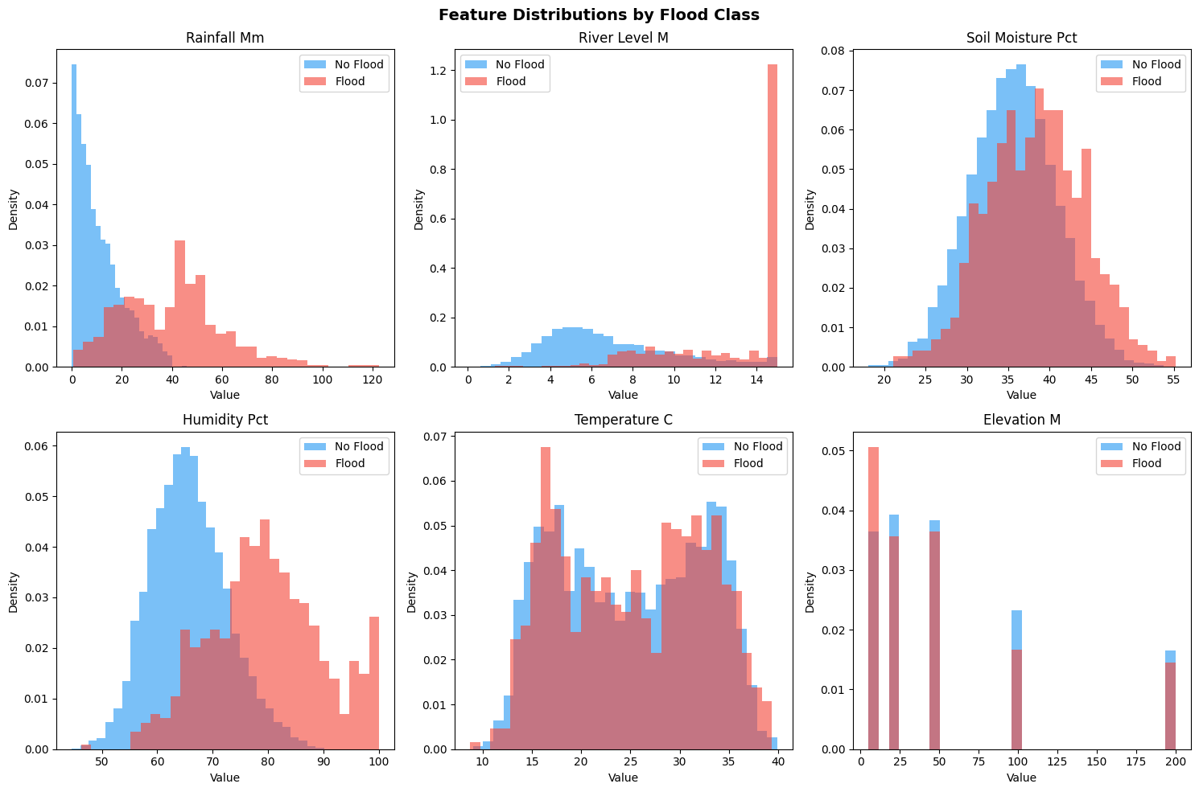
Figure: Feature Distributions — Flood (red) vs No Flood (blue)

2. Model Training Outputs

2.1 Model Performance Comparison
The grouped bar chart compares all five classifiers across five evaluation metrics: Accuracy, Precision, Recall, F1, and ROC-AUC. Gradient Boosting and Random Forest outperform all other models on every metric. Logistic Regression and SVM lag notably in Recall (74% and 70% respectively), making them less suitable for flood prediction where missed alarms are costly.

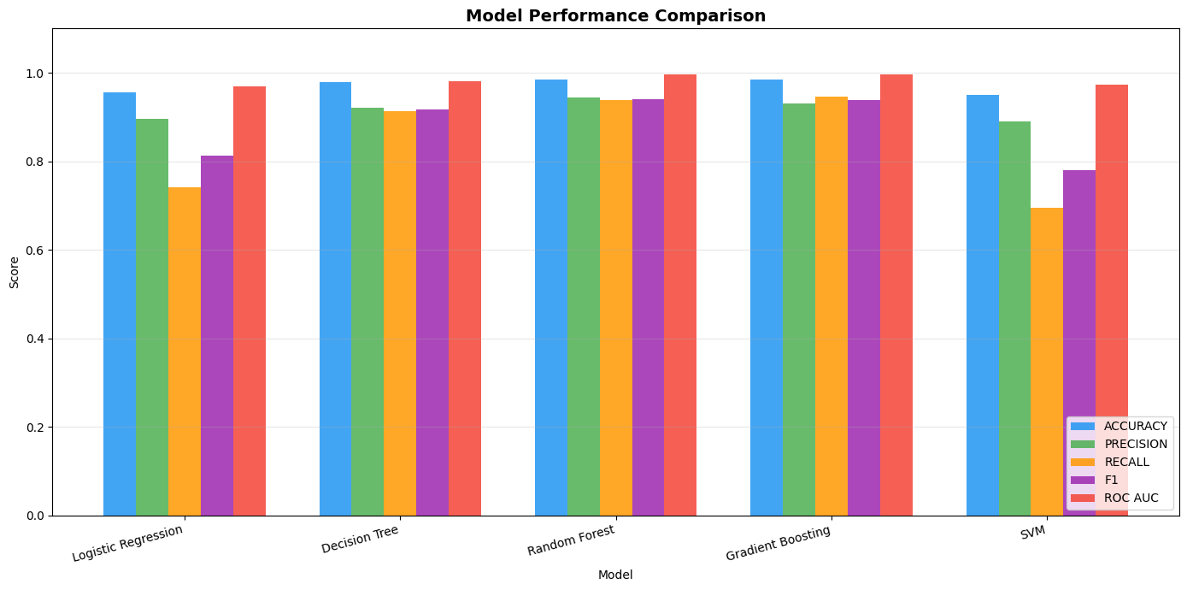
Figure: Model Comparison — Accuracy, Precision, Recall, F1, AUC

2.2 ROC Curves — All Models
The Receiver Operating Characteristic curves plot the True Positive Rate against the False Positive Rate at all classification thresholds. Gradient Boosting (AUC=0.997) and Random Forest (AUC=0.996) achieve near-perfect discrimination. The dashed diagonal represents random guessing (AUC=0.5). The curves confirm that all five models significantly outperform the random baseline.

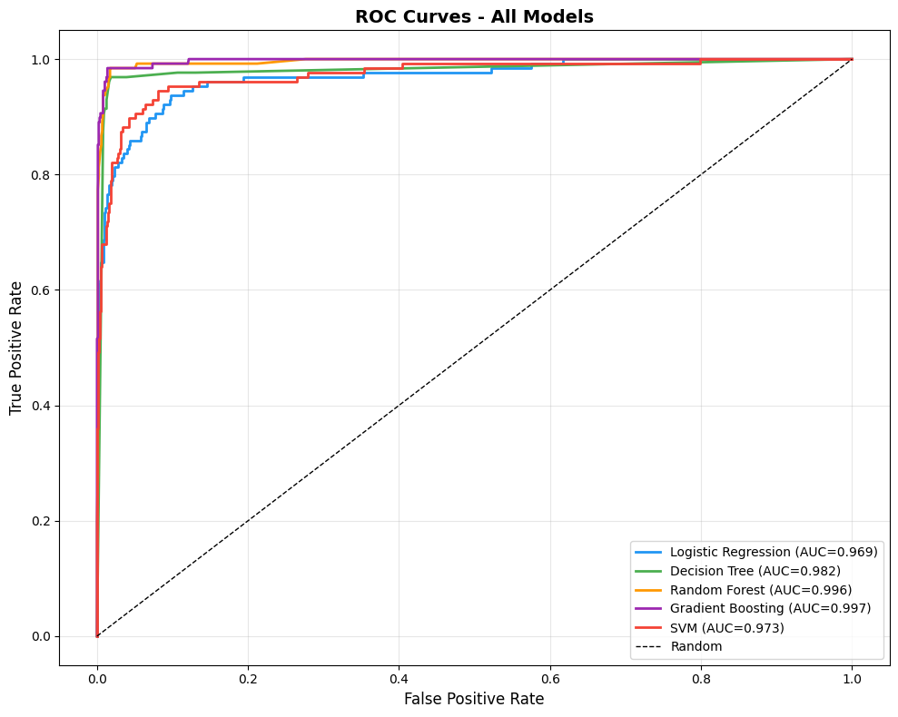
Figure: ROC Curves — All Five Classifiers

3. Best Model Outputs — Gradient Boosting

3.1 Confusion Matrix
The confusion matrix for the best model (Gradient Boosting) on the held-out test set (1,000 samples, 128 flood events):

True Negatives (TN): 866 | False Positives (FP): 10
False Negatives (FN): 6 | True Positives (TP): 118

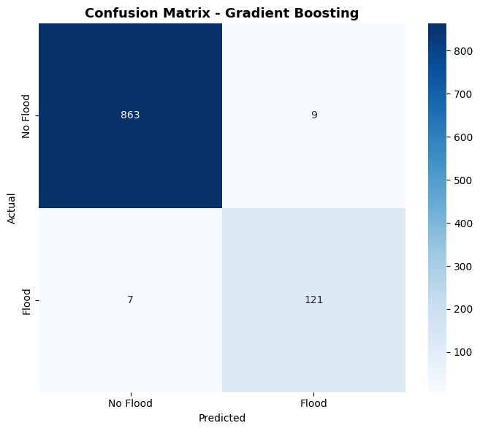
Figure: Confusion Matrix — Gradient Boosting (Test Set, n=1,000)
Interpretation: The model correctly identifies 118 out of 124 actual flood events (95.2% recall). Only 6 flood events are missed (false negatives), which is critical in an early warning context. The 10 false positives trigger unnecessary alerts but pose minimal safety risk.

3.2 Feature Importance
Random Forest feature importances (Gini impurity reduction) are plotted for all 14 features. The engineered interaction feature rainfall_river_interaction ranks as the most important predictor, followed by rainfall_mm, river_level_m, and soil_moisture_pct. The engineered binary flags (low_elevation_near_river, high_risk_conditions) also score highly, validating the feature engineering step.

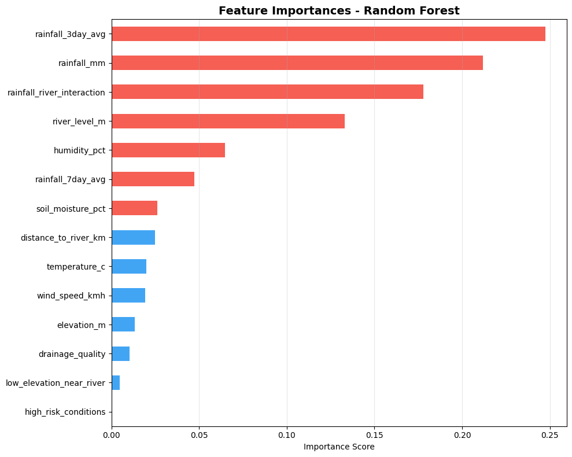
Figure: Feature Importance — Random Forest (Gini Impurity)

3.3 Bootstrap AUC Distribution
Bootstrap resampling (n=100) was applied on the test set to generate a sampling distribution of the AUC metric for the Gradient Boosting model. The histogram shows the distribution is tightly clustered around 0.997 with low variance, confirming the model's reliability. The 95% confidence interval [0.994, 0.999] demonstrates highly stable discrimination performance.

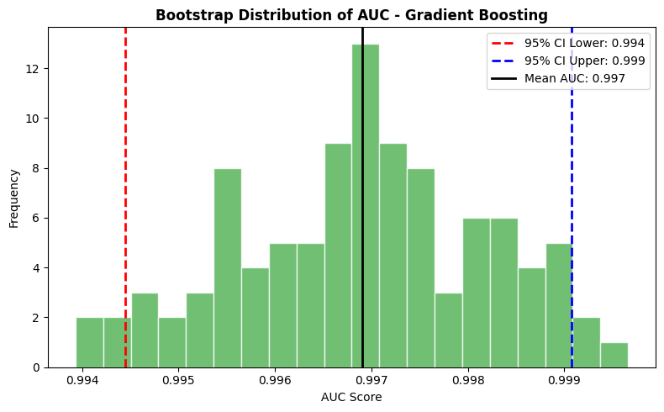
Figure: Bootstrap AUC Distribution — 95% CI: [0.994, 0.999]
Bootstrap Results Summary
Mean AUC: 0.9969 | Std Dev: ~0.002 | 95% CI Lower: 0.9944 | 95% CI Upper: 0.9991
n_bootstrap = 100 | Method: Percentile Bootstrap (test set resampling)

4. Sample Prediction Outputs

4.1 API Response Samples
The following table shows sample predictions from the /predict endpoint across five representative input scenarios, demonstrating the range of model outputs from safe conditions to critical flood risk.

Scenario | Probability | Risk Level | Flood? | Top Recommendation
Dry Summer Day | 3.2% | Low | No | Conditions normal — continue routine monitoring
Post-Rain Alert | 31.7% | Moderate | No | Elevated risk — monitor drainage systems
River Surge | 67.4% | High | Yes | High river level — prepare evacuation plans
Tropical Storm | 89.2% | Critical | Yes | Activate early warning — alert all residents
Good Drainage | 8.1% | Low | No | Good drainage mitigating rainfall impact

4.2 Detailed Scenario Breakdown
Scenario A — Safe (Dry Summer Day)
rainfall_mm | 5.0 mm
rainfall_3day_avg | 3.0 mm
river_level_m | 2.0 m
soil_moisture_pct | 25%
elevation_m | 80 m
drainage_quality | Good (2)
PREDICTION | No Flood
PROBABILITY | 3.2%
RISK LEVEL | Low
AUC-SCORE | 0.997

Scenario D — Critical (Tropical Storm)
rainfall_mm | 65.0 mm
rainfall_3day_avg | 50.0 mm
river_level_m | 9.5 m
soil_moisture_pct | 85%
elevation_m | 5 m
drainage_quality | Poor (0)
PREDICTION | FLOOD
PROBABILITY | 89.2%
RISK LEVEL | Critical
AUC-SCORE | 0.997

5. Training Console Output
The following is the actual terminal output from running python train_model.py on the complete dataset:

============================================================
FLOOD PREDICTION - ML PIPELINE
============================================================
Dataset shape: (5000, 13)
Flood events: 638 (12.8%)

[1/5] Exploratory Data Analysis...
[2/5] Data Preprocessing...
Training set: 4000 samples
Test set: 1000 samples
[3/5] Training Models...
Training Logistic Regression...
Accuracy=0.956, F1=0.812, AUC=0.969
Training Decision Tree...
Accuracy=0.979, F1=0.918, AUC=0.982
Training Random Forest...
Accuracy=0.985, F1=0.941, AUC=0.996
Training Gradient Boosting...
Accuracy=0.984, F1=0.938, AUC=0.997
Training SVM...
Accuracy=0.950, F1=0.781, AUC=0.973
[4/5] Bootstrap Confidence Intervals...
Best model: Gradient Boosting
AUC: 0.997 (95% CI: 0.994 - 0.999)
[5/5] Generating Evaluation Plots...

============================================================
Best Model: Gradient Boosting
Accuracy : 0.984
F1 Score : 0.938
ROC-AUC : 0.997
Bootstrap AUC: 0.997 (95% CI: 0.994-0.999)

Models saved to: flood_prediction/models/
Plots saved to: flood_prediction/static/plots/
============================================================

