Homework 1:
Introduction to R
due September 15, 2025 at 10:20 (upload to Pitch2Peer portal on Brightspace --> Week 1)
This assignment involves (a) downloading and installing R, (b) going through my example R script on Brightspace called AdvStatsR_Week_1_ClassScript.R, (c) watching two instructional videos and replicating the analyses shown in the videos, and (d) importing a data file and applying some basic commands to inspect a variable numerically and visually. While the data frame used in the instructional videos (part c) can be found on the internet (http://www.dangoldstein.com/flash/Rtutorial2/pedometer.csv), the data file that you will need to import is named parenting.sav, which can be found on Brightspace in the same folder as these instructions.

PART A: Download and install R

Of course, the first thing to do is to download and install R (if you have not yet done so). This can be done at the following website: https://www.r-project.org/. Click on “download R”, and you will need to select a CRAN mirror (for example the one located in the Netherlands, but it should not make a difference which one you choose). Follow the remaining instructions and you should be able to open the R statistical program at the end. If you want to, you can then also install RStudio.

If you need help to install R, you can get help via this video (if you don't need help, you do not need to watch these videos):
http://www.youtube.com/watch?v=W101Mof0Exc&index=7&list=PLycnP7USbo1V3jlyjAzWUB201cLxPq4NP

If you want to, you can also download and install RStudio (many students prefer to use RStudio over using R), which is a user interface for R. RStudio can be downloaded at the following website: https://www.rstudio.com/products/rstudio/download/. Be sure to download one of the free versions of RStudio (e.g., RStudio Desktop). Once you have installed RStudio, you should be able to open this program, which directly accesses R (i.e., you can just start RStudio; you don't need to also start R).
The following video shows you how to install both R and RStudio: http://www.youtube.com/watch?v=WJDrYUqNrHg

PART B: Recap of R commands learned in class (this will come in handy for the later parts of the homework)

Please go through my example R script from the class. I uploaded it to Brightspace under week 1; it's called something like AdvStatsR_Week_1_ClassScript.R
Do all the things I did in the example script; ideally, you don't just copy/paste my code but create your own script that is not exactly identical to what I did, but is similar (e.g., create your own vector using different/more/... numbers etc). That way you learn most.

PART C: Watch and learn!

Watch these two video by Dan Goldstein. The first video shows some basic stuff in R, the second video shows more basics plus a preview of more advanced stuff (such as linear regression analysis), which we will cover only later in the course. Watch both videos fully; and try to replicate the things that he does in the videos. Some of the important things for you to know how to do from these videos are: (1) importing an external data file, (2) using the $ to specify a variable in a specific dataframe (as in: dataframe$variable), (3) inspecting the structure of dataframes, (4) creating relatively simple plots (advanced ones: later classes), (5) accessing help files, (6) setting the working directory.

Video 1: https://www.youtube.com/watch?v=ZmtkqaRVTDc

Video 2: https://www.youtube.com/watch?v=GcmorHXygoI

After watching these videos and working through the commands there, we are going to work with the pedometer file and compute a few things (as a reminder, you can download the file here: http://www.dangoldstein.com/flash/Rtutorial2/pedometer.csv). As proof that you did these things, we are going to ask you below for some of the R code that you produce and some of the numbers that you computed (you can simply copy/paste these things from your R script into this word document).

- Provide the R code that (a) sets the working directory and (b) loads the 'pedometer.csv' file. (Please remember that setting the working directory works slightly differently for Macs vs PCs; if you can't remember, you can also have a look at my slides from the class. Also, in case the data frame seems to look wrong after importing it, one reason might be what I mentioned in the class about Dutch operating systems. Thus, if your imported file looks a bit odd, try using read.csv2 instead of read.csv, and try out to specify different separators with the argument sep = Have a look at the class slides again, if you cannot remember the details.)

getwd()
setwd("/Users/heyanyan/Desktop/2025_Master/R/Week1")
df <- read.csv("pedometer.csv")
df #n = 88

- Provide the R code that prints (a) the entire dataframe, (b) the first six rows (head), and (c) the last six rows (tail) of the dataframe.

df
head(df)
tail(df)

- What is the (a) mean and (b) standard deviation of the variable “Steps”? Please copy/paste both the R code to compute these numbers as well as the actual mean and SD.

> mean(df$Steps)
[1] 9652.193
> sd(df$Steps)
[1] 3598.471

- Provide the R code that produces (a) a boxplot and (b) a histogram of the number of steps (“Steps”)

x = boxplot(df$Steps)
x = hist(df$Steps)

- Provide the R code that produces a graph that indicates the number of data points for each day of the week (“Day”). Note: This requires that “Day” is a factor; R might automatically turn Day into a factor when loading the data frame; if it did not do that automatically , you need add a new variable to the dataframe in which Day is a factor (hint: the relevant command to turn an existing variable into a factor variable is called as.factor(); it's best to add this new factor variable under a new name to the data frame, e.g., using f_Day as the name of this newly added variable). And another hint: The command to create the figure is plot().

str(df)
df$f_Day <- factor(df$Day, levels = c("Mon", "Tue", "Wed", "Thu", "Fri", "Sat", "Sun"))
number_data_points <- table(df$Day)
number_data_points
plot(number_data_points,
main = "Number of Data Points for Each Day of the Week",
xlab = "Day", ylab = "Number",
col = macaron_colors[3], lwd = 10)

a easy way:
df$f_Day <- as.factor(df$Day)
plot(df$f_Day)
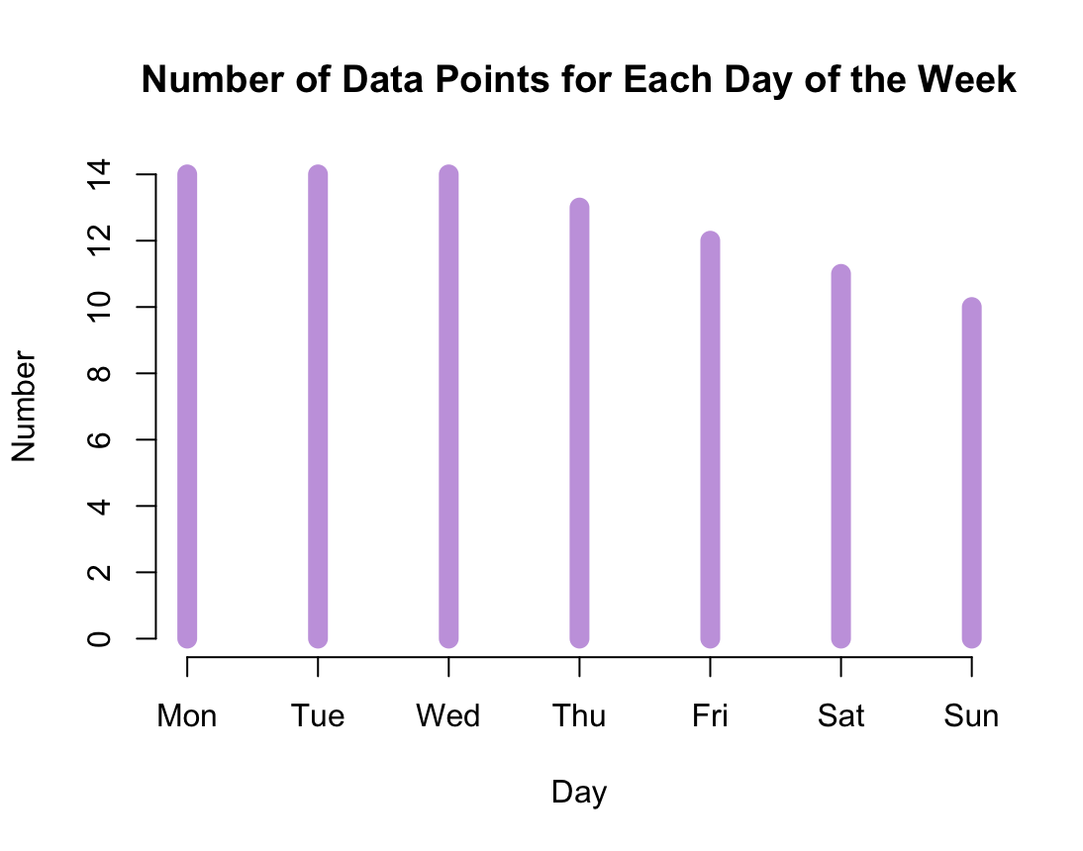

- Provide the R code that produces a density plot of the number of steps (“Steps”). Note: This requires the installation of the lattice package (please also include the R code for installing this).
-- paste your code/answers here --

install.packages("lattice")
library(lattice)
densityplot(df$Steps, col = macaron_colors[1])

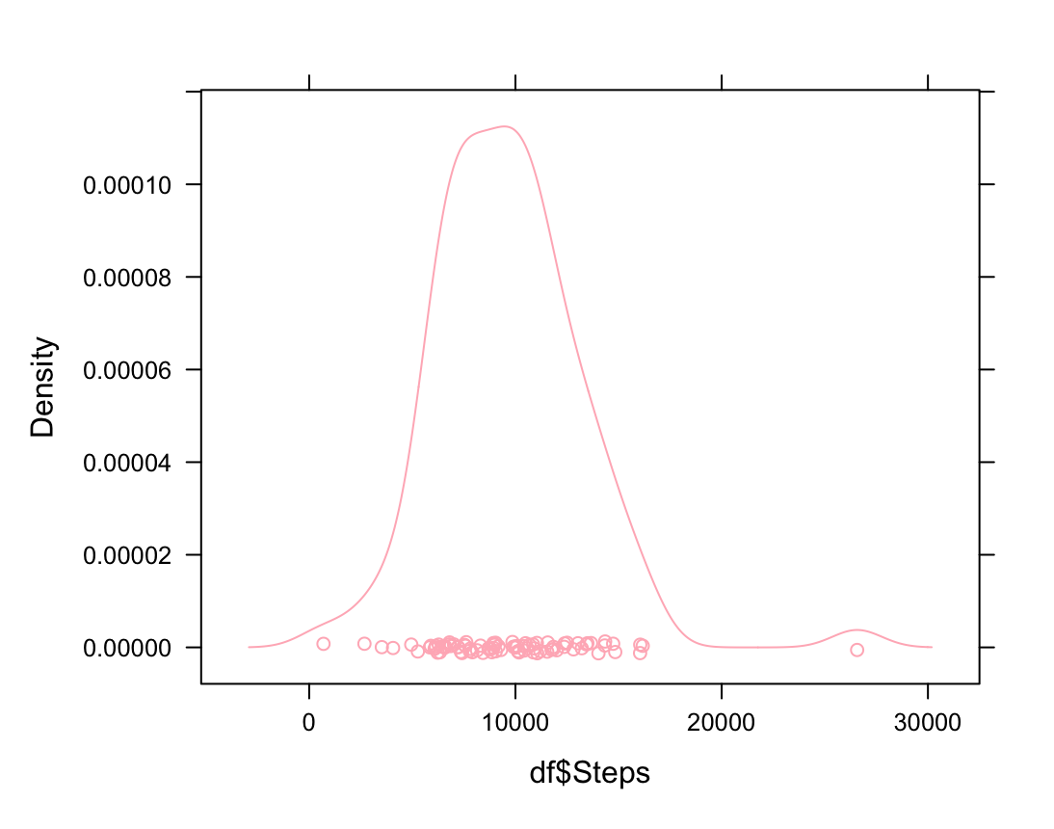

PART D: Apply what you have learned!

Most of the time you will want to analyze data sets that you collected yourself. Since we do not have time to collect data ourselves in the course, we will provide data sets for you. One dataframe that you will become familiar with in this course is called parenting.sav, which includes self-reports from 369 adolescents of the following variables:

PARTNO participant number
Gender participant sex (male = 0, female = 1)
Response parental responsiveness (low = 0, high = 1)
Demand parental demandingness (low = 0, high = 1)
Esteem self-esteem (range from low = 5 to high = 30)
Control self-control (range from low = 5 to high = 10)
Psycho psychopathic traits (ranges from low = 10 to high = 60)
SES socioeconomic level (ranges from low = 0 to high = 100)
Problems internalizing and externalizing behaviors (ranges from low = 0 to high = 25)
Neurotic neuroticism (ranges from low = 0 to high = 25)

- Provide the R code that will import the parenting datatfile. Note: This requires the installation of the foreign package (please also include the R code for installing this).

install.packages("foreign")
library(foreign)
df2 <- read.spss("parenting.sav", to.data.frame = TRUE)
df2

- Provide the R commands that print (a) the first six rows and (b) the last six rows of the dataframe.

head(df2)
tail(df2)

- Provide the R code that produces (a) a histogram and (b) a density plot for the variable “Psycho.”

hist(df2$Psycho, col = macaron_colors[2])
densityplot(df2$Psycho) (with the package of lattice)
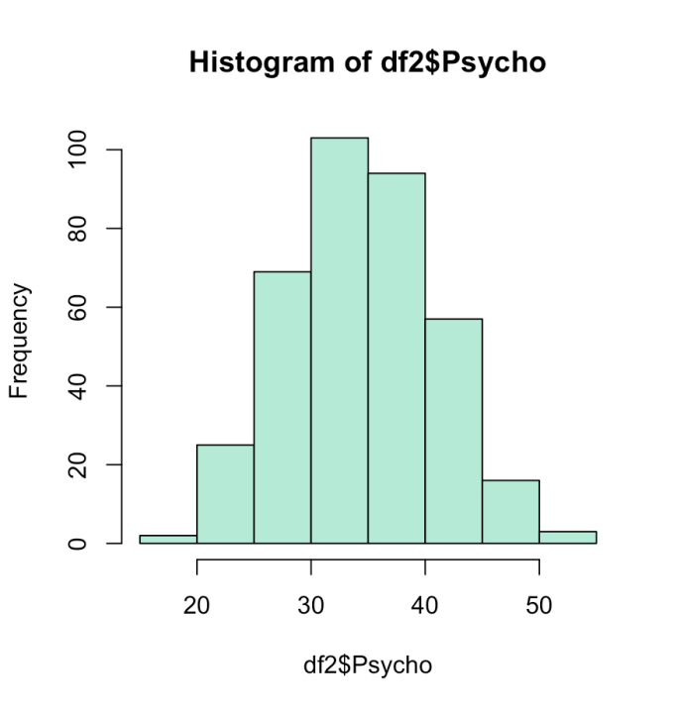

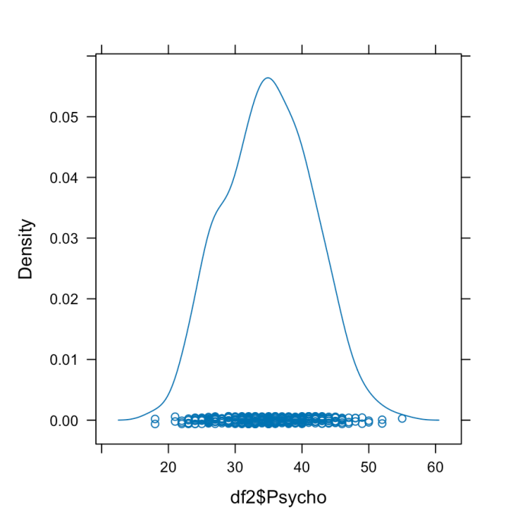

- Provide the R code that prints the (a) mean and (b) standard deviation of the variable “Psycho.”

> mean(df2$Psycho)
[1] 34.95122
> sd(df2$Psycho)
[1] 6.637984
Bonus assignment: Provide the R code to save the parenting data frame in your working directory as a csv file (save it without the row names).
write.csv(df2, file = "parenting.csv", row.names = FALSE)

