THE SU-27 SK

FLIGHT SIMULATION & COCKPIT

FOR FLIGHTGEAR.ORG

By Yanes Bechir 2017
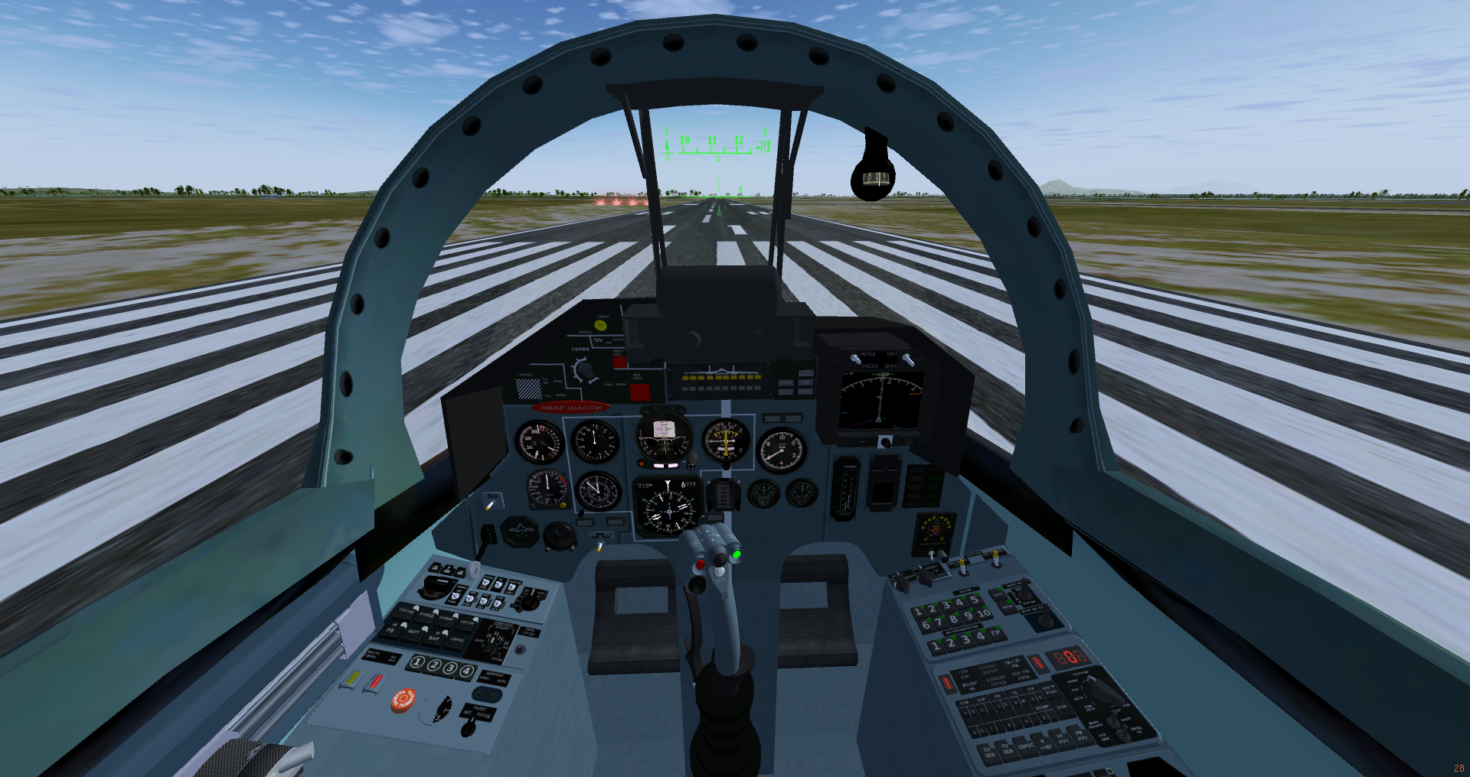
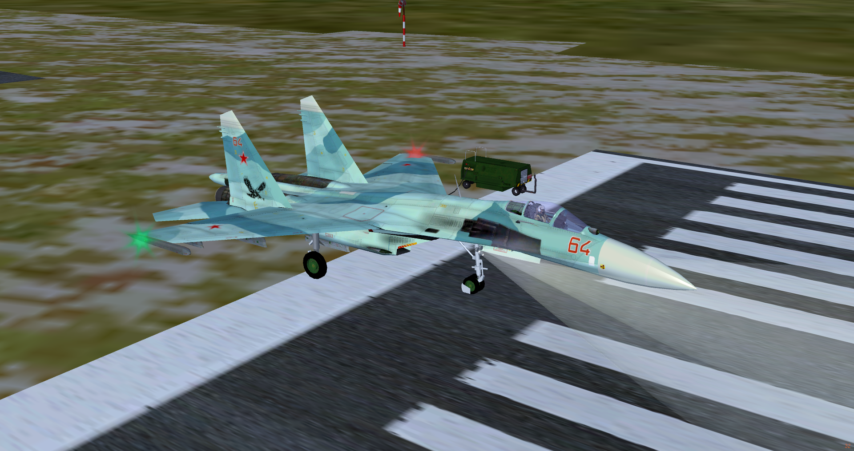

Introduction

This is an implementation of the SUKHOI's SU-27 4th generation fighter aircraft made for simulation in FlightGear 2017.2.1 and later .

This 4th generation fighter aircraft was built and planned initially to work in the Soviet Air Force as an air superiority fighter , and as a competitor for the 4th gen US and generally the west/NATO air forces superiority fighters , especially the Variants of the F-15 Eagle .
the SK variant of the fighter made first in the USSR and then in Russia & still in service in Russian and many air forces in the world , NATO reporting name : Flanker B.
You can get more information in Wikipedia by visiting this Page .
This aircraft have a stunning flight capabilities in combat maneuvers or in aerobatic shows ,
it was especially known by its amazing aerodynamics . It’s also obvious that it was an icon in the
USSR and Russia aerospace industry .
This variant as a commercial/export version has been even manufactured under license in India and China . And since it flies outside the soviet Geo-space , got a lot of upgrades and modified avionics and systems especially :
- GPS navigation capability .
- Navigation using standard VOR/NDB/TACAN frequencies bands.
- Improved Flight Control System .
- A lot of other upgrades that you can find in details by Googling for : “SU-27 upgrades” .

Before starting the docs :
This work uses a lot of models and scripts and other works made by
* the FGUK-team for their SU-27 prototype ,
* MIG-29 developers,
* The F-15 developers,(their svg HUD was a huge help ),
* The Mirage2000-5 developers ,
* A lot of FG Aircrafts developers ,
So Greetings and THANKS to all of them .

Greetings also flies to the FlightGear simulator Developers (The simulator Core developers, as they like to call themselves ;) ) who spent a lot of time and efforts to bring a such beautiful piece of software .

The current aircraft package is at version 0.4 (as of late November 2017), so this is a “DEVELOPMENT” version , just published for Fun, Tests, and may be some contributions .

General flight characteristics

- Crew: 1
- Length: 21.9 m (72 ft)
- Wingspan: 14.7 m (48 ft 3 in)
- Height: 5.92 m (19 ft 6 in)
- Wing area: 62 m² (667 ft²)
- Empty weight: 16,380 kg (36,100 lb)
- Loaded weight: 23,430 kg (51,650 lb) with 56% internal fuel
- Max. takeoff weight: 30,450 kg (67,100 lb)
- Fuel capacity: 9,400 kg (20,724 lb) internal
- Power-plant: 2 × Saturn AL-31F turbofans
  - Dry thrust: 75.22 kN (16,910 lbf) each
  - Thrust with afterburner: 122.6 kN (27,560 lbf) each
Performance
- Maximum speed:
  - At altitude: Mach 2.35 (2,500 km/h, 1,550 mph)
  - At sea level: Mach 1.13 (1,400 km/h, 870 mph[103])
- Range:
  - At altitude: 3,530 km (2,193 mi; 1,906 nmi)
  - At sea level: 1,340 km (800 mi; 720 nmi)
- Service ceiling: 19,000 m (62,523 ft)
- Rate of climb: 300 m/s[107] (59,000 ft/min)
- Wing loading:
  - With 56% fuel: 377.9 kg/m² (77.3 lb/ft²)
  - With full fuel: 444.61 kg/m² (10,550.75 lb/ft²)
- Thrust/weight: 1.07 with 56% internal fuel; 0.91 with full fuel
- Maximum g-load: +9 g

Cockpit

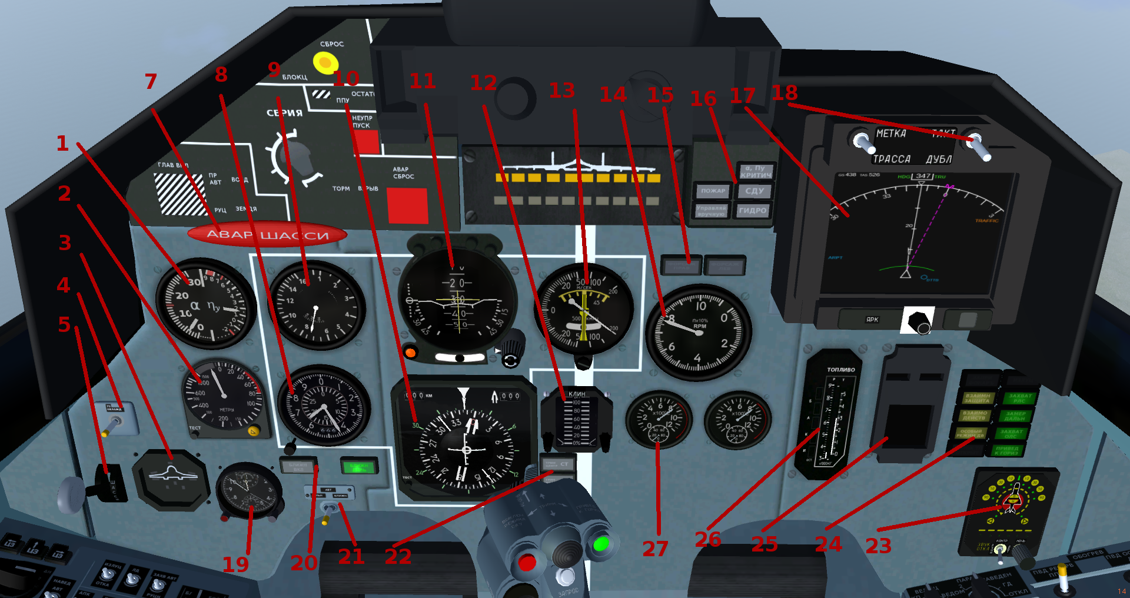
- Alpha (Angle Of Attack) and G meter.
- Radar Altimeter (M).
- Flaps/Gears/Slats/Air Brake deployment indicator .
- Laser range finder (Not in use till now).
- Gears control lever .
- Cockpit pressure indicator.(Not included in current published model).
- Gears Emergency handle (Pneumatic).
- Pressure Altimeter (M for big needle/Mx1000 for the small).
- Air Speed Indicator (KM) and Mach scale .
- Horizontal Situation Indicator (HSI).
- Attitude Indicator .
- FOD Engines Intakes position indicator .
- Vertical Velocity indicator(M/s).
- Engines tachometer (RPM % ).
- Afterburners indicators lights.
- Upper indicators panels .
- MFD/Radar display .
- MFD/ Radar display switcher .
- Clock watch & Chronometer .
- Inner & outer radio navigation markers indicator lights (for ILS landing ops).
- Inner & outer radio markers navigation switch .
- Pilot/ FCS Trimmers indicators (pitch,roll & rudders ).
- Radar Warning System display device (RWS/RWR).
- Status leds indicators panel (canopy, radar,drag-chute,…etc..) .
- EKRAN (Early warning system) display .
- Fuel quantity indicator.
- Exhaust temperature indicators (°C).

