THE SU-27 COCKPIT FOR FLIGHTGEAR
By Yanes

A cockpit instruments & lights nominology

PIC N°1:

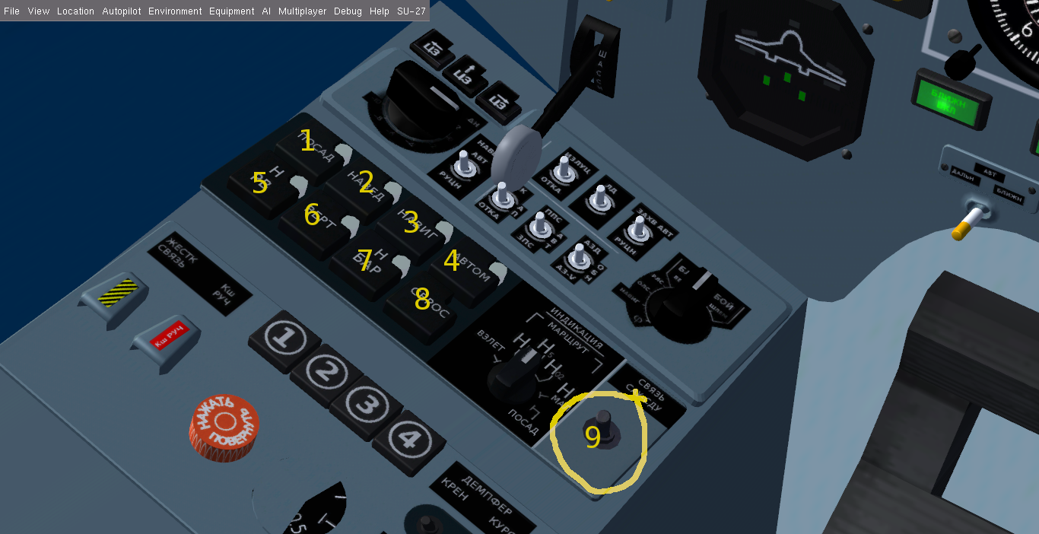
The Autopilot panel

1 : LAND: by activating the AP (switch n°9) and pressing this button ,the LAND mode will be engaged .
Correct runway localizer frequency must be already set in NAV1(use radio dialog , press F12 to show the dialog).and checked the beacons indicator lights ON .
You should also be at max 25° deviation from the localizer course at 1820m (6000 ft ) of
altitude .(keep your speed below 500 km/h ).
2:NAV : This is for the lateral radio NAV hold (Not Yet Implemented).
3:NAVIG : This button make an active AP (switch 9) follow the navigation route , route should
be set and ACTIVATED from the route manager dialog .
If no active route found the ACS (AP) will fail and a warning light will be lit (N°4 under the HUD see “pic2”).The AP then should be RESET by pressing button8 from the same panel .
4:AUTO : This button make an active AP (switch 9) maintain the current attitude (Roll & Pitch).
5:RADAR ALT : Radar altitude hold (Or Terrain follow ) NOT Yet Implemented.
6: VERT ; Vertical Speed hold mode ,NOT Yet Implemented.
7:ALT-HOLD : Barometric altitude hold mode ,This button make an active AP (switch 9) maintain the current barometric altitude , no matter what roll commands entered by the pilot .
8:RESET : This button reset the AP , thus , disengaging any already active mode and solves the
ACS failures due to lost route or localizer .use it generally when you see light N°4 (PIC2).
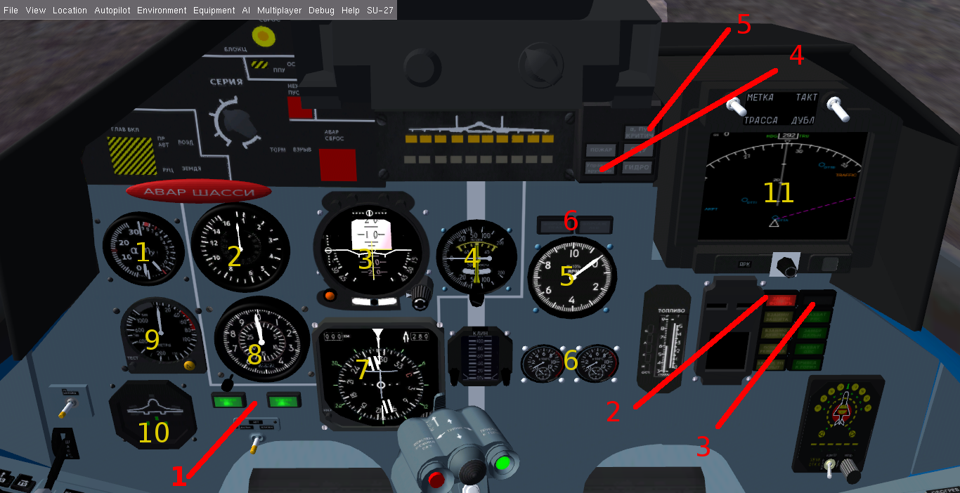
Cockpit Lights & visual warnings :

PIC N°2:

Cockpit instruments (Yellow ) & lights (Red).
INSTRUMENTS :

1: G-Load & Alpha (AoA) indicator .
2:Air Speed Indicator (KM/H).
3:Attitude Indicator .
4:Vertical Speed Indicator(m/s) .
5:Throttle Engine RPM Indicator(%).
6:Turbines Temperature Indicator .
7: HSI ,Horizontal Situation Indicator .
8: Barometric Altimeter (x1000 m).
9:Radar Altimeter (m) max 1600m.
10 :Flight Controls Indicator (Gears , Flaps , Slats ,AirBrake).

LIGHTS & VISUAL WARNINGS :

1: NAV Radio beacons reception : The left one for the VOR,VOR/DME or Localizer , the right for the Glide Slope (GS) beacons signals.
2: Canopy : open or Not correctly locked .
3:Radar Emission : Radar is emitting waves and detection is On (Toggle by pressing “SHIFT-R”).
put the detection ON in the HDD and HUD by switching the lever at the top right of HDD the to “TAKT”.
4: ACS Failure : Generally due to lost of beacons signal when AP is following it , or by pressing
the AP “NAVIG “ button with no route active (The AP then should be RESET by pressing button8 from the same panel ).
5:High AoA or G -Load .(A voice warning should be heard ).
6: Engines AfterBurner ON .

HUD SYMBOLOGY :

PIC.3 :

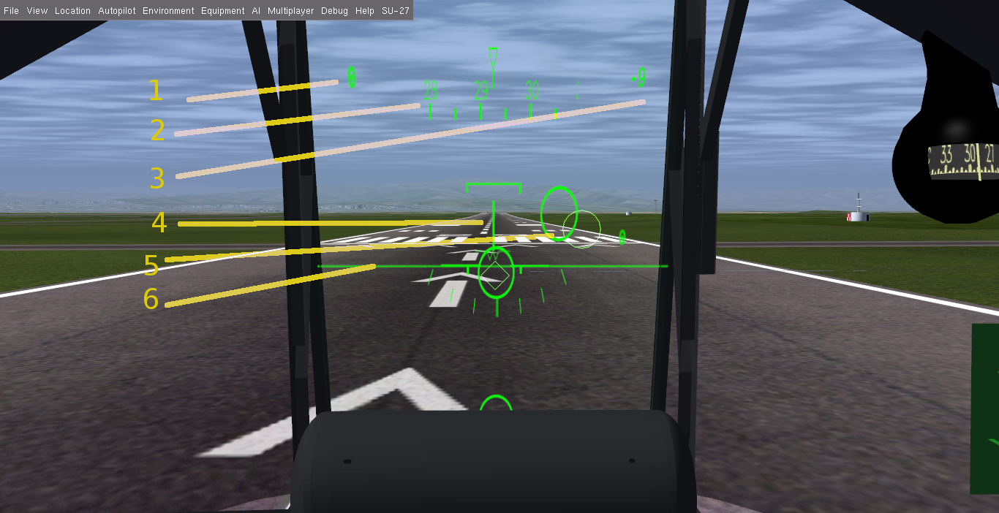

1: Air Speed .
2: Heading Scale (Currently at 292°).
3:Barometric Altitude (Pressure not set).
4: Attitude Indicator .
5:Target or Route marker .
6:Virtual Horizon Line .

