You said:
I would like to find a very good nicho to build an app or a system for it, can you recommend something?

ChatGPT said:
Great question 👌 Since you’re in the U.S. (Jacksonville area) and previously asked about AZ-900, I’ll suggest niches that are:
💰 Profitable
🚀 Real problems (not just “cool ideas”)
🧠 Technically achievable (good for cloud-based systems)
📈 Scalable
I’ll give you 5 strong niches, then I’ll tell you which one I’d pick if I were you.

1️⃣ Immigration Process Assistant (Huge Pain Point)
🎯 Target
People on:
TN visa
H1B
Student visa
Green card process
💡 Problem
Immigration paperwork is confusing, deadlines are stressful, and people rely on expensive lawyers.
🛠 App Idea
Document checklist generator
Visa renewal reminders
SSN appointment guide
Border crossing checklist
Timeline tracker
AI assistant trained on USCIS info
💰 Monetization
Freemium model
$9–$19/month subscription
Lawyer referral commissions
👉 This is strong because immigration stress = high willingness to pay.

2️⃣ Small Business Compliance Tracker (Very Underserved)
🎯 Target
Cleaning companies
Truck drivers
Contractors
Small construction companies
Latino-owned businesses
💡 Problem
They miss:
License renewals
Insurance expiration
State filings
OSHA compliance
Tax deadlines
🛠 App Idea
Business compliance dashboard
Renewal alerts
State-specific rules
Document vault
Simple checklist system
💰 Monetization
$15–$49/month per business
Scales well
Low competition in local markets
🔥 This is a VERY strong niche.

3️⃣ Field Service Management for Small Crews
🎯 Target
AC repair
Plumbing
Landscaping
Roofing
💡 Problem
Most small crews use:
WhatsApp
Paper
Excel
Nothing organized
🛠 App Idea
Job scheduling
GPS tracking
Client invoices
Crew management
Payment collection
Photo proof of work
💰 Monetization
$29–$79/month
👉 Boring niche = good niche.

4️⃣ AI Study Planner for Certifications
Since you asked about AZ-900 before…
🎯 Target
People preparing for:
AWS
Azure
CompTIA
PMP
Nursing exams
💡 Problem
People don’t know how to structure study plans.
🛠 App Idea
Custom study roadmap
Daily study goals
Practice exam tracking
Weakness detection
Smart reminders
💰 Monetization
Subscription model $10–$20/month
Very scalable globally.

5️⃣ Property Maintenance & HOA Communication App
🎯 Target
Small HOAs
Apartment buildings
Small landlords
💡 Problem
Maintenance tracking is chaotic.
🛠 App Idea
Ticket system
Tenant portal
Payment reminders
Document storage
Vendor management
💰 Monetization
$1–$3 per unit per month

🏆 If I Were You…
I would choose:
🥇 Small Business Compliance Tracker
OR
🥈 Immigration Assistant
Why?
Because:
They solve painful problems
They are not “trendy startup competition”
You can start simple
You can validate locally in Jacksonville
You can build using Azure (good practice for AZ-900 path 😉)

💡 The Secret Most People Miss
Don’t build for:
❌ Developers
❌ Gamers
❌ Social media users
Build for:
✅ Boring industries
✅ Immigrants
✅ Small businesses
✅ Blue-collar workers
They pay.

If you want, tell me:
Are you stronger in backend, frontend, or cloud?
Do you prefer B2B or B2C?
Do you want fast money or long-term SaaS?
And I’ll help you narrow it down to ONE niche and outline a real roadmap. 🚀

You said:
I am stronger in backend, frontend, or cloud, prefer B2B, fast money them if works move to SaaS

ChatGPT said:
Perfect. Backend + Cloud + B2B + fast money?
That changes everything.
You should NOT build a random app.
You should build a painkiller system you can sell for $2k–$10k per client before even thinking SaaS.
Here are the 3 best niches for YOUR profile 👇

🥇 1. Small Construction / Contractor Operations System (Best for Fast Cash)
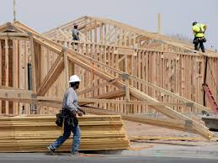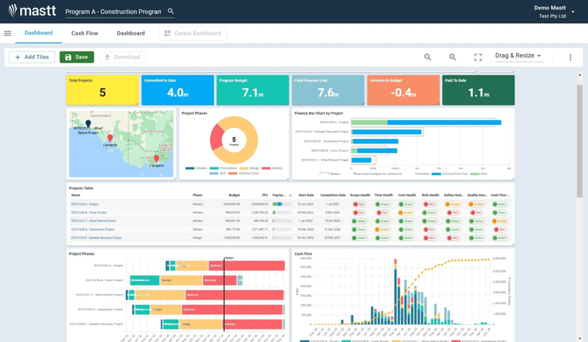
4
🎯 Target
Roofing companies
Remodeling contractors
Landscaping companies
Small construction crews (5–20 employees)
💥 The Problem
They use:
Excel
WhatsApp
Paper
Nothing organized
They lose money because:
Jobs aren’t tracked
Invoices are late
Materials are mismanaged
Crews are inefficient
💡 What You Build (MVP)
Job scheduling dashboard
Crew assignment
Cost tracking per job
Simple invoice generator
Mobile job updates (photos + status)
Owner analytics dashboard
You can build this fast using:
Azure App Service
Azure SQL
Role-based auth
Basic dashboard (React / Next / etc.)
💰 How You Make Fast Money
Instead of SaaS:
👉 Charge $3,000 – $8,000 to build + deploy
👉 $300–$800/month support
Sell 3 clients = real income.
Then later → convert to SaaS template.
This is HIGH probability.

🥈 2. Local Business Compliance & License Tracker

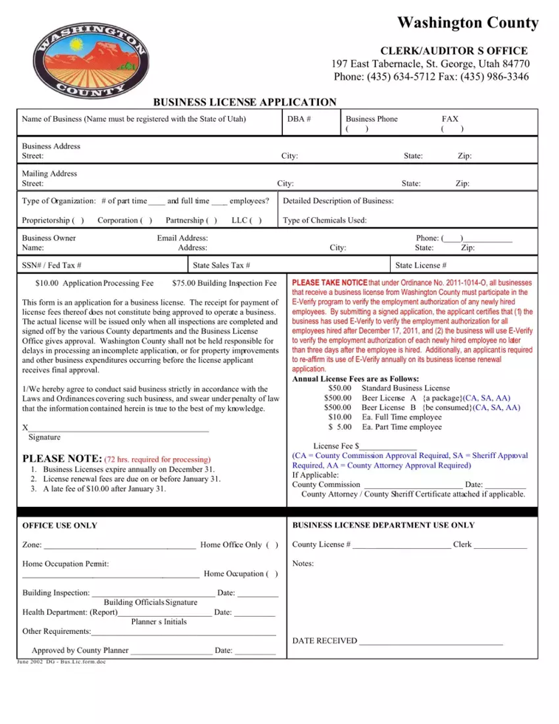
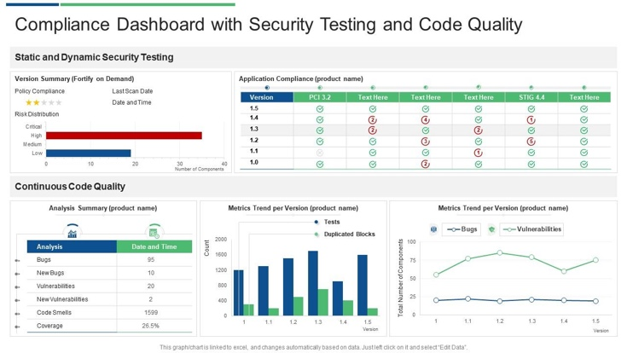
4
🎯 Target
Cleaning companies
Truck drivers
Contractors
Small Hispanic-owned businesses
💥 Problem
They forget:
Insurance renewals
Business licenses
State filings
Permits
Workers comp renewals
Miss one = fines.
💡 MVP
Business profile
Renewal calendar
Alerts (SMS/email)
Document vault
Checklist by industry
💰 Monetization Strategy
Start custom:
$2k setup
$150–$400/month
Later → SaaS at $29–$59/month
This is less competitive than generic CRM.

🥉 3. B2B Custom AI Internal Tool Builder
🎯 Target
Businesses that want:
AI chatbot trained on internal docs
Proposal generator
Auto-quote generator
Internal workflow automation
You position yourself as:
“AI systems developer for local businesses.”
💰 Monetization
$5k–$20k per project
High margin
Backend + cloud heavy (perfect for you)

🔥 If Fast Money Is Priority
Pick Construction / Contractor System.
Why?
They have money.
They understand ROI.
They already pay for QuickBooks.
They hate paperwork.
Few developers target them directly.
You could literally:
Call 10 contractors in Jacksonville.
Ask what they struggle with.
Build for one.
Turn into template.
That’s how real SaaS starts.

🚀 90-Day Roadmap
Month 1
Interview 10 contractors.
Identify top 3 pain points.
Build ugly but functional MVP.
Month 2
Sell custom build to 1–2 clients.
Deploy on Azure.
Add reporting dashboard.
Month 3
Refactor into reusable system.
Standardize features.
Prepare SaaS version.

⚠️ What NOT To Do
Don’t build:
Another CRM
Another project management tool
Another task manager
Another AI wrapper app
Build vertical software for one industry.

If you want, I can:
Help you pick ONE niche
Define exact feature list
Define tech stack
Create pricing model
Or design your offer so you can close first client
What level are you at right now?
Freelancer? Full-time job? Looking to quit?
Top of Form
Bottom of Form

Perfect. That’s the right mindset for fast B2B money.
Let’s design something practical you can actually sell to contractors.

🏗 The Niche: Small Contractors (5–20 employees)
Target:
Roofing
Remodeling
Landscaping
Concrete
Small construction crews
Not enterprise.
Not 1-man handyman.
Not 100-employee company.
Small growing companies = best opportunity.

💥 What Problem You Solve
Contractors don’t lose money because of lack of work.
They lose money because of:
❌ Poor job tracking
❌ No visibility on job profitability
❌ Late invoices
❌ Poor crew scheduling
❌ No cost tracking per project
❌ No simple dashboard
Most use:
Excel
WhatsApp
Paper
Memory
That’s your opportunity.

🎯 Your Positioning
You are NOT building “another CRM.”
You are building:
“A Profit Control System for Small Contractors”
That language sells.

🧠 What You Actually Build (Simple MVP)
1️⃣ Job Dashboard
Main screen:
Active Jobs
Completed Jobs
Profit per Job
Cost vs Budget
Days in progress
Simple but powerful.

2️⃣ Job Detail Page
Each job has:
Client info
Address
Contract value
Material cost
Labor cost
Crew assigned
Photos
Status
This alone is worth money.

3️⃣ Crew Assignment
Owner assigns:
Job
Crew members
Start date
End date
Crew sees job on mobile view.

4️⃣ Cost Tracking
Per job:
Material purchases
Labor hours
Subcontractor payments
System calculates:
Contract Value: $25,000
Total Costs: $18,000
Profit: $7,000
Margin: 28%
Contractors LOVE seeing this.

5️⃣ Invoice Generator
Basic:
Generate invoice
Mark as paid
See unpaid balance

💰 How You Make Fast Money
You do NOT launch SaaS first.
You do this:
Step 1: Talk to 5 Contractors
Ask:
How do you track job profit?
How do you assign crews?
What’s your biggest operational headache?
You’ll hear gold.

Step 2: Build Custom Version for One
Charge:
$3,000–$6,000 build fee
$300–$600/month support + hosting
Even ONE client validates everything.

Step 3: Turn Into Template
After 2–3 clients:
Standardize features
Turn into SaaS
$49–$149 per user/month

🛠 Tech Stack (Since You’re Backend/Cloud Strong)
You could use:
Backend:
.NET / Node
REST API
Role-based access
Database:
Azure SQL
Auth:
Azure AD B2C
Hosting:
Azure App Service
Storage:
Azure Blob (job photos)
You don’t need anything fancy.

🚨 Why This Is Better Than Immigration (For You)
Faster validation
Bigger upfront payments
Lower legal risk
Easier sales (ROI conversation)
Less trust barrier
Contractors care about:
“Will this make me more money?”
That’s easier to sell than legal guidance.

🔥 If You Want Real Strategy
Here’s the aggressive move:
Instead of building first…
Create mockup (Figma or simple demo).
Visit 10 contractors locally.
Pitch idea.
Close one before coding.
You’d be surprised how often this works.

Let me challenge you:
Would you be comfortable walking into local contractor offices and pitching this?
Or do you prefer cold email / online outreach?
Your sales style matters.

Good. That’s a smart decision.
Now let’s stop thinking like a developer and start thinking like someone who wants to close their first $5,000 deal.
We’ll design this properly.

🎯 Step 1: Narrow the Contractor Type
Do NOT target “all contractors.”
Pick ONE:
Roofing
Remodeling
Landscaping
Concrete
HVAC
If you don’t choose, marketing becomes weak.
👉 My recommendation: Remodeling / General Home Renovation
Why?
Medium project sizes ($10k–$100k)
Multiple crews
Materials + labor tracking matters
Lots of chaos

💰 The Real Problem You’re Selling
Not scheduling.
Not invoices.
You are selling:
“Know exactly how much profit you make per job.”
Small contractors often don’t actually know.
That’s painful.

🏗 Your Version 1 System (Lean & Sellable)
Keep it SIMPLE.
1️⃣ Dashboard
Active Jobs
Completed Jobs
Total Revenue (month)
Total Costs (month)
Profit margin %

2️⃣ Job Page
Each job has:
Client name
Address
Contract value
Estimated cost
Actual cost
Labor hours
Materials list
Status
Photo uploads
Auto-calculate:
Profit
Margin
That’s your main value.

3️⃣ Cost Entry
Simple forms:
Add material expense
Add labor hours
Add subcontractor payment
System updates profit instantly.
That’s powerful.

4️⃣ Basic Crew Assignment
Owner assigns:
Job
Start date
Crew members
Mobile-friendly view only.
No complex app at first.

🚀 What You DO NOT Build Yet
❌ Accounting integration
❌ Payment gateway
❌ AI
❌ Advanced CRM
❌ Complex scheduling
Stay focused.

💵 Pricing Strategy (Important)
Don’t say:
“I built software.”
Say:
“I help contractors increase job profit visibility.”
Initial Offer:
Custom Setup Package:
System setup
Custom branding
Data migration (if needed)
Hosting included
$3,000 – $6,000 one-time
Then:
$300–$500/month
If they’re doing $1M/year revenue, this is nothing.

📈 How You Find First Client
Option A (Local Strategy):
Google: “Remodeling contractor Jacksonville”
Make list of 20
Visit 5 in person
Call 10
Email 5
Option B (Warm Intro):
Ask friends
Facebook local business groups
LinkedIn

🧠 Sales Angle Script (Simple)
Don’t pitch tech.
Say:
“Most small contractors I talk to don’t actually know their real profit per job until months later. I build simple systems that show job profit in real time. Is that something you currently track well?”
Then listen.
If they say:
“We use QuickBooks.”
You say:
“QuickBooks shows accounting. I’m talking about job-level profitability while the project is still active.”
That opens the door.

🔥 60-Day Game Plan
Week 1–2:
Talk to 10 contractors
Identify exact pain
Refine feature list
Week 3–6:
Build MVP
Week 7–8:
Close first paid client

Now I need one decision from you:
Which contractor niche do you choose?
Remodeling?
Roofing?
Landscaping?
HVAC?
Concrete?
Pick ONE and we’ll design the exact version for that niche.

Good. Naming matters more than people think.
For contractors, the name must sound:
Strong 💪
Money-focused 💰
Professional 🏗
Simple (easy to say on the phone)
Not “techy startup”
You are selling to blue-collar business owners, not Silicon Valley.

🔥 Strong Name Directions (That Actually Sell)
🥇 Profit-Focused Names (Best for Contractors)
These speak directly to MONEY.
JobMargin
BuildMargin
ProfitBuilt
CrewProfit
SiteMargin
TradeProfit
MarginTrack
JobYield
ConstructMargin
BuiltForProfit
👉 My top 3 from this list:
BuildMargin
JobMargin
ProfitBuilt
They are clear and powerful.

🥈 Control & Management Names
More operational feeling.
CrewControl
SiteControl
TradeControl
BuildControl
ContractorHQ
TradeOps
SiteOps
BuildOps
👉 Strong choices:
BuildOps
CrewControl
ContractorHQ

🥉 Premium Sounding (Scalable SaaS Feel)
These sound bigger and long-term.
ProBuild Systems
Titan Trade Systems
ForgeOps
IronLedger
BluePeak Systems
ConstructIQ
TradeVista
BuildSphere

🧠 My Professional Recommendation
Since you want:
Fast B2B money
Then move to SaaS
Serious contractors
Clean positioning
I would choose:
🏆 BuildMargin
Why?
Clear what it does
Profit-focused (contractors care about this)
Sounds professional
Easy to say
Easy to brand
Works as custom + SaaS later
Example positioning:
BuildMargin – Real-Time Job Profit Control for Contractors
That sounds strong.

🚫 What To Avoid
Fancy startup names (like “Zentrofy”)
Too generic (ContractorApp)
Too technical (CloudConstruct AI)
Long names
Hard-to-spell names
Contractors must remember it instantly.

Perfect. For BuildMargin, the logo must communicate:
Strength 💪
Construction industry 🏗
Profit growth 📈
Professional B2B trust
Not startup-cute. Not techy. Not playful.
Below are 3 strong logo directions that would work extremely well for contractors.

1️⃣ Industrial + Profit Arrow (Most Powerful)

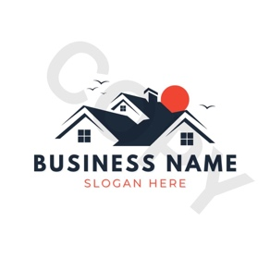

4
Concept:
Combine:
A roofline or building shape
An upward arrow integrated subtly
Bold strong typography
Why This Works:
Arrow = profit growth
Roof/building = construction
Very clear message
Color Direction:
Dark navy + construction orange
Charcoal + safety yellow
Black + deep green
This is the safest and strongest option.

2️⃣ Strong Wordmark (Premium & Clean)
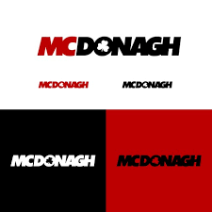
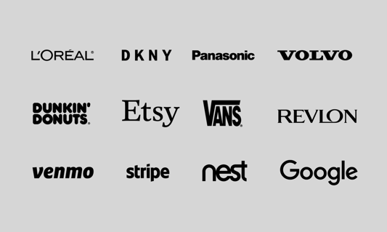
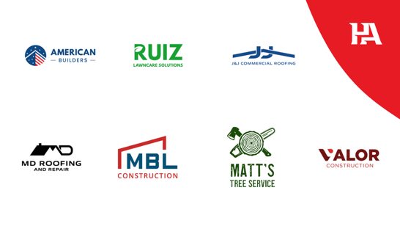
4
Concept:
No icon.
Just powerful typography.
Example styling:
BUILD (bold)
Margin (lighter weight)
Or:
BuildMARGIN (emphasis on margin)
Why This Works:
Feels established
Easy to print on shirts, trucks, invoices
Very professional SaaS look
This is best if you want long-term brand scalability.

3️⃣ Shield / Badge Style (Trust & Authority)
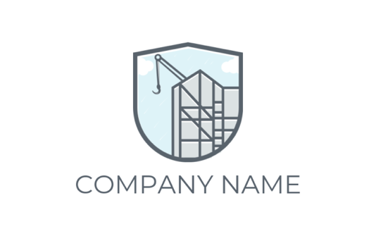


4
Concept:
A shield containing:
Subtle building outline
Small upward bar/arrow
Why This Works:
Conveys protection of profit
Feels strong & serious
Appeals to traditional contractors
Less modern SaaS feel — more traditional contractor vibe.

🔥 My Professional Recommendation
For your positioning (profit-focused, B2B, scalable SaaS):
👉 Go with Option 1 or 2.
If you want:
Aggressive sales & clarity → Arrow + Building
Clean SaaS future → Strong Wordmark

📐 Font Style Direction
Avoid:
❌ Script fonts
❌ Rounded playful fonts
❌ Startup bubbly fonts
Use:
Bold sans-serif
Geometric
Industrial feel
Tight spacing

🎨 Color Psychology for Contractors
Best choices:
Navy (trust)
Charcoal (strength)
Orange (construction energy)
Dark green (profit)
Steel gray (industrial)
Avoid bright neon or pastel.

Perfect. Profit-focused is the right move for contractors.
You are selling money clarity, not software.
Here are the strongest professional names in that direction 👇

🏆 Top 5 Profit-Focused Names (Ranked)
1️⃣ BuildMargin ⭐ (Best Overall)
Strong.
Clear.
Professional.
Scalable.
Why it works:
“Build” = construction
“Margin” = profit
Simple and memorable
Works for custom + SaaS later
Positioning:
BuildMargin – Real-Time Profit Control for Contractors
This is very clean.

2️⃣ JobMargin
More direct.
Very clear about job-level profitability.
Positioning:
JobMargin – Know Your Profit Before the Job Ends
Strong sales angle.

3️⃣ ProfitBuilt
Feels solid and established.
A bit more brand-like.
Positioning:
ProfitBuilt – Construction Profit Intelligence
Good if you want a slightly premium feel.

4️⃣ TradeProfit
More blue-collar sounding.
Very direct.
Slightly less premium, but very clear.

5️⃣ MarginTrack
Feels more like a tool.
A bit more “software” sounding.
Less emotional, more operational.

🔥 My Honest Recommendation
Go with:
🥇 BuildMargin
It’s:
Professional
Clear
Brandable
Easy to pitch
Easy to expand (roofing, HVAC, landscaping, etc.)
And it sounds like a real company.

🧠 Next Smart Step
Before locking it:
Say it out loud like you're pitching:
“Hi, I run BuildMargin. We help contractors track job profit in real time.”
If that sounds natural, you’ve got it.

That is a very solid niche with high potential. The construction industry has traditionally been slow to adopt digital tools, but there is now a massive push toward modernization, especially among smaller firms that find enterprise-level software (like Procore or Autodesk) too expensive and complex.
Here is an analysis of why this is a good niche, the problems you would be solving, and some potential challenges:
1. Why it's a "Good" Niche
High Fragmentation: There are millions of small contractors (roofing, HVAC, plumbing, general remodeling) who still run their entire business on paper, Excel, and WhatsApp.
The "Goldilocks" Problem: Existing tools are often either too simple (basic to-do lists) or too complex (full ERP systems). A "Small Contractor" system that hits the middle ground is highly desirable.
Sticky Revenue: Once a contractor moves their project photos, client lists, and bids into your system, they are unlikely to leave.
2. Core Problems You Can Solve
To be successful, your system should address these specific "pain points":
Estimation & Bidding: Helping them create professional, accurate quotes quickly on a mobile device while at a job site.
Project Documentation: A central place for "Before/After" photos, site notes, and change orders.
Scheduling: Moving away from a whiteboard to a shared digital calendar for crews.
Communication Gap: Providing a simple portal for homeowners to see updates, which reduces "Where are we at?" phone calls.
Payment Collection: Integrating tools like Stripe or Melio to get paid via credit card or ACH immediately upon job completion.
3. Current Market Competition
You aren't entering an empty room, so you’ll need to differentiate. Major players include:
Jobber / Housecall Pro: Great for "service" businesses (cleaning, lawn care) but sometimes lack deep "project" features.
Buildertrend / CoConstruct: The industry leaders for builders, but can be very expensive and have a steep learning curve.
ContractorForeman: A more affordable, feature-rich alternative.
4. How to Differentiate
If you want to win in this niche, consider these "angles":
AI-First: Use AI to scan hand-drawn blueprints or convert voice notes from the field into professional project summaries.
Hyper-Vertical: Don't just build for "construction." Build "The Operating System for Residential Roofers" or "The System for Custom Cabinet Makers."
Extreme Simplicity: Build a "Mobile-Only" system. Many contractors don't want to sit at a laptop; they want to do everything from their phone.
5. Potential Challenges
Customer Acquisition Cost (CAC): Contractors are busy and often hard to reach via traditional digital ads.
Churn: Small businesses in construction can be seasonal or have high failure rates.
Feature Creep: Every contractor works slightly differently, and they will all ask for different "must-have" features.
What is your background? Are you looking to build the software yourself (SaaS), or are you looking to start a consulting/agency business where you implement existing tools for these contractors?

Building a specialized tool for Florida Wind Mitigation (the OIR-B1-1802 Form) is a classic "low-hanging fruit" opportunity. While it sounds technical, the "automation" part is actually a straightforward data-mapping exercise.
The complexity isn't in the math; it’s in the photo verification and form mapping. Here is the breakdown of the technical requirements and how difficult they are to automate:
1. The Data "Fields" (Low Difficulty)
The form has 7 main sections that are mostly checkboxes. Automating this part is simply a matter of building a clean mobile UI.
Building Code: Date of construction (Pre-2001 vs. Post-2001).
Roof Covering: Material type (Shingle, Tile, Metal) and permit dates.
Roof Deck Attachment: Nailing patterns (e.g., 8d nails at 6"/12" spacing).
Roof-to-Wall Attachment: Hardware type (Toe nails, Clips, Single/Double Wraps).
Roof Geometry: Hip vs. Gable (the "10% rule").
Secondary Water Resistance (SWR): Use of self-adhering underlayment.
Opening Protection: Impact ratings for every window and door.
2. The "Photo Evidence" Requirement (Medium Difficulty)
Florida law requires at least one photo to validate every single attribute marked. This is where most inspectors fail or spend hours back at the office.
The Automation Win: Build a "Guided Camera." Instead of a generic camera roll, the app says, "Now take a photo of the Roof-to-Wall attachment in the attic."
The Value-Add: The app should automatically watermark each photo with the GPS coordinates, timestamp, and the specific Form Question ID. This makes the report "audit-proof" for insurance companies.
3. The "Hip Roof" Calculation (The Math Bit)
To qualify for the "Hip Roof" discount (the biggest one), non-hip features (like gables) must be less than 10% of the total roof perimeter.
Automation Strategy: Create a simple calculator where the inspector enters the total perimeter (e.g., 200 ft) and the length of the gables (e.g., 15 ft). The app calculates the percentage (7.5%) and automatically checks the "Hip" box if it’s under 10%.
4. Technical Hurdles & "Moats"
Feature | Technical Effort | Why it's a "Moat" (Hard for others to copy)
PDF Generation | Low | Mapping data to the exact state-mandated OIR-B1-1802 PDF layout.
Offline Sync | Medium | Attic inspections usually have zero cell service. Data must save locally and sync later.
E-Signatures | Low | Capturing the inspector’s digital signature and license number securely.
Product Approval Lookup | Medium | A database search for Florida Product Approval (FL#) or Miami-Dade NOA numbers for windows/doors.
How to Build it (The "Florida MVP")
Skip the Desktop: Build a mobile-first web app (PWA) or a simple React Native app.
The "One-Touch" PDF: The moment the inspector hits "Complete," the app should email a perfectly formatted PDF to the homeowner and the insurance agent.
The MSFH Integration: Since you're interested in the "My Safe Florida Home" grant, include a feature that flags if a house doesn't qualify for a discount but would if they used the grant to upgrade their roof-to-wall straps.
Is this something you'd like to try building as a web-based tool first, or are you thinking of a native mobile app for iOS/Android?

That is a smart move. Building this as a web-based tool (specifically a Progressive Web App or PWA) allows you to bypass the App Store hurdles while still giving contractors an "app-like" experience on their phones.
Based on the latest 2026 Florida Office of Insurance Regulation (OIR) updates, here is how you should architect your web-based Wind Mitigation & MSFH Concierge:
1. The Core Data Engine (Form OIR-B1-1802)
Florida recently updated the Uniform Mitigation Verification Inspection Form (effective April 2026). Your software needs to map directly to these 7 sections:
Building Code: Logic to flag if a home was built to FBC 2001 or SFBC-94 (High Velocity Hurricane Zones like Miami-Dade/Broward).
Roof Covering: Capture permit dates and product approval numbers.
Roof Deck Attachment: Options for 6d/8d nails and spacing (6" or 12").
Roof-to-Wall: Document Clips, Single Wraps, or Double Wraps.
Geometry: Automatic "Hip Roof" calculator (must be $< 10\%$ gable to qualify).
SWR & Opening Protection: Verification of secondary water barriers and impact-rated windows/doors.
2. The "MSFH Grant" Logic Layer
This is your biggest differentiator. The My Safe Florida Home (MSFH) program provides up to **$10,000** in matching grants ($2 from the state for every $1 spent).
The "Grant-Ready" Check: Your tool should automatically scan the inspection results and generate a "Grant Opportunity Report."
Example: If the inspection shows "Toenails" for roof-to-wall attachment, your app should pop up: "This home qualifies for an MSFH upgrade to Clips/Wraps. Estimated Grant: $3,500. Estimated Insurance Savings: 12%."
Required Docs: The app should have a dedicated folder to store the Notice of Acceptance (NOA) and Florida Product Approval numbers required for grant reimbursement.
3. Technical Implementation (Web-First)
Component | Tech Choice | Why?
Frontend | Next.js + Tailwind CSS | Fast, SEO-friendly (for your marketing site), and great for building complex forms.
Offline Support | Service Workers (PWA) | Critical. Inspectors in attics have no signal. The app must cache the form and photos locally and sync when they step outside.
Image Handling | Cloudinary or AWS S3 | High-res photos are required. You need a system that can auto-resize them for the final PDF to keep the file size under 5MB.
PDF Generation | Puppeteer or React-PDF | To "print" the data onto the exact, state-mandated OIR-B1-1802 layout.
4. The "Automation" Killer Features
Photo Labeling: Instead of a general upload, provide a "Photo Checklist." The user taps "Roof-to-Wall Photo," and the app opens the camera. Once taken, it automatically captions the photo and attaches it to Section 4 of the form.
Permit Lookup API: Integrate an API (like BuildingPermits.com or local county scrapers) to auto-fill the "Year of Roof Replacement" and "Permit Number" just by entering the address.
Inspector Sign-Off: Use a canvas-based signature pad so the inspector can sign with their finger on their phone screen.
5. Monetization Strategy
The "Pay-Per-Report" Model: Charge $5–$10 per completed report. This is low friction for inspectors who only do a few a month.
The "Contractor Lead" Model: Give the software to home inspectors for free. In exchange, when a home "fails" a section (e.g., weak roof-to-wall), the app asks the homeowner if they want a quote from a partner contractor to fix it. You then sell that "high-intent" lead to a roofing/hurricane shutter company.

