一维试验记录

1. M = 100 # number of trajectories (batch size)
2. N = 10 # number of time snapshots
3. learning_rate = 3.0*1e-3
4. epoch = 3000
5. Xi = torch.tensor([np.linspace(0.6,1.3,M)]).transpose(-1,-2).float()
6. self.scheduler = StepLR(self.optimizer, step_size=500, gamma=0.6)

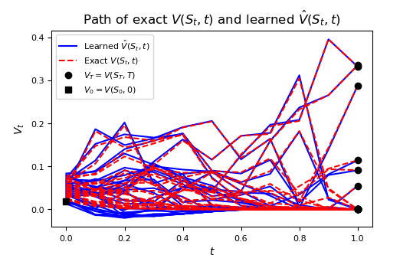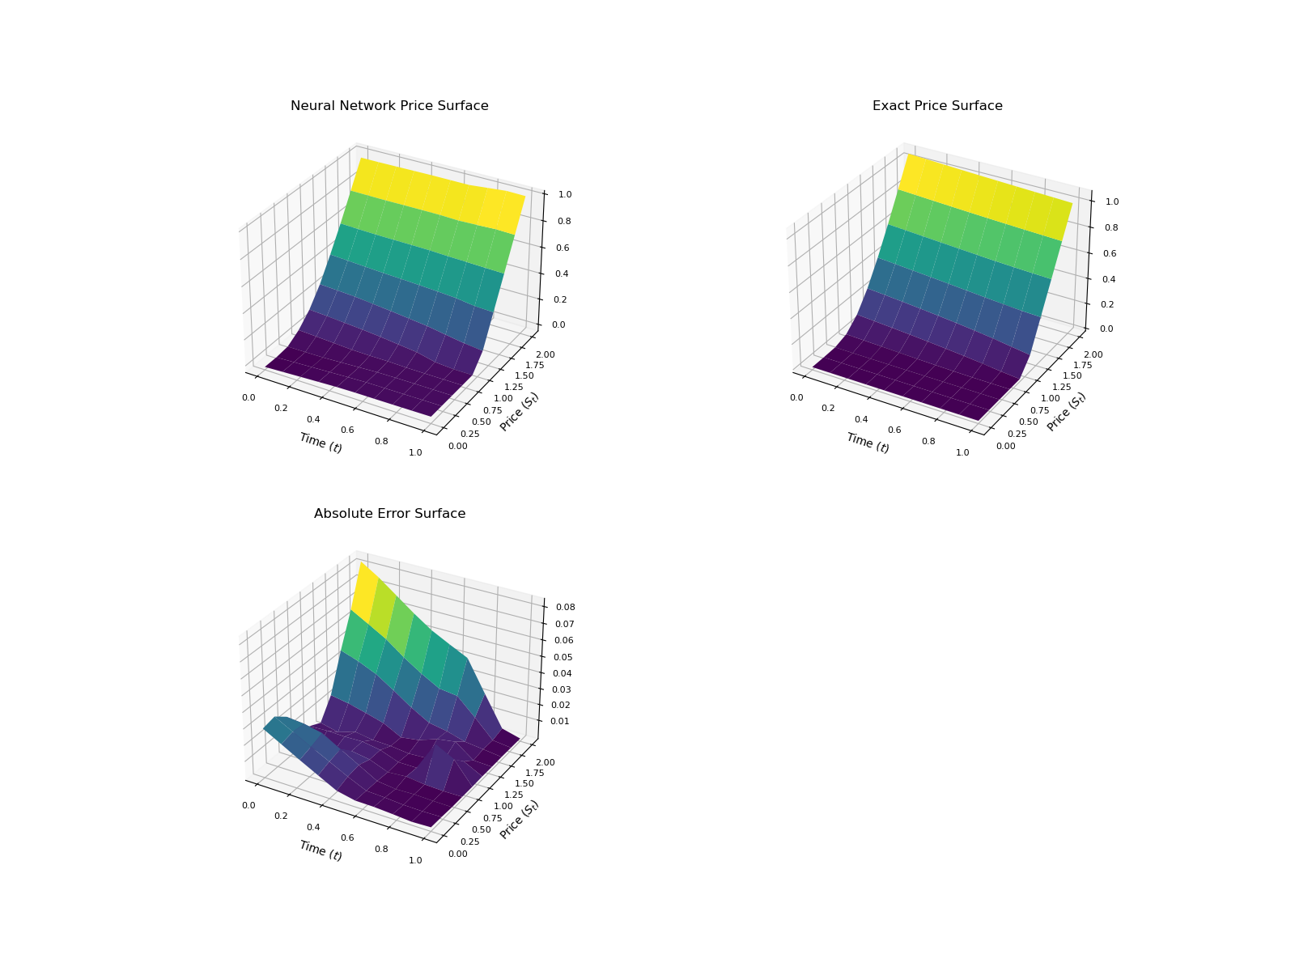

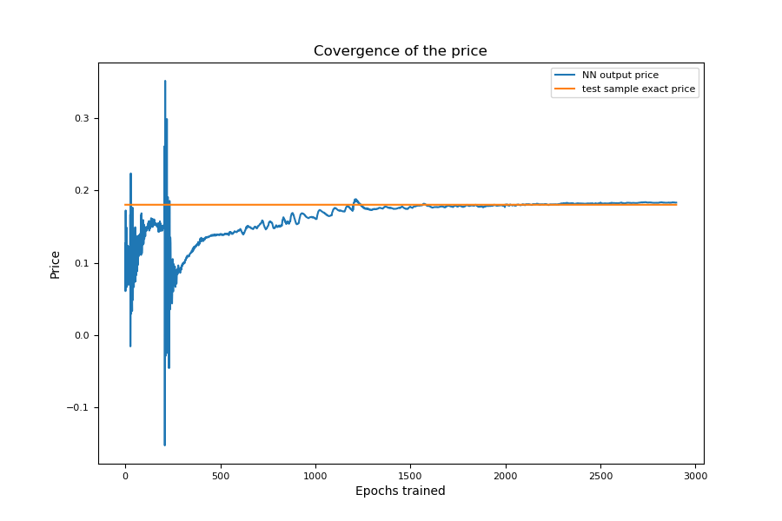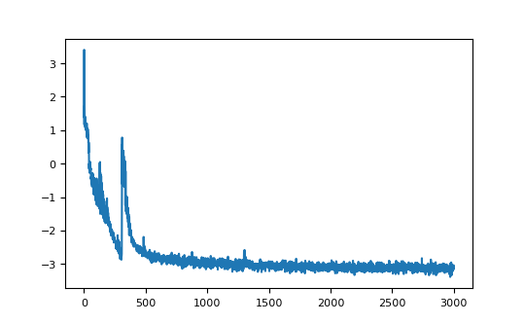

评价out_of_sample_test_t = 0.0

out_of_sample_test_S = 1.0，但生成路径的起点都是0.6到1.3之间，所以在0.6到1.3之间为起点cover到的点error都不错