**Currently owned materials**

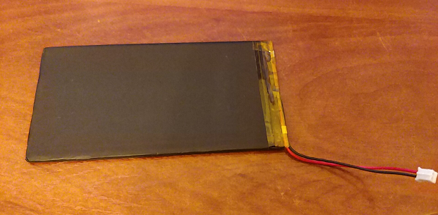

3.7v polymer lithium battery

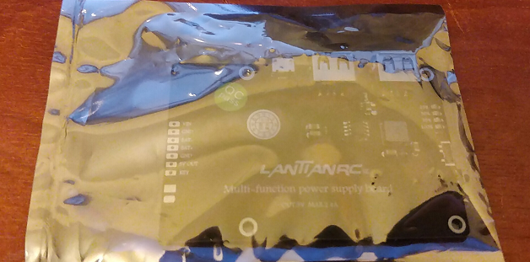

3.7A to 5A 2.4A power supply board

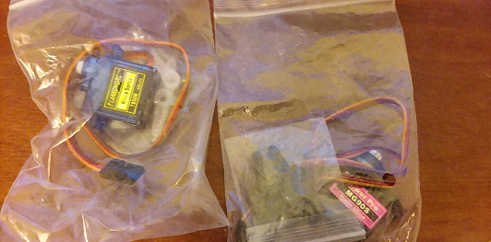

9g servo

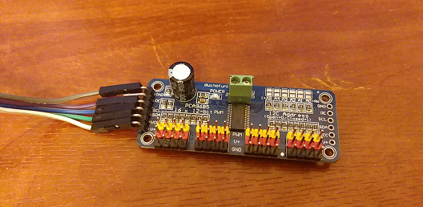

IPCA9685

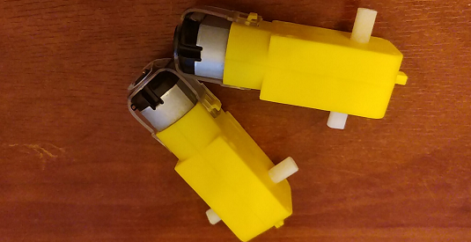

TT motor(1:48)

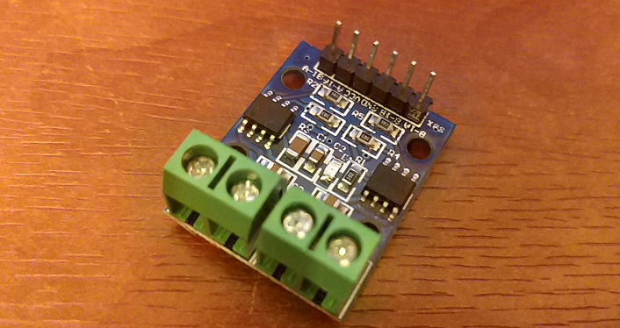

L9110

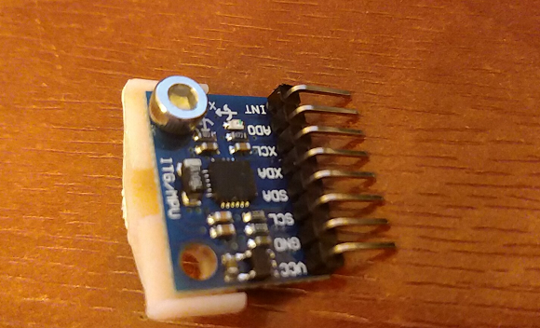

A super cheap mpu6050+gy521 (2rmb for 6 axis...)

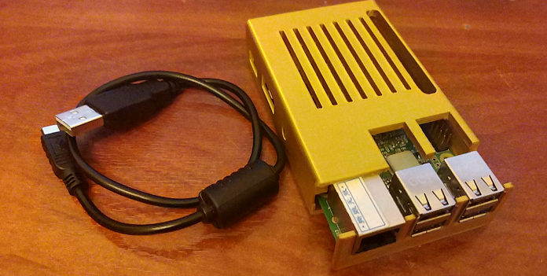

Raspberry pi 3b

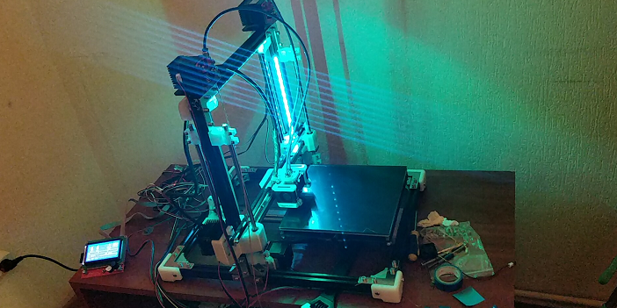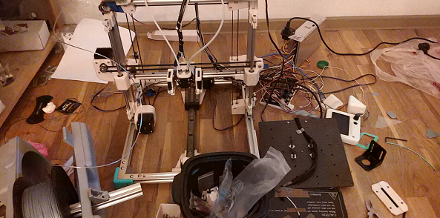

3d printer that we made in holidays *2 (1 needs some fix ..)

**What we still need**

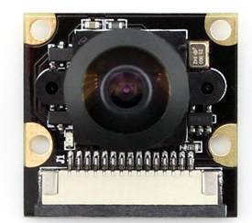

A CSI camera

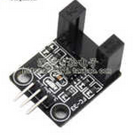

Some photoelectric speed measuring modules

**Ubuntu Mate for Raspberry pi**

<https://ubuntu-mate.org/raspberry-pi/>

Use Win32DiskImager to write，nothing special…

Official issues: First boot setup WiFi doesn’t work, at all. Reboot and WiFi will be available.

sudopasswd to change root password

install SSH

sudo apt-get install openssh-server

install VNC

sudo apt install -y xrdp

install ROS Kinetic

<http://wiki.ros.org/kinetic/Installation/Ubuntu>

what you need

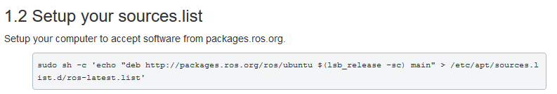

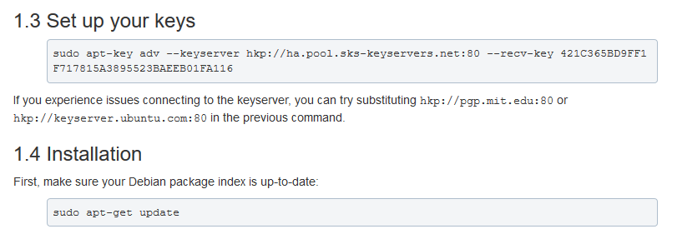

You need onlyu one of them

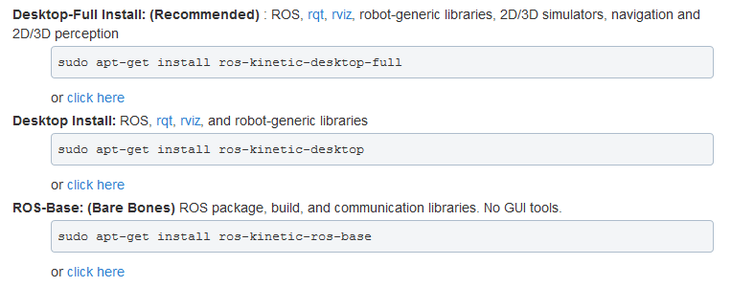

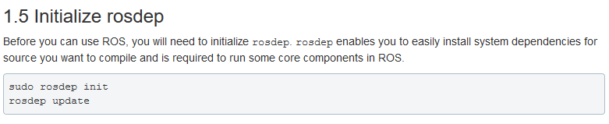

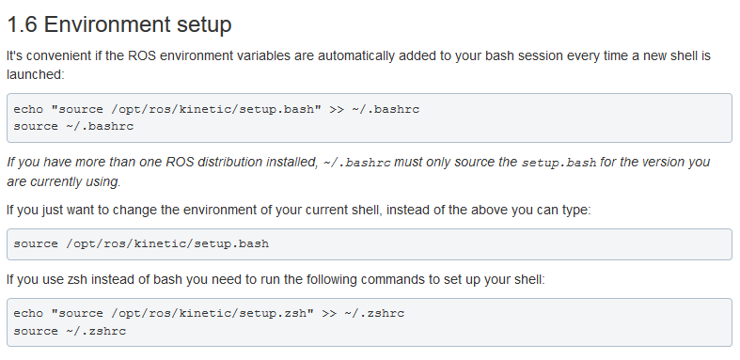

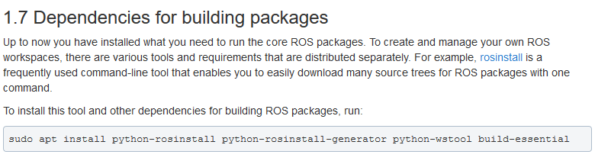

**What if ROS doesn’t work with python3**

pip3 install pyyaml

sudo apt-get install python3-catkin-pkg-modules

sudo apt-get install python3-rospkg-modules

after installed those pack you might need re install ros again….

**What if you do not want to set a Static IP for your Pi**

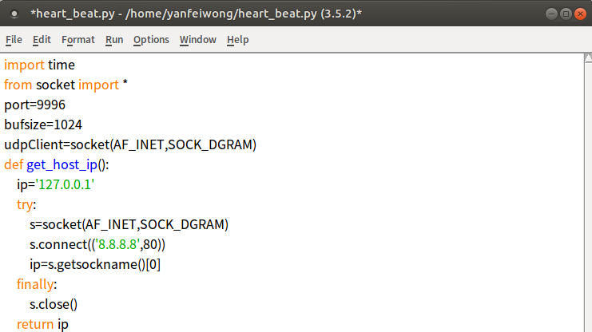

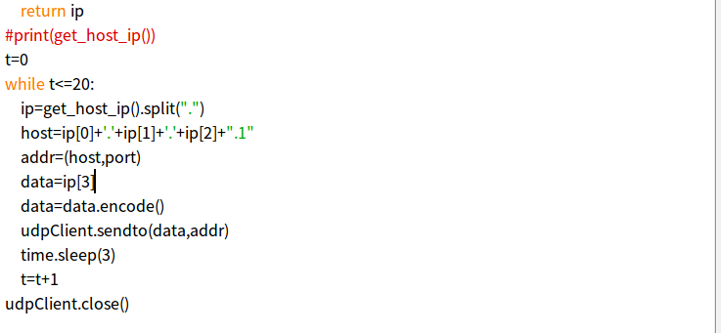

sudo nano /etc/rc.local

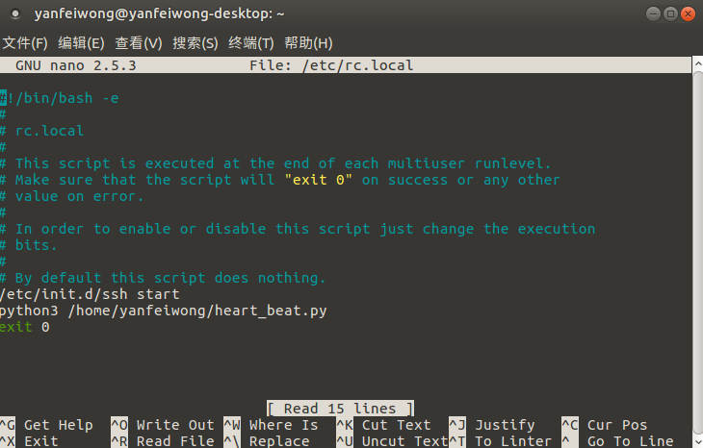

chmod +x /etc/rc.local

Then every time it boot up ,it will send its ip to the host, like 20 times in 1 minute ,just don’t forget the port you set….