**How to FIX ros**

Ros may broken after some software update .. (twice for me ..)

**Remove ros**

sudo apt-get purge ros-*

**Reinstall ros**

http://wiki.ros.org/kinetic/Installation/Ubuntu

**Reinstall rospy**

sudo apt install --reinstall python-rosinstall python-rosinstall-generator python-wstool build-essential

**File sharing (samba)**

sudo apt-get install samba samba-common-bin

sudo nano /etc/samba/smb.conf

(*change user to your user name)

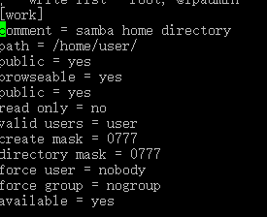

save it

sudo /etc/init.d/samba restart

sudo smbpasswd -a user

**I2C on Ubuntu mate on raspberry pi 3b**

sudo raspi-config

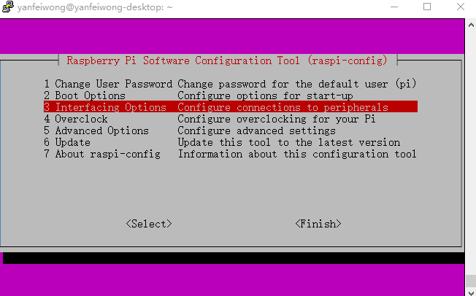

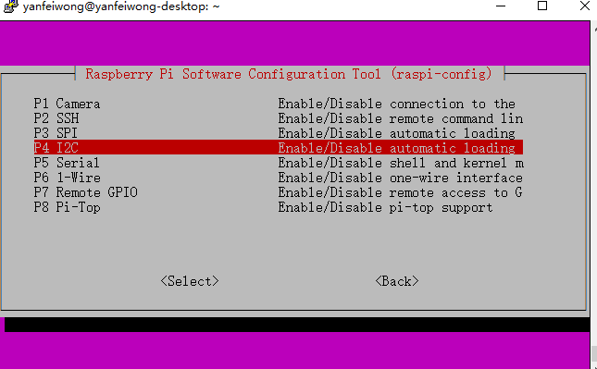

sudo apt-get install -y i2c-tools

sudo i2cdetect -y 1

