CrossShare

Windows

|  |  |  |  |
| --- | --- | --- | --- |
| 修訂時間 | 版本 | 內容 | 編輯者 |
| 20241107 | v1 | 初版 | Jack |
| 20241213 | v2 | 1. 新增Protocol 3-6. 圖片傳輸進度 2. 新增Protocol 3-7. 推送訊息 3. 新增Other 4-1. 推送訊息內容 | Jack |
| 20241213 | v2.1 | 新增推送title Other 4-1. 推送訊息內容 | Jack |

目錄

目錄 3

**1.** **架構說明** 4

**2.** **NamedPipe** 5

**3.** **Protocol** 6

3-1. 取得連線狀態GetConnStatus 7

3-2. 取得客戶列表GetClientList 9

3-3. 更新客戶列表UpdateClientStatus 10

3-4. 傳送檔案SendFile 12

3-5. 檔案進度UpdateProgress 16

# **架構說明**

CrossShare採用P2P(Peer to Peer)的方式連線，主要功能為多平台連線及互傳文字、檔案、圖片**等**。

Windows上則是基於：Network (Golang) ⮂ Windows Pipe Server (C++) ⮂ Windows Pipe Client (C++)。

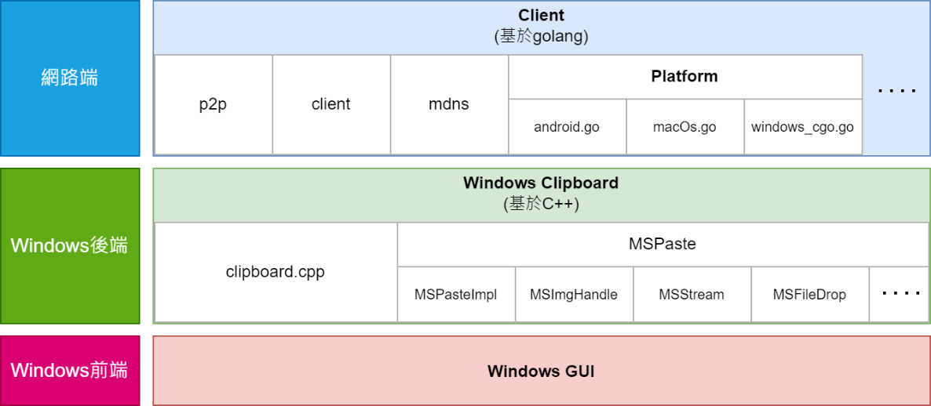

* Windows前端處理UI
* Window後端處理前端的命令，以及與Network的溝通
* 網路端則與對端網路溝通與傳輸

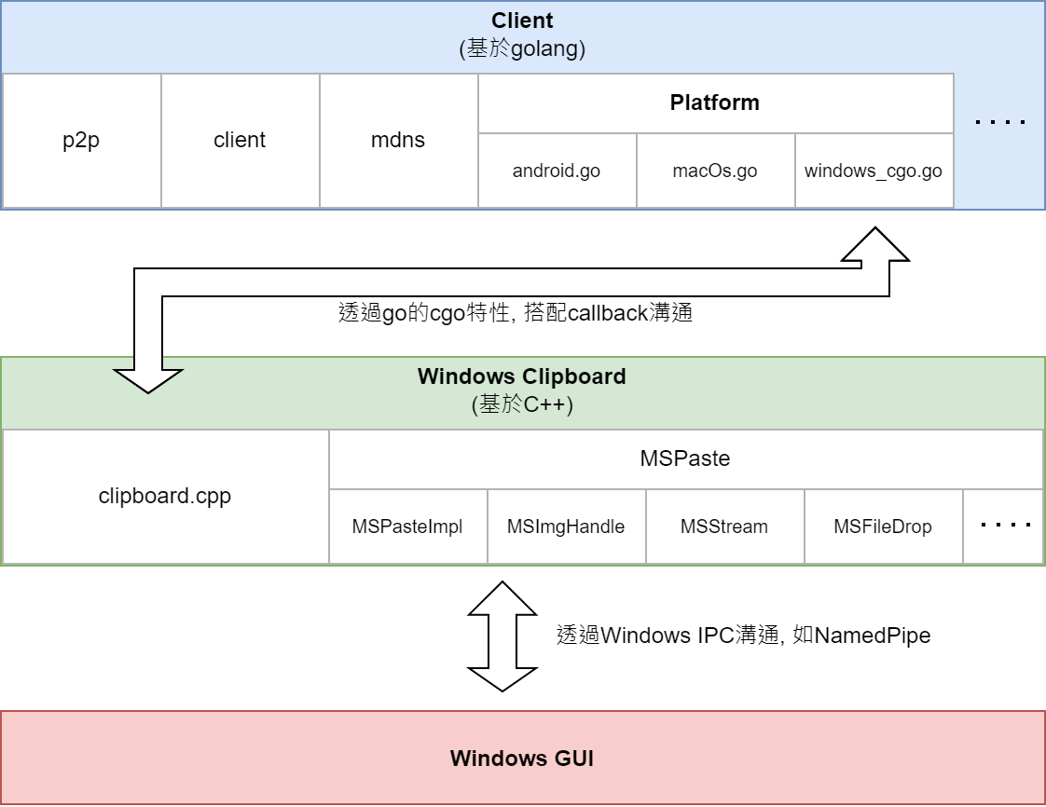

# **NamedPipe**

|  |  |
| --- | --- |
| PipeName | \\.\pipe\CrossSharePipe |
|  |  |

# **Protocol**

Protocol採用Header-Type-Code-Length-Content的形式，並且使用Bytes array傳送，每個封包最大長度為1024 bytes。

|  |  |  |  |
| --- | --- | --- | --- |
|  | **內容** | **大小(bytes)** | **備註** |
| **Header** | Header | 5 | 固定值: ***RTKCS*** |
| **Type** | Message type | 1 | 請參考Table3-2 |
| **Code** | Function code | 1 | 請參考Table3-3 |
| **Length** | Content length | 4 (as Integer) | content的長度 |
| **Content** | Content |  |  |

Table 3-1

|  |  |  |
| --- | --- | --- |
| **Type** | | |
| **Value** | **Description** | **Notes** |
| 0 | Request | Request後需要等待接收Response |
| 1 | Response | 收到Request後需要發送Response |
| 2 | Notify | 不需要Request, 直接發送 |

Table 3-2

|  |  |  |
| --- | --- | --- |
| **Code** | | |
| **Value** | **Description** | **Notes** |
| 0 | Reserved |  |
| 1 | GetConnStatus | 取得連線資訊 |
| 2 | GetClientList | 取得客戶列表 |
| 3 | UpdateClientStatus | 更新客戶狀態 |
| 4 | SendFile | 準備發送檔案, 詢問對端是否接收 |
| 5 | UpdateProgress | 檔案傳輸/接收進度 |
| 6 | UpdateImageProgress | 圖片接收進度 |
| 7 | NotiMessage | 顯示推送訊息 |

Table 3-3

* 1. 取得連線狀態GetConnStatus

|  |  |  |  |  |
| --- | --- | --- | --- | --- |
| **GetConnStatus** | | | | |
| **Description** | 取得server與client端連線狀態。  目前用於確認Windows GUI與services是否成功連線 | | | |
| **Request** | | | | |
| **Property** | **Value** | | **Length (Bytes)** | **Notes** |
| Header | RTKCS | | 5 |  |
| Type | 0 | | 1 |  |
| Code | 1 | | 1 |  |
| Length | Content長度 | | 4 | 高位在前, 低位在後 |
| Content | N/A | | 0 |  |
| Example(Hex) | Header | RTKCS | | |
| 0x52 0x54 0x4B 0x43 0x53 | | |
| Type | 0 | | |
| 0x00 | | |
| Code | 1 | | |
| 0x01 | | |
| Length | 0 | | |
| 0x00 0x00 0x00 0x00 | | |
| Content | N/A | | |
| 0x52 0x54 0x4B 0x43 0x53 0x00 0x01 0x00 0x00 0x00 0x00 | | | |
| **Response** | | | | |
| **Property** | **Value** | | **Length (Bytes)** | **Notes** |
| Header | RTKCS | | 5 |  |
| Type | 1 | | 1 |  |
| Code | 1 | | 1 |  |
| Length | Content長度 | | 4 | 高位在前, 低位在後 |
| Content | 與Server端的連線狀態, 狀態碼0/1 | | 1 | 0: Connected failed  1: Connected successfully |
| Example(Hex) | Header | RTKCS | | |
| 0x52 0x54 0x4B 0x43 0x53 | | |
| Type | 1 | | |
| 0x01 | | |
| Code | 1 | | |
| 0x01 | | |
| Length | 1 | | |
| 0x00 0x00 0x00 0x01 | | |
| Content | 0x01 | | |
| 0x52 0x54 0x4B 0x43 0x53 0x01 0x01 0x00 0x00 0x00 0x01 0x01 | | | |

* 1. 取得客戶列表GetClientList

待訂

* 1. 更新客戶列表UpdateClientStatus

|  |  |  |  |  |  |  |
| --- | --- | --- | --- | --- | --- | --- |
| **UpdateClientStatus** | | | | | | |
| **Description** | | 更新Client連線狀態 | | | | |
| **Notify** | | | | | | |
| **Property** | | **Value** | | | **Length (Bytes)** | **Notes** |
| Header | | RTKCS | | | 5 |  |
| Type | | 2 | | | 1 |  |
| Code | | 3 | | | 1 |  |
| Length | | Content長度 | | | 4 | 高位在前, 低位在後 |
| Content | Status | 客戶端連線狀態, 狀態碼0/1 | | | 1 | 0: Disconnected  1: Connected |
| IP | 客戶端IP地址, 含有Port. 長度共6 bytes  最大為255.255.255.255:65535 (0xFF 0xFF 0xFF 0xFF 0xFF 0xFF) | | | 6 | Port(2 bytes) 高位在前, 低位在後 |
| ID | 客戶端連線ID, 長度固定46 bytes | | | 46 |  |
| Name | 客戶端名稱 | | |  | 使用UTF-16 LE |
| Example(Hex) | | Header | RTKCS | | | |
| 0x52 0x54 0x4B 0x43 0x53 | | | |
| Type | 2 | | | |
| 0x02 | | | |
| Code | 3 | | | |
| 0x03 | | | |
| Length | 69 | | | |
| 0x00 0x00 0x00 0x45 | | | |
| Content | Status | 1 | | |
| 0x01 | | |
| IP | 192.168.30.1:12345 | | |
| 0xC0 0xA8 0x1E 0x01 0x30 0x39 | | |
| ID | QmQ7obXFx1XMFr6hCYXtovn9zREFqSXEtH5hdtpBDLjrAz | | |
| 0x51 0x6D 0x51 0x37 0x6F 0x62 0x58 0x46 0x78 0x31 0x58 0x4D 0x46 0x72 0x36 0x68 0x43 0x59 0x58 0x74 0x6F 0x76 0x6E 0x39 0x7A 0x52 0x45 0x46 0x71 0x53 0x58 0x45 0x74 0x48 0x35 0x68 0x64 0x74 0x70 0x42 0x44 0x4C 0x6A 0x72 0x41 0x7A | | |
| Name | abc‘s 電腦 | | |
| 0x61 0x00 0x62 0x00 0x63 0x00 0x27 0x00 0x73 0x00 0x20 0x00 0xFB 0x96 0x66 0x81 | | |
| 0x52 0x54 0x4B 0x43 0x53 0x02 0x03 0x00 0x00 0x00 0x45 0x01 0xC0 0xA8 0x1E 0x01 0x30 0x39 0x51 0x6D 0x51 0x37 0x6F 0x62 0x58 0x46 0x78 0x31 0x58 0x4D 0x46 0x72 0x36 0x68 0x43 0x59 0x58 0x74 0x6F 0x76 0x6E 0x39 0x7A 0x52 0x45 0x46 0x71 0x53 0x58 0x45 0x74 0x48 0x35 0x68 0x64 0x74 0x70 0x42 0x44 0x4C 0x6A 0x72 0x41 0x7A 0x61 0x00 0x62 0x00 0x63 0x00 0x27 0x00 0x73 0x00 0x20 0x00 0xFB 0x96 0x66 0x81 | | | | |

* 1. 傳送檔案SendFile

|  |  |  |  |  |  |  |  |
| --- | --- | --- | --- | --- | --- | --- | --- |
| **SendFile** | | | | | | | |
| **Description** | | | 傳送檔案至指定客戶端, 並詢問客戶端是否接收檔案 | | | | |
| **Request** | | | | | | | |
| **Property** | | | **Value** | | | **Length (Bytes)** | **Notes** |
| Header | | | RTKCS | | | 5 |  |
| Type | | | 0 | | | 1 |  |
| Code | | | 4 | | | 1 |  |
| Length | | | Content長度 | | | 4 | 高位在前, 低位在後 |
| Content | IP | | 客戶端IP地址以及Port. 長度共6 bytes  最大為255.255.255.255:65535 (0xFF 0xFF 0xFF 0xFF 0xFF 0xFF) | | | 6 | Port(2 bytes) 高位在前, 低位在後 |
| ID | | 客戶端連線ID, 長度固定46 bytes | | | 46 |  |
| File size | | 檔案大小 | | | 8 | 高位在前, 低位在後 |
| Timestamp | | 檔案傳輸時間戳 | | | 8 | 高位在前, 低位在後 |
| File name | | 檔案路徑 | | |  | 使用UTF-16 LE |
| Example(Hex) | | Header | | RTKCS | | | |
| 0x52 0x54 0x4B 0x43 0x53 | | | |
| Type | | 0 | | | |
| 0x00 | | | |
| Code | | 4 | | | |
| 0x04 | | | |
| Length | | 140 | | | |
| 0x00 0x00 0x00 0x8C | | | |
| Content | | IP | 192.168.30.1:12345 | | |
| 0xC0 0xA8 0x1E 0x01 0x30 0x39 | | |
| ID | QmQ7obXFx1XMFr6hCYXtovn9zREFqSXEtH5hdtpBDLjrAz | | |
| 0x51 0x6D 0x51 0x37 0x6F 0x62 0x58 0x46 0x78 0x31 0x58 0x4D 0x46 0x72 0x36 0x68 0x43 0x59 0x58 0x74 0x6F 0x76 0x6E 0x39 0x7A 0x52 0x45 0x46 0x71 0x53 0x58 0x45 0x74 0x48 0x35 0x68 0x64 0x74 0x70 0x42 0x44 0x4C 0x6A 0x72 0x41 0x7A | | |
| File size | 60727169 (57.9MB) | | |
| 0x00 0x00 0x00 0x00 0x03 0x9E 0x9F 0x81 | | |
| Timestamp | 1697049243123 (2023-10-13 08:54:03.123 UTC) | | |
| 0x00 0x00 0x01 0x8B 0x20 0x04 0x6D 0xF3 | | |
| File path | D:\jack_huang\Downloads\新增資料夾\測試.mp4 | | |
| 0x44 0x00 0x3A 0x00 0x5C 0x00 0x6A 0x00 0x61 0x00 0x63 0x00 0x6B 0x00 0x5F 0x00 0x68 0x00 0x75 0x00 0x61 0x00 0x6E 0x00 0x67 0x00 0x5C 0x00 0x44 0x00 0x6F 0x00 0x77 0x00 0x6E 0x00 0x6C 0x00 0x6F 0x00 0x61 0x00 0x64 0x00 0x73 0x00 0x5C 0x00 0xB0 0x65 0x9E 0x58 0xC7 0x8C 0x99 0x65 0x3E 0x59 0x5C 0x00 0x2C 0x6E 0x66 0x8A 0x2E 0x00 0x6D 0x00 0x70 0x00 0x34 0x00 | | |
| 0x52 0x54 0x4B 0x43 0x53 0x00 0x04 0x00 0x00 0x00 0x8C 0xC0 0xA8 0x1E 0x01 0x30 0x39 0x51 0x6D 0x51 0x37 0x6F 0x62 0x58 0x46 0x78 0x31 0x58 0x4D 0x46 0x72 0x36 0x68 0x43 0x59 0x58 0x74 0x6F 0x76 0x6E 0x39 0x7A 0x52 0x45 0x46 0x71 0x53 0x58 0x45 0x74 0x48 0x35 0x68 0x64 0x74 0x70 0x42 0x44 0x4C 0x6A 0x72 0x41 0x7A 0x00 0x00 0x00 0x00 0x03 0x9E 0x9F 0x81 0x00 0x00 0x01 0x8B 0x20 0x04 0x6D 0xF3 0x44 0x00 0x3A 0x00 0x5C 0x00 0x6A 0x00 0x61 0x00 0x63 0x00 0x6B 0x00 0x5F 0x00 0x68 0x00 0x75 0x00 0x61 0x00 0x6E 0x00 0x67 0x00 0x5C 0x00 0x44 0x00 0x6F 0x00 0x77 0x00 0x6E 0x00 0x6C 0x00 0x6F 0x00 0x61 0x00 0x64 0x00 0x73 0x00 0x5C 0x00 0xB0 0x65 0x9E 0x58 0xC7 0x8C 0x99 0x65 0x3E 0x59 0x5C 0x00 0x2C 0x6E 0x66 0x8A 0x2E 0x00 0x6D 0x00 0x70 0x00 0x34 0x00 | | | | | |
| **Response** | | | | | | | |
| **Property** | | | **Value** | | | **Length (Bytes)** | **Notes** |
| Header | | | RTKCS | | | 5 |  |
| Type | | | 1 | | | 1 |  |
| Code | | | 4 | | | 1 |  |
| Length | | | Content長度 | | | 4 | 高位在前, 低位在後 |
| Content | Status | | 是否接收檔案, 狀態碼0/1 | | | 1 | 0: Reject  1: Accept |
| IP | | 客戶端IP地址以及Port. 長度共6 bytes  最大為255.255.255.255:65535 (0xFF 0xFF 0xFF 0xFF 0xFF 0xFF) | | | 6 | Port(2 bytes) 高位在前, 低位在後 |
| ID | | 客戶端連線ID, 長度固定46 bytes | | | 46 |  |
| File size | | 檔案大小 | | | 8 | 高位在前, 低位在後 |
| Timestamp | | 檔案傳輸時間戳 | | | 8 | 高位在前, 低位在後 |
| File name | | 檔案路徑 | | |  | 使用UTF-16 LE |
| Example(Hex) | | Header | | RTKCS | | | |
| 0x52 0x54 0x4B 0x43 0x53 | | | |
| Type | | 1 | | | |
| 0x01 | | | |
| Code | | 4 | | | |
| 0x04 | | | |
| Length | | 141 | | | |
| 0x00 0x00 0x00 0x8D | | | |
| Content | | Accept | 1 | | |
| 0x01 | | |
| IP | 192.168.30.1:12345 | | |
| 0xC0 0xA8 0x1E 0x01 0x30 0x39 | | |
| ID | QmQ7obXFx1XMFr6hCYXtovn9zREFqSXEtH5hdtpBDLjrAz | | |
| 0x51 0x6D 0x51 0x37 0x6F 0x62 0x58 0x46 0x78 0x31 0x58 0x4D 0x46 0x72 0x36 0x68 0x43 0x59 0x58 0x74 0x6F 0x76 0x6E 0x39 0x7A 0x52 0x45 0x46 0x71 0x53 0x58 0x45 0x74 0x48 0x35 0x68 0x64 0x74 0x70 0x42 0x44 0x4C 0x6A 0x72 0x41 0x7A | | |
| File size | 60727169 (57.9MB) | | |
| 0x00 0x00 0x00 0x00 0x03 0x9E 0x9F 0x81 | | |
| Timestamp | 1697049243123 (2023-10-13 08:54:03.123 UTC) | | |
| 0x00 0x00 0x01 0x8B 0x20 0x04 0x6D 0xF3 | | |
| File path | D:\jack_huang\Downloads\新增資料夾\測試.mp4 | | |
| 0x44 0x00 0x3A 0x00 0x5C 0x00 0x6A 0x00 0x61 0x00 0x63 0x00 0x6B 0x00 0x5F 0x00 0x68 0x00 0x75 0x00 0x61 0x00 0x6E 0x00 0x67 0x00 0x5C 0x00 0x44 0x00 0x6F 0x00 0x77 0x00 0x6E 0x00 0x6C 0x00 0x6F 0x00 0x61 0x00 0x64 0x00 0x73 0x00 0x5C 0x00 0xB0 0x65 0x9E 0x58 0xC7 0x8C 0x99 0x65 0x3E 0x59 0x5C 0x00 0x2C 0x6E 0x66 0x8A 0x2E 0x00 0x6D 0x00 0x70 0x00 0x34 0x00 | | |
| 0x52 0x54 0x4B 0x43 0x53 0x00 0x04 0x00 0x00 0x00 0x8D 0x01 0xC0 0xA8 0x1E 0x01 0x30 0x39 0x51 0x6D 0x51 0x37 0x6F 0x62 0x58 0x46 0x78 0x31 0x58 0x4D 0x46 0x72 0x36 0x68 0x43 0x59 0x58 0x74 0x6F 0x76 0x6E 0x39 0x7A 0x52 0x45 0x46 0x71 0x53 0x58 0x45 0x74 0x48 0x35 0x68 0x64 0x74 0x70 0x42 0x44 0x4C 0x6A 0x72 0x41 0x7A 0x00 0x00 0x00 0x00 0x03 0x9E 0x9F 0x81 0x00 0x00 0x01 0x8B 0x20 0x04 0x6D 0xF3 0x44 0x00 0x3A 0x00 0x5C 0x00 0x6A 0x00 0x61 0x00 0x63 0x00 0x6B 0x00 0x5F 0x00 0x68 0x00 0x75 0x00 0x61 0x00 0x6E 0x00 0x67 0x00 0x5C 0x00 0x44 0x00 0x6F 0x00 0x77 0x00 0x6E 0x00 0x6C 0x00 0x6F 0x00 0x61 0x00 0x64 0x00 0x73 0x00 0x5C 0x00 0xB0 0x65 0x9E 0x58 0xC7 0x8C 0x99 0x65 0x3E 0x59 0x5C 0x00 0x2C 0x6E 0x66 0x8A 0x2E 0x00 0x6D 0x00 0x70 0x00 0x34 0x00 | | | | | |

* 1. 檔案進度UpdateProgress

|  |  |  |  |  |  |  |  |
| --- | --- | --- | --- | --- | --- | --- | --- |
| **UpdateProgress** | | | | | | | |
| **Description** | | | 更新檔案傳輸進度 | | | | |
| **Notify** | | | | | | | |
| **Property** | | | **Value** | | | **Length (Bytes)** | **Notes** |
| Header | | | RTKCS | | | 5 |  |
| Type | | | 2 | | | 1 |  |
| Code | | | 5 | | | 1 |  |
| Length | | | Content長度 | | | 4 | 高位在前, 低位在後 |
| Content | IP | | 客戶端IP地址以及Port. 長度共6 bytes  最大為255.255.255.255:65535 (0xFF 0xFF 0xFF 0xFF 0xFF 0xFF) | | | 6 | Port(2 bytes) 高位在前, 低位在後 |
| ID | | 客戶端連線ID, 長度固定46 bytes | | | 46 |  |
| File size | | 檔案大小 | | | 8 | 高位在前, 低位在後 |
| Sent size | | 已傳送的數據大小 | | | 8 | 高位在前, 低位在後 |
| Timestamp | | 檔案傳輸時間戳 | | | 8 | 高位在前, 低位在後 |
| File name | | 檔案名稱 | | |  | 使用UTF-16 LE |
| Example(Hex) | | Header | | RTKCS | | | |
| 0x52 0x54 0x4B 0x43 0x53 | | | |
| Type | | 2 | | | |
| 0x02 | | | |
| Code | | 5 | | | |
| 0x05 | | | |
| Length | | 88 | | | |
| 0x00 0x00 0x00 0x58 | | | |
| Content | | IP | 192.168.30.1:12345 | | |
| 0xC0 0xA8 0x1E 0x01 0x30 0x39 | | |
| ID | QmQ7obXFx1XMFr6hCYXtovn9zREFqSXEtH5hdtpBDLjrAz | | |
| 0x51 0x6D 0x51 0x37 0x6F 0x62 0x58 0x46 0x78 0x31 0x58 0x4D 0x46 0x72 0x36 0x68 0x43 0x59 0x58 0x74 0x6F 0x76 0x6E 0x39 0x7A 0x52 0x45 0x46 0x71 0x53 0x58 0x45 0x74 0x48 0x35 0x68 0x64 0x74 0x70 0x42 0x44 0x4C 0x6A 0x72 0x41 0x7A | | |
| File size | 60727169 (57.9MB) | | |
| 0x00 0x00 0x00 0x00 0x03 0x9E 0x9F 0x81 | | |
| Sent size | 32134526 (30.6MB) | | |
| 0x00 0x00 0x00 0x00 0x01 0xEA 0x55 0x7E | | |
| Timestamp | 1697049243123 (2023-10-13 08:54:03.123 UTC) | | |
| 0x00 0x00 0x01 0x8B 0x20 0x04 0x6D 0xF3 | | |
| File name | 測試.mp4 | | |
| 0x2C 0x6E 0x66 0x8A 0x2E 0x00 0x6D 0x00 0x70 0x00 0x34 0x00 | | |
| 0x52 0x54 0x4B 0x43 0x53 0x02 0x05 0x00 0x00 0x00 0x58 0xC0 0xA8 0x1E 0x01 0x30 0x39 0x51 0x6D 0x51 0x37 0x6F 0x62 0x58 0x46 0x78 0x31 0x58 0x4D 0x46 0x72 0x36 0x68 0x43 0x59 0x58 0x74 0x6F 0x76 0x6E 0x39 0x7A 0x52 0x45 0x46 0x71 0x53 0x58 0x45 0x74 0x48 0x35 0x68 0x64 0x74 0x70 0x42 0x44 0x4C 0x6A 0x72 0x41 0x7A 0x00 0x00 0x00 0x00 0x03 0x9E 0x9F 0x81 0x00 0x00 0x00 0x00 0x01 0xEA 0x55 0x7E 0x00 0x00 0x01 0x8B 0x20 0x04 0x6D 0xF3 0x2C 0x6E 0x66 0x8A 0x2E 0x00 0x6D 0x00 0x70 0x00 0x34 0x00 | | | | | |

* 1. 圖片傳輸進度UpdateImageProgress

|  |  |  |  |  |  |  |  |
| --- | --- | --- | --- | --- | --- | --- | --- |
| **UpdateImageProgress** | | | | | | | |
| **Description** | | | 更新圖片傳輸進度 | | | | |
| **Notify** | | | | | | | |
| **Property** | | | **Value** | | | **Length (Bytes)** | **Notes** |
| Header | | | RTKCS | | | 5 |  |
| Type | | | 2 | | | 1 |  |
| Code | | | 6 | | | 1 |  |
| Length | | | Content長度 | | | 4 | 高位在前, 低位在後 |
| Content | IP | | 客戶端IP地址以及Port. 長度共6 bytes  最大為255.255.255.255:65535 (0xFF 0xFF 0xFF 0xFF 0xFF 0xFF) | | | 6 | Port(2 bytes) 高位在前, 低位在後 |
| ID | | 客戶端連線ID, 長度固定46 bytes | | | 46 |  |
| File size | | 圖片大小 | | | 8 | 高位在前, 低位在後 |
| Sent size | | 已傳送的數據大小 | | | 8 | 高位在前, 低位在後 |
| Timestamp | | 圖片傳輸時間戳 | | | 8 | 高位在前, 低位在後 |
| Example(Hex) | | Header | | RTKCS | | | |
| 0x52 0x54 0x4B 0x43 0x53 | | | |
| Type | | 2 | | | |
| 0x02 | | | |
| Code | | 6 | | | |
| 0x06 | | | |
| Length | | 76 | | | |
| 0x00 0x00 0x00 0x4C | | | |
| Content | | IP | 192.168.30.1:12345 | | |
| 0xC0 0xA8 0x1E 0x01 0x30 0x39 | | |
| ID | QmQ7obXFx1XMFr6hCYXtovn9zREFqSXEtH5hdtpBDLjrAz | | |
| 0x51 0x6D 0x51 0x37 0x6F 0x62 0x58 0x46 0x78 0x31 0x58 0x4D 0x46 0x72 0x36 0x68 0x43 0x59 0x58 0x74 0x6F 0x76 0x6E 0x39 0x7A 0x52 0x45 0x46 0x71 0x53 0x58 0x45 0x74 0x48 0x35 0x68 0x64 0x74 0x70 0x42 0x44 0x4C 0x6A 0x72 0x41 0x7A | | |
| File size | 60727169 (57.9MB) | | |
| 0x00 0x00 0x00 0x00 0x03 0x9E 0x9F 0x81 | | |
| Sent size | 32134526 (30.6MB) | | |
| 0x00 0x00 0x00 0x00 0x01 0xEA 0x55 0x7E | | |
| Timestamp | 1697049243123 (2023-10-13 08:54:03.123 UTC) | | |
| 0x00 0x00 0x01 0x8B 0x20 0x04 0x6D 0xF3 | | |
| 0x52 0x54 0x4B 0x43 0x53 0x02 0x06 0x00 0x00 0x00 0x4C 0xC0 0xA8 0x1E 0x01 0x30 0x39 0x51 0x6D 0x51 0x37 0x6F 0x62 0x58 0x46 0x78 0x31 0x58 0x4D 0x46 0x72 0x36 0x68 0x43 0x59 0x58 0x74 0x6F 0x76 0x6E 0x39 0x7A 0x52 0x45 0x46 0x71 0x53 0x58 0x45 0x74 0x48 0x35 0x68 0x64 0x74 0x70 0x42 0x44 0x4C 0x6A 0x72 0x41 0x7A 0x00 0x00 0x00 0x00 0x03 0x9E 0x9F 0x81 0x00 0x00 0x00 0x00 0x01 0xEA 0x55 0x7E 0x00 0x00 0x01 0x8B 0x20 0x04 0x6D 0xF3 | | | | | |

* 1. 推送訊息NotiMessage

|  |  |  |  |  |  |  |  |
| --- | --- | --- | --- | --- | --- | --- | --- |
| **NotiMessage** | | | | | | | |
| **Description** | | | 推送訊息: 依照訊息代碼, 自Table4-1訊息內容搭配訊息參數, 顯示於UI上 | | | | |
| **Notify** | | | | | | | |
| **Property** | | | **Value** | | | **Length (Bytes)** | **Notes** |
| Header | | | RTKCS | | | 5 |  |
| Type | | | 2 | | | 1 |  |
| Code | | | 7 | | | 1 |  |
| Length | | | Content長度 | | | 4 | 高位在前, 低位在後 |
| Content | Timestamp | | 訊息時間戳 | | | 8 | 高位在前, 低位在後 |
| NotiCode | | 訊息代碼 | | | 1 | 參考表4-1 |
| NotiLength1 | | 訊息參數長度 | | | 4 | 高位在前, 低位在後  長度為NotiParam bytes |
| NotiParam1 | | 訊息參數 | | |  | 使用UTF-16 LE |
| NotiLength2 | | 訊息參數長度 | | | 4 | **\*optional**  高位在前, 低位在後 |
| NotiParam2 | | 訊息參數 | | |  | **\*optional**  使用UTF-16 LE |
| ... | | ... | | |  | 若有多項NotiLength, NotiParam以此類推 |
| Example(Hex) | | Header | | RTKCS | | | |
| 0x52 0x54 0x4B 0x43 0x53 | | | |
| Type | | 2 | | | |
| 0x02 | | | |
| Code | | 7 | | | |
| 0x07 | | | |
| Length | | 88 | | | |
| 0x00 0x00 0x00 0x58 | | | |
| Content | | Timestamp | 1697049243123 (2023-10-13 08:54:03.123 UTC) | | |
| 0x00 0x00 0x01 0x8B 0x20 0x04 0x6D 0xF3 | | |
| NotiCode | 1 | | |
| 0x01 | | |
| NotiLength1 | 14 | | |
| 0x00 0x00 0x00 0x0E | | |
| NotiParam1 | Device1 | | |
| 0x44 0x00 0x65 0x00 0x76 0x00 0x69 0x00 0x63 0x00 0x65 0x00 0x31 0x00 | | |
| NotiLength2 | 1 | | |
| 0x00 0x00 0x00 0x01 | | |
| NotiParam2 | 3 | | |
| 0x03 | | |
| 0x52 0x54 0x4B 0x43 0x53 0x02 0x07 0x00 0x00 0x00 0x58 0x00 0x00 0x01 0x8B 0x20 0x04 0x6D 0xF3 0x01 0x00 0x00 0x00 0x0E 0x44 0x00 0x65 0x00 0x76 0x00 0x69 0x00 0x63 0x00 0x65 0x00 0x31 0x00 0x00 0x00 0x00 0x01 0x03 | | | | | |

# **Other**

* 1. 推送訊息內容

|  |  |  |  |  |
| --- | --- | --- | --- | --- |
| **NotiMessage Table** | | | | |
| **Code** | **Lang** | **Title** | **Content** | **Scenario** |
| 1 | EN | Connection status | {$DeviceName} is now online.  Devices online count: {$Number} | 成功連線至客戶端 |
| 2 | EN | Connection status | {$DeviceName} has been disconnected  Devices online count: {$Number} | 與客戶端失去連線 |
| 3 | EN | File transfer | {$FileName} transferred to {$DeviceName} is complete | 檔案成功傳輸至客戶端 |
| 4 | EN | File transfer | {$FileName} received from {$DeviceName} is complete | 檔案成功接收自客戶端 |
| 5 | EN | File transfer | {$DeviceName} declined to receive {$FileName} | 客戶端拒絕接收檔案 |

Table 4-1