华北水利水电大学 编译原理 实验报告
2019～2020学年 第 二 学期 2017 级 计算机 专业
班级： 2017168 学号： 201616530 姓名： 杨德邦
实验三 LR分析

- 实验要求：
⑴ 选择LR分析方法；
⑵ 选择对各种常见程序语言都用的语法结构，如赋值语句或表达式或控制流语句等作为分析对象，并且与所选语法分析方法要比较贴切。
⑶ 实验时间为6学时。

二、实验内容：
（1）根据给定文法，先对文法进行解析，构造识别活前缀的DFA并输出；
（2）根据DFA构造LR分析表并输出；
（3）分析给定表达式是否是该文法识别的正确的算术表达式（要求输出归约过程）
（4）假如给定表达式文法为：
G(E’): E’→#E#
E→E+T | T
T→T*F |F
F→(E)|i
分析的句子可为:
(i+i)*i和i+i)*i
- 设计思想
构造确定有穷自动机：首先为文法的第一个产生式的右部产生式的最左边添加标记点，并将添加好的列为状态1。将点后跟有非终字符的该非终字符产生式添加入状态1，并根据点后的符号延申出其它产生式状态，构造go函数。对其它产生式也进行相同处理，以点在最后尾为止。
根据go函数填写分析表。Go函数形参1是状态，形参2是符号。若形参2是终结符，则置分析表[形参1，形参2]为a（下表为函数的输出）。若形参2为非终符号，这置[形参1，形参2]为函数的输出结果。若形参1的状态是第一个产生式且标记点在末尾，则置[形参1，形参2]为acc。若形参1状态集中有标记符在末尾的产生式，则置[形参1，形参2]为该产生式的编号。
- 实验设计过程：
C = ['S→E', 'E→E+T','E→T', 'T→T*F','T→F','F→(E)', 'F→i']
Vn = ['S', 'E', 'T', 'F']
Vt = ['+','*','(', ')', 'i', '#']
begin = 'S→·E'
BEGIN = 'S'
def findI(I, v):
newI = []
global C
for i in range(len(I)):
index = location(I[i])
if index != -1 and I[i][index] == v:
newI.append(getNextPointI(I[i]))
addNewI(newI, C)
return newI
def addNewI(newI, C):
if newI == []:
return
oldLen = len(newI)
for i in range(oldLen):
index = location(newI[i])
if index != -1 and isVn(newI[i][index]):
for j in range(len(C)):
if getKey(C[j]) == newI[i][index]:
_ = addFirstPoint(C[j])
if _ not in newI:
newI.append(_)
if oldLen != len(newI):
addNewI(newI, C)
def location(i):
index = i.index('·')
if index != -1 and (index + 1) != len(i):
return index + 1
return -1
def getNextPointI(i):
iArr = i.split('·')
iArr[1] = iArr[1][0] + '·' + iArr[1][1:]
return ''.join(iArr)
def isVn(i):
global Vn
if i in Vn:
return True
return False
def getKey(i):
iArr = i.split('→')
return iArr[0]
def addFirstPoint(i):
iArr = i.split('→')
iArr[1] = '·' + iArr[1]
return '→'.join(iArr)
def printI(I):
for i in I:
print(i)
print("")
def generateTable(GO, I):
global Vt, Vn
res = {}
for k1 in range(len(I)):
res[k1] = {}
for k2 in Vt + Vn:
res[k1][k2] = ' '

for g in GO:
for vt in Vt:
if vt in g:
addTd(res, g[0], g[1], g[2], 's')
for vn in Vn:
if vn in g:
addTd(res, g[0], g[1], g[2], '')
endI = getEndPointI()
for i in range(1, len(endI)):
for In in I:
if endI[i] in In:
for vt in Vt:
if res[I.index(In)][vt] != '':
print('检测到冲突，自动生成SLR表')
generateSLRTable(GO, I)
return
addTd(res, I.index(In), vt, i, 'r')
for In in I:
if endI[0] in In:
addTd(res, I.index(In), '#', 'acc', '')

print("\n表：")
print("", end='\t')
for k in Vt + Vn:
if k == Vn[-1]:
print(k)
else:
print(k, end='\t')
for k1 in res:
print(str(k1), end='\t')
for k2 in res[k1]:
print(res[k1][k2], end='\t')
print("")
def generateSLRTable(GO, I):
print("生成FIRST集：")
first = getFirst()
print(first)
print("生成FOLLOW集")
follow = getFOLLOW(first)
print(follow)
global Vt, Vn
res = {}
for k1 in range(len(I)):
res[k1] = {}
for k2 in Vt + Vn:
res[k1][k2] = ' '

for g in GO:
for vt in Vt:
if vt in g:
addTd(res, g[0], g[1], g[2], 's')
for vn in Vn:
if vn in g:
addTd(res, g[0], g[1], g[2], '')
endI = getEndPointI()
for i in range(1, len(endI)):
for In in I:
if endI[i] in In:
for vt in follow[endI[i].split('→')[0]]:
if res[I.index(In)][vt] != '':
addTd(res, I.index(In), vt, i, 'r')
for In in I:
if endI[0] in In:
addTd(res, I.index(In), '#', 'acc', '')

print("\n表：")
print("", end='\t')
for k in Vt + Vn:
if k == Vn[-1]:
print(k)
else:
print(k, end='\t')
for k1 in res:
print(str(k1), end='\t')
for k2 in res[k1]:
print(res[k1][k2], end='\t')
print("")
def addTd(table, k, a, j, key):
j = str(j)
table[k][a] = key + j
def getEndPointI():
global C
endI = []
for i in C:
endI.append(i + '·')
return endI
def getFirst():
global C, Vt, Vn
first = {}
for i in C:
first[i.split('→')[0]] = []
while True:
flag = False
for i in C:
key = i.split('→')[0]
r1 = i.split('→')[1][0]
if r1 in Vt or r1 == 'ε':
if addInSet(first[key], r1) == True:
flag = True
if r1 in Vn:
empty = 0
for t in i.split('→')[1]:
if t in Vn:
if addInSet(first[key], [_ for _ in first[t] if _ != 'ε']) == True:
flag = True
if checkEmpty(t) == False:
break
else:
empty += 1
else:
break
if empty == len(i.split('→')[1]):
if addInSet(first[key], 'ε') == True:
flag = True
if flag == False:
break
return first
def getFOLLOW(first):
follow = {}
global C, BEGIN
for v in Vn:
if v == BEGIN:
follow[v] = set('#')
else:
follow[v] = set()
while True:
_flag = False
for i in C:
left = i.split('→')[0]
right = i.split('→')[1]
for index in range(len(right)):
if right[index] in Vt or 'ε' in right[index]:
continue
if index == (len(right) - 1):
for _ in follow[left]:
lg = len(follow[right[index]])
follow[right[index]].add(_)
if lg < len(follow[right[index]]):
_flag = True
else:
if right[index + 1] in Vt:
follow[right[index]].add(right[index + 1])
lg = len(follow[right[index]])
if lg < len(follow[right[index]]):
_flag = True
else:
for _ in first[right[index + 1]]:
if _ != 'ε':
follow[right[index]].add(_)
lg = len(follow[right[index]])
if lg < len(follow[right[index]]):
_flag = True
flag = False
for _ in right[index + 1:]:
if (_ in Vt) or ('ε' not in first[_]):
flag = True
if flag == False:
for _ in follow[left]:
follow[right[index]].add(_)
lg = len(follow[right[index]])
if lg < len(follow[right[index]]):
_flag = True

if _flag == False:
break
return follow
def checkEmpty(v):
global C
for i in C:
iArr = i.split('→')
if iArr[0] == v and iArr[1] == 'ε':
return True
return False
def addInSet(arr, o):
flag = False
if type(o) == str:
if o not in arr:
flag = True
arr.append(o)
else:
for m in o:
if m not in arr:
flag = True
arr.append(m)
return flag
def main():
global begin, C
I = []
GO = []
I0 = [begin]
addNewI(I0, C)
I.append(I0)
print("添加I0:")
printI(I[0])
for In in I:
for v in (Vn + Vt):
newI = findI(In, v)
if newI != []:
thisI = I.index(In)
if newI in I:
GO.append([thisI, v, I.index(newI)])
else:
GO.append([thisI, v, len(I)])
print("添加I" + str(len(I)) + ":")
I.append(newI)
printI(newI)
print("GO关系:")
for g in GO:
print("GO(I" + str(g[0]) + ", " + g[1] + ") = I" + str(g[2]))
generateTable(GO, I)

if __name__ == '__main__':
main()
- 实验结果
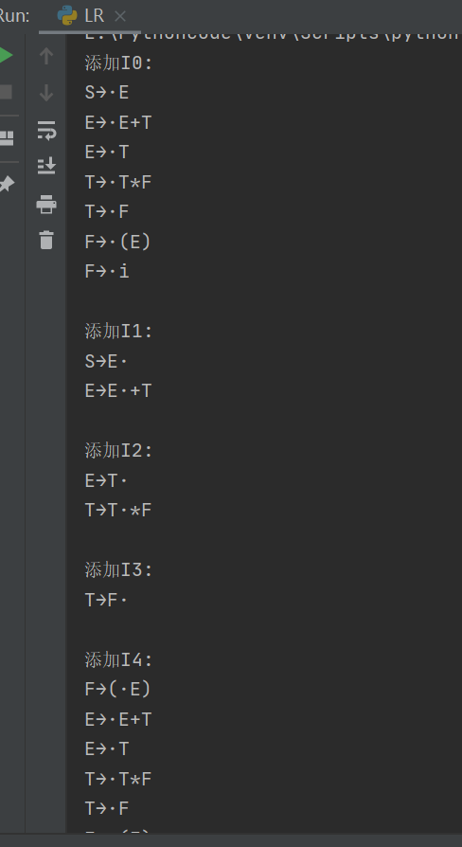
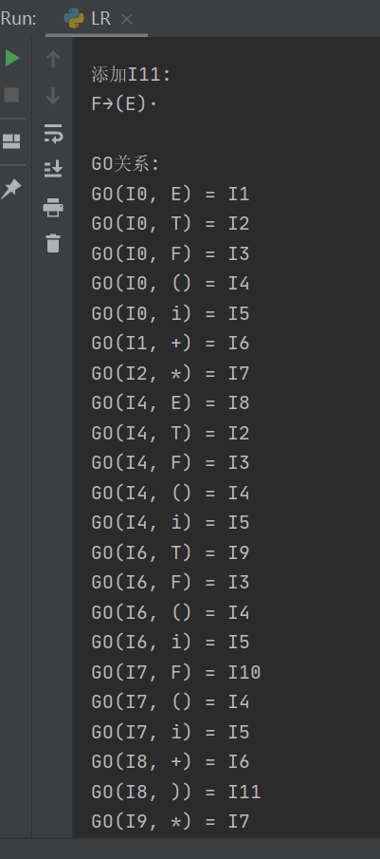
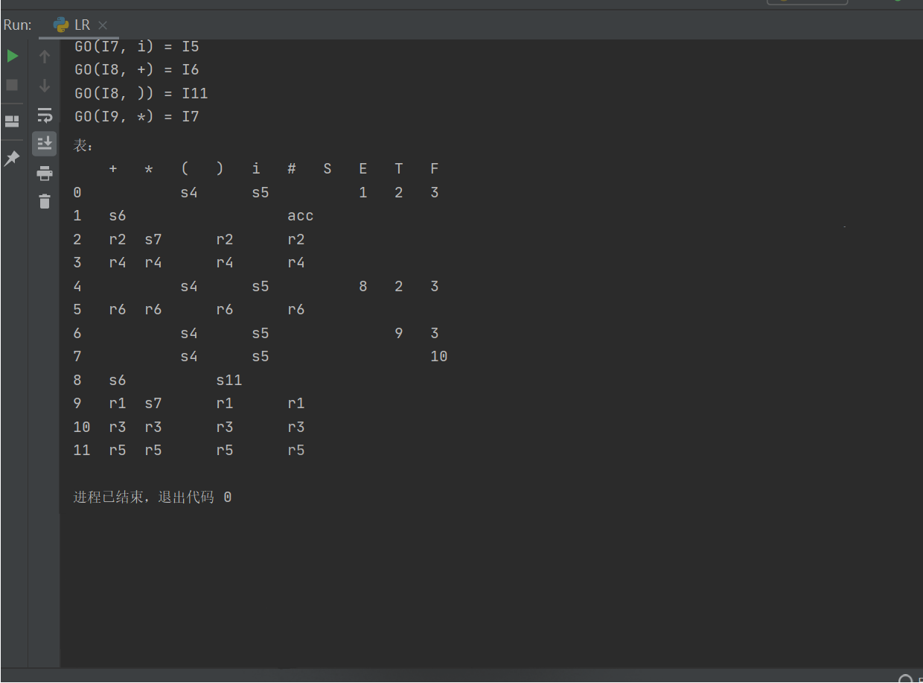
五、小结
本次实验是SLR型文法的实验，对分析的句子和文法的范围较小，编写程序的目的更侧重于对编程能力的提高，因为在选择的数据结构上考虑不周，在规约时总存在错误，故只好取消了规约的功能。也惊醒我在对编程的规划阶段应该将眼光放得更远更广。

