数据库实验报告

一.系统介绍：
火车售票管理系统。
火车售票系统是为提高火车售票的售票效率，丰富火车售票的营销手段而建立的，火车站售票总站的下属代售点可以通过公用的互联网资源，实现网上的售票，查询及管理工作。通过本系统可以实现车次，日期，乘车区间等信息，查询价格，路程，座位等即时信息。
二.功能模块：
用户：储存用户信息，联系购票用户
订单：查询记录售票信息
列车信息：存储列车相关出行信息
普通列车：记录各编号普通列车基本信息
高铁动车：记录各编号高铁动车基本信息
三.E—R图：
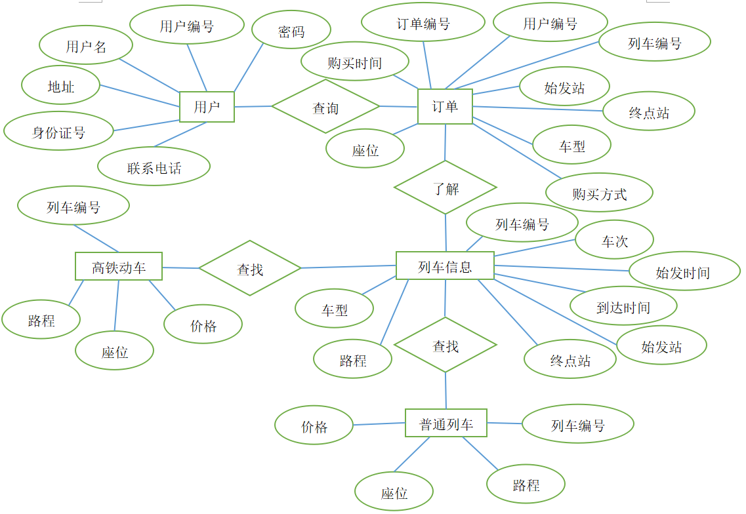
四.数据库表结构：
1.用户表：
Unumber | Uname | Password | Adress | Cnumber | Pnumber
0001 | amid | 00000001 | 武汉市 | 220802198104150000 | 13992223910
0002 | quarrel | 00000011 | 长沙市 | 220802198109213000 | 18520067441
0003 | cheek | 00000111 | 武汉市 | 310802167104150000 | 13492234127
0004 | component | 00000012 | 兰州市 | 622701199808142000 | 15293322101
0005 | melt | 00000022 | 贵阳市 | 120203199808241000 | 13923203540

2.订单表：
Onumber | Unumber | Tnumber | Start | Finish | Models | Seat | Buying | Time
000001 | 0001 | T333 | 长沙 | 武汉 | 普通列车 | 二 | 1 | 2018.12.07
000002 | 0001 | T394 | 武汉 | 杭州 | 普通列车 | 二 | 1 | 2018.12.10
000003 | 0002 | T333 | 长沙 | 武汉 | 普通列车 | 二 | 2 | 2018.12.07
000004 | 0003 | T394 | 武汉 | 杭州 | 普通列车 | 二 | 1 | 2018.12.10
000005 | 0004 | K107 | 兰州 | 贵阳 | 高铁动车 | 一 | 1 | 2018.12.04
000006 | 0004 | K132 | 贵阳 | 兰州 | 高铁动车 | 一 | 1 | 2018.12.07
000007 | 0005 | K107 | 兰州 | 贵阳 | 高铁动车 | 二 | 2 | 2018.12.06
000008 | 0005 | T322 | 贵阳 | 北京 | 普通列车 | 二 | 2 | 2018.12.10

3.列车信息表：
Tnumber | Count | Stime | Etime | Start | Finish | Models | Distance
T333 | 1 | 2018.12.0808:00:00 | 2018.12.0810:30:00 | 长沙 | 武汉 | 普通列车 | 280km
T333 | 2 | 2018.12.0814:30:00 | 2018.12.0817:00:00 | 长沙 | 武汉 | 普通列车 | 280km
T394 | 1 | 2018.12.1020:00:00 | 2018.12.1102:00:00 | 武汉 | 杭州 | 普通列车 | 570km
T322 | 1 | 2018.12.1108:30:00 | 2018.12.1117:30:00 | 贵阳 | 北京 | 普通列车 | 1722km
K107 | 1 | 2018.12.0608:00:00 | 2018.12.0700:00:00 | 兰州 | 贵阳 | 高铁动车 | 1085km
K132 | 1 | 2018.12.1114:30:00 | 2018.12.1206:30:00 | 贵阳 | 兰州 | 高铁动车 | 1085km
K130 | 1 | 2018.12.0814:30:00 | 2018.12.0816:30:00 | 武汉 | 西安 | 高铁动车 | 650km
K130 | 2 | 2018.12.0820:00:00 | 2018.12.0900:00:00 | 西安 | 武汉 | 高铁动车 | 650km

4.普通列车表：
Tnumber | Distance | Seat | Price
T333 | 280km | 一 | 230
T333 | 280km | 二 | 120
T394 | 570km | 一 | 500
T394 | 570km | 二 | 400
T322 | 1722km | 一 | 725
T322 | 1722km | 二 | 680
T544 | 200km | 一 | 120
T544 | 200km | 二 | 80
T680 | 623km | 一 | 540
T680 | 623km | 二 | 470
T332 | 280km | 一 | 230
T332 | 280km | 二 | 120

5.高铁动车表：
Tnumber | Distance | Seat | Price
K107 | 1085km | 一 | 500
K107 | 1085km | 二 | 450
K130 | 650km | 一 | 500
K130 | 650km | 二 | 450
K132 | 1085km | 一 | 500
K132 | 1085km | 二 | 450
K285 | 460km | 一 | 390
K285 | 460km | 二 | 340

五.SQL语句：
Customer表
create table Customer
(Unumber char(10),
Uname char(10),
Password char(8),
Adress char(10),
Cnumber char(18),
Pnumber char (11),
primary key (Unumber));
insert
into Customer(Unumber,Uname,Password,Adress,Cnumber,Pnumber)
values('0001','amid','00000001','武汉市','220802198104150000','13992223910');
insert
into Customer(Unumber,Uname,Password,Adress,Cnumber,Pnumber)
values('0002','quarrel','00000011','长沙市','220802198109213000','18520067441');
insert
into Customer(Unumber,Uname,Password,Adress,Cnumber,Pnumber)
values('0003','cheek','00000111','武汉市','310802167104150000','13492234127');
insert
into Customer(Unumber,Uname,Password,Adress,Cnumber,Pnumber)
values('0004','component','00000012','兰州市','622701199808142000','15293322101');
insert
into Customer(Unumber,Uname,Password,Adress,Cnumber,Pnumber)
values('0005','melt','00000022','贵阳市','120203199808241000','13923203540');

Dingdan表
create table Dingdan
(Onumber char(10),
Unumber char(10),
Tnumber char(10),
Start char(10),
Finish char(10),
Models char(10),
Seat char(10),
Buying char(10),
Time char(20),
primary key(Onumber),
foreign key(Tnumber) references Gaotie(Tnumber)
on delete cascade
on update cascade,
foreign key(Tnumber) references Lieche(Tnumber)
on delete cascade
on update cascade,
foreign key(Unumber) references Customer(Unumber)
on delete cascade
on update cascade
);
insert
into Dingdan(Onumber,Unumber,Tnumber,Start,Finish,Models,Seat,Buying,Time)
values('000001','0001','T333','长沙','武汉','普通列车','二',1,'2018.12.07');
insert
into Dingdan(Onumber,Unumber,Tnumber,Start,Finish,Models,Seat,Buying,Time)
values('000002','0001','T394','武汉','杭州','普通列车','二',1,'2018.12.10');
insert
into Dingdan(Onumber,Unumber,Tnumber,Start,Finish,Models,Seat,Buying,Time)
values('000003','0002','T333','长沙','武汉','普通列车','二',2,'2018.12.07');
insert
into Dingdan(Onumber,Unumber,Tnumber,Start,Finish,Models,Seat,Buying,Time)
values('000004','0003','T394','武汉','杭州','普通列车','二',1,'2018.12.10');
insert
into Dingdan(Onumber,Unumber,Tnumber,Start,Finish,Models,Seat,Buying,Time)
values('000005','0004','K107','兰州','贵阳','高铁动车','一',1,'2018.12.04');
insert
into Dingdan(Onumber,Unumber,Tnumber,Start,Finish,Models,Seat,Buying,Time)
values('000006','0004','K132','贵阳','兰州','高铁动车','一',1,'2018.12.07');
insert
into Dingdan(Onumber,Unumber,Tnumber,Start,Finish,Models,Seat,Buying,Time)
values('000007','0005','K107','兰州','贵阳','高铁动车','二',2,'2018.12.06');
insert
into Dingdan(Onumber,Unumber,Tnumber,Start,Finish,Models,Seat,Buying,Time)
values('000008','0005','T322','贵阳','北京','普通列车','二',2,'2018.12.10');

Train表
create table Train
(Tnumber char(10),
Count int,
Stime char(30),
Etime char(30),
Start char(10),
Finish char(10),
Models char(10),
Distance char(10),
foreign key (Tnumber)references Gaotie(Tnumber)
on Delete cascade
on update cascade,
foreign key (Tnumber)references Lieche(Tnumber)
on delete cascade
on update cascade
);
insert
into Train(Tnumber,Count,Stime,Etime,Start,Finish,Models,Distance)
values('T333','1','2018.12.08 08:00:00','2018.12.08 10:30:00','长沙','武汉','普通列车','280km');
insert
into Train(Tnumber,Count,Stime,Etime,Start,Finish,Models,Distance)
values('T333','2','2018.12.08 14:30:00','2018.12.08 17:00:00','长沙','武汉','普通列车','280km');
insert
into Train(Tnumber,Count,Stime,Etime,Start,Finish,Models,Distance)
values('T394','1','2018.12.10 20:00:00','2018.12.11 02:00:00','武汉','杭州','普通列车','570km');
insert
into Train(Tnumber,Count,Stime,Etime,Start,Finish,Models,Distance)
values('T322','1','2018.12.11 08:30:00','2018.12.11 17:30:00','贵阳','北京','普通列车','1722km');
insert
into Train(Tnumber,Count,Stime,Etime,Start,Finish,Models,Distance)
values('K107','1','2018.12.06 08:00:00','2018.12.07 00:00:00','兰州','贵阳','高铁动车','1085km');
insert
into Train(Tnumber,Count,Stime,Etime,Start,Finish,Models,Distance)
values('K107','1','2018.12.06 08:00:00','2018.12.07 00:00:00','兰州','贵阳','高铁动车','1085km');
insert
into Train(Tnumber,Count,Stime,Etime,Start,Finish,Models,Distance)
values('K107','1','2018.12.06 08:00:00','2018.12.07 00:00:00','兰州','贵阳','高铁动车','1085km');
insert
into Train(Tnumber,Count,Stime,Etime,Start,Finish,Models,Distance)
values('K130','2','2018.12.08 20:00:00','2018.12.09 00:00:00','西安','武汉','高铁动车','650km');

Lieche表
create table Lieche
(Tnumber char(10),
Distance char(10),
Seat char(10),
Price char(10));
insert
into Lieche(Tnumber,Distance,Seat,Price)
values('T333','280km','一','230');
insert
into Lieche(Tnumber,Distance,Seat,Price)
values('T333','280km','二','120');
insert
into Lieche(Tnumber,Distance,Seat,Price)
values('T394','570km','一','500');
insert
into Lieche(Tnumber,Distance,Seat,Price)
values('T394','570km','二','400');
insert
into Lieche(Tnumber,Distance,Seat,Price)
values('T322','1722km','一','725');
insert
into Lieche(Tnumber,Distance,Seat,Price)
values('T322','1722km','二','680');
insert
into Lieche(Tnumber,Distance,Seat,Price)
values('T544','200km','一','120');
insert
into Lieche(Tnumber,Distance,Seat,Price)
values('T544','200km','二','80');
insert
into Lieche(Tnumber,Distance,Seat,Price)
values('T680','623km','一','540');
insert
into Lieche(Tnumber,Distance,Seat,Price)
values('T680','623km','二','470');
insert
into Lieche(Tnumber,Distance,Seat,Price)
values('T332','280km','一','230');
insert
into Lieche(Tnumber,Distance,Seat,Price)
values('T332','280km','二','120');

Gaotie表
create table Gaotie
(Tnumber char(10),
Distance char(10),
Seat char(10),
Price char(10));
insert
into Gaotie(Tnumber,Distance,Seat,Price)
values('K107','1085km','一','500');
insert
into Gaotie(Tnumber,Distance,Seat,Price)
values('K107','1085km','二','450');
insert
into Gaotie(Tnumber,Distance,Seat,Price)
values('K130','650km','一','500');
insert
into Gaotie(Tnumber,Distance,Seat,Price)
values('K130','650km','二','450');
insert
into Gaotie(Tnumber,Distance,Seat,Price)
values('K132','1085km','一','500');
insert
into Gaotie(Tnumber,Distance,Seat,Price)
values('K132','1085km','二','450');
insert
into Gaotie(Tnumber,Distance,Seat,Price)
values('K285','460km','一','390');
insert
into Gaotie(Tnumber,Distance,Seat,Price)
values('K285','460km','二','340');
- 流程图：
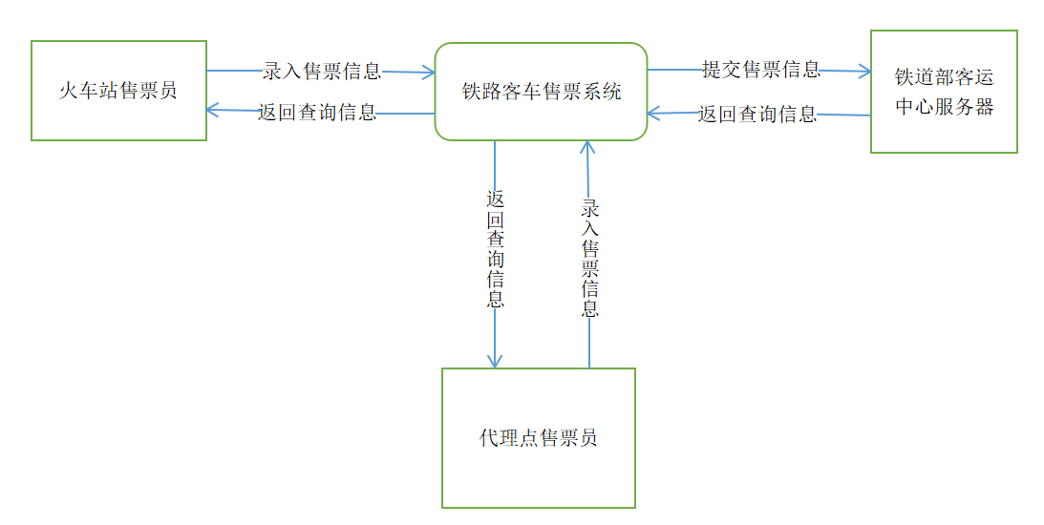
- 界面截图：
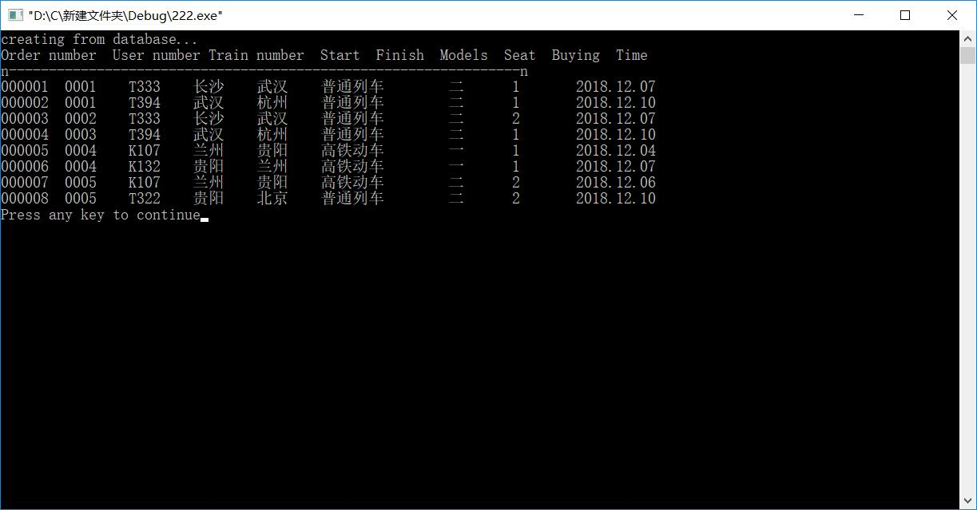
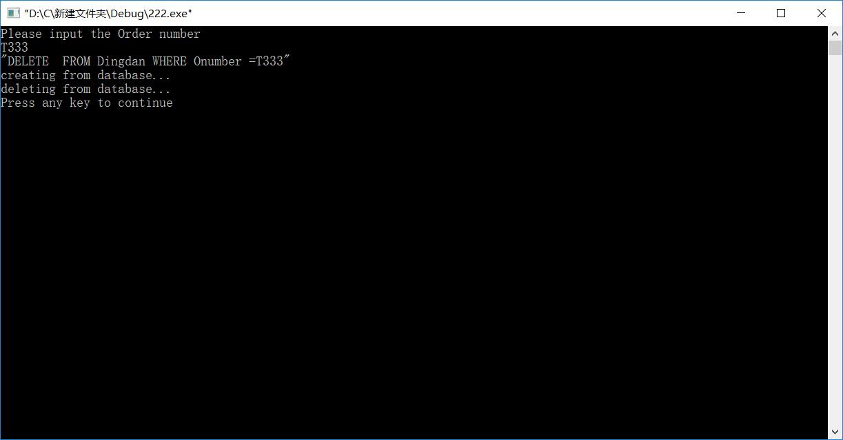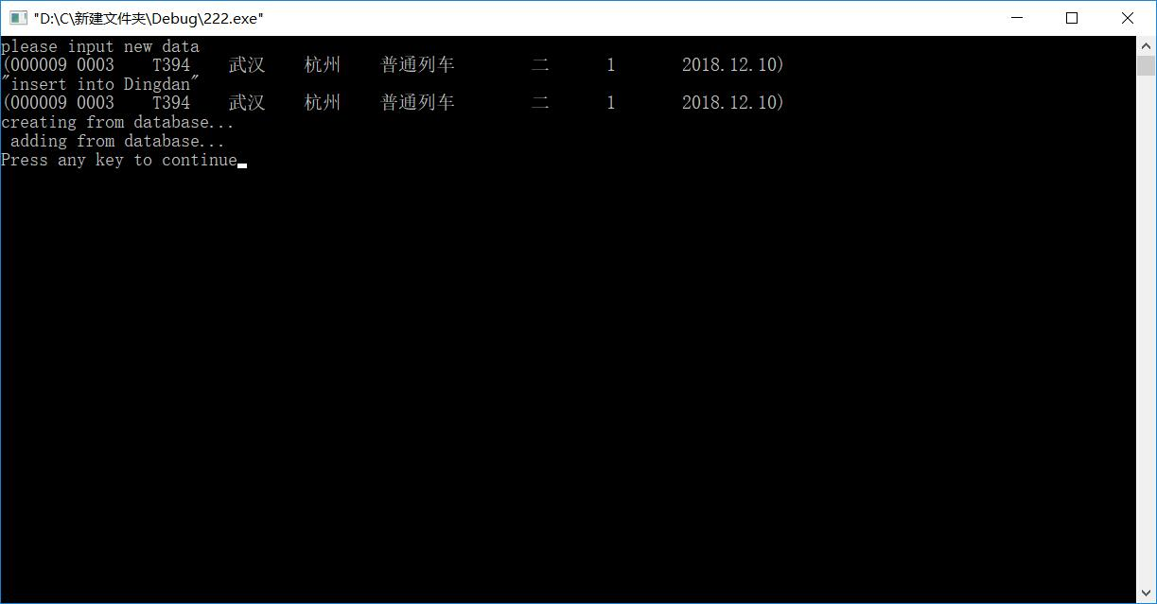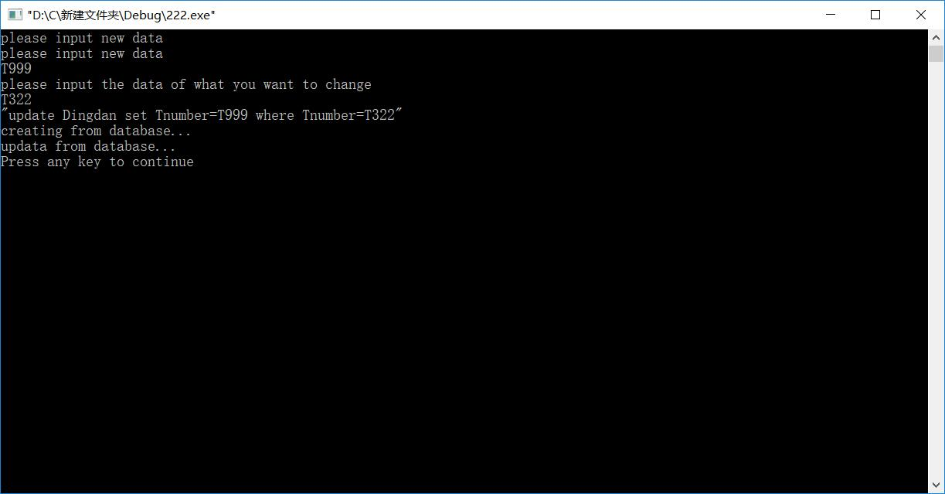
- 代码：
1.查找
#import "C:\Program Files\Common Files\System\ado\msado15.dll" no_namespace rename ("EOF", "EndOfFile")
#include <iostream>
#include <iomanip> //for setw()
using namespace std;
class Dingdan
{
public:
char Onumber[10];
char Unumber[10];
char Tnumber[10];
char Start[10];
char Finish[10];
char Models[10];
char Seat[10];
char Buying[10];
char Time[20];
public:
Dingdan(){}
~Dingdan(){}
};

int main()
{
Dingdan dd;
::CoInitialize(NULL); // 初始化OLE/COM库环境 ，为访问ADO接口做准备
// 创建记录集对象
_RecordsetPtr m_pRecordset("ADODB.Recordset");
//m_pRecordset.CreateInstance(__uuidof(Recordset));
//创建connection对象
_ConnectionPtr m_pConnection("ADODB.Connection");
//设置连接字符串
_bstr_t strConnect=("driver={SQL Server};Server=(local)\\sqlexpress;DATABASE=TLSPXT;UID=sa;PWD=sa123456");
//_bstr_t strConnect= "Provider=SQLOLEDB;Database=CAP; uid=ca; pwd=ca123456;";

_bstr_t bstrSQL("select * from Dingdan"); //查询语句，表stu_info

std::cout<<"creating from database..."<<endl;
try
{
m_pConnection->Open(strConnect,"","",adModeUnknown);
if(m_pConnection==NULL)
cerr<<"Lind data ERROR!n";
_variant_t onumber,unumber,tnumber,start,finish,models,seat,buying,time;

while(1)
{
// 取得表中的记录
m_pRecordset->Open(bstrSQL,m_pConnection.GetInterfacePtr(),adOpenDynamic,adLockOptimistic,adCmdText);
cout << "Order number User number Train number Start Finish Models Seat Buying Time \n";
cout<<"n----------------------------------------------------------------n\n";
while (!m_pRecordset->EndOfFile)
{
onumber = m_pRecordset->GetCollect(_variant_t((long)0));
unumber = m_pRecordset->GetCollect("Unumber");
tnumber = m_pRecordset->GetCollect("Tnumber");
start = m_pRecordset->GetCollect("Start");
finish = m_pRecordset->GetCollect("Finish");
models = m_pRecordset->GetCollect("Models");
seat = m_pRecordset->GetCollect("Seat");
buying = m_pRecordset->GetCollect("Buying");
time = m_pRecordset->GetCollect("Time");
if (onumber.vt != VT_NULL && unumber.vt != VT_NULL && tnumber.vt != VT_NULL && start.vt != VT_NULL && finish.vt != VT_NULL && models.vt != VT_NULL && seat.vt != VT_NULL && buying.vt != VT_NULL && time.vt != VT_NULL)
{
cout.setf(ios::left);
cout << setw(10) << (char*)(_bstr_t)onumber;
cout << setw(10) << (char*)(_bstr_t)unumber;
cout << setw(10) << (char*)(_bstr_t)tnumber;
cout << setw(5) << (char*)(_bstr_t)start;
cout << setw(5) << (char*)(_bstr_t)finish;
cout << setw(10) << (char*)(_bstr_t)models;
cout << setw(5) << (char*)(_bstr_t)seat;
cout << setw(5) << (char*)(_bstr_t)buying;
cout << setw(5) << (char*)(_bstr_t)time;
cout.unsetf(ios::left);
cout << endl;
}
m_pRecordset->MoveNext(); ///移到下一条记录
}
cout << "n----------------------------------------------------------------n\n";
m_pRecordset->Update();
//m_pConnection->Execute(query_cmd,NULL,1); //用Execute执行sql语句来删除
m_pRecordset->Close(); // 关闭记录集
}
}
// 捕捉异常
catch(_com_error e)
{
// 显示错误信息
// cerr << "nERROR:" << (char*)e.Description();//抛出异常
}
if(m_pConnection->State)
m_pConnection->Close();
::CoUninitialize();
return 0;
}
2.删除
#import "C:\Program Files\Common Files\System\ado\msado15.dll" no_namespace rename ("EOF", "EndOfFile")
#include <iostream>
#include <string.h>
#include <stdio.h>
#include <iomanip> //for setw()
using namespace std;

int main()
{
::CoInitialize(NULL); // 初始化OLE/COM库环境 ，为访问ADO接口做准备
// 创建记录集对象
_RecordsetPtr m_pRecordset("ADODB.Recordset");
//m_pRecordset.CreateInstance(__uuidof(Recordset));
//创建connection对象
_ConnectionPtr m_pConnection("ADODB.Connection");
//设置连接字符串
_bstr_t strConnect=("driver={SQL Server};Server=(local)\\sqlexpress;DATABASE=TLSPXT;UID=sa;PWD=sa123456");
//_bstr_t strConnect= "Provider=SQLOLEDB;Database=cinema_manager; uid=dd; pwd=dd123456;";

_bstr_t bstrSQL("select * from Dingdan"); //查询语句，表stu_info
char Mleft[100]="DELETE FROM Dingdan WHERE Onumber =\'";
char m[20];
char Mright[2]="\'";
cout<<"Please input the Order number "<<endl;
cin.getline(m,10);
strcat(Mleft,m);
strcat(Mleft,Mright);
cout<<Mleft<<endl;
char * query_cmd = Mleft;
std::cout<<"creating from database..."<<endl;
try
{
m_pConnection->Open(strConnect,"","",adModeUnknown);
if(m_pConnection==NULL)
cerr<<"Lind data ERROR!n";
_variant_t onumber,unumber,tnumber,start,end,models,seat,buying,time;

m_pRecordset->Open(bstrSQL,m_pConnection.GetInterfacePtr(),adOpenDynamic,adLockOptimistic,adCmdText);

m_pConnection->Execute(query_cmd,NULL,1); //用Execute执行sql语句来删除
m_pRecordset->Update();
m_pRecordset->Close(); // 关闭记录集
std::cout<<"deleting from database..."<<endl;
}
// 捕捉异常
catch(_com_error e)
{
// 显示错误信息
// cerr << "nERROR:" << (char*)e.Description();//抛出异常
}
if(m_pConnection->State)
m_pConnection->Close();
::CoUninitialize();
return 0;
}
3.增加
#import "C:\Program Files\Common Files\System\ado\msado15.dll" no_namespace rename ("EOF", "EndOfFile")
#include <iostream>
#include <iomanip> //for setw()
using namespace std;
class Dingdan
{
public:
char Onumber[10];
char Unumber[10];
char Tnumber[10];
char Start[10];
char Finish[10];
char Models[10];
char Seat[10];
float Buying;
char Time[10];
public:
Dingdan(){}
~Dingdan(){}
};
int main()
{
Dingdan ding;
::CoInitialize(NULL); // 初始化OLE/COM库环境 ，为访问ADO接口做准备
// 创建记录集对象
_RecordsetPtr m_pRecordset("ADODB.Recordset");
//m_pRecordset.CreateInstance(__uuidof(Recordset));
//创建connection对象
_ConnectionPtr m_pConnection("ADODB.Connection");
//设置连接字符串
_bstr_t strConnect=("driver={SQL Server};Server=(local)\\sqlexpress;DATABASE=TLSPXT;UID=sa;PWD=sa123456");
//_bstr_t strConnect= "Provider=SQLOLEDB;Database=CAP; uid=sa; pwd=sa123456;";

_bstr_t bstrSQL("select * from Dingdan"); //查询语句，表stu_info
char Mleft[100]="insert into Dingdan\'";
char m[20];
cout<<"please input new data"<<endl;
cin.getline(m,10);
strcat(Mleft,m);
strcat(Mleft,"\'");
strcat(Mleft,"where Tnumber=\'");
cin.getline(m,10);
strcat(Mleft,m);
strcat(Mleft,"\'");
cout<<Mleft<<endl;
char * query_cmd = Mleft;

std::cout<<"creating from database..."<<endl;
try
{
m_pConnection->Open(strConnect,"","",adModeUnknown);
if(m_pConnection==NULL)
cerr<<"Lind data ERROR!n";
_variant_t Onumber,Unumber,Tnumber,Start,End,Models,Seat,Buying,Time; //对应库中的cid,cname,city,discnt

// 取得表中的记录
m_pRecordset->Open(bstrSQL,m_pConnection.GetInterfacePtr(),adOpenDynamic,adLockOptimistic,adCmdText);
m_pConnection->Execute(query_cmd,NULL,1);
m_pRecordset->Update();
m_pRecordset->Close(); // 关闭记录集
std::cout<<"adding from database..."<<endl;
}
// 捕捉异常
catch(_com_error e)
{
// 显示错误信息
// cerr << "nERROR:" << (char*)e.Description();//抛出异常
}
if(m_pConnection->State)
m_pConnection->Close();
::CoUninitialize();
return 0;
}
4.修改
#import "C:\Program Files\Common Files\System\ado\msado15.dll" no_namespace rename ("EOF", "EndOfFile")
#include <iostream>
#include <iomanip> //for setw()
using namespace std;
class Dingdan
{
public:
char Onumber[10];
char Unumber[10];
char Tnumber[10];
char Start[10];
char Finish[10];
char Models[10];
char Seat[10];
float Buying;
char Time[20];
public:
Dingdan(){}
~Dingdan(){}
};

int main()
{
Dingdan dd;
::CoInitialize(NULL); // 初始化OLE/COM库环境 ，为访问ADO接口做准备
// 创建记录集对象
_RecordsetPtr m_pRecordset("ADODB.Recordset");
//m_pRecordset.CreateInstance(__uuidof(Recordset));
//创建connection对象
_ConnectionPtr m_pConnection("ADODB.Connection");
//设置连接字符串
_bstr_t strConnect=("driver={SQL Server};Server=(local)\\sqlexpress;DATABASE=TLSPXT;UID=sa;PWD=sa123456");
//_bstr_t strConnect= "Provider=SQLOLEDB;Database=CAP; uid=sa; pwd=sa123456;";

_bstr_t bstrSQL("select * from Dingdan"); //查询语句，表stu_info
char Mleft[100]="update Dingdan set Tnumber=\'";
char m[20];
cout<<"please input new data"<<endl;
cin.getline(m,10);
strcat(Mleft,m);
strcat(Mleft,"\'");
strcat(Mleft,"where Tnumber=\'");
cout<<"please input the data of what you want to change"<<endl;
cin.getline(m,10);
strcat(Mleft,m);
strcat(Mleft,"\'");
cout<<Mleft<<endl;
char * query_cmd = Mleft;

std::cout<<"creating from database..."<<endl;
try
{
m_pConnection->Open(strConnect,"","",adModeUnknown);
if(m_pConnection==NULL)
cerr<<"Lind data ERROR!n";
_variant_t onumber,unumber,tnumber,start,end,models,seat,buying,time;

// 取得表中的记录
m_pRecordset->Open(bstrSQL,m_pConnection.GetInterfacePtr(),adOpenDynamic,adLockOptimistic,adCmdText);
m_pConnection->Execute(query_cmd,NULL,1);
m_pRecordset->Update();
m_pRecordset->Close(); // 关闭记录集
std::cout<<"updata from database..."<<endl;
}
// 捕捉异常
catch(_com_error e)
{
// 显示错误信息
// cerr << "nERROR:" << (char*)e.Description();//抛出异常
}
if(m_pConnection->State)
m_pConnection->Close();
::CoUninitialize();
return 0;
}

- 心得体会：
从这次实验中，我们对SQL语句的使用更加熟练，在建表和进行操作时也更加注意级联，约束条件，参考条件等细节，对于授权等操作也更加熟练，对于使用VC的ADD进行数据库的访问也有了一定的掌握，在连接数据库的过程中，对于自我的C++语言的使用也是一种复习，从中体会了学科之间紧密的联系。实验中所反应出的小组成员的一些问题，例如摆脱不了书本的提示，对于代码中的部分内容并不是很懂，会忘记操作流程，数据粗心输错等都凸显了出来，之后的学习中，这些问题也将引起我们的注意。

