leetcode第三题
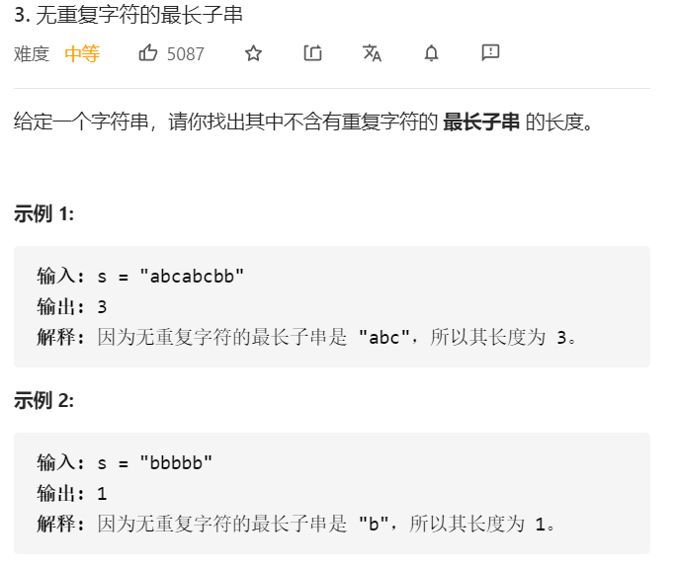

代码
class Solution {
public static int lengthOfLongestSubstring(String s) {

int left = 0;
int right = 0;
int ans = 0;
int cur = 0;
int len = s.length();
int[] record = new int[128];
while (right < len) {
int index = s.charAt(right) - ' ';
if (record[index] == 0) {
record[index] = 1;
cur = right - left + 1;
if (cur > ans) {
ans = cur;
}
right++;
} else {
while (record[index] == 1) {
record[s.charAt(left) - ' '] = 0;
left++;
if (left >= right) {
left = right;
break;
}
}
}

}
return ans;
}
}

