MedTrajectory Supplementary Material
S1. Cohorts, event construction and objectives
The UK Biobank (UKB) cohort comprises 502,411 participants, partitioned at the participant level as shown in Table S1. Task populations may overlap and are therefore not additive. Risk-evaluation records are indexed by participant, clinical landmark, prediction horizon and outcome. Test identifiers were inherited before protocol-specific retraining rather than held out untouched, because the risk baselines had already been inspected; the reference risk comparisons remain exploratory.
TABLE S1. UKB partitions and task populations
Population | All | Eligible / evaluated
Training | 397,049 | 322,205
Validation | 99,263 | 80,546
Test partition | 6,099 | 6,035
Test generation | - | 1,669
Corrected test risk | - | 4,668 / 260,110 rows
Corrected validation risk | - | 71,325 / 5,238,757 rows
Diagnoses, procedures, cancer registrations, and mortality records are drawn from UKB fields 41202/41262, 41200/41260, 40006/40005, and 40001/40000, respectively. The base vocabulary has 8,424 entries: 8,422 clinical event types (1,123 diagnosis, 6,634 procedure, 127 cancer registration and 538 mortality tokens) and two special tokens for padding (0) and no event (1). Adding control tokens gives a model vocabulary of 8,445 entries. ICD-based events use three-character codes, whereas procedures use OPCS-4. Same-age ties follow token-key order rather than clinical priority. The four prefix tokens for sex, BMI, smoking, and alcohol are masked until the recruitment age.
We embed structured ICD reference descriptions with Qwen at 1,024 dimensions and project them to 64 by PCA, while procedures and unmatched entries start from zero. All embeddings remain trainable. A0 and A2 share the same six-layer, eight-head decoder with a hidden dimension of 64, together with RMSNorm, SwiGLU, the masking scheme, and the prediction heads. A2 alone applies rotation to the queries and keys of dynamic clinical events, leaving the values unchanged.
The training gap wavelengths form a geometric sequence of 32 head-specific frequency pairs (eight heads, four frequency pairs per head), running from max(2 × the first gap percentile, 7 days) to 1.5 × the 95th percentile. We scale each angular frequency by
$$s_{h,k}=\exp\left[ln⁡\left(2\right)tanh⁡\left(ρ_{h,k}\right)\right],$$
and bound the scale to [0.5, 2]. We express phases in days and center them on the first event. With the untempered candidate-logit log sum exp L and ε = 0.1 day, the rate and the positive-gap loss are
$$r=\frac{1}{exp(-L)+ε}$$
$$-log(r)+r[max(Δt,1 day)+ε]$$
The positive gaps contribute, while static and BOS targets are excluded. At UKB rollout, an independent uniform U yields
$$max(1 day,\frac{-log(U)}{r}-ε)$$
We evaluate the NLL under the frozen positive gap objective, rather than the clamped sampler likelihood. The auxiliary gap is unused and contributes no loss.
The horizon query head uses learned 1-, 5- and 10-year queries with rotary features that combine each query with the current age, and it produces disease-specific outputs and cross interactions. For disease outputs $u_{1},u_{2},u_{3}$, we parameterize the cumulative logits as $g_{1}=u_{1}$, $g_{2}=u_{1}+softplus(u_{2})$, and $g_{3}=u_{1}+softplus(u_{2})+softplus(u_{3})$, and then applied a sigmoid to each. The masked binary cross-entropy uses observable disease-horizon labels. Risk post training jointly updates the backbone and the head for 10,000 iterations, using 0.2 times the event/time loss plus the horizon loss. This head is distinct from the frozen-backbone mortality head in Supplementary S2.
UKB training uses AdamW with β_1 = 0.9 and β_2 = 0.99, a batch size of 128, 100,000 steps, a cosine learning-rate schedule from 3 × 10⁻⁴ to 3 × 10⁻⁵, 500 warm-up steps, a weight decay of 0.1, gradient clipping at 1, a dropout rate of 0.1, a context length of 133, and FP32 precision, with seeds 42–44 and the final checkpoints retained. The matched ETHOS and Foresight baselines share the task and the budget but use a schedule from 6 × 10⁻⁴ to 6 × 10⁻⁵, 1,000 warm-up steps, and a weight decay of 0.2; these are not official reproductions.
UKB generation requires at least 8 history events and at least 3 future events. The first 65% of each trajectory serves as context, and 20 rollouts sample identity with temperature 0.8 and top-p 0.9 while sampling time from untempered logits. Generation stops at 30 events, 10 years, or a mortality event. The Jaccard index is the intersection over the union, with two empty sets scored as 1. The time MAE excludes empty predictions, whereas the count MAE does not. Rollouts are averaged within participant, then across participants, then across seeds. Hit@10 is computed in the teacher-forced setting. All four principal endpoints use the same N = 1,669, and same-age events are split by 128 cuts.
[UKB application number]
[Etheics/REC reference]
[Informed consent statement]
[Data access conditions]
S2. UKB inference, risk and diagnostic analyses
Generation uses 10,000 paired participant resamples shared across the three seeds, and a participant enters a comparison only when finite outcomes exist in both models. The Relative-minus-Absolute (A2 − A0) Jaccard difference is the sole confirmatory generation contrast; all other outcomes and reference comparisons are secondary. The standard deviation across seeds (ddof = 1) is not a patient interval. Interval estimates are conditional on the trained models and do not account for retraining variability.
Two UKB readout regimes. Table II and Table III of the main text report diagnosis-only readouts. In N1 each patient contributes one next-diagnosis target (N = 1,534), the history ends at the clinical event immediately preceding that target, and Top@k ranks each method's registered diagnostic candidates, with 1,123 candidates for most methods and 1,255 native diagnosis entries for Delphi. In G1 the first 65% of the locked 1,669 trajectories is used as history, 20 rollouts are drawn, and generated futures are scored against future diagnoses only, with up to 30 future diagnoses, a 256-native-event computation cap and method-specific termination; the timing column of Table III is taken from the separate ten-year evaluation in Table S13e. Table S2 and the locked-test means table instead use the prespecified 10-year, mortality-terminated rollout over the multitype event space. That legacy protocol also generates multitype events, but its Diagnosis Jaccard is computed on diagnosis sets, its Hit@10 scores the next clinical event, and its count and timing endpoints use clinical events; its rollout limits, stopping rules and empty-set convention also differ from the later N1/G1 evaluations, and two empty diagnosis sets score 1 in the legacy protocol but 0 in G1. Because the candidate space, the termination rule and the scoring window differ, absolute values are not comparable across the two regimes; for example, Hit@10 is 0.4076 in the multitype-generation regime but 54.11% in the diagnosis-only regime. Only within-regime contrasts are interpreted, and no difference between regimes is inferred.
TABLE S2. Paired UKB generation differences
Contrast / endpoint | Difference [95% CI]
A2-A0: Jaccard | +0.01385 [0.01065, 0.01706]
A2-A0: Hit@10 | +0.03215 [0.02077, 0.04394]
A2-A0: time MAE (d) | -5.01 [-6.57, -3.44]
A2-A0: count MAE | -0.899 [-1.007, -0.787]
A2-ETHOS: Jaccard | +0.02227 [0.01778, 0.02686]
A2-ETHOS: Hit@10 | +0.02656 [0.01398, 0.03934]
A2-ETHOS: time MAE | -5.07 [-7.39, -2.73]
A2-ETHOS: count MAE | -7.506 [-7.736, -7.277]
A2-Foresight: Jaccard | +0.03878 [0.03204, 0.04560]
A2-Foresight: Hit@10 | +0.03435 [0.02017, 0.04873]
A2-Foresight: time MAE | -4.73 [-7.11, -2.37]
A2-Foresight: count MAE | -9.111 [-9.389, -8.832]
Risk landmarks use observed events in six 5-year age bands starting at 50-75. Positive labels require an outcome within 1/5/10 years; negatives require event-free follow-up through that horizon; otherwise excluded. AUROC/AUPRC/Brier/ECE are unweighted means over estimable sex-disease-horizon-age strata. ECE uses 10 equal-width bins.
Risk inference uses 10,000 shared participant draws (seed 20260815), weighted Mann-Whitney AUROC with half-credit for ties and within-seed contrasts averaged. The fixed noninferiority margin is -0.005. Corrected test A2-A0 AUROC was +0.003893 [-0.005792, 0.009059]: noninferiority was not established. Corrected validation met it without superiority; it does not override test. Historical nine-model validation used 1,000 draws and Holm over 36 comparisons; none passed adjusted P<0.05.
TABLE S3. Corrected test risk macro metrics
Model | AUROC | AUPRC | Brier | ECE
MT Relative | 0.7501 | 0.2616 | 0.0314 | 0.0323
MT Absolute | 0.7462 | 0.2646 | 0.0292 | 0.0305
MT Relative no-age | 0.7424 | 0.2103 | 0.0363 | 0.0378
Cox | 0.7263 | 0.2062 | 0.0417 | 0.0366
MDRMF | 0.7203 | 0.2134 | 0.0281 | 0.0244
Logistic | 0.7158 | 0.2046 | 0.2795 | 0.4612
Med-BERT | 0.7051 | 0.2014 | 0.0353 | 0.0381
A2/A0/no-age use three-seed means; reference systems use fixed seed-42 checkpoints. The 277 valid AUROC strata contain 4,668 test participants. Non-MT comparisons are exploratory. Med-BERT follows the configuration of the original publication and is not budget-matched to MedTrajectory; the budget-matched variant and its metrics are retained in the aggregate numerical archive.
Correction removed 53 test participants/2,090 rows and 8,032 validation participants/237,170 rows, without new inference or fitting. Anchor-only input records had no direct supervised target in the examined MT path, but feature baselines were not refit. The audit does not prove unchanged optimization. Test A2-A0 seed differences were +0.012425, -0.018108 and +0.017362.
The waiting-time validation criterion failed: A2-A0 NLL +4.365343 [3.091455,6.196786] across 71,293 participants/539,955 positive-gap pairs. This is not the rollout-time endpoint. Legacy event-space experiments changed eligibility and targets (test N=6,107/6,099/6,099); their procedure gains are not pure input effects.
The UKB disease-spectrum analysis scored 80,546 validation participants with a seed-42 risk-posttrained checkpoint. Of 1,123 diagnosis categories, 186 had >=20 future cases: median age-sex AUROC 0.9063. Sex-by-5-year-age strata were averaged; labels used future first-recorded age, not incident fixed-horizon risk. Pooled DeLong and 10,000-draw bootstrap intervals are pointwise; checkpoint selection is not included.
Death-token removal reduced A2 Jaccard by 0.0305 and raised count MAE by 11.35; A2-A0 Jaccard remained +0.0151 [0.0117,0.0189]. A separate frozen-backbone mortality head used disjoint fit/calibration/evaluation sets. At 10 years N=187/88 deaths, A0/A2 calibrated AUROC=0.8910/0.8379 and Brier=0.1240/0.1589. A2 head-minus-rollout Brier=-0.0970 [-0.1552,-0.0367]. Small sample size and sparse bins limit calibration conclusions.
TABLE S4. Dataset structure and trajectory protocols
Item | UK Biobank | MIMIC-IV
Clinical unit | Dated diagnosis, procedure, cancer and mortality events | Completed hospital admission records
Clock | Continuous age at recorded event | Discharge pseudo-age; record availability, not onset
Events | 8,422 clinical event types + two special tokens; four static context tokens | A: diagnosis; B: diagnosis/procedure joint token; C: first two codes
History | First 65% of eligible events | First two completed records
Future | 10 years; 30 events; stop at mortality | 365.25 days; 30 records; no death/EOS stop
Test generation | 1,669 participants; 20 rollouts | 2,000 common patients; 20 rollouts
Contrast | Within-UKB paired contrasts | Within-MIMIC paired contrasts; not pooled raw scores
The expanded protocol retained patient partitions and nonoverlapping supervised windows, with 75,674 training, 9,459 validation and 9,452 test patients contributing supervised transitions. Training/validation/test had 250,320/30,997/31,044 transitions. Overlapping or touching admissions were barriers rather than silently bridged gaps; unknown diagnoses were retained as OTHER. Time was exact discharge pseudo-age, an availability proxy for a completed record rather than onset or next-admission time.
Representation A contained principal diagnoses. B used one joint token for principal diagnosis plus principal HCPCS or an explicit missing/unknown procedure. C used the first two mapped codes, ordered diagnoses then eligible HCPCS, with minimum training frequency 20. The same windows and clocks were retained, but token-space metrics were not directly ranked across A/B/C. Static context was sex; other context slots were missing. Historical semantic dictionary/PCA provenance was inherited and is not newly established as strictly train-only.
Full-budget A/B/C comparisons included A0, A2, MedBERT, DoctorGRU, ETHOS and Foresight, with seeds 42-44 and 100,000 supervised updates; MedBERT additionally used its frozen 20,000-update MLM budget. These task-adapted reference systems do not constitute official original-model reproductions. Fixed final checkpoints were used without test tuning. The 54-model matrix was supplemented by A2 index-phase controls in A/B/C and fixed-diagnosis procedure-on/off controls in A.
Time is the discharge pseudo-age of completed records, not symptom onset or within-stay event time. A/B/C retain the same patient windows and clock but alter target representation. Historical admission-anchored experiments used different eligibility and event ordering and are not pooled with this protocol.
The fixed completed-record rollout protocol selected the earliest retained window with at least three records per patient, ordered patients by a fixed hash and capped the test cohort at 2,000. The first two completed records formed history. Twenty rollouts shared patient-keyed event/time uniforms across models, sampled the untempered full candidate distribution and capped exponential waiting rate (t_min=0.1 day), and stopped at 365.25 days or 30 records. There was no death-token/EOS termination. This is not the historical admission-anchored evaluation.
Eight outcomes were retained: diagnosis-set Jaccard and recall, record-count MAE, conditional first-record-time MAE, normalized token edit distance, generated OTHER fraction, empty-trajectory rate and record-cap rate. A/B/C reference diagnosis sets were evaluable for 1,327/1,318/721 of 2,000 patients; other denominators were exported per metric. Unknown reference sets were not scored as perfect. Conditional timing must be read alongside empty generation and count error.
The full-budget A2-A0 Jaccard differences were A +0.00172 [0.00034,0.00315], B +0.00002 [-0.00150,0.00158] and C +0.00235 [0.00029,0.00428]. A2-ETHOS intervals crossed zero in all representations. A2 count MAE was worse than A0 in all three. Real-time-minus-index Jaccard was A +0.00249 [0.00113,0.00398], while B/C crossed zero. The index control changes rotary phase only, retaining absolute age.
For the pure procedure-input comparison, both A2 arms retained the same patients, diagnosis vocabulary, future diagnosis targets, parameter capacity, initialization and 100k budget. Procedure-on minus off gave Jaccard +0.00155 [0.00006, 0.00305], recall +0.00302 [0.00086, 0.00511], but count MAE +0.03201 [0.01482, 0.04964]. Next-record Hit@10 changed by -0.00193 [-0.00381, -0.00003], CE by +0.01308 [0.00865, 0.01784], and time NLL by +0.01712 [0.00271, 0.03186]. No universal procedure-input benefit was established.
Separate same-budget next-record adaptation covered A/B/C x A0/A2/ETHOS/Foresight/MedBERT x scratch/UKB initialization x three seeds (90 models, 10k target updates). A2 adaptation reset relative-time frequencies as well as target-specific parameters. DoctorGRU had no compatible UKB source and was not assigned an artificial transfer result. A/B adapted A2 time NLL was lower than A0, whereas C Hit@10/CE/joint loss favored A0. CE plus time NLL is a derived loss, not an independent fourth win. Source pretraining compute was unequal.
The transfer rollouts use the five transfer-compatible families (A0/A2/ETHOS/Foresight/Med-BERT) across scratch and UKB initialization and seeds 42-44 at fixed last-10k checkpoints; the initial eighteen checkpoints (A0/A2/ETHOS) were extended by twelve Foresight and Med-BERT checkpoints. No new training or repeated teacher-forced test was added. Compatible backbone parameters were transferred; target embeddings/heads and unavailable static parameters were reset. A2 time frequencies were reset under the original mapping. Source compute is unequal; this is not zero-shot transfer.
All models use the same sampler, candidate vocabulary, patient cuts, horizon and patient-keyed random uniforms. Train-only actual-checkpoint acceptance verified strict loading, deterministic replay, future isolation and memory before evaluation. Paired differences use a common finite intersection across seeds/arms; 2,000 shared patient bootstrap draws give pointwise unadjusted intervals, conditional on the three fitted seeds.
MIMIC mortality is a separate 30/90/365-day landmark task in B/C with Cox, Logistic, MDRMF, MedBERT-Paper, MedBERT-Matched, A0 and A2. It assumes one-year death-record coverage; absent records do not prove complete follow-up. Existing predictions were not refit or test-recalibrated. Any ensemble monotonicity violation occurred in 3,153/2,909 raw B/C patients and 8/75 after existing validation-only calibration; separate horizon calibration does not ensure monotonicity.
S4. Diagnosis persistence and historical-gap diagnostics
Full-budget A0/A2 scores reuse 5,433 validation patients at common two-record cuts. The primary label is any principal diagnosis in the retained future window within 365.25 days; next record is secondary. All 1,508 training-derived labels are retained, including nonestimable ones. Comparisons require >=20 positives and negatives per endpoint/stratum. History is the union of the two prefix diagnoses; Last uses only the last; Freq. uses training frequency and is constant within disease. Future truth is never a predictor.
All-patient primary comparisons contain 78 diseases. A0/A2 macro ordinary AUROC=0.8261/0.8272, AP=0.1410/0.1451; History=0.6076/0.0682 and Last=0.5779/0.0594. Only 5,089 patients with two identifiable prefix diagnoses enter recurrence strata. Among 51 prefix-absent diseases A0/A2 AUROC=0.7707/0.7719; among eight seen-prefix diseases, 0.6232/0.6585. Different disease sets prevent attributing macro differences solely to recurrence. Prefix absence is not incident disease.
Per-seed and ensemble scores are retained. Paired DeLong intervals use ensemble scores; BH includes all 1,708 eligible tests in this diagnostic. The supplementary MIMIC spectrum uses a different age-sex-stratified AUROC; main Figure 4 is the UKB spectrum.
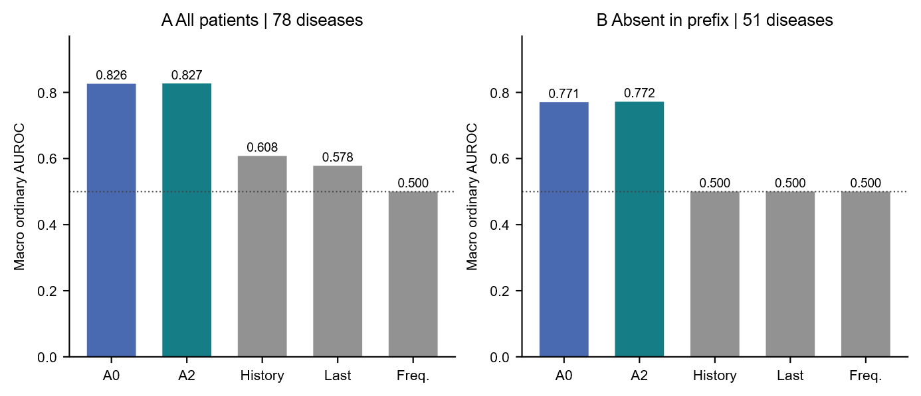
Fig. S1. Ordinary macro AUROC of three-seed ensemble scores. All supported diseases are retained within each stated stratum. No macro confidence interval is implied.
Historical-gap quartiles use 44,003 training patients' earliest eligible windows; boundaries are 27.9934/139.0035/628.0903 days, with equality entering the higher bin. Reused full-budget A0/A2/index trajectories cover the same 2,000 test patients. Q4-minus-Q1 Jaccard interactions are A2-A0 -0.001833 [-0.006262,0.002670] and real-time-index -0.003107 [-0.007905,0.001471]. Neither supports a larger long-gap content benefit. The count interaction -0.175886 [-0.234170,-0.117711] indicates attenuation of A2 count harm, not a Q4 win.
TABLE S5a. Historical-gap strata: Relative minus Absolute
Q | Jaccard | Count MAE | Time MAE (d)
Q1 | +0.0032  [-0.0002, 0.0064]  N=362 | +0.2063  [0.1576, 0.2601]  N=496 | -3.2831  [-5.3046, -1.3616]  N=367
Q2 | +0.0027  [0.0001, 0.0052]  N=372 | +0.1623  [0.1227, 0.2043]  N=509 | -2.8796  [-4.7603, -1.0153]  N=375
Q3 | -0.0008  [-0.0029, 0.0012]  N=297 | +0.0740  [0.0402, 0.1108]  N=501 | +1.2160  [-0.5552, 3.0912]  N=298
Q4 | +0.0013  [-0.0017, 0.0049]  N=296 | +0.0304  [-0.0006, 0.0600]  N=494 | -2.6108  [-4.6699, -0.5818]  N=303
TABLE S5b. Historical-gap strata: Real-time minus index-phase RoPE
Q | Jaccard | Count MAE | Time MAE (d)
Q1 | +0.0052  [0.0018, 0.0086]  N=362 | +0.1715  [0.1272, 0.2201]  N=496 | -3.4276  [-5.5214, -1.4540]  N=367
Q2 | +0.0036  [0.0014, 0.0059]  N=372 | +0.1463  [0.1079, 0.1870]  N=509 | -3.2580  [-4.8961, -1.5937]  N=375
Q3 | -0.0019  [-0.0044, 0.0006]  N=297 | +0.0745  [0.0409, 0.1108]  N=501 | +0.5127  [-1.1992, 2.3984]  N=298
Q4 | +0.0021  [-0.0010, 0.0053]  N=296 | +0.0286  [-0.0039, 0.0597]  N=494 | -2.1451  [-4.0786, -0.1307]  N=303
Entries are paired differences [pointwise 95% CI], conditional on three fitted seeds, with endpoint-specific finite N. Higher Jaccard and lower errors favor Relative. Q1-Q4 boundaries are fixed from training data; the Q4-minus-Q1 interactions, not separate significance labels, test effect heterogeneity. All eight metrics are retained in results/aggregate/historical_gap_all_contrasts.csv.
S5. Same-budget transfer generation
Thirty existing last-10k checkpoints: A0/A2/ETHOS/Foresight/Med-BERT x scratch/UKB initialization x seeds 42-44. Common Jaccard/recall N=1,327; count/edit/coverage N=2,000. Conditional first-record-time denominators differ by arm; contrasts use common finite patients. Twenty rollout replicates are collapsed within patient before inference. No test-based checkpoint selection or sampler adjustment was used. Foresight and Med-BERT were transfer-compatible at this target budget; DoctorGRU had no compatible UKB source and was not assigned an artificial transfer result.
TABLE S6. Transfer rollout performance at 10k target updates
Model / init. | Jaccard | Recall | Count MAE | First-time MAE (d)
A0 / scratch | 0.0123 +/- 0.0004 | 0.0204 +/- 0.0012 | 1.4119 +/- 0.0300 | 119.94 +/- 0.83
A0 / UKB | 0.0370 +/- 0.0013 | 0.0547 +/- 0.0025 | 1.4317 +/- 0.0252 | 120.03 +/- 1.10
A2 / scratch | 0.0130 +/- 0.0007 | 0.0225 +/- 0.0019 | 1.4333 +/- 0.0414 | 119.46 +/- 1.50
A2 / UKB | 0.0367 +/- 0.0012 | 0.0560 +/- 0.0032 | 1.4703 +/- 0.0373 | 118.77 +/- 1.13
ETHOS / scratch | 0.0117 +/- 0.0005 | 0.0199 +/- 0.0011 | 1.4230 +/- 0.0322 | 119.05 +/- 1.09
ETHOS / UKB | 0.0364 +/- 0.0011 | 0.0545 +/- 0.0023 | 1.4531 +/- 0.0186 | 118.93 +/- 0.59
Foresight / scratch | 0.0111 +/- 0.0004 | 0.0186 +/- 0.0009 | 1.3961 +/- 0.0220 | 120.57 +/- 0.70
Foresight / UKB | 0.0360 +/- 0.0005 | 0.0534 +/- 0.0007 | 1.4340 +/- 0.0107 | 119.47 +/- 0.32
Med-BERT / scratch | 0.0039 +/- 0.0002 | 0.0062 +/- 0.0006 | 1.4281 +/- 0.0162 | 124.50 +/- 0.74
Med-BERT / UKB | 0.0063 +/- 0.0008 | 0.0118 +/- 0.0014 | 1.5056 +/- 0.0336 | 121.27 +/- 0.82
Values are arithmetic seed means +/- sample SD, not confidence intervals. Jaccard/recall: N=1,327; count: N=2,000. First-time means are conditional on each arm's finite predictions; paired timing contrasts use common patients.
TABLE S7. Structure and coverage at the same checkpoints
Model / init. | Norm. edit | Unknown fraction | Empty fraction | Cap fraction
A0 / scratch | 0.8429 +/- 0.0072 | 0.0153 +/- 0.0004 | 0.3923 +/- 0.0251 | 0.0000 +/- 0.0000
A0 / UKB | 0.8246 +/- 0.0039 | 0.0142 +/- 0.0006 | 0.3989 +/- 0.0177 | 0.0000 +/- 0.0000
A2 / scratch | 0.8400 +/- 0.0072 | 0.0150 +/- 0.0004 | 0.3929 +/- 0.0248 | 0.0000 +/- 0.0000
A2 / UKB | 0.8233 +/- 0.0060 | 0.0152 +/- 0.0006 | 0.3972 +/- 0.0203 | 0.0000 +/- 0.0000
ETHOS / scratch | 0.8417 +/- 0.0063 | 0.0153 +/- 0.0005 | 0.3892 +/- 0.0200 | 0.0000 +/- 0.0000
ETHOS / UKB | 0.8241 +/- 0.0035 | 0.0151 +/- 0.0001 | 0.3958 +/- 0.0126 | 0.0000 +/- 0.0000
Foresight / scratch | 0.8392 +/- 0.0052 | 0.0150 +/- 0.0004 | 0.4067 +/- 0.0195 | 0.0000 +/- 0.0000
Foresight / UKB | 0.8260 +/- 0.0048 | 0.0148 +/- 0.0007 | 0.4004 +/- 0.0141 | 0.0000 +/- 0.0000
Med-BERT / scratch | 0.8542 +/- 0.0054 | 0.0168 +/- 0.0010 | 0.4131 +/- 0.0177 | 0.0000 +/- 0.0000
Med-BERT / UKB | 0.8594 +/- 0.0021 | 0.0156 +/- 0.0008 | 0.3732 +/- 0.0101 | 0.0000 +/- 0.0000
Fractions are patient means of 20 rollout summaries; N=2,000. An empty rollout has unknown fraction zero by definition, so unknown fraction is interpreted jointly with empty generation.
TABLE S8. Paired diagnosis-Jaccard contrasts
Contrast | Difference [95% paired CI] | Seed-difference SD
A0: UKB - scratch | 0.024761 [0.021708, 0.027899] | 0.00096
A2: UKB - scratch | 0.023654 [0.020637, 0.026655] | 0.00054
ETHOS: UKB - scratch | 0.024765 [0.021657, 0.028029] | 0.00096
Foresight: UKB - scratch | 0.024947 [0.021944, 0.027863] | 0.000254
Med-BERT: UKB - scratch | 0.002331 [0.001785, 0.002941] | 0.000600
Scratch: A0 - ETHOS | 0.000602 [-0.000003, 0.001205] | 0.00067
Scratch: A2 - ETHOS | 0.001398 [0.000809, 0.001978] | 0.00070
Scratch: A2 - A0 | 0.000796 [0.000323, 0.001262] | 0.00044
UKB init: A0 - ETHOS | 0.000598 [-0.000624, 0.001784] | 0.00093
UKB init: A2 - ETHOS | 0.000286 [-0.000856, 0.001417] | 0.00045
UKB init: A2 - A0 | -0.000312 [-0.001412, 0.000685] | 0.00049
Gain: A0 - ETHOS | -0.000003 [-0.001274, 0.001255] | 0.00031
Gain: A2 - ETHOS | -0.001111 [-0.002397, 0.000169] | 0.00045
Gain: A2 - A0 | -0.001108 [-0.002284, -0.000041] | 0.00042
N=1,327 in all listed contrasts. Bootstrap intervals are conditional on the three fitted seeds and unadjusted; the study is exploratory. All eight endpoints, per-seed denominators and paired contrasts are supplied in the aggregate numerical archive.
S6. Transfer outcomes and interpretation
Initialization improved diagnosis Jaccard and recall in all five families, decreased normalized edit distance in A0, A2, ETHOS and Foresight but not in Med-BERT, and increased count MAE in all five. Adapted A0/A2 did not establish Jaccard superiority over ETHOS. A0-ETHOS count MAE was -0.02142 [-0.03203,-0.01037], but first-time MAE was +1.14643 days [0.35374,1.87982]. A2-ETHOS count MAE was +0.01716 [0.00719,0.02776]. Scratch A2 Jaccard exceeded A0 and ETHOS; this was not established after adaptation.
A0 and A2 are separate evaluated systems, not a per-metric maximum. Absolute-model success supports their common modeling approach, while only controlled temporal contrasts isolate the added branch. Mean ranks are descriptive; paired intervals do not incorporate retraining uncertainty or multiplicity across all follow-ups. CE plus time NLL is derived, not an independent fourth win.
UKB and MIMIC differ in event channels, static context, clock semantics, eligibility, horizons and stopping rules. These differences are plausible explanations for heterogeneous performance, not identified causes. Future recorded diagnoses are not incident disease; generated terminal-event frequency is not mortality risk. Retrospective sampling, one-year mortality recording coverage, unequal source budgets and calibration limits remain.
The aggregate archive contains per-seed means, finite denominators, coverage, all-label diagnosis results and paired contrasts. Only aggregate tables and editable figures were synchronized; no patient arrays, identifiers or weights are redistributed.
Supporting UKB numerical results
TABLE S9. Locked-test generation means and seed SD
Model | Jaccard | Hit@10 | First-event MAE, d | Count MAE
MedTrajectory-Absolute | 0.0572  ±0.0020 | 0.3755  ±0.0084 | 302.46  ±0.73 | 13.691  ±0.765
MedTrajectory-Relative | 0.0711  ±0.0012 | 0.4076  ±0.0054 | 297.44  ±1.70 | 12.792  ±1.035
ETHOS-Matched | 0.0488  ±0.0041 | 0.3811  ±0.0086 | 302.51  ±0.49 | 20.298  ±0.698
Foresight-Matched | 0.0323  ±0.0021 | 0.3733  ±0.0045 | 302.18  ±3.55 | 21.903  ±0.314
N=1,669 for all four endpoints. Values are three-seed means +/- sample SD, not patient confidence intervals. Paired intervals are reported in the UKB inference section.
TABLE S10. Predefined fixed-horizon disease panel
Outcome | ICD-10
Hypertension | I10-I15
Ischemic heart disease | I20-I25
Myocardial infarction | I21-I22
Atrial fibrillation/flutter | I48
Heart failure | I50
Cerebrovascular disease | I60-I69
Type 2 diabetes | E11
Chronic kidney disease | N18
COPD | J44
Lipoprotein disorders | E78
All ten outcomes use 1-, 5- and 10-year queries and six 5-year landmark-age bands starting at ages 50-75. Main Table IV reports the corrected macro benchmark. The archived expanded 38-outcome panel was not eligibility-corrected and is not used as evidence of disease-by-window test performance. No matched head-versus-no-head ablation establishes the isolated contribution of the horizon-query head.
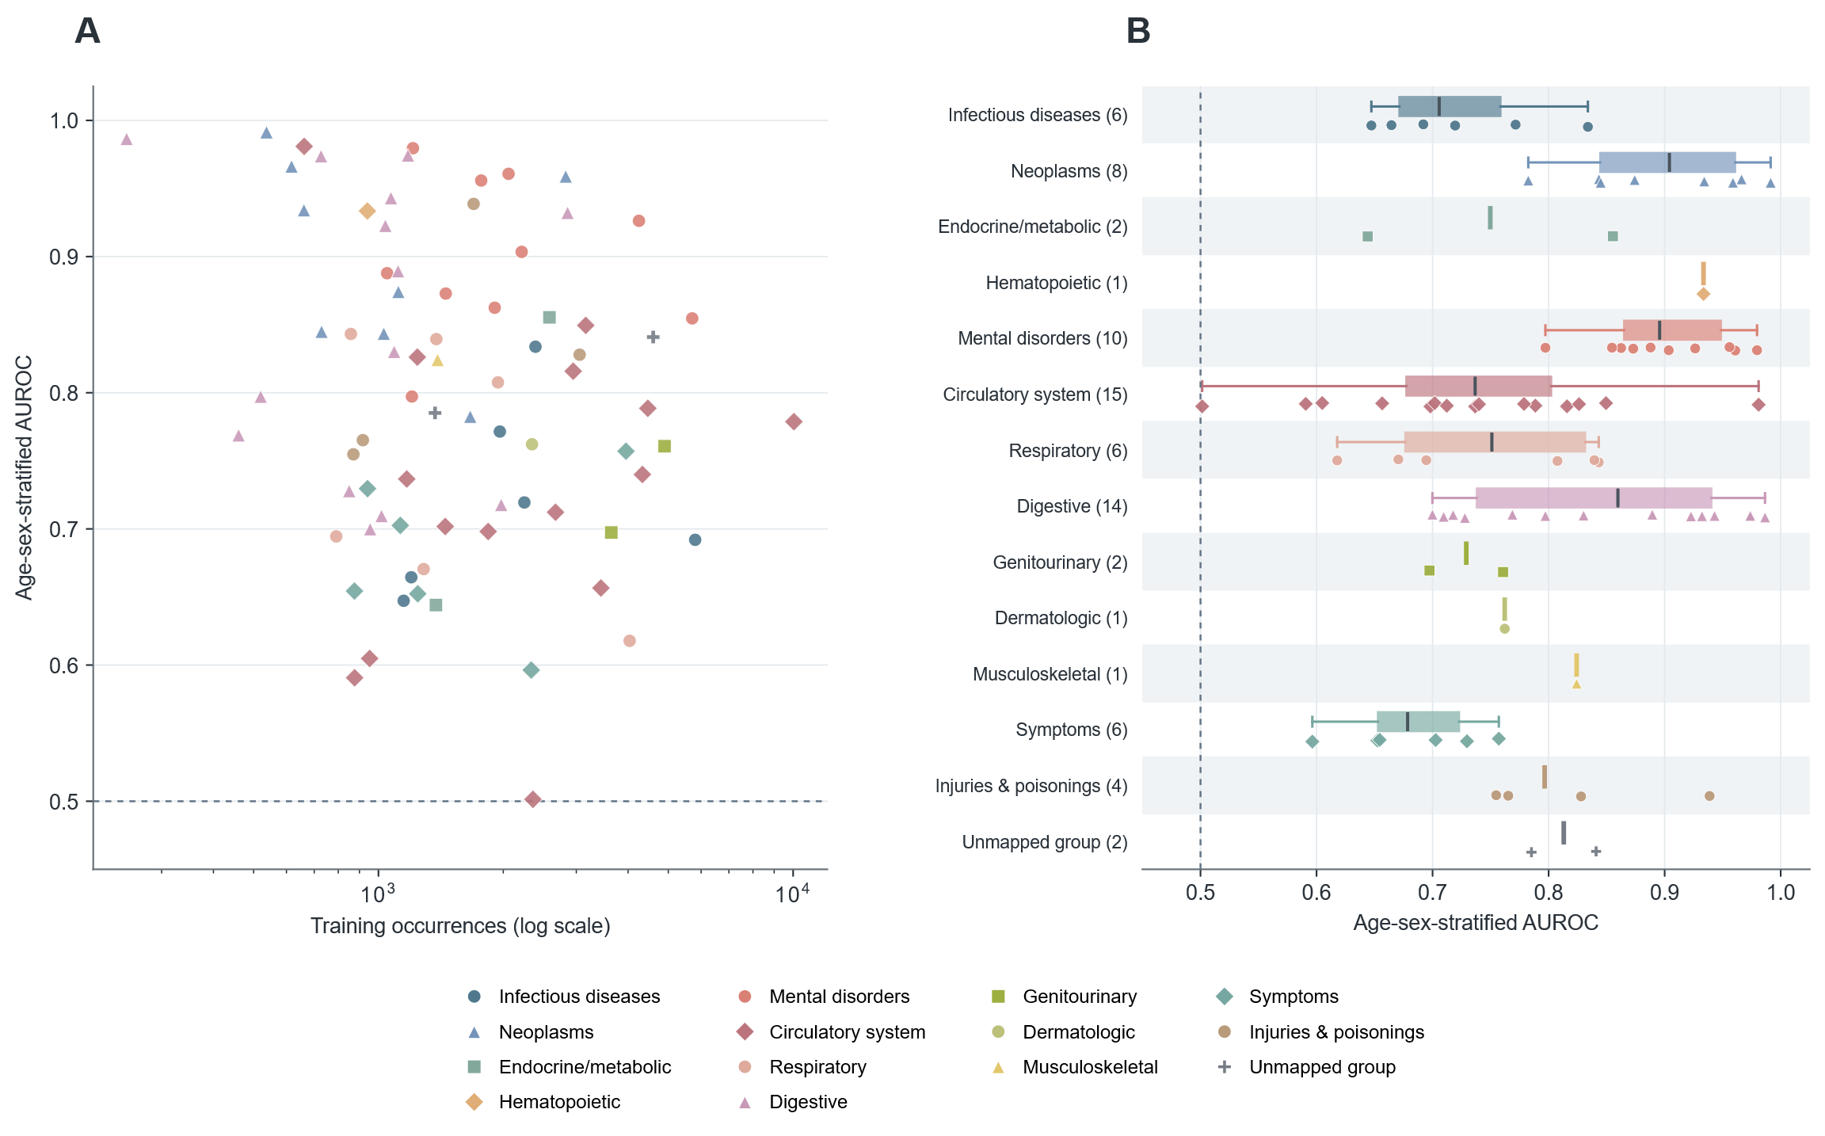
Fig. S2. MIMIC A future recorded principal-diagnosis spectrum. All 78 supported categories are shown in 5,433 validation patients. The 365.25-day endpoint includes recurrence; age-sex-stratified AUROC differs from the ordinary macro baseline comparison.
Complete model comparison heatmaps
Cells show three-seed means +/- sample SD. Green denotes a better mean rank within the displayed representation and metric, not significance or effect magnitude; bold numbers mark the best observed mean. CE + time NLL is a derived joint loss. Token vocabularies differ across A/B/C, and conditional generation timing requires joint interpretation with empty trajectories and count error.

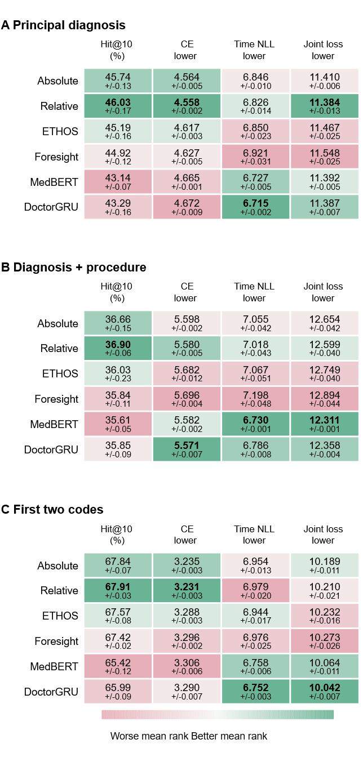
Fig. S3. Full-budget next-record comparison. A/B/C are shown in full. Six task-adapted families; 100k supervised updates, with the fixed additional MedBERT MLM stage. These are task adaptations, not official reproductions.

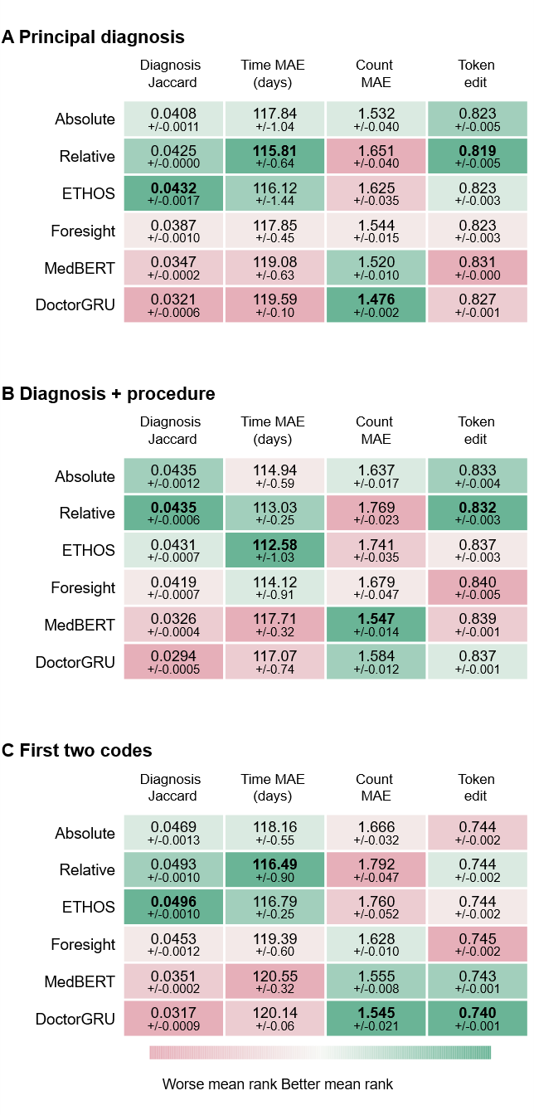
Fig. S4. Full-budget free-generation comparison. A/B/C are shown in full. Six task-adapted families; 100k supervised updates, with the fixed additional MedBERT MLM stage. These are task adaptations, not official reproductions.
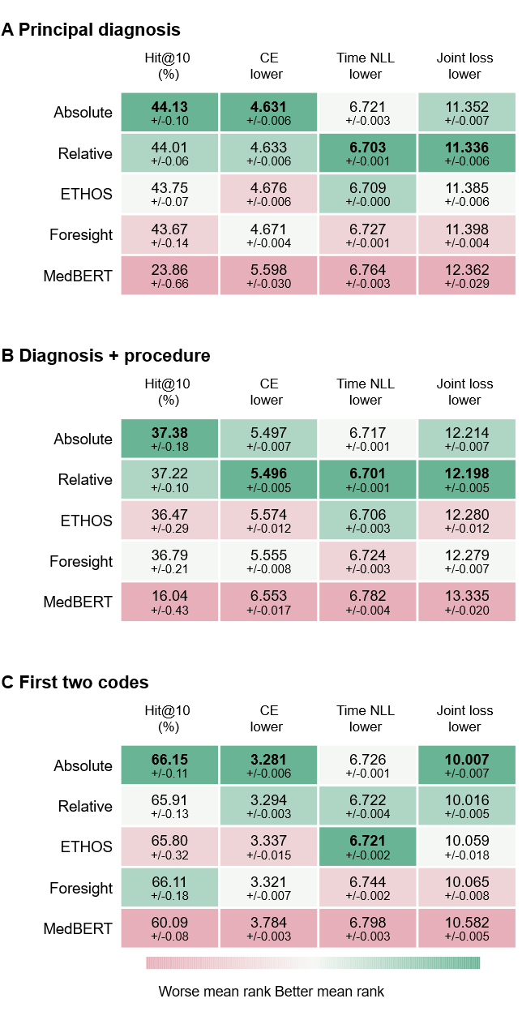
Fig. S5. UKB-initialized next-record comparison at 10k target updates. A/B/C are shown in full. Five transfer-compatible families; target budgets match, but source objectives and compute do not. DoctorGRU has no compatible UKB source. These are task adaptations, not official reproductions.

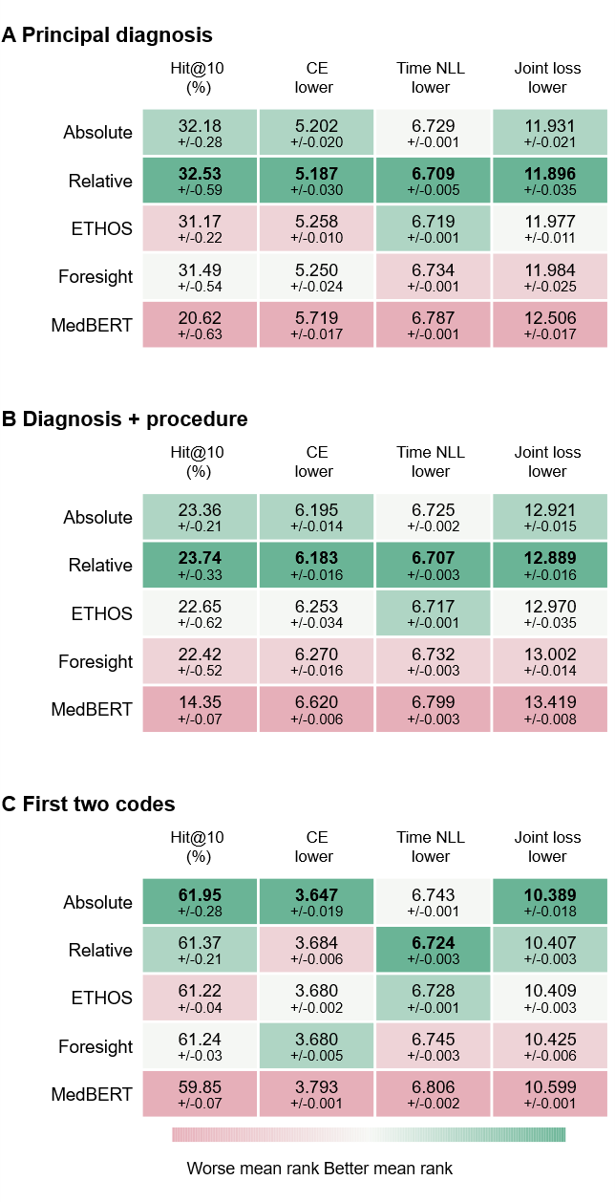
Fig. S6. Scratch next-record comparison at 10k target updates. A/B/C are shown in full. Five transfer-compatible families; target budgets match, but source objectives and compute do not. DoctorGRU has no compatible UKB source. These are task adaptations, not official reproductions.

S7. Semantic embedding comparison
We compared four ICD-10 representations to assess the structural information retained at the model's embedding dimension: ICD chapter one-hot, an ICD block one-hot ontology proxy, PubMedBERT and Qwen text-embedding-v4. The comparison used a common set of 1,254 three-character ICD-10 codes.
Reference groupings comprised 17 chapters, 183 represented ICD blocks and 373 Phecode parent groups. Blocks were called sections in the earlier analysis. For each grouping, k-means used the number of observed groups as k, ten initializations and random seed 0; codes lacking that reference mapping were excluded from that grouping's score. Adjusted Rand index (ARI) and normalized mutual information (NMI) quantify agreement.
Representations were mean-centered and projected by singular-value decomposition to at most 64 principal components. Chapter one-hot remained 17-dimensional; the block proxy, PubMedBERT and Qwen had native dimensions of 263, 768 and 1,024.
TABLE S11. Structural agreement after projection
Reference | Representation | ARI | NMI
A. ICD chapter | ICD chapter one-hot | 1.0000 | 1.0000
A. ICD chapter | ICD block one-hot proxy | -0.0007 | 0.2764
A. ICD chapter | PubMedBERT | 0.9718 | 0.9830
A. ICD chapter | Qwen text-embedding-v4 | 0.9746 | 0.9850
B. ICD block | ICD chapter one-hot | 0.1657 | 0.7056
B. ICD block | ICD block one-hot proxy | 0.2596 | 0.8579
B. ICD block | PubMedBERT | 0.2825 | 0.7761
B. ICD block | Qwen text-embedding-v4 | 0.4982 | 0.8665
C. Phecode parent | ICD chapter one-hot | 0.0943 | 0.6256
C. Phecode parent | ICD block one-hot proxy | 0.0996 | 0.7174
C. Phecode parent | PubMedBERT | 0.1771 | 0.8145
C. Phecode parent | Qwen text-embedding-v4 | 0.3211 | 0.8636
Higher agreement is favorable. Values are descriptive single-protocol results, not patient-level performance estimates. The block one-hot proxy has no learned ontology attention and is not a reproduction of the full GRAM model.
S7.1 Effect of dimensionality reduction
Table S12 compares native and projected representations. Qwen block ARI was 0.4985 at 1,024 dimensions and 0.4982 at 64 dimensions; Phecode ARI was 0.3207 and 0.3211, respectively. These measurements were closely preserved after projection.
TABLE S12. Native versus 64-dimensional ARI
Reference | Representation | Native  dim. | Native  ARI | 64-dim.  ARI
A. ICD block | ICD block one-hot proxy | 263 | 1.0000 | 0.2596
A. ICD block | PubMedBERT | 768 | 0.2859 | 0.2825
A. ICD block | Qwen text-embedding-v4 | 1024 | 0.4985 | 0.4982
B. Phecode parent | ICD block one-hot proxy | 263 | 0.4197 | 0.0996
B. Phecode parent | PubMedBERT | 768 | 0.1944 | 0.1771
B. Phecode parent | Qwen text-embedding-v4 | 1024 | 0.3207 | 0.3211
The chapter representation has 17 dimensions and is omitted from the native-versus-64 comparison because it cannot supply 64 components.
S7.2 Interpretation and initialization
At the projected dimension, Qwen had higher block and Phecode ARI/NMI than PubMedBERT and the block one-hot proxy. Chapter one-hot achieved perfect chapter agreement by construction. The block proxy achieved perfect native block ARI but lost substantial agreement after projection; its lower-dimensional result should not be generalized to ontology-based models as a whole.
Both text encoders received structured prompts containing the ICD code, description, chapter and a task hint. The hierarchy labels were therefore partly supplied in the representation inputs. These analyses assess retention of reference structure rather than independent discovery of clinical relationships.
The comparison supports Qwen as a compact semantic initialization choice for this workflow. It does not establish that Qwen initialization improves downstream trajectory generation or disease prediction relative to alternative initializations. No downstream initialization ablation is reported here.
The 1,254-code comparison is separate from the matrix used to initialize MedTrajectory. The model input matrix was constructed from the ICD-10 2019 English reference (code, label, block, chapter, hierarchy level and task prompt), encoded with Qwen text-embedding-v4 at 1,024 dimensions and projected to 64 dimensions. Matched ICD-based tokens used these reference vectors; procedure and unmatched entries started at zero. All event embeddings remained trainable.

S13. Diagnosis-only evaluation regime
Tables II and III of the main text evaluate the diagnosis-only regime. N1 scores one next-diagnosis target per patient (N = 1,534) with the history truncated at the clinical event immediately preceding the target, and ranks each method's registered diagnostic candidates, with 1,123 candidates for most methods and 1,255 native diagnosis entries for Delphi. G1 draws 20 rollouts from the first 65% of each locked 1,669-participant trajectory and scores generated futures against future diagnoses only. These values are not comparable with the multitype-generation metrics in Table S2 or with the locked-test means table, which use the prespecified 10-year, mortality-terminated rollout over the multitype event space; the legacy Diagnosis Jaccard is likewise computed on diagnosis sets, but its rollout limits, stopping rules and empty-set convention differ.
TABLE S13a. Untimed diagnosis-content generation (G1)
Method | Jaccard / % | Precision / % | Recall / %
MT Absolute | 2.741 | 3.927 | 9.755
MT Relative | 2.938 | 4.777 | 6.707
Delphi | 1.655 | 2.158 | 7.820
GPT | 3.047 | 3.330 | 22.775
BERT | 3.286 | 3.646 | 21.889
ETHOS | 2.299 | 2.475 | 20.831
Med-BERT | 3.365 | 3.758 | 21.743
TrajGPT | 2.346 | 2.563 | 19.043
TCF | 2.928 | 3.207 | 21.187
N=1,669; 20 rollouts per patient. Jaccard, precision and recall are percentages and are computed on generated diagnoses only. All accepted rollouts are retained.
TABLE S13b. Untimed diagnosis trajectory structure (G1)
Method | Mean count | Count MAE | Norm. edit
MT Absolute | 10.182 | 8.980 | 0.9509
MT Relative | 4.390 | 3.869 | 0.9343
Delphi | 9.999 | 8.045 | 0.9816
GPT | 30.000 | 27.571 | 0.9823
BERT | 30.000 | 27.571 | 0.9828
ETHOS | 30.000 | 27.571 | 0.9840
Med-BERT | 30.000 | 27.571 | 0.9829
TrajGPT | 30.000 | 27.571 | 0.9854
TCF | 30.000 | 27.571 | 0.9836
Length counts repeated diagnoses. Diagnosis-only baselines without a native stopping rule reach the 30-diagnosis computation limit, so generated length is not itself a favorable-direction score; the longer outputs of GPT, BERT, ETHOS, Med-BERT, TrajGPT and TCF reflect that limit rather than superior content.
TABLE S13c. Ten-year generation content
Method | Jaccard / % | Precision / % | Recall / %
MT Absolute | 2.626 | 3.747 | 10.191
MT Relative | 2.938 | 4.757 | 6.590
Delphi | 1.678 | 2.358 | 5.181
TCF | 2.560 | 2.711 | 27.522
ETHOS definite | 0.604 | 1.185 | 0.871
ETHOS possible | 2.168 | 2.307 | 23.198
TABLE S13d. Ten-year trajectory structure
Method | Mean count | Count MAE | Norm. edit
MT Absolute | 14.043 | 12.865 | 0.9516
MT Relative | 4.110 | 3.598 | 0.9339
Delphi | 5.574 | 3.898 | 0.9792
TCF | 62.202 | 59.826 | 0.9888
ETHOS definite | 0.384 | 2.229 | 0.9262
ETHOS possible | 39.275 | 36.897 | 0.9856
TABLE S13e. Conditional first-diagnosis timing
Method | MAE / days | Available pairs / %
MT Absolute | 519.07 | 77.63
MT Relative | 515.66 | 70.74
Delphi | 695.38 | 86.67
TCF | 520.72 | 91.79
GPT + time head | 642.69 | 83.47
BERT + time head | 636.76 | 83.51
ETHOS + time head | 636.10 | 83.87
Med-BERT + time head | 633.72 | 83.62
TrajGPT + time head | 652.98 | 83.40
Timed truth contains all post-cut diagnoses at or before cut age +3,652.5 days, retaining repeats, same-day events and empty futures. Twenty rollouts use the frozen native sampler and a 256-event cap, without a 30-diagnosis stop. Time MAE first averages available rollouts within patient, then available patients. Availability is the patient mean of rollout-pair availability, not the fraction of patients with any usable rollout.
ETHOS propagates its native gap-token intervals, and its final bin spans 180 days to infinity. Definite and possible window membership are separate scoring scenarios, not mathematical lower and upper bounds on Jaccard or error; no midpoint time or ETHOS point-time MAE is imputed. TCF retains native time feedback from the last visible diagnosis, including pre-cut events excluded from scoring. Delphi retains its calendar and death/age-85 stopping. GPT, BERT and Med-BERT have no native time output, and the TrajGPT fixed-day rollout grid is not a learned timing prediction.
TABLE S13f. A2 minus comparator in N1 Hit@10
Comparator | Difference, pp [95% CI] | A2 / ref. wins | Holm p
MT Absolute | +0.065 [-1.434, 1.565] | 72/71 | 1.000
Delphi | +27.640 [24.967, 30.378] | 492/68 | 1.77e-78
GPT | +26.141 [23.468, 28.879] | 484/83 | 5.08e-68
BERT | +25.033 [22.295, 27.771] | 474/90 | 3.54e-62
ETHOS | +25.424 [22.621, 28.227] | 485/95 | 3.40e-62
Med-BERT | +25.359 [22.621, 28.096] | 476/87 | 4.08e-64
TrajGPT | +39.309 [36.506, 41.982] | 655/52 | 6.22e-132
TCF | +33.638 [30.769, 36.441] | 595/79 | 5.66e-97
N1 N=1,534. pp: percentage points. Ties equal N minus the two win counts. Holm adjustment covers the 72 primary comparisons of the N1 and G1 families; the p values test patient-win balance with an exact two-sided sign test, so a small p can favour the comparator despite a positive mean difference. Bootstrap intervals estimate mean differences and are marginal and unadjusted.

