MedTrajectory: Forward Generation of Multitype Longitudinal Patient Trajectories
Shuaiyu Yang
Graphical Abstract
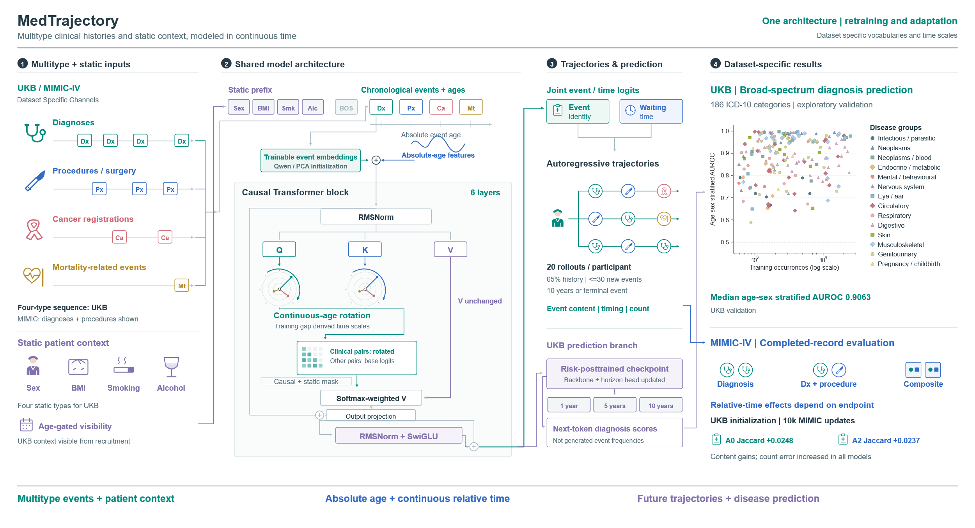

Abstract Longitudinal electronic health records capture how a patient's clinical course evolves over time, spanning diseases, interventions, and a broad range of other health events. Building on this data source, generative modeling has recently moved from predefined outcome prediction to modeling of future clinical trajectories. Yet existing approaches vary in their coverage of clinical events and temporal representations, so that contributions of heterogeneous clinical events and the irregular temporal relationships among them may be incompletely understood. As a result, the information conveyed by relative time is rarely exploited, and the role that individual clinical events play in generative tasks remains poorly explained. To address these problems, we develop MedTrajectory, an autoregressive Transformer that integrates multitype clinical events through absolute age encoding and continuous relative-time attention. We evaluate the model primarily in UK Biobank and replicate the analyses in MIMIC-IV to probe cross-setting generalization. In this setting, multitype modeling improved several trajectory measures, while relative-time attention raised the locked-test Diagnosis Jaccard from 0.0572 to 0.0711 under the multitype-generation protocol, albeit with representation-dependent effects in MIMIC-IV. Finally, our death-event analyses underscore that trajectory termination and mortality-risk estimation are distinct targets, and the separate fixed-horizon risk evaluation in UK Biobank did not establish the prespecified noninferiority.
Index Terms: Electronic health records, longitudinal modeling, generative models, clinical trajectory prediction.

I. INTRODUCTION
Longitudinal electronic health records (EHRs) are dated accounts of patients' clinical courses, they record diagnosed diseases, delivered interventions, and changes in followed health status. These sequences with time allow computational models to learn longitudinal disease patterns and anticipate future clinical events from accumulated patient histories. In recent years, advances in deep learning, particularly Transformer-based architectures, have substantially improved the representation of such records and the prediction of subsequent events [1,2].
Early Transformer-based EHR models, including BEHRT [1] and Med-BERT [2], primarily encode histories for predefined outcomes. Consequently, more recent generative approaches shift this objective toward the future patient timeline itself. For instance, Foresight [3] generates heterogeneous clinical concepts from longitudinal records, ETHOS [4] models patient health trajectories within generative framework, and Delphi-2M [5] generates long term disease trajectories through autoregressive disease event prediction. This shift changes the prediction target from a single outcome to a sequence whose event content, elapsed time and termination all require evaluation.
Despite this shift, however, several aspects of longitudinal EHR structure remain insufficiently characterized in generative trajectory modeling. Existing approaches differ substantially in the types and granularity of clinical events they include, which make it difficult to isolate the contribution of extending diagnosis centered sequences to structured multitype EHRs. In addition, longitudinal trajectories depend not only on absolute age or event order but also on the time actually elapsed between clinical events, yet the contribution of continuous event time to multistep trajectory generation inadequately quantified. Since trajectory generation and conventional risk prediction target different quantities, it remains unclear whether improved generative fidelity carries over to fixed-horizon risk discrimination.
To address these problems, we propose MedTrajectory, an autoregressive model for multitype longitudinal EHRs that integrates heterogeneous clinical events with absolute age and continuous relative time representations. Specifically, this study makes the following contributions:
1) We develop a unified multitype EHR representation and quantify what procedures, cancer registrations, and mortality related events add to diagnosis centered trajectories.
2) We introduce continuous relative time attention alongside absolute age encoding, with a separate monotonic horizon query head for disease prediction. UKB comparisons establish the temporal branch's generation benefit.
3) We operate death token ablation and independent mortality estimation that quantify termination effects and distinguish generated terminal events from calibrated risk.
4) We add MIMIC-IV adaptation and same target budget transfer analyses that test reuse of the framework and characterize diagnostic content gains alongside timing and count tradeoffs.

II. RELATED WORK
The representation of clinical concepts, longitudinal outcome prediction and temporally informed generation of patient trajectories develop rapidly and expand in more areas.

A. Disease coding and prediction
Clinical concepts in EHRs can be represented through standardized codes, ontology structure or biomedical text. Phecodes group ICD codes into clinically meaningful phenotypes [6], while GRAM incorporates hierarchical ontology information into representation [7]. PubMedBERT [8] and SapBERT [9] supply semantic representations learned from biomedical language and terminology. These strategies inform code initialization, the contribution of adding an event channel remains a separate question because its inclusion can alter the history, target vocabulary and cohort.
Longitudinal prediction progressed from recurrent and attention-based designs, including Doctor AI [10] and RETAIN [11], to Transformer-based representations including BEHRT [1] and Med-BERT [2]. DeepHit [12], Dynamic-DeepHit [13] and SurvTRACE [14], [15] then extend this line to time bounded outcomes via incorporating time-to-event outcomes and censoring. However, some of them target a predefined outcome or the next recorded visit, and a useful generated sequence does not by itself establish accurate disease risk ranking or probability calibration.

B. Generative patient trajectory and temporal modeling
Generative EHR modeling takes the work a step further, shifting the target from predefined outcomes to the patient's future trajectory as a whole. Foresight generates subsequent heterogeneous clinical concepts from longitudinal records [3], whereas ETHOS represents temporally ordered Patient Health Timelines without task-specific retraining [4]. Delphi-2M follows a related route, combining autoregressive disease event modeling with continuous age and patient context to produce long term disease trajectories [5]. Collectively, these studies establish that generative patient modeling is feasible, yet they differ considerably in event space, temporal representation and evaluation protocol. Such heterogeneity makes it difficult to attribute observed performance differences to any single design choice.
Among the divergence in these studies, temporal representation deserves particular attention, since clinical events arise at irregular intervals rather than on a fixed schedule. BEHRT incorporates age and event position into its input representation [1]. CEHR-BERT goes further by introducing explicit time-interval and age representations [16], and HiTANet adopts time-aware attention for longitudinal risk prediction [17]. Adaptive clinical risk estimates have likewise been derived from generative health trajectory models [18]. As whether multitype event structure and continuous inter event time shape multistep generation in the same way they shape fixed horizon prediction remains unresolved, we retain absolute age while adding elapsed-time attention, and evaluate multistep generation separately from the horizon-query readout. Also, a further index phase control in MIMIC-IV examines whether the rotary branch benefits from actual intervals rather than event order alone.

III. METHODS

A. Problem formulation
We formulate longitudinal patient trajectory modeling as an autoregressive generation problem over clinical events and continuous time. Let $H_{i}={\{(e_{j},t_{j})\}}_{j=1}^{i}$ denote the observed history, in which $e_{j}$ is a clinical event and $t_{j}$ is its occurrence age, MedTrajectory then models the joint distribution of the next event $e_{i+1}$ and the associated inter event interval ${Δt}_{i+1}$, conditioned on the preceding trajectory and patient context $c$:
$$p\left(e_{i+1},Δt_{i+1}∣H_{i},c\right)$$
The primary target is therefore the future sequence of clinical events together with their timing, fixed-horizon clinical risk is evaluated separately as a downstream task.

B. Multitype longitudinal EHR representation

1) Multitype clinical events and patient context
MedTrajectory represent diagnoses, procedures, cancer registrations and mortality records. ICD-based events as diagnoses, cancer registrations and mortality records use three-character ICD-10 categories, while procedures use OPCS-4, then the dynamic vocabulary contains 8,424 entries, comprising 8,422 clinical event types and two special tokens for padding and no event. Additionally, chronological ordering, initialization and dataset specific MIMIC representations are detailed in Supplementary S1 and S3.
Moreover, four prefix tokens encode sex, BMI, smoking and alcohol, masked until recruitment age. They cannot reveal these covariates to earlier events. MIMIC uses sex; other context slots are unavailable.

2) Semantic initialization of clinical codes
ICD-10-based events are initialized from structured English reference text with Qwen text-embedding-v4 [19], and then projected from 1,024 to 64 dimensions by PCA. Procedures and unmatched entries start at zero vectors, and all event embeddings remain trainable. Additionally, historical MIMIC dictionary/PCA provenance is inherited.
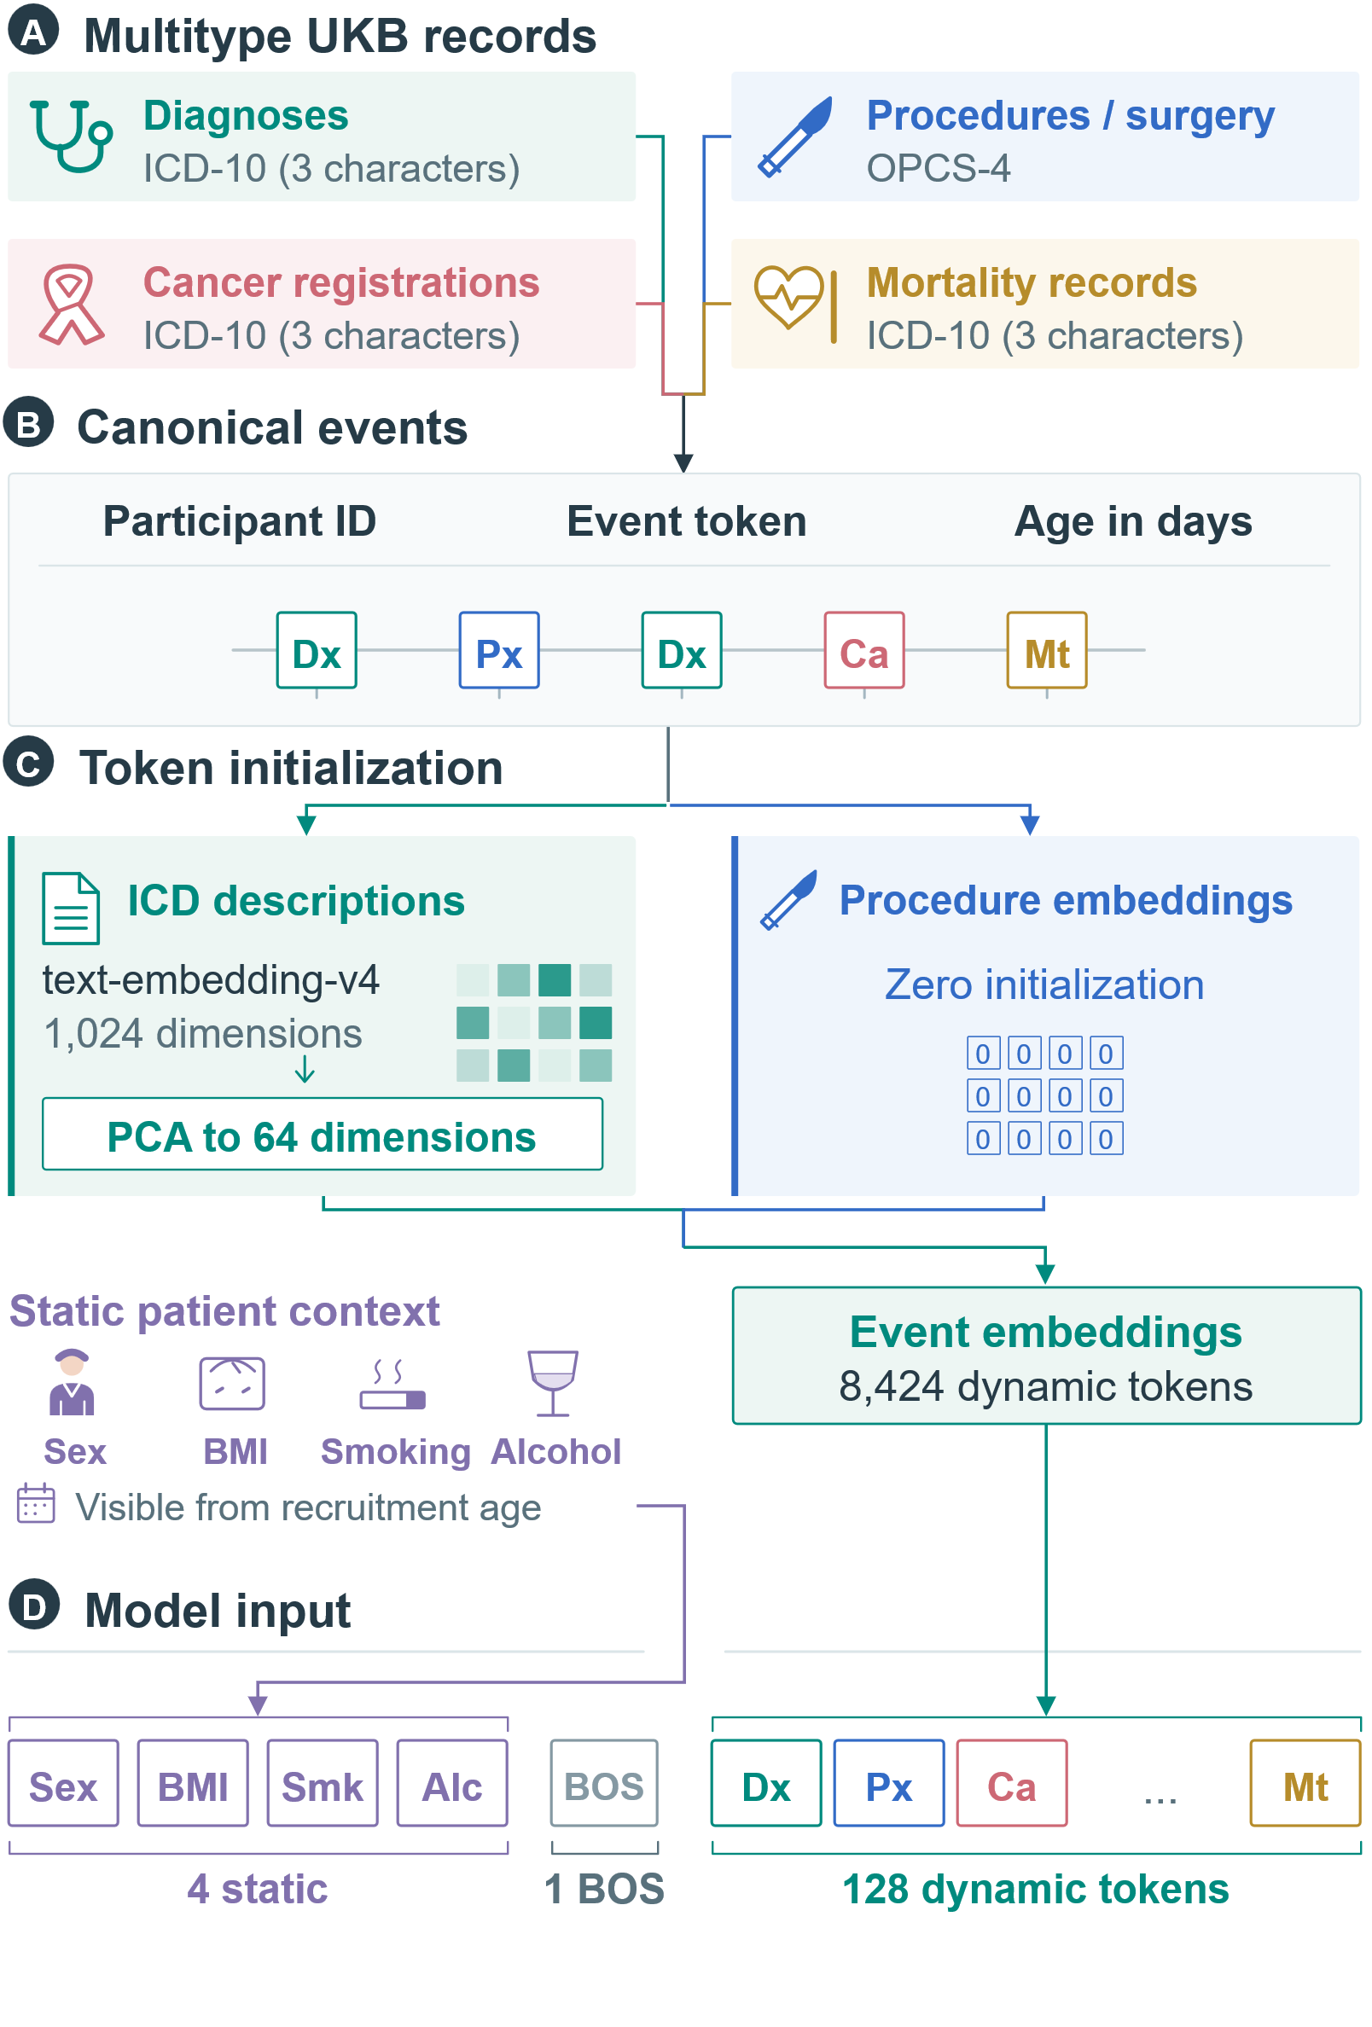
Figure 1 Multitype EHR data flow and token initialization. ICD-based events use semantic initialization; procedure embeddings start from zero and remain trainable. Recruitment age gates the four static context tokens.

C. MedTrajectory architecture

1) Autoregressive backbone
MedTrajectory is built on a six-layer, decoder-only causal Transformer [20] with eight attention heads and a hidden dimension of 64, amounting to approximately 1.39M trainable parameters. Causal masking confines the representation of each event to preceding clinical events and to the patient context that is temporally available at that position, which is what allows trajectory generation to proceed autoregressively. Each clinical event enters the model as its event embedding combined with a continuous representation of its absolute age, which we describe in the following subsection.

2) Absolute-age representation
Let $t_{i}$ denote the age when event $i$ occurs, measured in days since birth. We first convert it to years, $τ_{i}=t_{i}/365.25$, and then construct sinusoidal features over a geometric sequence of frequencies,
$$ω_{k}={10000}^{-2k/d}, k=0,…,d/2-1,$$
so that absolute age enters the model at multiple temporal resolutions:
$$A_{i}=[sin(τ_{i}ω_{0}), cos(τ_{i}ω_{0}), …], x_{i}=E(e_{i})+W_{A}A_{i}.$$
Here $d=64$ is the hidden dimension, so that $A_{i}∈R^{d}$ and $W_{A}$ is a trainable $64×64$ matrix without bias, and $E(e_{i})$ is the event token embedding. Static context uses the time gated prefix described above.
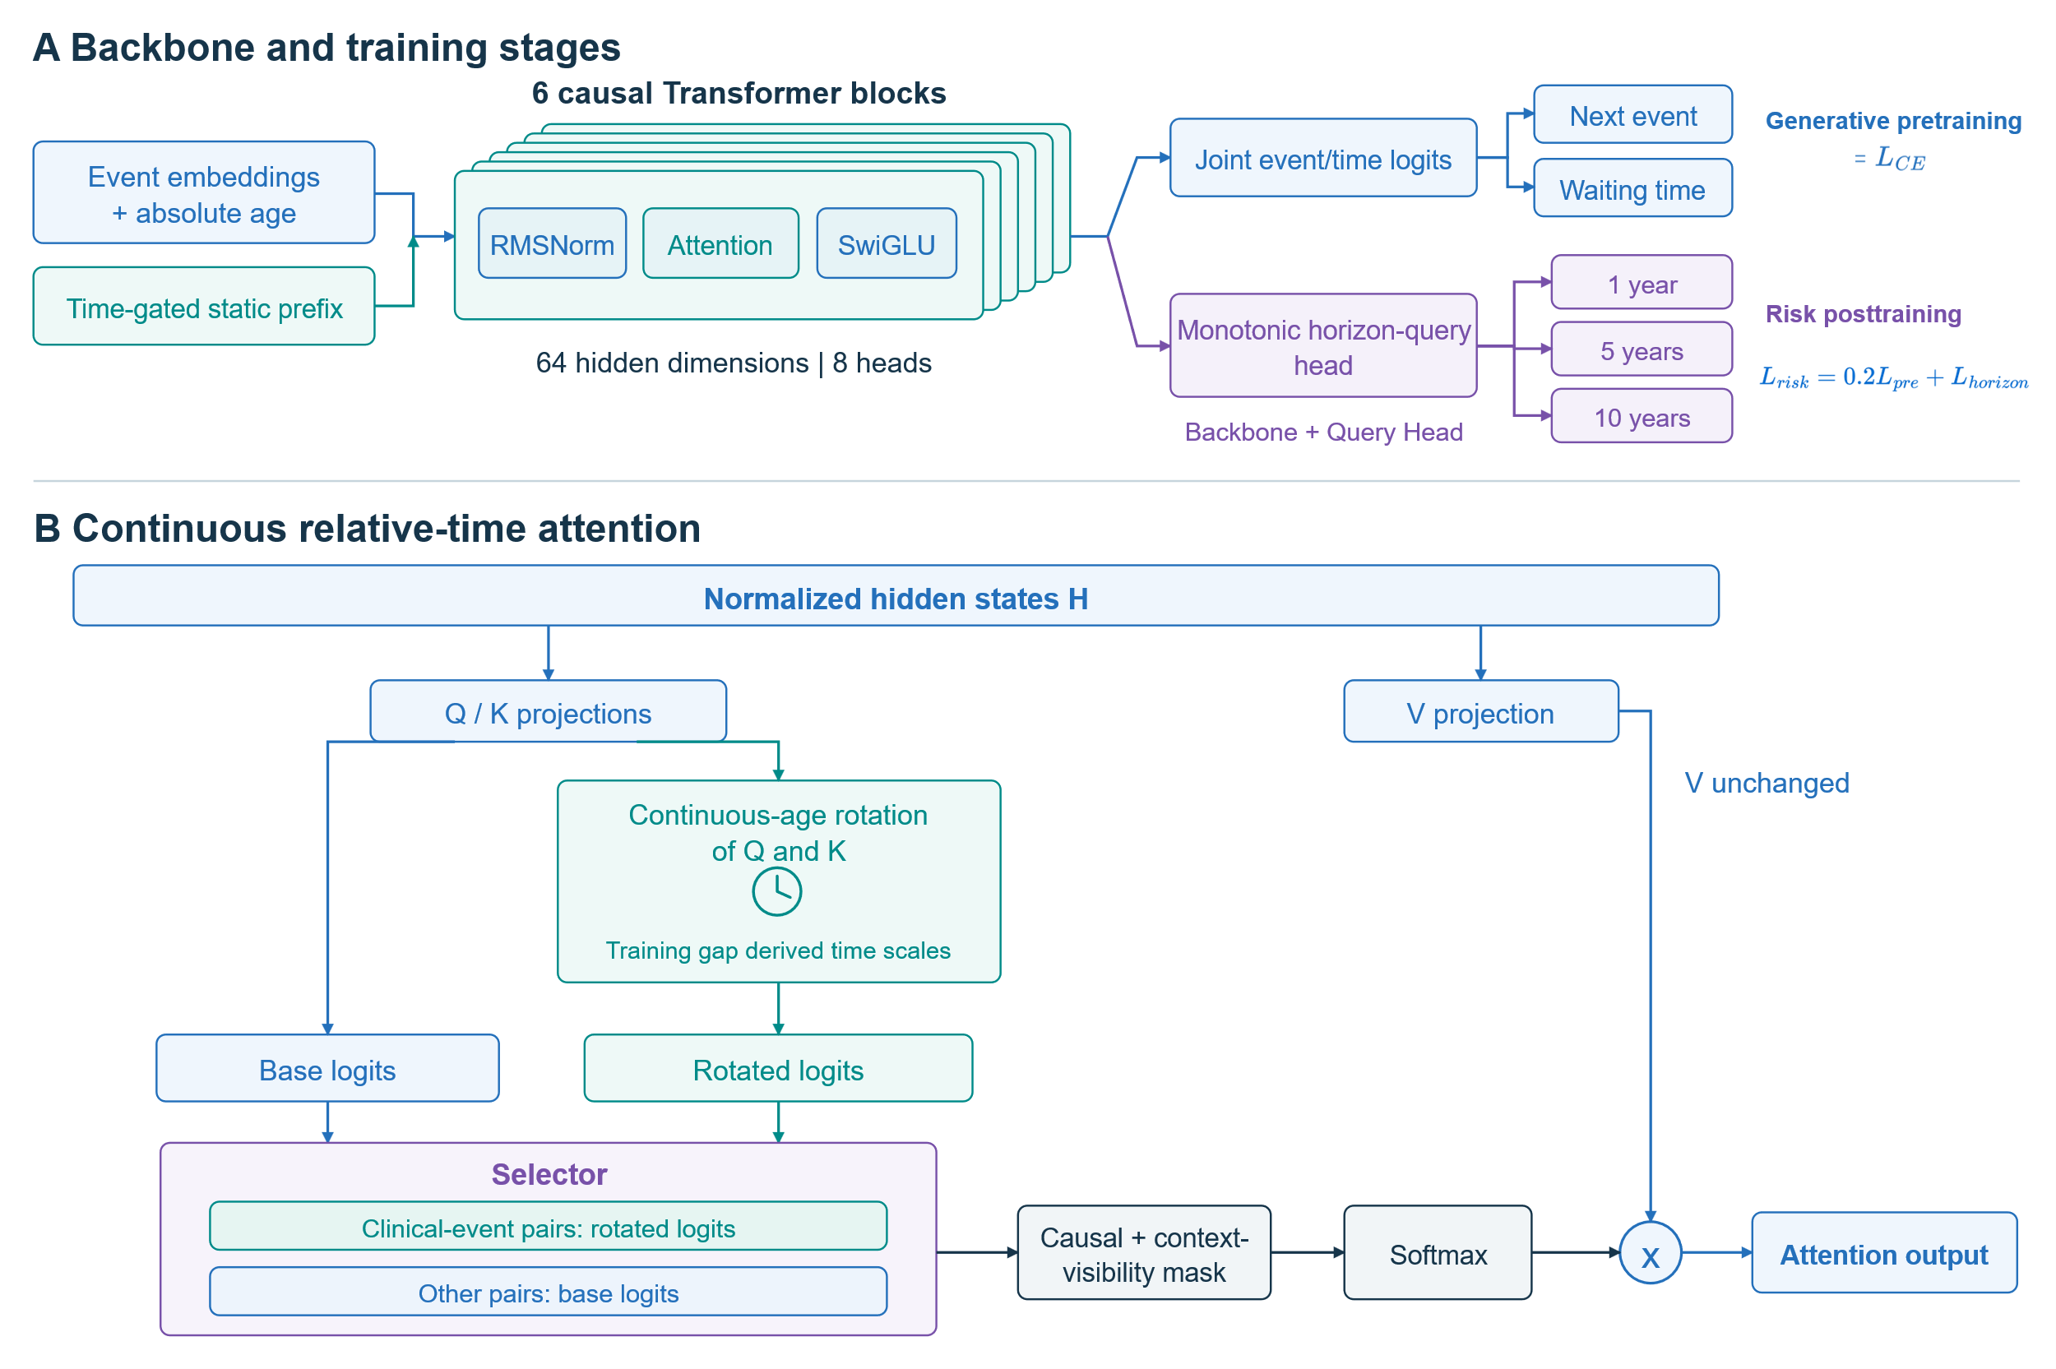
Figure 2. MedTrajectory architecture and training stages. (a) Generative pretraining with joint event/time logits and separate downstream risk posttraining, which updates the backbone and horizon-query head. (b) Continuous-age rotation of Q/K only, masked logit replacement for dynamic-clinical-event pairs, and unrotated V.

3) Continuous relative-time attention
To capture the irregular temporal relationships between clinical events, MedTrajectory augments the absolute age representation with additive continuous age relative attention, where rotary position embedding [21] is adapted to continuous clinical ages [22]. For any two events $i$ and $j$, their temporal relationship is defined by the continuous age difference,
$$Δt_{ij}=t_{i}-t_{j}.$$
This age difference enters self-attention as an additive, masked correction applied to the query and key only. Given hidden representations $H$, we first compute the standard query, key, and value projections,
$$Q=HW_{Q}, K=HW_{K}, V=HW_{V}.$$
For a given pair of events, the correction replaces the base logit by the rotated logit only when both positions correspond to dynamic clinical events,
$$s_{base}(i,j)=\frac{q_{i}^{⊤}k_{j}}{\sqrt{d_{h}}}, s_{rope}(i,j)=\frac{(R(t_{i})q_{i})^{⊤}(R(t_{j})k_{j})}{\sqrt{d_{h}}},$$
$$s(i,j)=s_{base}(i,j)+m(i,j)\left(s_{rope}(i,j)-s_{base}(i,j)\right),$$
where $R(t)$ denotes the continuous age rotational transformation and $m(i,j)=1$ when both $i$ and $j$ are dynamic clinical events and 0 otherwise. Attention is then computed as
$$Attention=softmax\left(s+M_{visibility}\right)V.$$
Here $M_{visibility}$ combines causal masking with recruitment time visibility of static covariates. This design renders attention scores directly sensitive to the real time interval between clinical events while keeping the value stream unchanged, preserving the conventional Transformer attention structure. Also, we retain both encodings, so that modeling event time intervals does not discard the information of the patient’s absolute age.

D. Generation objective and horizon query risk head
The next event logits jointly determine the categorical event distribution and an exponential waiting-time rate, as detailed in Supplementary S1. Generative pretraining minimizes
$$L_{pretrain}=L_{CE}+L_{dt},$$
where $L_{CE}$ is next event cross-entropy and $L_{dt}$ is the positive gap exponential objective. No separate time gap regression head contributes to the final pretraining loss.
The horizon query head asks whether a specified disease will be recorded within 1, 5 or 10 years of a clinical landmark. It uses learned horizon queries to read the history, rather than counting disease tokens in sampled futures. Risk posttraining updates both the backbone and head; the frozen-backbone mortality head is a different analysis.
Additionally, to further assess whether the learned trajectory representation also supports fixed horizon clinical prediction, we attach an independent risk head to estimate disease occurrence within 1-, 5-, and 10-year horizons. The horizon specific risks are parameterized monotonically to reflect nested cumulative incidence across increasing horizons:
$$P\left(Y_{1y}=1\right)≤P\left(Y_{5y}=1\right)≤P\left(Y_{10y}=1\right),$$
Disease risk post training jointly updates the backbone and a monotonic horizon-query head using $0.2(L_{CE}+L_{dt})+L_{horizon}$. Supplementary S1 defines the head and masked binary cross-entropy.

IV. EXPERIMENTS

A. Cohort and evaluation sets
We evaluated MedTrajectory using longitudinal UK Biobank records [23]. The cohort comprised 502,411 participants partitioned into training (N=397,049), validation (N=99,263) and test (N=6,099). The test partition yielded a trajectory-generation cohort of 1,669 participants. For fixed-horizon risk, 6,035 participants met base model-input eligibility, and 4,668 contributed outcome-observable records after eligibility correction. The two task populations overlap and are therefore not additive. Test identifiers predate protocol specific retraining, prior risk-baseline inspection makes those reference comparisons exploratory. MIMIC-IV [24] provides a separate hospital record evaluation.

B. Model variants and baselines
We evaluate two principal design factors, expansion of the clinical event space and explicit relative time modeling. Then we develop MedTrajectory into two versions, absolute version and relative version. The Absolute (A0) retains continuous absolute age encoding; Relative (A2) adds relative time attention. For trajectory generation, we further evaluate matched implementations of ETHOS and Foresight under common data splits and event representations. The fixed horizon risk benchmarks included Cox regression, logistic regression, Med-BERT, and MDRMF-Clinical. MIMIC additionally includes DoctorGRU and an index phase A2 control, which is shown in Supplementary S1-S3.
We additionally evaluate a diagnosis-only setting in which the target is restricted to diagnosis events: one next-diagnosis target per patient (N = 1,534) with history truncated at the event immediately preceding that diagnosis, and an untimed generation setting that scores generated futures against future diagnoses only (Tables II and III). Common mapped diagnosis targets were scored using each method's registered diagnostic candidate vocabulary, with 1,123 candidates for most methods and 1,255 native diagnosis entries for Delphi. Seven published models or backbones are compared under this setting. These diagnosis-only readouts and the multitype-generation readouts in Supplementary Tables S2 and S9 answer different questions and are not numerically comparable.

C. Trajectory generation evaluation
For 1,669 held out UKB participants, we sample 20 autoregressive rollouts from the first 65% of each eligible trajectory, allowing up to 30 new events over a 10-year window and a mortality termination. Diagnosis Jaccard, first-event-time MAE and event-count MAE score are computed from generated futures, Hit@10 separately scores teacher forced next-event ranking, shown in Supplementary S1.

D. Clinical risk and cross-setting evaluation
Fixed horizon disease risk benchmark covers several predefined outcomes, hypertension, ischemic heart disease, myocardial infarction, atrial fibrillation/flutter, heart failure, cerebrovascular disease, type 2 diabetes, chronic kidney disease, COPD and lipoprotein disorders. Each is assessed at 1, 5 and 10 years. Outcome observable labels and the corrected participant restriction are shared across A0, A2, no-age and the risk reference systems; metrics are macro-averaged across estimable sex-disease-horizon-age strata.
Death is additionally examined as a secondary case because it serves both as a clinical event and as a trajectory termination state. Rollout death frequency, death token ablation, and an independently trained outcome observable mortality head were used to distinguish event generation, sequence termination, and calibrated clinical risk, shown in Supplementary S2.
Expanded MIMIC-IV models use completed admissions at discharge pseudo age, an availability proxy rather than onset. A is principal diagnosis, B a diagnosis-procedure joint token, and C a first two code composite. Training from scratch uses 100k supervised updates, training from UKB adaptation uses fixed last 10k checkpoints and three seeds. Rollouts use two records, 20 samples, 365.25 days and a 30-record cap in 2,000 common patients. Validation diagnosis baselines and training-defined gap strata reuse existing predictions, Supplementary S3-S6.
Supplementary Table S4 contrasts dataset construction and evaluation. MIMIC-IV assesses adaptation of the framework, not direct external validation of UKB risk estimates.

E. Statistical analysis
In UKB, the prespecified primary generation endpoint is Diagnosis Jaccard in the locked test. Patient level paired bootstrap resampling keep each participant's predictions together, with shared resamples across three trained seeds. The locked generation and the prespecified clinical risk comparisons each use 10,000 resamples and 95% confidence intervals. MIMIC uses 2,000 patient-paired draws; disease AUROC uses paired DeLong inference and a stated BH family. Follow-up comparisons are exploratory; intervals condition on fitted seeds. SD across three seeds is separate from patient uncertainty. Historical validation comparisons use their own Holm family, shown in Supplementary S6.

V. RESULTS

A. Multitype event representation in UKB
Expanding diagnosis-only histories with procedures increased Full Top10 from 0.2935 to 0.4832 and selected disease mean AUROC from 0.7274 to 0.7949; adding cancer/mortality records yielded 0.4891 and 0.7972 (Table I). These historical comparisons support the multitype representation, but also change eligibility and targets. The fixed-target MIMIC procedure analysis provides a complementary input-only contrast, with a small content gain and endpoint-specific tradeoffs.
TABLE I. Progressive event-space expansion
Model | Diagnosis Top@10 | Full Top10 | disease mean AUROC
Disease only | 0.2935 | 0.2935 | 0.7274
+ procedures | 0.5527 | 0.4832 | 0.7949
+ cancer/death | 0.5601 | 0.4891 | 0.7972

B. Next diagnosis prediction and trajectory generation
In the diagnosis-only next-diagnosis task (N = 1,534), our model achieved Hit@10 of 54.04%/54.11%, compared with 14.80%-29.07% across the seven comparators (Table II). Both exceeded every comparator under the Holm-adjusted paired tests (Supplementary Table S13f). Against BERT, the strongest external Hit@10 mean, our model with relative time module improved by 25.03 percentage points.
In free generation, MedTrajectory had the highest precision, lowest count MAE and normalized edit distance, while Med-BERT had the highest Jaccard, shown in Table III. Additionally, Relative did not separate from Absolute in diagnosis-only Hit@10 (+0.065 points [-1.434, 1.565]; adjusted p = 1), whereas in the multitype-generation regime Relative improved Hit@10 by 3.21 points (Supplementary Table S2). Complete recall and length results accompany the paired comparisons in Supplementary Tables S13a-S13e and S2.
TABLE II. UKB next-diagnosis prediction (diagnosis-only candidate space)
Method | Hit@1  (%)↑ | Hit@5  (%)↑ | Hit@10  (%)↑ | MRR↑
Ours(Relative) | 23.53 | 45.31 | 54.11 | 0.3411
Ours(Absolute) | 23.01 | 44.20 | 54.04 | 0.3336
Delphi | 5.48 | 16.56 | 26.47 | 0.1246
GPT | 6.26 | 18.77 | 27.97 | 0.1380
BERT | 6.65 | 19.36 | 29.07 | 0.1397
ETHOS | 7.17 | 19.95 | 28.68 | 0.1447
Med-BERT | 6.52 | 19.04 | 28.75 | 0.1393
TrajGPT | 2.61 | 9.26 | 14.80 | 0.0711
TCF | 3.98 | 13.56 | 20.47 | 0.0990
N = 1,534 next-diagnosis targets; one target per patient, history ends at the clinical event immediately preceding the target; Top@k ranks each method's registered diagnostic candidates, with 1,123 candidates for most methods and 1,255 native diagnosis entries for Delphi. Values are not comparable with the multitype-generation metrics in Supplementary Table S9.
TABLE III. UKB untimed diagnosis-content generation and ten-year first-diagnosis timing
Method | Jaccard  (%)↑ | Precision  (%)↑ | Time  MAE↓ | Norm.  edit↓
Ours(Relative) | 2.938 | 4.777 | 515.66 / [70.74] | 0.9343
Ours(Absolute) | 2.741 | 3.927 | 519.07 / [77.63] | 0.9509
Delphi | 1.655 | 2.158 | 695.38 / [86.67] | 0.9816
GPT | 3.047 | 3.330 | 642.69 / [83.47] | 0.9823
BERT | 3.286 | 3.646 | 636.76 / [83.51] | 0.9828
ETHOS | 2.299 | 2.475 | 636.10 / [83.87] | 0.9840
Med-BERT | 3.365 | 3.758 | 633.72 / [83.62] | 0.9829
TrajGPT | 2.346 | 2.563 | 652.98 / [83.40] | 0.9854
TCF | 2.928 | 3.207 | 520.72 / [91.79] | 0.9836
N=1,669; 20 rollouts averaged within patient. Jaccard, precision and normalized edit distance are scored on generated diagnoses only, with up to 30 future diagnoses and a 256-native-event computation cap; diagnostic baselines without a native stopping rule reach the 30-diagnosis cap, so length is not a favorable-direction score. Bold marks the best mean, not significance. Recall and generated length are reported in Supplementary Tables S13a and S13b; For GPT, BERT, ETHOS, Med-BERT and TrajGPT, Time MAE uses a separately trained first-diagnosis time head on the frozen backbone; content and edit metrics retain the original untimed-generation protocol. Time MAE is conditional on an available predicted-reference pair, and rollout-pair availability is given in brackets (Supplementary Table S13e). These values are not comparable with the multitype-generation metrics in Supplementary Table S9.
In the separate 10 year evaluation, A2 had Jaccard 2.938%, precision 4.757% and count MAE 3.598 (Supplementary Tables S13c and S13d). Also, the first diagnosis MAE was 515.66 days, versus 519.07 for our absolute model, 695.38 for Delphi and 520.72 for TCF. Availability differed (70.74%-91.79%), so these conditional means do not establish timing superiority. ETHOS interval-membership results are reported separately (Supplementary Table S13c).

C. Fixed horizon prediction of selected diseases
The horizon-query evaluation tests a different use of the learned history: disease-specific prediction at 1, 5 and 10 years. Table IV compares the corrected ten-outcome benchmark in 4,668 held-out participants (260,110 scored records; 277 valid AUROC strata). Relative had macro AUROC 0.7501 versus 0.7462 for Absolute and 0.7424 without absolute age; reference AUROCs ranged from 0.7051 to 0.7263. The AUROC advantage did not carry over to AUPRC, where Absolute was slightly higher (0.2646 versus 0.2616), and both Brier and ECE were lowest for MDRMF (0.0281 and 0.0244) rather than for either MedTrajectory variant.
The prespecified Relative-minus-Absolute difference was +0.003893; its lower bound (-0.005792) fell below the -0.005 noninferiority margin. Non-MedTrajectory comparisons are exploratory (Supplementary S2). These are system-level macro results, not evidence of improvement for every disease/window or an isolated benefit of adding the horizon head.
TABLE IV. Corrected fixed-horizon risk benchmark
Model | AUROC↑ | AUPRC↑ | Brier↓ | ECE↓
MT Relative | 0.7501 | 0.2616 | 0.0314 | 0.0323
MT Absolute | 0.7462 | 0.2646 | 0.0292 | 0.0305
Relative no-age | 0.7424 | 0.2103 | 0.0363 | 0.0378
Cox | 0.7263 | 0.2062 | 0.0417 | 0.0366
MDRMF | 0.7203 | 0.2134 | 0.0281 | 0.0244
Logistic | 0.7158 | 0.2046 | 0.2795 | 0.4612
Med-BERT | 0.7051 | 0.2014 | 0.0353 | 0.0381
MT: MedTrajectory. A0/A2/no-age are three-seed means; other systems use fixed seed-42 checkpoints. Higher AUROC/AUPRC and lower Brier/ECE are favorable. Med-BERT follows the configuration of the original publication and is not budget-matched to MedTrajectory; a budget-matched variant is retained in the aggregate numerical archive.

D. Death tokens and trajectory termination
Mortality-related tokens encode clinical information and terminate a generated trajectory. Blocking them reduced validation Jaccard from 0.0697 to 0.0378 for Absolute and from 0.0834 to 0.0530 for Relative, while increasing count MAE in both models (Fig. 3A/B). Relative retained a paired content advantage of +0.0151 after blocking.
In the locked test, the observed mortality was 0.1220, compared with rollout death frequencies 0.6530/0.7290 for our two models. Figure 3C separately compares four models on the same outcome-observable validation subset. An independently calibrated head brought mean probabilities closer to observed mortality; this does not make rollout frequencies calibrated risk. Blocking changes the candidate distribution and stopping rule jointly, rather than identifying the training cause of excessive death generation.
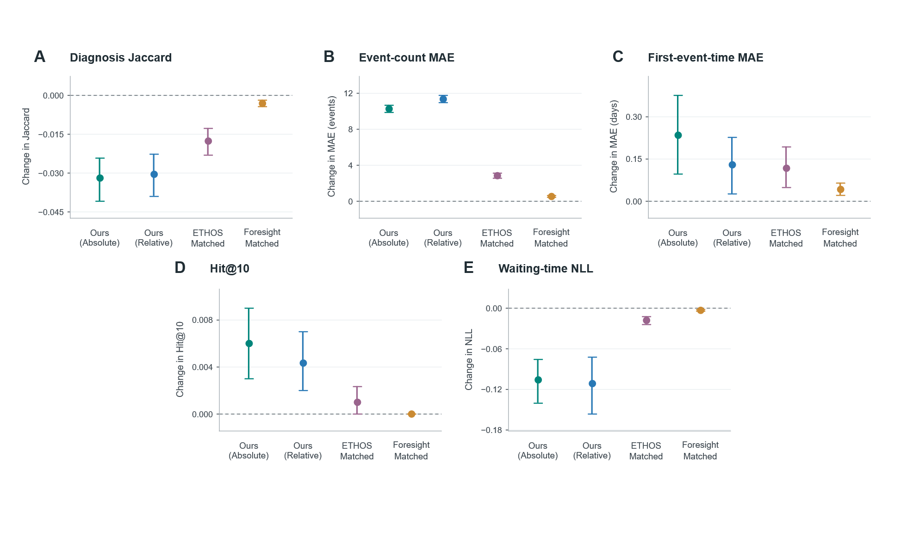
Figure 3. Effects of death token blocking on trajectory generation in UK Biobank. Panels show changes in diagnosis Jaccard, event count mean absolute error (MAE), first-event-time MAE in days, Hit@10, and waiting time negative log likelihood (NLL). Points indicate mean paired differences, calculated as blocked minus original; error bars represent unadjusted 95% percentile confidence intervals. Panels include 1,000 validation patients, and trajectory sampling uses 20 rollouts per patient with a 10-year window and a 30 event cap. Blocking removes death from both event candidates and the waiting-time rate and prevents death-triggered termination; the experiment therefore evaluates their combined effect.

E. UKB future diagnosis-record discrimination
The UKB validation disease spectrum provides complementary evidence across diagnostic categories (Fig. 4). Among 80,546 participants, 186 ICD-10 categories met the threshold of 20 future records; median age sex stratified AUROC was 0.9063. This is exploratory future-record discrimination over remaining follow-up, not the fixed-horizon risk benchmark in Table IV.
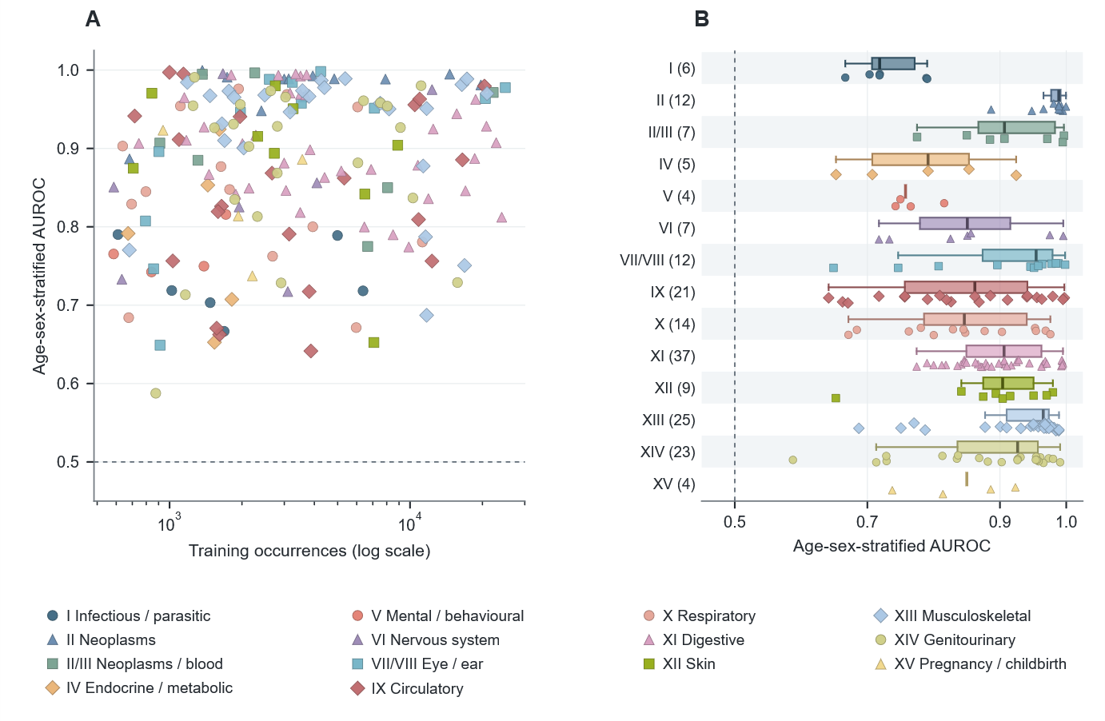
Figure 4. Exploratory UKB future diagnosis-record discrimination. A: age-sex-stratified AUROC versus training frequency for all 186 supported ICD-10 categories. B: the same values by source chapter group; parentheses give category counts. Dots are diseases; boxes show disease-level quartiles and 1.5-IQR whiskers, not uncertainty. This exploratory validation analysis is distinct from fixed-horizon risk.

F. MIMIC-IV adaptation and UKB-initialized transfer
For 78 supported future recorded diagnoses, Absolute/Relative achieved ordinary macro AUROCs of 0.8261/0.8272, compared with 0.6076 for diagnosis history and 0.5779 for the last diagnosis. Among 51 prefix-absent diagnoses, their AUROCs were 0.7707/0.7719. In the separate full-budget representation experiment, Relative improved rollout Jaccard over Absolute by 0.00172 and over index phase RoPE by 0.00249, without established superiority over ETHOS.
In this experiment, UKB initialization increased Jaccard from 0.01225 to 0.03702 for Absolute and from 0.01305 to 0.03670 for Relative (Fig. 5). ETHOS and Foresight showed similar gains of 0.02476 and 0.02495, respectively, whereas Med-BERT improved by 0.00233. After initialization, our Absolute model achieved the highest mean Jaccard and lowest Count MAE, while our Relative achieved the highest recall (0.05603), lowest first record Time MAE 118.77 days, and lowest normalized edit distance 0.82326.
Additionally, UKB initialization improved Jaccard and recall in all five models. Normalized edit distance decreased in both our models, ETHOS, and Foresight, but increased in Med-BERT. Time MAE was evaluated only for nonempty generated and reference futures. In short, these results support improved diagnostic-content generation after target-domain adaptation, rather than uniform improvement across generation endpoints, zero-shot transportability, or equal total pretraining compute.
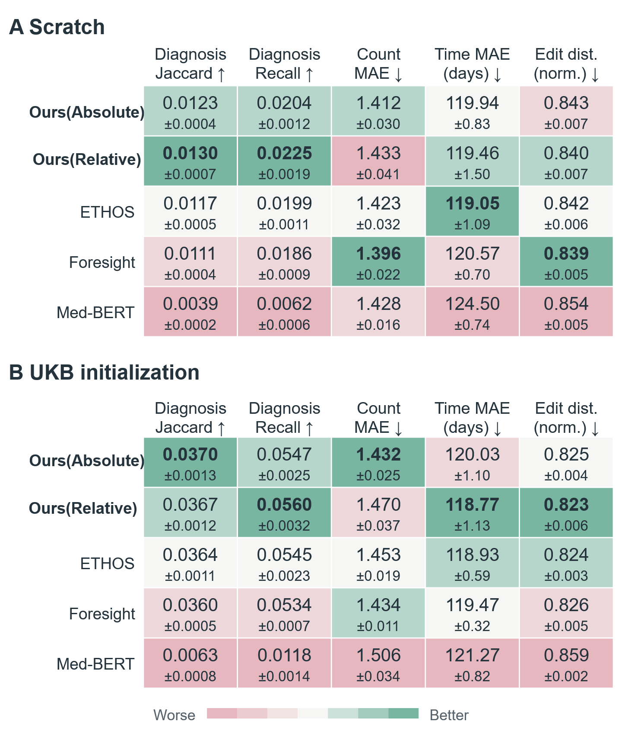
Figure 5. Effect of UKB initialization on free-generation performance in MIMIC-IV. (A) Training from scratch; (B) UKB-pretrained initialization, both with 10,000 target domain updates. Five models are evaluated using diagnosis Jaccard, recall, Count MAE, first-record Time MAE (days), and normalized edit distance. Values are mean +/- SD across three seeds, and green/red shading indicates better/worse rankings within each panel and metric. Bold values mark the best means, not statistical significance.

VI. DISCUSSION

A. Multitype continuous-time trajectory modeling
We developed MedTrajectory, a generative model for multitype longitudinal EHR trajectories that integrates heterogeneous clinical events with continuous temporal representations. Across the experiments reported here, expanding the event space beyond diagnosis-only sequences improved trajectory modeling, with procedures providing the largest incremental contribution. In UK Biobank, continuous relative-time information improved sampled clinical content, timing, and trajectory length, together with teacher-forced next-event ranking.
These findings suggest that longitudinal EHR trajectories are better modeled as heterogeneous clinical event processes than as disease sequences alone. Diagnoses describe observed disease states, whereas procedures, cancer related records, mortality events, and temporal intervals supply complementary information about patient state transitions. Notably, the benefit of relative time was obtained with a compact model, which suggests that representing clinical structure well may matter more than increasing model capacity in this setting.
Although the relative time model consistently improved sampled trajectory fidelity, absolute generation performance remained modest. The present results are therefore best read as evidence that richer event and temporal representations improve generative modeling, rather than as a demonstration of high precision simulation of individual patient futures. The distinction matters for downstream clinical use, where sequence realism, calibration, and decision utility each require separate validation.

B. Termination, risk readout and transfer
Improved trajectory generation did not establish a corresponding benefit in fixed horizon risk discrimination. The held out risk test produced a small positive seed averaged difference, with uncertainty spanning both improvement and deterioration. Generative trajectory modeling targets event types, ordering, timing, and trajectory length, whereas fixed-horizon risk prediction targets a predefined binary outcome. These results therefore support evaluating the two targets separately, rather than assuming that better generation preserves risk performance.
The relative time representation may thus contribute most strongly when the prediction target depends on the detailed temporal organization of multiple future events. Fixed horizon discrimination, by contrast, depends primarily on whether a target outcome occurs within a specified window, and much of the temporal structure that improves sequence realism may not alter the ranking of individuals for that binary endpoint. This interpretation is also consistent with the broad spectrum analysis, in which the generative representation retained substantial future disease signal despite only modest Relative versus Absolute differences in fixed horizon AUROC.
Death events further illustrate this distinction. In an autoregressive trajectory model, death simultaneously represents an observed clinical event and a potential sequence termination state. Our results indicate that event generation, trajectory termination, and clinical risk estimation should be treated as related but distinct modeling objectives.
C. Limitations and future directions
Firstly, MIMIC-IV includes dataset-specific training and adaptation from UKB-pretrained parameters, and we report both; this does not establish zero-shot transportability or unchanged-model external validation; broader generalization across healthcare systems and temporal representations requires further evaluation.
Secondly, the history future split in the locked generation task was defined by token count rather than aligned to a timestamp boundary. For 128 of 1,669 participants, the split therefore fell within a group of events sharing the same recorded age, such that some same time events entered the observed context while the remainder were withheld. This convention was prespecified and is reflected in the one-step waiting-time objective, which excludes same day targets, but its influence on the remaining trajectory endpoints was not separately quantified.
Additionally, event count agreement is partly coupled to the prespecified terminal-event rule. Because rollouts terminate when a mortality related event is generated, earlier terminal-event generation can mechanically shorten sampled trajectories. The mortality token ablation confirmed that this termination mechanism substantially affects event-count MAE; trajectory length results should therefore be interpreted jointly with the termination rule rather than as an independent count of events occurring within the follow up window.
Furthermore, the current model focuses on structured clinical events and does not yet incorporate medications, laboratory measurements, imaging, or clinical text, which may provide additional information about patient state. Future work should investigate multimodal longitudinal patient representations and evaluate their clinical utility in prospective settings.
Finally, the eligibility correction re-evaluated frozen risk models on eligible participants. An audit found no direct supervised-loss contribution from anchor-only records in the examined MedTrajectory training path. Feature-based baselines were not refitted or reselected on eligible-only data; their comparisons remain exploratory.

VII. CONCLUSION
We present MedTrajectory, an autoregressive model for multitype longitudinal EHRs that combines heterogeneous clinical events with absolute age and continuous relative time representations. MedTrajectory integrates multitype clinical events with absolute age and continuous relative-time attention for future-trajectory generation, with a separate horizon-query risk readout. UKB establishes improved generation with the relative time branch. Death token analysis clarifies the contribution of termination while showing that the content advantage persists after token blocking. MIMIC-IV demonstrates task adaptation and improved generated diagnostic content from UKB initialization, with count and endpoint-specific tradeoffs. These findings support the framework's modeling and transfer value, the corrected risk result and retrospective protocols delimit claims about clinical prediction and deployment.

Code Availability
The MedTrajectory source code and the full supplementary material are available at https://github.com/yang-shuai-yu/MedTrajectory under the Apache License 2.0. Access-controlled UK Biobank and MIMIC-IV records are not redistributed.

ACKNOWLEDGMENT
The author used a commercially available large language model for English-language editing and readability improvement of this manuscript. The tool was used for language polishing only; it did not generate scientific content, data, analyses, or conclusions. The author reviewed and verified all text and takes full responsibility for the content of this article.

REFERENCES
[1] Y. Li et al., "BEHRT: Transformer for electronic health records," Sci. Rep., vol. 10, Art. no. 7155, 2020, doi: 10.1038/s41598-020-62922-y.
[2] L. Rasmy, Y. Xiang, Z. Xie, C. Tao, and D. Zhi, "Med-BERT: Pretrained contextualized embeddings on large-scale structured electronic health records for disease prediction," npj Digit. Med., vol. 4, Art. no. 86, 2021, doi: 10.1038/s41746-021-00455-y.
[3] Z. Kraljevic et al., "Foresight—a generative pretrained transformer for modelling of patient timelines using electronic health records: A retrospective modelling study," Lancet Digit. Health, vol. 6, no. 4, pp. e281–e290, Apr. 2024, doi: 10.1016/S2589-7500(24)00025-6.
[4] P. Renc et al., "Zero shot health trajectory prediction using transformer," npj Digit. Med., vol. 7, Art. no. 256, 2024, doi: 10.1038/s41746-024-01235-0.
[5] A. Shmatko et al., "Learning the natural history of human disease with generative transformers," Nature, vol. 647, no. 8088, pp. 248–256, Nov. 2025, doi: 10.1038/s41586-025-09529-3.
[6] P. Wu et al., "Mapping ICD-10 and ICD-10-CM codes to phecodes: Workflow development and initial evaluation," JMIR Med. Inform., vol. 7, no. 4, Art. no. e14325, 2019, doi: 10.2196/14325.
[7] E. Choi, M. T. Bahadori, L. Song, W. F. Stewart, and J. Sun, "GRAM: Graph-based attention model for healthcare representation learning," in Proc. 23rd ACM SIGKDD Int. Conf. Knowledge Discovery and Data Mining, 2017, pp. 787–795, doi: 10.1145/3097983.3098126.
[8] Y. Gu et al., "Domain-specific language model pretraining for biomedical natural language processing," ACM Trans. Comput. Healthcare, vol. 3, no. 1, pp. 1–23, Jan. 2022, doi: 10.1145/3458754.
[9] F. Liu, E. Shareghi, Z. Meng, M. Basaldella, and N. Collier, "Self-alignment pretraining for biomedical entity representations," in Proc. Conf. North American Chapter Assoc. Computational Linguistics: Human Language Technologies, 2021, pp. 4228–4238, doi: 10.18653/v1/2021.naacl-main.334.
[10] E. Choi, M. T. Bahadori, A. Schuetz, W. F. Stewart, and J. Sun, "Doctor AI: Predicting clinical events via recurrent neural networks," in Proc. Machine Learning for Healthcare Conf., PMLR, vol. 56, 2016, pp. 301–318.
[11] E. Choi, M. T. Bahadori, J. A. Kulas, A. Schuetz, W. F. Stewart, and J. Sun, "RETAIN: An interpretable predictive model for healthcare using reverse time attention mechanism," in Advances in Neural Information Processing Systems, vol. 29, 2016.
[12] C. Lee, W. R. Zame, J. Yoon, and M. van der Schaar, "DeepHit: A deep learning approach to survival analysis with competing risks," in Proc. AAAI Conf. Artif. Intell., vol. 32, no. 1, 2018, doi: 10.1609/aaai.v32i1.11842.
[13] C. Lee, J. Yoon, and M. van der Schaar, "Dynamic-DeepHit: A deep learning approach for dynamic survival analysis with competing risks based on longitudinal data," IEEE Trans. Biomed. Eng., vol. 67, no. 1, pp. 122–133, Jan. 2020, doi: 10.1109/TBME.2019.2909027.
[14] Z. Wang and J. Sun, "SurvTRACE: Transformers for survival analysis with competing events," in Proc. 13th ACM Int. Conf. Bioinformatics, Computational Biology and Health Informatics (ACM-BCB), 2022, pp. 1–9, doi: 10.1145/3535508.3545521.
[15] H. Shinohara et al., "The potential of the transformer-based survival analysis model, SurvTrace, for predicting recurrent cardiovascular events and stratifying high-risk patients with ischemic heart disease," PLoS One, vol. 19, no. 6, Art. no. e0304423, 2024, doi: 10.1371/journal.pone.0304423.
[16] C. Pang et al., "CEHR-BERT: Incorporating temporal information from structured EHR data to improve prediction tasks," in Proc. Machine Learning for Health, PMLR, vol. 158, 2021, pp. 239–260.
[17] J. Luo, M. Ye, C. Xiao, and F. Ma, "HiTANet: Hierarchical time-aware attention networks for risk prediction on electronic health records," in Proc. 26th ACM SIGKDD Int. Conf. Knowledge Discovery and Data Mining, 2020, pp. 647–656, doi: 10.1145/3394486.3403107.
[18] P. Renc et al., "Foundation model of electronic medical records for adaptive risk estimation," GigaScience, vol. 14, Art. no. giaf107, 2025, doi: 10.1093/gigascience/giaf107.
[19] Alibaba Cloud, "Embedding," Alibaba Cloud Model Studio documentation. Accessed: Sep. 16, 2026. [Online]. Available: https://www.alibabacloud.com/help/en/model-studio/embedding
[20] A. Vaswani et al., "Attention is all you need," in Advances in Neural Information Processing Systems, vol. 30, 2017.
[21] J. Su, M. Ahmed, Y. Lu, S. Pan, W. Bo, and Y. Liu, "RoFormer: Enhanced transformer with rotary position embedding," Neurocomputing, vol. 568, Art. no. 127063, 2024, doi: 10.1016/j.neucom.2023.127063.
[22] Z. Song, Q. Lu, H. Zhu, D. Buckeridge, and Y. Li, "TrajGPT: Irregular time-series representation learning of health trajectory," IEEE J. Biomed. Health Inform., vol. 30, no. 5, pp. 3888–3899, May 2026, doi: 10.1109/JBHI.2025.3620205.
[23] C. Sudlow et al., "UK Biobank: An open access resource for identifying the causes of a wide range of complex diseases of middle and old age," PLoS Med., vol. 12, no. 3, Art. no. e1001779, 2015, doi: 10.1371/journal.pmed.1001779.
[24] A. E. W. Johnson et al., "MIMIC-IV, a freely accessible electronic health record dataset," Sci. Data, vol. 10, Art. no. 1, 2023, doi: 10.1038/s41597-022-01899-x.

