Supplementary Materials
Supplementary Tables S1-S33 are provided in the accompanying Supplementary_Tables.xlsx workbook. Worksheet names match the table numbers. Supplementary Figures S1-S5 and the supplementary text remain in this document.

Supplementary S1. Cohort construction and EHR data sources

S1.1 Study population and longitudinal cohort construction
Patient trajectories were constructed from longitudinal health records in the UK Biobank (UKB). The source cohort comprised 502,411 participants. Among these, 471,239 participants were alive on 1 July 2020 and constituted the longitudinally observable population used to define the main longitudinal cohort.
Participants were first identified as longitudinally observable if they were alive on 1 July 2020. This yielded 471,239 participants. Within this longitudinally observable population, 378,574 satisfied the longitudinal eligibility criteria, defined as availability of a usable birth-time anchor and at least one observed clinical event. The remaining 92,665 participants were anchor-only. Thus, 378,574 refers specifically to the eligible subset of the longitudinally observable cohort and should not be interpreted as the model-development sample.
Clinical events were linked to participant age using the available birth-time anchor and ordered chronologically to construct individual longitudinal trajectories. The modeled event space included diagnoses, procedures, cancer registrations, and mortality-related records. Detailed source fields, coding systems, event standardization procedures, and vocabulary construction are described in Supplementary S2.

S1.2 Participant level base partitioning
The full UKB source population was assigned to mutually exclusive participant-level training (397,049), validation (99,263), and risk-test (6,099) partitions. The test EIDs were inherited from a preceding explicit split and fixed before protocol-specific retraining; all records from a participant remained in one partition. Here, locked evaluation refers to the frozen evaluation protocol, not a claim that the partition had never been inspected in earlier developmental work.
Because model eligibility was determined after partition assignment, not all participants within each base partition contributed usable model inputs. Base model-input eligibility was assessed independently within each base partition and required a usable birth-time anchor together with at least one observed clinical event; equivalently, the participant was not anchor-only. Across the complete source population, 408,786 participants satisfied this criterion: 322,205 in the training partition, 80,546 in the validation partition, and 6,035 in the held-out test partition. This base eligibility definition does not include the additional requirement of survival to 1 July 2020 used to define the longitudinally observable cohort in S1.1.

S1.3 Task-specific analysis cohorts and temporal definitions
Within the held-out test partition of 6,099 participants, 1,669 satisfied the prespecified trajectory-generation eligibility criteria of at least eight observed historical events and at least three future events. These participants constituted the locked trajectory-generation cohort. The generation cohort was therefore a task-specific subset of the held-out test partition rather than an independent participant partition. The generation evaluation followed the locked Track G protocol. The same participant partition had previously been inspected during development of non-MedTrajectory risk baselines; those comparisons remain exploratory (S10).
For the primary trajectory-generation evaluation, a locked analysis cohort of 1,669 eligible participants was used. Each participant trajectory was divided chronologically, with the first 65% of the longitudinal event sequence retained as observed context and the subsequent portion withheld as the participant-specific future trajectory. Autoregressive generation proceeded from this split point over a follow-up window of up to 10 years. Each model generated 20 autoregressive rollouts per participant. All 1,669 participants contributed finite values to Diagnosis Jaccard, Hit@10, first-event-time MAE, and event-count MAE. The separate one-step waiting-time objective was evaluable in 1,541 participants, because same-day future targets were excluded from its likelihood calculation by pre-specification. Additional eligibility requirements, sampling parameters, termination rules, and effective sample sizes are described in Supplementary S5.
The fixed-horizon risk-test partition contained 6,099 participants, of whom 6,035 were base model-input eligible. After enforcing model_eligible=1 and anchor_only=0, 4,668 contributed 260,110 participant-landmark-horizon-outcome records. Historical outputs had inadvertently included 53 anchor-only participants contributing 2,090 records; S13 documents the correction. Age-band landmarks and horizon-specific outcome masks determine which eligible participants contribute records. Controls require event-free follow-up through the complete 1-, 5-, or 10-year prediction window.
These task-specific analyses were intentionally separated. The generation analysis evaluates the content, ordering, timing, and length of an individually withheld future trajectory, whereas the fixed-horizon analysis evaluates whether predefined clinical outcomes occur within specified follow-up intervals.

S1.4 Ethics, data access, and informed consent
[TO BE FILLED: UK Biobank application number.]
[TO BE FILLED: ethics approval / REC reference.]
[TO BE FILLED: informed-consent statement.]
[TO BE FILLED: data-access conditions.]
Supplementary Table S1. UK Biobank cohort, base partitions, and analysis subsets. Base model-input eligibility refers to the non-anchor-only criterion applied across the complete source population. Longitudinal eligibility additionally requires survival to the 1 July 2020 landmark. The locked generation cohort is a task-specific subset of the held-out test partition (1,669 of 6,099), not an additional base partition.
Full table: Supplementary_Tables.xlsx, worksheet S1.

Supplementary S2. Clinical event representation and vocabulary construction

S2.1 Dynamic clinical event sources
MedTrajectory represents each participant record as a unified chronological sequence of timestamped clinical events. Four dynamic event types were included: diagnoses, procedures, cancer registrations, and mortality-related records. Diagnoses were extracted from UK Biobank fields 41202/41262, procedures from fields 41200/41260, cancer registrations from fields 40006/40005, and mortality-related records from fields 40001/40000.
Diagnosis, cancer-registration, and mortality-related records were standardized to three-character ICD-10 categories. Procedure events retained OPCS-4 codes. Each standardized clinical concept was mapped to a discrete event token and paired with the participant's age at the recorded event. The resulting dynamic vocabulary contained 8,424 clinical-event tokens, including 1,123 diagnosis tokens, 6,634 procedure tokens, 127 cancer-registration tokens, and 538 mortality-related tokens. Including model-control and special tokens, the full vocabulary contained 8,445 tokens.
The multitype representation was designed to preserve the heterogeneous nature of longitudinal healthcare records rather than reducing each trajectory to a diagnosis-only sequence. In particular, procedures provide information about diagnostic and therapeutic interventions, whereas cancer-registration and mortality-related records represent clinically important disease-progression and terminal-state information. The contribution of these event classes was evaluated explicitly in the event-space ablations reported in Supplementary S8.

S2.2 Temporal ordering and trajectory construction
For each participant, clinical-event dates were converted to continuous age relative to the participant-specific birth-time anchor. Events were then ordered chronologically to construct a single longitudinal sequence.
When multiple clinical events shared the same recorded age, a deterministic tie-breaking rule was applied based on the frozen vocabulary ordering rather than clinical importance. Specifically, same-age events were ordered by ascending vocabulary token identifier. Token identifiers were assigned according to lexicographic ordering of token keys, whose registered prefixes were cancer:, death:, diag:, and proc:. Consequently, the resulting deterministic ordering among same-age events was cancer registrations, followed by mortality-related events, diagnoses, and procedures, with lexicographic ordering applied within each event type.
This ordering rule is solely a reproducibility convention and does not encode a clinical priority or causal relationship between event types. Because the vocabulary was frozen before model training, identical source records always produced the same canonical event sequence across preprocessing runs, model variants, and random seeds.
Each dynamic event was represented by both its discrete event identity and its continuous age of occurrence. Absolute age was used by the temporal encoding described in Supplementary S3, whereas pairwise differences between event ages were used by the continuous relative-time attention mechanism.

S2.3 Recruitment-derived static context
In addition to dynamic clinical events, MedTrajectory incorporated four participant-level contextual variables as prefix tokens: sex, body mass index (BMI), smoking status, and alcohol use. The corresponding UK Biobank fields were 31, 21001, 20116, and 1558, respectively. Recruitment age was obtained from field 21022 and was used as the observation-time anchor for these recruitment-derived contextual variables; it was not represented as an additional fifth static-context token.
Because these contextual variables were observed at recruitment rather than throughout the participant's life course, they were not made visible to model states corresponding to ages before recruitment. For an event occurring before the recruitment age, the recruitment-derived context remained masked; it became available only for events occurring at or after recruitment. This temporal-visibility rule was applied to prevent information observed at recruitment from leaking into earlier portions of the longitudinal trajectory. The same principle is reflected in the main manuscript, where static context is described as masked before recruitment and visible thereafter.
Ethnicity, height, and weight were not included as separate contextual inputs in the current MedTrajectory configuration.

S2.4 Clinical code embedding initialization
Clinical-event embeddings remained trainable. UKB ICD-10 diagnosis, cancer-registration, and mortality tokens used an ICD-10 2019 English reference prior: structured text containing code, label, block, chapter, hierarchy level, and a task prompt was encoded with Qwen text-embedding-v4 (1,024 dimensions) and reduced to 64 dimensions by PCA. The supplied input matrix contained 1,781 exact mappings and six aliases, including I84 to K64. The unmatched death:U50 entry and 6,634 non-ICD procedure/other entries had zero initial vectors, rather than semantic reference vectors or random fallback vectors. All entries remained learnable.
The semantic initialization procedure itself is not treated as a primary contribution of MedTrajectory. Detailed comparisons among ICD hierarchy representations, ontology-based representations, PubMedBERT, and Qwen text embeddings, together with dimensionality-reduction analyses, are reported separately in Supplementary S12.
This organization separates two distinct aspects of the input representation: S2 defines how clinical events and patient context are constructed and presented to the model, whereas Supplementary S12 evaluates alternative initialization strategies for ICD-based token embeddings.
Supplementary Table S2. UK Biobank clinical event sources and vocabulary composition
Full table: Supplementary_Tables.xlsx, worksheet S2.
Supplementary Table S3. Patient context variables
Full table: Supplementary_Tables.xlsx, worksheet S3.

Supplementary S3. Model architecture and prediction objectives

S3.1 Autoregressive backbone
MedTrajectory uses a decoder-only causal Transformer to model longitudinal clinical-event sequences autoregressively. The UK Biobank configuration contains six Transformer layers, eight attention heads, and a hidden dimension of 64, corresponding to approximately 1.39 million trainable parameters. Each Transformer block uses RMSNorm and a SwiGLU feed-forward module. A causal attention mask restricts each position to preceding clinical events and temporally available patient context, enabling autoregressive generation of future patient trajectories.
Dynamic clinical events are represented by trainable token embeddings and are supplemented with continuous temporal information. Both principal model variants use the same backbone, vocabulary, static-context representation, prediction heads, and training objectives. MedTrajectory Absolute incorporates continuous absolute age only, whereas MedTrajectory Relative additionally introduces a continuous relative-time transformation within self-attention. Thus, their comparison isolates the contribution of relative temporal information while holding the remaining architecture fixed.
The detailed absolute-age representation and continuous relative-time transformation are described in Supplementary S3.2 and S3.3, respectively.

S3.2 Continuous absolute age encoding
Absolute age encodes the participant's position in the life course independently of ordinal token position. Each clinical event $e_{i}$ is paired with its occurrence age $a_{i}$, measured in days relative to the participant-specific birth-time anchor. Before being combined with the event embedding, age is converted from days to years,
$$τ_{i}=\frac{a_{i}}{365.25}.$$
For embedding dimension $d=64$, the sinusoidal frequency basis is
$$ω_{k}={10000}^{-2k/d}, k=0,…,\frac{d}{2}-1.$$
The unprojected age representation is defined by
$$\tilde{A}{\left(a_{i}\right)}_{2k}=sin⁡\left(τ_{i}ω_{k}\right), \\ \tilde{A}{\left(a_{i}\right)}_{2k+1}=cos⁡\left(τ_{i}ω_{k}\right).$$
Unlike a fixed sinusoidal positional encoding, MedTrajectory subsequently applies a learnable linear projection without bias,
$$A\left(a_{i}\right)=W_{A}\tilde{A}\left(a_{i}\right), W_{A}∈R^{64×64},$$
and adds the resulting vector to the trainable event-token embedding:
$$h_{i}^{\left(0\right)}=E\left(e_{i}\right)+A\left(a_{i}\right).$$
Thus, absolute age is initialized from a standard sinusoidal frequency basis but can be reweighted and recombined through the learned projection $W_{A}$. Patient-level context is incorporated separately through the temporally gated prefix described in Supplementary S2.
The same absolute-age representation is retained in both MedTrajectory-Absolute and MedTrajectory-Relative. Consequently, the Relative-versus-Absolute comparison evaluates the additional effect of continuous inter-event temporal relationships without removing information about absolute life stage.

S3.3 Data adaptive continuous relative-time attention
MedTrajectory-Relative supplements absolute life-stage information with a continuous relative-time transformation inside self-attention. In contrast to the fixed frequency basis used for absolute-age encoding, the final relative-time mechanism (additive_v2_2) derives its characteristic temporal scales from the empirical distribution of inter-event intervals in the training data.
Let
$$g_{n}=a_{n+1}-a_{n}, g_{n}>0$$
denote the positive gap, in days, between consecutive dynamic clinical events in the training set. The lower and upper wavelength bounds are defined as
$λ_{lo}=max(2P_{1}(g),7), λ_{hi}=1.5P_{95}(g).$
where $P_{1}$ and $P_{95}$ denote the first and 95th percentiles of the positive inter-event-gap distribution.
A geometrically spaced wavelength grid is then constructed:
$${\left\{λ_{m}\right\}}_{m=1}^{HK}=\operatorname{GeomSpace}\left(λ_{lo} , λ_{hi} , HK\right),$$
with $H=8$ attention heads and $K=4$ frequency pairs per head, yielding 32 initial temporal wavelengths. The grid is rearranged into a head-major layout such that each attention head receives four temporal scales spanning the overall wavelength range.
For attention head $h$ and frequency pair $k$, the base angular frequency is
$$ω_{h,k}^{\left(0\right)}=\frac{2π}{λ_{h,k}},$$
with units of radians per day. Each frequency is then modulated by a learnable bounded scale
$$s_{h,k}=\exp\left[ln⁡\left(2\right)tanh⁡\left(ρ_{h,k}\right)\right],$$
where $ρ_{h,k}$ is trainable and
$$s_{h,k}∈\left(0.5 , 2\right).$$
The effective angular frequency is therefore
$$ω_{h,k}=ω_{h,k}^{\left(0\right)}s_{h,k},$$
and the corresponding effective wavelength is
$$λ_{h,k}^{eff}=\frac{λ_{h,k}}{s_{h,k}}.$$
Unlike the absolute-age encoding, the relative-time phase is constructed after centering each sequence at its first event:
$${\tilde{a}}_{b,t}=a_{b,t}-a_{b,0}.$$
The phase for batch element $b$, head $h$, sequence position $t$, and frequency pair $k$ is
$$ϕ_{b,h,t,k}={\tilde{a}}_{b,t}ω_{h,k}.$$Because $\tilde{a}$ is measured in days and $ω$ in radians per day, $ϕ$ is expressed in radians. Centering removes dependence on a constant shift of the entire patient timeline and makes the rotary component explicitly sensitive to relative temporal structure.
For a paired query or key representation $x$, the rotary transformation is
$$Rot⁡\left(x , ϕ\right)=x\cos{ϕ}+rot⁡\left(x\right)\sin{ϕ},$$
where $rot⁡\left(⋅\right)$ denotes the standard pairwise two-dimensional rotation. The transformation is applied to queries and keys,
$$q_{b,h,t}^{'}=Rot⁡\left(q_{b,h,t} , ϕ_{b,h,t}\right), \\ k_{b,h,t}^{'}=Rot⁡\left(k_{b,h,t} , ϕ_{b,h,t}\right),$$
whereas the value pathway remains unchanged.
Because the interaction between two rotated representations depends on their phase difference,
$$ϕ_{i}-ϕ_{j}∝a_{i}-a_{j},$$
attention becomes sensitive to the actual continuous time separating clinical events rather than only their token distance. The Absolute model omits this relative-time transformation while retaining the absolute-age encoding defined in Supplementary S3.2.
An earlier developmental CARoPE formulation used the conventional rotary basis
$$ω_{k}={10000}^{-2k/d_{h}},$$
with age converted to years $\left(a/365.25\right)$ and additional per-head learnable scaling. This legacy formulation is distinct from the data-adaptive additive_v2_2 mechanism used in the final MedTrajectory-Relative model and is reported only as a developmental ablation in Supplementary S9.
Supplementary Table S4. Comparison of temporal representations used in MedTrajectory.
Full table: Supplementary_Tables.xlsx, worksheet S4.

S3.4 Joint event and waiting-time objective
Let $z_{v}$ denote next-event logits. Event probabilities use a categorical softmax. For the waiting-time rate, the implementation excludes ignored tokens and the no-event token, computes $L=logsumexp(z_{v})$, and sets $r=\frac{1}{exp(−L)+ε}$, with $ε=0.1 day$. The positive-gap objective is $−log(r)+r[max(Δt,1 day)+ε]$. Next-event cross-entropy and this objective are added during pretraining. Valid time targets must have strictly positive observed gaps; static-prefix and BOS targets are excluded by the time-loss mask.
At rollout, event identity is drawn after temperature 0.8 and top-p 0.9 filtering, while the rate uses the untempered logits. An independent uniform draw $U$ produces $max(1 day,\frac{−log(U)}{r}−ε)$. Conditional on the history and logits, this waiting-time draw does not depend on the sampled event identity. Thus the reported NLL is the frozen positive-gap exponential objective, not the likelihood of the subsequently clamped rollout distribution. The auxiliary log-gap regression head has zero loss weight in the final configuration and is not used by the sampler.

S3.5 Monotonic disease-risk head and posttraining
The disease-risk head uses learned horizon queries at 1, 5, and 10 years. For each horizon, rotary transformations are applied to the query at current age plus the horizon and to the hidden state at current age. Pairwise dot and cross features are concatenated, linearly projected, added to the hidden state, normalized, and passed through a disease-specific linear output layer. This horizon-query construction is shared by the Absolute and Relative backbone variants.
For raw outputs $u_{1},u_{2},u_{3}$ of a disease, cumulative-risk logits are $g_{1}=u_{1}$, $g_{2}=u_{1}+softplus(u_{2})$, and $g_{3}=u_{1}+softplus(u_{2})+softplus(u_{3})$; probabilities are $sigmoid(g_{h})$. Masked binary cross-entropy is averaged over outcome-observable disease–horizon labels at the selected prediction position. Risk posttraining jointly updates the backbone and risk head from the final pretraining checkpoint for 10,000 iterations with loss $0.2(L_{CE}+L_{dt})+L_{horizon}$. The auxiliary gap-regression coefficient is zero. This head is distinct from the frozen-backbone mortality head in S11.5.

Supplementary S4. Training configuration and reproducibility

S4.1 MedTrajectory training configuration
The MedTrajectory architecture, temporal representations, and prediction objectives are described in Supplementary S3. This section reports the optimization, training-budget, numerical, and hardware settings used for the experiments reported in the main manuscript.
The principal MedTrajectory models were trained using AdamW with $β_{1}=0.9$ and $β_{2}=0.99$. The batch size was 128. The initial learning rate was $3×{10}^{-4}$ and was decayed to a minimum of $3×{10}^{-5}$ using a cosine schedule with 500 warm-up iterations. Weight decay was 0.1, gradient clipping was applied at a maximum norm of 1.0, and dropout was 0.1. Generative pretraining was performed for 100,000 optimization iterations.
The maximum model context contained 133 tokens, comprising four temporally gated static-context tokens, one beginning-of-sequence token, and up to 128 dynamic clinical-event tokens. Training was performed in fp32 without mixed-precision optimization. The reported MedTrajectory experiments used three predefined random seeds (42, 43, and 44). Training was conducted on CUDA-enabled NVIDIA RTX 4090D GPUs.
For downstream fixed-horizon risk modeling, the pretrained longitudinal backbone was coupled to the risk head described in Supplementary S3. Risk-head optimization used the separate fine-tuning objective defined in Supplementary S3, with a next-event loss weight of 0.2 and a horizon-risk loss weight of 1.0. Risk-head fine-tuning was performed for 10,000 iterations. The generative trajectory evaluation and the downstream risk evaluation were conducted under their respective frozen evaluation protocols described in Supplementary S5 and S6.
Supplementary Table S5. MedTrajectory training and implementation configuration.
Full table: Supplementary_Tables.xlsx, worksheet S5.

S4.2 Training of matched generative baselines
ETHOS-Matched and Foresight-Matched were implemented as task-level generative baselines for comparison under the same longitudinal prediction setting. They were not evaluated using the original published checkpoints and should not be interpreted as exact reproductions of the published ETHOS or Foresight systems. Instead, the matched implementations were trained using the same participant partitions, clinical-event vocabulary, longitudinal task definition, and overall training budget used for the MedTrajectory generation experiments.
Both matched generative baselines used a batch size of 128 and were trained for 100,000 optimization iterations. Their optimizer schedule used an initial learning rate of $6×{10}^{-4}$, a minimum learning rate of $6×{10}^{-5}$, 1,000 warm-up iterations, and weight decay of 0.2. The same predefined training seeds (42, 43, and 44) were used for the matched generation comparisons.
These matched baselines therefore provide comparisons under a common generation task and data representation rather than controlled reproductions of the original published model implementations.
Supplementary Table S6. Training configuration for the matched generative baselines. ETHOS-Matched and Foresight-Matched are task-level matched implementations trained under the common trajectory-generation framework used in this study. They are not exact reproductions of the originally published systems or evaluations of their official checkpoints.
Full table: Supplementary_Tables.xlsx, worksheet S6.

S4.3 Reproducibility and experiment freezing conventions
All participant-level dataset assignments were fixed before model fitting, and records from the same participant were retained within a single partition. The frozen participant assignments were used consistently across MedTrajectory variants, random seeds, and matched baselines. Clinical-event vocabulary construction and canonical trajectory ordering were likewise fixed before model training, as described in Supplementary S1 and S2.
Model development, hyperparameter selection, and architectural modification were performed using development and validation data. The principal temporal-model comparison, the locked trajectory-generation evaluation protocol, and its primary endpoint were specified before evaluation on the locked generation test set. No model architecture or sampling configuration was modified on the basis of performance observed in that locked test set. Protocol-specific evaluation and statistical procedures are described separately in Supplementary S5 and S6.

Supplementary S5. Trajectory generation evaluation protocol and metrics

S5.1 Locked trajectory generation cohort and context future construction
Trajectory generation performance was evaluated on a locked analysis cohort of 1,669 participants. This analysis was designed as a retrospective held out generation task: future clinical events were withheld from each participant's observed longitudinal history and were subsequently used only for comparison with autoregressively generated trajectories. No prospective enrollment or real-time prediction was involved.
For each eligible participant, the longitudinal clinical event sequence was divided chronologically. The first 65% of the trajectory was retained as the observed context, and the remaining portion was withheld as the participant-specific future trajectory. Participants were required to have at least eight observed historical events before the split point and at least three future events available after the split point. Generation began at the individual participant-specific split point and proceeded for a maximum follow-up duration of 10 years.
Each evaluated model generated 20 independent autoregressive future trajectories per participant. The same locked cohort, context future construction, and rollout protocol were applied across MedTrajectory variants and matched generative baselines. All the 1,669 participants contributed valid information to the first-event-time analysis and the remaining trajectory fidelity endpoints.
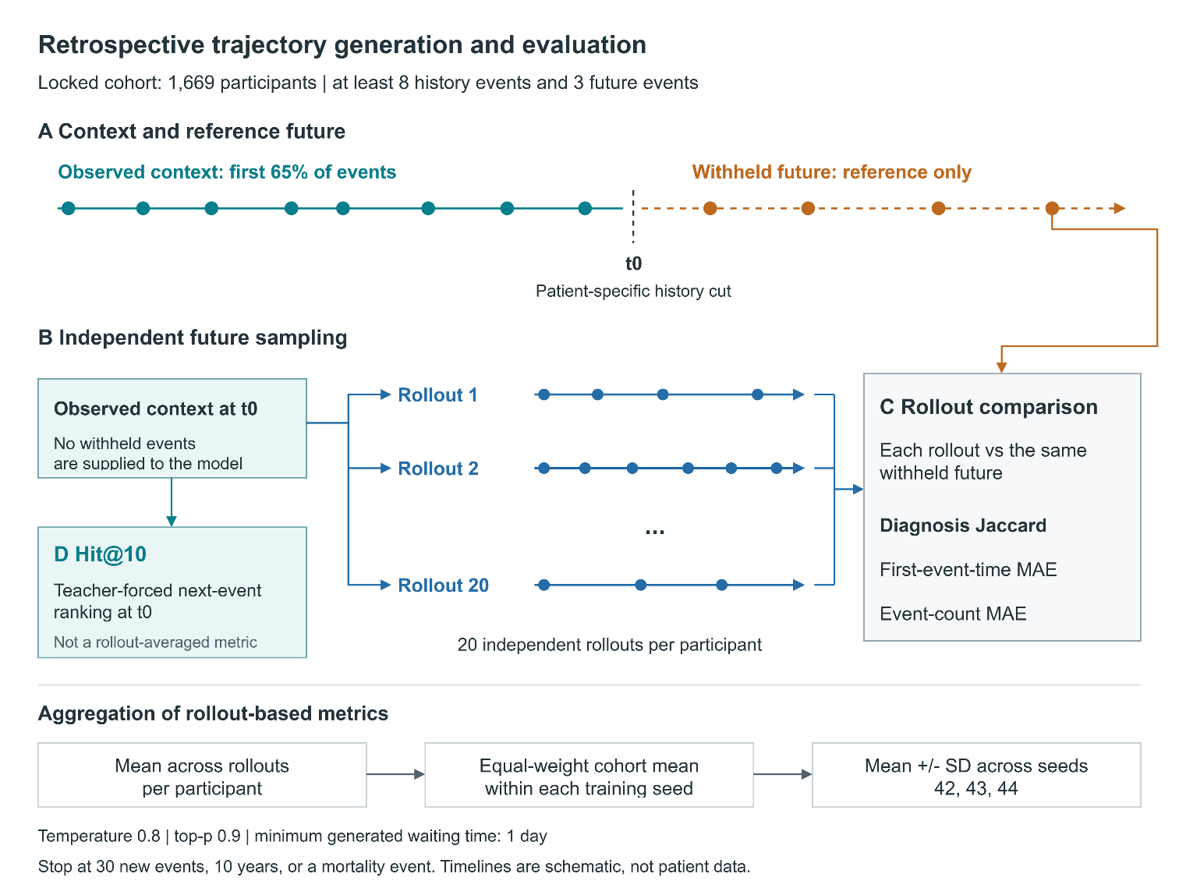
Supplementary Figure S1. Retrospective generation protocol. (A) The first 65% of events provides context; remaining events form the reference future. (B) Twenty rollouts share the same history boundary. (C) Diagnosis Jaccard, first-event-time MAE, and event-count MAE are averaged across rollouts within participants, then across participants within each seed. (D) Hit@10 uses teacher-forced ranking at the history boundary, without rollout averaging. Timelines are schematic.

S5.2 Autoregressive rollout procedure
At each generation step, the model produced a categorical distribution over candidate next clinical events and a corresponding waiting-time prediction. Event sampling was performed after softmax normalization of the next-event logits. Tokens not eligible for clinical-event generation, including ignored control tokens and the no-event token, were removed from the candidate distribution before sampling.
Event identity was sampled using a temperature of 0.8 and nucleus sampling with a top-$p$ threshold of 0.9. The temperature adjustment was applied to event identity only and did not modify the waiting-time prediction. No additional logit bias was applied to mortality-related events.
Generated waiting times were constrained to be at least one day to preserve chronological progression. Each rollout was permitted to generate at most 30 new clinical events and was terminated earlier if either the 10-year follow-up limit was reached or a mortality-related terminal event was generated.
The resulting rollout therefore jointly reflected sampled clinical-event identity, predicted inter-event timing, and trajectory termination under a fixed generation protocol. Sampling parameters were held constant across the principal MedTrajectory comparison and matched generative baselines.
The reference future uses the same 10-year window but no 30-event count cap. Empty generated trajectories contribute to set and count metrics but not to first-event-time MAE; participant means use finite rollout errors. If both diagnosis sets are empty, Jaccard is defined as 1; if only one is empty, it is 0. Event-type Jensen–Shannon divergence is 0 for two empty sequences and 1 when exactly one is empty.
Supplementary Table S7. Locked trajectory generation evaluation protocol.
Full table: Supplementary_Tables.xlsx, worksheet S7.

S5.3 Trajectory fidelity endpoints
Generated trajectories were evaluated using four complementary endpoints representing distinct properties of the withheld future trajectory: diagnostic content, immediate next-event prediction, first-event timing, and overall trajectory length. No single composite generation score was used.
Diagnosis Jaccard
Diagnosis Jaccard measured overlap between the set of diagnosis tokens in an individual generated rollout and the set of diagnosis tokens in the corresponding withheld future trajectory:
$$J\left(A , B\right)=\frac{∣A∩B∣}{∣A∪B∣},$$
where $A$ and $B$ denote the generated and observed future diagnosis sets, respectively. Jaccard similarity was calculated separately for each rollout and then averaged across the participant's evaluable rollouts. Higher values indicate greater diagnostic-content agreement. Diagnosis Jaccard was the prespecified primary trajectory-generation endpoint.
Hit@10
Hit@10 assessed one-step next event ranking at the context–future boundary. Unlike the rollout-based trajectory metrics, Hit@10 was calculated once per participant from the model's next-event distribution at the history cut point and therefore did not involve averaging across the 20 sampled trajectories.
The target was the next observed clinical event in the reference future trajectory. Hit@10 was equal to one when this target appeared among the ten highest-ranked candidate events and zero otherwise. Higher values indicate better immediate next-event ranking.
First event time mean absolute error
First-event-time MAE measured the absolute difference, in days, between the time of the first generated future event and the time of the first event in the corresponding reference future trajectory:
$${AE}_{ir}^{\left(time\right)}=∣{\hat{t}}_{ir,1}-t_{i,1}∣,$$
where $i$ indexes participants and $r$ indexes autoregressive rollouts.
The metric was calculated separately for each rollout for which both the generated trajectory and the reference future trajectory contained an evaluable first event. Non-finite or undefined rollout-level values, including those arising from empty generated trajectories, were excluded before averaging. The participant-level first-event-time MAE was therefore the arithmetic mean over that participant's evaluable rollouts, rather than necessarily all 20 rollouts.
The cohort level endpoint was subsequently obtained by averaging the participant-level values across evaluable participants. The locked analysis contained 1,669 participants with a finite participant-level first-event-time MAE. Lower values indicate better temporal agreement.
Event-count mean absolute error
Event-count MAE measured the absolute difference between the number of generated events in an individual rollout and the number of events in the corresponding withheld future trajectory:
$${AE}_{ir}^{\left(count\right)}=∣{\hat{n}}_{ir}-n_{i}∣.$$
The metric was calculated separately for each rollout and averaged across the participant's evaluable rollouts. Participant-level values were then averaged across the evaluation cohort. Lower values indicate better agreement in trajectory length and event density.
Supplementary Table S8. Trajectory generation endpoints.
Full table: Supplementary_Tables.xlsx, worksheet S8.

S5.4 Aggregation across rollouts and random seeds
For rollout-based trajectory metrics, aggregation was performed hierarchically. First, the metric was calculated separately for each autoregressive rollout and finite rollout-level values were averaged arithmetically to obtain one participant-level value. Second, participant-level values were averaged with equal weight across all participants with a finite value for that metric to obtain the cohort summary for each independently trained model seed. Thus, rollout-based results followed a two-stage aggregation,
$$m_{is}=\frac{1}{R_{is}}\sum_{r∈R_{is}}{m_{isr}},$$
followed by
$$M_{s}=\frac{1}{N_{s}}\sum_{i∈I_{s}}{m_{is}},$$
where $R_{is}$ denotes the set of evaluable rollouts for participant $i$ under training seed $s$, and $I_{s}$ denotes participants with a finite participant-level value.
For Hit@10, no rollout level averaging was performed because the metric was evaluated once at the observed history cut point. Other one step developmental metrics, including Hit@1, Hit@5, reciprocal rank, and waiting-time negative log likelihood, were likewise evaluated directly at the history cut and did not depend on sampled future rollouts.
The principal generation benchmark was evaluated independently for training seeds 42, 43, and 44. For each model and endpoint, the reported central value was the arithmetic mean of the three seed-specific cohort summaries. The accompanying $±$ value was the sample standard deviation across the three training seeds, calculated with $n-1$ degrees of freedom ($ddof=1$). It therefore quantifies between-seed variability and is not a participant-level confidence interval.

S5.5 Metric specific evaluability and paired participant sets
Metric specific analyses used all participants with finite values for the endpoint under comparison. Consequently, the effective paired participant set could differ slightly across endpoints. For paired model comparisons, a participant was retained only when that endpoint was finite for both compared models across all required training seeds. This metric-specific restriction was applied after establishing the common underlying participant cohort and does not reflect reassignment of participants between models or dataset partitions.

Supplementary S6. Fixed-horizon risk evaluation and statistical analysis

S6.1 Fixed-horizon clinical risk task
Fixed-horizon clinical-risk prediction was evaluated separately from autoregressive trajectory generation. Whereas the generation task assessed the content, timing, and length of an individually withheld future trajectory, the risk task evaluated whether a prespecified clinical outcome occurred within a defined follow-up horizon.
Risk prediction was evaluated at 1-, 5-, and 10-year horizons. Prediction landmarks were defined at ages 50, 55, 60, 65, 70, and 75 years. Evaluation was stratified by sex and age, with disease-specific predictions assessed independently at each horizon. The principal fixed-horizon benchmark used the held-out risk-test cohort described in Supplementary S1.

S6.2 Outcome observable label construction
For each disease outcome and prediction horizon $h$, labels were defined according to whether the outcome was observable over the complete prediction window. Let $T_{event}$ denote the time from the prediction landmark to the first occurrence of the target outcome and $T_{followup}$ the available event-free follow-up time. The horizon-specific label was defined as
$$Y_{h}=\left\{\begin{matrix}1, & T_{event}≤h, \\ 0, & T_{followup}≥h\text{ and }T_{event}>h, \\ \text{excluded}, & T_{followup}<h\text{ and no target event was observed}.\end{matrix}\right.$$
Thus, a participant was treated as a control only when follow-up was sufficient to establish that the target outcome did not occur during the complete prediction horizon. Participants whose follow-up ended before the horizon without a recorded target event were not treated as negative controls for that horizon.
Label eligibility was determined separately for each outcome, landmark, and prediction horizon. Consequently, the number of evaluable observations could differ across diseases and horizons.

S6.3 Risk prediction metrics and aggregation
Fixed-horizon risk performance was characterized using both discrimination and probabilistic-performance measures.
Area under the receiver operating characteristic curve (AUROC) measured discrimination between participants with and without the target outcome within the specified horizon.
Area under the precision recall curve (AUPRC) provided a complementary discrimination measure that is sensitive to outcome prevalence.
Brier score measured the mean squared difference between predicted probability and observed binary outcome, with lower values indicating better probabilistic accuracy.
Expected calibration error (ECE) used ten equal-width bins over [0,1]. Within each bin, the absolute difference between mean predicted probability and observed event frequency was weighted by the bin's fraction of evaluated rows. Bins were left-closed and right-open except the final bin, which included 1.
For the principal benchmark, metric values were macro averaged across valid combinations of sex, disease, prediction horizon, and age stratum. Each valid stratum contributed equally to the macro average rather than being weighted by its number of participants. Strata for which the corresponding metric could not be validly estimated were excluded from that metric specific macro average.
Supplementary Table S9. Fixed-horizon clinical risk evaluation protocol.
Full table: Supplementary_Tables.xlsx, worksheet S9.

S6.4 Statistical analysis of locked trajectory generation
Statistical comparisons of the locked trajectory-generation endpoints were performed using participant-level paired bootstrap resampling. The participant was the prespecified resampling unit. Before statistical inference, rollout-based metrics had already been collapsed to one participant-level value per model and training seed according to Supplementary S5; therefore, all repeated rollouts belonging to a participant entered or left a bootstrap sample together.
For a comparison between models $A$ and $B$, the paired effect within training seed $s$ was
$$δ_{s}=\frac{1}{N}\sum_{i=1}^{N}{\left(m_{is}^{A}-m_{is}^{B}\right)},$$
where $m_{is}^{A}$ and $m_{is}^{B}$ are the participant-level values for the corresponding endpoint. The reported observed effect was the arithmetic mean of the three seed-specific paired effects,
$$Δ=\frac{1}{3}\sum_{s∈\{42,43,44\}}{δ_{s}}.$$
Confidence intervals were estimated using 10,000 paired bootstrap replicates with bootstrap seed 20260819. In each replicate, $N$ participant indices were sampled with replacement from the metric-specific paired participant set. The same resampled participant indices were applied to all three training seeds, preserving correspondence between participants across independently trained models and seeds. The paired mean difference was calculated separately within each seed and then averaged across the three seed-specific differences. The 95% confidence interval was defined by the 2.5th and 97.5th percentiles of the resulting bootstrap distribution.
This procedure preserves the paired participant structure and avoids averaging model probabilities or predictions across independently trained seeds before calculating model differences. Training seeds therefore represent repeated model fits, whereas the participant remains the statistical resampling unit.

S6.5 Metric specific paired analysis sets
For each endpoint, paired inference was restricted to participants with finite values for both models being compared across all required training seeds. The underlying locked cohort and participant identifiers were common across models; however, endpoint-specific evaluability could reduce the paired analysis set for a particular metrics.

S6.6 Seed level summaries versus inferential confidence intervals
Descriptive generation results and paired inferential results summarize different sources of variation. For each model, the principal generation table reports the arithmetic mean of the three independently trained seeds together with the sample standard deviation across seeds ($ddof=1$). These $±$ values describe between training seed variability.
In contrast, confidence intervals for model differences were obtained from the patient level paired bootstrap defined above. They therefore quantify uncertainty in the paired participant-level effect under the prespecified resampling procedure and should not be interpreted as confidence intervals derived from the three training seeds.

S6.7 Fixed-horizon risk comparison and noninferiority criterion
The prespecified principal fixed-horizon risk comparison evaluated whether MedTrajectory-Relative was noninferior to MedTrajectory-Absolute in macro-averaged AUROC. The estimand was the unweighted mean AUROC across valid sex-by-disease-by-horizon-by-age strata.
Because AUROC is a stratum level rank statistic rather than a participant-level scalar, inference used a participant-level paired bootstrap in which the stratum-specific AUROCs and the resulting macro average were recomputed within every bootstrap replicate. Participants were sampled with replacement, with the number of draws equal to the number of evaluable participants. Each participant's prediction rows received a bootstrap multiplicity equal to the number of times that participant was sampled.
Within each stratum, AUROC was recomputed using the bootstrap multiplicities as observation weights, corresponding to a weighted Mann-Whitney statistic with ties assigned one-half credit. If, in a given bootstrap replicate, any compared model had no positive cases or no negative cases within a stratum, that stratum was excluded from the macro average for that replicate. Consequently, the number of valid strata could vary slightly across bootstrap replicates.
For training seed $s$, the paired difference was
$$δ_{s}^{\left(b\right)}={MacroAUROC}_{Relative,s}^{\left(b\right)}-{MacroAUROC}_{Absolute,s}^{\left(b\right)},$$
for bootstrap replicate $b$. The same participant resample was used for all three training seeds within a replicate, and the replicate-level comparison statistic was
$$Δ^{\left(b\right)}=\frac{1}{3}\sum_{s∈\{42,43,44\}}{δ_{s}^{\left(b\right)}}.$$
The point estimate was calculated from the full evaluation sample as the arithmetic mean of the three seed-specific macro-AUROC differences. The 95% confidence interval was defined by the 2.5th and 97.5th percentiles of 10,000 participant-level bootstrap replicates, using the prespecified bootstrap seed 20260815.
The noninferiority contrast was
$$Δ_{risk}={AUROC}_{Relative}-{AUROC}_{Absolute},$$
with a prespecified noninferiority margin of
$$M=-0.005.$$
Noninferiority was concluded if the lower bound of the bootstrap 95% confidence interval exceeded $-0.005$. Superiority was evaluated separately and required the confidence interval to exclude zero in the favorable direction.

S6.8 Multiple comparisons and evidence hierarchy
The sole confirmatory trajectory-generation endpoint was Diagnosis Jaccard for the locked Relative-versus-Absolute comparison. Other locked trajectory endpoints and matched generative-baseline and death-mechanism comparisons were secondary. The Relative-versus-Absolute fixed-horizon contrast was the prespecified principal risk comparison, with its own noninferiority margin. Historical nine-model risk comparisons, extended disease-spectrum analyses, developmental architecture and capacity experiments, semantic analyses, and other validation-only ablations were exploratory.
Where a family of formal multiple comparisons produced $P$ values, multiplicity was controlled using the Holm step-down procedure. Holm-adjusted $P$ values are reported only for the analysis family from which they were calculated and are not transferred across-datasets, evaluation stages, or endpoints.
Bootstrap counts were specific to each analysis: 10,000 for the prespecified validation clinical-risk comparison (S9.2), validation waiting-time NLL (S9.3), locked generation, and locked-test risk comparison; 1,000 for the historical nine-model validation risk family (S10.5); and 2,000 for other developmental validation analyses under their documented protocols. These analyses are not interchangeable.
Supplementary Table S10. Statistical analysis plan and evidence hierarchy.
Full table: Supplementary_Tables.xlsx, worksheet S10.

S6.9 Summary of statistical interpretation
The statistical framework therefore separates three distinct quantities: descriptive variation across independently trained model seeds, participant-level uncertainty in paired model differences, and evidence level within the prespecified analysis hierarchy. Locked-test inference is reported separately from developmental validation analyses, and results from validation-only analyses are not used as inferential evidence for the locked evaluation sets.

Supplementary S7. MIMIC-IV external replication protocol

S7.1 Cross-dataset evaluation design
We evaluated MedTrajectory in MIMIC-IV v3.1 to examine whether the principal modeling findings observed in UK Biobank persisted under a substantially different longitudinal EHR setting. The MIMIC-IV analysis was designed as a cross-dataset evaluation of model-design choices rather than a transportability test of UK Biobank-trained parameters. Because MIMIC-IV differs from UK Biobank in care setting, coding systems, longitudinal depth, event density, and timestamp resolution, all models were retrained from scratch using dataset-specific vocabularies while preserving the MedTrajectory backbone and the principal Absolute-versus-Relative temporal comparison.
Two questions were evaluated. First, we tested whether incorporating procedure information beyond diagnosis-centered histories improved forward trajectory modeling. Second, we examined the behavior of continuous relative-time modeling under alternative MIMIC-IV event representations. Effect sizes were interpreted within each MIMIC representation; absolute metric values were not compared directly between UK Biobank and MIMIC-IV or between representations with different token granularity.

S7.2 Dataset and clinical event construction
The analysis used the MIMIC-IV v3.1 hospital module, comprising 364,627 patients and 546,028 hospital admissions. Diagnoses recorded under ICD-9-CM and ICD-10-CM were harmonized using Phecode mappings; 91.62% of diagnosis rows were successfully mapped. Procedures were represented using CPT/HCPCS codes, and recorded date of death provided the mortality-related event source.
MIMIC-IV does not contain a cancer-registry source directly analogous to that used in UK Biobank, and no separate cancer-registration event class was therefore introduced. Diagnosis records provide within-admission ordering but not distinct diagnosis timestamps; diagnosis events were consequently anchored to admission time. Event age was expressed in days relative to the MIMIC anchor year.
Static context was restricted to sex. Clinical-code semantic initialization followed the same general pipeline used in UK Biobank: reference descriptions were encoded using Qwen text-embedding-v4 and projected from 1,024 dimensions to the 64-dimensional model space using principal component analysis. The 64-dimensional representation retained 78.47% of the embedding variance.

S7.3 Event representations and temporal granularity
Because multiple MIMIC-IV events belonging to the same admission can share an identical timestamp, we evaluated several representations with different event granularity.
The event-level representation emitted every mapped diagnosis and procedure as a separate event. The principal-diagnosis-plus-procedure representation emitted the principal diagnosis and principal procedure for each admission. The principal-diagnosis representation emitted one principal diagnosis per admission and served as the prespecified primary visit-level representation for the temporal comparison. A composite-visit representation, formed from the first two admission codes, was evaluated as a sensitivity analysis.
The event-level and principal-diagnosis-plus-procedure representations used the same 4,152-token dynamic vocabulary and differed in how many events were emitted from each admission rather than in the available token set. The principal-diagnosis and composite-visit vocabularies contained 1,786 and 3,192 dynamic tokens, respectively.
The representations differed markedly in temporal resolution. In the test set, the proportion of adjacent event pairs occurring on the same day was 93.35% for the event-level representation, 29.65% for the principal-diagnosis-plus-procedure representation, 1.13% for the principal-diagnosis representation, and 1.17% for the composite-visit representation. The corresponding training-set proportions were 93.28%, 29.58%, 1.03%, and 1.17%.
Supplementary Table S11. MIMIC-IV event representations used in the cross-dataset evaluation. Historical Design A/B/C labels are provided only to map the publication-facing descriptions to the original analysis artifacts. Absolute generation metrics should not be compared across representations with different token granularity.
Full table: Supplementary_Tables.xlsx, worksheet S11.

S7.4 Model retraining and generation protocol
All MIMIC-IV models were trained from scratch using the corresponding dataset-specific vocabulary. The Transformer body retained the six-layer, eight-head, 64-dimensional architecture used in the UK Biobank experiments. MedTrajectory Absolute retained continuous absolute-age encoding without the final relative-time attention mechanism, whereas MedTrajectory Relative additionally used the final continuous relative-time formulation described in Supplementary S3. For MIMIC-IV Relative models, the temporal wavelength parameters were derived from inter-event gaps in the MIMIC training data.
The principal visit-level analyses used independently trained seeds 42, 43, and 44. Training was run for 100,000 iterations under the common MIMIC configuration.
The primary generation evaluation followed the UK Biobank eligibility and rollout protocol as closely as permitted by the MIMIC representation: at least eight observed history events and at least three future events were required, the first 65% of each eligible trajectory was retained as observed context, and the remaining trajectory was withheld for evaluation. Twenty autoregressive rollouts were generated per participant with a maximum follow-up of 10 years, sampling temperature 0.8, top-$p=0.9$, minimum waiting time of one day, mortality-event termination, and at most 30 newly generated events.
Because MIMIC-IV longitudinal histories are substantially shorter than UK Biobank trajectories, we additionally evaluated a relaxed-eligibility sensitivity cohort requiring at least three history events and two future events, capped at 2,000 participants.

S7.5 Participant matching and statistical analysis
All primary comparisons were paired at the patient level using the original MIMIC patient identifier. Representation-specific row indices were not used for cross-model pairing because participant ordering differed across constructed datasets.
For each training seed, the paired effect for endpoint $m$ was
$$δ_{s}=\frac{1}{N}\sum_{i=1}^{N}{\left(m_{is}^{A}-m_{is}^{B}\right)},$$
and the reported three-seed effect was
$$Δ=\frac{1}{3}\sum_{s∈\{42,43,44\}}{δ_{s}}.$$
Participant-level 95% confidence intervals were estimated using 10,000 paired bootstrap replicates. Within each bootstrap replicate, the same resampled participant indices were applied to all three training seeds, preserving participant correspondence across models and independently trained seeds. Training-seed variability was summarized separately using the sample standard deviation of the three seed-specific effects ($ddof=1$); this quantity is distinct from the participant-level bootstrap confidence interval.
Paired Wilcoxon signed-rank tests were retained as secondary inferential summaries. Interpretation emphasized effect sizes, bootstrap confidence intervals, and consistency between the protocol-matched and relaxed-eligibility analyses rather than counts of nominally significant endpoints.

S7.6 Matched multitype event analysis
The contribution of procedure information was evaluated using exactly matched participants under a visit-level representation. The diagnosis-only arm emitted principal diagnosis events, whereas the multitype arm additionally emitted principal procedure events.
Under the UKB-aligned eligibility rule, 541 participants were common to all compared arms and all three training seeds. Adding procedure events increased Hit@10 by $+0.0906$ (95% CI, +0.0481 to +0.1331), reduced first-event-time MAE by 40.65 days (95% CI, 21.57 to 61.34 days), reduced event-count MAE by 1.919 (95% CI, 1.750 to 2.093), and reduced sequence-edit distance by 0.0371 (95% CI, 0.0323 to 0.0419).
Diagnosis-specific endpoints did not improve uniformly. Diagnosis Jaccard changed by $+0.0039$ (95% CI, $-0.0011$ to $+0.0090$) and was therefore not considered robustly improved in the primary matched analysis. Diagnosis recall decreased by $0.0287$ (95% CI, $0.0201$ to $0.0376$). These results indicate that procedure information contributed to next-event ranking, timing, and overall trajectory structure without uniformly increasing diagnosis-only content recovery.
The relaxed-eligibility analysis contained 1,999 participants common to the compared arms and reproduced the same qualitative pattern. Hit@10 increased by $+0.0655$, first-event-time MAE decreased by 66.41 days, event-count MAE decreased by 0.830, sequence-edit distance decreased by 0.0148, and diagnosis recall decreased by 0.0276.
For Diagnosis Jaccard in the relaxed cohort, the bootstrap mean-difference confidence interval excluded zero, whereas the paired Wilcoxon test did not. Given this inferential disagreement and the null-compatible primary-cohort estimate, Diagnosis Jaccard is reported conservatively as not robustly changed by adding procedures.
Supplementary Table S12. Paired effect of adding procedures to diagnosis-centered visit trajectories. Effects are multitype minus diagnosis-only. Negative differences favor the multitype model for error/distance metrics.
Full table: Supplementary_Tables.xlsx, worksheet S12.

S7.7 Relative-time effects across MIMIC-IV event representations
The Relative-versus-Absolute comparison did not reproduce the uniform improvement observed in the UK Biobank locked generation test. Instead, effect direction varied across the MIMIC-IV event representations.
On the prespecified principal-diagnosis representation, the UKB-aligned cohort contained 574 evaluable participants. Relative-minus-Absolute effects were -0.400 days for first-event-time MAE, -0.229 for event-count MAE, and -0.0028 for sequence-edit distance. None of the principal endpoints significantly favored the Absolute model. In the larger relaxed-eligibility cohort, event-count MAE and sequence-edit distance favored Relative more clearly, while retaining the same directions as in the protocol-matched cohort.
The principal-diagnosis-plus-procedure representation showed a different pattern. First-event-time MAE favored Relative, whereas event-count MAE and sequence-edit distance favored Absolute. In contrast, the composite-visit representation favored Relative on event-count MAE and sequence-edit distance.
For these two trajectory-structure endpoints, the sign of the Relative-minus-Absolute effect was stable across the protocol-matched and relaxed eligibility analyses within each visit-level representation: the principal-diagnosis and composite-visit representations favored Relative, whereas the principal-diagnosis-plus-procedure representation favored Absolute.
The association between temporal-model performance and representation should not be interpreted causally. The representations differ simultaneously in temporal granularity, token composition, sequence length, information content, and eligible participant sets. The findings therefore establish representation dependence but do not identify a single representation property as the cause.
Supplementary Table S13. Relative-minus-Absolute effects across visit-level MIMIC-IV representations. Values are MedTrajectory-Relative minus MedTrajectory-Absolute in the UKB-aligned cohort. For MAE and distance metrics, negative differences favor Relative. The accompanying worksheet includes participant-level bootstrap confidence intervals, between-seed sample standard deviations, and secondary unadjusted paired Wilcoxon P values.
Full table: Supplementary_Tables.xlsx, worksheet S13.

Supplementary Table S14. Cross cohort consistency of trajectory structure effects.
Full table: Supplementary_Tables.xlsx, worksheet S14.

S7.8 Event level temporal analysis
The event-level representation was evaluated separately. Because 93.35% of adjacent event pairs shared the same admission date, this representation contained substantially fewer non-zero inter-event intervals than the visit-level alternatives.
The event-level temporal analyses were single-seed and differed in temporal mechanism, vocabulary, and sequence construction. The Track-R additive_v2_2 build gave a first-event-time MAE difference of −32.6539 days, whereas the legacy CARoPE build gave +28.8671 days. These are distinct exploratory builds, not alternative estimates from an identical analysis. Neither contrast supports the principal visit-level replication conclusion.
Importantly, these observations do not establish that same-day events caused the difference in temporal-model behavior. Event-level and visit-level representations differ in multiple properties simultaneously, precluding causal attribution to timestamp resolution alone.

S7.9 Matched generative baseline analysis
Both MedTrajectory-Absolute and MedTrajectory-Relative were additionally compared with an ETHOS-Matched implementation under the corresponding MIMIC-IV task protocol.
In the UKB aligned cohort, Diagnosis Jaccard improved by +0.0166 for MedTrajectory Absolute relative to ETHOS-Matched and by +0.0152 for MedTrajectory Relative. In the relaxed cohort, the corresponding differences were +0.0225 and +0.0217. Both MedTrajectory variants also showed favorable effects on several other generation endpoints.
Because the Absolute model achieved effects of similar magnitude to the Relative model, the matched-baseline advantage cannot be attributed specifically to continuous relative-time modeling. Instead, these comparisons support an advantage of the broader MedTrajectory modeling configuration relative to the matched time-token baseline under the evaluated MIMIC task.
Supplementary Table S15. Diagnosis Jaccard effect relative to ETHOS-Matched. The comparable Absolute and Relative effects show that this matched-baseline contrast does not isolate the contribution of continuous relative-time attention.
Full table: Supplementary_Tables.xlsx, worksheet S15.

S7.10 MIMIC-IV specific limitations and interpretation
The MIMIC-IV analysis differs from the UK Biobank evaluation in several important respects. First, MIMIC-IV is hospital-based and contains substantially shorter longitudinal histories, with many participants contributing only a small number of admissions. Second, diagnosis timing is available at admission-level resolution rather than as distinct diagnosis-event timestamps. Third, MIMIC-IV does not provide a directly analogous cancer-registry event source. Fourth, static context was restricted to sex, whereas the UK Biobank models additionally used body mass index, smoking, and alcohol information. Finally, the event-level temporal comparison was available for a single final-model seed and was treated as exploratory.
The cross-dataset evaluation therefore provides different levels of support for the two model-design findings. Procedure-enriched visit representations reproduced improvements in next-event ranking, first-event timing, and trajectory-structure agreement, although diagnosis-specific content measures did not improve uniformly. In contrast, the uniform Relative-versus-Absolute pattern observed in UK Biobank did not generalize across all MIMIC representations. Relative-time effects depended on the representation under which they were evaluated.
These results should therefore be interpreted as evidence that multitype clinical-event information generalizes across distinct EHR settings, while the utility of continuous relative-time modeling is sensitive to the structure of the underlying longitudinal representation.
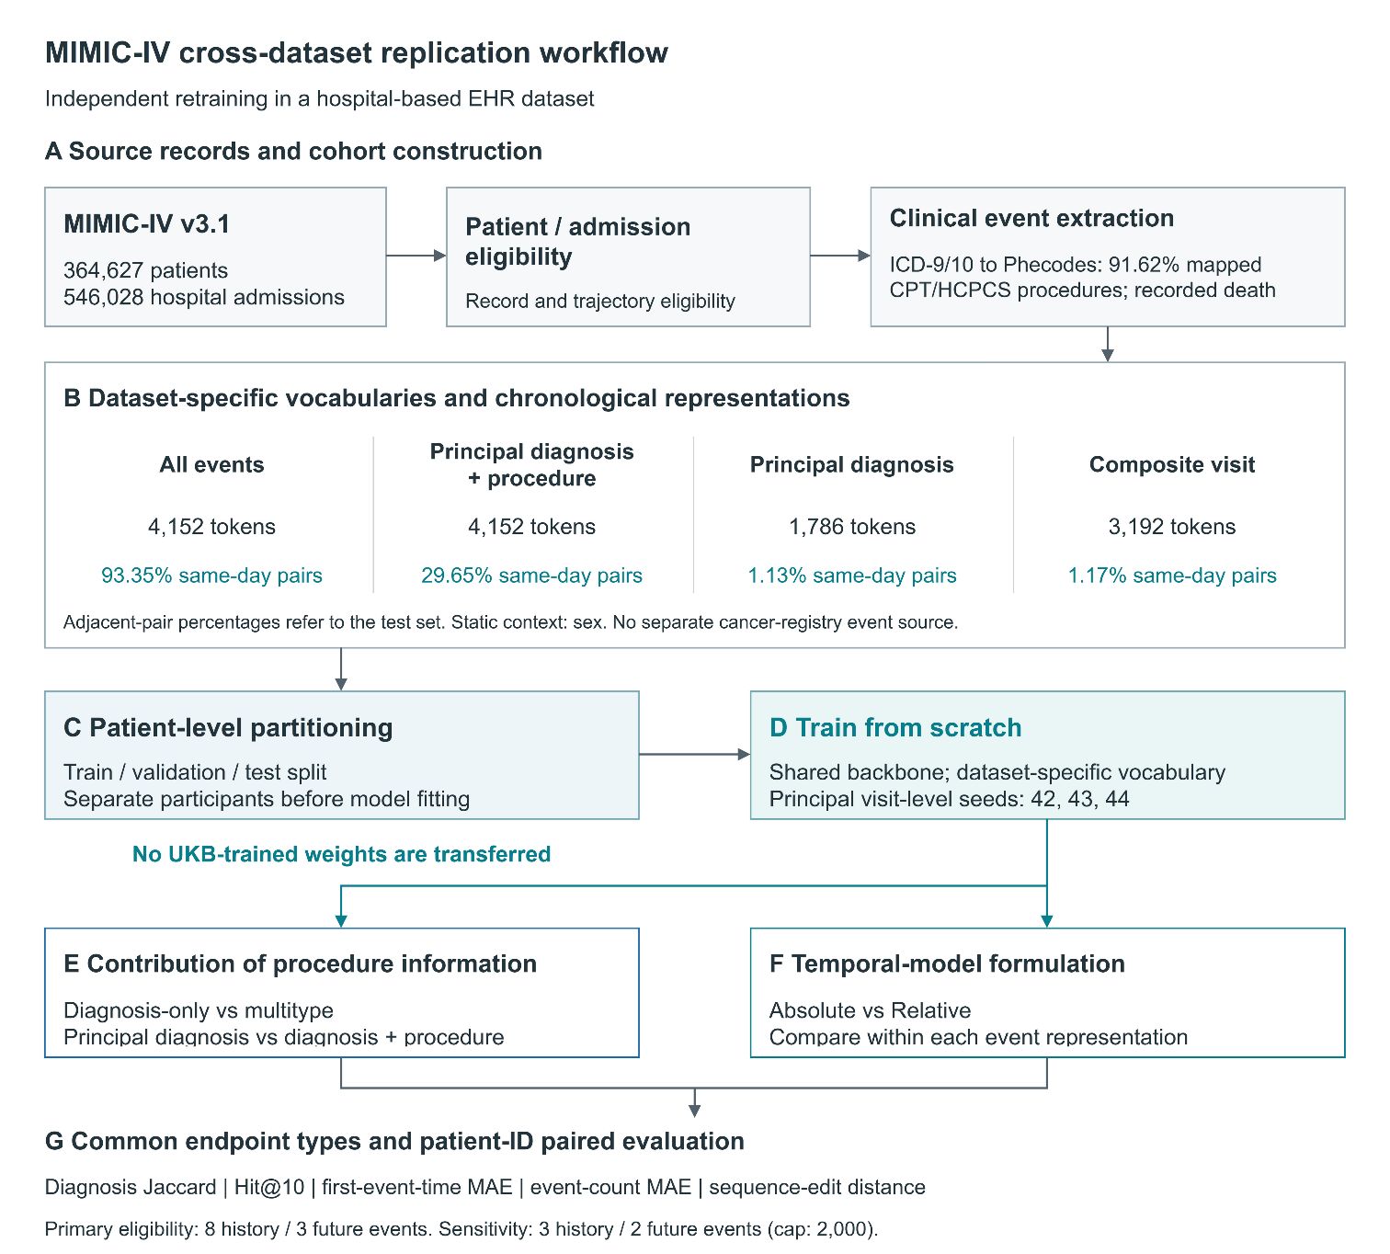
Supplementary Figure S2. MIMIC-IV cross-dataset replication workflow. (A–D) Hospital records undergo eligibility assessment, clinical-event extraction, dataset-specific vocabulary and trajectory construction, patient-level partitioning, and model training from scratch. (E) Diagnosis-only and procedure-enriched representations are compared to assess the contribution of multitype clinical information. (F) Absolute and Relative temporal formulations are compared within each event representation. (G) Evaluation uses common endpoint types and patient-level pairing. Same-day adjacent-event proportions refer to the test set. This analysis evaluates replication of modeling choices rather than transfer of UK Biobank-trained model weights.

Supplementary S8. Event space and static context ablations

S8.1 Progressive expansion of the dynamic clinical event space
The progressive event-space comparison used legacy Delphi_rec models evaluated on their explicit test splits, rather than the final MedTrajectory checkpoints. Full Top10 denotes next-event top-10 accuracy over the evaluated event vocabulary. The selected-disease mean AUROC is the unweighted mean over the ten diseases in the legacy selected-disease evaluation.
The diagnosis-only configuration achieved a Full Top10 of 0.2935 and a selected disease mean AUROC of 0.7274. Adding procedure events increased these values to 0.4832 and 0.7949, respectively. Extending the event space further with cancer registration and mortality-related records yielded Full Top10 of 0.4891 and selected disease mean AUROC of 0.7972.
The disease-only, diagnosis-plus-procedure, and full multitype runs evaluated 6,107, 6,099, and 6,099 participants and 25,162, 54,175, and 55,468 targets, respectively. Thus, the reported increments combine added information with changes in target composition and eligibility; they are not an isolated causal estimate of adding procedures. In the procedure-enriched run, restricting targets to diagnoses gave Top10=0.453267. The progressive and factorial contrasts should not be added.
Supplementary Table S16. Progressive expansion of the dynamic event space. This progressive-input comparison uses a diagnosis-only reference. It is distinct from the factorial event-space analysis below, whose reference configuration includes both diagnosis and mortality-related events.
Full table: Supplementary_Tables.xlsx, worksheet S16.

S8.2 Factorial event space analysis
A historical developmental validation ablation compared a diagnosis-plus-mortality reference (P0) with the full multitype configuration (P2), while holding the corresponding temporal setting fixed. Its three-seed paired summary and interval are retained under the original protocol, not the participant-bootstrap risk protocol in S10. Its profile-specific eligibility has not been reanalysed here.
Under this comparison, the full multitype configuration achieved a three-seed mean language-model AUROC of 0.810281, compared with 0.683252 for the diagnosis-plus-mortality reference. The corresponding paired effect was
$$ΔAUROC=0.127029,$$
with a 95% confidence interval of
$$0.123193\text{ to }0.130864.$$
Thus, expanding the structured event space from diagnosis-plus-mortality records to the full multitype representation was associated with a substantial improvement in the language-model discrimination measure used in this developmental ablation.
Supplementary Table S17. Factorial event space and static context ablation and key formal contrast.
Full table: Supplementary_Tables.xlsx, worksheet S17.

S8.3 Effect of recruitment derived static context
We separately evaluated the contribution of recruitment derived patient context. The static context comprised sex, body mass index, smoking status, and alcohol use, with temporal visibility gated by recruitment age as described in Supplementary S2.
In the historical uncorrected validation comparison, adding static context increased macro AUROC by 0.026818. In the corrected nine-model family, the corresponding estimate was +0.025555 (S10.5).
This effect should be interpreted separately from the event space contrast above. The event space and static context analyses modify different input factors and were evaluated under different comparison structures; their effect sizes should therefore not be added or interpreted as components of a single cumulative gain.

S8.4 Interaction with the developmental relative-time configuration
A developmental factorial analysis also examined the interaction between static context and an earlier relative-time formulation. In this historical configuration, the interaction estimate between the legacy temporal component and the static prefix was
$$-0.061026$$
with a 95% confidence interval of
$$-0.068845\text{ to }-0.052912.$$
This result applies only to the earlier developmental temporal formulation and should not be interpreted as an interaction estimate for the final continuous relative-time mechanism used in MedTrajectory-Relative. The legacy temporal formulation and its distinction from the final model are described further in Supplementary S9.

S8.5 Interpretation of the two ablation designs
The progressive-input and factorial analyses address related but non-identical questions. The progressive analysis provides an intuitive assessment of how performance changes as event classes are added to a diagnosis-only representation. The factorial analysis instead provides a controlled contrast within a predefined model-configuration matrix, using a diagnosis-plus-mortality reference. Accordingly, numerical differences from the two analyses should not be directly subtracted from or combined with one another.
Taken together, however, both analyses support the same qualitative conclusion: restricting the longitudinal record to diagnosis information omits useful signal, and incorporating additional structured clinical-event types—particularly procedures—improves the information available to the longitudinal model.

Supplementary S9. Temporal representation, capacity, and locked generation results

S9.1 Final temporal model variants
We evaluated the contribution of temporal representation using three principal MedTrajectory configurations built on the same multitype clinical-event representation.
MedTrajectory Absolute incorporated the continuous absolute-age representation described in Supplementary S3 but did not include the final continuous relative-time transformation.
MedTrajectory Relative retained the same absolute-age representation and additionally incorporated the final continuous relative-time mechanism within self-attention.
A no-age variant retained the relative-time mechanism while removing the absolute-age representation, providing a complementary assessment of whether absolute life-course position contributed information beyond pairwise temporal relationships.
The Absolute and Relative models shared the same backbone architecture, event vocabulary, static-context representation, prediction heads, and training objectives; their comparison therefore isolates the additional contribution of continuous relative-time modeling while retaining absolute-age information.

S9.2 Developmental validation of the principal temporal variants
Before locked generation evaluation, the principal temporal variants were compared on developmental validation data using the outcome-observable fixed-horizon risk protocol. The clinical Relative-minus-Absolute comparison was subsequently repeated after applying the same input-eligibility correction as in S10 and S13.
The corrected analysis included 71,325 participants and 5,238,757 records. Three-seed mean macro AUROC was 0.735727 for MedTrajectory-Absolute and 0.735151 for MedTrajectory-Relative. The Relative-minus-Absolute difference was -0.000576 (95% CI [-0.003990, +0.002956]). Its lower limit exceeded the unchanged -0.005 margin, satisfying the prespecified validation clinical noninferiority criterion; the interval included zero and did not establish superiority.
The historical uncorrected analysis included 79,357 participants and 5,475,927 records, with mean AUROCs of 0.733156 for Absolute and 0.733428 for Relative, and a difference of +0.000272 (95% CI [-0.003241, +0.003795]). Both analyses used 10,000 shared participant bootstrap resamples (seed 20260815), averaging the three within-seed differences in each replicate. S13 reports corrected seed-specific estimates and the audit.
This validation clinical comparison is distinct from the nine-model, 36-contrast family in S10.4-S10.5 and does not override the held-out test result in S10.2. Meeting the clinical noninferiority criterion also does not imply that the overall developmental decision rule passed: the waiting-time NLL improvement criterion in S9.3 was not met. Table S18 retains the original three-variant comparison for historical context; corrected validation no-age results were not included in this reanalysis.
Supplementary Table S18. Historical uncorrected validation results for the three principal temporal variants. A0, A2, and A2 noAge denote Absolute, Relative, and Relative no-age. Corrected Absolute-versus-Relative validation inference is reported in S9.2 and S13; no-age values here are historical and must not be mixed with corrected estimates.
Full table: Supplementary_Tables.xlsx, worksheet S18.

S9.3 Prespecified waiting time NLL criterion
The prespecified developmental waiting-time analysis used teacher-forced consecutive event pairs from the rightmost context window of each validation participant, not one history-cut target per participant. It used the final generative-pretraining checkpoint for each model and seed.
For MedTrajectory-Relative versus MedTrajectory-Absolute, the validation difference in waiting-time NLL was
$$ΔNLL=+4.365343,$$
with a 95% confidence interval of
$$3.091455\text{ to }6.196786.$$
This analysis included 71,293 validation participants with at least one valid positive-gap target and 539,955 matched teacher-forced event rows for each model–seed combination. Same-day targets were excluded. Participant-level means were compared using 10,000 shared participant bootstrap resamples across the three seeds. The seed-specific Relative-minus-Absolute NLL differences were −5.0778, −0.7902, and +18.9640. The improvement criterion was not met. This is not the locked generation analysis: its 1,541 valid first waiting-time targets are a distinct task-specific count.

S9.4 Legacy temporal representation experiments
The legacy MultiScaleAgeRoPE configuration predates and differs from the final MedTrajectory-Relative mechanism in S3. The following estimates are retained as historical developmental results; they were not reanalysed with the eligibility correction and are not evidence for the corrected primary risk comparison.
In validation risk evaluation, the absolute-age control with static context achieved a macro AUROC of 0.728834. The legacy temporal configuration achieved 0.698336 without static context and 0.664129 with static context. Thus, the earlier relative-time formulation did not provide a consistent validation advantage and showed an unfavorable interaction with the static prefix.
The estimated interaction between the legacy temporal formulation and static context was
$$-0.061026$$
with a 95% confidence interval from
$$-0.068845\text{ to }-0.052912.$$
These results should not be interpreted as evidence against the final continuous relative-time mechanism because the legacy and final mechanisms differ in their temporal parameterization and implementation.

S9.5 Exploratory capacity scaling
Earlier developmental capacity experiments are retained below with their historical validation and test estimates. These models and participant populations were not reanalysed in the eligibility correction; the results do not characterize scaling of the final MedTrajectory-Relative model.
The compact reference configuration contained approximately 1.39 million parameters. Larger variants contained approximately 3.67 million and 4.03 million parameters. Validation macro AUROC values were 0.717275, 0.723697, and 0.706786 for the small, medium, and large configurations, respectively. Corresponding test macro AUROC values were 0.735256, 0.715972, and 0.694866.
These exploratory experiments did not show a monotonic or consistent performance advantage from increasing parameter count. However, because these capacity experiments were conducted within the earlier developmental temporal model family rather than the final MedTrajectory Relative configuration, they should not be interpreted as a general scaling law analysis for the final model.
Supplementary Table S19. Legacy temporal representation.
Full table: Supplementary_Tables.xlsx, worksheet S19.
Supplementary Table S20. Exploratory capacity scaling within the legacy temporal model family. These capacity experiments were conducted within the legacy developmental model family and do not establish a general scaling result for the final MedTrajectory-Relative model.
Full table: Supplementary_Tables.xlsx, worksheet S20.

S9.6 Locked trajectory generation benchmark
After model design and the generation evaluation protocol were frozen, MedTrajectory Absolute and MedTrajectory Relative were evaluated on the locked trajectory-generation cohort together with the ETHOS-Matched and Foresight-Matched task level baselines.
For each model, Table S21 reports the mean of the three independently trained seeds (42, 43, and 44) together with the sample standard deviation across seeds ($ddof=1$). These $±$ values quantify between-seed variation and are not participant-level confidence intervals. Participant-level metric construction and hierarchical aggregation across rollouts, participants, and training seeds are described in Supplementary S5; paired statistical inference is described in Supplementary S6.
MedTrajectory Relative achieved the highest Diagnosis Jaccard and the lowest event-count MAE among the four evaluated generative models. Relative to MedTrajectory Absolute, Diagnosis Jaccard increased from 0.05721 to 0.07107 and Hit@10 from 0.37547 to 0.40763, while first-event-time MAE decreased from 302.46 to 297.44 days and event-count MAE from 13.691 to 12.792.
Compared with ETHOS-Matched and Foresight-Matched, MedTrajectory Relative likewise showed higher diagnostic content overlap and lower event count error, with directionally consistent differences in the other trajectory generation endpoints.
Supplementary Table S21. Locked trajectory generation performance. Values are the mean ± sample standard deviation across training seeds 42, 43, and 44 (ddof=1). Effective N=1,669 for Diagnosis Jaccard, Hit@10, first-event-time MAE, and event-count MAE. The ± values are not participant-level confidence intervals.
Full table: Supplementary_Tables.xlsx, worksheet S21.

S9.7 Paired effects on the locked generation test
Formal paired comparisons were performed using the participant-level paired bootstrap described in Supplementary S6.
Relative to MedTrajectory-Absolute, MedTrajectory-Relative increased Diagnosis Jaccard by +0.01385 (95% CI [0.01065, 0.01706]) and Hit@10 by +0.03215 (95% CI [0.02077, 0.04394]).
Relative-minus-Absolute differences were -5.01 days for first-event-time MAE (95% CI [-6.57, -3.44]) and -0.899 for event-count MAE (95% CI [-1.007, -0.787]). Negative differences indicate lower error for Relative.
The positive effect on Diagnosis Jaccard corresponds to the prespecified confirmatory generation endpoint. The remaining trajectory measures were secondary endpoints.
Against the matched task-level baselines, MedTrajectory Relative improved Diagnosis Jaccard by $+0.02227$ versus ETHOS Matched and $+0.03878$ versus Foresight-Matched. Event count MAE was lower by $7.506$ and $9.111$ events, respectively. Paired effects for all four trajectory endpoints are reported in Table S22.
Supplementary Table S22. Patient level paired effects on the locked trajectory generation test. Values are paired effect estimates with 95% participant-level bootstrap confidence intervals. Positive differences favor MedTrajectory Relative for Diagnosis Jaccard and Hit@10; negative differences favor MedTrajectory Relative for the two MAE endpoints. Bootstrap construction, metric specific paired sets, shared participant resampling across seeds, and seed level effect aggregation are described in Supplementary S6.
Full table: Supplementary_Tables.xlsx, worksheet S22.

S9.8 Interpretation across temporal objectives
The temporal analyses therefore distinguish three related but non-equivalent objectives. The final continuous relative-time mechanism improved multi step sampled trajectory fidelity on the locked generation test, including the prespecified primary Diagnosis Jaccard endpoint. In contrast, the developmental waiting time NLL criterion was not met, and fixed-horizon risk discrimination showed only modest differences between the principal temporal variants. These findings indicate that improved representation of inter event timing can affect the organization of generated trajectories without necessarily producing parallel gains in one step waiting time likelihood or fixed-horizon outcome discrimination.

Supplementary S10. Fixed-horizon risk benchmark and developmental validation analyses

S10.1 Locked fixed-horizon risk benchmark
Fixed-horizon clinical risk performance was evaluated on the held out risk test cohort using the outcome-observable protocol described in Supplementary S6. The benchmark included MedTrajectory Relative, MedTrajectory Absolute, Cox proportional hazards regression, logistic regression, MDRMF-Clinical, and two Med-BERT-based comparison models.
For MedTrajectory, the reported benchmark values are the arithmetic means across independently trained seeds 42, 43, and 44. The classical and representation-learning baselines were evaluated using their frozen seed-42 checkpoints. All models were evaluated using the same outcome-observable label definition and landmark framework, and performance was macro-aggregated across valid sex × disease × horizon × age strata.
The non-MedTrajectory baseline comparisons are exploratory: the same held-out partition had already been inspected during earlier model development. They are not independent confirmatory evidence. This qualification is distinct from the prespecified Relative-versus-Absolute comparison reported in S10.2.
On the eligibility-corrected risk test, mean macro AUROC was 0.7501 for Relative and 0.7462 for Absolute. The corrected values were 0.7263 for Cox, 0.7203 for MDRMF-Clinical, 0.7158 for logistic regression, 0.7051 for Med-BERT-Paper, and 0.6659 for Med-BERT-Matched-S.
The corresponding macro AUPRC values were 0.2616 and 0.2646 for Relative and Absolute. Absolute had higher mean AUPRC and lower mean Brier score and ECE. The positive mean AUROC contrast therefore does not imply uniformly improved risk metrics.
Supplementary Table S23. Eligibility-corrected held-out fixed-horizon risk benchmark: 4,668 participants and 260,110 participant-landmark-horizon-outcome records. Only model_eligible=1 and anchor_only=0 participants are retained. MedTrajectory values are means over seeds 42, 43, and 44; other baselines use frozen seed-42 checkpoints. Metrics are macro-averaged over valid strata (277 for AUROC). Non-MedTrajectory comparisons remain exploratory because the partition had previously been inspected. S10.2 gives the prespecified risk contrast; S13 and Supplementary Correction Data retain historical results, per-seed values, and the implementation-correction audit.
Full table: Supplementary_Tables.xlsx, worksheet S23.

S10.2 Prespecified Relative versus Absolute risk comparison
The prespecified Relative-minus-Absolute risk comparison was repeated on the eligibility-corrected population using 10,000 patient-level bootstrap resamples (seed 20260815). A single participant resample was shared across all six model/seed predictions; within-seed differences were averaged over seeds 42, 43, and 44.
The corrected mean macro-AUROC difference was +0.003893, with a 95% percentile CI of [-0.005792, +0.009059]. The lower limit crossed the prespecified -0.005 noninferiority margin. Noninferiority was not established; the interval also included zero and does not establish superiority or inferiority.
The corrected seed-specific differences were +0.012425 (seed 42), -0.018108 (seed 43), and +0.017362 (seed 44). The confidence interval quantifies participant-sampling uncertainty conditional on these three trained seeds, not training-seed variance. S13 and Figure S5 retain the original analysis and the full correction record.

S10.3 No age sensitivity analysis on the locked risk test
The corrected no-age configuration achieved mean macro AUROC 0.7424, compared with 0.7501 for Relative and 0.7462 for Absolute. All three no-age seeds were included in the same eligibility correction.
The no-age result does not support removal of absolute life course information from the final model. More broadly, however, differences among the three temporal variants were substantially smaller in fixed-horizon risk discrimination than the differences observed in sampled trajectory generation fidelity.

S10.4 Developmental validation benchmark
Before the locked risk evaluation, model development and baseline comparison were performed on validation data. These historical results are retained to document the developmental process, but they should not be interpreted as independent locked-test evidence.
Reanalysis of the frozen historical validation configurations after the same eligibility correction yielded macro AUROC 0.731626 for Absolute with static context, 0.714225 for MDRMF-Clinical, 0.704646 for Med-BERT-Paper, 0.687040 for Cox, 0.686137 for logistic regression, and 0.670605 for Med-BERT-Matched-S. Table S24 also includes Absolute without static context and the earlier legacy temporal formulation. Historical uncorrected values are retained in Supplementary Correction Data.
These validation results served model-development and ablation purposes. In particular, the legacy temporal rows correspond to the earlier MultiScaleAgeRoPE formulation and not to the final continuous relative-time mechanism used in MedTrajectory-Relative.
Historical Med-BERT implementations. Both variants used six Transformer encoder layers and sequences of at most 133 tokens, with additive token, integer-age, position, and static-token-type embeddings. Med-BERT-Paper used six attention heads, hidden width 192, and feed-forward width 64; Med-BERT-Matched-S used eight heads, hidden width 64, and feed-forward width 256. The latter was designed to match Transformer-block capacity, not necessarily total parameter count including embeddings. Masked-language pretraining selected 35% of eligible dynamic clinical tokens and used 80% mask, 10% random-token, and 10% unchanged replacements; checkpoints were selected by validation MLM loss. The risk head read the hidden state at the prediction position and used cumulative softplus logit increments to enforce nondecreasing 1-, 5-, and 10-year risks. These are project-specific adaptations, not claims of exact reproduction of published checkpoints.
Historical feature baselines. Landmark inputs comprised age, static-feature availability, temporally gated one-hot sex, BMI, smoking, and alcohol categories, and disease-history occurrence, count, and recency. Missing categories were the one-hot reference. No blood-pressure, ethnicity, genetic, or imaging features were constructed in this implementation. Continuous inputs were standardized using training-set means and standard deviations. MDRMF-Clinical used a shared ReLU fully connected network with masked disease-by-horizon binary cross-entropy. Candidate depth/width pairs were (1,50), (2,100), (3,100), and (3,200), optimized with Adam at learning rate 0.0001 without weight decay and selected by validation loss. Logistic-R used L2-regularized logistic regression with class-balanced training weights and uncalibrated probability outputs. Class weighting does not ensure calibration to the evaluation prevalence; calibration comparisons require aligned outcome definitions, evaluated rows, and aggregation.
Supplementary Table S24. Eligibility-corrected reanalysis of the nine historical developmental validation configurations: 71,325 common participants, 5,238,757 matched records, and 323 valid AUROC strata. Frozen predictions are reused; models are not refitted or reselected. These configurations define the complete 36-comparison Holm family in S10.5/S25. The legacy temporal mechanism is not MedTrajectory-Relative. Original values and all corrected comparisons are retained in Supplementary Correction Data.
Full table: Supplementary_Tables.xlsx, worksheet S24.

S10.5 Historical validation paired comparisons
Paired inference was also performed during the historical validation stage. These analyses are retained for transparency regarding model development and ablation, but their confidence intervals and $P$ values apply only to the validation benchmark and must not be interpreted as inferential comparisons for the locked-test results in Table S23.
The original validation analysis included 79,357 common participants and 5,475,927 records. The corrected analysis included 71,325 participants and 5,238,757 records after excluding 8,032 anchor-only participants and 237,170 records. No positive labels were excluded. All 36 original pairwise comparisons among nine models were reproduced before recomputing the full corrected family. Both analyses used 1,000 shared patient bootstrap resamples (seed 42), two-sided twice-the-smaller plus-one tail P values capped at 1, and Holm step-down adjustment. The attainable family-adjusted floor is 36 x 2/1001 = 0.071928. The 95% intervals are pointwise, not simultaneous or multiplicity-adjusted.
In the corrected validation population, Absolute with static context minus Absolute without static context had a macro-AUROC difference of +0.025555 (95% CI [0.020560, 0.034348]). The corresponding differences were +0.044587 versus Cox and +0.026980 versus Med-BERT-Paper. Their Holm-adjusted P values were 0.071928; none met the 0.05 family-wise significance threshold.
The corrected Absolute-with-static minus MDRMF-Clinical difference was +0.017401 (95% CI [0.005221, 0.030568]; raw P=0.003996; Holm P=0.071928). Although this nominal interval excludes zero, the comparison is not significant after Holm adjustment. No contrast was Holm-significant in either the original or corrected 36-comparison family.
Supplementary Table S25. Eligibility-corrected historical validation paired AUROC comparisons. Holm adjustment uses all 36 pairwise contrasts among the nine S24 configurations; six are displayed here. Patient bootstrap: 1,000 shared replicates, seed 42, two-sided plus-one P values. The adjusted floor is 0.071928; no comparison is significant at Holm P<0.05. Intervals are pointwise 95% percentile CIs, not multiplicity-adjusted intervals. They do not apply to the test benchmark in S23. All 36 original and corrected results are retained in Supplementary Correction Data.
Full table: Supplementary_Tables.xlsx, worksheet S25.

S10.6 Extended fixed-horizon disease panel analysis
A separate validation-only analysis evaluated the frozen MedTrajectory representation across an extended set of 38 disease outcomes. This analysis was intended to examine the breadth and stability of fixed-horizon risk performance beyond the smaller headline outcome set; it was not part of the locked confirmatory evaluation.
Across the extended disease panel, the overall macro AUROC was 0.7465, macro AUPRC was 0.1420, Brier score was 0.0187, and ECE was 0.0173. These values summarize the extended validation analysis and should not be directly compared with Table S23 as though they were measured on the same disease set or evaluation stage.
The extended-panel analyses in S10.6-S10.7 are legacy exploratory results and were not included in the present eligibility correction. Their split-specific provenance and eligibility require separate verification; they do not support the corrected primary risk interpretation.

S10.7 Disease count and horizon specific exploratory analyses
The disease-count and horizon subgroup summaries formerly reported here could not be reconciled to a verified, split-specific source under the stated aggregation. They are therefore not used as quantitative evidence in this review version. Table S27 retains the original values as an explicitly unverified historical archive.
No validation/test label or replacement estimate is inferred from a similar numerical value in another artifact. The archived subgroup values remain separate from the source-identified 38-outcome validation summary in S10.6.
Rare-outcome subgroup summaries additionally require caution because small case counts can produce unstable AUROC estimates. No conclusion that rarer diseases are predicted more accurately is drawn from the archived table.
Supplementary Table S26. Historical extended-panel validation summary. These estimates were not eligibility-corrected and are not directly comparable with the disease set or evaluation stage in S23.
Full table: Supplementary_Tables.xlsx, worksheet S26.
Supplementary Table S27. Archived disease-count and horizon summaries. Split-specific provenance and aggregation remain unresolved. Values are retained for audit only and are not used to support the manuscript conclusions.
Full table: Supplementary_Tables.xlsx, worksheet S27.

S10.8 Interpretation of fixed-horizon risk results
The generation and risk analyses address distinct targets. Relative had a small positive mean risk AUROC difference on the corrected held-out test set, but noninferiority was not established. The corrected validation clinical comparison met the same margin without establishing superiority (S9.2). Validation and test estimates come from separate participant samples and need not yield identical decisions. Relative did not uniformly improve AUPRC, Brier score, or calibration. Improved generation should not be described as proven preservation of held-out risk discrimination.
These results support treating trajectory generation fidelity and fixed-horizon clinical risk prediction as distinct evaluation targets. The developmental validation analyses and extended disease-panel experiments provide supporting context but are not substitutes for the locked-test comparison.

Supplementary S11. Future diagnosis-record discrimination and death-related secondary analyses

S11.1 Broad-spectrum future diagnosis-record discrimination
This exploratory validation analysis scored 80,546 participants using raw next-token logits from the seed-42 MedTrajectory-Relative checkpoint selected by validation horizon AUROC during 38-outcome risk posttraining. It did not average across three training seeds and did not use sampled rollouts to define disease scores.
The analysis considered all 1,123 diagnosis categories represented in the model vocabulary. Among these, 681 had at least one future case in the validation data, and 186 categories with at least 20 future cases constituted the principal broad-spectrum analysis set.
Across the 186 eligible diagnosis categories, the median age–sex-stratified AUROC was 0.9063, with an interquartile range of 0.8144 - 0.9671. The median pooled AUROC was 0.9326. Performance varied across diseases and ICD-10 chapters, indicating that the generative representation contained broadly distributed future diagnosis-record information rather than signal restricted to a small number of high-frequency conditions.
At the last prediction position of the evaluation context, a diagnosis token was positive only if its first recorded occurrence age was later than the prediction age. Every other participant was assigned a negative label, including those with an already-recorded diagnosis and those with no later record. Labels used remaining recorded follow-up without a fixed-horizon, minimum control follow-up, or censoring adjustment. Only diagnosis tokens were considered; cancer-registry tokens were not merged with diagnosis tokens. Consequently, the endpoint is future first-recorded diagnosis-token discrimination, not adjudicated disease incidence or fixed-horizon risk.
Supplementary Table S28. Future diagnosis-record discrimination by ICD-10 chapter.
Full table: Supplementary_Tables.xlsx, worksheet S28.

S11.2 Disease level results
Table S29 reports all 186 categories with at least 20 future records. Pooled AUROC uses all scored participants. Age-sex-stratified AUROC is an unweighted mean over sex-by-five-year age bins containing both labels; age bins are determined at the prediction position. Displayed pooled 95% confidence intervals use a logit-delta transformation of the DeLong standard error (method A). Sensitivity intervals use 10,000 patient-level percentile bootstrap resamples (method B; seed 20260916), with common resamples across diseases and 2.5th and 97.5th percentiles. All resamples were estimable for all 186 reported categories. Both methods condition on the validation-selected checkpoint and do not account for checkpoint-selection optimism or retraining uncertainty. Historical probability-scale intervals and both revised interval sets are retained in Supplementary Correction Data (s29_method_a_b_comparison.csv); no interval is transferred to age-sex-stratified AUROC.
Supplementary Table S29. Future diagnosis-record discrimination across 186 ICD-10 categories. Results are exploratory. Pointwise 95% confidence intervals are reported without multiplicity adjustment; patient-level bootstrap intervals are provided as a sensitivity analysis.
Full table: Supplementary_Tables.xlsx, worksheet S29.
S11.3 Rollout mortality frequency is not calibrated mortality risk
Mortality related events require separate interpretation because they serve both as clinical events and as trajectory termination states. We therefore examined mortality in three complementary ways: occurrence of mortality-related events in autoregressive rollouts, removal of mortality-related tokens from the generation candidate set, and a separately trained outcome-observable mortality head.
In the locked generation cohort, the observed mortality proportion was 0.1220. In contrast, the mean proportion of autoregressive rollouts containing a mortality-related event was approximately 0.6530 for MedTrajectory Absolute and 0.7290 for MedTrajectory Relative. The large-scale difference between observed mortality and rollout death frequency indicates that the latter should not be interpreted as an individual calibrated probability of death.
S11.4 Mortality token ablation
To assess the role of mortality-related events in trajectory termination, generation was repeated on the validation sample after removing mortality-related tokens from the candidate generation vocabulary while keeping all model parameters fixed. No retraining was performed.
For MedTrajectory-Relative, Diagnosis Jaccard decreased from 0.0834 to 0.0530 and event-count MAE increased from 12.9335 to 24.2815 after mortality-related tokens were excluded. MedTrajectory-Absolute showed a similar deterioration in trajectory-content overlap and trajectory-length agreement.
Importantly, the Relative model retained an advantage over the Absolute model after mortality-token removal. With mortality-related tokens excluded, the Relative-minus-Absolute difference in Diagnosis Jaccard remained $+0.0151$ (95% CI, $0.0117$ to $0.0189$). Thus, the main generation advantage of the final relative-time model was not explained solely by differences in the frequency of generated mortality events.
Supplementary Table S30. Mortality token ablation. Effective paired sample sizes differ by endpoint: $N=1,000$ for Diagnosis Jaccard, $N=999$ for Hit@10 with a non-mortality first target, and $N=822$ for event-count MAE in participants without observed death. These are validation-only intervention results.
Full table: Supplementary_Tables.xlsx, worksheet S30.
S11.5 Independent outcome-observable mortality head
We next reformulated mortality as a conventional clinical-risk endpoint using an independent outcome-observable discrete-time mortality head attached to the frozen generative backbone. The mortality head was evaluated at 1-, 5-, and 10-year horizons using the same principle of horizon-specific outcome observability described for disease-risk prediction.
The mortality analysis used an evaluation subset of the validation cohort, separate from the subsets used for head fitting and Platt calibration. The shared Platt intercept and positive slope were fitted across observed horizon targets in the calibration subset. For reporting, raw or calibrated probabilities were averaged across seeds 42, 43, and 44 within each participant before evaluating the horizon-specific mask. The saved patient sets and masks were identical across seeds. Table S31 reports the calibrated patient-wise ensemble, not the mean of three seed-level metric values. Figure S3 shows raw and calibrated reliability using ten equal-width bins; empty bins are omitted and the last bin includes probability 1. The curves are descriptive, particularly in sparsely populated bins, and do not establish superiority.
The number of evaluable participants decreased with increasing horizon: 495 participants with 37 deaths were evaluable at 1 year, 366 with 78 deaths at 5 years, and 187 with 88 deaths at 10 years. The relatively small 10-year sample should be considered when interpreting long-horizon discrimination and calibration.
At 10 years, the MedTrajectory-Relative mortality head achieved AUROC 0.8379, AUPRC 0.8493, Brier score 0.1589, and ECE 0.0930. The Absolute mortality head achieved AUROC 0.8910 and Brier score 0.1240. These results do not support a general superiority claim for the Relative mortality head; instead, this analysis was designed to distinguish a purpose-trained clinical-risk probability from mortality frequency in sampled autoregressive trajectories.
Supplementary Table S31. Independent outcome-observable mortality head performance. Values use Platt-calibrated probabilities averaged across seeds 42, 43, and 44 within each patient before computing metrics; they are not arithmetic means of seed metrics. Calibration was fitted outside the validation evaluation subset. ECE uses ten equal-width probability bins. Figure S3 reports the corresponding reliability curves.
Full table: Supplementary_Tables.xlsx, worksheet S31.
S11.6 Comparison of mortality head and rollout based probabilities
The independent mortality head was further compared with rollout-derived mortality probability using paired 10-year Brier-score differences. Negative differences favor the dedicated mortality head.
For MedTrajectory Relative, the head-minus-rollout Brier-score difference was
$$-0.0970$$
with a 95% confidence interval of
$$-0.1552\text{ to }-0.0367.$$
Corresponding differences were $-0.0920$ for Absolute, $-0.0235$ for ETHOS-Matched, and $-0.1045$ for Foresight-Matched.
This comparison reinforces that rollout mortality frequency and purpose-trained outcome-observable mortality risk are distinct statistical quantities.
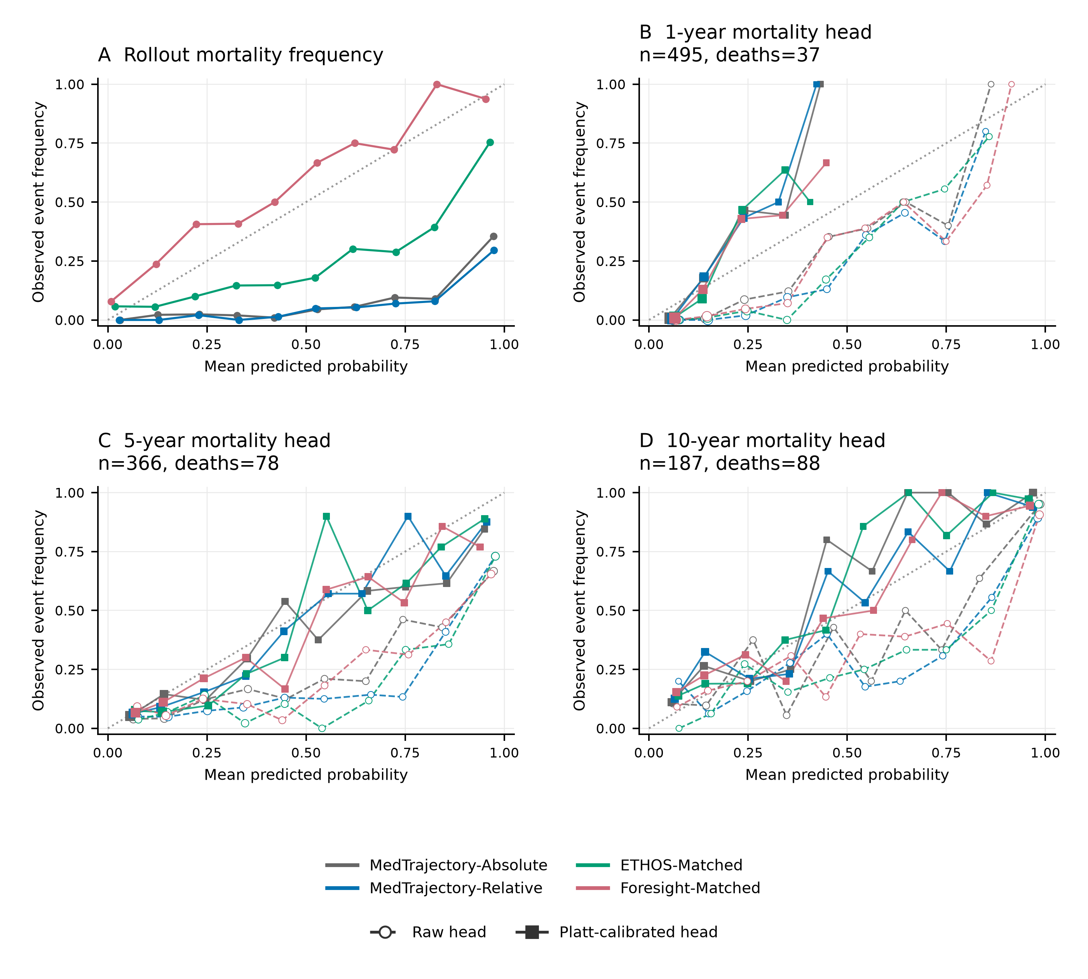
Supplementary Figure S3. Validation mortality reliability. (A) Raw rollout mortality frequencies, pooling the existing bin counts across seeds 42, 43, and 44; repeated seed predictions are not treated as independent participants for inference. (B-D) Outcome-observable mortality-head reliability at 1, 5, and 10 years, using patient-wise mean probabilities across the same three seeds. Dashed open-circle curves are raw head outputs; solid square curves are Platt-calibrated outputs. All panels use ten equal-width bins over [0,1]; empty bins are omitted. Head marker area increases with bin count. The dotted diagonal indicates perfect calibration. Small bins can produce unstable observed rates. Brier scores and ECEs for the calibrated head remain in Table S31.

S11.7 Interpretation
The mortality analyses distinguish three related but non-equivalent quantities: generation of a mortality-related event, termination of an autoregressive trajectory, and calibrated clinical mortality risk. Mortality token removal substantially altered trajectory length and content, showing that mortality-related events participate in the generation and termination process. However, rollout mortality frequency was poorly aligned in scale with observed mortality, whereas a dedicated outcome-observable mortality head provided a more appropriate formulation for clinical risk estimation. Rollout death frequency should therefore not be interpreted directly as an individual mortality probability.

Supplementary S12. Semantic embedding analyses and additional exploratory experiments

S12.1 Semantic representations of ICD-10 codes
To examine alternative initialization strategies for ICD-10-based clinical-event embeddings, we compared representations derived from ICD hierarchy structure, a GRAM-style ontology proxy, PubMedBERT, and Qwen text-embedding-v4.
All four semantic representations were evaluated on a common set of 1,254 ICD-10 codes. Structural reference labels comprised 17 chapters, 183 represented ICD blocks (called sections in Tables S32–S33), and 373 Phecode parent groups. Separate k-means fits used the number of observed groups as k, ten initializations, and random_state=0. ARI and NMI compared cluster assignments with those reference labels.
Embeddings were centered and reduced by singular-value decomposition to at most 64 principal components. Native dimensions were 17 for chapter one-hot, 263 for the block one-hot ontology proxy, 768 for PubMedBERT, and 1,024 for Qwen. The chapter representation therefore remained 17-dimensional rather than becoming 64-dimensional. The ontology proxy is not a reproduction of the complete GRAM model.

S12.2 Structural agreement at 64 dimensions
At 64 dimensions, Qwen text-embedding-v4 showed higher structural agreement than PubMedBERT for both ICD-section and Phecode groupings. Qwen achieved a section ARI of 0.4982 and a Phecode ARI of 0.3211, compared with 0.2825 and 0.1771 for PubMedBERT.
The results indicate that the Qwen representation retained clinically meaningful local grouping structure after projection to the dimensionality required by the MedTrajectory backbone. However, these clustering metrics were used only to compare initialization strategies and should not be interpreted as direct evidence of improved trajectory-generation performance.
Supplementary Table S32. Structural agreement of ICD-10 representations at 64 dimensions.
Full table: Supplementary_Tables.xlsx, worksheet S32.

S12.3 Effect of PCA dimensionality reduction
Because MedTrajectory uses a 64-dimensional hidden representation, we evaluated whether projecting the higher-dimensional semantic embeddings to 64 dimensions materially altered their structural agreement.
For Qwen text-embedding-v4, section ARI changed from 0.4985 in the native 1,024-dimensional space to 0.4982 after PCA projection to 64 dimensions. Phecode ARI changed from 0.3207 to 0.3211. Thus, projection to the model dimensionality preserved the measured structural agreement closely.
For PubMedBERT, section ARI changed from 0.2859 to 0.2825 and Phecode ARI from 0.1944 to 0.1771. The ontology proxy showed a larger reduction because dimensionality reduction was applied to an explicitly sparse structural representation.
Supplementary Table S33. Effect of dimensionality reduction on clinical code representations.
Full table: Supplementary_Tables.xlsx, worksheet S33.

S12.4 Low dimensional visualization
A complementary low-dimensional visualization was used to illustrate qualitative differences among the representation strategies. The visualization was intended as an exploratory aid rather than a quantitative endpoint and was not used for model selection independently of the ARI/NMI analyses.

S12.5 Interpretation and role within MedTrajectory
Semantic initialization was treated as a supporting representation choice rather than a central contribution of MedTrajectory. The embedding analyses show that Qwen text embeddings retained stronger agreement with ICD-section and Phecode structure than the alternative text and ontology proxies under the evaluated low-dimensional protocol, and that projection from 1,024 to 64 dimensions caused little loss in the corresponding Qwen structural metrics.
These findings motivated the initialization strategy used for ICD-based clinical event tokens. However, all embeddings remained trainable, and the central conclusions of the study concern multitype event representation and continuous temporal modeling rather than semantic initialization alone.
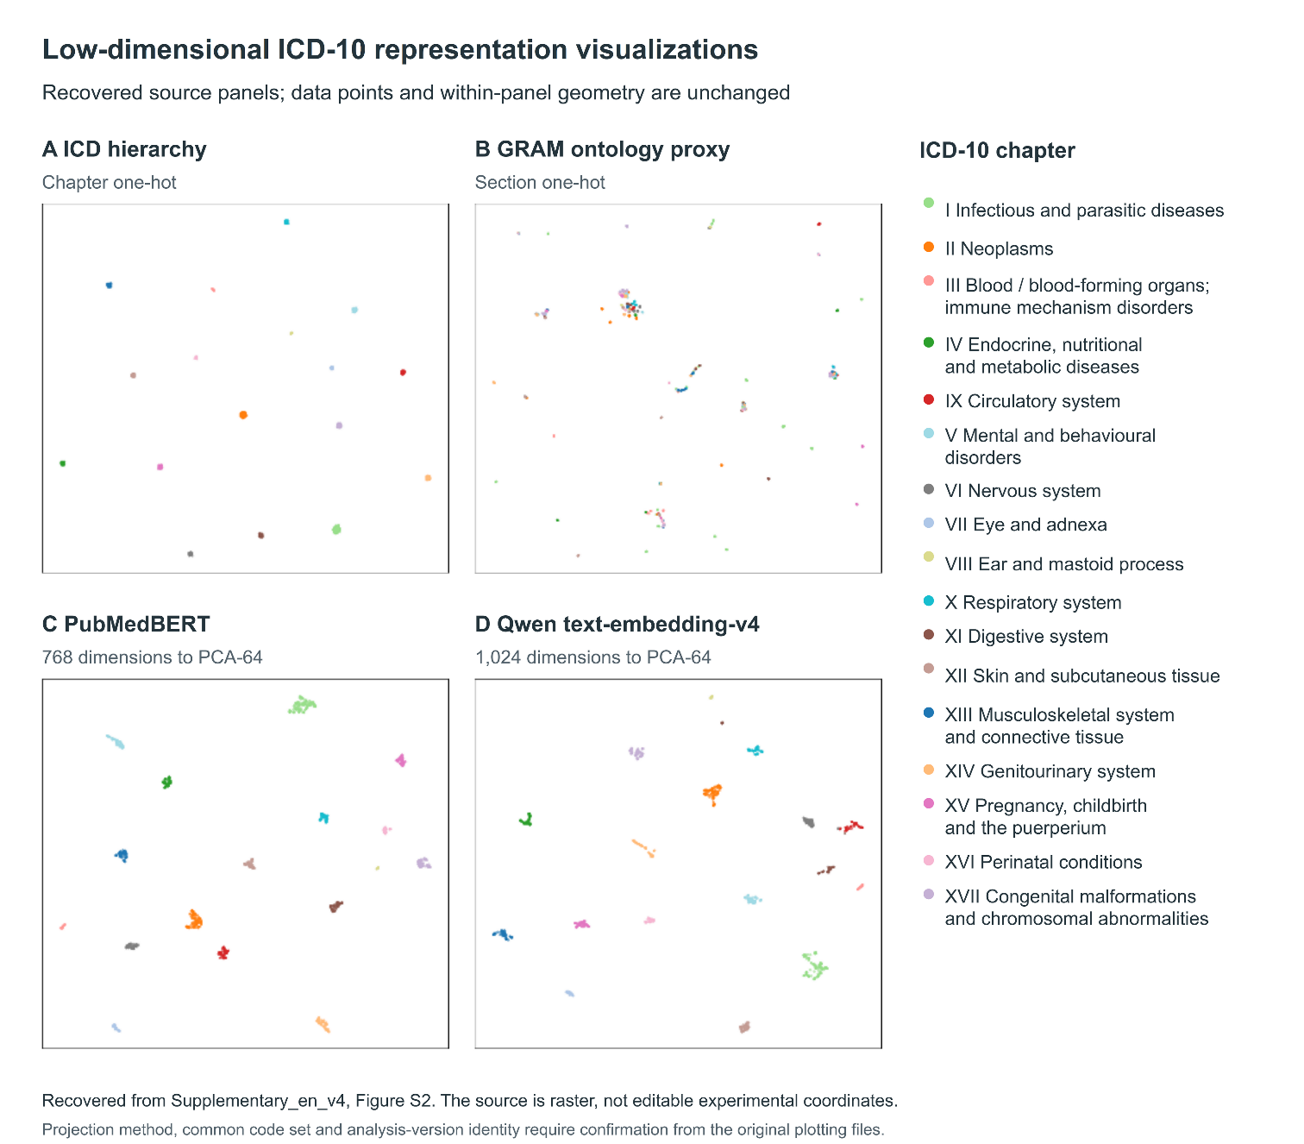
Supplementary Figure S4. Low-dimensional visualization of ICD-10 representation strategies. Two-dimensional visualizations of (A) ICD chapter one-hot representations, (B) a GRAM-style section one-hot ontology proxy, (C) PubMedBERT embeddings, and (D) Qwen text-embedding-v4 embeddings. PubMedBERT and Qwen embeddings were reduced from 768 and 1,024 dimensions, respectively, to 64 dimensions using principal component analysis before visualization. Colors indicate ICD-10 chapters. These exploratory visualizations illustrate code-representation structure and do not directly measure downstream trajectory-generation performance.

Supplementary S13. Eligibility-correction audit

S13.1 Fixed rule and scope
The correction retained only model_eligible=1 and anchor_only=0 participants using each split's matching index. This outcome-independent rule corrects inadvertent inclusion of participants lacking clinical input events. Such participants had a synthetic token-1 record to keep their binary representation nonempty, but the landmark path had not enforced input eligibility. No global token-1 deletion was applied. Patient identities, labels, prediction ages, and complete row keys were checked across 14 test configurations, nine historical validation configurations, and the six model/seed prediction files for the validation clinical comparison. Saved predictions were reaggregated without new inference, retraining, checkpoint selection, or changes to margins, seeds, or bootstrap counts.

S13.2 Historical and corrected test inference
The historical test analysis comprised 4,721 participants and 262,200 records: mean Relative-minus-Absolute AUROC +0.004657, 95% CI [-0.004815, +0.009810], which met the -0.005 criterion. The corrected analysis comprised 4,668 participants and 260,110 records: +0.003893, 95% CI [-0.005792, +0.009059], which did not establish noninferiority. Exclusion removed 53 participants and 2,090 records, with no positive labels removed. All 14 configurations retained 277 valid AUROC strata. The historical result is retained for audit and is not the conclusion for the corrected target population.

Corrected macro AUROC by training seed
Seed | Absolute | Relative | Relative no-age | Relative - Absolute
42 | 0.738757 | 0.751182 | 0.743731 | +0.012425
43 | 0.762540 | 0.744432 | 0.740863 | -0.018108
44 | 0.737193 | 0.754555 | 0.742534 | +0.017362
Mean | 0.746163 | 0.750056 | 0.742376 | +0.003893

S13.3 Historical and corrected validation clinical inference
Excluding 8,032 input-ineligible participants removed 237,170 validation records. The original difference was +0.000272 (95% CI [-0.003241, +0.003795]); the corrected difference was -0.000576 (95% CI [-0.003990, +0.002956]). Both met the -0.005 noninferiority margin and neither established superiority. The corrected population retained 323 valid AUROC strata among 358 stored strata.
For each of 10,000 replicates (seed 20260815), one participant resample was shared across all six model/seed prediction arrays. Within-seed Relative-minus-Absolute macro-AUROC differences were then averaged. The intervals quantify participant-sampling uncertainty conditional on seeds 42, 43, and 44, not uncertainty over retraining. Parallel execution preserved replicate order and the frozen statistic. Independent checks reproduced the historical validation interval and matched serial recomputation for selected replicate blocks in both populations.

Corrected validation macro AUROC by training seed
Seed | Absolute | Relative | Relative - Absolute
42 | 0.728816 | 0.733643 | +0.004827
43 | 0.750905 | 0.731521 | -0.019384
44 | 0.727461 | 0.740288 | +0.012827
Mean | 0.735727 | 0.735151 | -0.000576
The corrected validation clinical result and corrected test result differ in their relation to the same fixed margin. Validation noninferiority is not evidence that test noninferiority was established, and neither clinical analysis changes the failed historical waiting-time NLL criterion. The corrected test inference remains the basis for the manuscript's held-out risk conclusion.

S13.4 Complete supplementary correction data
Supplementary Correction Data contain test_all_14_configurations.csv (four metrics for all test configurations), test_noninferiority.json (original and corrected test inference), model_metric_changes.csv (the nine historical validation configurations), all_36_comparison_changes.csv (their complete paired family), and validation_clinical_noninferiority.json (the separate original and corrected three-seed clinical comparison). The validation correction removed 8,032 participants after feature-label masking; the 8,848 anchor-only participants present in the landmark manifest were not all evaluable.

S13.5 Remaining scope and interpretation
The checked Track G manifests contained no input-ineligible participants (test 1,669; validation 1,000). An audit of all 74,844 anchor-only training records found no eligible cross-entropy, time, or horizon-risk targets in the examined MedTrajectory batch-construction path. This supports absence of direct supervised loss contributions, not identical optimization after resampling or retraining. Logistic, Cox, and MDRMF feature caches did contain ineligible records; their fitting and validation selection were not repeated. Corrected risk results describe the original frozen models on the corrected evaluation population. MIMIC builders and saved data showed no analogous sentinel injection, and the reported paired estimates were independently reproduced. Historical profile-specific analyses remain outside this correction.
Supplementary Figure S5. Risk discrimination and eligibility correction. (A) All three trained seeds and their arithmetic mean on the corrected test population. (B) Original and corrected Relative-minus-Absolute mean AUROC with paired 95% patient-bootstrap intervals. The dashed line marks the unchanged -0.005 noninferiority margin. These intervals condition on the three trained seeds; they do not incorporate training-seed variance.
