CIGI

*© 2018 Centre for International Governance Innovation*

**A i,000-day Journey, or Why the Digital Infrastructure Must Be Resilient**

*Diiiash7g1 ull(st eudgPmroafenssor of* Economics *at the Graduate Center of the City University ofNew* York, and a columnist *forThe New York*

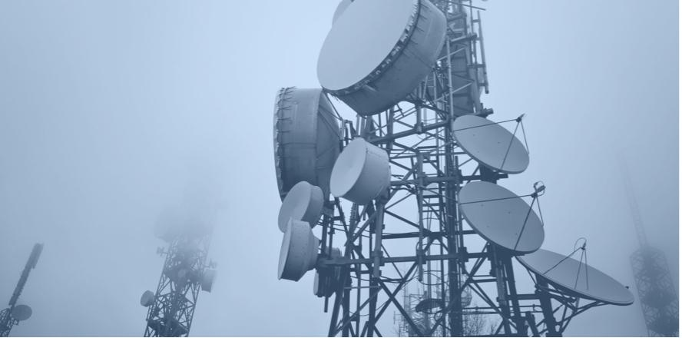

But things don't have to be that way. There is an alternative: progressive capitalism. Progressive capitalisrn is not an oxymoron; we can indeed channel the power of the market to serve society.

In the 1980s, Ronald Reagan's regulatory "reforms," which reduced the ability of government to curb the excesses of the market, were sold as great energizers of the economy. But just the opposite happened: Growth slowed, and weirder still, this happened in the innovation capital of the world.

The sugar rush produced by President Trump's largess to corporations in the 2017 tax law didn't deal with any of these long-run problems, and is already fading. Growth is expected to be a little under 2 percent next year.

This is where we've descended to, but not where we have to stay. A progressive capitalism based on an understanding of what gives rise to growth and societal well­being gives us a way out of this quagmire and a way up for our living standards.

Standards of living began to improve in the late 18th century for two reasons: the development of science (we learned how to learn about nature and used that knowledge to increase productivity and longevity) and developments in social organization (as a society, we learned how to work together, through institutions like the rule of law, and democracies with checks and balances).

Key to both were systems of assessing and verifying the truth. The real and long-lasting danger of the Trump presidency is the risk it poses to these pillars of our economy and society, its attack on the very idea of knowledge and expertise, and its hostility to institutions that help us discover and assess the truth.

There is a broader social compact that allows a society to work and prosper together, and that, too, has been fraying. America created the first truly middle-class society; now, a middle-class life is increasingly out of each for its citizens.

**CIGIO** *V*

'CIGIonline

We need a new consumer protection regulatory framework that can readily address today's digital threats.

@jon_penney

2 Q 9 Copy link to Tweet



iew kinds of consumer protections had to be developed like food and drug safety

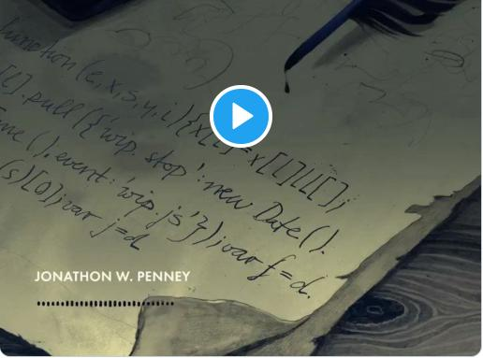

2:43 PM • Oct 31, 2019 0

America arrived at this sorry state of affairs because we forgot that the true source of the wealth of a nation is the creativity and innovation of its people. One can get rich either by adding to the nation's economic pie or by grabbing a larger share of the pie by exploiting others — abusing, for instance, market power or informational advantages. We confused the hard work of wealth creation with wealth-grabbing (or, as economists call it, rent-seeking), and too many of our talented young people followed the siren call of getting rich quickly.

Beginning with the Reagan era, economic policy played a key role in this dystopia: Just as forces of globalization and technological change were contributing to growing inequality, we adopted policies that worsened societal inequities. Even as economic theories like information economics (dealing with the ever-present situation where information is imperfect), behavioral economics and game theory arose to explain why markets on their on are often not efficient, fair, stable or seemingly rational, we relied more on markets and scaled back social protections.

The result is an economy with more exploitation — whether it's abusive practices in the financial sector or the technology sector using our own data to take advantage of us at the cost of our privacy. The weakening of antitrust enforcernent, and the failure of regulation to keep up with changes in our economy and the innovations in creating and leveraging market power, meant that markets became more concentrated and less competitive.

AUTHOR

**Paul Krugman**

*Distinguished Professor of Economics at the Graduate Center of the City University of New York, and a columnist for The New York*