# What does a basic HTML look like:

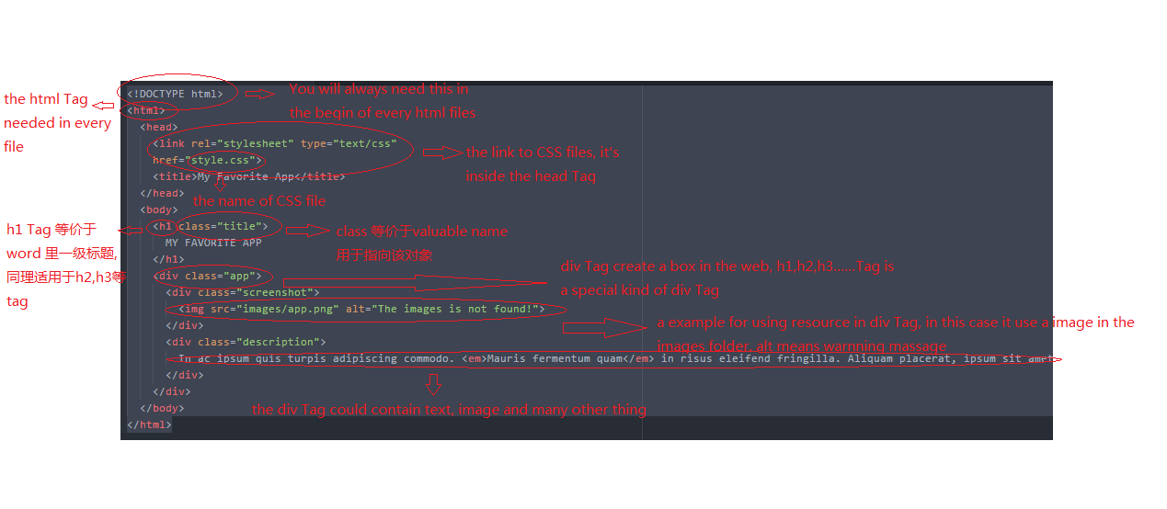

# Html documents structure:

<head>

Title, CSS, JS

</head>

<body>

Contents(the stuff that show on the browser)

</body>

# Some of the common Tags of HTML:

<b> contents </b>: make the contents looks bolder

<em> contents </em>: make the contents italics(斜)

<a href=”URL”> contents </a>: make a link that links to the given URL

<img src=”url” alt=”test”>: image tag, the “url” should be the path of a image, the “test” should be the information that being display if the browser fail to load the image. The image tag is a void tag, without a closing tag.

<br>: break tag, use to break the line.It is a void tag(without a closing tag)

<p> contents </p>: p tag, stand for paragraph

<span> contents </span>: a normal inline tag.

<div> contents </div>: a normal block tag