# Intelligent agent:

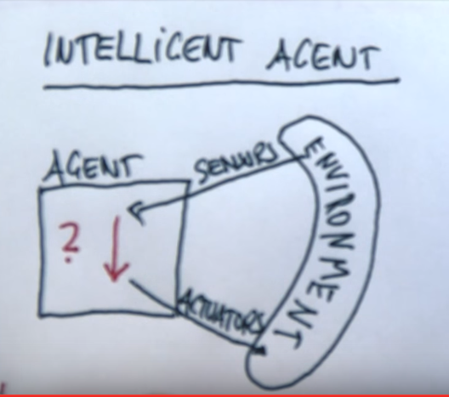d

# The four key attributes of intelligent agent’s environment:

Fully Observable -- Partially Observable

Deterministic (确定性的) -- Stochastic (随机性的)

Discrete(非连续) -- Continuous(连续)

Benign(良性的) -- Adversarial(对抗性的)

# Note:

AI is uncertainty management in computer software.