GlideNet Platform Usage and Dataset Operation Guide
This dataset hosting website is designed to provide you with lightweight and efficient data link management services. Rather than storing physical files directly, the platform focuses on aggregating resource links for high-quality multiphase flow numerical simulations from both domestic and international sources. We rely on various cloud data storage platforms, including ModelScope, Kaggle, Zenodo, and trusted institutional repositories, to ensure direct access without the need for special network environments. Through this platform, you can easily upload dataset links, manage external data sources, and quickly find and download the resources you need, thereby breaking down geographical barriers and achieving efficient data interoperability and unified management.
Currently, this user guide only includes tutorials for uploading and downloading datasets based on the ModelScope or Kaggle platforms. For other platforms, please refer to their official documentation. As for submitting dataset resource links and related information to this hosting website, you can find guidance through this guide or directly on the website pages.
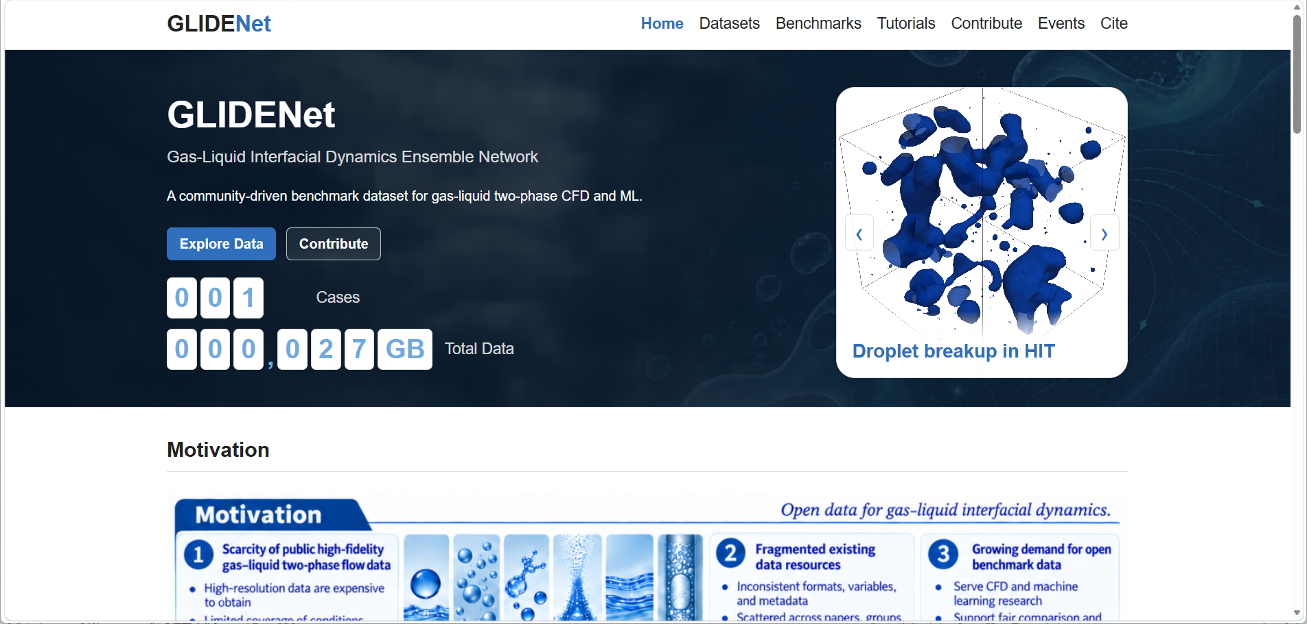
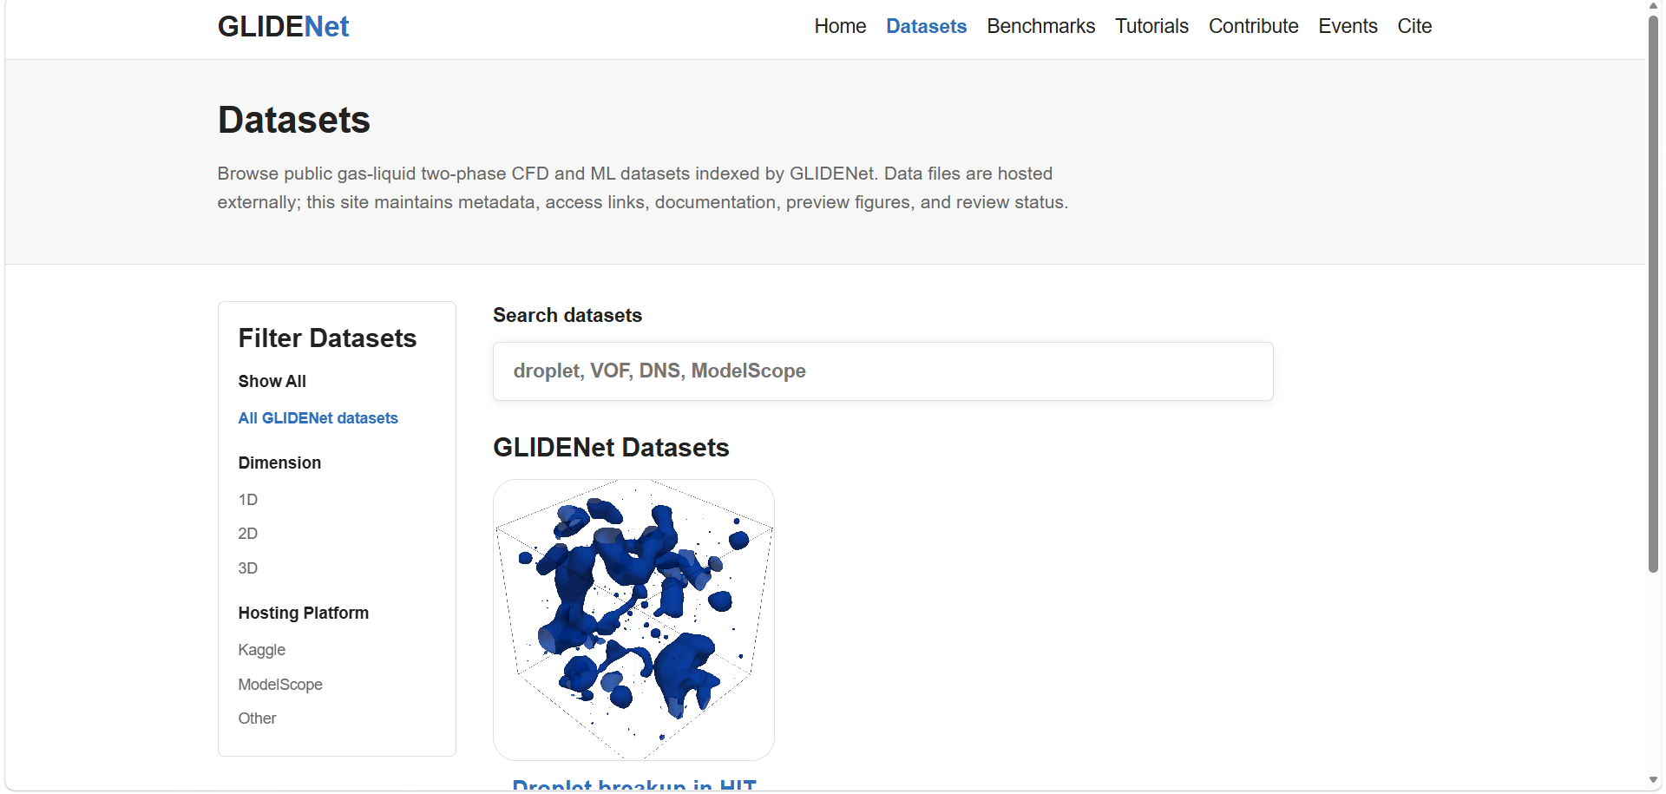
图1 Multiphase Data Hub Website Page Example

Dataset submission
This section primarily introduces various methods for uploading datasets to cloud storage platforms such as Kaggle or ModelScope, as well as the specific requirements for data files.

Kaggle

Install Kaggle CLI on the cluster (Prerequisite: python 3 and pip installed)
python3 -m pip install --user --upgrade kaggle
Add the user’ s local command directory to your PATH:
echo ' export PATH = "$HOME/.local/bin:$PATH" ' >> ~/.bashrc
source ~/.bashrc
Verify the installation:
kaggle --version

Configure Kaggle API credentials
Register an account on Kaggle at https://www.kaggle.com/. Then, navigate to Settings -> API Tokens -> Create Legacy API Token to download the kaggle.json file (which serves as your account credentials).
Next upload this file to the cluster:
mkdir -p ~/.kaggle
chmod 700 ~/.kaggle
mv kaggle.json ~/.kaggle/kaggle.json
chmod 600 ~/.kaggle/kaggle.json
Test the authentication:
kaggle datasets list -m
If no authentication errors occur, the Kaggle CLI is properly configured.

File upload specification
This specification does not enforce a unified data format, but requires that metadata is clear, files are readable, and variable meanings are unambiguous.
Each Kaggle dataset should contain at least:
dataset-metadata.json
info.json
data/

dataset-metadata.json
This is a required Kaggle file, usually generated automatically by the Kaggle CLI:
kaggle datasets init -p <path/to/dataset>
After generation, it must be edited manually:
{
"title": "Dataset title",
"id": "kaggle-user/dataset-slug",
"licenses": [
{
"name": "CC-BY-4.0"
}
]
}
Note that the kaggle-user must match your Kaggle username.

Data files
The actual data should be placed inside data/. No strict format is enforced; accepted types include:
- .npy / .npz / .h5 / .hdf5
- .dat / .vtk / .vti / .vtu
- Extensionless binary files such as Gvol.000001 / V.000001 / P.000001
For the first two common data formats, it is sufficient to clearly specify the variables, shapes, units, grid, and reading method in info.json.
For the third category-extensionless files or solver-specific binary files, additional explanations must be provided:
header size in bytes
dtype
payload shape
vector component arrangement
reshape order
And provide:
load_example.py
Otherwise, external users will find it hard to read the data reliably. Recommended structure:
data/Gvol/
data/V/
data/P/
data/train/
data/test/
The specific structure can be different, but it must be explained clearly in info.json.
- Two-phase / multiphase flow variables requirements
Complete CFD flow field data should ideally include velocity, pressure, and an interface variable. Common Naming:
Velocity: U / V / velocity / u,v,w
Pressure: P / p / pressure
Interface: alpha / Gvol / VOF / phi
And the phase convention for the interface variable must be stated. Other variables can be optionally uploaded, such as curvature, interface normal vector, vorticity, temperature, density field, viscosity field, etc.
Fixed case parameters should be written into info.json, for example:
rho_l, rho_g, mu_l, mu_g, surface tension, gravity, Re, We, Oh
- Grid requirements
For uniform grids, there is no need to upload separate grid / geometry files; however, the info.json file must clearly specify the following:
grid dimensions
physical extent
dx / dy / dz
coordinate order
cell-centered or node-centered
boundary conditions
For non-uniform, curvilinear, or unstructured grids, the corresponding grid / geometry / coordinate files must be uploaded.

info.json
This is the core metadata file. It should contain two sections:
global: overall dataset information, such as physical problem, material properties, initial/boundary conditions, grid, variables, license, citation, etc.
local: file paths and time information for each snapshot / case / sample.
The global section must include at least:
- dataset_id;
- title;
- description;
- format;
- the number of snapshots / samples;
- variables;
- grid;
- physics;
- contributors;
- license;
- DOI or citation reference;
- known_limitations.
The local section must include at least:
- snapshot / sample id;
- time (if available);
- file paths for each variable.
For example:
{
"schema_version": "0.1.0",
"dataset_type": "multiphase_flow_simulation",
"global": {
"dataset_id": "kaggle-user/dataset-slug",
"title": "Dataset title",
"description": "Short dataset description.",
"format": "custom binary",
"snapshots": 1,
"variables": ["Gvol"],
"grid": {
"type": "uniform_cartesian",
"cell_dims": [256, 256, 256],
"domain_bounds_xyz": [[-3.14159, 3.14159], [-3.14159, 3.14159], [-3.14159, 3.14159]],
"field_location": "cell_centered",
"coordinate_order": "x,y,z"
},
"physics": {
"flow_type": "two_phase_flow",
"configuration": "droplet breakup in homogeneous isotropic turbulence",
"physical_parameters": {
"density_liquid": "TBD",
"density_gas": "TBD",
"viscosity_liquid": "TBD",
"viscosity_gas": "TBD",
"surface_tension": "TBD"
},
"boundary_conditions": "TBD",
"initial_conditions": "TBD"
},
"contributors": ["TBD"],
"license": "TBD",
"doi": "TBD",
"known_limitations": []
},
"local": [
{
"id": 0,
"snapshot_id": "000001",
"time": {
"value": null,
"units": "TBD"
},
"files": {
"Gvol": "./data/Gvol/Gvol.000001"
}
}
]
}

Data upload
- Web upload: Suitable for small files, no proxy required.
- Upload from cluster via command line: Requires access to a set of Google / Kaggle-related domains, so a proxy/VPN is needed.
Steps:
- Establish an SSH reverse tunnel from the local proxy port. Run the following in local PowerShell:
ssh -N -R 7897:127.0.0.1:7897 `
-i C:\Users\Administrator\.ssh\id_rsa `
user@cluster_ip
Keep this window open during the upload process.
- Set proxy environment variables on the cluster:
export HTTP_PROXY = http://127.0.0.1:7897
export HTTPS_PROXY = http://127.0.0.1:7897
export http_proxy = http://127.0.0.1:7897
export https_proxy = http://127.0.0.1:7897
- Test cluster network connectivity:
curl -I https://www.googleapis.com
curl -I https://storage.googleapis.com
curl -I https://www.kaggle.com
It should not time out.
- Upload:
Place all files in a folder (such as kaggle_dataset)
export PATH = "$HOME/.local/bin:$PATH"
cd /path/to/kaggle_dataset
kaggle datasets init -p
Run the command to generate dataset-metadata.json and edit it (ensuring the id matches your Kaggle username otherwise the upload will fail).
- Finally execute the upload command:
kaggle datasets create -p . -r tar -t
Once completed, the dataset will appear on your Kaggle profile. You can then verify that the title, description, license, etc., meet the specifications and set the dataset to public in the dataset settings.

Modelscope
This part introduces three main methods for uploading datasets to the ModelScope community: upload using GIT commands, upload using Python SDK and upload via web interface.

Creating a Dataset Repository
Register an account on the ModelScope website at
https://modelscope.cn/my/overview, then create a dataset repository, then create a dataset repository.
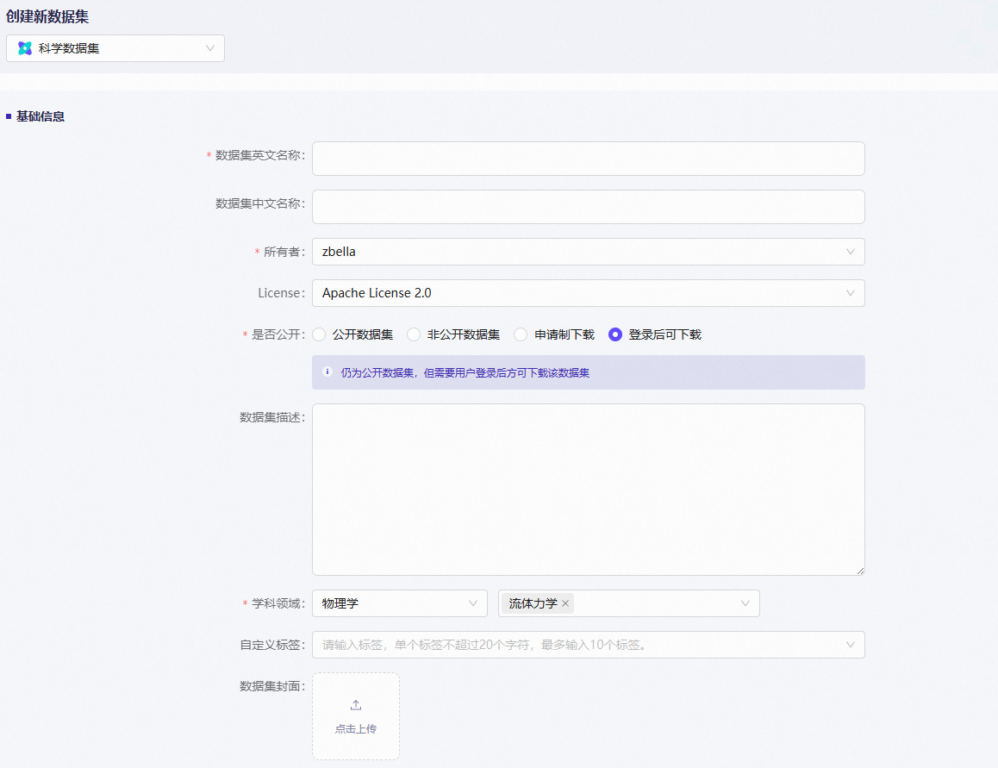
The repository URL will be:
https://www.modelscope.cn/datasets/username/datasetname.git.

File Upload Specification
This specification does not enforce a unified data format, but requires clear metadata, readable files, and well-defined variable meanings.
Each dataset must at least include:
README.md
data/
info.json

README.md
A brief description of the case data.

Data files
The actual data should be placed inside data/. No strict format is enforced; accepted types include:
- .npy / .npz / .h5 / .hdf5
- .dat / .vtk / .vti / .vtu
- Extensionless binary files such as Gvol.000001 / V.000001 / P.000001
For the first two common data formats, it is sufficient to clearly specify the variables, shapes, units, grid, and reading method in info.json.
For the third category-extensionless files or solver-specific binary files, additional explanations must be provided:
header size in bytes
dtype
payload shape
vector component arrangement
reshape order
And provide:
load_example.py
Otherwise, external users will find it hard to read the data reliably. Recommended structure:
data/Gvol/
data/V/
data/P/
data/train/
data/test/
The specific structure can be different, but it must be explained clearly in info.json.
- Two-phase / multiphase flow variables requirements
Complete CFD flow field data should ideally include velocity, pressure, and an interface variable. Common Naming:
Velocity: U / V / velocity / u,v,w
Pressure: P / p / pressure
Interface: alpha / Gvol / VOF / phi
And the phase convention for the interface variable must be stated. Other variables can be optionally uploaded, such as curvature, interface normal vector, vorticity, temperature, density field, viscosity field, etc.
Fixed case parameters should be written into info.json, for example:
rho_l, rho_g, mu_l, mu_g, surface tension, gravity, Re, We, Oh
- Grid requirements
For uniform grids, there is no need to upload separate grid / geometry files; however, the info.json file must clearly specify the following:
grid dimensions
physical extent
dx / dy / dz
coordinate order
cell-centered or node-centered
boundary conditions
For non-uniform, curvilinear, or unstructured grids, the corresponding grid / geometry / coordinate files must be uploaded.

info.json
This is the core metadata file. It should contain two sections:
global: overall dataset information, such as physical problem, material properties, initial/boundary conditions, grid, variables, license, citation, etc.
local: file paths and time information for each snapshot / case / sample.
The global section must include at least:
- dataset_id;
- title;
- description;
- format;
- the number of snapshots/samples;
- variables;
- grid;
- physics;
- contributors;
- license;
- DOI or citation reference;
- known_limitations.
The local section must include at least:
- snapshot/sample id;
- time (if available);
- file paths for each variable.
For example:
{
"schema_version": "0.1.0",
"dataset_type": "multiphase_flow_simulation",
"global": {
"dataset_id": "kaggle-user/dataset-slug",
"title": "Dataset title",
"description": "Short dataset description.",
"format": "custom binary",
"snapshots": 1,
"variables": ["Gvol"],
"grid": {
"type": "uniform_cartesian",
"cell_dims": [256, 256, 256],
"domain_bounds_xyz": [[-3.14159, 3.14159], [-3.14159, 3.14159], [-3.14159, 3.14159]],
"field_location": "cell_centered",
"coordinate_order": "x,y,z"
},
"physics": {
"flow_type": "two_phase_flow",
"configuration": "droplet breakup in homogeneous isotropic turbulence",
"physical_parameters": {
"density_liquid": "TBD",
"density_gas": "TBD",
"viscosity_liquid": "TBD",
"viscosity_gas": "TBD",
"surface_tension": "TBD"
},
"boundary_conditions": "TBD",
"initial_conditions": "TBD"
},
"contributors": ["TBD"],
"license": "TBD",
"doi": "TBD",
"known_limitations": []
},
"local": [
{
"id": 0,
"snapshot_id": "000001",
"time": {
"value": null,
"units": "TBD"
},
"files": {
"Gvol": "./data/Gvol/Gvol.000001"
}
}
]
}

Upload using GIT Commands

Clone the dataset repository
mkdir -p ~/modelscope_upload
cd ~/modelscope_upload
git clone https://www.modelscope.cn/datasets/user_name/dataset_name.git
cd dataset_name
If authentication is prompted, follow the ModelScope page instructions to authenticate using your account and access token.

Configure Git user information
git config --global user.name "Your Name"
git config --global user.email "Your Email"

Configure Git LFS to track large files
For CFD binary large files, Git LFS must be used. For example:
git lfs track "data/Gvol/*"
git lfs track "data/V/*"
git lfs track "data/P/*"
If files share a common extension, you can also track by extension:
git lfs track "*.dat"
git lfs track "*.npz"
git lfs track "*.h5"
git lfs track "*.hdf5"
Verify that .gitattributes has been generated:
cat .gitattributes

Upload data files
Copy the prepared dataset directory to the ModelScope repository directory. You can use rsync:
rsync -avP /path/to/prepared_dataset/ ./
Check Git and LFS status:
git status
git lfs status
Confirm that large files are being tracked by LFS.
Stage and upload:
git add .gitattributes .
git commit -m "Upload dataset"
git push

Upload using Python SDK
The ModelScope library provides HTTP-based file and folder upload interfaces, ensuring a more stable upload experience while also performing necessary checks on file size and folder quantity. Therefore, you can conveniently upload local dataset folders or specify particular local data files for upload.

Prerequisites
Ensure you have installed the modelscope library. If not installed, use the following command to install it:
pip install modelscope
Complete access token login in the SDK:
from modelscope.hub.api import HubApi
YOUR_ACCESS_TOKEN = 'Get your SDK token from https://modelscope.cn/my/myaccesstoken'
api = HubApi()
api.login(YOUR_ACCESS_TOKEN)
You can obtain your SDK access token from Account Settings -> Access Tokens.

Upload using File Interface
Assume you have already created a dataset repository with username user and dataset name my-test-data.
- Upload Dataset Folder
owner_name = 'user'
dataset_name = 'my-test-data'
api.upload_folder(
repo_id = f"{owner_name}/{dataset_name}",
folder_path = '/path/to/local/dir',
commit_message = 'upload dataset folder to repo',
repo_type = 'dataset'
)
Parameter Description
Field Name | Required | Type | Description
repo_id | Yes | str | Dataset ID. Ensure your access token has permission to upload to the corresponding repository.
folder_path | Yes | str | Absolute path of the local folder to be uploaded
path_in_repo | No | str | Specific path and folder name where the folder will be uploaded
commit_message | No | str | Description of changes included in this upload commit
token | No | str | User access token with upload permissions. Can be omitted if already logged in
repo_type | No | str | Repository type: model, dataset. Defaults to model if not specified
allow_patterns | No | str | File type patterns to allow for upload, e.g., *.json. Defaults to None
ignore_patterns | No | str | File type patterns to ignore during upload, e.g., *.log. Defaults to None
max_workers | No | int | Number of threads to use for upload. Defaults to min(8,os.cpu_count() + 4))
revision | No | str | Branch to upload to. Defaults to master
For more parameters, please refer to the interface documentation in the open-source code.
- Upload Data File
owner_name = 'user'
dataset_name = 'my-test-data'

api.upload_file(
path_or_fileobj = '/path/to/local/your_file.suffix',
path_in_repo = 'repo_path/your_file.suffix',
repo_id = f"{owner_name}/{dataset_name}",
repo_type = 'dataset',
commit_message = 'upload dataset file to repo',
)
Parameter Description
Field Name | Required | Type | Description
path_or_fileobj | Yes | str | Absolute path of the local file to be uploaded
path_in_repo | Yes | str | Specific path and filename where the file will be uploaded
repo_id | Yes | str | Model ID/Dataset ID. Ensure your access token has permission to upload to the corresponding repository. Use dataset ID when uploading datasets
token | No | str | User access token with upload permissions. Can be omitted if already logged in
repo_type | No | str | Specify as dataset for dataset repositories. Defaults to model if not specified
commit_message | No | str | Commit message for this upload
commit_description | No | str | Commit description for this upload
buffer_size_mb | No | int | Buffer size in MB for hash calculation. Defaults to 1
tqdm_desc | No | str | Progress bar description. Defaults to [Uploading]
disable_tqdm | No | bool | Whether to disable progress bar. Defaults to False
For more parameters, please refer to the interface documentation in the open-source code.

Upload using CLI Tool
After installing the modelscope library, you can also directly use CLI commands to upload dataset folders or files. Assume owner_name is your desired username or organization name, and repo_name is the dataset name, so owner_name/repo_name is the dataset ID.
# 登陆
modelscope login --token Your-Modelscope-Token
# 上传文件夹
modelscope upload owner_name/repo_name /path/to/your_folder --repo-type dataset
# 上传文件
modelscope upload owner_name/repo_name /path/to/your_file.suffix data/your_file.suffix --repo-type dataset
# 完整用法示例
modelscope upload [repo_id] [local_path] [path_in_repo] --repo-type dataset --include '*.json' --exclude '*.log' --commit-message 'init' --commit-description 'my first commit' --token 'xxx-xxx' --max-workers 16 --endpoint 'https://www.modelscope.cn'
Parameter Description
Parameter | Short | Type | Default | Description
repo_id | - | str | required | Positional, repository ID (format: owner/repo-name)
local_path | - | str | None | Positional, local file or folder path (optional)
path_in_repo | - | str | None | Positional, target path in repository (optional)
--repo-type | - | choice | dataset | Repository type (model/dataset)
--include | - | list | None | Glob patterns for files to include
--exclude | - | list | None | Glob patterns for files to exclude
--commit-message | - | str | None | Commit message
--commit-description | - | str | None | Commit description
--token | - | str | None | Access token
--max-workers | - | int | min(8, cpu+4) | Upload concurrency threads
--endpoint | - | str | None | ModelScope server endpoint
You can also use modelscope upload --help to view detailed CLI tool parameters.
Notes
- Individual file size cannot exceed 50 GB, total number of files cannot exceed 100,000, and files within a single subfolder cannot exceed 10,000, otherwise an error will occur;
- File and folder upload interfaces will automatically mark files with extensions listed in the Git section below or files larger than 5 MB as GIT LFS uploads;
- Total size of all files not marked for LFS upload cannot exceed 500 MB.

Upload via Web Interface
If you are the dataset creator or have appropriate permissions, you can also directly create or upload data files through the web interface. The current page supports uploading up to 1,000 files at once with a total size of up to 500MB. For other scenarios, we recommend using HTTP-based upload interfaces like upload_folder in the Python SDK.

Dataset information submission
This section explains how to submit dataset links and relevant metadata to the Multiphase Data Hub, effectively linking your data to the cloud storage.

Submitting a Dataset
On the homepage, click “Contribute” to navigate to the dataset submission page.
Click “Open a Dataset Submission Issue” to initiate your submission request.
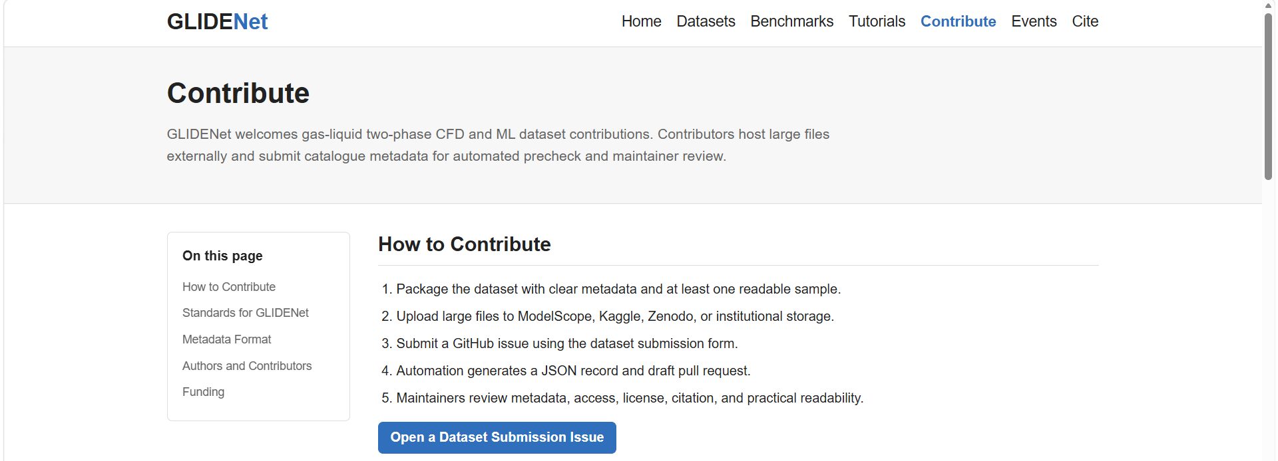
Fill in the relevant details for your dataset in the Issue form. (Fields marked with a red asterisk are required. )
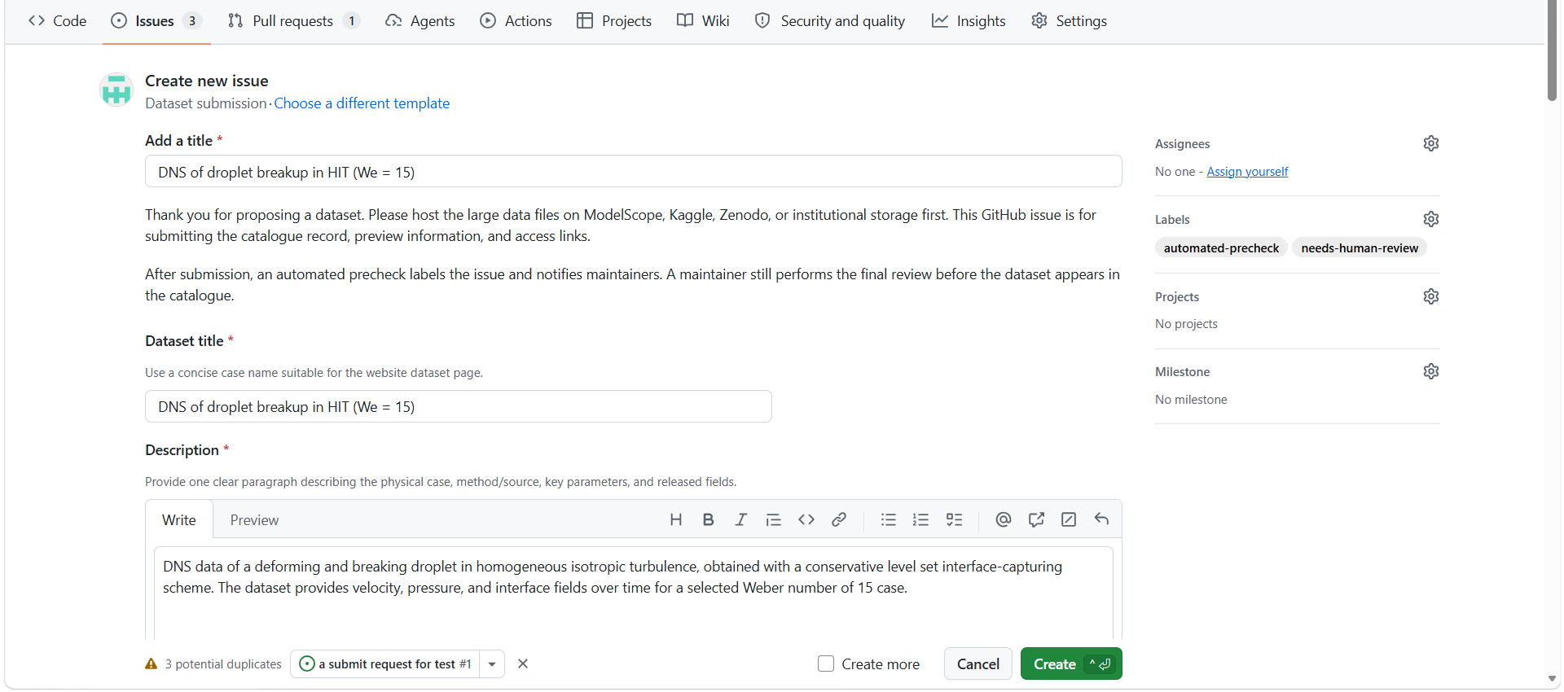
Review the “Submission” checklist to ensure everything meets the requirements, check the confirmation box, and then click “Create” to finalize your submission.
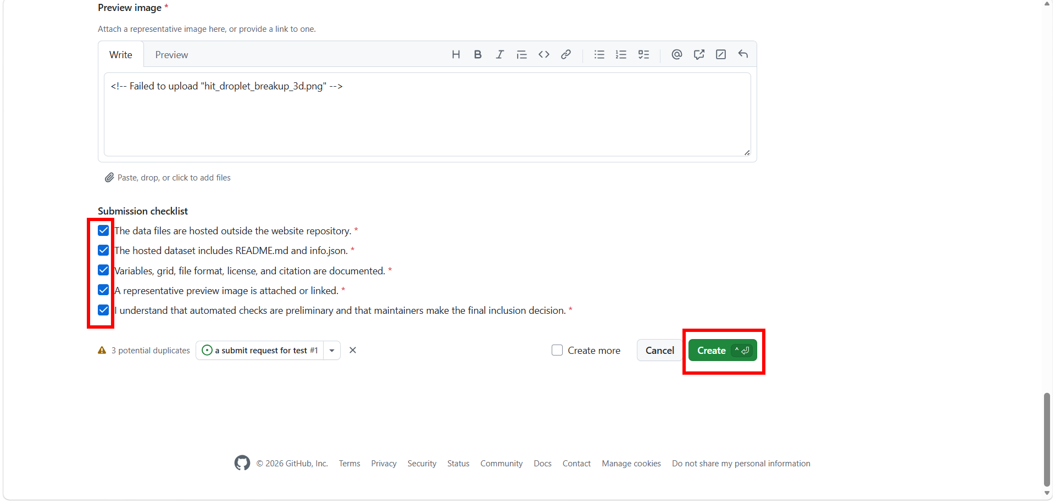
Once submitted, the system will automatically send an email to the site maintainers to request a review of your information.
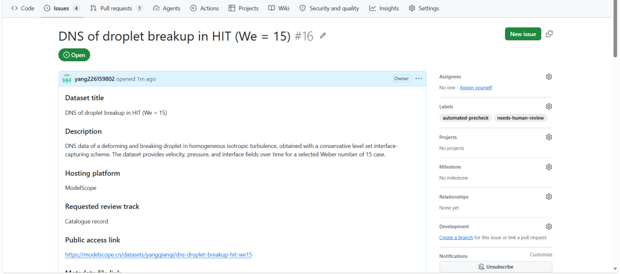

Modifying Dataset Information
If you need to update information for a dataset that is already live on the website, you have two options:
Option 1: Use the email link at the bottom of the website to contact the maintainers directly. Please include a clear description of the changes you ’d like to make.
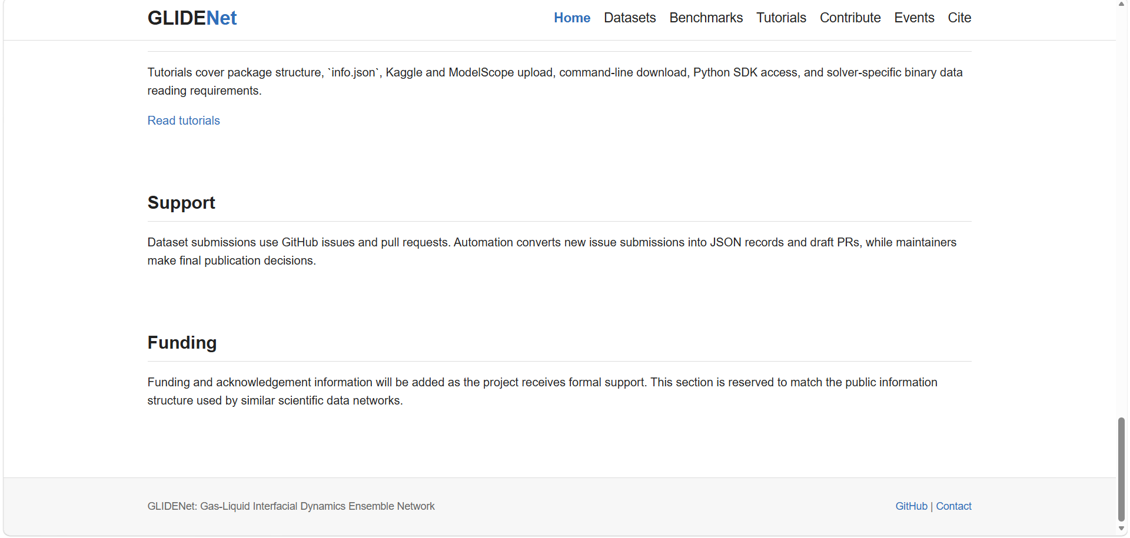
Option 2: Click the GitHub project link at the bottom of the page to visit the repository. Locate the info.json file for your dataset inside the ./dataset folder, make the necessary edits, and submit a pull request.
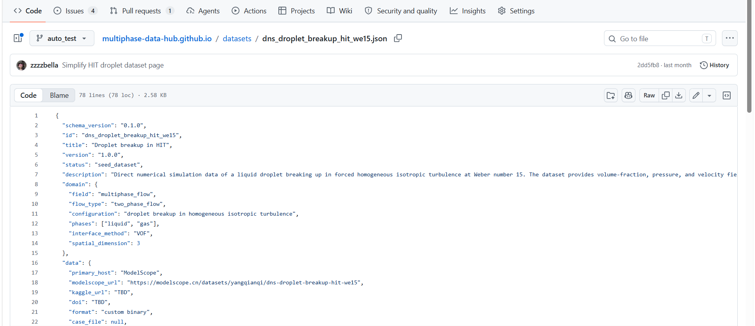
If you need to change the cover image or the detail page images, navigate to the ./website/assets/ directory. Delete the existing image files and upload your new ones. Be sure to update the “visuals” parameter in the info.json file to reflect the new image paths.
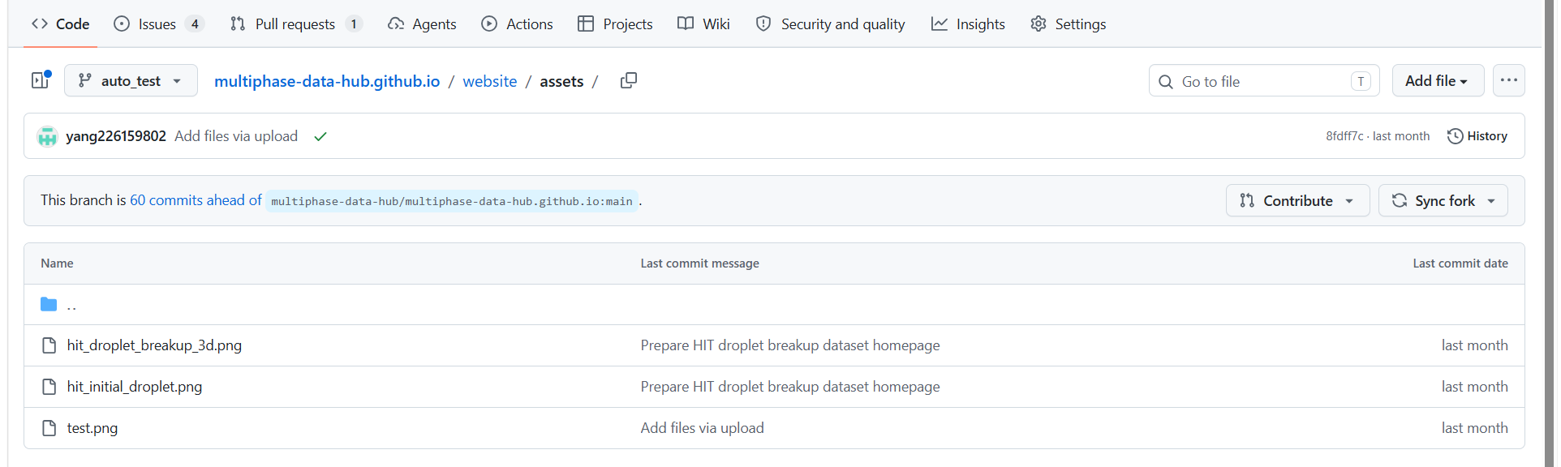

Dataset Download
This section provides instructions on how to download dataset files from cloud storage platforms like Kaggle or ModelScope.

Kaggle

Manual Web Download (Suitable for Small Files)
This is the most basic method. You only need a browser and a logged-in Kaggle account.
Navigate to the dataset page, review the “About Dataset” section for background information, and use the “Data Explorer” to confirm the file format and size meet your requirements.
To download: Click the “Download” button on the page and select to download the entire dataset as a ZIP archive. Alternatively, click “Data Explorer” to select individual dataset files for download.

Kaggle API Download (Recommended Method)
For datasets larger than 1 GB, browser downloads are prone to throttling or interruptions. Using the official API is not only faster but also supports resumable downloads and automation.

Install the Kaggle CLI
Ensure Python 3.6 or later is installed on your computer, then run the following in the terminal (CMD/PowerShell on Windows, or Terminal on Mac/Linux):
pip install kaggle --upgrade

Obtain and Configure API Credentials
Download credentials:
Log in to Kaggle, go to your Settings page, scroll down to the API section, and click “Create New API Token” (or "Legacy API Key"). The browser will automatically download a kaggle.json file.
Place the file:
Mac / Linux: Run
mkdir -p ~/.kaggle
in the terminal, then move the kaggle.json file into that folder, and set read-only permissions:
chmod 600 ~/.kaggle/kaggle.json
Windows: Create a folder named .kaggle in the C:\Users\YourUsername\ directory, and place the kaggle.json file inside it.

Execute the Download Command
Run the following commands in the terminal:
# Basic download (format: username/dataset-name)
kaggle datasets download -d <owner>/<dataset-name>
# Download to a specified folder (my_datasets)
kaggle datasets download -d <owner>/<dataset-name> -p ./my_datasets
# Download a specific file from the dataset (e.g., T_K_id000.dat) to a specified folder
kaggle datasets download -d <owner>/<dataset-name>/<data>/<T_K_id000.dat> -p ./my_datasets/<data>/<T_K_id000.dat>
# Automatically unzip after download
kaggle datasets download -d <owner>/<dataset-name> --unzip
Tip: If the download is interrupted, simply re-run the same command, the API will automatically resume from where it left off.

kagglehub Download

Authentication
Interactive login: Call kagglehub.login( ) in your code; the system will prompt you to manually enter your username and Token.
Environment variables: Export the credentials as environment variables by setting KAGGLE_USERNAME and KAGGLE_KEY.
Configuration file: Similar to the CLI approach, place the kaggle.json file in the ~/.kaggle/kaggle.json directory.

Run a Python Program to Download
import kagglehub
import kagglehub
# Download the latest version of the dataset
kagglehub.dataset_download('bricevergnou/spotify-recommendation')
# Download a specific version of the dataset
kagglehub.dataset_download('bricevergnou/spotify-recommendation/versions/1')
# Download only a single file from the dataset
kagglehub.dataset_download('bricevergnou/spotify-recommendation', path = 'data.csv')
# Download an entire directory while preserving its nested structure
kagglehub.dataset_download(
'moltean/fruits/versions/99',
path = 'fruits-360_meta/fruits-360-meta/Papers',
)
# Force download of a dataset, directory, or file (even if already cached locally)
kagglehub.dataset_download('bricevergnou/spotify-recommendation', force_download = True)
# Download the dataset to a custom output directory
kagglehub.dataset_download('bricevergnou/spotify-recommendation', output_dir = './data')
# Download a single file from the dataset to a custom output directory
kagglehub.dataset_download('bricevergnou/spotify-recommendation', path = 'data.csv', output_dir = './data')
# Overwrite an existing output directory (force re-download and replace existing files)
kagglehub.dataset_download('bricevergnou/spotify-recommendation', output_dir = './data', force_download = True)

cURL (Universal Network Request Tool) Download
#!/bin/bash
# Syntax: curl -L -o <filename> <dataset-download-link> -u <username>:<API_Key>
# Pass credentials directly in the command
curl -L -o ~round-jet-premixed-coffee.zip https://www.kaggle.com/api/v1/datasets/download/waitongchung/round-jet-premixed-coffee -u my_user:1234567890abcdef1234567890abcdef

# Or use environment variables
# 1. Set environment variables (valid for the current terminal session)
export KAGGLE_USERNAME = "my_user"
export KAGGLE_KEY = "1234567890abcdef1234567890abcdef"
# 2. Use environment variables to make the download request
curl -L -o my_dataset.zip https://www.kaggle.com/api/v1/datasets/download/<owner>/<dataset-name> -u $KAGGLE_USERNAME:$KAGGLE_KEY

Modelscope
In this part, we will introduce you to downloading datasets on the ModelScope platform. Whether you prefer using the Python SDK, GIT, or command-line tools, detailed steps are provided here to help you get started quickly.

Quick Start

Download Specific Files
Visit the dataset page. Click the Download button next to each file to download it directly.
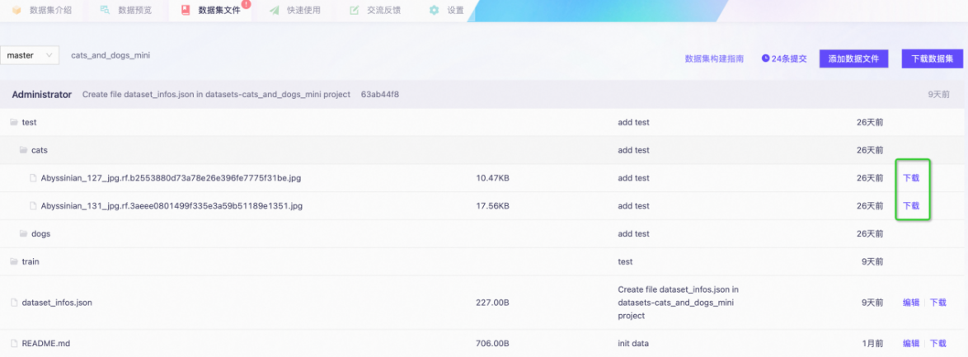

Download Entire Dataset
Click the Download Dataset button to see specific commands for downloading datasets using the SDK, GIT, or command line.
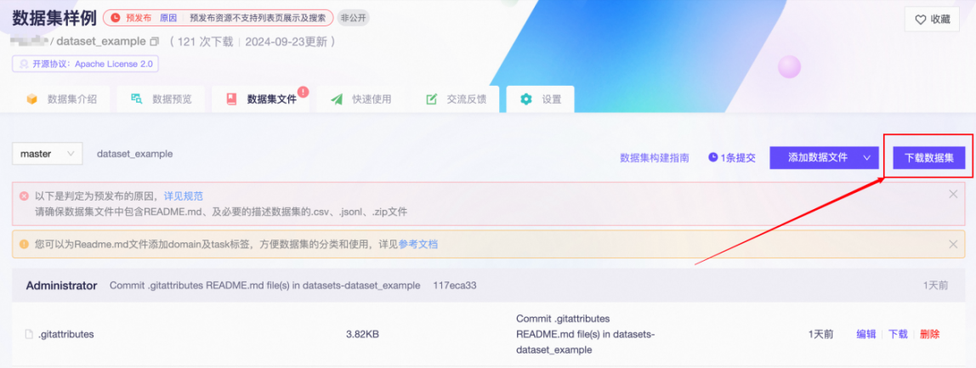

Download Datasets Using Python SDK
You can easily download datasets using the modelscope library and perform related operations (create, delete, update, and retrieve information).

Install Python SDK
First, ensure you have installed ModelScope ’s Python SDK using the following command:
pip install modelscope[framework]

Dataset Download Example
Use the following code to download a dataset:
from modelscope import MsDataset
# Load dataset
ds = MsDataset.load('afqmc_small', split = 'train')

Download Datasets Using GIT
If you prefer using GIT, you can download datasets as follows.

Public Dataset Download
# Install Git LFS (Large File Storage)
git lfs install
# Clone public dataset
git clone https://www.modelscope.cn/datasets/<namespace>/<dataset-name>.git
# Example: git clone https://www.modelscope.cn/datasets/DAMO_NLP/jd.git

Private Dataset Download
Note: You need appropriate dataset permissions.
# Use Git LFS
git lfs install
# Clone private dataset
git clone http://oauth2:<your_access_token>@www.modelscope.cn/datasets/<namespace>/<dataset-name>.git
Or use the following method:
git clone http://<your_user_name>@www.modelscope.cn/datasets/<namespace>/<dataset-name>.git
# Enter your access token as password

Obtain Access Token
Log in to ModelScope official website. Go to Personal Center -> Access Tokens, and copy your access token.

Download Dataset Files Using Command Line Tools
Through the command line, you can flexibly download dataset files.

Command Format
modelscope download --dataset DATASET_NAME [options] [files ...]
Parameters
Parameter | Short | Type | Default | Description
--dataset | - | str | None | Dataset ID (required)
files | - | str | - | Positional, files to download (supports multiple)
--revision | - | str | None | Version/branch/tag
--cache_dir | - | str | None | Cache directory
--local_dir | - | str | None | Local directory (takes precedence over cache_dir)
--include | - | list | None | Glob patterns for files to include
--exclude | - | list | None | Glob patterns for files to exclude
--token | - | str | None | Access token (required for private datasets)
--endpoint | - | str | None | ModelScope server endpoint
--max-workers | - | int | default | Maximum concurrent download threads

Usage Examples
Command examples using SA1B-Dense-Caption as an example:
Download a single file
modelscope download --dataset 'Tongyi-DataEngine/SA1B-Dense-Caption' dataset_infos.json
Download multiple file
modelscope download --dataset 'Tongyi-DataEngine/SA1B-Dense-Caption' dataset_infos.json README.md
Download specific files
modelscope download --dataset 'Tongyi-DataEngine/SA1B-Dense-Caption' --include 'data/train-000*'
Filter out specific files
modelscope download --dataset 'Tongyi-DataEngine/SA1B-Dense-Caption' --exclude 'data/train-000*'
Specify cache_dir for download
modelscope download --dataset 'Tongyi-DataEngine/SA1B-Dense-Caption' --include 'data/train-000*' --cache_dir './cache_dir'
Dataset files will be downloaded to ./cache_dir
Specify local_dir for download
modelscope download --dataset 'Tongyi-DataEngine/SA1B-Dense-Caption' --include 'data/train-000*' --local_dir './local_dir'
Dataset files will be downloaded to ./local_dir
Note: If both cache_dir and local_dir are specified, local_dir takes precedence and cache_dir will be ignored.

Access Token Required for Private Dataset Downloads
You can obtain your access token from “My Page -> Setting -> Access Tokens” .

Method 1: Login first, then download
modelscope login --token YOUR_MODELSCOPE_ACCESS_TOKEN

Method 2: Specify token parameter for download
modelscope --token 'YOUR_MODELSCOPE_ACCESS_TOKEN' download --dataset 'YOUR_DATASET_NAME'

