AI-based correlation in anomaly detection

1 Conclusion

This AIC project aims to solve benign anomaly detection problem. This study focuses on reduce false positives on benign cybersecurity log events. The experiment run on DARPA OpTC, get good result.

The work has been done in AIC at present:
- Designed and implemented the Sequence Detector model of un-supervised benign anomaly detection including three transformer autoencoder. The first one learns from the context concerning attention mechanisms. The second transformer autoencoder learns from log events content including content template and value parameters. The thired transformer autoencoder learns from the mixture information of log events, focus on sequence information. Considering two sides information to provide accurate predictions. Specific detail in section 3.3, 5.4.
- Designed and implemented the framework combined DeepCASE to Sequence Detector, through replacing human labelling work by sequence detector. The experiments have been done on single datafile, but do not finish on whole dataset yet (needs H100).
- Implemented the metric in Interpreter evaluation. In section 4.3.
- Designed the framework of interpretation, the combination of RAG and LLM. In section 3.5.
- Preprocessed the big dataset, DARPA OpTC partial data. In section 3.1, 4.1.

The performance of this project at present:
- The ContextBuilder prediction has the accuracy about 75% and F1-score 74% on 122 event type classes.
- The SequenceDetector has the performance about 88% of AUC-ROC and 90% F1-score.
- The Interpreter has accuracy about 93% and F1-score 91% on single one data file (AIA-51-75.ecar-last.csv), still need do further experiment on whole dataset in H100.

The work needs to do in the next phase:
- Finish the experiment of DeepCASE+SequenceDetector on whole dataset.
- Based on the results of DeepCASE+SequenceDetector, the interpretation model (RAG+LLM) needs to be constructed.

The work can be expanded in the future:
To explore more way to discover more benign anomalous in DARPA OpTC to reduce data extremely imbalance.
To explore the way to update existed Interpreter when new information coming.
To expand the window size (e.g. 20) , or cross multiple days.

2 solution
With aim to efficiently detect benign anomalies and interpretate in comprehensive, the solution includes off-line analysis part and on-line analysis part. Off-line analysis focuses on anomaly detection and prepares local knowledge base, while on-line analysis focus on provided accurate and convinced explanation for the end user.
In the part of off-line work, it starts from Context Builder. The context vector is produced from history event sequences, and as the input of Context Builder. The Context Builder outputs attention vector on event sequences. The Sequence Detector detects event sequence concerning event content and event sequence with attention vector. The Sequence Detector results, (i.e. labels of event sequences), together with the event context as the input of Interpreter to cluster and score to fill cluster set.
On-line network event logs go through Context Builder and Interpreter to check whether there is the most similar cluster from Cluster set to help to detect anomalous.
For assistant end user to judge whether the new network event logs or complex event sequences are normal or not, RAG is used to retrieve the top-N most similar cluster from Cluster set. The retrieved content as the background to help LLM to reason and make a decision.
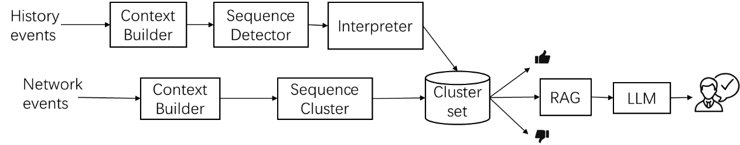

- The history events log goes through modules (CB, SD) to produce labels for event sequence. One datafile by one datafile.
- The history events log goes through modules (CB, SC.fit() ) to supply Cluster set. All datafile together.
- The network events log goes through modules (CB, SC.predict() ) to check whether there is the most similar cluster in Cluster set to quickly make a certain decision. Only run on one test datafile.

3 Compositions

3.1 Data preprocessing
According to name-value pairs in origin Json data files, general preprocess work is done on the data including removing incorrect/null records, unifying the timestamp.

The event content and event sequence both need to be considered in this project. To treat records from DARPA OpTC JSON files under specific key-value conditions, event type, event template and template value are assigned based on keys like action, object, and other attributes. In specific, two parts of preprocess work need to do.
- The sequence of event type only be needed in Content Builder, event type is extracted by “object” and “actions” as unique eventID to composite event sequence. At the same time, more analysis is made on each record.
- Multicast and unicast is considered. When analysing network FLOW events with action is “OPEN” or “START”, checks if the destination IP address is in the multicast range (224.0.0.0 – 239.255.255.255), and classifies flows into multicast flows and unicast flows.
- In “PROCESS” events, the “image_path” field shows where the process executable is located. The processes can be classified as system or user based on their file path. ( Windows OS: e.g. "C:\\Windows\\System32", "C:\\Windows\\SysWOW64", "C:\\Program Files\\WindowsApps")
- Security-relevant file access events include the file access to critical paths, such as reading security logs (e.g., Security.evtx).
- To identify unusual process chains (Suspicious Process Spawning), we analyzed the parent-child relationships between processes. Normal process flows follow expected patterns, while malicious activity often creates unexpected parent-child relationships.

Unusual Process Chain | Why It’s Suspicious?
PING.EXE → Explorer.EXE | Normal: PING.EXE doesn't launch GUI apps.
CMD.EXE → PowerShell.EXE → CertUtil.EXE | Possible fileless attack or malware download.
WINWORD.EXE → CMD.EXE → PowerShell.EXE | Potential malicious macro in a Word document.
RUNDLL32.EXE → CMD.EXE → Wscript.EXE | Common LOLBin (Living Off the Land Binary) attack.
LSASS.EXE → Any Process | LSASS.EXE should never start a process. Possible credential theft.

- The event content is considered in Sequence Detector including event template and parameter values. All the feature names as follows:
extract out the specific fields name and the values. prepare data for BERT.
['action', 'actorID', 'hostname', 'id', 'object', 'objectID', 'pid', 'ppid', 'principal', 'tid', 'timestamp',
'properties_acuity_level', 'properties_image_path', 'properties_src_pid', 'properties_src_tid',
'properties_stack_base', 'properties_stack_limit', 'properties_start_address', 'properties_subprocess_tag',
'properties_tgt_pid', 'properties_tgt_tid', 'properties_user_stack_base', 'properties_user_stack_limit',
'properties_dest_ip', 'properties_dest_port', 'properties_direction', 'properties_l4protocol',
'properties_src_ip', 'properties_src_port', 'properties_size', 'properties_file_path', 'properties_info_class',
'properties_new_path', 'properties_end_time', 'properties_start_time', 'properties_parent_image_path',
'properties_command_line', 'properties_data', 'properties_key', 'properties_type', 'properties_value',
'properties_base_address', 'properties_module_path', 'properties_tgt_pid_uuid', 'properties_sid',
'properties_user']

The event template consided three situations:
- event field name
combine all properties feature names with non-empty value as the event field names, and the combination of the non-empty value of each properties feature as the event field values, which is as the parameters of event template.
- Event Type+ event field name
the value of action+object as the event type( when the value is not empty),. Combine event type to event filed name as event template. The event field value is as the parameters of event template.

- event feature + event field name
except properties, combine all the values of main features (pid+principal+tid ) as event feature, which is combined again with event field name as event template. The event field value is as the parameters of event template.

3.2 ContextBuilder
Follow the ContextBuilder in DeepCASE, embedding the event sequence at first, the context vector is produced in preprocessor, then using Encoder-Decoder architecture with attention mechanism, produced weighted-attention vector. And output the event without context or under confidence threshold.

3.3 SequenceDetector – BERT
For labelling the event sequence instead of human operator in DeepCASE, the way of reconstruction-based anomaly detection using transformer model is used to made up of Sequence Detector.
The transformer model can train the event sequence with weighted-attention vector, which is the output of ContextBuilder, to know the normal traffic pattern. Anomalies are detected when reconstruction error (difference between normal sequence and anomaly sequence) is high.

The Sequence Detector has implemented in un-supervised learning using Transformer Autoencoder following the pipeline in LogFormer, as shown in the below figure.
The input for Sequence Detector starts from event content embedding. The main part in this model is composed of two suits transformer autoencoders and a transition layer. The first suit of transformer autoencoder used modified content multi-head attention mechanism. It replaced the general multi-head attention layer in the encoder to the customer content attention model. It focuses on learn the potential pattern in content including event template and value parameters.
The transition layer transfers the vector of event content to the vector of event context. The context attention from Context Builder is used to element-size multiply with the event context vector, the result as the input feed in the second suit transformer autoencoder to learn the potential pattern in sequence.
because of two suits of TransformerEncoder and TransformerDecoder that running on the server, Sequence Detector is memory-consumption. For solving the out-of-memory problem in server, data parallel is used and feed in smaller data as input.
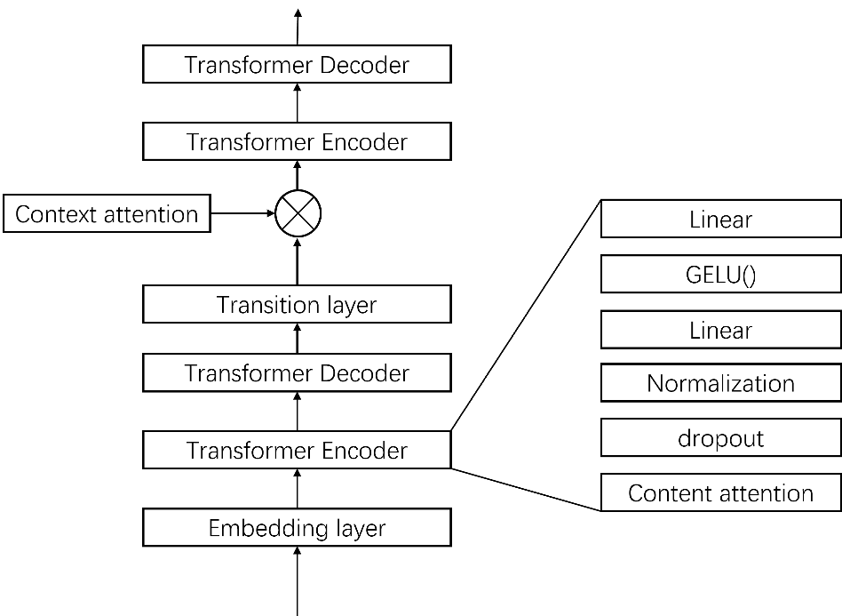
Figure the architecture of Sequence Detector

Content attention
To enhance the expressiveness of Transformer-based models in the context of log anomaly detection, a modified multi-head attention mechanism, as shown as in the figure below integrates structured parameter information into the attention computation. This design allows the model to attend not only to sequence context and content but also to event-specific parameters embedded at the character level.
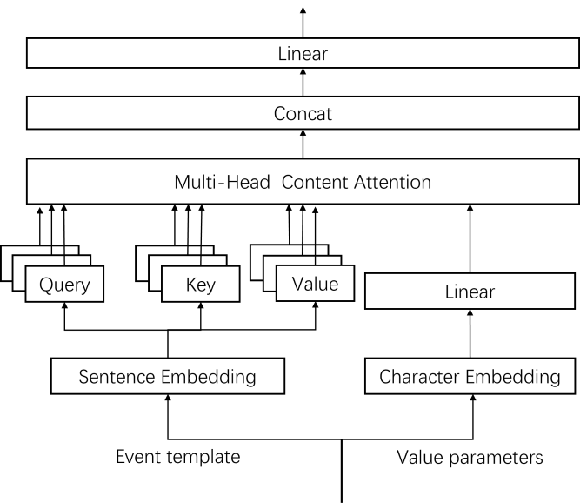
Figure the architecture of Content attention

The event content is embedded includes two parts. The field names are embeded using SentenceTransformer based on Distilbert. And the field values are embedded using Pytorch embedding layer.

Let the input $x∈R^{L×d}$ be a sequence of embedded event template IDs of length $L$ and embedding dimension $d$. The model utilizes standard multi-head attention, decomposing $d$` into $h$ heads of size $d_{h}=d/h$.

Then define linear projections for queries, keys, and values:
$$Q=W_{q}x, K=W_{k}x, V=W_{v}x, W_{q},W_{k},W_{v}∈R^{d×d}$$
These are reshaped into $\left(h,L,d_{h}\right)$ and transposed for multi-head computation.
In parallel, event parameters—such as numeric values, IPs, or file path—are embedded using a character-level embedding. Each parameter is tokenized into a sequence of character IDs, passed through an embedding layer:
$$e_{c}=\text{Embedding}\left(param_chars\right)∈R^{P×d_{p}}$$
$$ϕ_{p}=\text{Linear}\left(e_{c}\right)∈R^{P×d_{h}}$$
Here, $P$ is the parameter token length and $d_{p}$ is the parameter embedding dimension. The output $φ_{p}$ is averaged along the token dimension to obtain a scalar bias per attention head:

$$b_{p}=\text{mean}\left(ϕ_{p},\text{dim}=−1\right)∈R^{h}$$
This bias is broadcasted to each head and added to the attention logits:

$$\text{Attention}\left(Q,K,V\right)=\text{Softmax}\left(\frac{QK^{T}}{\sqrt{d_{h}}}+b_{p}\right)V$$
The multi-head output is reassembled and projected via:
$$\text{Output}=W_{o}⋅\text{Concat}\left(head_{1},…,head_{h}\right)$$
where $W_{o}∈ℝ^{d×d}$ is a final linear projection. The entire computation is end-to-end differentiable and supports batch-first or sequence-first modes.

Sequence Detector in transformer-based Autoencoder architecture has advantages that semantic awareness, flexibility and scalability. It integrating parameter-level context allows the model to differentiate log events beyond surface structure. The character-level encoding can generalize to variable-length and previously unseen tokens, which is typical in log parameter spaces. The computation is compatible with standard Transformer modules and can be dropped into encoder or decoder blocks.

3.4 Sequence Cluster(Interpreter)
Following Interpreter in DeepCASE, clustering the event sequence with attention for retrieval, refer to the clustering (DBSCAN) in Interpreter. For clustering big size group, sample-based clustering is used.

Sample-Based Clustering with Centroid Propagation
In large-scale log analysis or embedding-based clustering tasks, applying traditional clustering algorithms such as DBSCAN directly to all data points often leads to out-of-memory (OOM) errors due to the high dimensionality and volume of the data. To address this, we propose a sampling-based clustering with centroid propagation approach, which balances computational efficiency with global structure awareness.
Method Overview
Let $V=\{v_{i}\}_{i=1}^{N}⊂R^{d}$be the set of feature vectors (e.g., event embeddings), and let
$I⊂\{1,…,N\}$ be the indices defined by a context mask selecting a subset of interest. Our method proceeds in three main stages:
1. Stratified Vector Sampling
To reduce computational cost, we sample a small subset of vectors from the context-specific set $V_{I}$​. Given a sampling ratio $r∈\left(0,1\right)$, we randomly select:
$$S=\text{Sample}\left(V_{I},\left\lfloor r⋅\left|I\right|\right\rfloor \right)$$
This sample is representative of the underlying distribution while being small enough to allow direct clustering.
2. Clustering Sampled Vectors
We then apply a density-based clustering algorithm (DBSCAN) to the sampled subset $S$:
$$L_{s}=\text{DBSCAN}\left(S;ε,\backslash textttmin_samples\right)$$
where ε\varepsilonε and min_samples are standard DBSCAN parameters. Clusters labeled as noise (i.e., $L_{s}=−1$) are excluded from further processing.
For each valid cluster label lll, we compute the cluster centroid $c_{l}$ as:
$$c_{l}=\frac{1}{\left|S_{l}\right|}\sum_{v_{j}∈S_{l}}{v_{j}}$$
This results in a set of representative centroids $\{c_{l}\}_{l=1}^{K}$​.
3. Full-Set Propagation via Nearest Centroids
To assign cluster labels to the full context vector set $V_{I}$, we compute the cosine distance between each full vector and the set of centroids:
$${\text{label}\left(i\right)=arg{m}in}_{l}\left(1−cos\left(v_{i},c_{l}\right)\right) \text{for all }v_{i}∈V_{I}$$
Each vector is assigned the label of its nearest centroid. This propagation mechanism enables efficient, large-scale label inference while preserving the overall cluster structure discovered in the sample.
Advantages
- Memory Efficiency: Only a small representative subset is clustered using DBSCAN, avoiding OOM issues.
- Global Awareness: The centroid propagation phase approximates the global distribution without re-running DBSCAN.
- Scalability: This method can be applied independently across partitions, making it parallelizable for distributed environments.

And score each cluster following the way in Interperter.
In case of updating Interpreter when have new or complex event sequences, two way can go: (1) for data with label ‘-2’ that not in training data, they can save to fit later by Interpreter off-line update.
(2)For data with label ‘-1’ that not convinced and label ‘-3’ that suspicious, they are sent to human operator to further work.

3.5 RAG
it prefers to the combination of prompt engineering and agentic RAG, this can expand the advancement of this project.
The combined workflow benefits from structured interpretability (via prompt engineering) while also incorporating adaptive decision-making and contextual retrieval (via Agentic RAG), enabling the system to dynamically adjust to new or evolving patterns.

Using prompt, using RAG, using the combination of prompt and RAG are three pathways to different outcomes.
The outcome using the combination can detect newest anomalous with the assistant of RAG and friendly communication with the assistant of LLM. This needs to daily maintain the retrieval dataset.
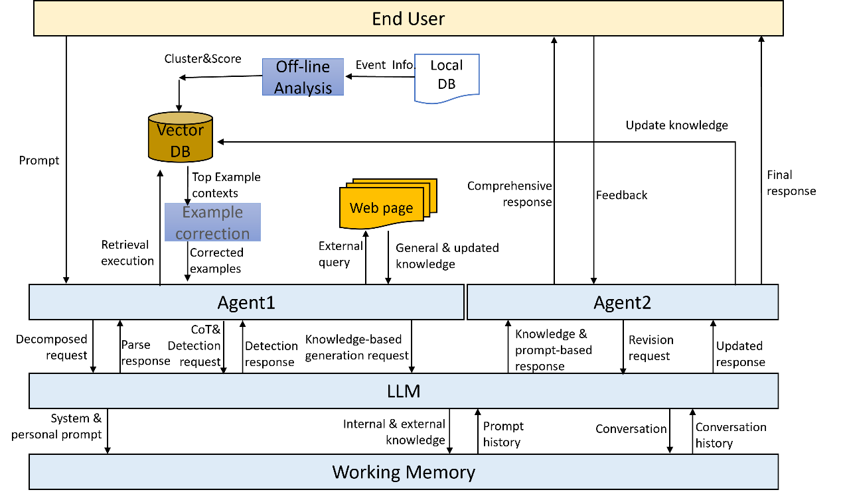
Figure Data flow of Agentic RAG and LLM in anomaly detection

There are two agents here, one agent (Agent1) responsible for the RAG, another agent (Agent2) work on the feedback process.
Agent1 receives the prompt for anomaly detection request from the end user, then decomposes it and extracts key information, and combines the key information to specific prompt template, send it to LLM at last. The LLM save necessary system and personal prompt to working memory and produce the response. According to the response, Agent1 retrieve relative existed event sequences from Vector DB, which stored clustered event sequences from off-line analysis module. To assure the retrieved content correction, the example correction method is applied, corrected examples is sent to Agent1 to transfer to LLM as background knowledge. LLM detects anomalous following CoT mechanism based on the most similar event sequences. Agent1 supplies general knowledge through external query and transfer all results to LLM to make final response to Agent2 for this detection.
Agent2 sends the final response to end user and receives the feedback from the end user. Then Agent2 make a revision, request LLM to make updated response. If there is new information to update in Vector DB, Agent2 response to edit the Vector DB. Agent2 send the final response to end user at last. This feedback process is repeated until end user is satisfied. Working memory stored prompt information, internal and external knowledge, and conversation history to long-term memory.

4 Evaluation

4.1 Dataset
Because DARPA OpTC is more popular than others, one paper [4] provided the labels publicly https://github.com/AT03380/optc-labels , one of research directions on DARPA OpTC is anomaly detection [1], DARPA OpTC is the first choice.
- DARPA OpTC
- The latest iteration[1] and the transition pilot of DARPA TC. It also named Scalable Transparency Architecture for Research Collaboration (STARC) in E5 [2].
- along with TA1 and TA2 in TC, collected 3 days'attack data from 500 hosts.
- The suggestion of the research using this dataset is anomaly detection [1].

The review on the usage of DARPA OpTC as follows, most of these are about APT and provenance graph. Some use all of the data, some use all the data from malicious hosts, some randomly chose several hosts; most are use the data from ecar folder, one use one day data from ecar-bro folder.

The DARPA OpTC dataset comprises over 17 billion events, collected over the course of a week from 500 hosts. Due to the substantial volume of data, two subsets of benign data were selected to evaluate the benign anomaly detection and the false positive reduction in this phase.
We chose part of data in DARPA OpTC to evaluate the anomaly detection and the false positive reduction in this project.
The data extracting from OpTC
- The benign records of 100 (51-75, 101-125, 151-175, 201-225) hosts in the day of 19Sep is about 116,535,961.
- The benign reords of 5 hosts (51,52,53, 54,55) across 5days ( 18-19Sep, 19Sep, 20-23Sep) is 95,296,900.

The data has been pre-processed, each record has been assigned an event type to build the context in Context Builder, and the field names and values have been embedded for the Sequences Detector.

According to the research on OpTC, they provided benign anomalous of OpTC, it is admin.json.

Because we only need the data in 20Sep and 21Sep, based on admin.json,
to get the label for each benign anomaly host. The data is extracted for host 123,124 in 20-23Sep in BenignAnomalyHost, and labelled the data for host 123, 124 in 20-23Sep. That is 20-23-123.json, 20-23-124.json.
The label is one extra column in csv data files.

Because the benign anomaly data most appeared in 20/9/2019 , the data of host 123 and 124 in 20Sep as the validate data and testing data.

4.2 Metrics
Normally, we use AUC-ROC, F1-score, and accuracy to evaluate. While there are some new metrics for specific target.

Sequence label Coverage rate- evaluate on test data labelling
**Contextual Recall Metric** 70%
Recall = (# of abnormal items that are covered by at least one prediction in their forward context) / (total # of abnormal items)
this version measures how many real abnormal events are caught by at least one predicted label in the relevant prediction window.
This is a recall-style metric for forward-looking predictions, adapted to sequence data.

To evaluate the performance of our anomaly detection system, we define a custom metric function, `compute_metrics_recall`, which measures both pointwise classification accuracy and a *context-aware recall* that better captures temporal detection fidelity.

Let $y=\left[y_{1},y_{2},…,y_{T}\right]$ denote the ground truth binary label sequence, and $\hat{y}=\left[\hat{y_{1}},\hat{y_{2}},…,\hat{y_{T}}\right]$ the corresponding predicted binary sequence, where $y_{t}=1$ indicates an anomalous item at timestep $t$. The function performs the following computations:

* **Contextual Recall (Window-based)**: To account for temporal tolerance in anomaly detection, we introduce a window-based recall computation. For each ground truth anomaly at time$t$, we define a *context window* of size $w$, looking backward up to $w$steps. An anomaly is considered successfully detected if any prediction within this context window is also labeled as anomalous:

$\text{Recall}=\frac{\text{\# Ground Truth Anomalies Detected Within Window}}{\text{\# Ground Truth Anomalies}}$

Specifically, a true anomaly at position$t$ is considered detected if:
$∃j∈\left[\max\left(0,t−w+1\right),t\right]\text{ such that }\hat{y_{j}}=1$

This windowed recall reflects the model’s ability to detect anomalous patterns in a temporally flexible manner, which is particularly important in real-world log or sequence data where exact alignment between ground truth and prediction may not be achievable due to noise or lag.

Evaluate on Test file ( 124(20).csv ) :
Real label for each event, vs. predicted label for context by SD
Confusion Matrix:
[[1913699 861470]
[ 25 573]]
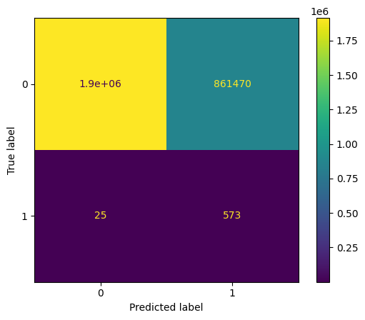

4.3 Metrics For Interpreter

False Positive Reduction Estimation on Clustering
To estimate the potential reduction of false positives in the training phase, we introduce the Reduced False Positive Ratio metric, denoted as reduced_FP_train. This metric leverages unsupervised clustering to identify and isolate anomalous or unexpected event sequences from the full dataset.
Let $C=\left[c_{1},c_{2},…,c_{N}\right]$ be the cluster assignment vector produced by an unsupervised clustering algorithm (e.g., DBSCAN or HDBSCAN), where each $c_{i}$ corresponds to the cluster label assigned to the $i$-th event sequence. Special cluster labels such as -1,-2,-3 are reserved for noise or unclustered data points, which typically represent unusual or suspicious sequences.
We define the number of such unexpected sequences as:
$$U=\sum_{i=1}^{N}{1\left[c_{i}∈\{−1,−2,−3\}\right]}$$
The reduced_FP_train metric is then computed as:
$${\text{ReducedFP}}_{\text{train}}=1−\frac{U}{N}​$$
where:
- U: number of sequences marked as unclustered or suspicious,
- N: total number of event sequences in the training set.
This metric approximates the proportion of event sequences that have been successfully grouped into well-formed clusters (i.e., potentially benign or frequent patterns), and thus are less likely to contribute to false positives during detection.
By minimizing the proportion of unclustered data, we aim to reduce the false positive rate by focusing detection and manual labeling efforts on a small subset of potentially suspicious sequences. These unclustered sequences are then subjected to manual investigation or labeling in a downstream step.

Coverage as a Proxy for Confidence
( Sequence context event label > confidence threshold ) / len( Sequence context event label )

‘-1’ label not only has items smaller then confidence threshold, but also has items can’t be clustered in manual analysis.

Incorrect method:
To assess the proportion of event sequences that the clustering algorithm is able to confidently categorize, we define a metric called coverage, denoted as coverage.
Let $C=\left[c_{1},c_{2},…,c_{N}\right]$ represent the cluster assignments of all $N$ event sequences. In this setting, a label of -1 indicates an unclustered or noise point, typically used by density-based clustering algorithms such as DBSCAN or HDBSCAN to denote low-confidence or anomalous sequences.
We define the number of unclustered (i.e., low-confidence) sequences as:
$$U=\sum_{i=1}^{N}{1\left[c_{i}=−1\right]}$$
Then, the coverage is computed as:
$$\text{Coverage}\frac{N−U}{N}$$

This metric quantifies the fraction of the dataset for which the model is confident in its assignment to a meaningful cluster. Intuitively, it reflects the effective confidence rate of the unsupervised model over the training set.
A high coverage score indicates that most event sequences fall into high-confidence clusters, while a lower coverage suggests the presence of many ambiguous or anomalous sequences that may require further manual inspection or specialized handling.

Suspicious Cluster Rate Based on Score Distribution
To estimate the proportion of clusters that may contain anomalous or mixed-behavior sequences, we introduce the Suspicious Cluster Rate metric. This metric leverages the distributional properties of a confidence or anomaly score (e.g., reconstruction loss, classification probability) associated with each event sequence.
Let:
- $C=\{c_{1},c_{2},…,c_{K}\}$ denote the set of unique cluster IDs produced by an unsupervised clustering algorithm, where noise or invalid clusters are labeled as -1, -2, -3.
- $C^{'}=C∖\{−1,−2,−3\}$ denote the filtered set of valid clusters.
- Each cluster $c∈C^{'}$is associated with a set of confidence or anomaly scores $\{s_{i}\}_{i∈c}$
For each valid cluster ccc, we compute the mean score $\overline{s_{c}}$​. If $\overline{s_{c}}$ is a non-integer float, we interpret the cluster as potentially suspicious—that is, it may represent a mixture of normal and abnormal sequences. This heuristic is particularly effective in semi-supervised or label-smoothed scoring contexts, where integer-like scores (e.g., exactly 0 or 1) are expected for pure clusters.
The Suspicious Cluster Rate is then computed as:
$$\text{SuspiciousClusterRate}=\frac{\left|\{c∈C^{'} ∣ \overline{s_{c}}∉Z\}\right|}{\left|C^{'}\right|}$$

This metric quantifies the proportion of clusters whose internal scoring structure suggests uncertainty, heterogeneity, or partial anomaly content. A higher value indicates more ambiguous clustering results, guiding manual inspection or further refinement of cluster assignments.

Suspicious Event Sequence Rate
To estimate the proportion of potentially anomalous or uncertain event sequences within the training set, we define the Suspicious Rate metric. This measure captures individual event sequences that are neither clearly normal nor clearly abnormal, based on a scoring heuristic (e.g., soft confidence scores, anomaly likelihoods).
Let:
- $N$ be the total number of event sequences,
- $U⊂C$ be the set of sequences assigned to special clusters labeled -1,-2, or -3, which are treated as unexpected or unclustered,
- $S=\{s_{1},s_{2},…,s_{M}\}$ be the sequence-level scores assigned to each event (e.g., output of a classifier or anomaly detector).
We define suspicious sequences as those whose score is a non-integer float, i.e., scores that are neither exactly 0 nor 1. This often reflects ambiguous, borderline, or uncertain cases.
Let:
$S_{\text{suspicious}}=\{s_{i}∈S∣s_{i}∈R, s_{i}∉Z\}$

Then, the Suspicious Rate is computed as:
$$\text{SuspiciousRate}=\frac{\left|S_{\text{suspicious}}\right|}{N−\left|U\right|}$$
This ratio represents the fraction of non-excluded (i.e., clustered and analyzable) event sequences that are deemed suspicious under the scoring model.
A high suspicious rate may indicate:
- Many borderline cases,
- Noisy or overlapping feature distributions,
- The need for better model calibration or feature separation.

Evaluation Metrics and Post-Processing for Label-Aware Testing
To evaluate the classification performance of our model, we employ a two-phase assessment strategy: one that includes all prediction outcomes, and another that focuses strictly on the core labels of interest (e.g., normal and anomalous sequences), excluding special internal labels used for uncertainty tracking.
1. Full Evaluation with Diagnostic Labels
When ground truth labels $y_{\text{test}}$ are available, we first compute standard classification metrics over all predicted outcomes using the classification_report from scikit-learn, which includes:
- Precision, recall, and F1-score for each class,
- Macro, micro, and weighted averages.
To provide more granular insight into edge-case predictions, we extend the evaluation using a custom confusion matrix utility (confusion_report) that includes diagnostic labels:
- -3: Low-confidence prediction (e.g., low confidence threshold),
- -2: Class not seen during training,
- -1: Low-density cluster (e.g., below DBSCAN/HDBSCAN ε threshold).
These special predictions are incorporated into the confusion matrix under the labels:
- LOW CONFIDENCE, NOT IN TRAIN, and LOW EPS, respectively.
The confusion matrix helps identify how frequently the model fails to make confident or valid predictions and whether these failures align with challenging classes.
2. Filtered Evaluation on Core Classes
To accurately quantify the model’s performance on the primary classification task (e.g., distinguishing normal vs. anomalous events), we apply a post-filtering step. All instances where the prediction falls into diagnostic categories -3, -2, or -1 are removed:
$$mask_{core}​=\{i∣\hat{y_{i}}​∉\{−3,−2,−1\}\}$$

We then recompute the classification report using only the retained instances:
$$\text{classification_report}\left(y_{\text{true}}\left[\text{mask}\right],\hat{y}\left[\text{mask}\right]\right)$$

This yields precision, recall, and F1-score metrics that more accurately reflect model behavior on valid, in-distribution classes. The weighted F1-score, which accounts for class imbalance, is explicitly reported as a summary measure:
$$\text{WeightedF1}=\sum_{i}{\frac{n_{i}}{N}}⋅\text{F}{\text{1}}_{\text{i}}$$

Where $n_{i}$ is the support (number of samples) for class $i$, and $N$ is the total number of filtered samples.

5 Experiment

cluster on training data. predict the score of cluster which the most similar sequence in. otherwise the predict label is -2, means no label data in training. result : np.array of shape=(n_samples,) Predicted maliciousness score. Positive scores are maliciousness scores. A score of 0 means we found a match that was not malicious. Special cases:
* -1: Not confident enough for prediction
* -2: Label not in training
* -3: Closest cluster > epsilon

5.1 Parameter Selection

for new data, Sequence Detector can detect, expand and update embedding space. This means that characters embedding is more and more bigger.

Subsystem | Parameter | Range | default choice | Best choice
 | Sequence length | 10 | 10 | 10
 | Sequence time | 1 day | 1 day | 1 day
 | Random seeds | 42 | 42 | 42
CB | Hidden dimension | 2⁰,~ 2¹⁰ |  | 128
 | Delta | (0,1, step=0.1) |  | 0.1
 | Confidence_threshold | (0,1, step=0.1) |  | 0.1
 | Learning rate | 0.1-0.000001 |  | 0.001
 | Num_layers | 1 | 1 | 1
 | bidirectional | False | False | False
 | LSTM | False | False | False
 | Teach_ratio | 0.5 | 0.5 | 0.5
 | Batch
SD | Embed_content_dim | 768 | 768 | 768
 | Embed_context_dim | 128 | 128 | 128
 | Embed_param_dim | 3 | 3 | 3
 | nhead | 8 | 8 | 8
 | Learning rate | 0.1-0.000001 |  | 0.01
 | Loss weight | 0.5 | 0.5 | 0.5
 | optimizer | Adam, OneCycleLR |  | SGD, OneCycleLR
 | Dropout | 0.1 | 0.1 | 0.3
 | Dim_ff | 4 | 4 | 8
 | Batch | 10*
Interpreter | epsilon | (0,1, step=0.1) |  | <0.01
 | Mini samples | 5 | 5 | 5

5.2 Environmental parameters
V100:
# torch version=2.5.1 + cu121
# python=3.10
# cuda=12.4
Pandas=1.5.1

H100:
Pandas= 2.2.3
# torch version=2.5.1
# python=3.10.16
# cuda=12.1

5.3 Context Builder fitting
Context Builder is fitting on whole data.

Metric： weighted-F1, accuracy of predicted confidence next eventID based on context in CB
Manual analysis, on train data
Semi-analysis, on test data

when grid search confidence threshold , the performance is increased straight as the below figure.
Size=condidence_threshold
Label=performance

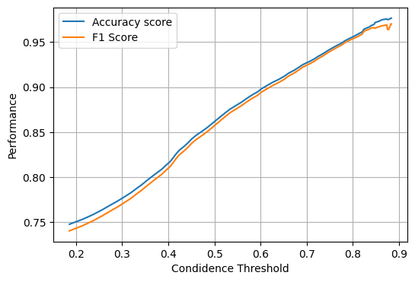
10 epoches CB based on Iram’s CB on 100 hosts:

evaluate on train set:
2025-06-27 09:40:54.233018
precision recall f1-score support

0 0.2347 0.3449 0.2793 4477
1 0.0000 0.0000 0.0000 19
2 0.6425 0.4871 0.5541 24195
3 0.4284 0.5366 0.4765 2432
4 0.6401 0.3767 0.4743 3621
7 0.5046 0.2785 0.3589 395
8 0.5305 0.4146 0.4654 398
9 0.8687 0.5898 0.7026 2221
10 0.8004 0.9311 0.8608 31226
11 0.7654 0.3979 0.5236 2533
13 0.0000 0.0000 0.0000 25
14 0.0000 0.0000 0.0000 14
18 0.0000 0.0000 0.0000 101
19 0.8815 0.8943 0.8878 5656
20 0.5345 0.3387 0.4146 76734
25 0.7168 0.4875 0.5803 44055
26 0.0000 0.0000 0.0000 4
27 0.5820 0.3062 0.4012 11017
28 0.9393 0.9141 0.9266 559
30 0.8353 0.9523 0.8900 11704
31 0.5225 0.1590 0.2438 13149
32 0.0000 0.0000 0.0000 1
33 0.5366 0.3716 0.4391 68726
34 0.8516 0.7280 0.7850 404199
35 0.6185 0.5874 0.6026 187144
36 0.4896 0.2593 0.3390 725
37 0.0000 0.0000 0.0000 32
38 0.4194 0.0498 0.0890 261
39 0.4223 0.2149 0.2849 12940
40 0.6739 0.5350 0.5965 1557
41 0.0000 0.0000 0.0000 14
42 0.8290 0.9288 0.8761 1269007
43 0.7018 0.5991 0.6464 230851
46 1.0000 0.6667 0.8000 27
48 0.0000 0.0000 0.0000 8
49 0.6000 0.5581 0.5783 86
50 0.6458 0.4530 0.5325 978
52 0.0000 0.0000 0.0000 36
53 0.0000 0.0000 0.0000 21
55 0.2876 0.1641 0.2090 524
56 0.0000 0.0000 0.0000 2
57 0.7546 0.1696 0.2770 81235
58 0.0000 0.0000 0.0000 6
59 0.0000 0.0000 0.0000 2425
60 0.0000 0.0000 0.0000 27
62 0.0000 0.0000 0.0000 14
63 0.0000 0.0000 0.0000 3
64 0.6667 0.8810 0.7590 385340
65 0.6719 0.3435 0.4545 626
67 0.5468 0.2491 0.3423 2300
69 0.0000 0.0000 0.0000 27
71 0.0000 0.0000 0.0000 14
73 0.0000 0.0000 0.0000 53
74 0.3000 0.0779 0.1237 77
75 0.0000 0.0000 0.0000 3
76 0.0000 0.0000 0.0000 18
77 0.8902 0.9031 0.8966 2002
78 0.5822 0.3575 0.4430 2249
79 0.3502 0.4003 0.3736 572
80 0.5000 0.0833 0.1429 12
81 0.0000 0.0000 0.0000 170
82 0.6400 0.3951 0.4885 81
83 0.7581 0.7325 0.7451 2041
84 0.0000 0.0000 0.0000 1
85 0.0000 0.0000 0.0000 92
89 0.0000 0.0000 0.0000 1
90 0.0000 0.0000 0.0000 1
92 0.0000 0.0000 0.0000 1
93 0.0000 0.0000 0.0000 1
98 0.0000 0.0000 0.0000 1
99 0.0000 0.0000 0.0000 1
100 0.0000 0.0000 0.0000 14
102 0.0000 0.0000 0.0000 1
105 0.0000 0.0000 0.0000 1
106 0.0000 0.0000 0.0000 3
107 0.0000 0.0000 0.0000 6
108 0.0000 0.0000 0.0000 3
109 0.0000 0.0000 0.0000 4
111 0.0000 0.0000 0.0000 1031
112 0.7457 0.4904 0.5917 27143
113 0.0000 0.0000 0.0000 5167
114 0.7116 0.6028 0.6527 32849
115 0.7000 0.4275 0.5308 131
116 0.0000 0.0000 0.0000 8
117 0.0000 0.0000 0.0000 2
118 0.7324 0.5098 0.6012 102
119 0.0000 0.0000 0.0000 25
120 0.0000 0.0000 0.0000 27

accuracy 0.7642 2957585
macro avg 0.3188 0.2403 0.2641 2957585
weighted avg 0.7566 0.7642 0.7485 2957585

evaluate on test set:
1750783584.112876
precision recall f1-score support

0 0.5800 0.5042 0.5395 4595
1 0.2857 0.3333 0.3077 6
2 0.5948 0.4839 0.5337 38286
3 0.6193 0.5920 0.6053 2240
4 0.6266 0.5816 0.6032 2256
7 0.7087 0.5988 0.6492 3986
8 0.6587 0.6740 0.6663 3985
9 0.8319 0.5779 0.6820 3570
10 0.9090 0.9087 0.9089 21425
11 0.7599 0.4091 0.5319 4163
12 0.0000 0.0000 0.0000 3
13 0.4877 0.3584 0.4132 332
14 0.0000 0.0000 0.0000 27
18 0.4902 0.3426 0.4033 2417
19 0.9550 0.9504 0.9527 14506
20 0.4311 0.4516 0.4411 102499
22 0.0000 0.0000 0.0000 19
24 0.0000 0.0000 0.0000 1
25 0.7066 0.5088 0.5916 51819
26 0.9167 0.8231 0.8674 147
27 0.5693 0.5129 0.5396 27905
28 0.8628 0.7658 0.8114 427
29 0.0000 0.0000 0.0000 0
30 0.7963 0.8426 0.8188 16580
31 0.4459 0.2161 0.2911 10506
32 0.0000 0.0000 0.0000 4
33 0.5311 0.4085 0.4618 95263
34 0.8559 0.6496 0.7386 461841
35 0.6546 0.5557 0.6011 242782
36 0.5152 0.6269 0.5656 20219
37 0.0000 0.0000 0.0000 20
38 0.0000 0.0000 0.0000 831
39 0.4869 0.3170 0.3839 35469
40 0.6333 0.6310 0.6321 5200
41 0.0000 0.0000 0.0000 284
42 0.8200 0.9273 0.8703 1507847
43 0.6335 0.6652 0.6490 314305
44 0.9129 0.5188 0.6616 586
46 0.9080 0.6005 0.7229 2661
48 0.6107 0.5374 0.5717 3132
49 0.6579 0.3521 0.4587 142
50 0.8221 0.4905 0.6144 2836
51 0.9061 0.4778 0.6257 586
52 0.0000 0.0000 0.0000 3
53 0.0000 0.0000 0.0000 3
55 0.4739 0.5937 0.5271 14535
57 0.7531 0.8940 0.8175 141868
58 0.0000 0.0000 0.0000 4
59 0.6407 0.1779 0.2785 3648
62 0.3226 0.0144 0.0275 696
63 0.0000 0.0000 0.0000 3
64 0.7995 0.7697 0.7843 137190
65 0.7717 0.3777 0.5071 1504
66 0.0000 0.0000 0.0000 2
67 0.6052 0.5956 0.6004 3608
71 0.3065 0.2598 0.2812 689
72 0.0000 0.0000 0.0000 2
73 0.0721 0.1792 0.1028 173
74 0.5138 0.4745 0.4934 274
75 0.0000 0.0000 0.0000 42
76 0.0000 0.0000 0.0000 9
77 0.8960 0.8712 0.8834 1987
78 0.4270 0.5900 0.4954 3632
79 0.3572 0.3977 0.3764 1129
80 0.4216 0.3299 0.3702 391
81 0.0000 0.0000 0.0000 206
82 0.6819 0.6042 0.6407 518
83 0.1603 0.0213 0.0377 1171
84 0.0000 0.0000 0.0000 6
85 0.0000 0.0000 0.0000 5
87 0.0000 0.0000 0.0000 43
91 0.0000 0.0000 0.0000 43
98 0.0000 0.0000 0.0000 1
99 0.0000 0.0000 0.0000 1
100 0.0000 0.0000 0.0000 12
101 0.0000 0.0000 0.0000 15
102 0.0000 0.0000 0.0000 1
103 0.0000 0.0000 0.0000 15
104 0.0000 0.0000 0.0000 15
107 0.0000 0.0000 0.0000 13
109 0.0000 0.0000 0.0000 23
111 0.0000 0.0000 0.0000 1466
112 0.6504 0.4628 0.5408 43291
113 0.6403 0.1533 0.2474 8973
114 0.6808 0.6625 0.6715 52425
115 0.8841 0.3675 0.5191 166
116 0.0000 0.0000 0.0000 8
118 0.6905 0.4677 0.5577 124
119 0.0000 0.0000 0.0000 46
120 0.0000 0.0000 0.0000 38
121 0.0000 0.0000 0.0000 2

accuracy 0.7559 3425727
macro avg 0.3839 0.3127 0.3349 3425727
weighted avg 0.7510 0.7559 0.7476 3425727

5.4 Sequence Detector labelling
Content loss and context loss comparison figure:
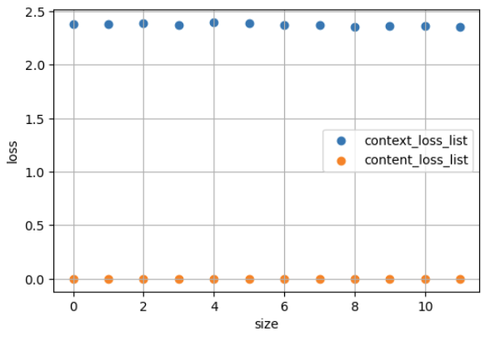
The performance of Sequence Detector on one datafile: AIA-51-75.csv
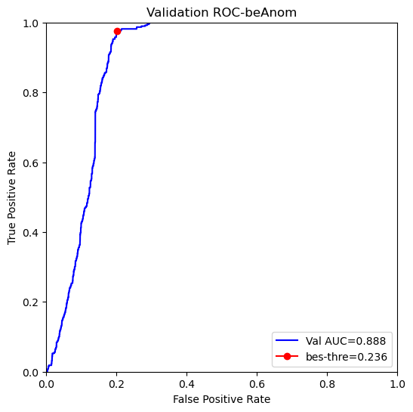
AUC-ROC: 0.8884

Best Threshold = 0.24

Best FPR = 0.20
Number of testing data: 63
Precision: 0.9988
Recall: 0.7991
F1 score: 0.8871

5.5 Manul analysis
Risk level, AIA-51-75.ecar-last-onlyScoreLabel-3-train.csv

Risk Categorization Strategy
To further interpret the anomaly scores and provide actionable intelligence, we categorize each event into one of five risk levels, following a statistical approach inspired by the DeepCASE framework. Given a set of anomaly scores produced by our model, we compute the mean ($μ$) and standard deviation ($σ$) of the scores across the dataset. These values are then used to define symmetric thresholds around the mean, enabling a tiered classification of risk.
Each score is assigned a risk level as follows:
- INFO (0): Scores equal to the mean ($x = μ$).
- LOW (1): Scores within one standard deviation from the mean （ $μ− σ≤x < μ$ or $μ< x ≤μ+ σ$ ).
- MEDIUM (2): Scores between one and two standard deviations from the mean on either side.
- HIGH (3): Scores between two and three standard deviations from the mean.
- ATTACK (4): Scores beyond three standard deviations from the mean, on either side.
This risk stratification helps translate continuous anomaly scores into discrete categories that can be more easily interpreted by security analysts. It also enables us to examine the distribution of alerts across different severity levels, thereby supporting both quantitative evaluation and qualitative insights into model behavior.

Event seq metrics
Prepare for clustering, calculate the score or label or risk level.
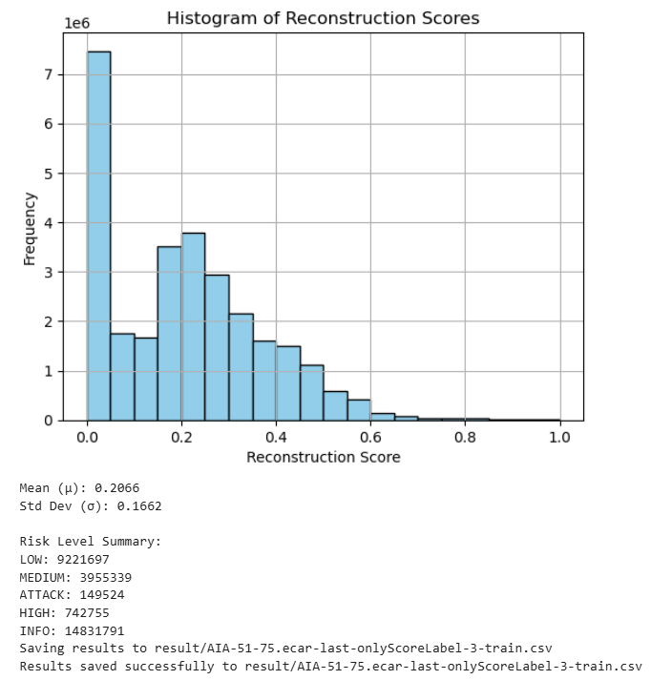

Cluster size distribution

For 100 hosts
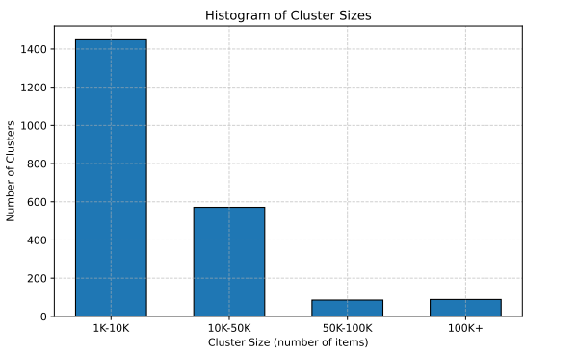
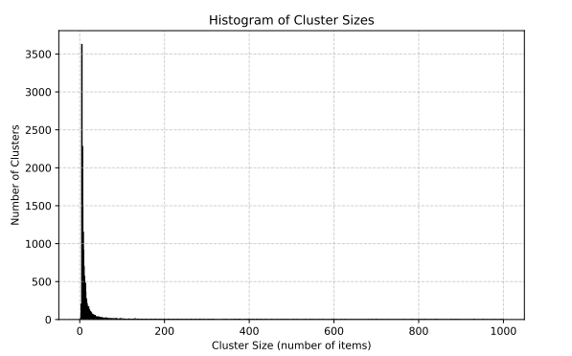

For 5 hosts

For one datafile

AIA-51-75-ecar-last.csv
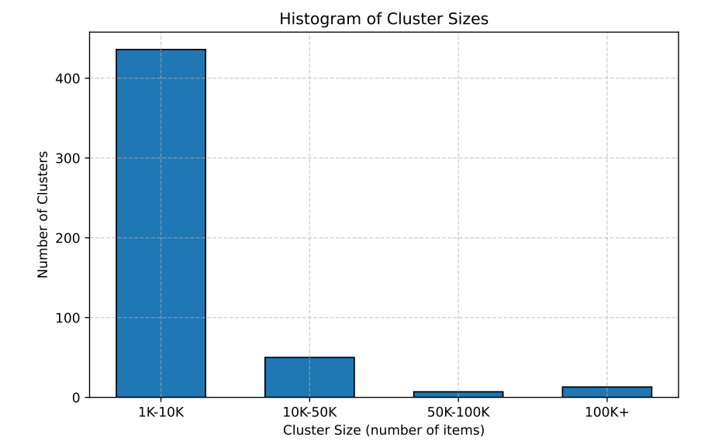
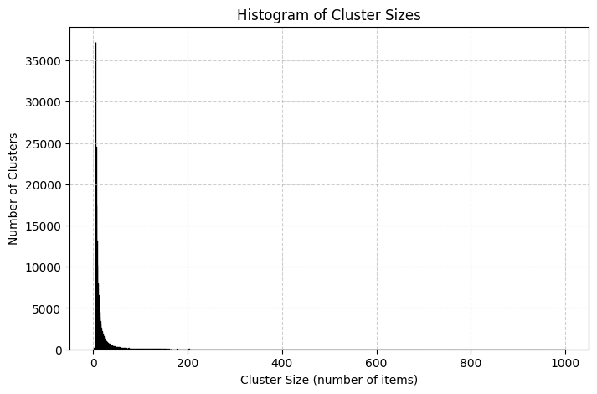

5.6 Semi-automatically analysis
20-23-124(20).csv

Anomaly_Cover_rate

Confusion Matrix:
[[1913699 861470]
[ 25 573]]


Classification report
Cluster score method: max()

Metric=lables

51-75.csv

Next evaluate the normal and anomalous, and three unexpected scenes:
Classification report
precision recall f1-score support

-3.0 0.0000 0.0000 0.0000 0
-2.0 0.0000 0.0000 0.0000 0
-1.0 0.0000 0.0000 0.0000 0
0.0 1.0000 0.5868 0.7396 2310795
1.0 0.0000 0.0000 0.0000 536

accuracy 0.5866 2311331
macro avg 0.2000 0.1174 0.1479 2311331
weighted avg 0.9997 0.5866 0.7394 2311331

Confusion matrix
T\P LOW EPS NOT IN TRAIN LOW CONFIDENCE 0 1
0 688022 4 247664 1355873 19232
1 343 0 168 25 0

Next only evaluate the normal and anomalous:
{'0': {'precision': 0.9999815620349023, 'recall': 0.9860141589187734, 'f1-score': 0.992948744472269, 'support': 1375105.0},
'1': {'precision': 0.0, 'recall': 0.0, 'f1-score': 0.0, 'support': 25.0},
'accuracy': 0.9859962330834176,
weighted F1: 0.9929306925654589

Limitation of DeepCASE

No source code on update Interpreter.
No source code on setting 5 risk categories, only simple score the clusters.

Reference
[1] Analyzing the Usefulness of the DARPA OpTC Dataset in Cyber Threat Detection Research
[2] Final report for DARPA TC, https://apps.dtic.mil/sti/citations/AD1092961
[3] NETHAWK: Hunting advanced persistent threats via structural and temporal graph anomalies
[4] Effective IDS under constraints of modern enterprise networks: revisiting the OpTC dataset

